P802.1CF Fog deployment scenario
Date: 2018-09-24
Authors:
Name | Affiliation | Phone | Email
Max Riegel | Nokia |  | Maximilian.riegel@nokia.com
Notice:
This document does not represent the agreed view of the OmniRAN TG It represents only the views of the participants listed in the ‘Authors:’ field above. It is offered as a basis for discussion. It is not binding on the contributor, who reserve the right to add, amend or withdraw material contained herein.
Copyright policy:
The contributor is familiar with the IEEE-SA Copyright Policy <http://standards.ieee.org/IPR/copyrightpolicy.html>.
Patent policy:
The contributor is familiar with the IEEE-SA Patent Policy and Procedures:
<http://standards.ieee.org/guides/bylaws/sect6-7.html#6> and <http://standards.ieee.org/guides/opman/sect6.html#6.3>.

Abstract
This document provides text proposal for a new clause to fog deployment scenario

    - Fog deployment scenario
Fog computing describes a distributed computing architecture where major processing and storage resources are relocated from the Cloud to the computing nodes more near to the input and output to the physical world. Fog computing deploys virtualization techniques known from the Cloud like virtual machines or containers on the distributed computing nodes, which can even be tiny IoT devices. Locating data processing more near to the edge of the computing infrastructure avoids transmission delays and allows for better real-time behavior and higher reliability for time-critical applications.
Fog computing promises benefits for security through local encapsulation of sensitive data and processes, better cognition through adaptation of computing nodes to the physical requirements, higher agility through rapid scaling and relocation on a common infrastructure, lower latency through tightly located data processing, and increased efficiency through dynamic pooling and leveraging spare resources of distributed computing nodes. Fog computing can be considered as a front end to Cloud to enable the offload of bandwidth-intensive and/or time-critical processes and applications towards the interfaces to the real world.
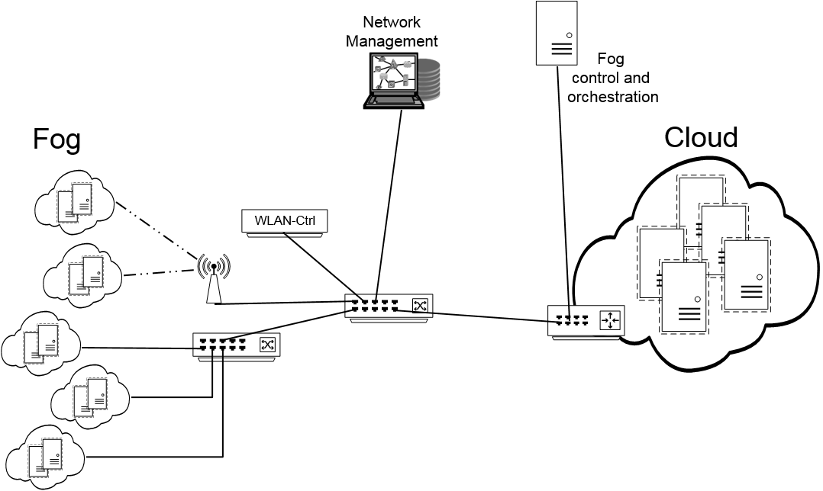
Figure 26+1 – Fog communication infrastructure
A well-defined and managed communication network is necessary between the central Cloud and the distributed Fog computing nodes to facilitate proper operation of distributed applications and to guarantee defined service levels. Processes in the Fog and in the Cloud communicate with each other through IP protocols, for which IEEE 802 technologies are commonly used to realize the packet transport. In addition to wired connections frequently realized together with power feeding over Ethernet, wireless connectivity is possible as well when wires can’t be used or are too expensive to install. When the wireless access technologies provide the IEEE 802 MAC service to the processing environment in the Fog computing node, the higher layer control of the Fog nodes can be kept agnostic to the lower layer IEEE 802 technology used for the access link.
Figure 26+1 illustrates an example of a communication network for Fog computing showing the same architectural structure as the access networks explained in the previous clauses. In the NRM, the Fog computing devices represent the terminals, connected either wired or wireless to NAs. The backhaul aggregates the links of the TEs and provides the connectivity between the Fog nodes among each other, as well as between the Fog nodes and the Cloud, which resides in the example behind the AR. As for all managed networks, a dedicated network management system deals with operation, administration, and maintenance of the infrastructure. Due to its distributed nature and the remote locations of the Fog nodes, a Fog control and orchestration entity provides the services of the SS to TEs and AR in order to establish and maintain a secure and trusted computing environment for the dynamic Fog system.
Figure 26+2 shows that the Fog communication infrastructure based on IEEE 802 technologies nicely maps to the NRM of IEEE 802 access network.

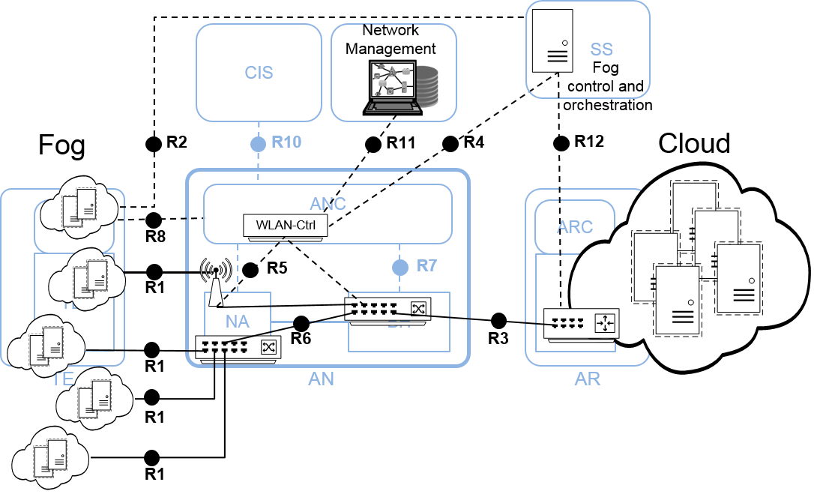
Figure 26+2 – Mapping of Fog communication infrastructure to NRM
Fog computing comprises more than just the packet forwarding between Fog nodes and between Fog nodes and the Cloud, but a secure, managed communication network is a prerequisite, that provides defined service levels, dynamic attachment and removal of Fog computing nodes, and open interfaces towards the processes in the Fog and Cloud. The IEEE 802 access network reference model is well suited to specify the communication infrastructure of Fog computing.

