P802.1CF/D2.0 CID100, 101 resolution proposal
Date: 2018-06-05
Authors:
Name | Affiliation | Phone | Email
Hao Wang | Fujitsu |  | wangh@cn.fujitsu.com
Notice:
This document does not represent the agreed view of the OmniRAN TG It represents only the views of the participants listed in the ‘Authors:’ field above. It is offered as a basis for discussion. It is not binding on the contributor, who reserve the right to add, amend or withdraw material contained herein.
Copyright policy:
The contributor is familiar with the IEEE-SA Copyright Policy <http://standards.ieee.org/IPR/copyrightpolicy.html>.
Patent policy:
The contributor is familiar with the IEEE-SA Patent Policy and Procedures:
<http://standards.ieee.org/guides/bylaws/sect6-7.html#6> and <http://standards.ieee.org/guides/opman/sect6.html#6.3>.

Abstract
This document provides text amendment proposals to address CID100, 101 of 802.1CF-D2.0

Text amendments to address CID100:

6.1.7.3 AN setup for authorized spectrum access

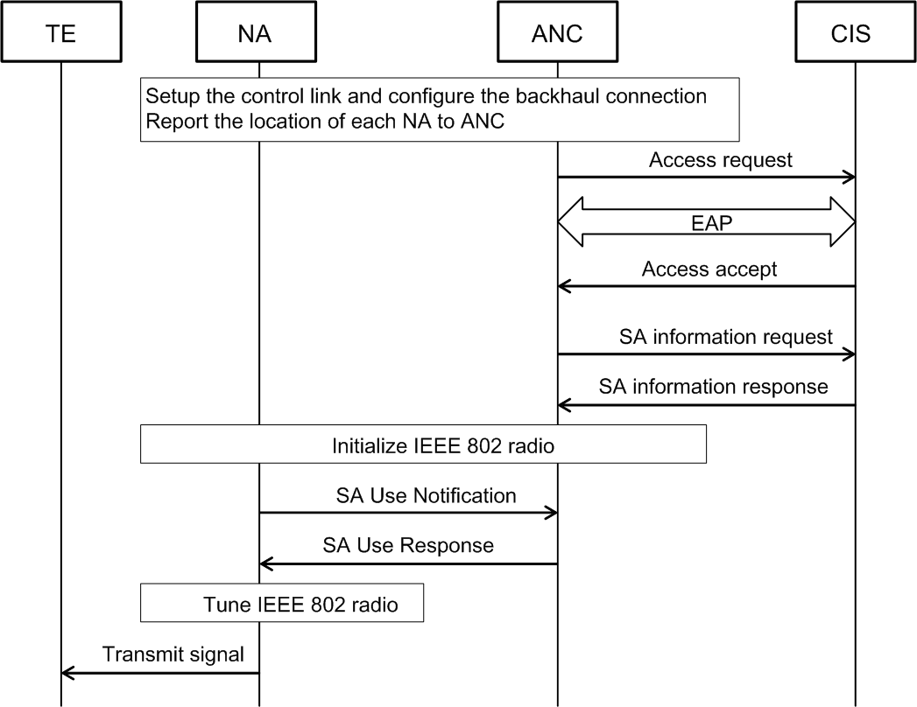
Figure 31 Detailed procedure of AN setup for authorized spectrum access

Figure 31 shows the detailed procedure of AN setup for authorized spectrum access. This procedure is also described as follows:
- After AN power-up, the NA should establish a secure connection to the ANC, report its geolocation based on the preconfigured information, and configure the port to the BH.
- The ANC generates an access request message on behalf of the NA containing the geolocation and other related information. The access request message is sent from the ANC over R10 to the valid CIS.
- Upon receipt of an access request message, the CIS starts the EAP message exchange with the ANC.
- If the identifier of ANC is known and requested access can be granted, the CIS informs the ANC with an access accept message to authorize the access to the medium. The pairwise master key is delivered in the access accept message from the CIS to the ANC.
- Once the authentication process succeeds, the ANC can query the CIS via sending the SA information request message to request a list of available channels and maximum allowed EIRP per channel from the CIS.
- Upon receipt of an SA information request message, the CIS returns an SA information response message to the ANC providing the requested information.
- Based on the retrieved information, NA can be initially switched on and perform a spectrum sensing procedure on the specified channel(s).
- The results of the above sensing should be provided to ANC embedded in an SA use notification message.
- As the spectrum availability information provided by the CIS and spectrum sensing results from the NA is gathered, the ANC should determine the operation channel(s) and indicate the NA through SA use response message to commence operation on the selected channel(s).

NA may hand over radio configuration information used for TVWS to the TEs located in the same area,
avoiding interference to the primary services.

6.1.7.4 Primary service protection

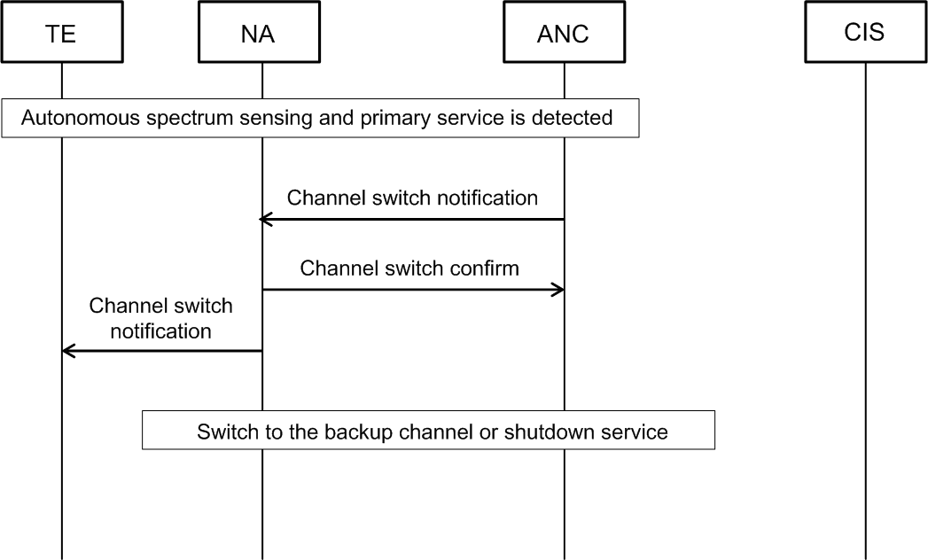
Figure 32 Detailed procedure for primary service protection for authorized spectrum access

Figure 32 illustrates the detailed procedure for primary service protection for authorized spectrum access. This procedure is also described as follows:
- Independent procedure of spectrum sensing may be performed periodically by TE and NA as the operation of the primary service changes over time. If the activity of the primary service is detected through the distributed sensing technique by both TE and NA, the ANC should be notified immediately.
- If the ANC concludes that the operating channel is under interference and primary service needs to be protected, a channel switch notification message will be generated and sent from the ANC to the NA.
- In this situation, the NA should update the status of the listed backup channels and notify the ANC with a channel switch confirm message.
- Meanwhile, the NA will start a timer to schedule the channel switch, and notify the TE about the action with a channel switch notification message.
- If the backup channel is available when the timer expired, the NA will continue its operation on the backup channel and reestablish communication with the TE. Otherwise, the NA should terminate its operation on current channel and the connectivity service will be shut down.

