P802.1CF-D1.0 CID 24, 50, 98 remedies
Date: 2018-04-05
Authors:
Name | Affiliation | Phone | Email
Max Riegel | Nokia Bell Labs |  | maximilian.riegel@nokia.com
Notice:
This document does not represent the agreed view of the OmniRAN TG It represents only the views of the participants listed in the ‘Authors:’ field above. It is offered as a basis for discussion. It is not binding on the contributor, who reserve the right to add, amend or withdraw material contained herein.
Copyright policy:
The contributor is familiar with the IEEE-SA Copyright Policy <http://standards.ieee.org/IPR/copyrightpolicy.html>.
Patent policy:
The contributor is familiar with the IEEE-SA Patent Policy and Procedures:
<http://standards.ieee.org/guides/bylaws/sect6-7.html#6> and <http://standards.ieee.org/guides/opman/sect6.html#6.3>.

Abstract
This document provides the agreed remedies for CID 24, 50, and 98, as well as a small amendment required by the updated information model in clause 8.1

98 | Technical | 53 | 7.1.5 | 1378 | List of access network setup-specific attributes is incomplete and requires clean-up. | Insert in section 7.1.5 a complete list of AN configuration attributes according to the information model provided in section 8.1.2 and revise text of attributes for authorized spectrum access as follows:  For the authorized spectrum access in TVWS, there are a few specific information elements:  — {1} Geolocation: Describes the location of the AN requesting authorization make use of unused TV spectrum  — {0+} OfferedChannels: List of available channels with maximum allowed EIRP Information provided by the spectrum database for authorized access to TVWS  — {1+} SpectrumSensingData: Measurement results delivered by the NAs and eventually by the TEs to the ANC for selection of the operating channel.  — {0+} BackupChannels: List of channelsthat can be used when the operating channel is heavily loaded or must be terminated. | Yes | Max R. | Accepted in principle. Textual amendments provided in DCN-18-38-00 according the completion of the information model in clause 8.1

Chapter

Network setup

Access network setup-specific attributes
AN setup covers essentially all base configuration parameters of the IEEE 802 technologies as well as the base attributes describing the network structure.

NMS
{1} ANCConfig: Initialization configuration for ANC
{1+} NAConfig: Initialization configuration for NA
{1+} BHConfig: Initialization configuration for BH

ANC
{1} ANConfig: Initialization configuration for AN
{1} OperationStatus: Indication of the status of the operation of AN

BH
{1} BHConfig: Initialization configuration for BH
{1} OperationStatus: Indication of the status of the operation of BH

NA
{1} NAConfig: Initialization configuration for NA
{1} OperationStatus: Indication of the status of the operation of NA
For set-up in TVWS, there are a few additional information elements:
{1} Geolocation: Geographic location of the NA
{1+} SensingCapabilities: Capability parameters for the NA

Sensing statistics

For the authorized spectrum access in TVWS, there are a few specific information elements:
{1} Geolocation: Describes the location of the AN requesting authorization make use of unused TV spectrum

{1+} SS_stats: Spectrum sensing statistics: Measurement results delivered by the NAs and eventually by the TEs to the ANC for selection of the operating channel.
The CIS provides information of the spectrum database:
{0+} OfferedChannels: List of available channels with maximum allowed EIRP Information provided by the spectrum database for authorized access to TVWS
{0+} BackUpChannels: Back-up channel list List of channels that can be used when the operating channel is heavily loaded or must be terminated.

Access network setup-specific basic functions

24 | Technical |  | 7.2 | 1544 | During section 7.2 one is expecting all the time to see the mapping to IEEE 802 techs but there is no reference of it at all. I think there are places of 7.2 where a reference to 7.2.8 would be welcome. For example, when talking about Network Selection, a link to ANQP and then to section 7.2.8 would be good |  | No | Antonio | Add statement to the introduction pointing to the mapping to IEEE 802 technologies at the end of the clause.

Access network discovery and selection (NDS)

Introduction
Access network discovery and selection describes the process by which a terminal detects the available access networks, followed by retrieval of information about each of the access networks and their nodes of attachment in range. The process concludes with the evaluation of the collected information and related information stored locally in order to determine the most appropriate node of attachment for the succeeding establishment of the connection.
NDS mainly applies to wireless access technologies, and various IEEE 802 technologies provide various capabilities as described in clause 7.2.8. Only a very limited subset of the functions are applicable to wired access technologies like IEEE 802.3.

###Amendment required due to acceptance of DCN 17-0079-05 as remedy for CID 104: Agreed information model contains association related information elements not yet represented in clause 7.3###

Association and disassociation

Association-specific attributes

Access link
{1} Link-ID: Unique link identifier
{1} LinkConfig: configuration values of the linkAn access link is established through the association process. It is defined through:

TE
{1+} SupportedLinkCapabilities: possible link configuration
{1+} SupportedSecurityCapabilities: possible security modes
{1+} SupportedQosCapabilities: possible QoS configuration
{1+} ResultCodes: Indication of the association results

NA
{1+} AllowedLinkCapabilities: allowed link configuration
{1+} AllowedSecurityCapabilities: allowed security modes
{1+} AllowedQosCapabilities: allowed QoS configurations
{1} PreferredLinkProfile: desired link configuration attributes
{1} PreferredSecurityProfile: desired security mode
{1} PreferredQosProfile: desired QoS mode

Association-specific basic functions

50 | Technical | 82 | 7.5.1.1 | 2313 | These terms were originated and defined by MEF, they must be acknowledged as such and referenced | Attribute origin to MEF and add MEF 6.2 (and MEF 10.3 if appropriate) reference | Yes | Glenn P. | text will be amended making appropriate attribute to basic concepts taken over from MEF and in particular MEF 6.2; MEF 10.3 is not applicable.

Data path establishment, relocation, and teardown

Introduction

Link characteristics
Various forwarding behaviors may exist in the NA, depending on the specific IEEE 802 access technology and configuration. Some technologies allow bridging—i.e., forwarding according to destination MAC addresses—to happen directly between TEs associated with the same NA. However, an NA may be configured to enforce that all user data coming from TEs are forwarded over R6 toward the BH. BH may contain functions to enable forwarding between the end stations without passing the data through the access router.
To describe the various forwarding behaviors, that may exist on a link, the specification adopts basic architectural concepts from Metro Ethernet Forum MEF 6.2 to characterize the bridging behavior and restrictions on a link through the access network. Forwarding in the access network may be restricted to one of the following schemes:
- Ethernet-Line (E-Line) characteristic represents a point-to-point connection carrying Ethernet frames only between the R1 interface of a particular TE and the R3 interface of its AR.
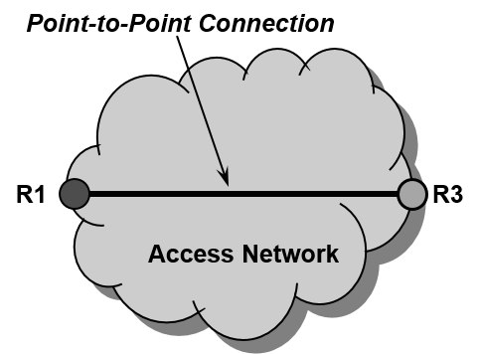
Figure 42—E-Line characteristic
Point-to-point connections between TEIs and ARIs require that the AR establish and maintain a dedicated interface for each of the connected TEs. Such configuration is commonly used in mobile networks where the IP connectivity has to be maintained across multiple ANs.

- Ethernet-LAN (E-LAN) characteristic provides multipoint-to-multipoint connectivity for Ethernet frames across a number of interfaces. Any TE connected to an AN with E-LAN characteristic can communicate with any other TE over the same link in that AN. Still, an AN can establish multiple separated links with multipoint-to-multipoint connectivity for groups of TEs by means of VLANs.
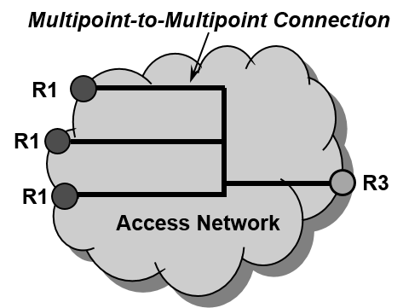
Figure 43—E-LAN service
E-LAN characteristic is usually deployed when all connected TEs belong to the same security domain and are allowed to communicate directly to each other. A benefit of E-LAN characteristic is that the AR needs only a single interface for a number of TEs and is less loaded, as communication between the connected TEs in an AN does not pass through the AR. Access networks within enterprises or industrial facilities commonly deploy E-LAN characteristic.
- Ethernet-Tree (E-Tree) characteristic distinguishes between leaf interfaces and root interfaces, as depicted in Figure 42. Leaf interfaces are restricted in the exchange of data only with root interface, but never directly with another leaf interface. Root interfaces can exchange data with any leaf interface and with any other root interface.
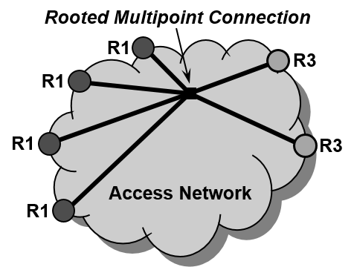
Figure 44—E-Tree service
E-Tree characteristic is usually deployed in ANs that are intended to serve a large number of TEs via a single interface of the AR, as in an E-LAN, but enforce that all user traffic is passing through the AR. E-Tree characteristic is commonly used for efficiently providing public broadband access, for connecting a huge number of small devices to a network such as for IoT, or for delivering multicast services efficiently to multiple interfaces.

Traffic types

However, there is one deficiency of the E-Tree characteristic for establishing public access networks: IPv6 operation requires direct host-to-host connectivity for neighbor discovery messages to allow secure neighbor discovery.

