[Wired/Wireless Use Cases and Communication Requirements for Flexible Factories IoT Bridged Network]
IEEE-SA Industry Connections Report
IEEE | 3 Park Avenue | New York, NY 10016-5997 | USA

Wired/Wireless Use Cases and Communication Requirements for Flexible Factories IoT Bridged Network
Author [TBD]
and any other important
authoring details
Trademarks and Disclaimers
IEEE believes the information in this publication is accurate as of its publication date; such information is subject to change without notice. IEEE is not responsible for any inadvertent errors.

The Institute of Electrical and Electronics Engineers, Inc.
3 Park Avenue, New York, NY 10016-5997, USA

Copyright © 20xx by The Institute of Electrical and Electronics Engineers, Inc.
All rights reserved. Published Month 20xx. Printed in the United States of America.

IEEE is a registered trademark in the U. S. Patent & Trademark Office, owned by The Institute of Electrical and Electronics Engineers, Incorporated.

PDF: ISBN 978-0-7381-xxxx-x STDVxxxxx
Print: ISBN 978-0-7381-xxxx-x STDPDVxxxxx

IEEE prohibits discrimination, harassment, and bullying. For more information, visit http://www.ieee.org/web/aboutus/whatis/policies/p9-26.html.

No part of this publication may be reproduced in any form, in an electronic retrieval system, or otherwise, without the prior written permission of the publisher.

To order IEEE Press Publications, call 1-800-678-IEEE.
Find IEEE standards and standards-related product listings at: http://standards.ieee.org

Notice and Disclaimer of Liability
Concerning the Use of IEEE-SA Industry Connections Documents
This IEEE Standards Association (“IEEE-SA”) Industry Connections publication (“Work”) is not a consensus standard document. Specifically, this document is NOT AN IEEE STANDARD. Information contained in this Work has been created by, or obtained from, sources believed to be reliable, and reviewed by members of the IEEE-SA Industry Connections activity that produced this Work. IEEE and the IEEE-SA Industry Connections activity members expressly disclaim all warranties (express, implied, and statutory) related to this Work, including, but not limited to, the warranties of: merchantability; fitness for a particular purpose; non-infringement; quality, accuracy, effectiveness, currency, or completeness of the Work or content within the Work. In addition, IEEE and the IEEE-SA Industry Connections activity members disclaim any and all conditions relating to: results; and workmanlike effort. This IEEE-SA Industry Connections document is supplied “AS IS” and “WITH ALL FAULTS.”

Although the IEEE-SA Industry Connections activity members who have created this Work believe that the information and guidance given in this Work serve as an enhancement to users, all persons must rely upon their own skill and judgment when making use of it. IN NO EVENT SHALL IEEE OR IEEE-SA INDUSTRY CONNECTIONS ACTIVITY MEMBERS BE LIABLE FOR ANY ERRORS OR OMISSIONS OR DIRECT, INDIRECT, INCIDENTAL, SPECIAL, EXEMPLARY, OR CONSEQUENTIAL DAMAGES (INCLUDING, BUT NOT LIMITED TO: PROCUREMENT OF SUBSTITUTE GOODS OR SERVICES; LOSS OF USE, DATA, OR PROFITS; OR BUSINESS INTERRUPTION) HOWEVER CAUSED AND ON ANY THEORY OF LIABILITY, WHETHER IN CONTRACT, STRICT LIABILITY, OR TORT (INCLUDING NEGLIGENCE OR OTHERWISE) ARISING IN ANY WAY OUT OF THE USE OF THIS WORK, EVEN IF ADVISED OF THE POSSIBILITY OF SUCH DAMAGE AND REGARDLESS OF WHETHER SUCH DAMAGE WAS FORESEEABLE.

Further, information contained in this Work may be protected by intellectual property rights held by third parties or organizations, and the use of this information may require the user to negotiate with any such rights holders in order to legally acquire the rights to do so, and such rights holders may refuse to grant such rights. Attention is also called to the possibility that implementation of any or all of this Work may require use of subject matter covered by patent rights. By publication of this Work, no position is taken by the IEEE with respect to the existence or validity of any patent rights in connection therewith. The IEEE is not responsible for identifying patent rights for which a license may be required, or for conducting inquiries into the legal validity or scope of patents claims. Users are expressly advised that determination of the validity of any patent rights, and the risk of infringement of such rights, is entirely their own responsibility. No commitment to grant licenses under patent rights on a reasonable or non-discriminatory basis has been sought or received from any rights holder. The policies and procedures under which this document was created can be viewed at http://standards.ieee.org/about/sasb/iccom/.

This Work is published with the understanding that IEEE and the IEEE-SA Industry Connections activity members are supplying information through this Work, not attempting to render engineering or other professional services. If such services are required, the assistance of an appropriate professional should be sought. IEEE is not responsible for the statements and opinions advanced in this Work.

Contents
Introduction 1
Scope 2
Purpose 2
Definitions 3
Factory Overview and Operation environment 3
Factory communication network environment 3
Radio Environment within Factories 4
(a) The Severe Environment for Wireless Communications 5
(b) Uncoordinated and Independent Systems 6
Wireless applications and communication requirements 9
Scope of wireless applications in factory 9
Wireless applications 9
communication requirements 10
Details of wireless application and communication requirements 12
Factory Usage scenarios 18
Usage scenarios example: Metal processing site 18
Usage scenarios example: Mechanical assembly site 20
Usage scenarios example: Elevated and high temperature work site 21
Usage scenarios example: Logistics warehouse site 22
Factory End to End Network architecture 24
Concept of architecture 24
Expectation for Enhancement of existing IEEE 802 functions 24
[New Project description and proposal] 26
Conclusions 26
Citations 26

Wired/Wireless Use Cases and Communication Requirements for Flexible Factories IoT Bridged Network

Introduction
Communication used in factories has until now been mainly wired communication, which has been preferred for its reliability. However, in recent years the shorter times of product development cycles demands greater flexibility in the layout of machines and sequence of processes,, and there are increasing expectations for the use of radio links amongst of the sensors and machines used in the manufacturing and factory processes.
This report is developed under the IEEE 802 Network Enhancements for Next Decade Industry Connections Activity (NEND-ICA). It addresses the integration and bridged wired and wireless IoT communications in the factory environment. The report includes use cases and requirements within the factory wireless environment. It presents problems and challenges observed within the factory and reports on feasibility of some possible solutions for overcoming these issues. Areas that may benefit from standardization are highlighted.

Roger thinks the following text should be removed out of the introduction. I can agree with that. But the rest the text “Material supporting the development …” can be maintained as it is one of the key scope of NEND and it is one of the key objectives of this report. If necessary we can edit to make general and not to pre-judge the outcome. As such deleted the target WG for the new PAR.

[leading towards a proposal to initiate new standards development makes the case for a new project. Material supporting the development of a new PAR is included in this report. ]
The report analyses the factories environments considering its foreseen evolution that includes dense radio devices utilization. It summarizes wireless use cases and their communication requirements which are obtained based on information gathered from literature and factories survey.
The report then presents an underlying End to End network architecture which encompasses the operation and control of the various services in the factory network according to their dynamic QoS requirements. It analyses the applicable standards and features in wired and wireless IEEE 802 technologies for managing requirements in End-to-End (E2E) network connectivity and TSN profiling for converged wired and wireless connectivity in factory environment.

[Old Overview duplicate with the above text and needs to be converged:
Communication used in factories has until now been mainly wired communication, which has been preferred for its reliability. However, in recent years the shorter times of product development cycles demands greater flexibility in the layout of machines and line construction, and there are increasing expectations for the use of wireless communications.
The report addresses the converged and bridged wired and wireless Internet of Things (IoT) communications in the factory environment. It analyses factory environment considering its foreseen evolution that includes dense radio devices utilization. It gives summary of use cases and requirements within the factory wireless environment which are obtained based on information gathered from literature and factories survey. It presents problems and challenges observed within the factory’s network and reports on feasibility for overcoming these issues leading towards potential project(s) for new standard(s) development. ]

Scope
The scope of this report is to capture current and future network requirements taking into consideration dense use of radio devices and its operation in factory environment. The report presents analysis of issues and challenges identified in maintaining reliable and time sensitive/constraint deliverable of control messages and data traffic across wired and wireless bridged network within the identified factory environment. Also to present analysis of applicable standards and features in wired and wireless IEEE802 technologies for managing requirements in E2E network connectivity.

Roger questioned the use of “bridged” network. The use of bridges in the factory network is quite common since multiple LAN wired and wireless with different segments which are generally bridged. Updated figure 3-1 that shows bridges used within the factory network

Purpose
The purpose of this report is to present an overview of issues and challenges in managing a reliable and time sensitive connectivity in E2E wired and wireless network characterized by dense radio devices installation and noisy factory environment. The report will also present technical analyses of the applicable features and functions in wired and wireless IEEE802 technologies for managing requirements in E2E network connectivity which can be used in an IEEE 802 standard solution based on TSN profiling for converged wired and wireless connectivity within the factory environment.

Definitions

Factory Overview and Operation environment

Factory communication network environment
Recent trends to introduce IoT devices, such as sensors and cameras in the factories are accelerated by strong demand for improving productivity under the constraints of reduced workers in aging population society and pressure for cost reduction. Digitalization of the factories as well as connection of information on production process and supply chain management within a factory and across factories becomes important. It is no doubt that commutation networks will be changing in factories for the next decade.
There are several system applications, e.g., preventive maintenance, management of materials and products, monitoring of movements and machine monitors which are integrated in the network. Future industrial network for a factory may consist of wired and wireless bridges for such systems above. The successful integration of wired and wireless systems is indispensable and more efforts will be required for wireless communication because of its narrow bandwidth and sensitive nature of environment. A multi layers network architecture is required in order to configure, coordinate radio technologies coexistence and manage the end to end flows and streams as illustrated in the following Figure 1.
Need to insert here a figure for the factory multi layers network architecture taken from one of the presentations made earlier in IEEE802.1 illustration E2E flow management and coordination of radio technologies used within the factor.
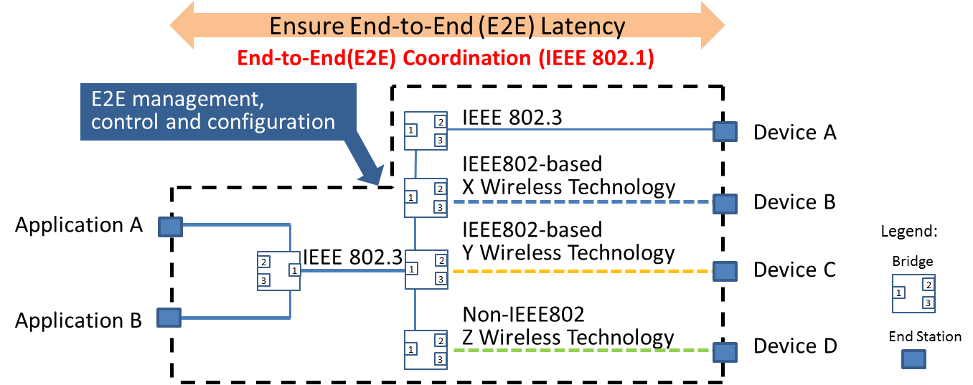
Figure 1 Example of Network Topology in Factory Environment
End-to-End (E2E) network topology for a factory today is configured by combination of wired LAN, such as 802.3, IEEE802-based and non-IEEE802 wireless technologies.
In order for factory IoT system to work well, a higher layer End to End coordination system is needed to configure, manage, and control data frames/streams that are transported in a mix of different technologies with varying QoS performance and attributes.

Traditionally, wireless communications have not been popular in the manufacturing field. There are still many stand-alone machines managed manually by skilled workers. Advanced factories, on the other hand, have been using communication networks called fieldbus, a type of wireline network. One of the reasons wireless commutations have not been used extensively in factories is because there are doubts about their stability and reliability. Technology developments as well as standardization are keys to success for wireless utilization. If these efforts are proven successful, wireless use for IoT connectivity in factory will increase resulting in more flexibility in the manufacturing process and improved productivity within the factory environment.
Note from the review during OmniRAN meeting in Geneva January 2018:
A figure or text explaining the need in the current network configuration used within typical factory and how the expansion of radio LAN or radio nodes within the wired network will require maintaining certain QoS requirements in the radio domain. It should also show the enhancement by introducing TSN functionality into the factory network.
One of the main considerations within the factory network is the need for the provisioning of QoS for large number of M2M type of data generated from many sensors at the same time with different priority-classes. These data types are periodic in nature and have relatively short packet size.
When the factory network is extended over radio, some incompatibility in QoS provisioning between wired and wireless segments become apparent. The first is due to dynamic variations in the available bandwidth (capacity and throughput) over the radio segment as results of the non-deterministic noise/interference, distortions and fading. These dynamic variations cause congestion not just because overloading of the data streams but also because of the wireless link quality deterioration. Under such conditions, the current protocols may not function properly.
Therefore, for the successful factory automation with high degree of flexibility, dynamic management and control of end-to-end streams/frames across mixed wired and wireless links required some kind of coordination at the higher layer is necessary as illustrated in Figure 1 above.
Impact of applying QoS and Time Synchronizations functions and protocols to heterogeneous factory network with mixed wired and wireless links in factory network is further analyzed in section “Factory End to End Network Architectur” with potential and possible solutions discussed. But first, details of the environment and cause of impairments and distortions to radio signals within the factory environment are presented next.

Radio Environment within Factories
It is true that wireless commutations are not always difficult everywhere in factories. However, we have to consider that some applications require high-reliable, low-latency and low-jitter data transmission compared with other application in other places like offices and homes in general. Furthermore, the measurement results have revealed that some factories are facing difficulties coming from (a) severe environment for wireless communications, and/or (b) existence of uncoordinated and independent systems in the same space.

(a) The Severe Environment for Wireless Communications
There are two source of impairment to radio signal within the factory environment that cause unpredictable variations to channel capacity, namely:
- Fluctuation of signal strength
- Noises
As follows are examples of such impairments observed within the factory environment.
Example of Fluctuation of signal Strength:
The layout of the environment for which measurements are made is shown in the figure below. Master and slave transceivers were located in LOS condition and there was no blockage during measurement.
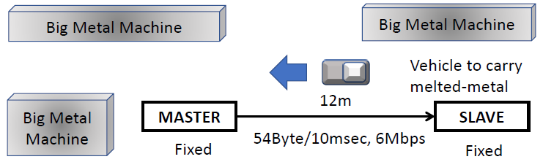
Figure 2 Layout in factory for which measurement of RSSI is recorded
The observed RSSI measurement in LOS condition is shown in figure 3 below.
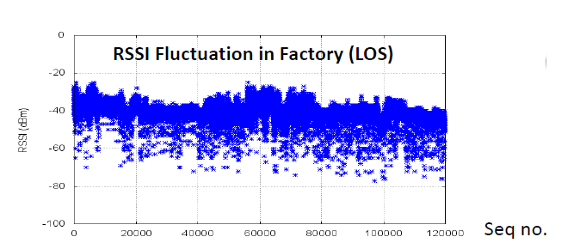
Figure 3 RSSI Fluctuation in Factory (LOS)
This fluctuation in RSSI is due to motions of materials, parts, products and carriers in closed space.
Example of Noises:
While carrying radio measurement within the factory environment strong noise signals were observed within the 1.9 GHz band and the 2.4 GHz band. These are shown in Figure 4.

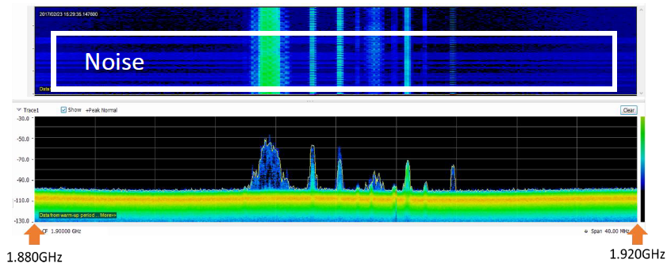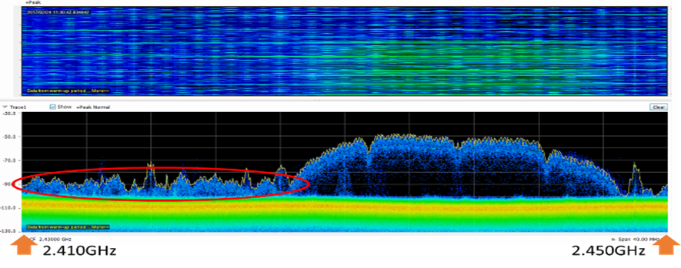
- 1.9 GHz band (b) 2.4GHz band
Figure 4 Measured noise spectral density within
(a) 1.9 GHz band and (b) 2.4 GHz band
In the 1.9 GHz band, the noise appears to cause problems for the communication with particular machines as well as problem for using the 1.9GHz band for internal telephone system.
The source of these noises is attributed to some kinds of manufacturing machines that are causing interference for wireless communications.

(b) Uncoordinated and Independent Systems
This issue within the factory environment is attributed to the progressive nature which leads to stepped approach of addition and installation of machines and equipment in the factory and due to coexistence of heterogeneous and legacy devices/systems used within the factory.
An example of using wireless technology in the factory is shown in Figure 5.
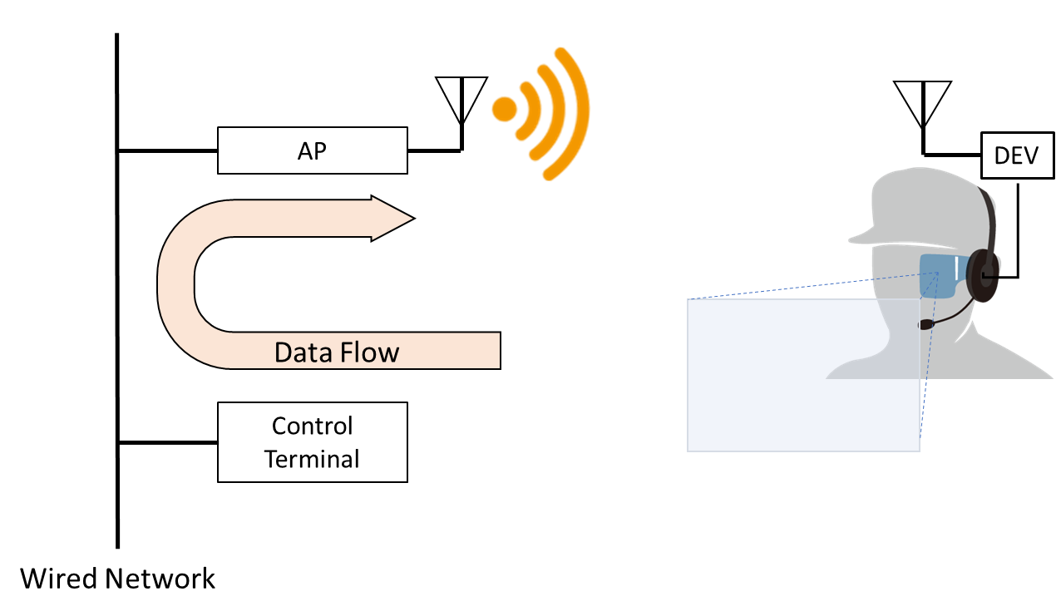
Figure 5 video monitor application as an example of using wireless technology

In this example it illustrates an application in which the data flow across the wired network and bridged across to the wireless domain. In this application there are QoS requirements and latency constraints for both the video signal and the control signal. Potential problem is a bottleneck for which delay or uncoordinated signal flow may occur due to disturbance and/or degradation in the radio signal.
When considering the coexistence of uncoordinated wireless systems, we observe the problem of interference between the legacy wireless communications used by some machinery in the factory with the new systems using Wi-Fi. The overlapping of signal causing potential interference is illustrated in Figure 6.
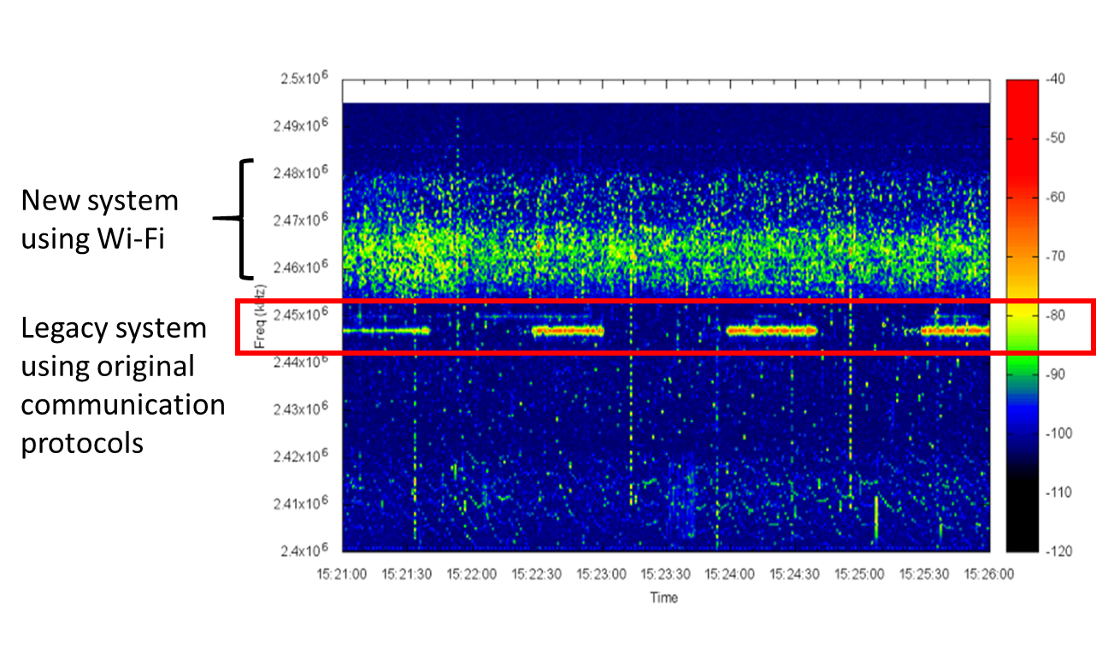
Figure 6 Coexistence of different wireless technologies

Some of the problems observe relates to the packet delivery delay. Figure 7 shows packet loss and packet delivery delay with different interference level. The packet latency increased from 8ms in case of no interference to around 2 second in the presence interference due to lack of coordination amongst the used wireless systems used in the factory.
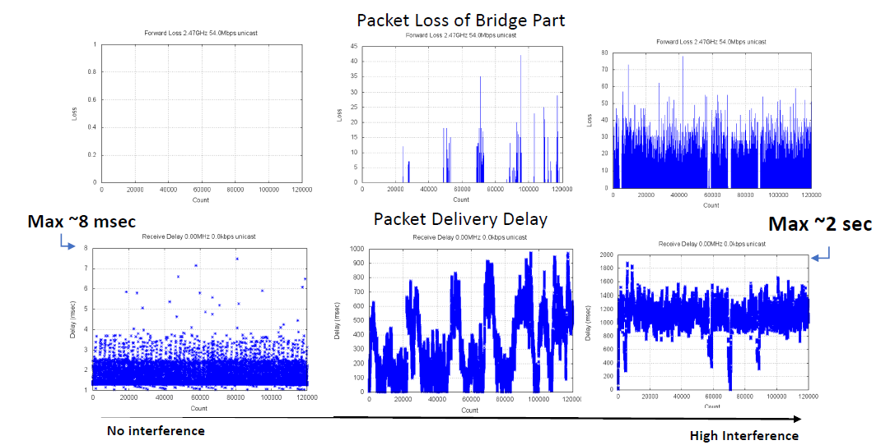
Figure 7 Impact of interference on latency in uncoordinated wireless systems
In this document, wireless applications and communication requirements are described to understand what shall be improved and enhanced for successful convergence of wired and wireless systems.

Wireless applications and communication requirements

Scope of wireless applications in factory
The wireless applications considered in this clause illustrate the use of wireless systems that are currently used –or will be used soon - in factories and factory related facilities. The applications correspond to wireless systems that are installed for specific purpose.
For example, wireless systems shown in Figure 8, there are individual systems (within the dotted lines) introduced for specific purposes such as “Collecting Management Information”, and a wireless network consisting of multiple such wireless systems and transmitting information aggregated by them. In this case, each individual system corresponds to a wireless application and described in following sub sections, but not the whole wireless network. That is, each wireless segment is considered as a separate application.
Section “Factory Usage Scenario” considers actual factory sites with large needs for wireless communication and describes usage scenarios where multiple wireless applications coexist.
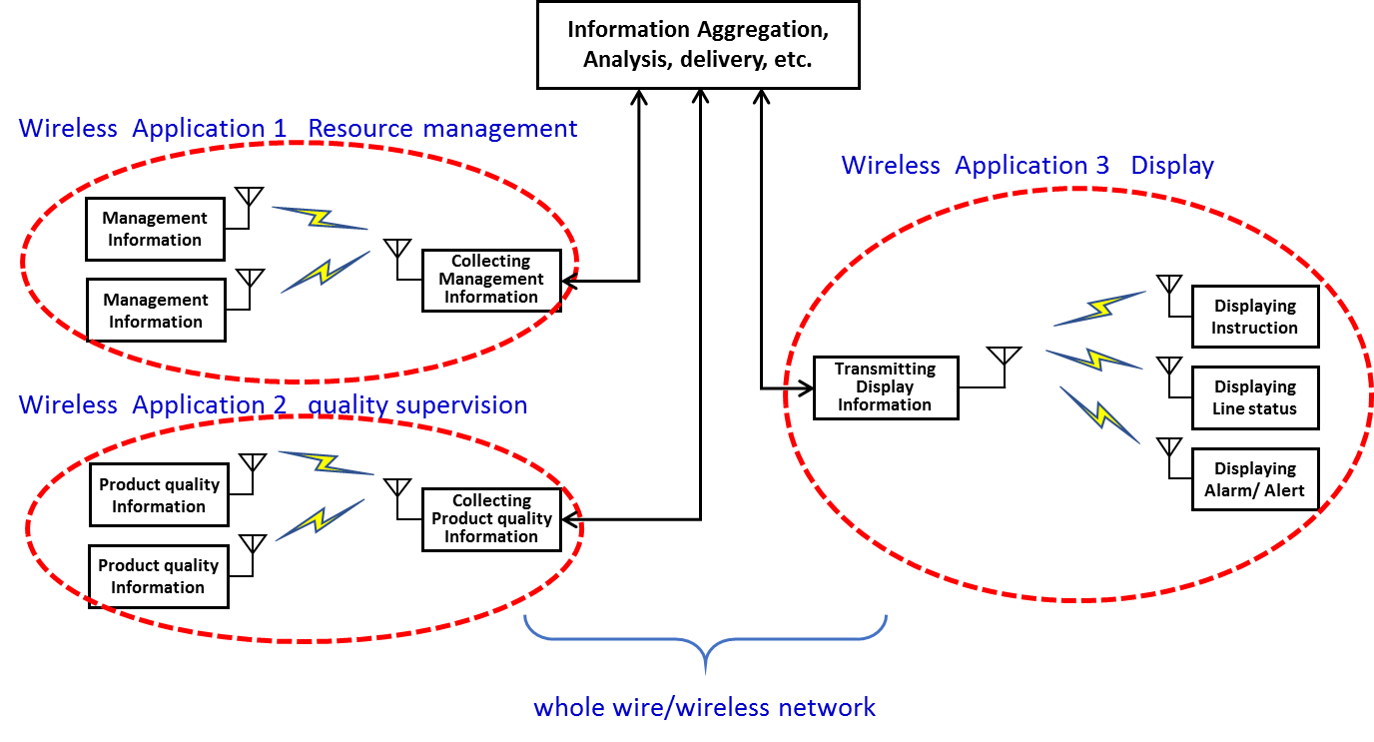
Figure 8 Scope of wireless applications in factory

Wireless applications
In our usage survey of wireless communication in factories, we collected various applications. We classified them according to their purposes, and organized their communication requirements. List of collected wireless applications are shown in Table 1. They were divided into six categories (equipment control, quality supervision, resource management, display, Human safety, and others) and then subdivided into thirteen [three] classifications according to their corresponding purposes.

Table 1 Wireless applications

Category | Description | Classification according to the purpose
Equipment Control | sending commands to mobile vehicles, production equipment | - Controlling, operating and commanding of production equipment, auxiliary equipment
Quality Supervision | collecting information related to products and states of machines during production | - Checking that products are being produced with correct precision  - Checking that production is proceeding with correct procedure and status
Factory Resource Management | collecting information about whether production is proceeding under proper environmental conditions, and whether personnel and things contributing to productivity enhancement are being managed appropriately | - Checking that the production environment is being appropriately managed  - Monitoring movement of people and things  - Checking the management status of equipment and materials (stock)  - Checking that the production equipment is being maintained  - Appropriate recording of work and production status
Display | For workers, receiving necessary support information, for managers, monitoring the production process and production status | - Providing appropriate work support  - Visually display whether the process is proceeding without congestion or delay  - Visually display the production status
Human Safety | collecting information about dangers to workers | - Ensuring the safety of workers
Other | Communication infrastructure with non-specific purposes | - Cases other than the above

communication requirements
[The communication requirements of each wireless applications are shown as the following parameters - mobility, number of terminals in the factory, density of terminals, average number of terminals influencing at a location, transmission data size, regularity of communications, communication frequency, delivery time tolerance, tolerance jitter, communication range, wireless terminal (master station) height, wireless terminal (sub-station) height, communication standard, frequency band and network topology.]
Figure 9 shows representative wireless applications and their features of wireless communication. Values of data size, data generation rate, number of wireless nodes, and so forth are different for different systems in factories, and according to the required functions of the systems, they use different wireless frequency bands and wireless standards. High frequency bands such as 60 GHz band are expected to be effective for systems with relatively large data volume requirements (image inspection equipment, etc.), 5 GHz band and 2.4 GHz band are being used for systems with medium requirements of data sizes and data generation rate, such as distributing control programs and control of mobile equipment, and relatively low wireless frequency bands such as 920 MHz band are being used for applications with low power requirements (such as environmental sensing).

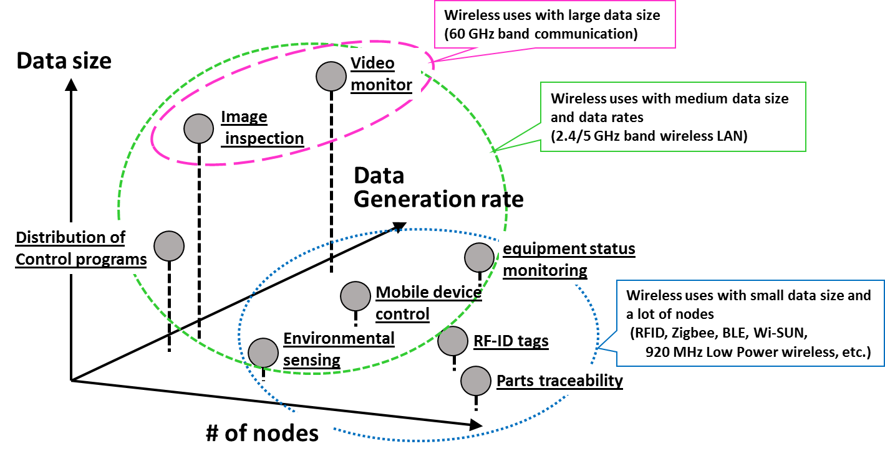
Figure 9 Representative wireless applications and their features of wireless communication

Figure 10 shows the permissible delay for representative wireless applications. There are wireless applications, such as robot control and urgent announcements, for which the urgency and accuracy of information arrival timing requires less than one millisecond latency. On the other hand, particularly in the categories of quality (inline inspection, etc.) and management (preventive maintenance, etc.), there are many wireless applications that tolerate latencies larger than hundred milliseconds.

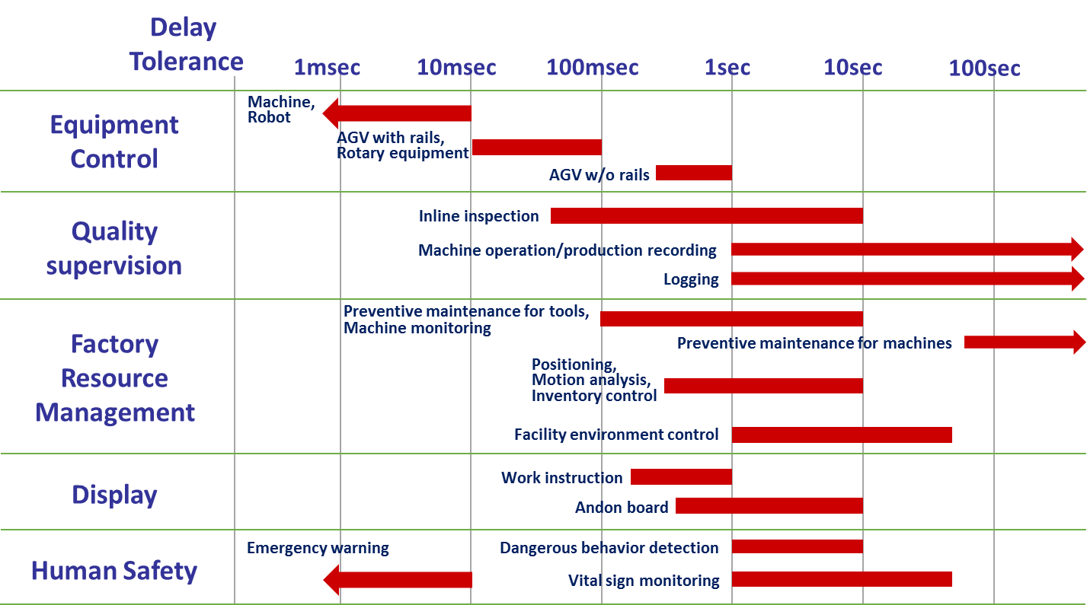
Figure 10 Permissible latencies of representative wireless applications

Details of wireless application and communication requirements
Communication requirements for the thirteen classifications of wireless applications are organized in Table 4-2 to 4-14. Each table contains further detailed purpose of the wireless application, corresponding information, and the communication requirements of transmitted data size, communication rate, delivery time tolerance, and Node density.
.
The values of the communication requirement parameters are one of the actual examples, and just serve as reference. In regard to parameters with wide range of values that are difficult to handle, unreasonably specific values are avoided and the entries are left empty.

.

Table 2 List of wireless applications and communication requirements for equipment control
- Controlling, operating and commanding of production equipment and auxiliary equipment
No. | Wireless application |  | Communication requirements
 | Purpose | Corresponding Information | Transmit Data Size (bytes) | Communication Rate | Delivery Time Tolerance | Node density
1 | control of liquid injection | water volume | 64 | once per 1 min. | 100 msec. | 1
2 | operation of conveyor control switch | PLC | 16 | 5 per day | 100 msec. | 5

Table 3 List of wireless applications and communication requirements for Quality Supervision -1
- Checking that products are being produced with correct precision
No. | Wireless application |  | Communication requirements
 | Purpose | Corresponding Information | Data Size (bytes) | Communication Rate | Delivery Time Tolerance | Node density
3 | size inspection by line camera (line sensor) | size measurements | 30K | once per sec. | 5 sec. | 1
4 | detect defect state | defect information (video) | 500 | one per 100 msec. | 500 msec. | 1
5 | detect incorrect operation | anomalous behavior due to adding impurities | 1M | once per sec. | 10 sec. | 1

Table 4 List of wireless applications and communication requirements for Quality Supervision -2
- Checking that manufacture is proceeding with correct procedure and status
No. | Wireless application |  | Communication requirements
 | Purpose | Corresponding Information | Data Size (bytes) | Communication Rate | Arrival Time Tolerance | Node density
6 | sensing for managing air conditioning | air stream | 64 | once per sec. | 1 min. | 1
7 | monitoring of equipment | state of tools, disposables | a few hundreds | once per sec. | 1 sec. | 2
8 | counting number of failsafe wrench operations | pulses | 64 | once per 1 min. | 100 msec. | 10

Table 5 List of wireless applications and communication requirements for Factory Resource Management -1
- Checking that the factory environment is being correctly managed
No. | Wireless application |  | Communication requirements
 | Purpose | Corresponding Information | Transmit Data Size (bytes) | Communication Rate | Delivery Time Tolerance | Node density
9 | anaging clean room (booth)dust count | Dust count (particles) | 32 | once per min. | 5 sec. | 5
10 | anaging carbon dioxide concentration | CO2 concentration | 16 | once per min. | 5 sec. | 2
11 | preventive maintenance | machine’s temperature | a few tens | real-time | 1 sec. | 2

Table 6 List of wireless applications and communication requirements for Factory Resource Management -2
- Monitoring movement of people and things
No. | Wireless application |  | Communication requirements
 | Purpose | Corresponding Information | Transmit Data Size (bytes) | Communication Rate | Delivery Time Tolerance | Node density
12 | movement analysis | wireless beacon | a few tens | twice per sec. | few secs.
13 | measuring location of people and things | transmission time (phase), radio signal strength, etc. | a few tens of thousands | once per sec. | 1 sec. | 2
14 | measuring location of products | location of products during manufacture | 200 | once per sec. | 1 sec. | 20

Table 7 List of wireless applications and communication requirements for Factory Resource Management -3
- Checking the management status of equipment and materials (stock)
No. | Wireless application |  | Communication requirements
 | Purpose | Corresponding Information | Transmit Data Size (bytes) | Communication Rate | Delivery Time Tolerance | Node density
15 | racking assets(beacon transmission) | information of equipment and things | 200 | once per sec. | 1 sec. | 20
16 | tracking parts, stock | RFID tag | 1K | 1~10 times per 30 mins. | 100 msec. | 3 to 30

Table 8 List of wireless applications and communication requirements for Factory Resource Management -4
- Checking that production equipment are being maintained
No. | Wireless application |  | Communication requirements
 | Purpose | Corresponding Information | Transmit Data Size (bytes) | Communication Rate | Delivery Time Tolerance | Node density
17 | managing facilities | activity of PLC | 4K | nce per sec. ~ once per min. | one ~ few tens of secs.
18 | measuring energy consumption | energy, current | 64 | once per min. | 1 min. | 1
19 | monitoring revolving warning light | defect information | 100 | few times per hour | 10 sec. | 25

Table 9 List of wireless applications and communication requirements for Factory Resource Management -5
- Appropriate recording of work and production status
No. | Wireless application |  | Communication requirements
 | Purpose | Corresponding Information | Transmit Data Size (bytes) | Communication Rate | Delivery Time Tolerance | Node density
20 | work record | text data | 100 | once per min. | 1 sec. | 9
21 | work proof | certification data | 1K | once per 3 hours | 10 sec. | 9
22 | Checking completion of process | image, torque waveform | 100~100K | once per 10 secs. ~ 1 min. | 1 sec. | 5

Table 10 List of wireless applications and communication requirements for Display -1
- Providing appropriate work support
No. | Wireless application |  | Communication requirements
 | Purpose | Corresponding Information | Transmit Data Size (bytes) | Communication Rate | Delivery Time Tolerance | Node density
23 | work commands (wearable device) | image | 600 | once per 10 secs. ~ 1 min. | 1~10 sec. | 10 to 20
24 | view work manual | text data | 100 | once per hour | 10 sec. | 9
25 | display information (image display) | image (video/still image) | 5M | once per 10 secs. ~ 1 min. | few sec.

Table 11 List of wireless applications and communication requirements for Display -2
- Visually display whether the process is proceeding without congestion or delay
No. | Wireless application |  | Communication requirements
 | Purpose | Corresponding Information | Transmit Data Size (bytes) | Communication Rate | Delivery Time Tolerance | Node density
26 | managing congestion | counter (number or remaining number) | few bytes | once per 10 secs. ~ 1 min. | few sec.
27 | managing operation activity | activity of PLC | 128 | once per hour | 100 msec | 2
28 | displaying revolving warning light | ON/OFF | ew bytes (a few contact points) | once per 10 secs. ~ 1 min. | 0.5~2.5 sec. | 30

Table 12 List of wireless applications and communication requirements for Display -3
- Visualization for monitoring production status
No. | Wireless application |  | Communication requirements
 | Purpose | Corresponding Information | Transmit Data Size (bytes) | Communication Rate | Delivery Time Tolerance | Node density
29 | managing operation activity | image | 6K | Continuous | 500 msec. | 1
30 | upporting workers | PLC | 200 | once per 10 secs. ~ 1 min. | 500 msec. | 5
31 | supporting maintenance | image, audio | 200 | once per 100 msec. | 500 msec. | 1

Table 13 List of wireless applications and communication requirements for Human safety
- Ensuring the safety of worker
No. | Wireless application |  | Communication requirements
 | Purpose | Corresponding Information | Transmit Data Size (bytes) | Communication Rate | Delivery Time Tolerance | Node density
32 | detecting dangerous operation | image | 6K | 0 per sec. (10fps) | 1 sec. | 1
33 | Collecting bio info for managing worker safety | vitals information | 100 | once per 10 sec. | 1 sec. | 9
34 |  | vitals information | 200 | once per 1 min. | 5 sec. | 20
35 |  | gait | about 100K | ~10 per sec (1fps~10fps) | 1 min. | 10 to 20
36 | detect entry to forbidden area | body temperature, infrared | 2 | when event occurs | 1 sec. | 1

Table 14 List of wireless applications and communication requirements for others
- Cases other than above
No. | Wireless application |  | Communication requirements
 | Purpose | Corresponding Information | Transmit Data Size (bytes) | Communication Rate | Delivery Time Tolerance | Node density
37 | sending data to robot teaching box | coordinates | few hundred kilobytes | twice per year | less than 500 msec. (safety standard) | 10
38 | relay of images moving | video | 75K | 30 per sec. |  | 1
39 | techniques, knowhow from experts | video, torque waveforms | 24K | 0 per sec. (60fps) | None | 1

Factory Usage scenarios

Usage scenarios example: Metal processing site
An illustration depicting a wireless usage scene at a metal working site is shown in Figure 11. A building has a row of machine tools, and materials and products (things) are managed in a certain area of the building. Workers are at locations within the building as needed to operate the machines. In the case of operation monitoring and preventive maintenance, sensors may be attached to machines. As machine tools may be used for twenty to thirty years, there may be many old machines, with sensors attached after installation. Communication is necessary to collect information from sensors, but if ceilings are high, installing wiring requires high site work, making the cost of wiring expensive. The cost and long work times required by rewiring work when machines are relocated make wireless communication desirable. In the case of management of objects and analysis of worker movement, the subjects move, so the use of wireless communication is a necessity.
In the case of operation monitoring, monitor cameras and sensors are installed on machines to monitor the operation status of the machines. For wireless operation, wired LAN to wireless LAN media converters are installed on wired LAN ports. On machines without wired LAN ports, adaptors may be connected for wireless networking. A wireless network is formed between the machines and a wireless access point, and when an intermittently operated machine is switched on, a link with a wireless access point is established automatically without human intervention. As the wireless interference conditions change with the ON/OFF of wireless devices operating in coordination with the intermittent operation start and stop of nearby machines, it is necessary for the wireless network to have flexibility, such as monitoring the radio environment and switching the used frequency channel. Using this network, time series data such as vibration and torque waveforms acquired by tools and sensors inside machines during operation are sent to a server. Using the acquired data on the server, analysis software detects anomalies or anomaly precursors, and informs a manager. According to requirements such as the number of devices, transmitted data volume, and necessity of real time response, the data is transmitted by an appropriate wireless network such as wireless LAN, Bluetooth, or Zigbee.
In the case of preventive maintenance, various sensors are installed on machine tools. The sensors and wireless communication device are implemented on a single terminal, and terminals may execute primary processing before sending, or the gateway may execute primary processing on data collected from sensors via a wireless network. When sensors and wireless device are implemented on a single terminal, the terminal may aggregate data received from other terminals within radio range and attach it to its own data when it transmits, to reduce the number of transmissions. It may be necessary to sample or compress the data to reduce the volume of data transmitted. Also, data may be normally recorded at the terminal, but limited under certain conditions in order to reduce the data volume.
In the case of management of objects and movement of workers, wireless communications such as Bluetooth Low Energy (BLE) are used to monitor the locations of people and things. A wireless location monitoring system uses tags which periodically transmit beacons and gateways which receive the beacons. Multiple gateways are placed in the monitor area and tags are attached to each person or thing to be monitored. Beacons transmitted by a tag are received by multiple gateways and the received signal strengths are used determine the location of the tag. By obtaining acceleration information as well as tag ID, the accuracy of location information can be increased. Wireless communication is also used when an operator remotely operates a robot with a terminal called a teaching box. The operator moves around the robot to visually check the position of the robot and its relation with the object being processed. The movement of the operator is only around the robot and not over a wide area, but it is important that the response of the wireless communications is fast. In order to ensure safety, commands triggered by an emergency stop switch need to be transmitted immediately and reliably.

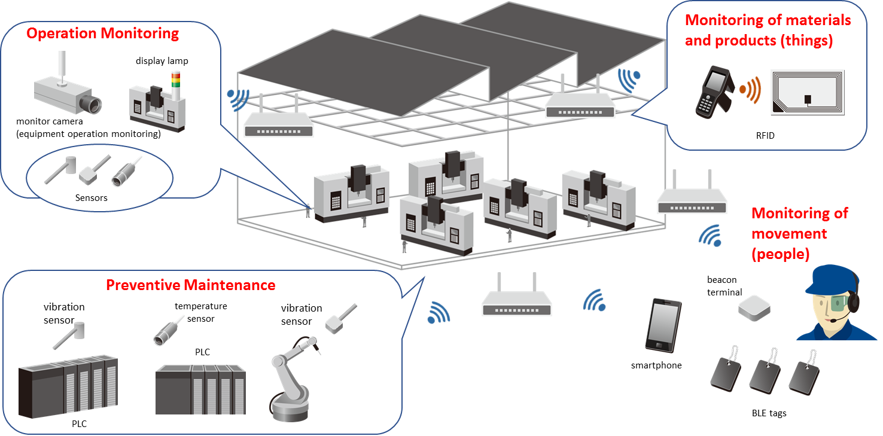
Figure 11 Usage scene: Metal working site

Usage scenarios example: Mechanical assembly site
A wireless usage scene at a mechanical assembly plant is shown in Figure 12. In a mechanical assembly plant, the benefit of wireless communications is expected where management of the environment is necessary, such as during welding and painting, building systems for collection and analysis of data for quality management and traceability, and management of operations, such as Automated Guided Vehicles (AGV) for transport of components.

Sensors such as temperature and humidity sensors and particle sensors are used for environmental monitoring in places such as a paint shop or a clean booth. Wireless communication is used for collecting sensor information because it is possible to manage data from remote rooms, and install sensors inside a room, such as in a clean booth, easily at any time without requiring reconstruction work. The sensors transmit collected environmental information to an upper layer server at periodic time intervals. It is required that no data is lost, that communication routes can be checked when necessary at times of trouble, and relay devices can be installed where radio signal reception is weak without complex expert knowhow.
Wireless communication is used to send data to servers - inspection data from large numbers of workbenches, operation sequences in Programmable Logic Controllers (PLC) used for machine control, error information and environmental information. Also, work tools such as torque-wrenches, acquire and send to servers data such as the number of wrench operations and the success of the operations, and even time series data such as vibration and torque waveforms. As ISO 9001 specifies the mandatory recording of inspection data, it requires the reliable collection of data, although strict requirements are not imposed on communication latency. Hence when transmitting data, it is necessary to check radio usage in the neighborhood, and use available frequency bands and time slots (transmission times) according to the requirements such as number of machines, transmitted data volume and necessity of real-time response.
In the case of production management display (such as an “Andon” display board), in coordination with the above information, wireless communication is used to send data for real-time display of production status information, such as production schedule, production progress and production line operation status.
In the case of AGV with autonomous driving ability, the AGV itself will be able to control its current position and path. Each AGV will be sent a command “go from position A to position B” from a parent device (fixed device) and the AGV will move accordingly. As an AGV may move over a wide area in a factory, it is possible that in some locations the quality of wireless communication will degrade due to physical obstruction by facilities and manufacturing machine tools. Hence, it is necessary to consider the radio propagation environment when deciding where to place wireless access points and to consider the use of multi-hop networks. The number of mobile vehicles used in factories is continuing to increase, and the related issues of the radio environment will require more consideration in the future.

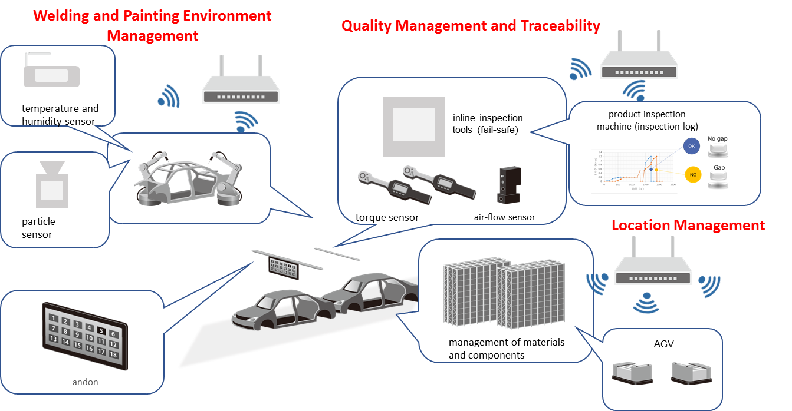
Figure 12 Usage scene example: Mechanical assembly site

Usage scenarios example: Elevated and high temperature work site
Figure 13 shows an illustration of a wireless communication scene in an elevated and high temperature work site. In production sites such as chemical plants and steel plants, there are intrinsic dangers due to collisions and falls, and extreme environments with high temperature, high humidity. Monitoring each worker’s location and situation from vitals sensors and visual images will be an important application. Workers move about, so it is necessary to collect data using wireless communication. It is assumed that production facilities will be used for many years, so it is necessary to collect information about facility operation and monitor facility operation from the point of view of preventive maintenance. In regard to collecting information from existing facilities, the use of wireless systems that can be easily added are promising for monitoring facility operation using cameras and indicator lights.

In a production site with elevated or high temperature work places, such as a drying furnace or a blast furnace, wireless communication is used to manage the safety of workers, by collecting workers’ vitals sensor information (pulse, activity, body temperature, room temperature, posture (fall detection), etc.) and environmental information (temperature and humidity, pressure, dew point, etc.), and remotely monitoring the situation at the production site using cameras etc. In such cases, wireless communications, such as multi-hop networks with wireless LAN / 920 MHz communication, are used to collect data. Using sensors that detect entry into forbidden areas, combined with BLE beacons, it is possible to monitor the location of workers and warn of entry into dangerous areas. Wireless communications are basically used to transmit position information and vital information of each worker, but it is also possible to send alerts to workers and managers when an abnormal situation arises. Vitals sensors should be of types that do not interfere with work, such as wristwatch type, pendant type, or breast-pocket type.

The communication terminals in a production site may form a wireless multi-hop network, and upload sensor data to a cloud service or server (where the data is finally collected) via a gateway. The uploaded data is used to monitor the workers status. For example, in the case of a system with a path from a sensor attached to a worker via a gateway to a server, wireless communication from the sensor to the gateway might use 920MHz band communication, wireless LAN, or Bluetooth. Communication from gateway to server will require connection via 3G/LTE or wired LAN. When the server is far from the gateway, and it is necessary to have a wireless connection (such as when wiring is not possible) a wireless mesh using wireless LAN, or a point-to-point 60 GHz frequency band system may be used as a backbone. In this case, interference between the wireless backbone and the communication between sensors and gateway must be considered.

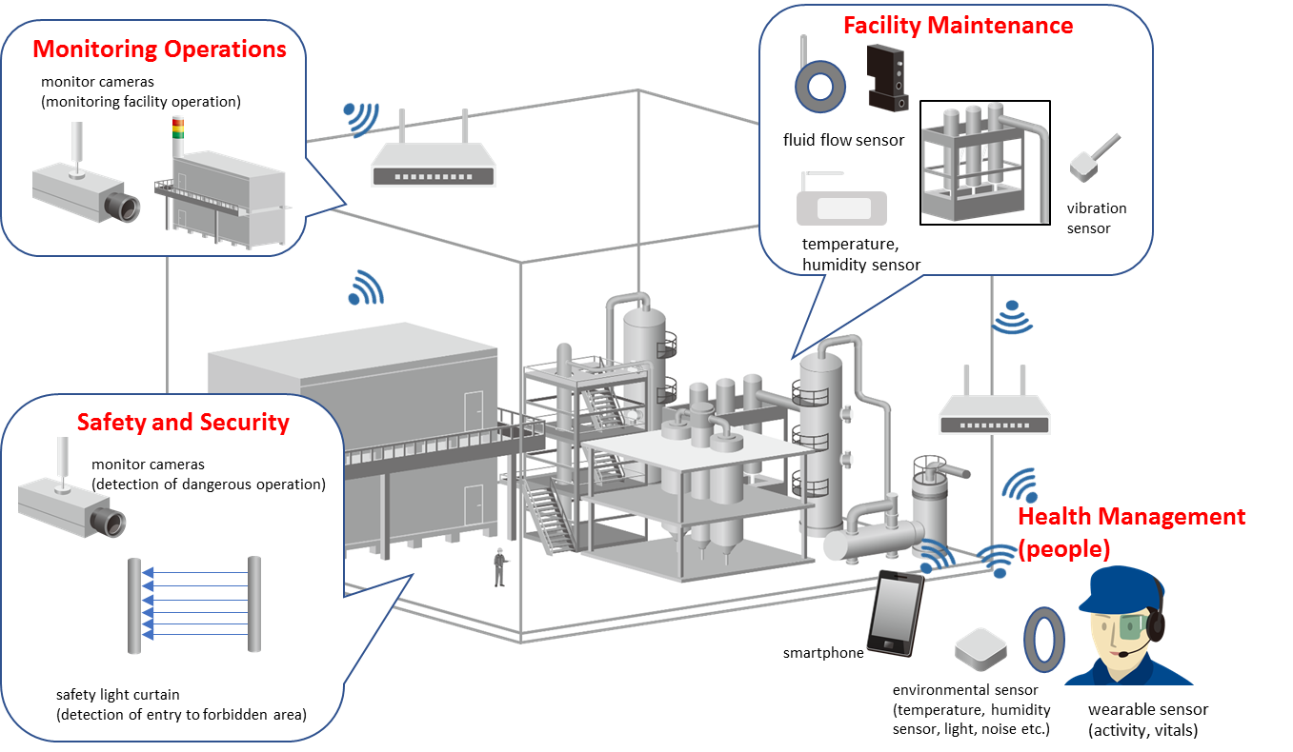
Figure 13 Usage scene example: Elevated and high temperature work site

Usage scenarios example: Logistics warehouse site
In a logistics warehouse, as shown in Figure 14, three-dimensional automatic storage is used to increase spatial use efficiency. Operation of a three-dimensional automatic storage system requires monitoring of storage operation, preventive maintenance of the stacking system, management of automated guided vehicle (AGV) movement, and so on. A large scale warehouse has multiple storage racks placed in a rows, each of over 30m height and 100m length, and separated by a few meters or less.
Footnote #3: A warehouse in which items are stored and managed in racks, and moved in and out automatically with computer control.
Footnote #4: Equipment for transporting in and out of a three-dimensional automatic storage system.
The operational status of the warehouse is monitored in conjunction with the transport of storage items in and out by a computer-controlled stacker-crane. When the stacker-crane makes an emergency stop due to detecting a stacking fault, workers might have to climb up a high ladder, tens of meters high, to manually check and repair the stack.
When the inspection and repair operation is in a high place, there is greater danger for the worker and operation delay time increases. Previously, workers had to spend time checking the storage even when there was actually no need to stop. Now cameras are used to remotely check the situation on the stacks and the stacker-crane to decide whether operation should be halted or continued, reducing the number of dangerous tasks of workers, and reducing the average time to recovering normal operation. However, in large-scale storage systems, the stacker-cranes move over large ranges, and wiring to cameras attached to stacker-cranes is difficult. Using wireless cameras eliminates the need for signal cables, and so the installing of wireless cameras in three-dimensional automatic storage systems is increasing. Information is sent from the wireless devices on the luggage platform of the stacker-crane to wireless access points (fixed stations) which are placed at one or both ends of the stacker-crane’s floor rail.
The images sent from the camera could be video (for example, 30 frames-per-second VGA) or still images (for example, JPEG or PNG with VGA resolution). The speed of the luggage-platform could be as fast as 5 meters-per-second, and the wireless device should automatically select, connect to, and transmit data to the wireless access point with the best link quality. It should also avoid interference with wireless devices on other stacker-cranes which might be running on parallel racks separated by just a few meters.
In three-dimensional automated storage systems, higher speeds of stacker cranes and their continuous operation are required to increase the transport efficiency. Sensors are attached to the drive system that drives the vertical motion of the luggage-platform, and the drive system that drives horizontal motion of the crane along its rails. A wireless communication device relays the sensor data, and computer analysis and learning of the data is used for preventive maintenance of the drive systems.
In some cases, in order to increase the flexibility of the layout in the warehouse, the luggage carried out by a stacker-crane is transported to another storage or work place by a forklift or AGV. The magnetic tape that is used taped on the floor to guide the motion of a trackless AGV cannot carry data, so control information such as destination is sent by wireless communication. Also, forklifts and AGVs have devices for detecting their location, and location information is relayed by wireless communication. Location information collected from forklifts and AGVs is used to manage their operation, and methods are being developed to improve transport efficiency by coordinating their motion with stacker-cranes, allowing the selection of the AGV with the shortest travel distance, for example.

In regard to use of sensors for preventive maintenance on drive systems of stacker-cranes, and managing movement of forklifts and AGVs, in large scale factories, the range of motion may extend over large areas with various large structures such as three-dimensional storage racks, so the placement of wireless access points and the selection of wireless frequency band are important issues.
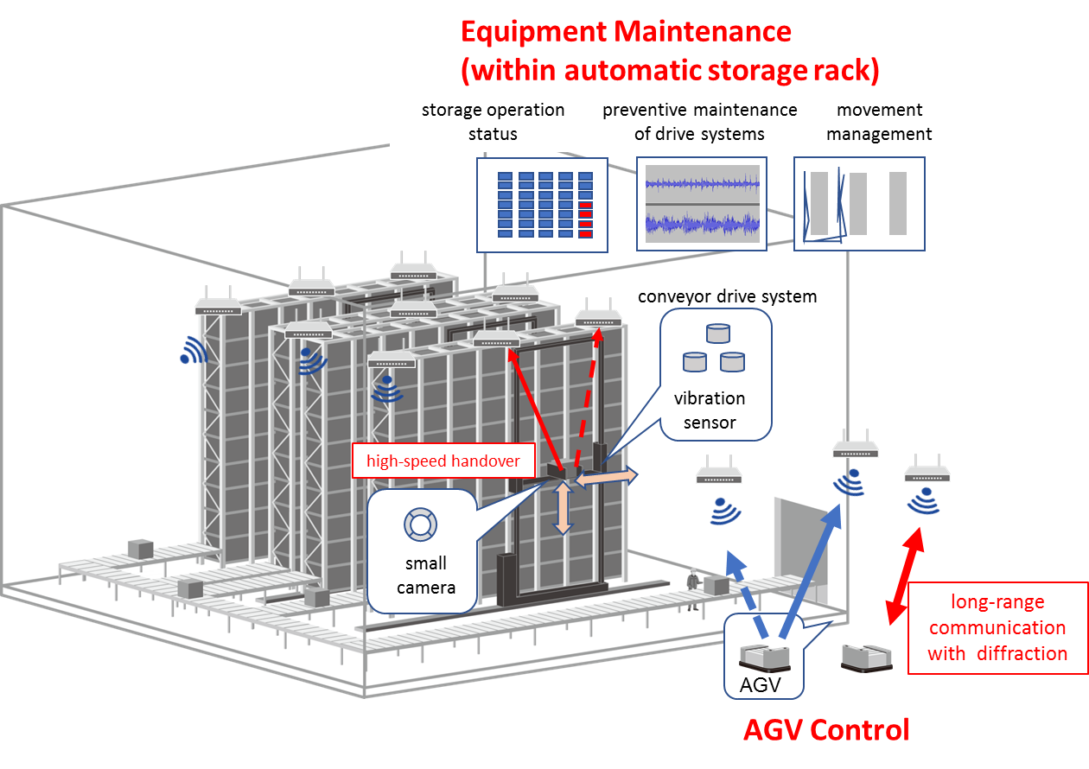
Figure 14 Usage scene example: Logistics warehouse site

Factory End to End Network architecture

Concept of architecture

Expectation for Enhancement of existing IEEE 802 functions

Preliminary and partial material inserted here (i.e. provisionally). More is needed. But check first on the intended contents of this section.

QoS management of frames/streams across their paths is important in the automation of factories. There are several functions and protocols within existing IEEE802 standards that maybe used effectively for the provision of QoS and priority control over bridged network. Example of such functions are given as follows.
- Stream Reservation Protocol (SRP)/Multiple Stream Reservation Protocol (MSRP). [802.1Qat]
- Forwarding and Queuing for Time-Sensitive Streams (FQTSS) [802.1Qav]
- Generalized Precision Time Protocol (gPTP)[802.1AS]
- Priority-based Flow Control (PFC) [802.1Qbb]
- Congestion Notification (CN) [802.1Qbb]
- Enhanced Transmission Selection (ETS) [802.1Qaz]
- Access Categories (ACs) for priority in EDCA [802.11e]
- Quality-of-service Management Frame (QMF) [802.11ae]

As an example, the Priority-based Flow Control（PFC）in the congestion notification protocols of IEEE802.1Qbb can create eight separate virtual links on a physical link. It enables pause based on user priorities or classes of service. As illustrated in Figure 15 below virtual link Six is signaled to stop because it is associated with the lowest QoS class. The PFC protocol functions well when the bandwidth in a physical link is stable and sufficiently lager than the required bandwidth of each virtual link.
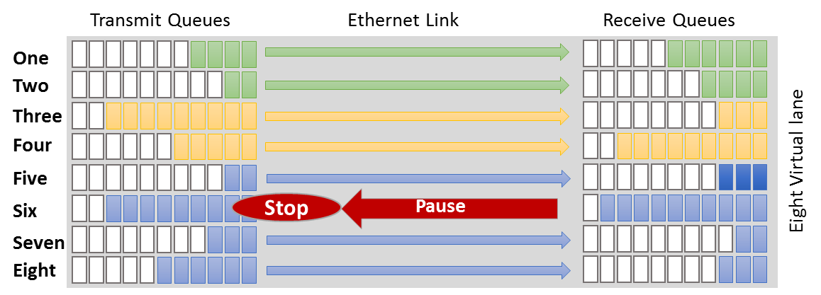
Figure 15 Example of operation of the PFC function
By considering the PFC operation under multi-hop scenario potentially with wireless links which has narrow and fluctuating nature of bandwidth, it is difficult to establish separated multiple virtual links with a margin. In such a case, data streams rush into the physical link with the lowest latency regardless of actual bandwidth at that time. This may cause congestion at a node leading to unnecessary stopping/interruption as illustrated by the example in Figure 16 below.
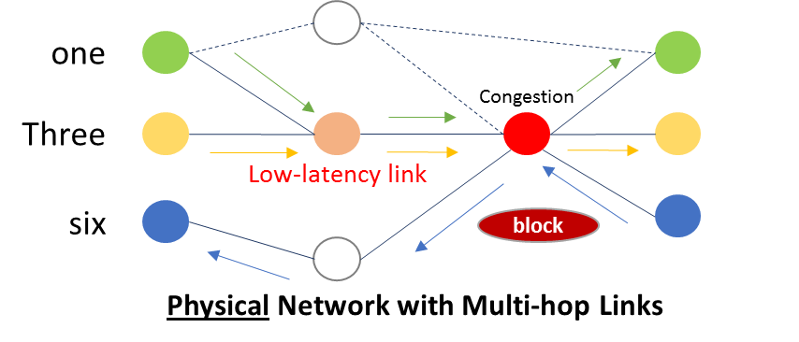
Figure 16 Impact of PFC function over multi-hop links with fluctuating bandwidth
It is easily observed that PFC on a single hop may not be sufficient to guarantee the overall end-to-end communication quality in the integrated wired and wireless network topology shown in Figure 16. To eliminate congestion and keep effective virtualization, dynamic load balance or other mechanism in a forcible manner in the wireless part is required .

[New Project description and proposal]

Conclusions
More body text. More body text. More body text. More body text. More body text. More body text.

Citations

Physical objects such as materials and equipment related to production are called “things”
Node density :number of terminals per 20mX20m

