Ch 6.9 amendment: Multiple-LAN enterprise network
Date: 2018-03-19
Authors:
Name | Affiliation | Phone | Email
Max Riegel | Nokia Bell Labs |  | maximilian.riegel@nokia.com
Notice:
This document does not represent the agreed view of the OmniRAN TG It represents only the views of the participants listed in the ‘Authors:’ field above. It is offered as a basis for discussion. It is not binding on the contributor, who reserve the right to add, amend or withdraw material contained herein.
Copyright policy:
The contributor is familiar with the IEEE-SA Copyright Policy <http://standards.ieee.org/IPR/copyrightpolicy.html>.
Patent policy:
The contributor is familiar with the IEEE-SA Patent Policy and Procedures:
<http://standards.ieee.org/guides/bylaws/sect6-7.html#6> and <http://standards.ieee.org/guides/opman/sect6.html#6.3>.

Abstract
This document provides the concrete amendment proposal according to comment #14 of p802-1cf-d1-0-comments-maxriegel.xls
Revision 1 provides revised figures to more clearly show VLANs addressing Revision requested with different ways to clearly represent VLANs in the figures.
Revision 2 corrects figure to show that Ethernet switches act both as NA as well as BH.

Chapter

Deployment scenarios

Enterprise network with multiple bridging domains
Many of the enterprise networks are not operated as a single flat bridging domain, but are segmented into multiple separate bridging domains for the purpose to differentiate various traffic classes and to introduce borders for the uncontrolled transfer of information to facilitate more fine grain security concepts.
Such segmentation can be achieved in a common infrastructure through the deployment of virtual LAN (VLAN) technology as defined in the IEEE 802.1Q specification. It allows Bridges to handle multiple different broadcast domains in a single Bridge, with broadcast domains establishing a VLAN identified either as exclusive assignment of bridge ports to a VLAN, or through VLAN tags added to the MAC frames, when multiple different VLANs are forwarded on a bridge port.
The following figure x depicts the enterprise network scenario introduced in the previous clause with the addition of VLAN technology leading to multiple virtual LANs within the same infrastructure.

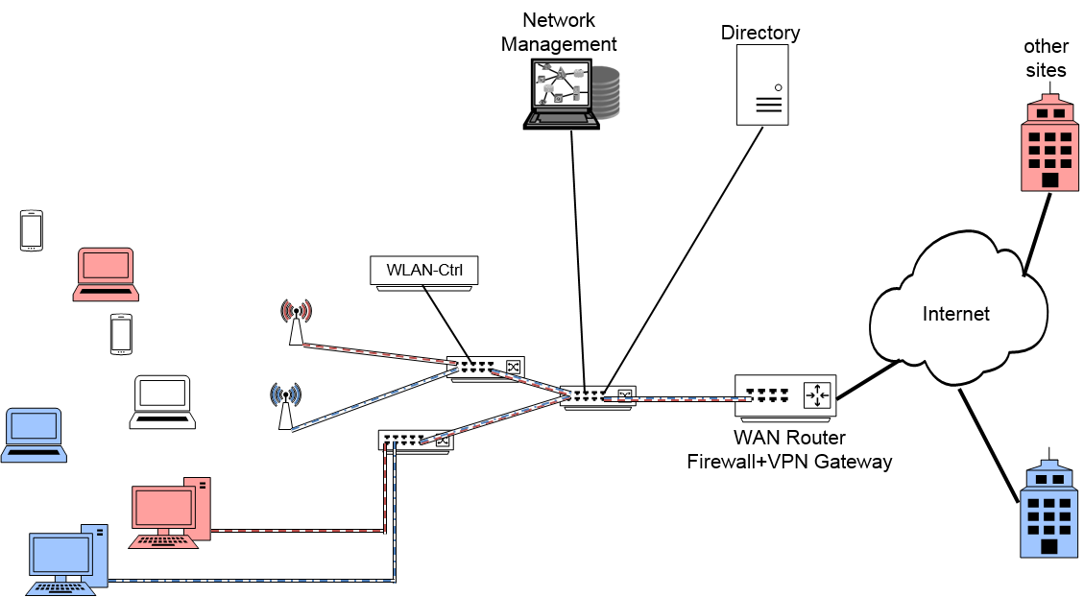
Figure x: VLAN enabled enterprise network scenario
Three different VLANs are shown in the example above through colors, two of them (red and blue) connected through VPNs over the Internet with other sites of the same enterprise, and a third one (cyan) aimed for providing BYOD devices access to the Internet. To realize the multiple LANs, VLAN support has to be enabled in the Bridges. All the VLANs belong to a single network under the control of a single entity. Therefore, single instances of the control entities (Network Management, Directory, WLAN-Ctrl) are sufficient to operate the multiple VLANs belonging to the same operational domain (enterprise).
The mapping to the NRM follows the single LAN enterprise scenario in the previous clause. The switching infrastructure builds the backhaul of the network, with terminal Ethernet ports and WLAN access points resembling the nodes of attachment. The functions of the WLAN controller fit well to the role of the ANC, and network management station and directory are typical realizations of the NMS and SS, respectively. VLAN capability is enabled on the datapath between access router and backhaul, inside the backhaul and on the interfaces between backhaul and NAs. The interface between the terminal and NA does not change through enabling VLAN support in the network. Each terminal is assigned to a single VLAN at the NA according to configuration information provided by the ANC.
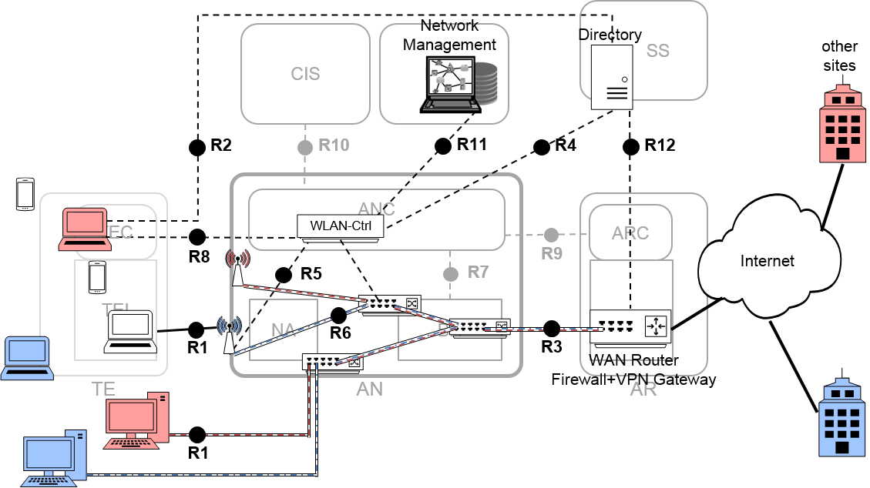
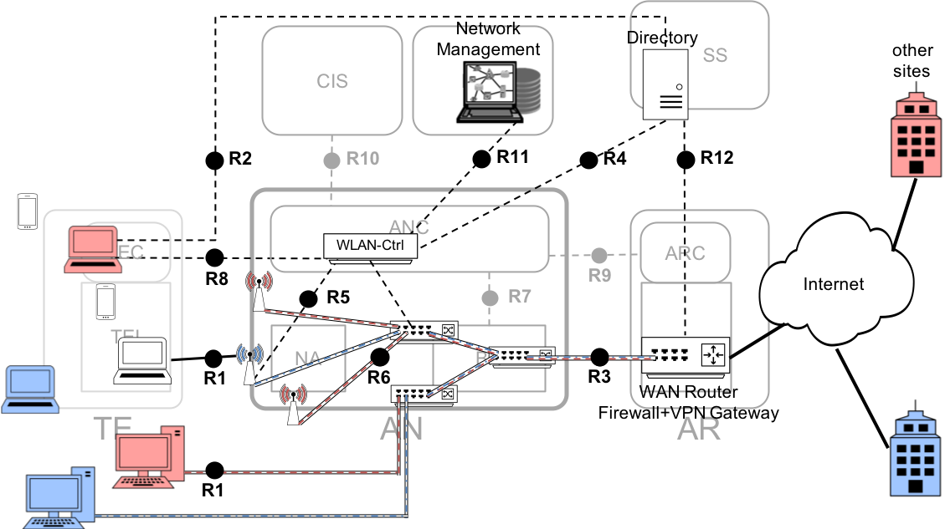
Figure x+: Mapping of VLAN enabled enterprise network to the NRM
As depicted in figure x+, the NRM is able to cover VLAN support without adding new interfaces or functional entities. Only the datapath and the Bridges located within the NA and BH require additional functionalities, which are visible on the control interfaces through additional attributes. Support of multiple bridging domains in the NRM closely follows the procedures for adding VLAN capabilities to real IEEE 802 networks, showing that the NRM is well suited to model the wide variety of real networks.

