Chapter 8.1 Information model of IEEE 802 access network
Date: 2018-04-03
Authors:
Name | Affiliation | Phone | Email
Max Riegel | Nokia |  | maximilian.riegel@nokia.com
Hao Wang | Fujitsu |  | wangh@cn.fujitsu.com
Notice:
This document does not represent the agreed view of the OmniRAN TG It represents only the views of the participants listed in the ‘Authors:’ field above. It is offered as a basis for discussion. It is not binding on the contributor, who reserve the right to add, amend or withdraw material contained herein.
Copyright policy:
The contributor is familiar with the IEEE-SA Copyright Policy <http://standards.ieee.org/IPR/copyrightpolicy.html>.
Patent policy:
The contributor is familiar with the IEEE-SA Patent Policy and Procedures:
<http://standards.ieee.org/guides/bylaws/sect6-7.html#6> and <http://standards.ieee.org/guides/opman/sect6.html#6.3>.

Abstract
This document proposes text for the section 8.1 Information model of IEEE 802 access network.
- The first edition captures proposal of the introductory text.
- The second edition refined the outline of 8.1 and introduced headlines as well as figure subscriptions.
- Revision-02 provides complete content of the user service information model.
- Revision-03 introduces BeaconPeriod to trigger BEACONBC in service selection
- Revision-04 introduces the complete information model of the access network infrastructure.
- Revision-05 includes resolutions to the comments collected on D1.0 draft

8 Network softwarization functions 3
8.1 Information model of IEEE 802 access network 3
8.1.1 Composition of information model 3
8.1.2 Session information model 3
8.1.2.1 Service selection information model 4
8.1.2.2 Access link information model 4
8.1.2.3 Security association information model 5
8.1.2.4 Data path information model 5
8.1.2.5 Service flow information model 6
8.1.2.6 Session statistics information model 7
8.1.2.7 Complete session information model 7
8.1.3 AN configuration information model 8
8.1.4 Network management information model 9

Network softwarization functions
…

Information model of IEEE 802 access network
An information model is used in software engineering to represent concepts, relationships, operations, and constraints in order to describe the data semantics for a particular system or functional unit. Generally, it describes relations between kind of things (classes), but can also make references to individual things (instances). It helps in sharing an organized structure of information requirements within the context of a domain.
Within this specification the mean of an information model is used to provide a structured representation of the configuration information and the statistics of IEEE 802 access network infrastructure and communication service. It describes the overall access network management information necessary to manager the connectivity service defined by IEEE 802. The information model serves as a basic model that will be applied to define the representation of the internal structure, the composition of networking elements and their operational settings, as well as the representation of the service of the access network with the operational parameters, dependencies, and usage statistics. The information models address operational aspects from a user and service aware aspects from a service provider perspective, including administration, maintenance and provisioning capabilities.
The information model of IEEE802 access network does not add new information to the descriptions in the previous chapters, but presents the same information in a more condense and structured way. The two following subsections introduce two complementing information models. The first section describes an information model from an operational perspective detailing service provisioning to users. It may be used for day-to-day network operations but also adds to the foundation of the business aspects of a network service provider. The second model from a structural perspective explains and supports network infrastructure configuration and maintenance tasks of a network service provider.

Composition of information model
This IEEE 802 access network information model is aligned and derived from the functional description of clause 7, including access network initialization, operation of user session for communication service delivery and network management, and exposes both the session states and the functions of the network entities of an access network as introduced in that chapter.
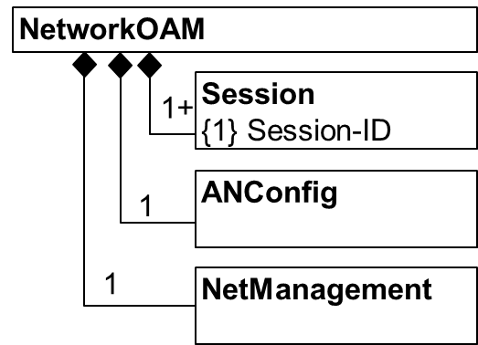
Figure 8-1: Basic information model

Session information model
Access networks establish and operate user sessions to deliver service to the attached terminals. The link between the terminal and the user is built through a subscription, which is used by a terminal to link its user with the service provider authorizing the usage of network resources.
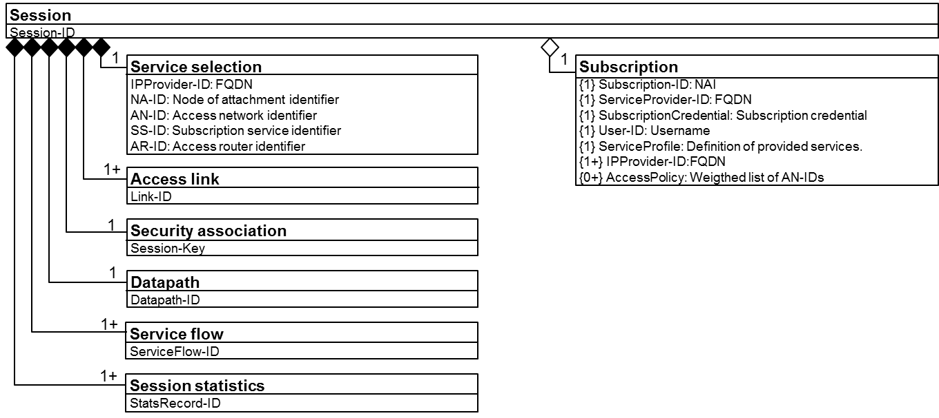
Figure 8-2: Session information model outline

Service selection information model
During network discovery and selection, the service selection information is collected and established.
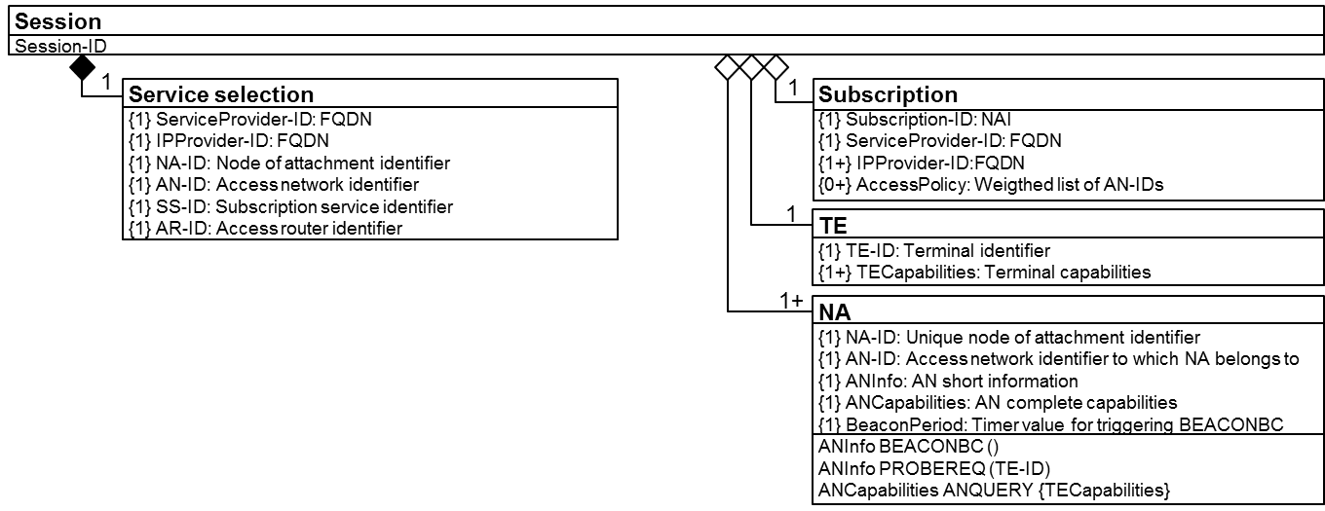
Figure 8-3: Service selection information relation

Access link information model
During the association phase, the access link information gets established.
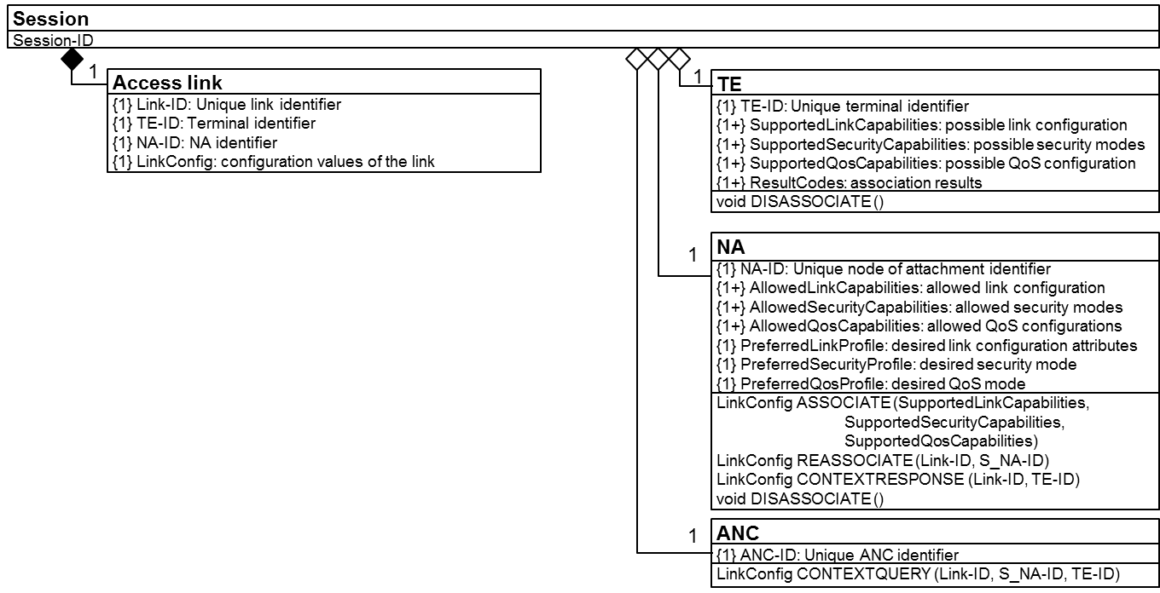
Figure 8-4: Access link information relation

Security association information model
During authentication and trust establishment phase, the security association is created.
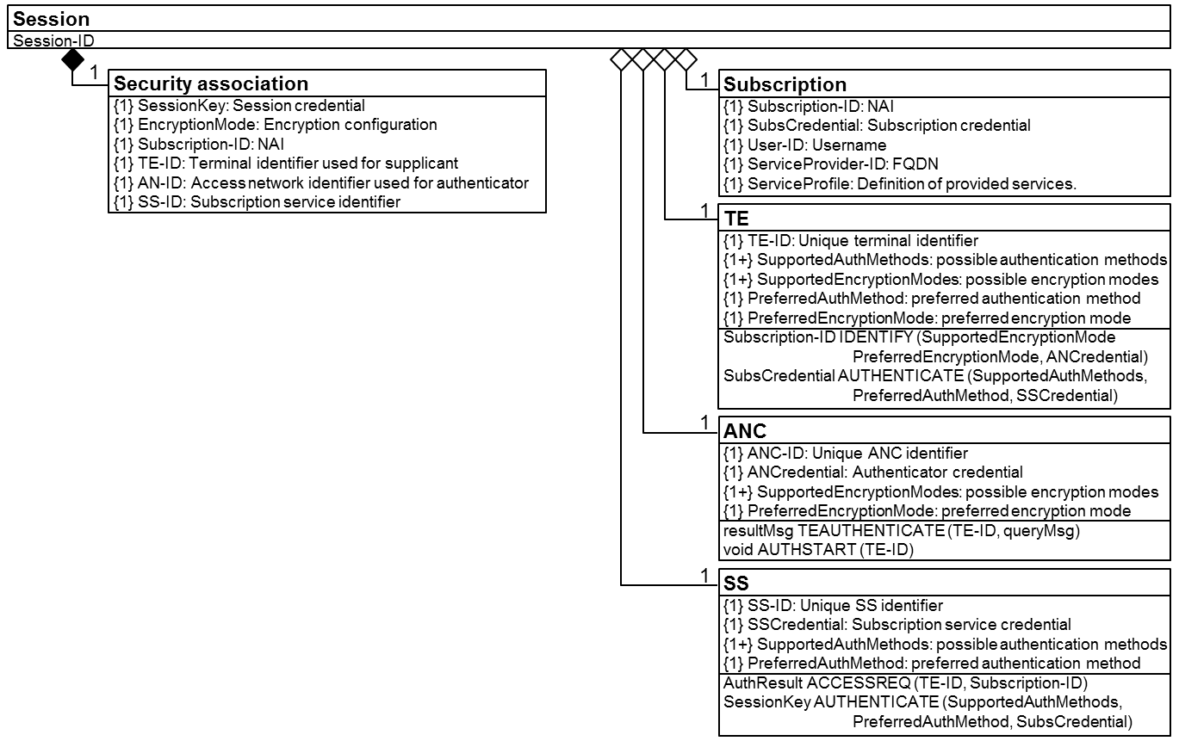
Figure 8-5: Security association information relation

Data path information model
During the data path establishment, the data path information is established.
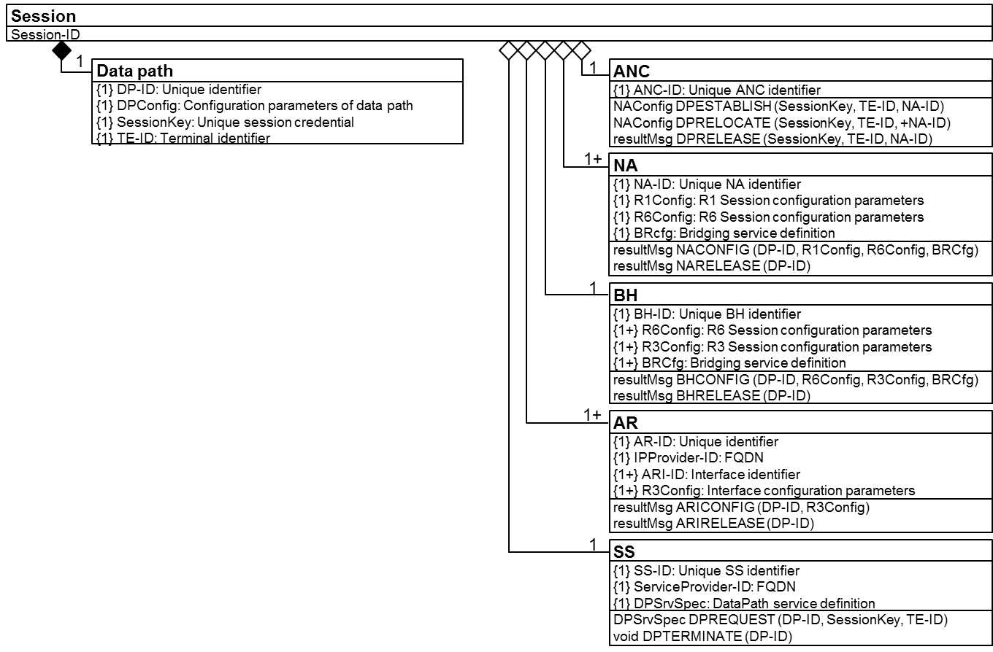
Figure 8-6: Data path information relation

Service flow information model
During the authorization, QoS, and policy control phase, the service flow information is established and maintained.

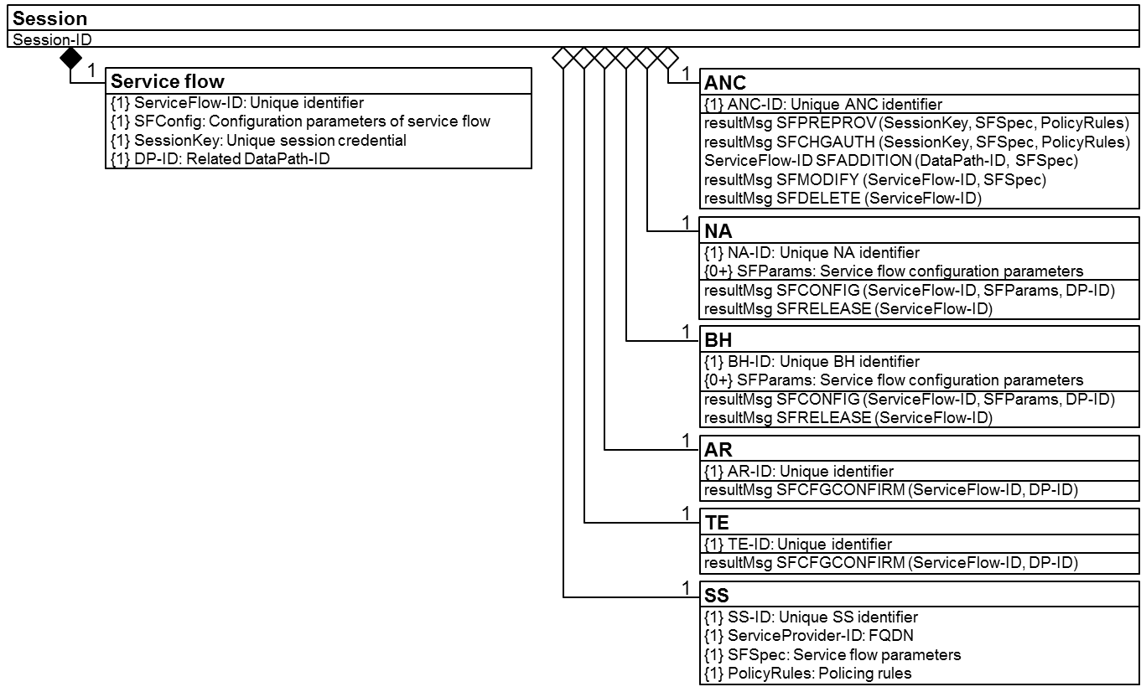
Figure 8-7: Service flow information relation

Session statistics information model
Through monitoring and accounting the session statistics information gets created and collected.
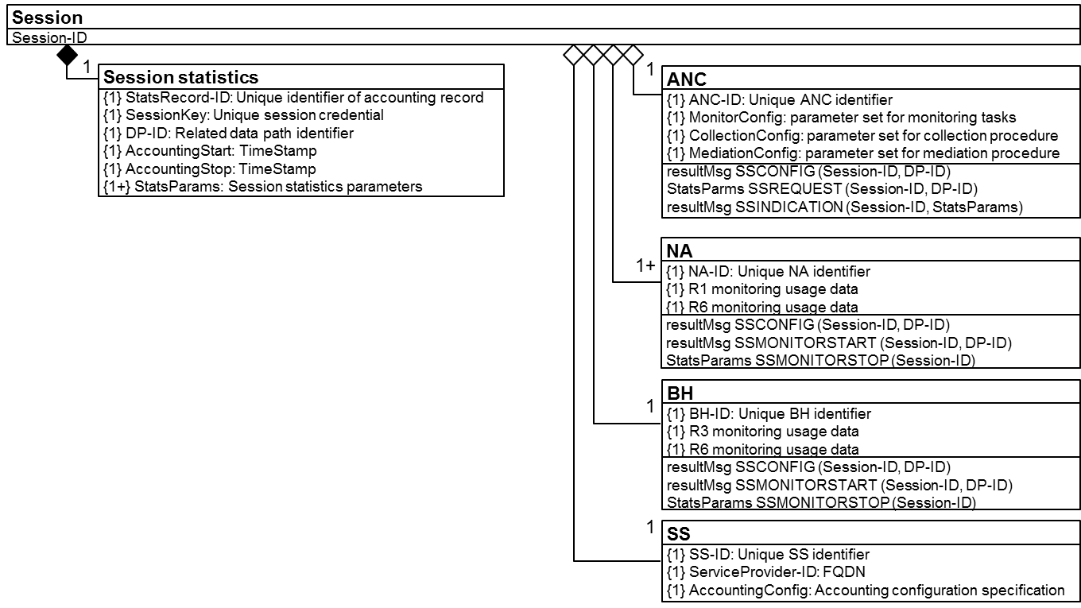
Figure 8-8: Session statistics information relation

Complete session information model
The complete session information model is created through combining the functional sections listed above into a single figure.
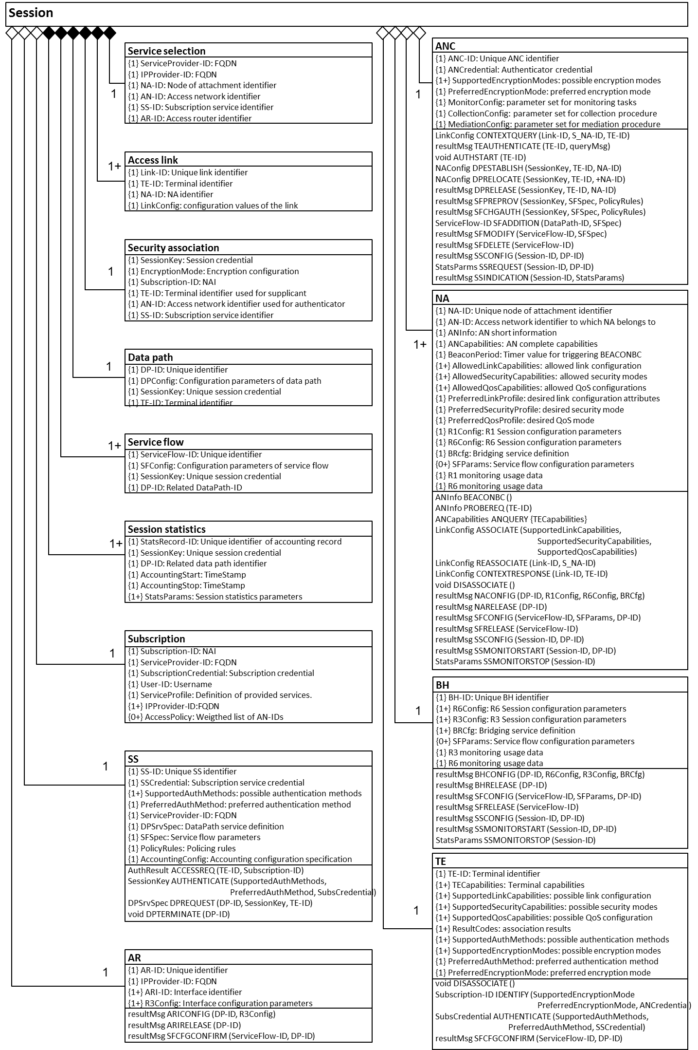
Figure 8-9: Complete session information model

AN configuration information model
As the access network is powered up, the initial configuration is provided by the NMS. The access network can be setup on both unlicensed and authorized spectrum.

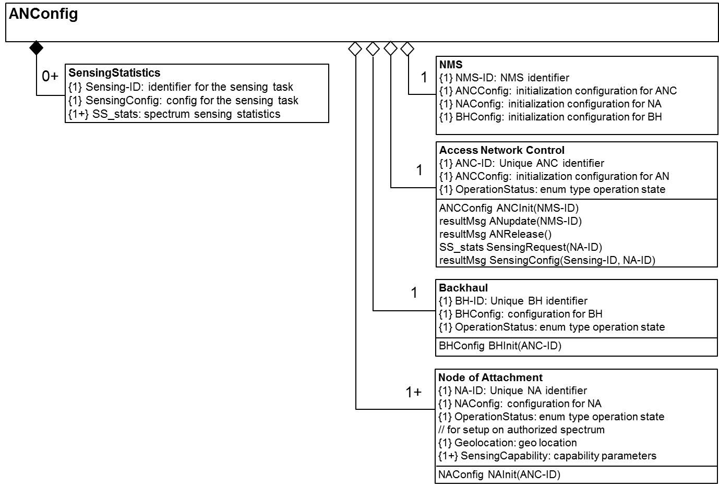
Figure 8-12 Information model of AN configuration

Network management information model
Functions for FDM are specified and statistics are maintained accordingly.

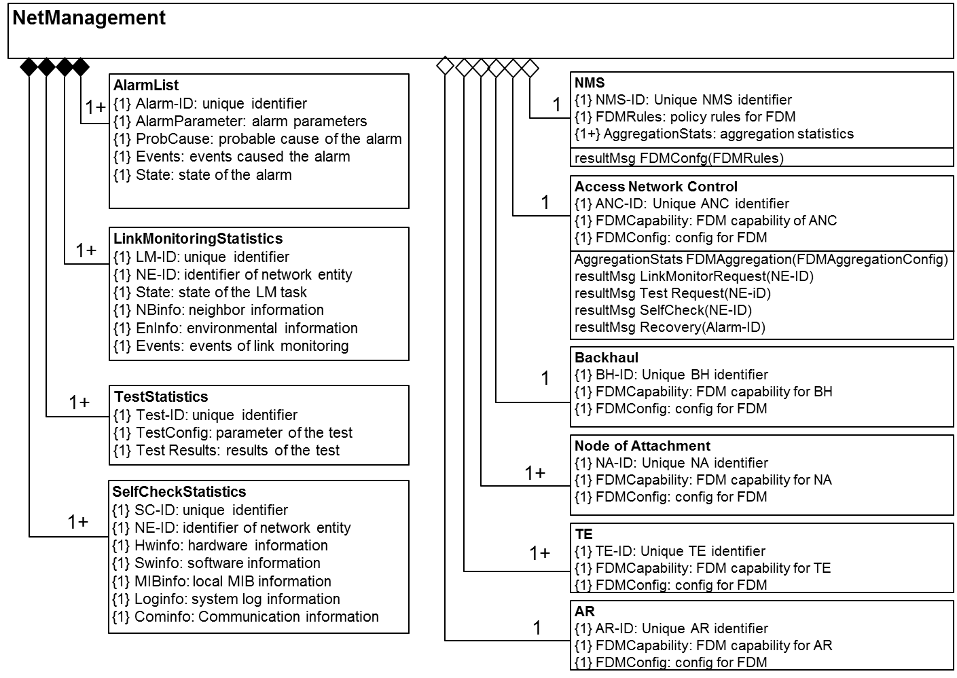
Figure 8-19 Information model of network management

