Chapter 8.1 Information model of IEEE 802 access network
Date: 2017-12-05
Authors:
Name | Affiliation | Phone | Email
Max Riegel | Nokia |  | maximilian.riegel@nokia.com
Hao Wang | Fujitsu |  | wangh@cn.fujitsu.com
Notice:
This document does not represent the agreed view of the OmniRAN TG It represents only the views of the participants listed in the ‘Authors:’ field above. It is offered as a basis for discussion. It is not binding on the contributor, who reserve the right to add, amend or withdraw material contained herein.
Copyright policy:
The contributor is familiar with the IEEE-SA Copyright Policy <http://standards.ieee.org/IPR/copyrightpolicy.html>.
Patent policy:
The contributor is familiar with the IEEE-SA Patent Policy and Procedures:
<http://standards.ieee.org/guides/bylaws/sect6-7.html#6> and <http://standards.ieee.org/guides/opman/sect6.html#6.3>.

Abstract
This document proposes text for the section 8.1 Information model of IEEE 802 access network.
- The first edition captures proposal of the introductory text.
- The second edition refined the outline of 8.1 and introduced headlines as well as figure subscriptions.
- Revision-02 provides complete content of the user service information model.
- Revision-03 introduces BeaconPeriod to trigger BEACONBC in service selection
- Revision-04 introduces the complete information model of the access network infrastructure.

8 Network softwarization functions 3
8.1 Information model of IEEE 802 access network 3
8.1.1 Service information model 3
8.1.1.1 Overview of service information model 4
8.1.1.2 Service selection information model 4
8.1.1.3 Access link information model 4
8.1.1.4 Security association information model 5
8.1.1.5 Data path information model 6
8.1.1.6 Service flow information model 6
8.1.1.7 Session statistics information model 7
8.1.1.8 Complete service information model 7
8.1.2 Infrastructure configuration and maintenance model 9
8.1.2.1 Overview of infrastructure configuration and maintenance model 9
8.1.2.2 Information model for access network (AN) setup 10
8.1.2.3 Information model for network discovery and selection (NDS) 11
8.1.2.4 Information model for association 11
8.1.2.5 Information model for authentication 12
8.1.2.6 Information model for datapath establishment and maintenance 12
8.1.2.7 Information model for QoS authorization 13
8.1.2.8 Information model for accounting and monitoring 13
8.1.2.9 Information model for fault diagnosis and maintenance (FDM) 14
8.1.2.10 Complete infrastructure configuration and maintenance model 14

Network softwarization functions
…

Information model of IEEE 802 access network
An information model is used in software engineering to represent concepts, relationships, operations, and constraints in order to describe the data semantics for a particular system or functional unit. Generally, it describes relations between kind of things (classes), but can also make references to individual things (instances). It helps in sharing an organized structure of information requirements within the context of a domain.
Within this specification the mean of an information model is used to provide a structured representation of the configuration information and the statistics of IEEE 802 access network infrastructure and communication service. Two different models are provided to enable both, the representation of the internal structure, the composition of networking elements and their operational settings, as well as the representation of the service of the access network with the operational parameters, dependencies, and usage statistics. The information models address operational aspects from a user and a service provider perspective.
The information model of IEEE802 access network does not add new information to the descriptions in the previous chapters, but presents the same information in a more condense and structured way. The two following subsections introduce two complementing information models. The first section describes an information model from an operational perspective detailing service provisioning to users. It may be used for day-to-day network operations but also adds to the foundation of the business aspects of a network service provider. The second model from a structural perspective explains and supports network infrastructure configuration and maintenance tasks of a network service provider.

Service information model
This information model is aligned and derived from the functional description of user session establishment with communication service delivery and session teardown in chapter 7, and exposes both the session states and the functions of the network entities of an access network as introduced in that chapter.
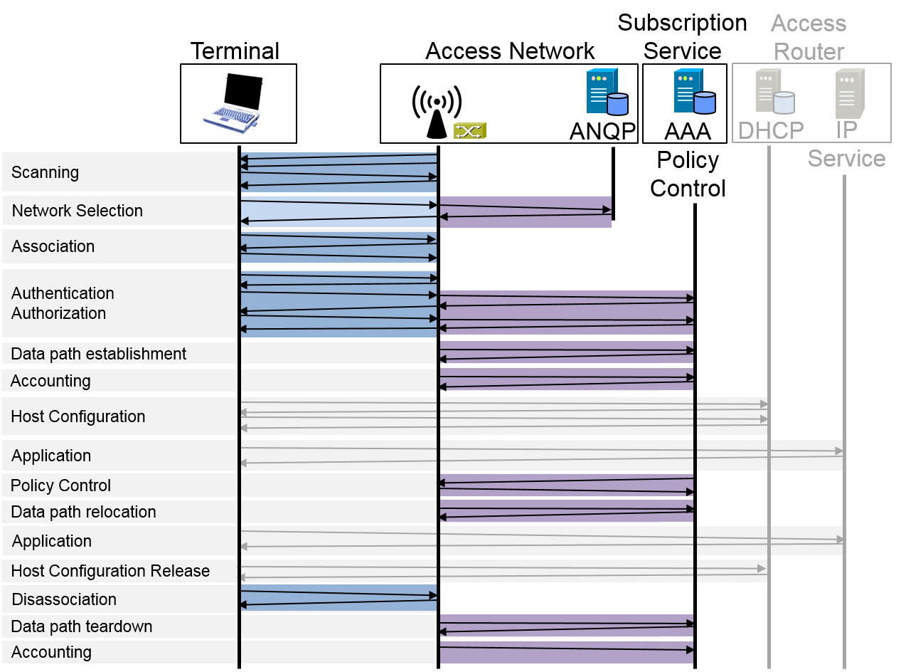
Figure 8-1: Functions during the life-cycle of a user session

Overview of service information model
The core element of the service information model is the user sessions. Access networks establish and operate user sessions to deliver service to the attached terminals. The link between the terminal and the user is built through a subscription, which is used by a terminal to link its user with the service provider authorizing the usage of network resources.
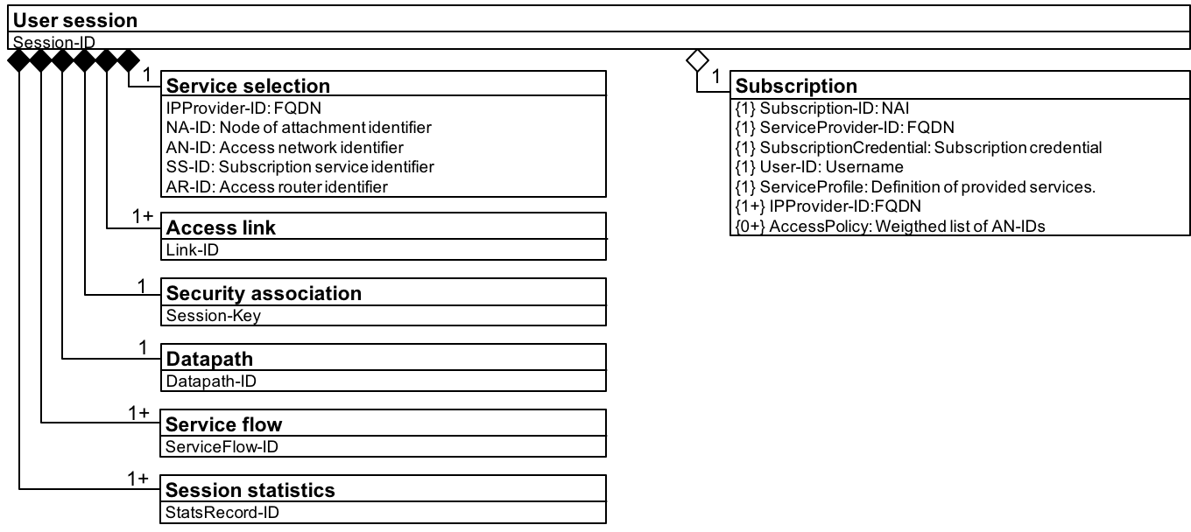
Figure 8-2: Service information model outline

Service selection information model
During network discovery and selection, the service selection information is collected and established.
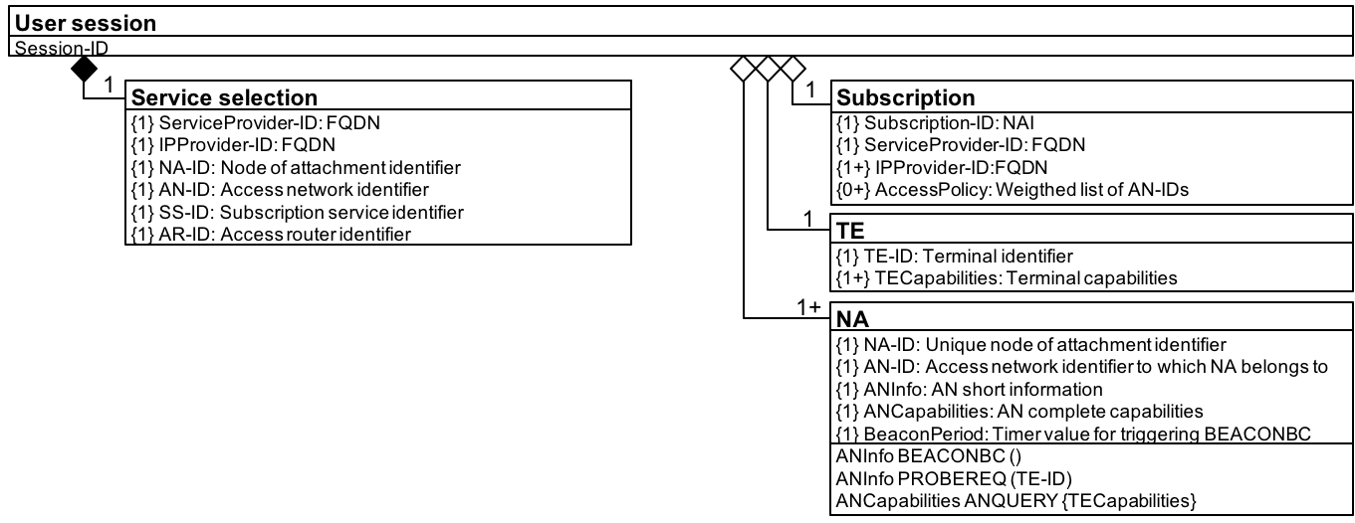
Figure 8-3: Service selection information relation

Access link information model
During the association phase, the access link information gets established.
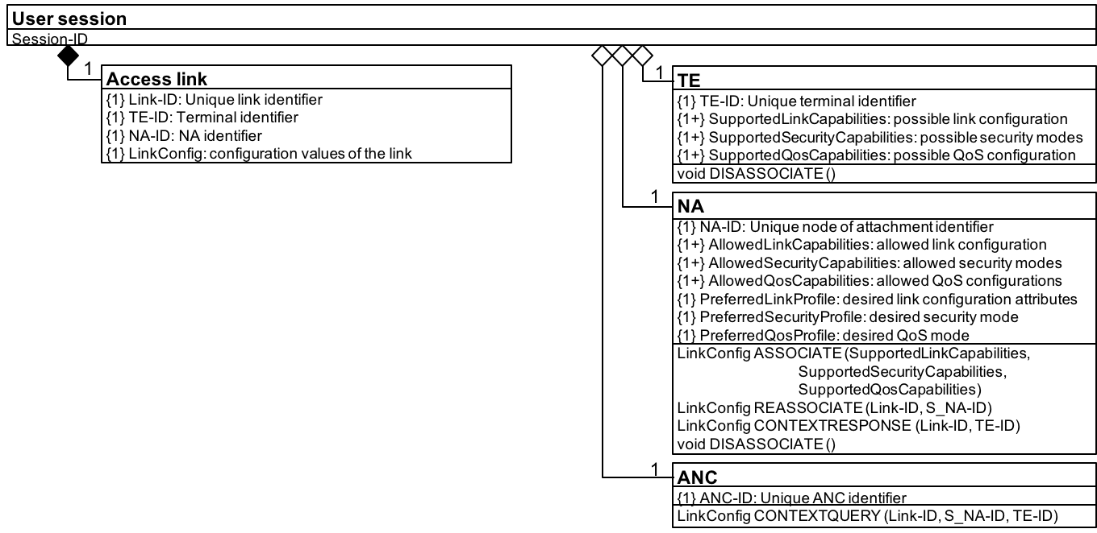
Figure 8-4: Access link information relation

Security association information model
During authentication and trust establishment phase, the security association is created.
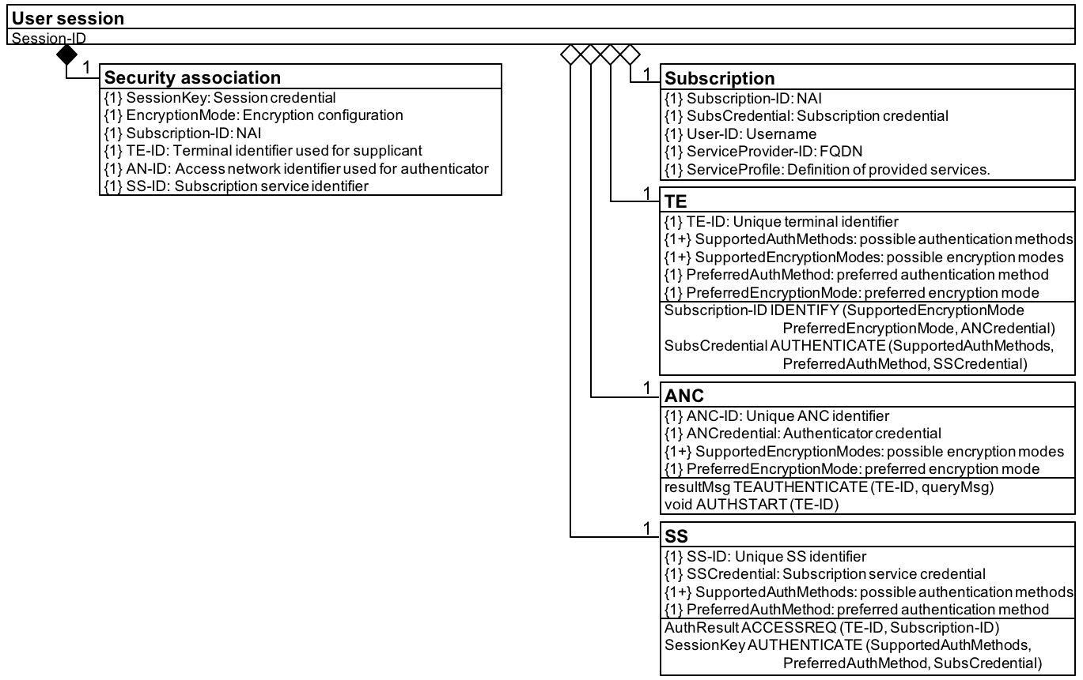
Figure 8-5: Security association information relation

Data path information model
During the data path establishment, the data path information is established.
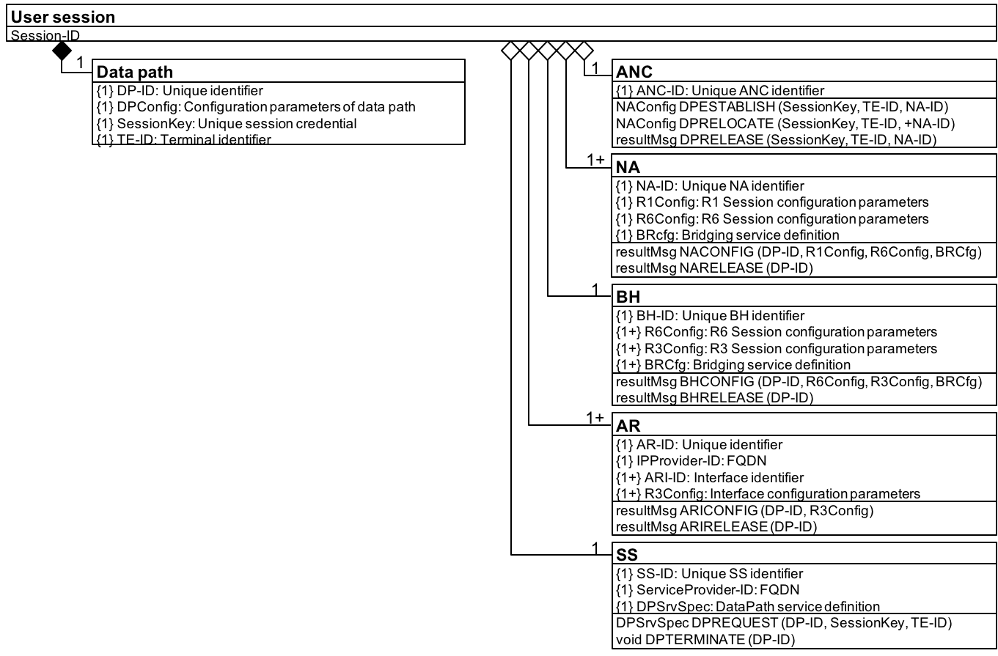
Figure 8-6: Data path information relation

Service flow information model
During the authorization, QoS, and policy control phase, the service flow information is established and maintained.
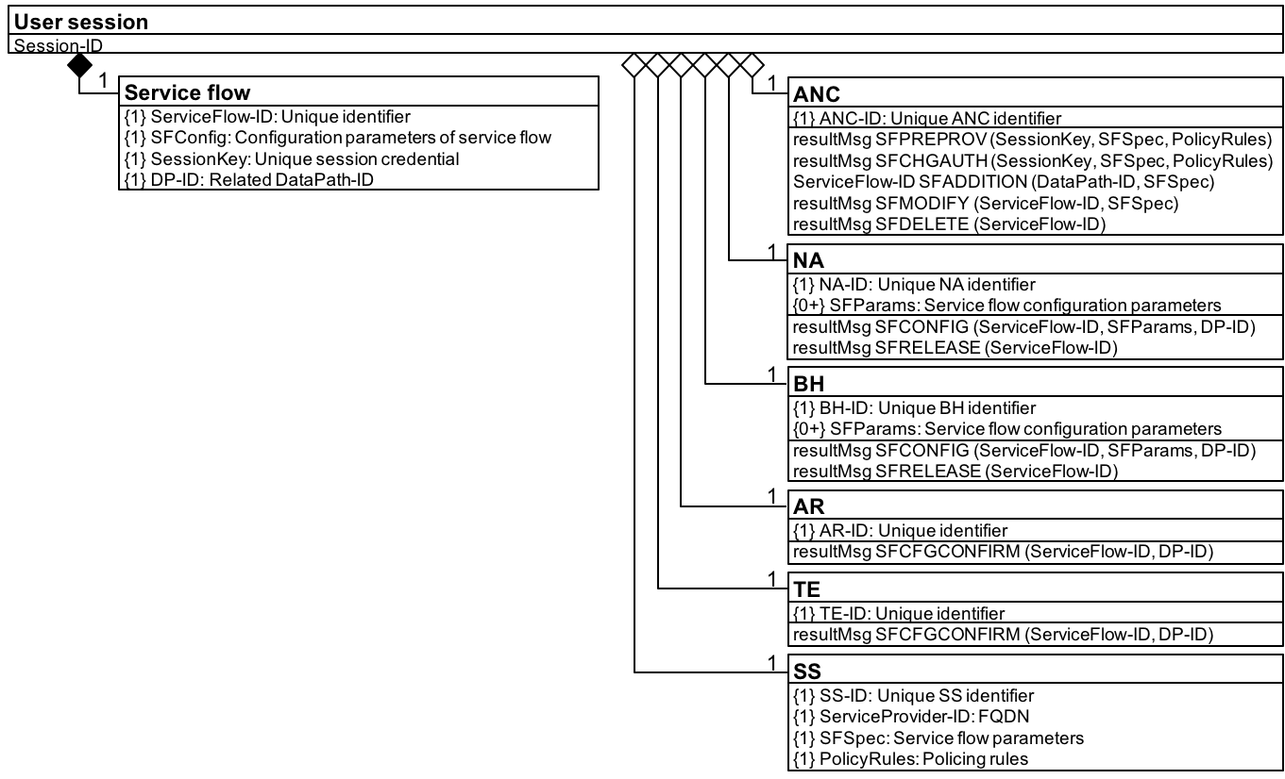
Figure 8-7: Service flow information relation

Session statistics information model
Through monitoring and accounting the session statistics information gets created and collected.
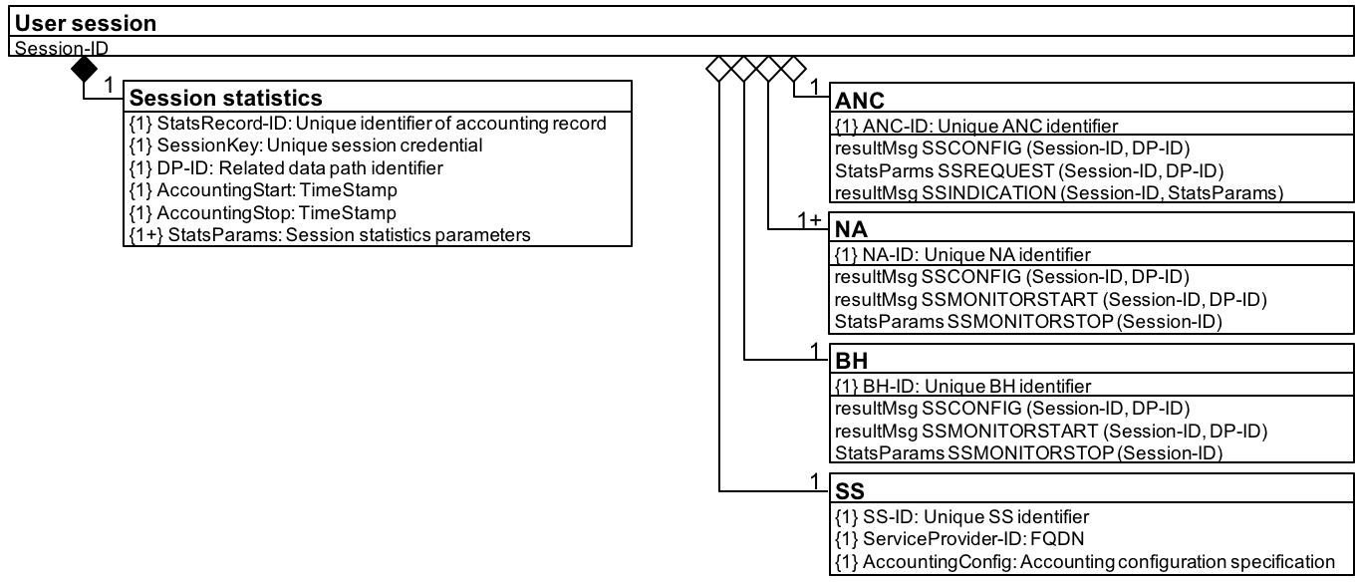
Figure 8-8: Session statistics information relation

Complete service information model
The complete service information model is created through combining the functional sections listed above into a single figure.
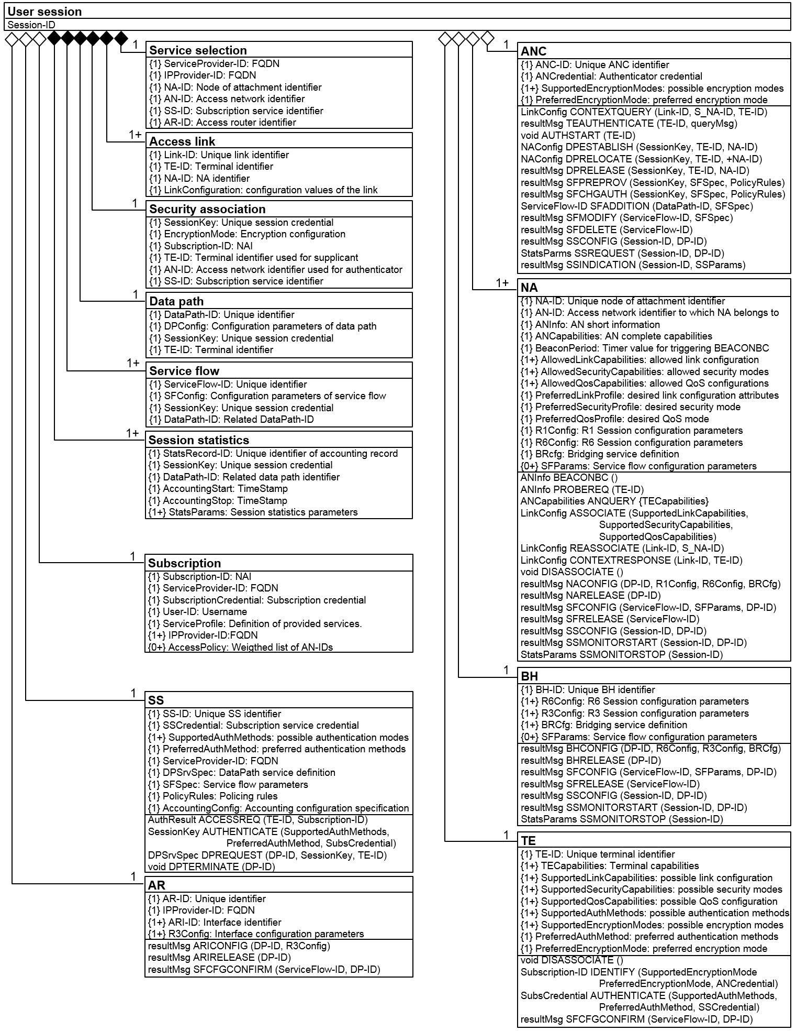
Figure 8-9: Complete service information model

Infrastructure configuration and maintenance model
This model focuses on the attributes held by the access network (AN) entities which can be provided to the network management service for the management purposes. Independent of the implementations or protocols used to transport the data, these attributes are essential to describe the operation and maintenance of the access network and to specify the relationships between its components that needs to be managed.
This model is aligned and derived from the NRM and exposes functional entities inside the access network and statistics derived from the specific control functions.
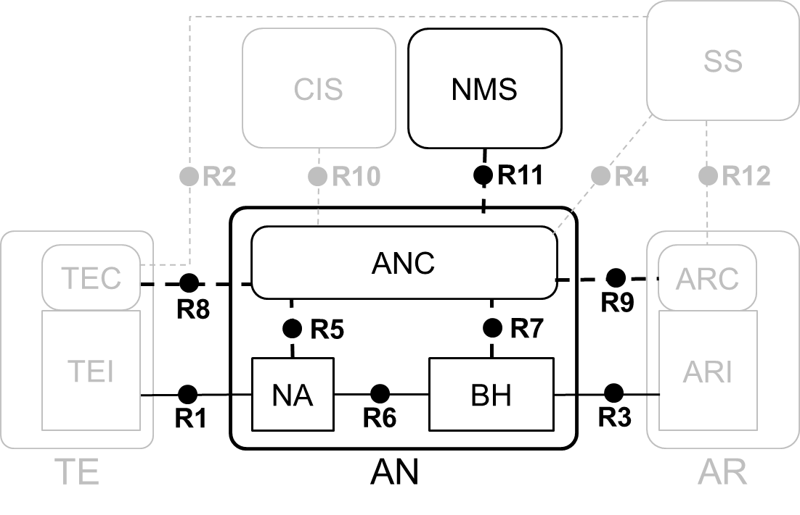
Figure 8-10: Network Reference Model

Overview of infrastructure configuration and maintenance model
The root element of the infrastructure configuration and maintenance model is the network management service (NMS). As the parameters provided by the NMS, the access network entities need to be setup, to follow the necessary 802 protocols, and to survey in the specific statistics prior to deliver services to the attached terminals.

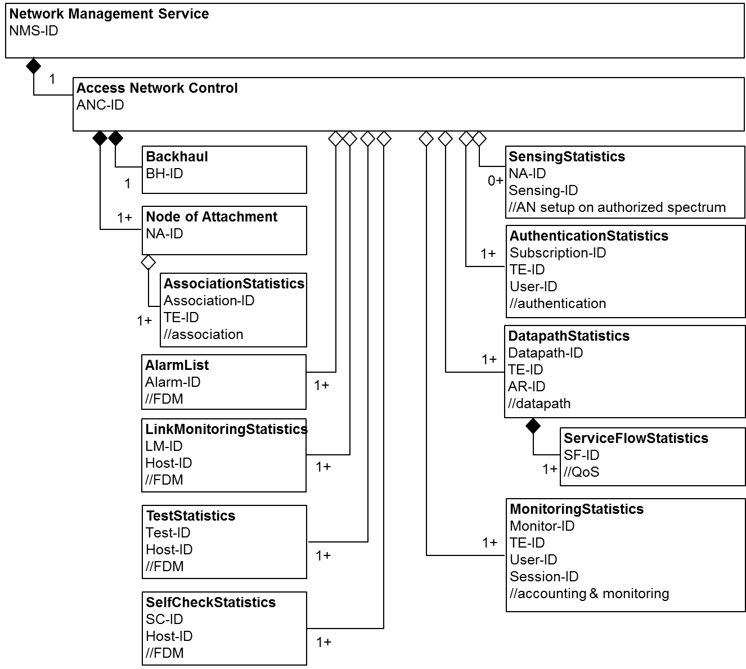
Figure 8-11 Infrastructure configuration and maintenance model outline

Information model for access network (AN) setup
As the access network is powered up, the initial configuration is provided by the NMS. The access network can be setup on both unlicensed and authorized spectrum.
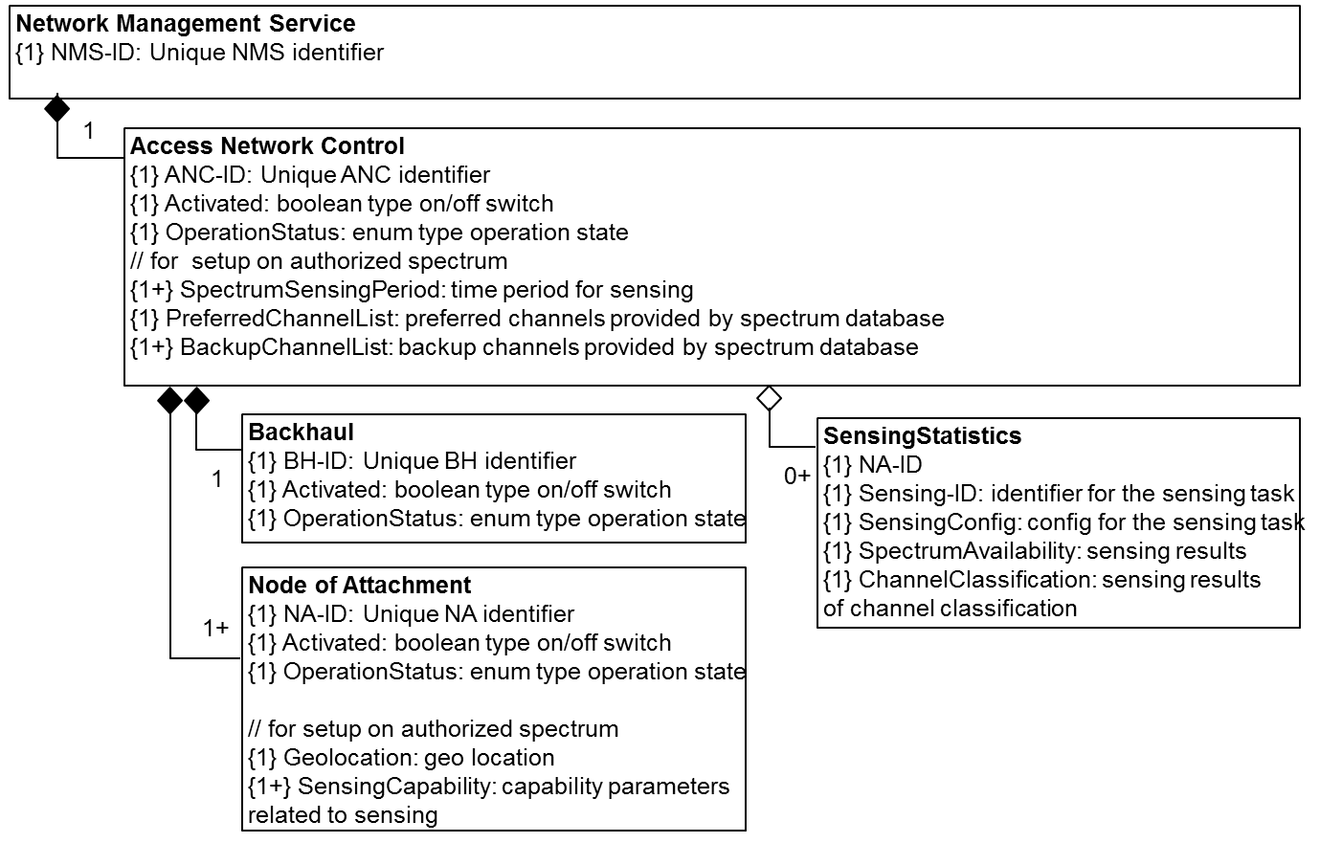
Figure 8-12 Information model for AN setup

Information model for network discovery and selection (NDS)
Although the main role of NDS is carried by the terminal, necessary information about the access network needs to be provided.
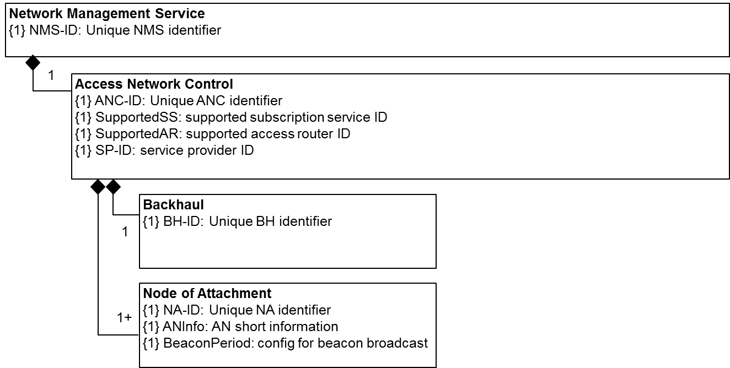
Figure 8-13 Information model for NDS

Information model for association
Association protocols are performed after the appropriate access network is selected.
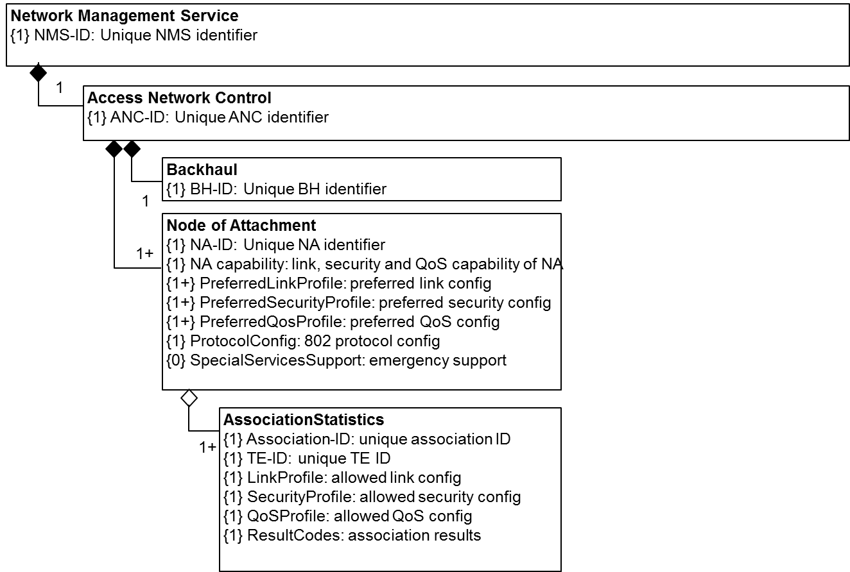
Figure 8-14 Information model for association

Information model for authentication
Trusted relationship need to be established for the associated terminals.
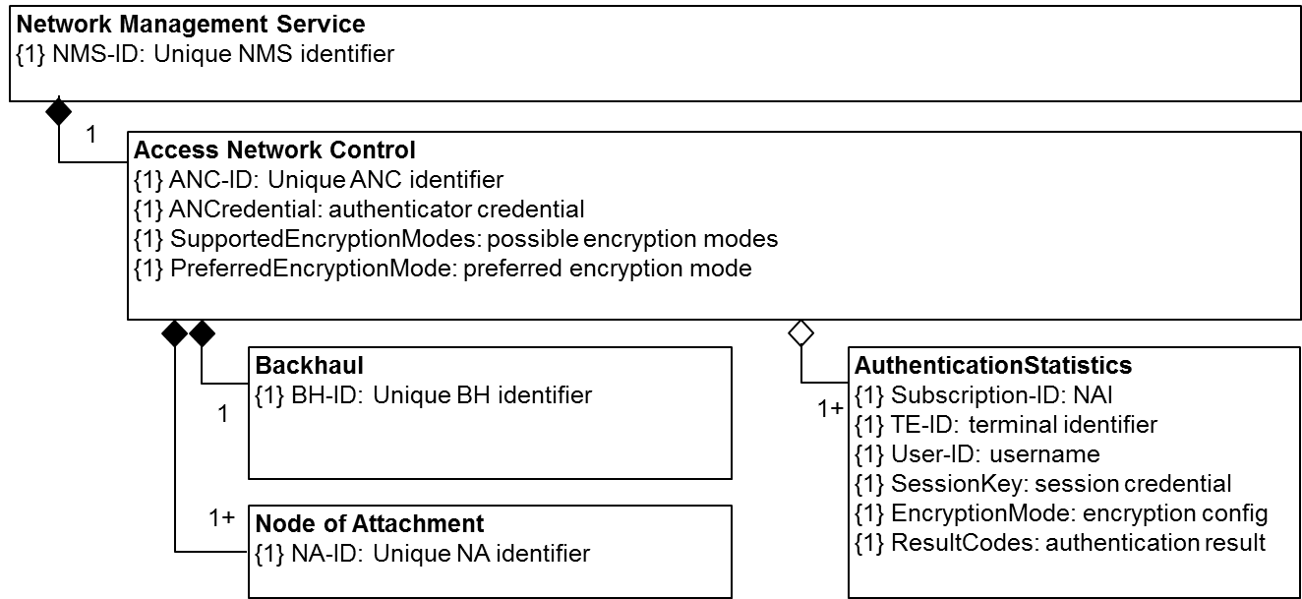
Figure 8-15 Information model for authentication

Information model for datapath establishment and maintenance
Datapath is established between the terminal and access router.
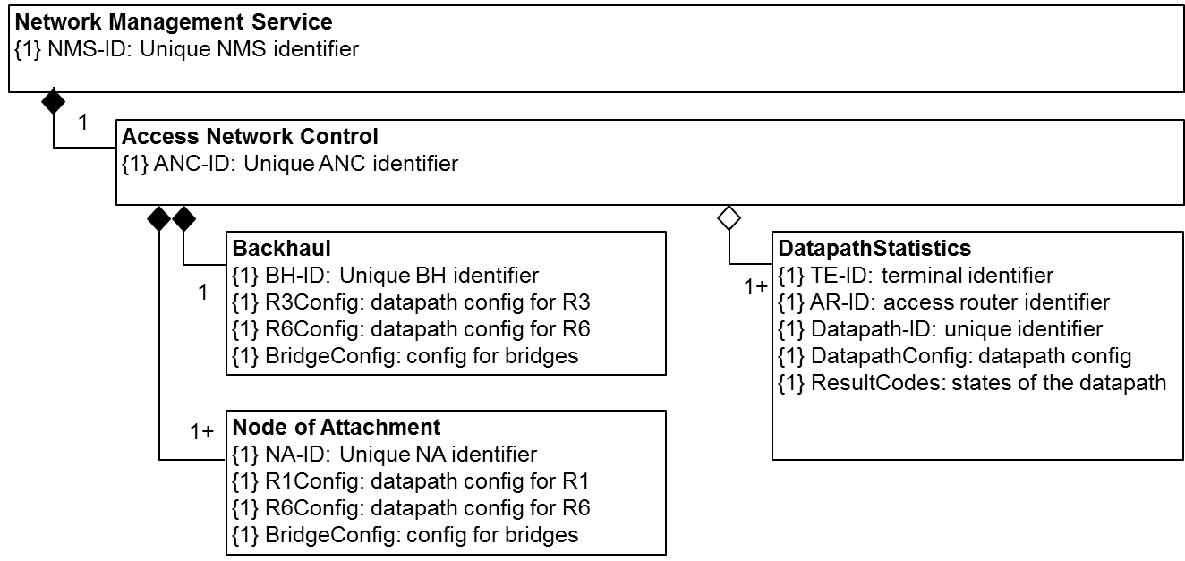
Figure 8-16 Information model for datapath establishment and maintenance

Information model for QoS authorization
Service flow is established for allocating resources and specifying QoS.
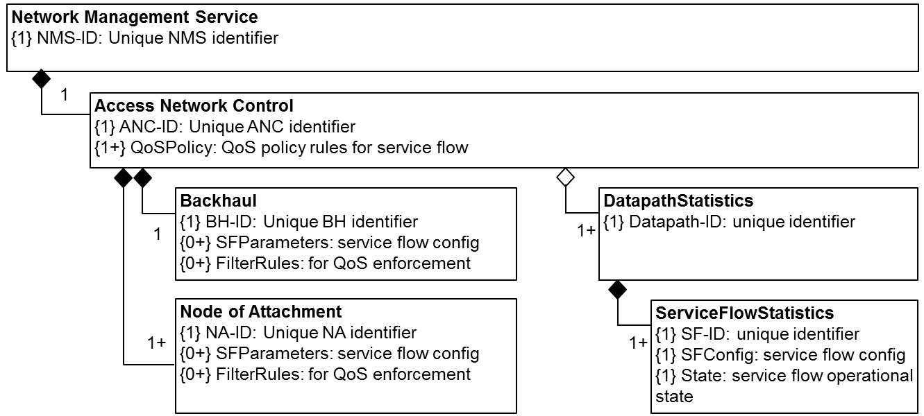
Figure 8-17 Information model for QoS authorization

Information model for accounting and monitoring
User session can be monitored based on the provided policy.
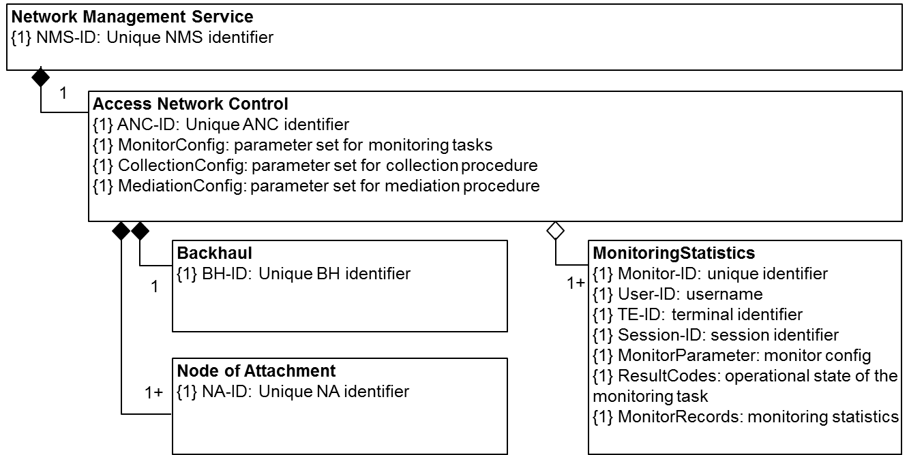
Figure 8-18 Information model for accounting and monitoring

Information model for fault diagnosis and maintenance (FDM)
Functions for FDM are specified and statistics are maintained accordingly.
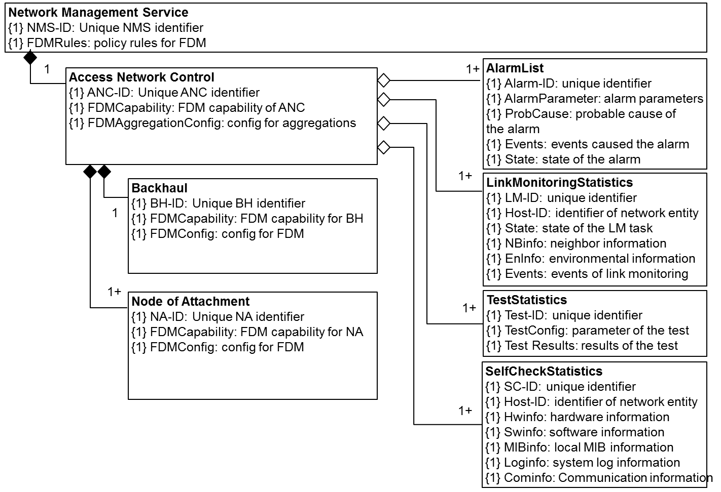
Figure 8-19 Information model for FDM

Complete infrastructure configuration and maintenance model
The complete infrastructure configuration and maintenance model is created through combining the functional sections listed above into a single figure.
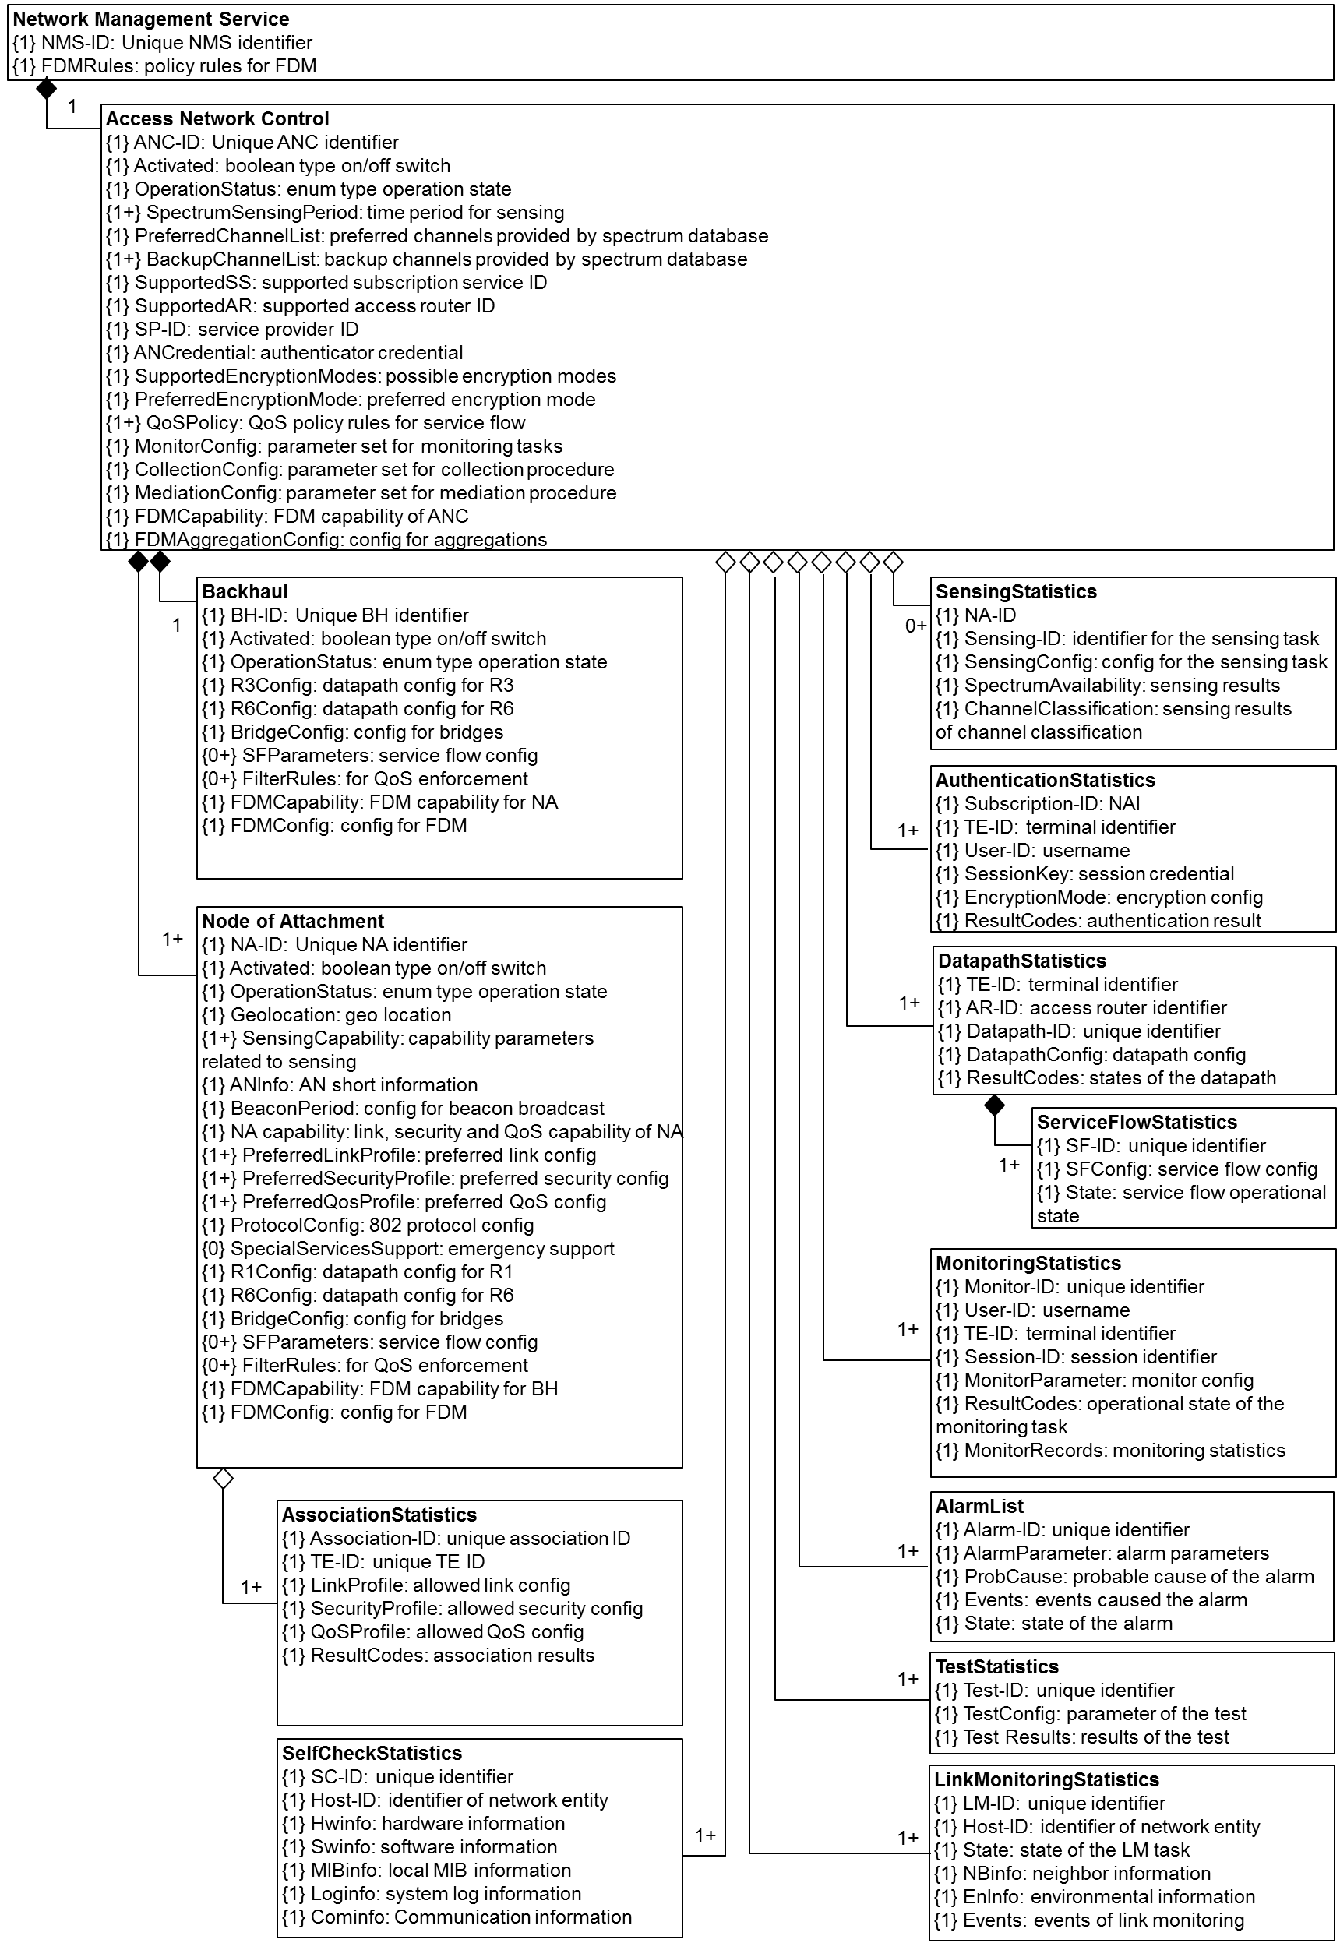
Figure 8-20 Complete information model for infrastructure configuration and maintenance

