Chapter 8.1 Information model of IEEE 802 access network
Date: 2017-10-09
Authors:
Name | Affiliation | Phone | Email
Max Riegel | Nokia |  | maximilian.riegel@nokia.com
Notice:
This document does not represent the agreed view of the OmniRAN TG It represents only the views of the participants listed in the ‘Authors:’ field above. It is offered as a basis for discussion. It is not binding on the contributor, who reserve the right to add, amend or withdraw material contained herein.
Copyright policy:
The contributor is familiar with the IEEE-SA Copyright Policy <http://standards.ieee.org/IPR/copyrightpolicy.html>.
Patent policy:
The contributor is familiar with the IEEE-SA Patent Policy and Procedures:
<http://standards.ieee.org/guides/bylaws/sect6-7.html#6> and <http://standards.ieee.org/guides/opman/sect6.html#6.3>.

Abstract
This document proposes text for the section 8.1 Information model of IEEE 802 access network.
- The first edition captures proposal of the introductory text.

8 Network softwarization functions 3
8.1 Information model of IEEE 802 access network 3
8.1.1 Infrastructure configuration and maintenance model 3
8.1.2 User service operation model 4

Network softwarization functions
…

Information model of IEEE 802 access network
An information model is used in software engineering to represent concepts, relationships, operations, and constraints in order to describe the data semantics for a particular system or functional unit. Generally, it describes relations between kind of things (classes), but can also make references to individual things (instances). It helps in sharing an organized structure of information requirements within the context of a domain.
Within this specification the mean of an information model is used to provide a structured representation of the configuration information and the statistics of IEEE 802 access network infrastructure and communication service. Two different models are provided to enable both, the representation of the internal structure, the composition of networking elements and their operational settings, as well as the representation of the service of the access network with the operational parameters, dependencies, and usage statistics. The information models address operational aspects from a user and a service provider perspective.
The information model of IEEE802 access network does not add new information to the descriptions in the previous chapters, but presents the same information in a more condense and structured way. The two following subsections describe first the information model from a structural perspective supporting network infrastructure configuration and maintenance tasks of a network service provider, and second the information model from a operational perspective providing services to users supporting day-to-day operations but also adding to the foundation of the business aspects of a network service provider.

Infrastructure configuration and maintenance model
This model is aligned and derived from the NRM and exposes functional entities according to the descriptions in chapter 6.
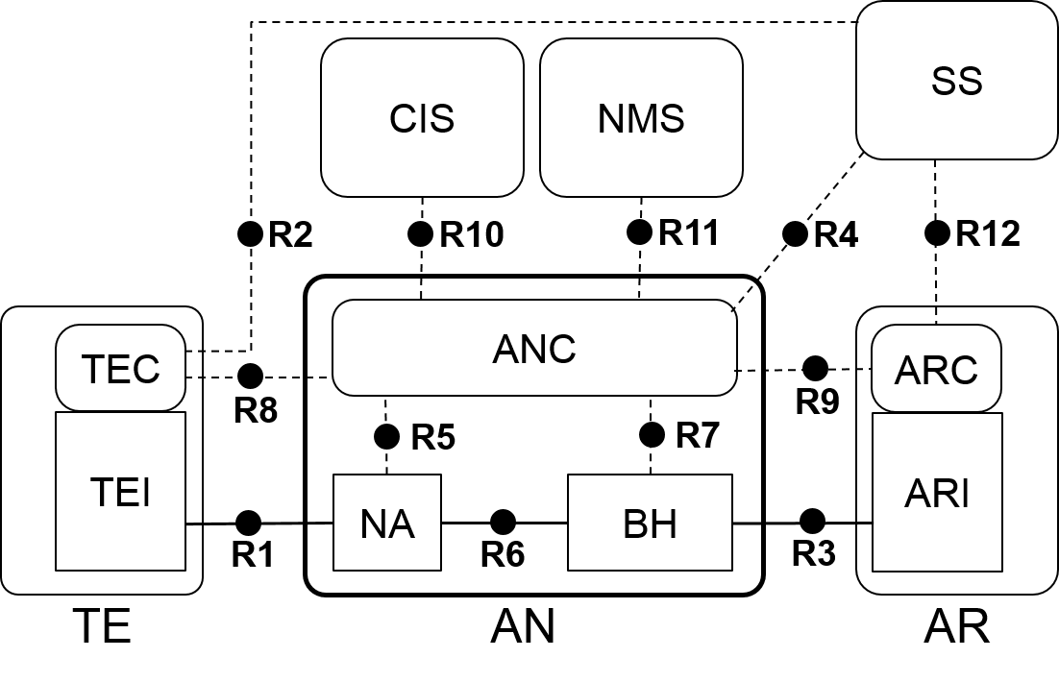
Figure 8-1: Network Reference Model

User service operation model
This model is aligned and derived from the functional description of a user session in chapter 7, and exposes the functional entities introduced in that chapter.
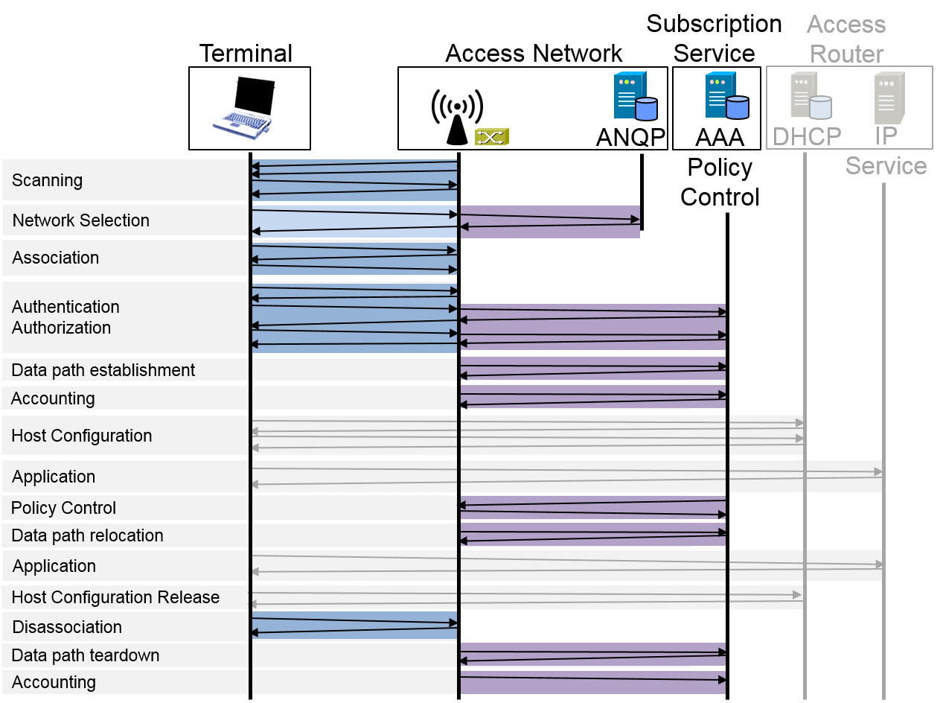
Figure 8-2: Life-cycle of a user session

