|  |  |  |  |
| --- | --- | --- | --- |
| Chapter 7.8.3.3 text revision proposal | | | |
| Date: 2017-09-26 | | | |
| **Authors:** | | | |
| Name | Affiliation | Phone | Email |
| Hao Wang | Fujitsu R&D Center | +86-10-59691000 | wangh@cn.fujitsu.com |
| Su Yi | Fujitsu R&D Center | +86-10-59691000 | yisu@cn.fujitsu.com |
| Xiaojing Fan | Fujitsu R&D Center | +86-10-59691000 | fanxiaojing@cn.fujitsu.com |
| Ryuichi Matsukura | Fujitsu/Fujitsu Laboratory | +81-44-754-2667 | r.matsukura@jp.fujitsu.com |
| **Notice:**  This document does not represent the agreed view of the OmniRAN TG It represents only the views of the participants listed in the ‘Authors:’ field above. It is offered as a basis for discussion. It is not binding on the contributor, who reserve the right to add, amend or withdraw material contained herein. | | | |
| **Copyright policy:**  The contributor is familiar with the IEEE-SA Copyright Policy <<http://standards.ieee.org/IPR/copyrightpolicy.html>>. | | | |
| **Patent policy:**  The contributor is familiar with the IEEE-SA Patent Policy and Procedures:  <[http://standards.ieee.org/guides/bylaws/sect6-7.html#6](http://standards.ieee.org/guides/bylaws/sect6-7.html)> and <[http://standards.ieee.org/guides/opman/sect6.html#6.3](http://standards.ieee.org/guides/opman/sect6.html)>. | | | |

# Abstract

This document provides the amendment for 7.8.3.3 in IEEE 802.1CF D0.6.2.2.

**Comments on D0.6.2.2:**

Review and revise chapter 7.8.3.3 to remove overlap with section 7.2 including fig 57.

**Proposed Text Changes:**

Please replace 7.8.3.3 of IEEE802.1CF D0.6.2.2 with the following text.

------------- Begin Text Changes ---------------

* **Automatic fault recovery by ANC**

In a lot of scenarios, ANC can do fault isolation and recovery on its own. When the root cause is identified, ANC may autonomously take recovery actions in order to minimize the time of service degradation or disruption.

For some faults, additional tests and diagnostics under the control of ANC may be necessary in order to obtain the required level of details.

In a scenario where multiple NAs operate in overlapping areas, ANC is allowed to do enhanced features for providing better services to the TE, such as interference coordination, load balancing, mobility support, etc. It may be necessary for ANC to monitor multiple communication interfaces simultaneously and perform the FDM functionalities in a coordinated fashion.

As shown in Figure 57, NA1 is requested to provide the diagnostic report for the ANC to verify whether a neighboring NA (NA2) operating on the same wireless channel causes severe mutual interference. The ANC automatically initiates the recovery actions on the corresponding NAs, e.g., re-assigns channels, to mitigate the interference.

The diagnostic report may also indicate that NA1 has encountered a software or hardware problem. In this case, ANC may initiate individual recovery procedure on NA1 such as reboot, software update, etc, to regain its capability.

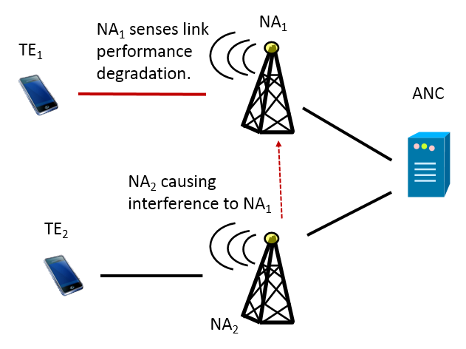

* **Multiple NAs controlled by the same controller**