Amendment of Chapter 4.2 Conventions
Date: 2017-09-25
Authors:
Name | Affiliation | Phone | Email
Max Riegel | Nokia |  | maximilian.riegel@nokia.com
Notice:
This document does not represent the agreed view of the OmniRAN TG It represents only the views of the participants listed in the ‘Authors:’ field above. It is offered as a basis for discussion. It is not binding on the contributor, who reserve the right to add, amend or withdraw material contained herein.
Copyright policy:
The contributor is familiar with the IEEE-SA Copyright Policy <http://standards.ieee.org/IPR/copyrightpolicy.html>.
Patent policy:
The contributor is familiar with the IEEE-SA Patent Policy and Procedures:
<http://standards.ieee.org/guides/bylaws/sect6-7.html#6> and <http://standards.ieee.org/guides/opman/sect6.html#6.3>.

Abstract
This document proposes additional content for section 4.2 to describe the notation used for the representation of the information models in Chapter 8.

4 Acronyms, abbreviations, and conventions 3
4.1 Acronyms 3
4.2 Conventions 3
4.2.1 Occurrence of information elements 3
4.2.2 Information model notation 3
4.2.2.1 Information element 3
4.2.2.2 Aggregation 3
4.2.2.3 Composition 4
4.2.2.4 Inheritance 4

Acronyms, abbreviations, and conventions

Acronyms
…

Conventions

Occurrence of information elements
The following notation is used for indicating the occurrence of the information elements:
{0+} Zero or more instances of this attribute are present.
{0-1} Zero or one instance of this attribute is present.
{1} Exactly one instance of this attribute is present.
{1+} One or more instances of this attribute are present.

Information model notation
A simplified UML object model notation is used for representation of the information model in this document.

Information element
Objects are represented through a class notation.
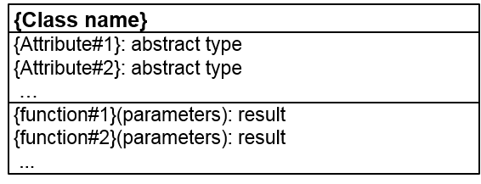
Figure x: Class notation
Information entities are denoted through a class name and comprise a list of attributes as well as a list of functions. Functions return a result value.

Aggregation
More complex information models are built through aggregation and composition. Aggregation is a special kind of association to model a relationship between a part to its whole.
In a basic aggregation relationship, that is depicted through a framed diamond at the whole component, the lifecycle of the part is independent of the existence of the whole object, i.e. continues to exist when the whole object is dissolved.
Figure x+1: Aggregation with bi-directional scope
Usually associations are assumed to be bi-directional; it means that the whole object is aware of its parts, but also that the parts know about belonging to the whole, i.e. the part can make references to other elements of the whole.
Figure x+2: Aggregation with uni-directional scope
A framed arrow towards the part is used to indicate an uni-directional association, when only the whole is aware of the relationship, but parts do not have visibility of the whole.

Composition
To display a composition aggregation, which is a tight relationship between a part to its whole, a filled diamond is used at the whole component to show that the lifecycle of the part is dependent from the existence of the whole object. In this kind of relationship, the part ceases when the whole object is dissolved.
Figure x+3: Composition with bi-directional scope
In its basic form, a composition is assumed to be bi-directional; it means that the whole object can reference to its parts, but also that the parts can reference the whole object and other parts of it.
Figure x+4: Composition with uni-directional scope
A framed arrow towards the part indicates an uni-directional composition, when only the whole is aware of the relationship and can reference the parts, but parts do not have visibility of the whole.

Inheritance
To show a relationship where one entity adopts all the functionality of the other entity and adds further details or operations, the notation of inheritance is used.
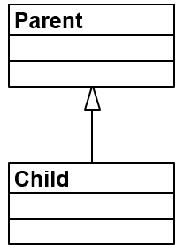
Figure x+5: Inheritance
A solid line from the child to the parent with an unfilled arrowhead indicates that all functionalities of the parent are taken over. A child may inherit from multiple parents.

