|  |  |  |  |
| --- | --- | --- | --- |
| Chapter 6 amendment proposal | | | |
| Date: 2017-04-20 | | | |
| **Authors:** | | | |
| Name | Affiliation | Phone | Email |
| Max Riegel | Nokia Bell Labs |  | maximilian.riegel@nokia.com |
|  |  |  |  |
|  |  |  |  |
| **Notice:**  This document does not represent the agreed view of the OmniRAN TG It represents only the views of the participants listed in the ‘Authors:’ field above. It is offered as a basis for discussion. It is not binding on the contributor, who reserve the right to add, amend or withdraw material contained herein. | | | |
| **Copyright policy:**  The contributor is familiar with the IEEE-SA Copyright Policy <<http://standards.ieee.org/IPR/copyrightpolicy.html>>. | | | |
| **Patent policy:**  The contributor is familiar with the IEEE-SA Patent Policy and Procedures:  <[http://standards.ieee.org/guides/bylaws/sect6-7.html#6](http://standards.ieee.org/guides/bylaws/sect6-7.html)> and <[http://standards.ieee.org/guides/opman/sect6.html#6.3](http://standards.ieee.org/guides/opman/sect6.html)>. | | | |

# Abstract

This document proposes amendments to Chapter 6 to provide the proposed text edits to address comment #2 on P802.1CF draft 0.4

6 Network Reference Model 3

6.1 Basic architectural concepts and terms (informative) 3

6.1.1 Protocol entities, peers, layers, services, and clients 3

6.1.2 Service interface primitives, parameters, and frames 3

6.3 Overview of IEEE 802 Network Reference Model 5

6.3.1 Schematic overview 5

6.3.2 6.2.2 Reference point types 6

6.4 Basic Network Reference Model 7

# Access Network Reference Model

over an IEEE 802 based networknetwork reference model introduced in this section as a generic representation of various implementations interfacethe network layer interface in 6-1

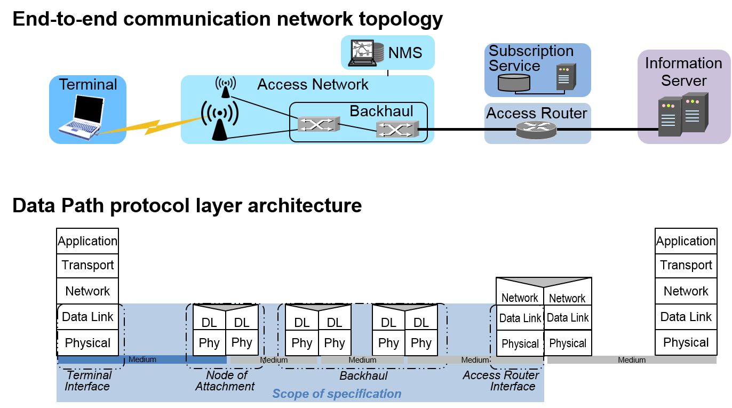

Figure 6-1: Scope of network reference model

Making use of a generic picture of t, a a a in this specification ,, or an interface to a switchconcurrently multiple terminals across multipleinterconnected with each other ,it the appropriate kind of enable information to

As shown through the data path protocol layer architecture figure, IEEE 802 access networks forward user data frames according to MAC addresses, and MAC addresses represent the endpoints of the links in the IEEE 802 access network.

## Basic architectural concepts and terms (informative)

NOTE— This section is essentially adopted from IEEE 802.1AC Chapter 7 with some figures added from IEEE 802 for illustration.

The architectural concepts used in this and other IEEE 802.1 standards are based on the layered protocol model introduced by the OSI Reference Model (ISO/IEC 7498-1) and used in the MAC Service Definition (IEEE Std 802.1AC), in IEEE Std 802, in other IEEE 802 standards, and (with varying degrees of fidelity) in networking in general. IEEE 802.1 standards in particular have developed terms and distinctions useful in describing the MAC Service and its support by protocol entities within the MAC Sublayer.

### Protocol entities, peers, layers, services, and clients

The fundamental notion of the model is that each protocol entity within a system exists or is instantiated at one of a number of strictly ordered layers, and communicates with peer entities (operating the same or an interoperable protocol within the same layer) in other systems by using the service provided by interoperable protocol entities within the layer immediately below, and thus provides service to protocol entities in the layer above. The implied repetitive stacking of protocol entities is bounded at the highest level by an application supported by peer systems, and essentially unbounded at the lowest level. In descriptions of the model, the relative layer positions of protocol entities and services is conventionally referred to by N, designating a numeric level. The N*-*service is provided by an N*-*entity that uses the (N – 1) service provided by the (N – 1) entity, while the N*-*service user is an (N + 1) entity.

Figure 1 illustrates these concepts with reference to the layered protocol model and service access points of IEEE 802 end stations.



Figure 1—IEEE 802 reference model

### Service interface primitives, parameters, and frames

Each N-service is described in terms of service primitives and their parameters, each primitive corresponding to an atomic interaction between …

## Overview of IEEE 802 Network Reference Model

The Network Reference Model (NRM) defines a generic foundation for the description of IEEE 802 access networks, which may include multiple network interfaces, multiple network access technologies, and multiple network subscriptions, aimed at unifying the support of different interface technologies, enabling shared network control and use of software-defined networking (SDN) principles.

### Schematic overview

Aa of

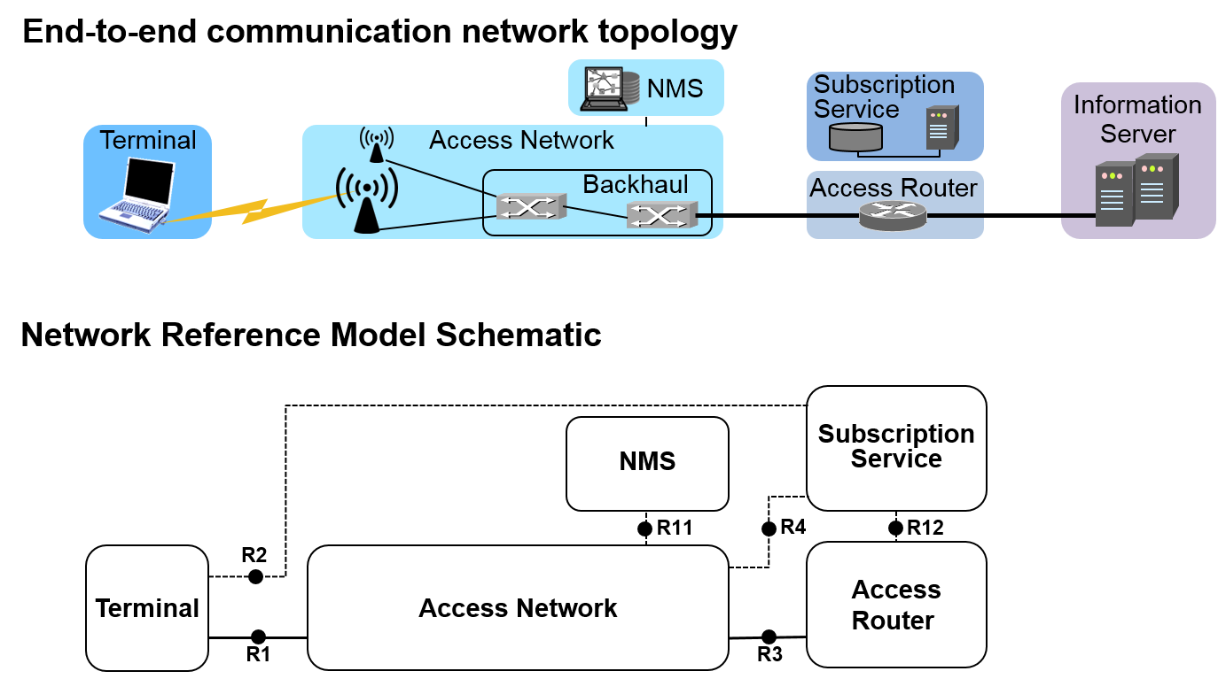

Figure 5—NRM overview

R12 indicates the interface between Subscription Service and Access Router, mainly for exchange of authorization and accounting information.

On the data path indicated by R1 and R3, the NRM covers both user data as well as transport functions, and avoids a functional separation into a user plane and into a transport plane. Through keeping these functions together, the specification provides an integrated model for backhaul connectivity combined with subscriber-specific connectivity functions as facilitated by the IEEE 802.1 bridging technologies.

Out of scope of this specification are the functions above the link layer and the infrastructure beyond the access router for providing IP-based information services to the terminals.

### Reference point types



Figure 6—Reference point types

There are two kinds of reference points used in the Network Reference Model:

* **A control interface** conveys IEEE 802 layer management information to another entity and is represented in the NRM by a dotted line. Usually IP-based protocols like SNMP or RADIUS will be used for the transport of the layer management information.
* **A port** carries the user data and can convey as well IEEE 802 control protocol information to the peer entity encoded in layer 2 frames. It is represented in the NRM by a solid line.

## Basic Network Reference Model

The Network Reference Model adopts the generic concepts of SDN by introducing dedicated control functions in the terminal, access network, and access router, with well-defined semantics for interfacing with higher layer management, orchestration, and analytics functions. Additionally …