Chap 8.3: Virtualized Network Instantiation
Date: 2017-05-02
Authors:
Name | Affiliation | Phone | Email
Max Riegel | Nokia |  | Maximilian.riegel@nokia.com
Notice:
This document does not represent the agreed view of the OmniRAN TG It represents only the views of the participants listed in the ‘Authors:’ field above. It is offered as a basis for discussion. It is not binding on the contributor, who reserve the right to add, amend or withdraw material contained herein.
Copyright policy:
The contributor is familiar with the IEEE-SA Copyright Policy <http://standards.ieee.org/IPR/copyrightpolicy.html>.
Patent policy:
The contributor is familiar with the IEEE-SA Patent Policy and Procedures:
<http://standards.ieee.org/guides/bylaws/sect6-7.html#6> and <http://standards.ieee.org/guides/opman/sect6.html#6.3>.

Abstract
This document provides the proposed remedy to CID#47 of the comments on P802.1CF d0.4.
The proposed text for chapter 8.3 is based on a comprehensive revision to omniran-16-0073-01-CF00-virtual-access-network-instantiation, initially submitted by Yonggang Fang (ZTETX) and being discussed and revised in the Atlanta F2F on January 16th, 2017. The part adopted without any further edits is marked in the document.
The proposed text adopts without further modifications the text portion reviewed and jointly amended in the Atlanta F2F, and proposes further edits to the reminder of the initial contribution not being discussed in the Atlanta F2F.
Revision 1 contains additional edits discussed in the May 2nd confcall, and added the flow figures discussed in the call.
Revision 2 is the cleaned version of rev 1 to avoid the slowdown of Word when editing.
Revision 3 with revised figure 8.3.4 showing confirm of NA teardown before instructing infrastructure provider to release physical resources

Virtualized access network Instantiation and release procedure

Introduction
In dense deployment scenarios, like shopping malls, airports, stations, or office buildings, often multiple ANs are installed to serve various needs for building management, public access, and corporate networking. Coverage areas of these ANs are widely overlapping, which creates challenges due to interference and congestion in the shared radio resource. To make the operational challenges of multiple overlapping ANs more manageable, and to reduce installation and operation cost, access network operators might consider sharing the access networks.
A single IEEE 802 access network infrastructure can be shared among multiple access network operators by creation of virtualized access networks for each of the operators. Effectively all functions of multiple access networks can be established through multiple instances on the same hardware.
A virtualized access network is a software defined access network which is associated with a service provider. A virtualized access network is implemented through the virtualized network function elements, and offer the common software interfaces to other functional modules of the virtualized access network. A service provider is expected to operate the virtualized access network in the same way as an access network realized in hardware.
The virtualized AN approach is different from a roaming scenario in that each access network operator has full access to their virtualized instance of the access network infrastructure, instead of allowing users of different service providers to connect to the same AN.
An instance of a virtualized access network is created dynamically by an orchestrator, when there is a need to establish a virtualized access network for a service provider.
The access network infrastructure requires an orchestrator with the possibility to create multiple instances of the NMS, the ANC, the NAs, and the backhaul connectivity. The orchestrator has not only to create the virtualized network entity instances but also has to establish the connections between the network entities in order to establish an instance of a virtualized AN. In addition, the orchestrator sets up the connectivity between the virtualized AN and its subscription services and access routers.
The virtualized access network instantiation is the procedure of creating the virtualized access network according to the configuration parameters (template) provided by the OSS of the access network operator. Within the OSS, an NMS is established according to the template, which is sent to the orchestrator. The orchestrator creates an virtualized AN, which consists of an instance of ANC, one or more instances of NA, and one or more instances of BH. The AN instance is associated with the NMS in the OSS of the access network operator.
After instantiation of the AN instance, the NMS needs to be populated with the configuration information and the AN has to be initialized. Initialization of a virtual AN instance follows the same procedures as described in chapter 7.1.
The virtualized access network instantiation does not cover the instantiation of network entities SS, and AR. If those network entities are virtualized, such instantiation are performed by external means outside of the scope of this specification. However, the instantiation of such network entities may be performed by the same orchestrator if they share the same physical computing and communications resources.
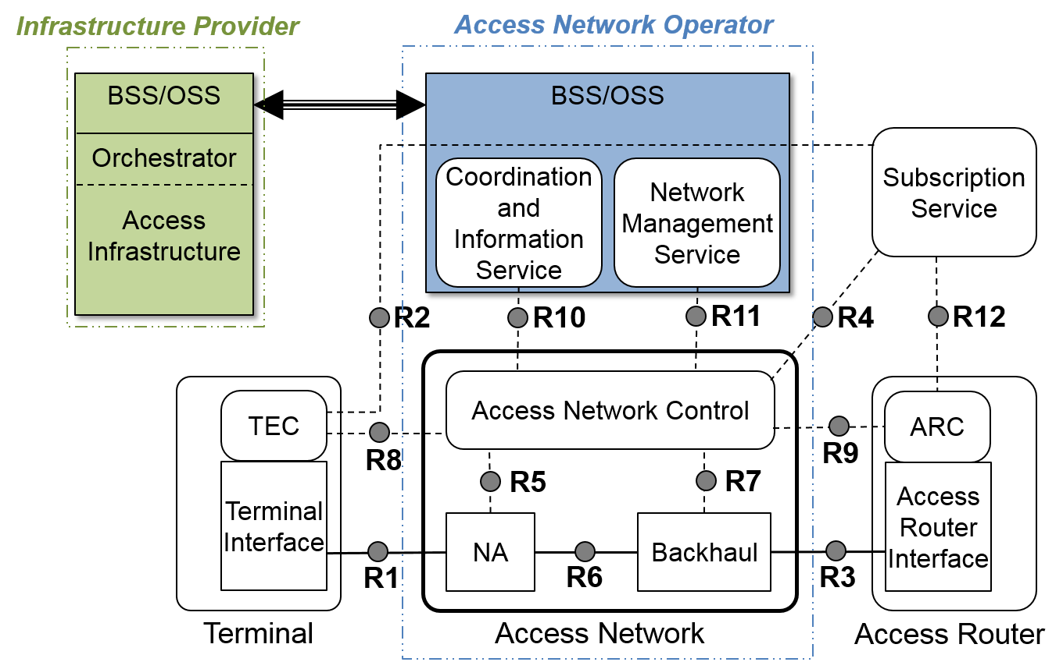
Figure 8-3-1: Instantiation reference architecture
Figure 8-1 shows the additional functions for network instantiation in relation to the network reference model.

Roles and Identifiers
The virtualized access network instantiation consists of the creation of virtualized access network functions through the orchestrator. It is initiated through the BSS/OSS of the access operator requesting the new instance of an access network and comprises the instantiation of a virtualized ANC, the instantiation of the required set of virtualized NAs, and the instantiation of the virtualized BH interconnecting the virtualized NAs with the related AR interfaces. Preceding to the request to the orchestrator to create a new instance of an access network, the access network operator establishes the NMS and the CIS for the new AN instance.

Orchestrator
The orchestrator is responsible for creating new instances of network functions; lifecycle managing resources; validating and authorizing resource requests from the OSS/BSS systems of access network operators. Instructions to the orchestrator are filtered and confirmed through the BSS/OSS of the infrastructure provider to ensure business integrity.

Access Network
AN is defined in section 6.5. A virtualized AN behaves the same way as a dedicated physical implementation, however has the possibility to dynamically adjust its resources according to service and load conditions.

Access Network Control
Access Network Control (ANC) is defined in the section 6.5. The virtualized ANC instance provides the same the functions as a physical access network control entity, and is connected with its NAs and BH, as well as with its NMS, CIS and the SSs and Ars, it has relations with.

Node of Attachment
Node of Attachment (NA) is defined in the section 6.5. In the virtualized access network, NAs are represented through virtualized instances of NA, which are created through multiple software instances based on a common hardware usually providing the physical interface to the communication medium and the lower layer PHY functionality. Through the sharing hardware for some of its functions, virtualized NAs are restricted in its free configurability. While the functional model is identical to a physical implementation of an NA, the management model does not provide the same configurability. A few of the management attributes, which could be modified in a physical instance, are read-only attributes in the model of the virtualized instances. Modifications to that attributes could only be performed by way of sending requests to the orchestrator, and often the requests may be denied because of impacting the operation of the other instances of the virtualized NAs on the same hardware.

Backhaul Network
Backhaul (BH) is defined in the section 6.5. In the virtualized access network, BH is represented through an instance created by the orchestrator. The virtualized BH may be implemented through VLAN or SDN technologies to allow for multiple instances in a shared environment.

Use Cases

Instantiation of a new virtualized access network
The instantiation of a new virtualized access network for an access network operator is performed through the orchestrator.
- The access network operator establishes the NMS and the CIS of the new access network and sends the desired configuration of the new access network together with the capabilities and interfaces of the CIS and NMS to the orchestrator.
- Based on the configuration information from the access network operator, the orchestrator creates the new instance of a virtualized access network through instantiation of an ANC, the requested number of NAs and the related BH, each of which represents the same functions as in physical implementations of access network infrastructure. The access network operator is informed about the successful instantiation of the new access network.
- Once the AN is instantiated, the NMS manages and controls the virtualized access network initiation and configuration by way of ANC, following the procedures as specified in chapter 7.1

Dynamically adding instances to the virtualized access network
The access network operator may add one or more new NA instances to the virtualized access network to improve the radio coverage or increase the access network capacity according to the deployment and live traffic demanding. Therefore, the virtualized access network topology and capacity may change like a physical access network would change through installation of further physical NAs.
The access network operator may add a new instance of NA. The OSS/BSS of the access network operator then communicates with the orchestrator to create a new instance of NA. When the orchestrator confirms the creation of a new instance of NA, the NMS initializes and manages it through the ANC.

Dynamically removing instances from the virtualized access network
The access network operator may remove one or more instances of NA when the radio coverage or access network capacity is not needed according to the deployment and live traffic.
The access network operator can remove an instance of NA by tearing it down through the NMS, and then instructing the orchestrator through the OSS/BSS to remove the instance. When the orchestrator receives the instruction from the OSS/BSS of the access network operator, it removes the instance and the associated resources in the virtualized infrastructure.

Removal of the entire virtualized access network
There are two cases to remove the entire virtualized access network:
- The access network operator tears down the entire virtualized access network through its NMS, and then informs the orchestrator to remove the instance of the access network.
- The orchestrator autonomously removes the virtualized access network instance when a fatal failure in the virtualized access network or in the physical access infrastructure has been detected, which can’t be corrected. The orchestrator informs in that case the OSS/BSS about the removal of the access network instance, usually followed by a re-instantiation of the virtualized access network instance.

Functional Requirements

Creation of multiple virtualized networking entities
In the virtualized access network environment, the orchestrator of access infrastructure plays an important role of controlling the virtualized access network instantiation.
The orchestrator first creates the virtualized network instances with default parameters and then establishes the connections between the network functions to allow the ANC to communicate with the NMS and CIS for configuration information of virtualized access network entities.

Virtualized AN Configuration
The virtualized AN configuration is performed through the ANC created by the orchestrator of the access infrastructure. Once the virtualized AN is instantiated, the access network operator can configure the virtualized AN through the NMS like configuring a real AN.
In the case of multiple virtualized ANs sharing the same infrastructure, each access network operator has its own configuration parameters and can configure its AN instance through its NMS.
If some configuration parameters (like radio interface parameters) are shared by multiple virtualized ANs, those parameters should be common and same to all the virtualized ANs.

Multiple Service Provider support
The access network virtualization allows multiple access network operators to share the physical infrastructure, each with its own connections to one or more access routers.
- A virtualized AN should be capable to discover and join its associated access routers, to which connectivity and trust relationship exists.
- Multiple virtualized ANs, each belonging to a different access network operator, should be able to be shared within the same physical access infrastructure.
- A virtualized AN should maintain its unique air interface identifiers and access network identifiers belonging to its access network operator.
- The virtualized BH should be able to forward the user packets of the virtualized AN to the designated access routers, to which the access network operator has a business relation.
- The orchestrator should provide defined allocation of radio resources shared among multiple ANs which belong to different access network operators.

Network Instantiation Procedures

Virtualized Access Network Instantiation Procedure
Before a virtualized access network instantiation, the related NMS instance is created either by the orchestrator if the NMS shares the same physical infrastructure or through other means, which are out of scope of this specification.
The access network operator can initiate the AN instantiation via issuing a command to the BSS/OSS of the orchestrator. Once the BSS/OSS of the orchestrator receives the ‘Create AN request’, it validates and verify the command. If the command is verified, the orchestrator creates an instance of ANC, the requested number of instances of NAs and the related instance of BH for interconnection of the NAs towards the ARs according to request. Once the ANC instance is created, it will discover and connect to the associated NMS.
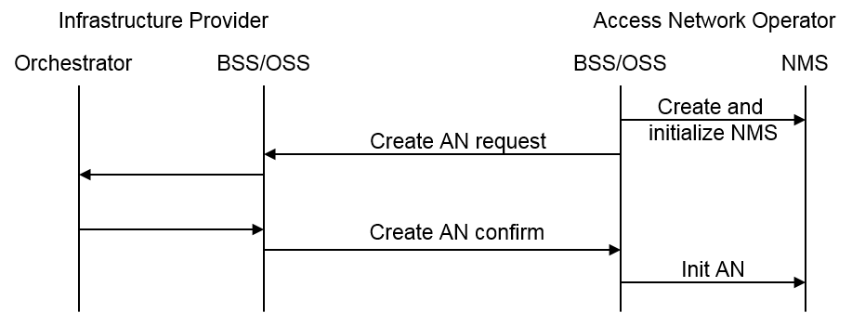
Figure 8-3-2: AN instantiation procedure
An access network initialization procedure according to 7.1 follows the instantiation to discover and join the related NMS and to retrieve the configuration information for provisioning of all the networking instances belonging to the AN.

Virtualized AN Release Procedure
There may be two causing reasons to release the virtualized AN.
- Access network operator initiated the AN release: before requesting the orchestrator to remove the networking instances, the access network operator orderly terminates the AN through the NMS.
- Orchestrator initiated AN release: the orchestrator autonomously performs to remove the virtualized access network instances.
When the access network operator needs to release the AN for some reason, like maintenance, upgrade, etc, it initiates an AN teardown through the related NMS and instructs after the teardown of the AN, the orchestrator to remove the related networking instances of NAs, BH, and ANC, and the associated resources.
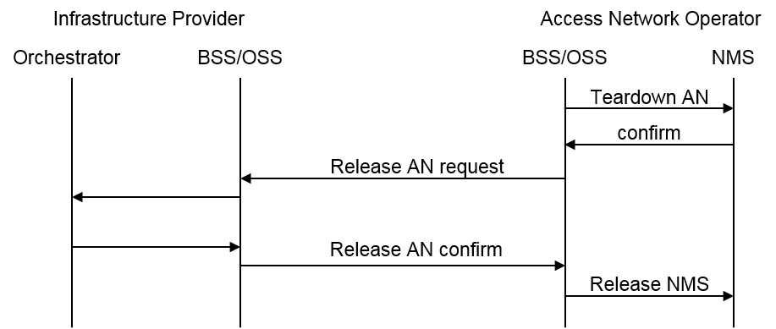
Figure 8-3-3: AN release procedure
When receiving a Release Request message from the BSS/OSS of the access network operator, the orchestrator validates the message and verifies that the request matches completely with the instance of AN. Only when complete match is determined, the orchestrator will remove all the instances associated to the AN and send a Release Response to the BSS/OSS of the access network operator.
In some case like fatal hardware or software failures, the orchestrator initiates by itself the release of the entire AN and removes the instances of NAs, BH, and ANC, belonging to that AN, in order to reestablish a defined status of the access infrastructure. The orchestrator sends a Release Notification message to the NMS to notify the access network operator about the fatal error condition and let the access network operator initiate further procedures to reestablish the AN.
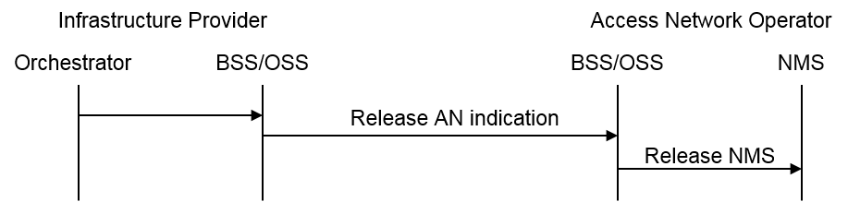
Figure 8-3-4: AN release procedure in the case of a fatal failure

Adding a New NA Instance to the AN Procedure
In some case, the access network operator may need to add a new instance of NA to increase the radio coverage or air link capacity. The access network operator initiates a command through its BSS/OSS to instruct the orchestrator to add the requested instance of NA (and related functionality of BH) and associated resources to the AN. When receiving the Add Request message from the BSS/OSS of the access network operator, the BSS/OSS of the orchestrator validates the message and verifies that the request matches completely with the business agreement and the physical capabilities of the access infrastructure. Only if complete match is determined and the requested instance do not collide with the operation of other ANs of the same access network infrastructure, the orchestrator will add the requested instances of NA together with the related functions of BH and associated resources to the AN.
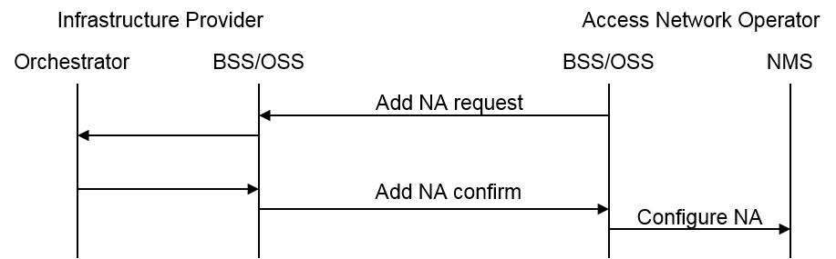
Figure 8-3-5: Add NA procedure
The newly added instance of NA triggers its initiation through the procedures described in 7.1.

Removal of an NA Instance from the AN Procedure
In some case, the service provider may need to remove an instance of NA to reduce the radio coverage or air link capacity or operational cost when not demanded by attached terminals. The access network operator initiates a command from its BSS/OSS to instruct the orchestrator to remove the requested instance of NA together with the related functions of BH and associated resources from the AN. When receiving the Remove Request message from the access network operator, the BSS/OSS of the orchestrator validates the message and verifies that the request matches completely with the business agreement and the instance of the virtualized AN. Only if complete match is determined, the orchestrator will remove the requested instances of NA together with related functions of BH and associated resources from the AN.
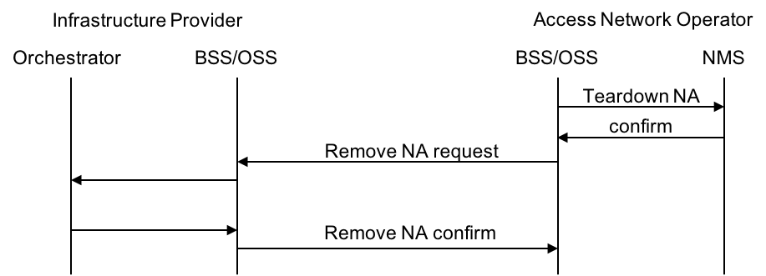
Figure 8-3-6: Remove NA procedure
Before requesting the removal of an NA, the access network operator has to tear down the NA through its NMS and ANC.

Update Virtualized AN Configuration Procedure
During the normal operation of AN, the AN operator may reconfigure the AN through its NMS within the capabilities provided at instantiation. Sometimes reconfiguration may touch capabilities, which are not under full control of the NMS In these cases, the CIS has to be queried for the change of operational parameters, which may collide with the operation of the other ANs of the same access infrastructure. Only when the reconfiguration does not collide with the operation of other ANs of the same access infrastructure, the orchestrator will change the configuration of the requested instances in the AN according to the wishes of the access network operator and responds back via the CIS. Otherwise the orchestrator will respond with a change denial message potentially providing some alternative proposal to best match the required reconfiguration.
#### end of proposal ###

