Chapter 6.9.3 Enterprise network
Date: 2017-03-14
Authors:
Name | Affiliation | Phone | Email
Max Riegel | Nokia Bell Labs |  | maximilian.riegel@nokia.com
Notice:
This document does not represent the agreed view of the OmniRAN TG It represents only the views of the participants listed in the ‘Authors:’ field above. It is offered as a basis for discussion. It is not binding on the contributor, who reserve the right to add, amend or withdraw material contained herein.
Copyright policy:
The contributor is familiar with the IEEE-SA Copyright Policy <http://standards.ieee.org/IPR/copyrightpolicy.html>.
Patent policy:
The contributor is familiar with the IEEE-SA Patent Policy and Procedures:
<http://standards.ieee.org/guides/bylaws/sect6-7.html#6> and <http://standards.ieee.org/guides/opman/sect6.html#6.3>.

Abstract
This document proposes content for description of the enterprise network deployment scenario.

Functional Decomposition and Design

Deployment scenarios

Enterprise network
Enterprise networks are privately operated network infrastructures within enterprises, organizations, or cooperates. They comprise a huge variety of implementations and sizes. Enterprise networks can span from a completely isolated network with a few PCs connected through a single Ethernet switch, up to a global network of many privately interconnected sites each having its comprehensive LAN with wired as well as wireless IEEE 802 connectivity of hundreds to thousands of terminals, devices and servers. The commonality of all such enterprise networks is the deployment of IEEE 802 bridging among all connected terminals in the local area network. The Internet Protocol is used for delivering services within enterprise networks. It implies that at least one access router exists, which is often embedded in the MAN router with the firewall to the Internet and the VPN gateway to the other remote sites of the same enterprise network.
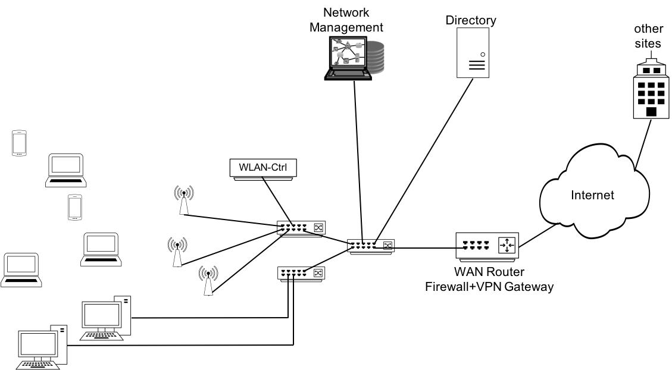
Figure x: Enterprise network scenario
The figure x above shows a typical enterprise network scenario providing wireless access to portable devices through a number of access point connected to an aggregation switch. Often, the aggregation switch is complemented by a WLAN controller, to accomplish a more seamless wireless network by facilitating central coordination of higher layer IEEE 802.11 functions. Another aggregation switch provides wired IEEE 802.3 connectivity to a number of workstations or PCs, as potentially also special devices like printers. The switches build the backhaul of the wireless access points and the wired terminal interfaces towards the access router. The access router coordinates the configuration of the IP protocol inside the enterprise and provides outside connectivity towards the Internet and other sites of the enterprise.
A directory service enables the central storage and maintenance of user specific subscription information. It allows to centrally configure user specific access rights to the network and services.
Due to the distributed realization of the network with network devices spread over the whole campus, enterprise networks usually have a dedicated network management station for configuration, administration, monitoring and maintenance of the whole network.
The components of an enterprise network can be easily mapped to the NRM. The switching infrastructure builds the backhaul of the network, with terminal Ethernet ports and WLAN access points resembling the nodes of attachment. The functions of the WLAN controller fit well to the role of the ANC, and network management station and directory are typical realizations of the NMS and SS, respectively.

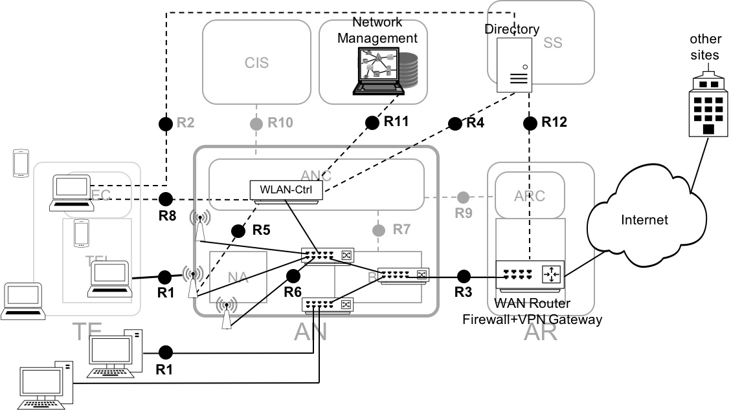
Figure x+: Mapping of enterprise network to the NRM
Even when the implementation of a real enterprise network may not completely resemble the functional decomposition of the NRM, it is clearly visible in Figure x+, that the components of an enterprise network are well fitting to the functional entities of the NRM. All reference points towards terminals are supported. Many of the reference points of the AN directly exist as interfaces in the enterprise networks. R6 is exposed on the interface between the switch and the access point, and R3 maps to the LAN cable between the core switch and the WAN router. Even control interfaces of the access network may be exposed in enterprise networks. R5 could be mapped to the communication between the WLAN controller and the WLAN access points, and R4 and R11 denote the protocol connections between the WLAN controller and the directory server and network management station, respectively. The information exchange between WAN router and directory server can be mapped to R12. However, not all reference points are such clearly exposed in enterprise networks. R7 and R9 may exist, but the related ANC functions may be distributed across the Ethernet switches in the backhaul.
Even when a typical implementation of an enterprise network widely follows the decomposition of functions represented by the NRM, equipment exist, which integrates and combines functions into a single device for functional or economic reasons. E.g. many WLAN controller do not only act as controller for the WLAN access points but also as Ethernet switch for the aggregation of the user data.

