Chapter 6.9.3 Enterprise network
Date: 2017-03-08
Authors:
Name | Affiliation | Phone | Email
Max Riegel | Nokia Bell Labs |  | maximilian.riegel@nokia.com
Notice:
This document does not represent the agreed view of the OmniRAN TG It represents only the views of the participants listed in the ‘Authors:’ field above. It is offered as a basis for discussion. It is not binding on the contributor, who reserve the right to add, amend or withdraw material contained herein.
Copyright policy:
The contributor is familiar with the IEEE-SA Copyright Policy <http://standards.ieee.org/IPR/copyrightpolicy.html>.
Patent policy:
The contributor is familiar with the IEEE-SA Patent Policy and Procedures:
<http://standards.ieee.org/guides/bylaws/sect6-7.html#6> and <http://standards.ieee.org/guides/opman/sect6.html#6.3>.

Abstract
This document proposes content for description of the enterprise network deployment scenario.

Functional Decomposition and Design

Deployment scenarios

Enterprise network
Enterprise networks are privately operated network infrastructures within enterprises, organizations and cooperates. They comprise a huge variety of implementations and sizes. Enterprise networks can span from a completely isolated network with a number of PCs connected through a single Ethernet switch, up to a global network of many privately interconnected sites each having its comprehensive LAN with wired as well as wireless IEEE 802 connectivity of hundreds to thousands of terminals, devices and servers. The commonality of all such enterprise networks is the deployment of IEEE 802 bridging among all connected terminals in the local area network with the use of the Internet protocol for the realization of services, which implies the existence of at least one access router, often embedded in the connectivity gateway to the Internet and other remote sites of the same enterprise network.
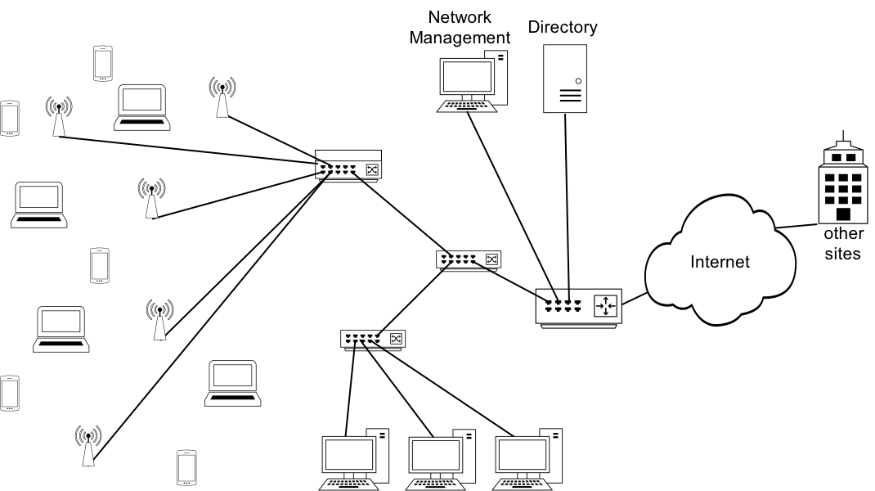
Figure x: Enterprise network scenario
The figure x above shows some typical enterprise network scenario with a wireless access for portable devices through a number of access point connected to an aggregation switch. In some cases, the aggregation switch may also act as a WLAN controller, to facilitate a central implementation or coordination of some IEEE 802.11 functions. Another switch provides wired IEEE 802.3 connectivity to a number of workstations or PCs, as well as special devices like printers. The switches connect the wireless access points with the wired terminals towards the access router, which coordinates the use of the IP protocol and provides outside connectivity towards the Internet and other sites of the enterprise. A directory service allows for the central storage and maintenance of user specific subscription information. Due to the realization through multiple separate devices, enterprise networks usually deploy a dedicated network management station to configure, monitor and maintain the network operation.

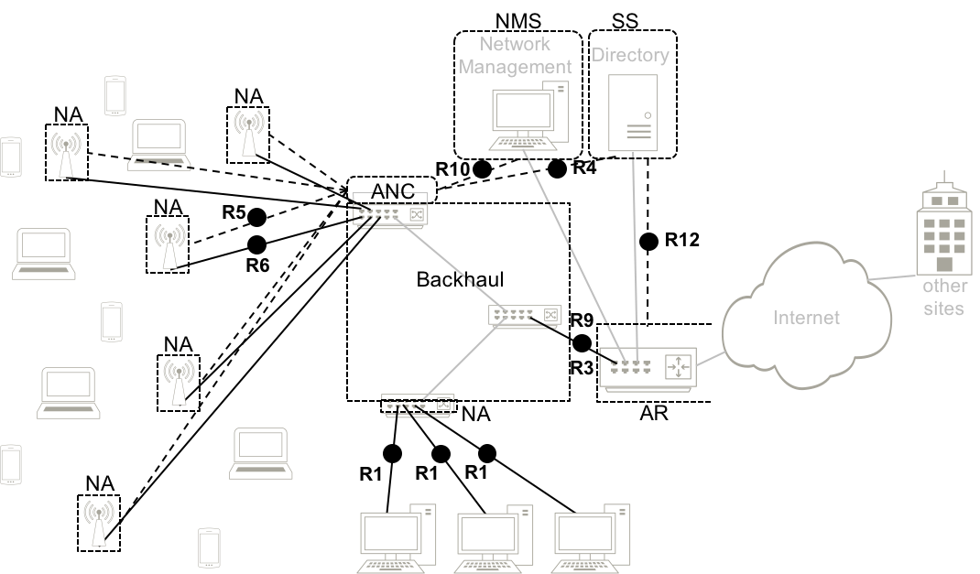
Figure x+: Mapping of enterprise network to the NRM
Even when the implementation of a real enterprise network does not completely resemble the functional decomposition of the NRM, it is clearly visible in Figure x+, that the functional entities of the NRM can be assigned to the network elements of the enterprise networks. It is also visible that not all reference points defined for the NRM are necessarily exposed in real enterprise network implementation, but when interfaces denoted by reference points are exposed, they are following the specification of the NRM. It is valid in particular for the reference points indicating a port in the NRM, as for such reference points IEEE 802 provides all details down to the PHY. The figure x+ shows also that real implementation often differs from the NRM in the control reference points. While the protocol information is forwarded according the definition for the NRM, the control entities in real networks usually are distributed across the network elements, and are not concentrated in a single entity. Control concentration allows for an abstract notation of the control signaling without assuming specific implementations, making it to a tool for generic specifications. Nevertheless it allows to provide a model for the protocol information of the control reference points.

