Chapter 6.9.1 Wi-Fi router
Date: 2017-03-14
Authors:
Name | Affiliation | Phone | Email
Max Riegel | Nokia Bell Labs |  | maximilian.riegel@nokia.com
Notice:
This document does not represent the agreed view of the OmniRAN TG It represents only the views of the participants listed in the ‘Authors:’ field above. It is offered as a basis for discussion. It is not binding on the contributor, who reserve the right to add, amend or withdraw material contained herein.
Copyright policy:
The contributor is familiar with the IEEE-SA Copyright Policy <http://standards.ieee.org/IPR/copyrightpolicy.html>.
Patent policy:
The contributor is familiar with the IEEE-SA Patent Policy and Procedures:
<http://standards.ieee.org/guides/bylaws/sect6-7.html#6> and <http://standards.ieee.org/guides/opman/sect6.html#6.3>.

Abstract
This document proposes more comprehensive content for description of the Wi-Fi router deployment scenario.

Functional Decomposition and Design

Deployment scenarios

Wi-Fi Router
The term Wi-Fi Router denotes a single device commonly used in residential networks to provide Internet access to a number of terminals over either a wireless or a wired connection. Usually a Wi-Fi router comprises an Ethernet plug for the network connection towards a DSL- or Cable modem, a router with DHCP server, Network Address Translation and a firewall to allow multiple terminals to communicate concurrently into the Internet through a secured gateway, an Ethernet switch providing four Ethernet plugs to establish a small residential LAN for wired connections of terminals and local services, as well as one or more IEEE 802.11 radio interfaces, which provide connectivity for wireless LAN terminals. In addition, the Wi-Fi router contains a local network management function, often realized through a web-based portal running on the same processor system, which also performs the routing functions, as well as the higher layer control and data frame processing functions of IEEE 802.11.
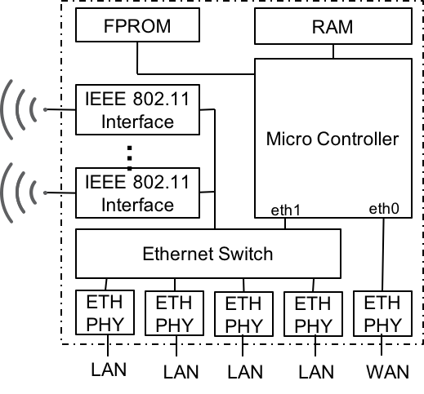
Figure x: Schematic Wi-Fi Router Circuitry
Figure x shows the circuit diagram of a usual implementation of a Wi-Fi router. Chip technology nowadays allows to integrate the whole Wi-Fi Router circuitry likely without the RAM and the FPROM onto a single chip.
The following figure x+ depicts the functions and interfaces of a Wi-Fi router mapped to the functional decomposition of the NRM. It is clearly visible that a Wi-Fi router comprises all the functional entities of the NRM and implements in addition a LAN-WAN gateway function. It acts as access router to the LAN side, and as terminal to the WAN side to provide IP connectivity from a local access network to a remote access network.
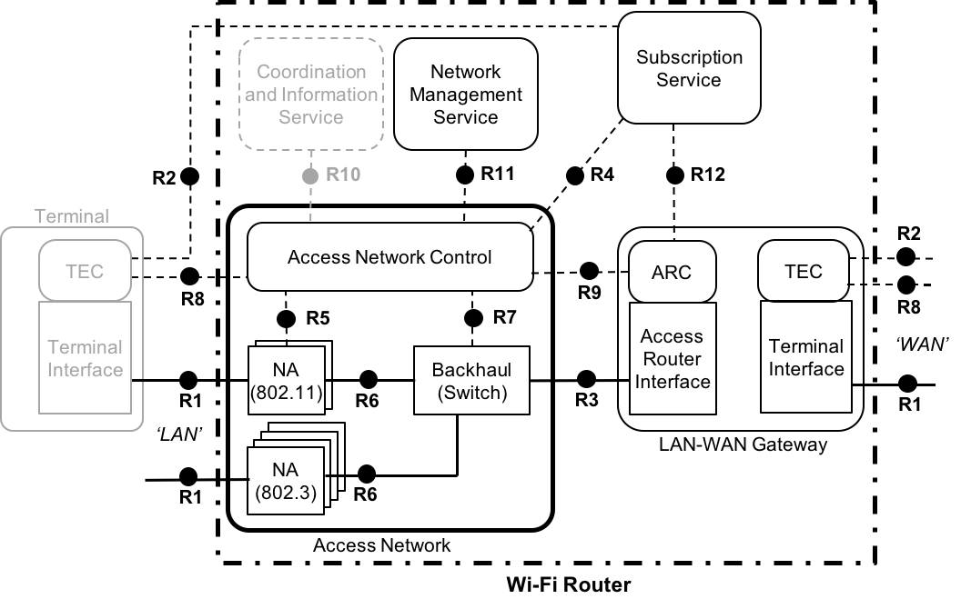
Figure x+: NRM mapping of the Wi-Fi router functions
Through the high integration of all the functions of an IEEE 802 access network into a single device, only a few reference points of the NRM become exposed. All the internal interfaces of the access network, as well as the interfaces of the access network towards access router, subscription service and network management service exist only as functional interfaces within the firmware of the Wi-Fi router. Implementations may favourite the adoption of the reference points as defined in this specification, but could also follow other decomposition and interfacing approaches.
The Wi-Fi router physically exposes only reference points belonging to the interfaces towards the terminal (LAN-side) and towards the wide area access network (WAN-side). The reference point R8 on the LAN-side represents e.g. the key management protocol and potentially the fast roaming protocol of IEEE 802.11, and R2 represents e.g. the EAP method, when 802.1X authentication is applied. On the WAN-side, R8 represents the remote configuration of the WAN interface, e.g. the assignment of VLAN parameters through TR-069, and R2 could be present when the wide area network operator deploys authentication based on subscriber credentials.
As Wi-Fi router usually realize an independent entity of an access network, the coordination and information service might be missing in most of the implementations. Nevertheless, in special cases, also a coordination and information service may exist when e.g. radio interfaces operating in TV WS are implemented, and an interface to a central spectrum database is present as an over -the-top service over the WAN interface.

