Chapter 6.7 (Network Virtualization) amendment proposal
Date: 2017-01-17
Authors:
Name | Affiliation | Phone | Email
Max Riegel | Nokia Bell Labs |  | maximilian.riegel@nokia.com
Notice:
This document does not represent the agreed view of the OmniRAN TG It represents only the views of the participants listed in the ‘Authors:’ field above. It is offered as a basis for discussion. It is not binding on the contributor, who reserve the right to add, amend or withdraw material contained herein.
Copyright policy:
The contributor is familiar with the IEEE-SA Copyright Policy <http://standards.ieee.org/IPR/copyrightpolicy.html>.
Patent policy:
The contributor is familiar with the IEEE-SA Patent Policy and Procedures:
<http://standards.ieee.org/guides/bylaws/sect6-7.html#6> and <http://standards.ieee.org/guides/opman/sect6.html#6.3>.

Abstract
This document proposes additional content for section 6.7 Network Virtualization to accommodate the results of the discussions on 2017-01-16 on the text for Chapter 8.3

6 Functional Decomposition and Design 3
6.7 Network Virtualization 3
6.7.1 Basic assumptions 3
6.7.2 Instantiation and lifecycle of virtualized access network 5
6.7.3 Multi-instance design and issues 5

Functional Decomposition and Design

Network Virtualization
Network virtualization, often also called network slicing, allows for cost-effective installations of multiple dedicated access networks for different applications, for particular security requirements, or for isolated operational domains at the same area. To enable virtualization, network elements are designed in a way that a single hardware element can realize multiple logical instances of the network element. However, due to common usage of a single hardware resource, some limitations regarding the configuration of the hardware- dependent parameters may exist—e.g., the operation channel of a radio interface must be the same for all the virtual interfaces operating on the same device, or the PHY speed of a wired Ethernet interface will be the same for all connections going over a common LAN cable.
IEEE 802 technologies provide the capabilities to realize multiple virtualized instances of network elements under the potential restrictions mentioned above, and support two variants of virtual networking:
- Virtual networks define multiple instances of multipoint links i.e. Layer 2 forwarding domains within an access network. A virtual network is denoted as VLAN and is identified within an access network through a VLAN-ID.
For example, IEEE 802.1Q defines the methods to share a common Ethernet infrastructure for the establishment of multiple virtual LANs (VLANs), and IEEE 802.11 describes the implementation of multiple virtual APs, each exposing its own SSID and defining its own security environment on a single radio interface.
- Virtualized access networks define instances of access network, each with its own ANC and NMS serving a number of network functions. Network functions in the access network are all elements carrying forward Ethernet data frames, i.e. NAs and BHs.
The model of a virtualized access network is defined by a template which represents an abstract description of a particular design, which can be instantiated multiple times.
The CIS is the only network entity shared among multiple virtualized access networks to allow for access to and adaptation of operational parameters.
A virtualized access network may comprise multiple virtual networks, however, virtual networks can exist without network virtualization.

Basic assumptions
The NRM represents a single instance of a virtualized IEEE 802 access network. The virtualized access network follows all the functional descriptions and exposes the same functional behavior at the reference points.
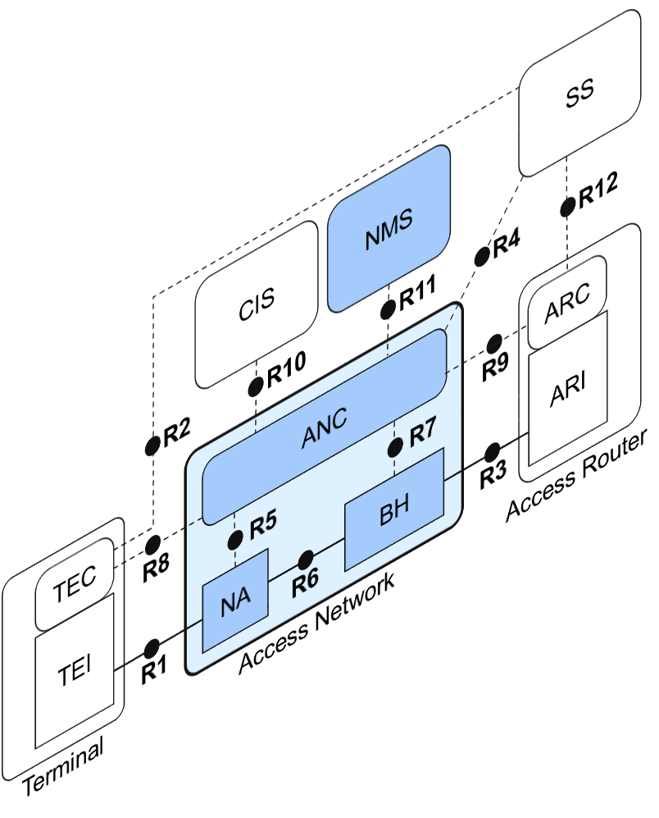
Figure 12—Single instance of IEEE 802 access network
In the case of a single instance of a virtualized access network, the NRM completely covers the functional behavior. It does not, however, show the particularities of a virtualized infrastructure. Virtualization of the access network leads to a separation of the physical infrastructure from the functional behavior.
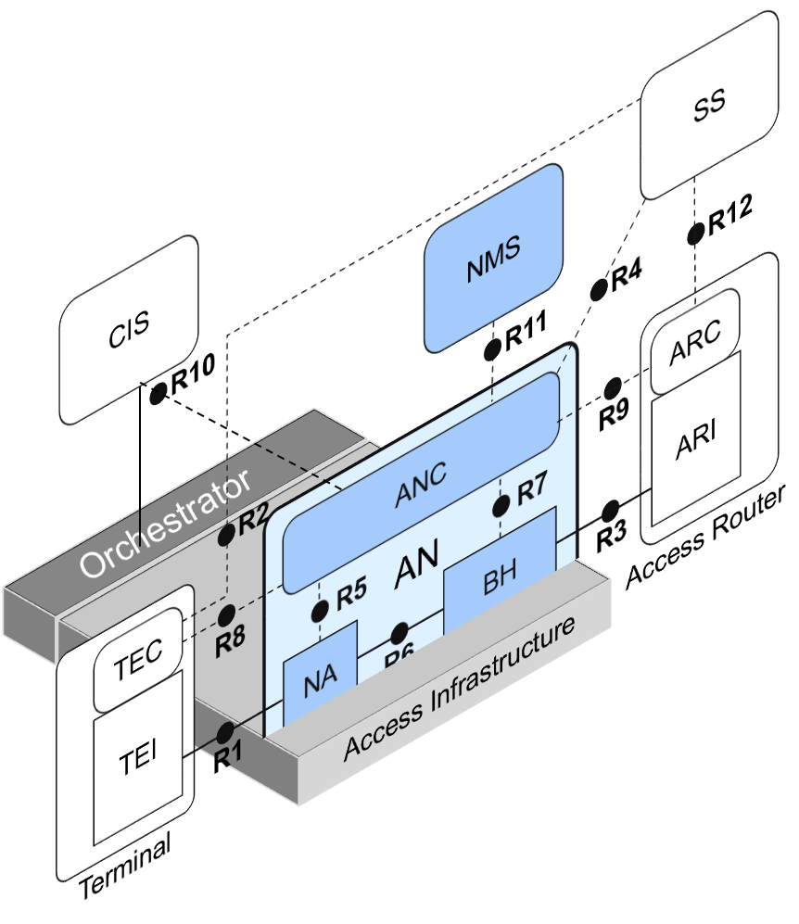
Figure 13—Virtualized access network residing on access infrastructure
As shown in Figure 13 above, the physical layer components of the Node of Attachment requiring dedicated hardware, as well as the physical layer of the backhaul realized through hardware, are becoming part of the access infrastructure layer, which consist of all the hardware components and computing resources that provide all the necessary resources of the virtualized access network.
Each of the virtualized access networks owns an instance of the NMS, which itself may be virtualized. However, as a virtualized access network provides exactly the same kind of interfaces as a physical implementation, the related NMS does not need to be virtualized.
An Orchestrator is attached to the Access Infrastructure and provides the automated arrangement, coordination, and management of the hardware and computing resources for the instantiation of the virtualized access network, and potentially also for the virtualized NMS instance. The Orchestrator provides to the Access Networks configuration information about the assigned resources by way of the CIS, and allows for dynamic adjustments of resources as long as other access networks on the same access infrastructure are not impacted.
The ANC still knows about every detail of the lower PHY layer configurations of NA as well as the details of BH; however, the information is provided by way of CIS, as the configuration of the access infrastructure predefines the configuration parameters of the lower PHY layer.

Instantiation and lifecycle of virtualized access network
A virtualized infrastructure allows for dynamic creation, modification, and teardown of access network instances. A new instance of access network is initiated by the Access Network Operator sending a request to the Infrastructure Provider, which creates the instance and uses its Orchestrator for reservation and assignment of infrastructure resources to that instance. Part of the instantiation is the establishment of the transport links towards coordination and information service, network management service, subscription services, and access routers.
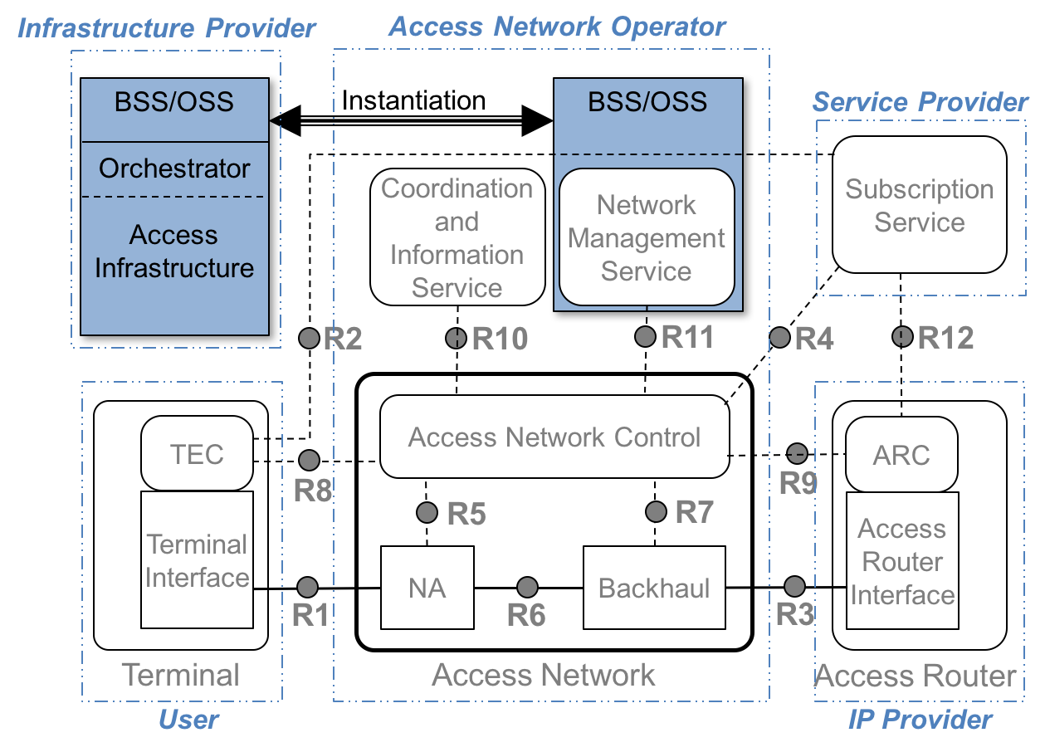
Figure xx: Virtualized access network instantiation
After instantiation, the access network initializes its operation, establishes the control connections toward subscription services, and access routers and gets ready for serving terminals.
During operation, the access network is able to adjust its resources by sending requests to the Orchestrator. It should be kept in mind that not all resource requests may be successfully fulfilled in the virtualized environment.
Allocated resources can be released during the runtime of the access network; and it is possible to completely remove an access network by first terminating service to terminals, then tearing down the control connections to NMSs, SSs, and ARs, and finally releasing all resources through instructing the Orchestrator to dissolve the access network instance.

Multi-instance design and issues
The full capabilities of network virtualization become visible in Figure 14, which depicts 3 different AN instances on a common access infrastructure. All three ANs have an R10 reference point toward the common CIS, which allows for each of the virtualized access network to get access to the lower PHY layer parameters, which are common for all three networks, and to request to the Orchestrator modifications to the networking and computing resource parameters. As far as the requests do not collide with requests of the other virtualized ANs, the Orchestrator can dynamically adjust the assignment of resources according to requests. For clarity of the visualization, the R2 reference point and signal flow is not shown in Figure 14.
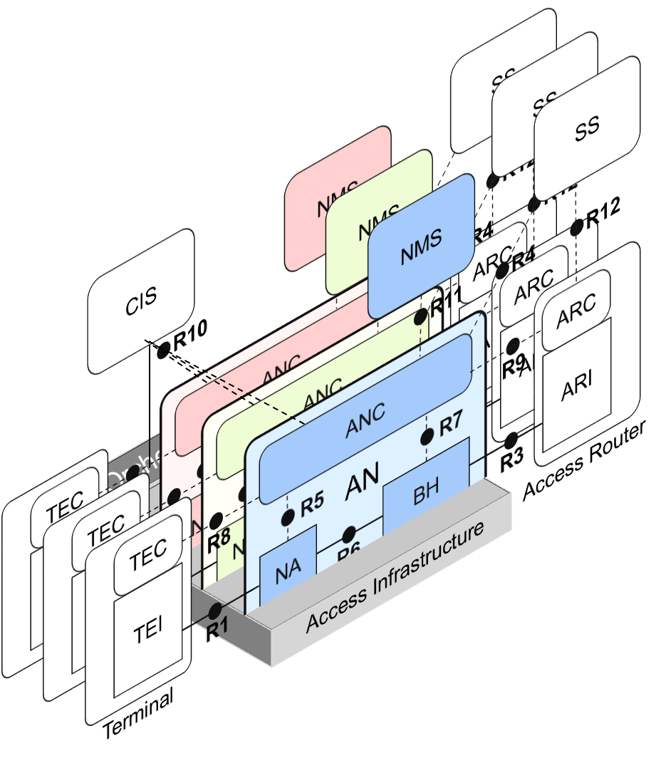
Figure 14—Multi-instance virtualization
Each of the three virtualized networks (network slices) fully realize the complete NRM, including NMS and own relations with SSs as well as ARs. Each of the slices can have its completely separate arrangements, and the virtualized networks are completely independent to each other, except in the use of the access infrastructure resources, which are shared among the ANs and imply some limitations, as the sum of used resources can’t exceed the total available resources. R10 interfaces of all virtualized access networks to a common CIS, which is tight to the Orchestrator of the access infrastructure, provide access to the infrastructure parameters and allow for dynamic allocation of resources. As the access infrastructure is shared among multiple AN instances, an AN can request to the Orchestrator modifications to the lower PHY layer parameters through the CIS, and it becomes possible that the resources are dynamically allocated by the ANC depending on load conditions and service requirements.

