|  |  |  |  |
| --- | --- | --- | --- |
| Chapter 7.1 text revision proposal | | | |
| Date: 2017-01-18 | | | |
| **Authors:** | | | |
| Name | Affiliation | Phone | Email |
| Max Riegel | Nokia Bell Labs |  | maximilian.riegel@nokia.com |
| Hao Wang | Fujitsu |  | wangh@cn.fujitsu.com |
|  |  |  |  |
| **Notice:**  This document does not represent the agreed view of the OmniRAN TG It represents only the views of the participants listed in the ‘Authors:’ field above. It is offered as a basis for discussion. It is not binding on the contributor, who reserve the right to add, amend or withdraw material contained herein. | | | |
| **Copyright policy:**  The contributor is familiar with the IEEE-SA Copyright Policy <<http://standards.ieee.org/IPR/copyrightpolicy.html>>. | | | |
| **Patent policy:**  The contributor is familiar with the IEEE-SA Patent Policy and Procedures:  <[http://standards.ieee.org/guides/bylaws/sect6-7.html#6](http://standards.ieee.org/guides/bylaws/sect6-7.html)> and <[http://standards.ieee.org/guides/opman/sect6.html#6.3](http://standards.ieee.org/guides/opman/sect6.html)>. | | | |

# Abstract

This document further revises the restructured and revised texts of chapter 7.1 based on the discussions during omniran meeting on 17th, Jan. And, it also rolls in the revisions from omniran-16-0078-00 for an initial group review.

Some parts of the texts are highlighted for further discussion.

7 Functional Decomposition and Design 3

7.1 Access network setup 3

7.1.1 Introduction 3

7.1.2 Roles and identifiers 3

7.1.2.1 Terminal 3

7.1.2.2 Access Network 3

7.1.2.3 Node of Attachment 4

7.1.2.4 Access Network Control 4

7.1.2.5 Coordination and Information Service 4

7.1.3 Use Cases 5

7.1.3.1 Access network initialization 5

7.1.3.2 Channel selection 5

7.1.3.3 Channel reselection 5

7.1.3.4 Mutual authentication of the entities involved in the dynamic spectrum authorization 6

7.1.3.5 Dynamic spectrum allocation 6

7.1.3.6 AN shutdown 6

7.1.4 Functional Requirements 6

7.1.4.1 Basic access network setup 6

7.1.4.2 Access network configuration 6

7.1.4.3 Operation on various channels 6

7.1.4.4 Multi-mode support 6

7.1.4.5 Support for multiple access technologies 7

7.1.4.6 Support for coordination among multiple access networks 7

7.1.5 Access network setup specific attributes 7

7.1.5.1 ??? 7

7.1.6 Access network setup specific basic functions 7

7.1.6.1 CIS discovery and mutual authentication 7

7.1.6.2 Querying for authorized shared spectrum information 7

7.1.6.3 Operating in authorized shared spectrum 8

7.1.7 Detailed procedures 8

7.1.7.1 Access Network Setup Procedure 8

7.1.7.2 Access Network Release Procedure 9

7.1.7.3 AN setup of authorized shared spectrum access 11

7.1.7.4 AN teardown of authorized shared spectrum access 12

7.1.7.5 Renewal of spectrum access authorization 13

7.1.8 Mapping to IEEE 802 Technologies 13

7.1.8.1 Overview 13

7.1.8.2 IEEE 802.3 specifics 13

7.1.8.3 IEEE 802.11 specifics 13

7.1.8.4 IEEE 802.16 specifics 14

7.1.8.5 IEEE 802.22 specifics 14

# Functional Decomposition and Design

## Access network setup

### Introduction

An access network requires configuration before becoming operational. Initial configuration consists of the establishment of connections to associated SSs, ARs, NMS and CIS. Depending on the implementation of the network, the configuration may also consist of adjustments to the radio interfaces, either to comply with regulatory requirements or to optimize radio resource usage.

Most, or for operation in TV white space (TVWS). TVWS is locally or temporarily unused spectrum assigned for TV broadcast and made available for general use through authorization procedures involving a spectrum database. According to FCC definitions, the TV WS spectrum is primarily assigned to provide TV broadcast service, or is used for the purpose of generating broadcast content, e.g. by making use through wireless microphones. Secondary users may leverage TV WS spectrum for other kind of services only when the primary users are not demanding the spectrum and the general use of the spectrum at a geographic location is authorized by the spectrum database.

Depending on the regulatory requirements and the intended use of the spectrum, sor authorized

, or in TV white space (TVWS)

### Roles and identifiers

#### Terminal

Before starting radio transmissions, the terminal has to determine the conditions for accessing the spectrum. Usually it receives the necessary information to configure the radio transmitter through scanning the spectrum, selecting its target NA and retrieving configuration parameters either from broadcast messages or through queries to the NA.

In authorized spectrum scenarios, the terminal may pursue and report spectrum scanning results as well as the geolocation information to spectrum management entities connected to the access network.

The generic role and identifiers of Terminal is defined in section 6.3.

#### Access Network

The AN is defined in Section 6.2. and consists of one or more NAs, one Access Network Control (ANC), and the backhaul network (BH) to provide connectivity between the NAs and the ARs, providing services over the access network.

An access network usually defines an operational domain; however, spectrum access may vary over the regional area, that the AN covers with its NAs. Within one access network, there may be different kind of NAs, and the NAs may operate in different frequency ranges, channel assignments, and spectrum regimes.

#### Node of Attachment

The generic purpose and identifier of NA is defined in Section 6.5. It is the device accessing the spectrum for radio transmissions to the terminal and it may sense the existence of neighboring radio systems either to enable shared access in a fair manner, or to report spectrum usage to a central management entity. In the case of authorized access to spectrum, the NA either performs the necessary procedures by itself, or it acts as an agent on behalf of a central management entity.

#### Access Network Control

ANC is defined in Section 6.3. If a central spectrum management entity is deployed in the ANC, it retrieves and stores the collected spectrum usage information of each NA and eventually provides assistance to NAs at boot-time to speed up or optimize the channel selection procedure in the NA.

In the case of operation in the TV WS, the ANC contains the function that is used to manage and control operations of TV WS-enabled NAs, such as setup, provisioning, and teardown in the authorized spectrum. The ANC also contains the functions to control spectrum sensing by the TEs, if available. The ANC also establishes a secure connection to the CIS in order to retrieve the geolocation specific spectrum usage information for its NAs and serving TEs..

The ANC may support the following functions for coexistence with primary services or other services in the authorized spectrum. (Support is not limited to these functions.)

* Coexistence management enables an NA to coexist with primary wireless devices in the authorized spectrum.
* Coexistence discovery and information (local) server is used to store the information used for deter­mining coexistence of NAs operating in the authorized spectrum shared with primary wireless ser­vices.

#### Coordination and Information Service

The CIS provides access to spectrum access parameters provided by external databases or shared across multiple ANs. The CIS may not only provide spectrum authorization information to the AN, but may also collect and forward spectrum usage information to external databases, like the spectrum database in the case of TV WS. The information in CIS could include the following:

* available bands and channels in shared spectrum
* available shared spectrum with geolocation information
* allowed maximum transmit power in the authorized spectrum
* primary service provider and secondary service providers and their operating status
* potential neighboring services and their interference levels

The spectrum information is propagated through the reference point R10 between ANC and CIS. The ANC may have a local copy of the information, that is periodically synchronized with CIS.

### Use Cases

#### Access network initialization

When the access network is powered up, the network elements receive their configurations from the ANC, which receives infrastructure and basic operational configuration values from the Network Management Service and other operational parameters for shared resources from the Coordination and Information Service.

#### Access network re-configuration (re-initialization)

???

### Functional Requirements

#### Access network boot-up

The access network needs to establish the connections with the subscription services and the access routers using the configuration parameters provided by the NMS for the configuration of access networks including NA backhaul network.

#### Access network configuration

AN configuration is the provisioning of the AN with:

* Air Interface Identifier
* Service Network Identifier
* Service Identity or Session Identifier
* Security information
* Radio parameters
* Service parameters, such as QoS information

AN configuration is under the control of ANC. After the AN is powered up, the ANC communicates with the NMS of the access network to get the configuration information, and then provisions the AN.

#### Channel selection

Channel selection is part of NA radio configuration for tuning the receiver and transmitter to particular operating frequencies within unlicensed bands. Since unlicensed spectrum usually provides multiple channels, and radio devices can arbitrarily select one of these channels for operation, it may happen that several devices are operating in the same frequency channel in the same coverage area, such that interference among devices is inevitable. To reduce the interference with each other in the unmanaged environment, the NAs should select, during initial setup, the best operating channel with the least amount of interference.

When operating with a channel bandwidth of 20MHz, the 2.4GHz ISM band allows for three or four non-overlapping channels depending on the regulatory region. The 5GHz band for unlicensed operation provides more than 20 channels of 20MHz each. The channel selection procedure in the NA determines the channel with the least amount of interference of all available channels. The channel selection procedure in the NA may operate in a local manner, may communicate with the channel selection procedures in adjacent NAs, or may deploy a central entity in the access network control to speed up the selection process and generate more optimized results.

When the NA initiates its radio interface, the channel selection function of the NA should measure the channel occupancy or radio resource usage of all the channels in the unlicensed band. Based on those measurements, and potentially with further information and guidance from the neighbor NAs and the ANC, the NA selects the channel with the most appropriate properties and initiates the radio interface for that channel.

An NA may report the channel measurement results to the ANC. The ANC stores the collected spectrum usage information of each NA and eventually provides assistance to newly initiated NAs to speed up or to optimize the channel selection procedure in the NA.

#### Channel reselection

The NA may switch during operation to another channel if it detects that the current operating channel is heavily overloaded or interfered. Switching the operating channel can be performed as a functional extension to the channel selection procedure and may cause a service interrupt.

As the ANC may store the operating channel information of each NA, it may provide assistance or coordination for reselecting a better operating channel in the coverage

Before switching to another channel, the NA may need to de-associate the devices under its service to trigger them to search for the service in another channel—potentially the channel to which the NA tunes in. The disassociation causes the terminal to enter the network discovery and selection procedure, which contains a scanning function for discovery of potential NAs in the coverage area.

#### Mutual authentication of the entities involved in the dynamic spectrum authorization

Mutual authentication is used by ANC and CIS to provide strong security and protection before the AN provides authorized shared access.

#### Dynamic spectrum allocation

Dynamic spectrum operation is controlled by ANC. ANC queries the CIS to get the channel usage information and determine the operating channel in the TV WS spectrum for the radio system for the locations of the NAs. If there is an available channel in the TV WS spectrum, ANC would set up the NA to operate in that channel. Otherwise, if there is no available channel in the TV WS spectrum, the ANC should not turn on the NA radio.

#### AN shutdown

During operation in the authorized shared access spectrum, the ANC should continue monitoring or be notified of the status of shared access spectrum in CIS. If it detects information that the primary user of the TV WS spectrum would like to operate in the channel that is being used by the NA, the ANC should check, whether there is another channel available, or disable services in the TV WS channel and turn off the NA radio, if no other channel in available.

#### Operation on various channels

Unlicensed bands usually consist of multiple channels. The NA should be able to operate on any of the channels of the band for which the radio interface is designed.

The NA may be equipped with a radio interface allowing operation in multiple unlicensed bands. In this case, the channel selection procedure should be able to operate across all the supported bands and select the least occupied channel of all the supported bands.

#### Multi-mode support

The NA should support all the different radio modes specified for compliance of its radio interface to allow for adaptation of operational parameters to the radio environment in the chosen channel. Such adaptation allows for more efficient use of the shared spectrum and benefits the performance of the whole system.

#### Support for multiple access technologies

The dynamic spectrum allocation and access network setup procedure SHOULD be able to support different access network technologies.

#### Support for coordination among multiple access networks

The dynamic spectrum allocation and access network setup procedure SHOULD be able to support the operating of an access network coordinated through CIS with neighboring ANs.

### Access network setup specific attributes

#### ???

### Access network setup specific basic functions

Dynamic spectrum allocation and access network setup and configuration describes the procedure for operating one or multiple NAs in an authorized spectrum environment shared with primary wireless devices. The procedure includes the following steps:

* CIS discovery and mutual authentication
* Querying for authorized shared spectrum information
* Configuration of the radio access network for operation in the authorized shared access spectrum

#### CIS discovery and mutual authentication

CIS discovery and mutual authentication is the process through which an AN finds and authenticates the CIS used to store authorized shared spectrum usage information for a given area, before querying the CIS to get the information about authorized shared spectrum usage.

The ANC may be preconfigured with the IP address or URL of the CIS server.

When ANC is powered up, it may load the default shared spectrum list, and it shall automatically communicate with CIS using preconfigured CIS information. If ANC can not communicate with CIS server, radio operation in the shared spectrum is not allowed for the NAs.

The communication between ANC and CIS should follow the protocols specified by the R10 reference point.

Once ANC receives the response from CIS, it shall start the mutual authentication with the CIS to make sure that the CIS being communicated with is the correct one.

#### Querying for authorized shared spectrum information

Querying for authorized shared spectrum information is the process by which information is acquired from CIS about authorized shared spectrum usage.

Before operating in authorized shared spectrum, the ANC needs to query the CIS to get information about authorized shared spectrum usage, using the protocols specified by the R10 reference point. Once it has received the usage status of authorized shared spectrum, the ANC can determine whether the AN can operate in a particular channel.

During operation in authorized shared spectrum, the ANC needs to constantly query the CIS to get usage status updates about the authorized shared spectrum.

#### Operating in authorized shared spectrum

Operating in authorized shared spectrum involves enabling the radio transmission of AN and informing the surrounding TEs about the operating channel, transmit power, and other radio parameters.

Once the AN is operating in the authorized shared spectrum, the ANC is responsible for controlling the radio transmission of NAs and TEs in the operating channels to meet the authorized shared access regulations in the given area.

### Detailed procedures

#### Access Network Setup Procedure

The access network setup procedure includes

* Discovery of supported subscription services and access routers
* Establishing the connections with the subscription services and access routers

The discovery procedure for supported subscription services and access routers is used by the powered up AN to find the configuration parameters for access network setup. Once the associated NMS is found and provides the configuration parameter, the ANC sets up the access network with the configuration information retrieved from the NMS of the AN using either unlicensed spectrum or authorized shared spectrum.

Figure 18 shows an example of procedure of access network setup. When the access network is powered up, the ANC on behalf of NAs sends a Discovery Request message to the NMS which is a part of the access network. After receiving the Discovery Request message, the NMS sends the Discovery Response message with the access network information for the ANC to provision the access network.

NA

NMS

2. Discovery Request

ANC

3. Discovery Response

4. Join Request

5. Join Response

1. Access network power-up

Figure 19—An example of access network setup procedure

The Discovery Request message may contain the following information:

* ANC/NA Identifiers
* List of required configuration parameters
* Time stamp of this message
* Discovery type through which the AN retrieves the IP addresses of the connected subscription ser­vices and access routers, such as manual configuration, DNS server, etc.
* The capability information of physical NAs attached to the AN

The Discovery Response message should include the following information:

* Required configuration parameters
* ANC Identifier
* Time stamp
* Access Router Interface ID and IP addresses which help NAs to choose a proper port for the follow­ing communication
* Subscription Service Interface ID
* Radio configuration information for the required area
* Connection parameters to the subscription services and access router such as ports and addresses of the network and the load information of each port.
* Access network capabilities (e.g., max NA number, max user number), security information, etc.

The Join Request message should include the following information:

* ANC or NA Identifier
* The Access Network Identifier
* Time stamp of this message
* ANC or NAs location information. This helps the NMS to determine whether to accept the join request
* Access network capabilities, encryption information, etc.

The Join Response message should include the following:

* Access network Identifier
* ANC or NA Identifier
* Time stamp of this message
* Result code indicating whether the Join Request is admitted or not. If not, it lists the reason of the rejection.

#### Access Network Release Procedure

There are two ways to release the access network: access network is released by itself, or it is released by the access network operator through the NMS.

NA

NMS

ANC

2. Release Confirm

1. Release Indication

(a)

NA

NMS

ANC

2. Release Response

1. Release Request

(b)

Figure 20—an example of access network release procedure

Figure 20 shows an example of access network release procedure. The access network could be released by the ANC (Figure 20a), or by the access network through NMS (Figure 20b). In some particular cases, such as at certain abnormal conditions, the access network may have to initiate access network release under the control of ANC (Figure 20a). In such case, the ANC will notify the access network operator through the NMS that the access network will be shut down. Either the access network operator responds to the notification or the access network will release itself.

The Release Indication message may contain the following information:

* ANC/NA Identifier
* Access Network identifier
* Time stamp of this message
* Reason code for release

The Release Confirm message should include the following:

* Access Network Identifier
* ANC/NA Identifier
* Time stamp of this message
* Result code

In normal case, the access network release should be controlled by the access network operator through the NMS. When the access network operator needs to release the access network for maintenance, power saving, or major software/hardware upgrade, it may initiate the access network release through the NMS (Figure20b). When the ANC receives the Release Request message from the NMS, it will verify the command and start the access network release according to the requirements. The ANC will send the Release Response to the NMS about the result of access network release.

The Release Request message may contain the following information:

* Access Network identifier
* ANC
* NA Identifier
* Time stamp of this message

The Release Response message should include the following:

* ANC/NA Identifier
* Access Network Identifier
* Time stamp of this message
* Result code

#### AN setup for authorized shared spectrum access

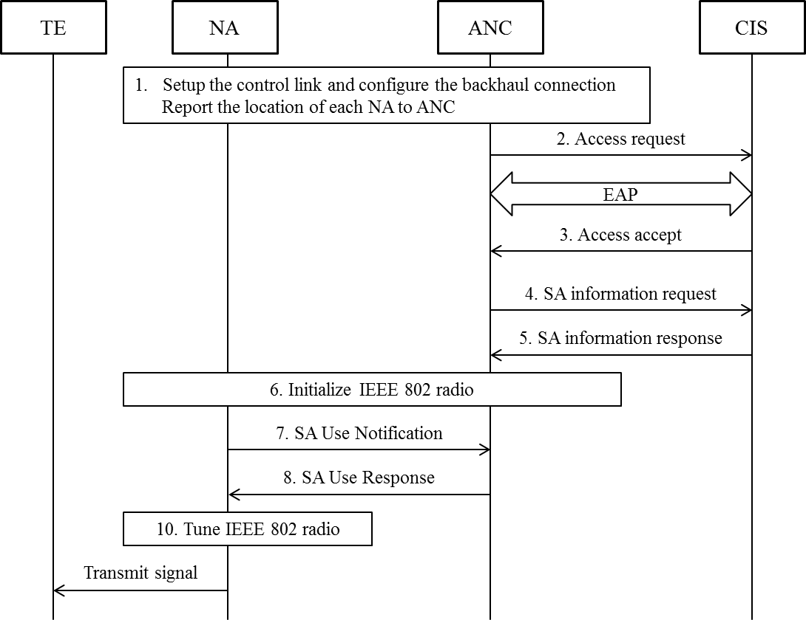

Figure 21—Detail procedure of AN setup for authorized shared spectrum access

1. After boot-up, the NA should establish a secure connection to the ANC and report its geolocation based on the preconfigured information and configures the port to the BH.
2. The ANC generates an access request message on behalf of the NA containing the geolocation and other related information. The access request message is sent from the ANC over R10 to the valid CIS.   
   After receipt of an access request message, the CIS starts the EAP message exchange with the ANC. When the identifier of ANC is known and requested access can be granted, the CIS informs the ANC with an access accept message of the allowed access. The pairwise master key is delivered in the access accept message from the CIS to the ANC.
3. Once the authentication process succeeds, the ANC can query the CIS via sending the SA information request message that allows the ANC to request a list of available channels and maximum allowed EIRP per channel from the CIS. After receipt of an SA information request message, the CIS returns an SA information response message to the ANC providing the requested information.
4. Based on the retrieved information, NA can be initially switched on and perform a spectrum sensing procedure on the specified channels. The result of the above sensing should be provided to ANC embedded in an SA use information request message.
5. As all the information on the spectrum availability resulting from the CIS and spectrum sensing function at the NA is gathered, the ANC should determine the operation channel(s) and indicate the NA through SA use response message to commence operation on the selected channel(s).
6. NA may hand over radio configuration information used for TVWS to the TEs located in the same area in order to control the interference to the primary services.

#### Primary service protection

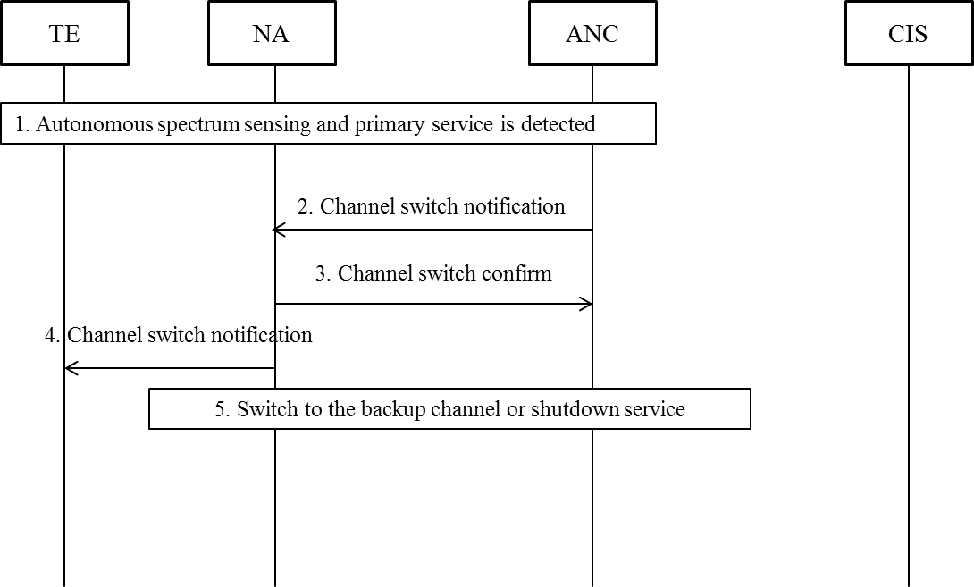

Figure 22—Detailed procedure for primary service protection for shared spectrum access

1. Independent procedure of spectrum sensing may be performed periodically by TE and NA as the operation of the primary service changes over time. If the activity of the primary service is detected through the distributed sensing technique by both TE and NA, the ANC should be notified immediately.
2. If the ANC concludes that the operating channel is under interference and primary service needs to be protected, a channel switch notification message will be generated and sent from the ANC to the NA.
3. In this situation, the NA should update the status of the listed backup channels and notify the ANC with a channel switch confirm message. Meanwhile, the NA will start a timer to schedule the channel switch and notifies the TE about the action with a channel switch notification message.
4. If the backup channel is available when the timer expired, the NA will continue its operation on the backup channel and re-establish communication with the TE. Otherwise, the NA should terminate its operation on current channel and the access service will be shutdown.

#### Renewal of spectrum access authorization

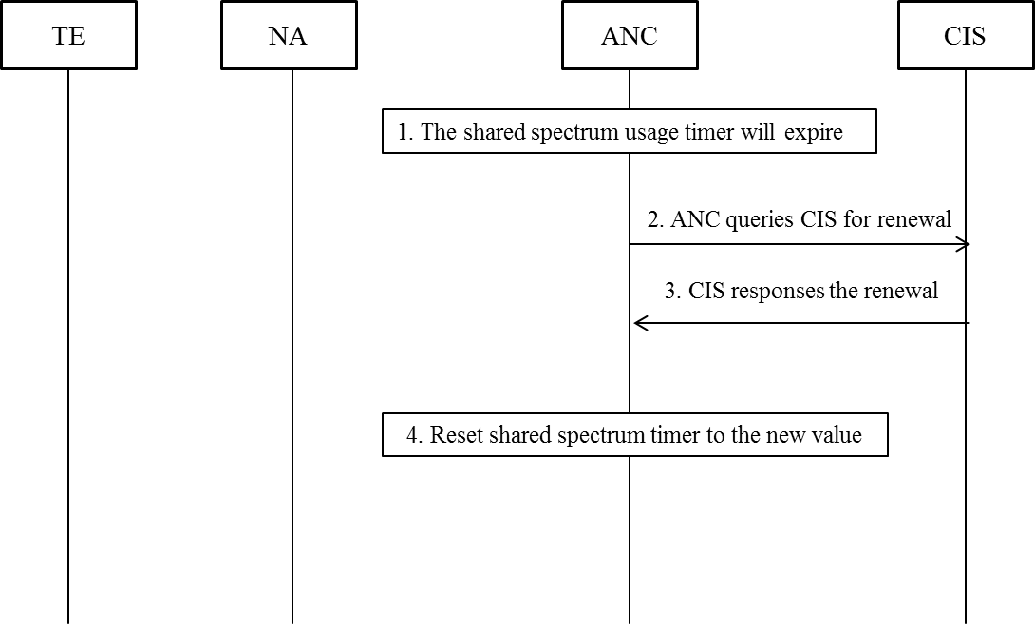

Figure 23— Detailed procedure of renewal of spectrum access authorization

1. When NA is operating in the shared spectrum, its ANC needs to set up a timer to track the granted period of opera­tion.
2. When the shared spectrum usage timer expired, the ANC will query the CIS with the updated location of NA to renew the use of shared spectrum.
3. If the operating channel is available, the CIS will grant the renewal request. Otherwise, it will reject the renewal request and trigger the re-initialization of the AN.
4. When the renewal request is granted, the ANC will reset the timer to the granted value and prolong the operation on current channel.

### Mapping to IEEE 802 Technologies

#### Overview

#### IEEE 802.3 specifics

#### IEEE 802.11 specifics

#### IEEE 802.16 specifics

#### IEEE 802.22 specifics