Data Path Functional Description Revision
Date: 2016-11-03
Authors:
Name | Affiliation | Phone | Email
Max Riegel | Nokia Bell Labs | +49 173 293 8240 | maximilian.riegel@nokia.com
Notice:
This document does not represent the agreed view of the OmniRAN TG It represents only the views of the participants listed in the ‘Authors:’ field above. It is offered as a basis for discussion. It is not binding on the contributor, who reserve the right to add, amend or withdraw material contained herein.
Copyright policy:
The contributor is familiar with the IEEE-SA Copyright Policy <http://standards.ieee.org/IPR/copyrightpolicy.html>.
Patent policy:
The contributor is familiar with the IEEE-SA Patent Policy and Procedures:
<http://standards.ieee.org/guides/bylaws/sect6-7.html#6> and <http://standards.ieee.org/guides/opman/sect6.html#6.3>.

Abstract
This document proposes several corrections and amendments to the text for the data path establishment, relocation and teardown chapter within Functional Design and Decomposition.

7 Functional Decomposition and Design 3
7.5 Data Path Establishment, Re-location and Teardown 3
7.5.1 Introduction 3
7.5.2 Roles and identifiers 5
7.5.2.1 Data Path 5
7.5.2.2 Terminal Interface (TEI) 6
7.5.2.3 Node of Attachment (NA) 6
7.5.2.4 Backhaul (BH) 6
7.5.2.5 Access Router Interface (ARI) 7
7.5.2.6 Subscription Service 7
7.5.2.7 Access network controller 7
7.5.3 Use Cases 8
7.5.3.1 Single, plain access network 8
7.5.3.2 Shared wireless access network 8
7.5.3.3 Multi-operator backhaul infrastructure 9
7.5.4 Functional Requirements 10
7.5.5 Data Path specific attributes 10
7.5.5.1 Node of Attachment 10
7.5.5.2 Backhaul 10
7.5.5.3 Access Router 10
7.5.5.4 Subscription Service 10
7.5.6 Data path specific basic functions 11
7.5.6.1 Retrieval of session specific data path configuration values for access network 11
7.5.6.2 Activation of data path in the NA 11
7.5.6.3 Teardown of data path in the NA 11
7.5.6.4 Activation of data path in the BH 11
7.5.6.5 Teardown of data path in the BH 11
7.5.6.6 AR interface establishment 11
7.5.6.7 AR interface teardown 11
7.5.7 Detailed procedures 11
7.5.7.1 Data path establishment 12
7.5.7.2 Data path relocation 12
7.5.7.3 Data path tear down 12
7.5.8 Mapping to IEEE 802 Technologies 13
7.5.8.1 Overview 13
7.5.8.2 IEEE 802.3 specifics 13
7.5.8.3 IEEE 802.11 specifics 13
7.5.8.4 IEEE 802.16 specifics 13
7.5.8.5 IEEE 802.22 specifics 13

Functional Decomposition and Design

Data Path Establishment, Re-location and Teardown

Introduction
The data path denotes the transport facility for the user payload between the terminal and the access router, or between the terminal and another terminal when direct communication between terminals on the same link is enabled.
Ethernet data frames are carried over the data path between the Link Service Access Points in the end stations of the communication. Forwarding on the data path between end stations is performed by IEEE 802.1Q bridging making use of the destination MAC address and further information elements in the Ethernet frame.
In access networks it is common to denote the forwarding directions either ‘upstream’ or ‘downstream’. Upstream indicates the direction from TE towards AR, while downstream denotes the direction from AR to TE.
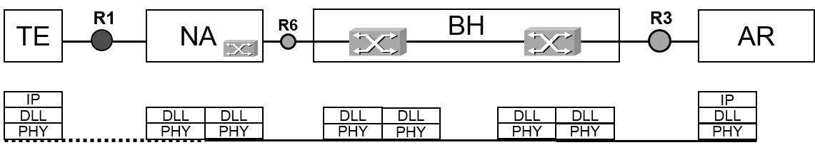
Figure 7-1: Ethernet Data Path
Depending of the IEEE 802 access technology and of the particular configuration various forwarding behavior exist in the NA. Some technologies allow that bridging, i.e. forwarding according to destination MAC addresses, may directly happen between TEs associated with the same NA. However an NA may be configured to enforce that all user data coming from TEs are forwarded over R6 towards the BH, and BH comprises the functions to restrict forwarding directly between the end stations.
Forwarding in the access network may be restricted to one of the following schemes:
Ethernet-Line behavior represents a point-to-point connection carrying Ethernet frames only between the R1 interface of a particular TE and the R3 interface of its AR.
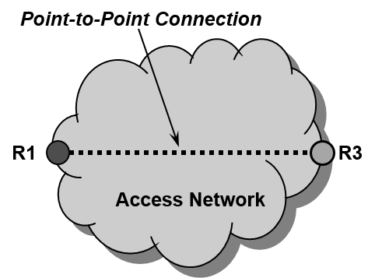
Figure 7-2: Ethernet Line behavior
Point-to-point connections between TEIs and ARIs require that the AR establish and maintain a dedicated interface for each of the connected TEs. Such configuration is commonly used in mobile networks where the IP connectivity has to be maintained across multiple ANs.
Ethernet-LAN behavior provides multipoint-to-multipoint connectivity for Ethernet frames across a number of interfaces. Any TE connected to an AN with Ethernet-LAN behavior can communicate with any other TE on the same link in that AN. Still an AN can establish multiple separated links with multipoint-to-multipoint connectivity for groups of TEs by means of VLANs.
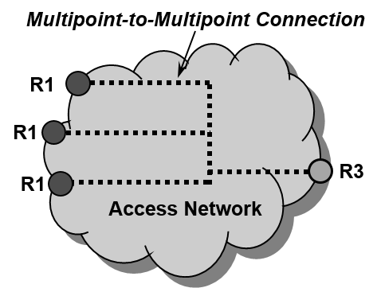
Figure 7-3: Ethernet LAN Service
Ethernet-LAN behavior is usually deployed when all connected TEs belong to the same security domain and are allowed to communicate directly to each other. A benefit of the Ethernet LAN behavior is that the AR needs only a single interface for a number of TEs and is less loaded as communication between the connected TEs in an AN does not pass through the AR. Access networks within enterprises or industrial facilities commonly deploy Ethernet-LAN behavior.
Ethernet-Tree behavior distinguishes between Leaf interfaces and Root interfaces, as depicted in Figure 7-4. Leaf interfaces are restricted in the exchange of data only with Root interface, but never directly with another Leaf interface. Root interfaces can exchange data with any Leaf interface and with any other Root interface.
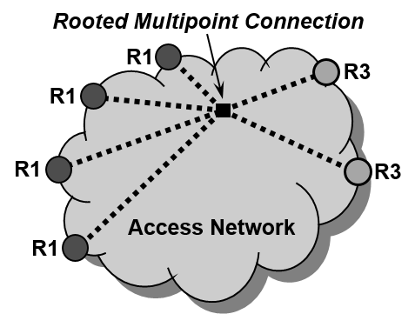
Figure 7-4: Ethernet Tree Service
The Ethernet-Tree behavior is usually deployed in ANs, which are aimed to serve a huge number of TEs by a single interface of the AR like in an Ethernet-LAN, but enforce that all user traffic is passing through the AR. Ethernet-Tree behavior is commonly used for efficiently providing public broadband access, for connecting a huge number of small devices to a network like for IoT, or for delivering multicast services efficiently to multiple interfaces.
Note: Ethernet-Tree behavior is widely deployed in Cable-Networks and DSL-Networks for aggregating broadband user traffic towards CMTS or BNG.
Note: The distinction of line, LAN, or tree behavior is also used by the Metro Ethernet Forum (MEF) in its definition of Ethernet Services.
The data path is either pre-established during Access network setup and/or dynamically configured when terminal connects to access network. A terminal resides on one data path during a terminal session, i.e. is associated with a single data path at session initiation, but may be assigned to different data paths for subsequent sessions.

Roles and identifiers

Data Path
The data path is established from the terminal interface over R1 to the node of attachment, continued over R6 to the backhaul and carried on over R3 to the access router interface.
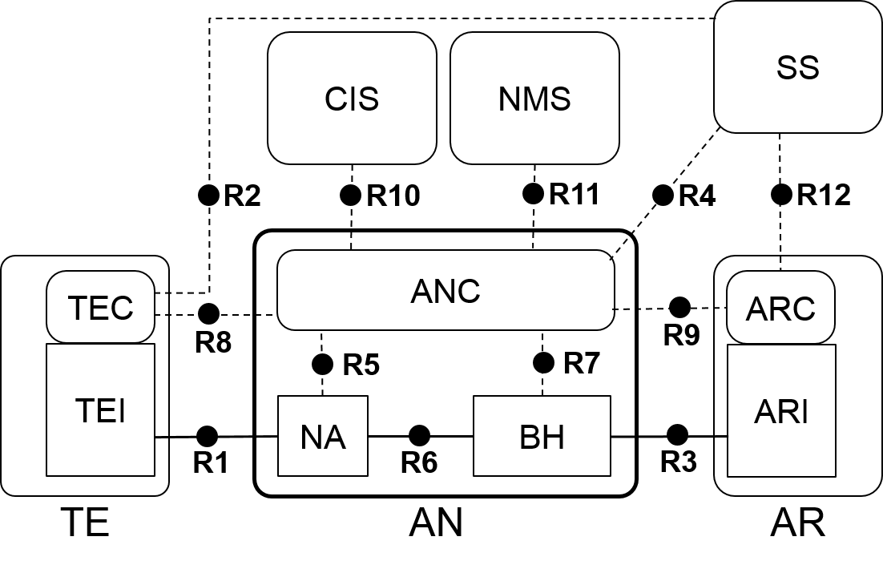
Figure 7-5: NRM, with data path represented by solid line
The solid line in Figure 7-5 indicates the interfaces in the NRM carrying the data path. The data path consists of multiple segments, which usually deploy different IEEE 802 PHY technologies.
Identifiers:
- DataPath-ID
  - Represents one particular data path through the access network.

The following entities participate in the operation of the data path.

Terminal Interface (TEI)
The TEI is the endpoint of the data path at the terminal. It provides the capability to establish the data path connection over the R1 interface by negotiation of transmission parameters with the NA according to configuration information provided by the terminal controller.
Identifiers:
- TE-ID
  - As defined in section 6.3
- TEI-ID
  - The TEI-ID represents the port of the terminal towards the access network.

Node of Attachment (NA)
The NA provides the communication port at the access network, to which the terminal connects to over R1, and forwards user payload from the terminal towards the backhaul, and vice versa.
The NA has at least two ports, one directing towards the terminal, and another directing towards the backhaul, but may have multiple ports towards terminals, when the NA concurrently connects multiple terminals. Ports towards terminals may be dynamically created and released when terminals establish or release their sessions. For each of the terminal side ports, the NA negotiates with the TEI the configuration parameters of the data path connection over R1 and forwards the data path over R6 towards the BH according to configuration information received from the ANC.
Forwarding behavior of the NA may be either point-to-point towards the BH, or it may realize LAN or tree behavior when multiple terminals are connected to the same NA and assigned to the same data path.
Identifiers:
- NA-ID
  - As defined in section 6.5
- R1-Port ID
  - Represents the port of the NA towards the TE. An R1-Port may concurrently serve multiple terminals on a single or multiple data paths.
- R6-Port ID
  - Represents the port of the NA towards the BH. An R6-Port may concurrently serve multiple data paths.

Backhaul (BH)
The BH provides the communication port, to which the NA connects to over R6, and forwards user payload from the NA towards the AR, and vice versa, or when direct terminal connections are enabled, towards the destination terminal, and vice versa.
The BH comprises at least two ports, one directing towards the NA, and another directing towards the ARI, but may comprise many more ports, when the AN consists of multiple NAs and eventually has interconnections with multiple ARs. The BH forwards the data path from the NA over R6 towards the AR over R3 or eventually also to other NAs, when LAN service or Tree service behavior is part of configuration information received from the ANC. Forwarding behavior of the BH may be either point-to-point between a single R6 and a single R3, or it may realize LAN service or tree service forwarding behavior when multiple NAs and/or multiple ARs are connected and assigned to the same data path.
Identifiers:
- BH-ID
  - As defined in section 6.8
- R6-Port ID
  - Represents the port of the BH towards the NA. An R6-Port may concurrently serve multiple data paths.
- R3-Port ID
  - Represents the port of the BH towards the AR. An R3-Port may concurrently serve multiple data paths.

Access Router Interface (ARI)
The ARI is the endpoint of the data path at the access router. It terminates the data path towards the router, which forwards user payload to communication peers not residing on the same data path based on IP addresses.
An access router may terminate multiple data paths either over a single access router interface serving multiple data paths, or over multiple access router interfaces attached to an AR instance.
Identifiers:
- Access Router Identifier (AR-ID)
  - As defined in section 6.3
- R3-PortID
  - R3-PortID represents the port of the AR towards the access network.

Subscription Service
The subscription service provides configuration information for the data path of a particular subscriber as part of the authorization to the access network controller and forwards related configuration information for the particular subscriber to the access router.
Identifier:
- Subscription Service Identifier (SS-ID)
  - As defined in section 6.3

Access network controller
The access network controller generates and distributes configuration information for the data path of a particular subscriber based on the authorization received from the Subscription Service eventually taking system configuration directives received from the Coordination and Information Service into account.
Identifiers:
- Access Network Controller Identifier (ANC-ID)
  - As defined in section 6.3

Use Cases

Single, plain access network
A single, plain wireless access network consists out of several nodes of attachments connected to a bridge with connection to a single access router and a single subscription server.
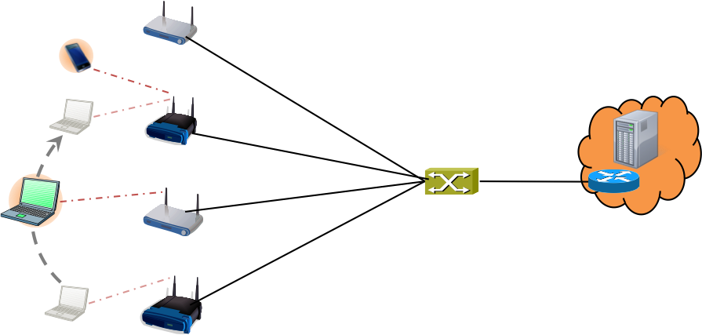
Figure 7-6: Simple plain access network
LAN behavior is provided by the single Ethernet bridge, which connects all the node of attachments with the access router. All terminals are assigned to the common data path, which allows for direct terminal-to-terminal communication and inherently provides mobility support when the terminals move from node of attachment to node of attachment, as the terminals stay on the same access router interface, which ensures that IP addressing is maintained during movements.

Shared wireless access network
A shared wireless access network leverages the same access network infrastructure for multiple separate services, each with its own access router and its own subscription service. It isolates each of the connected terminals to block direct terminal-to-terminal communication and enforces that all communication passes through the access router, providing enhanced capabilities for subscriber specific services and centralized policy enforcement and accounting.
Still mobility support by the bridged infrastructure has to be supported, to enable subscribers to move around in the wireless coverage area without losing IP connectivity or session states of applications.
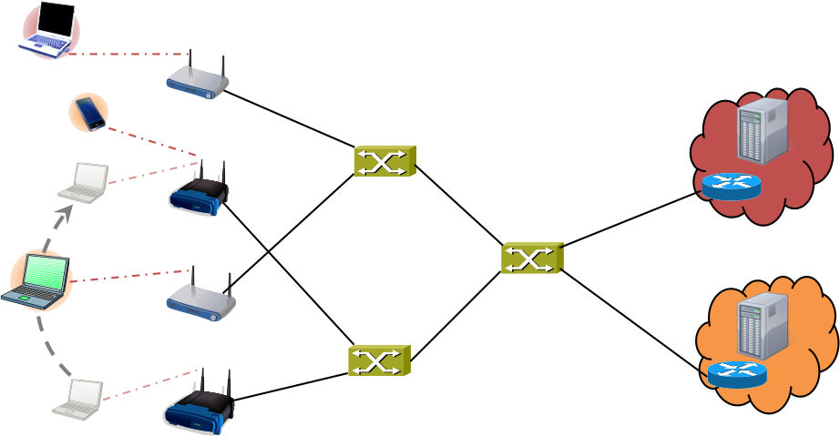
Figure 7-7: Shared wireless access network
Bridges and node of attachments provide two independent access networks in a virtualized manner with the same coverage area for each of the service provider operating its own access router and subscription service. Forwarding behavior in the node of attachments and in the bridges is restricted to point-to-point behavior enforcing all user payload packets to pass through the access router.

Multi-operator backhaul infrastructure
The third use case shows the scenario, when a backhaul infrastructure composed by networks of multiple Ethernet operators is used by multiple service providers, each with its own access points and its own subscription service and access router.
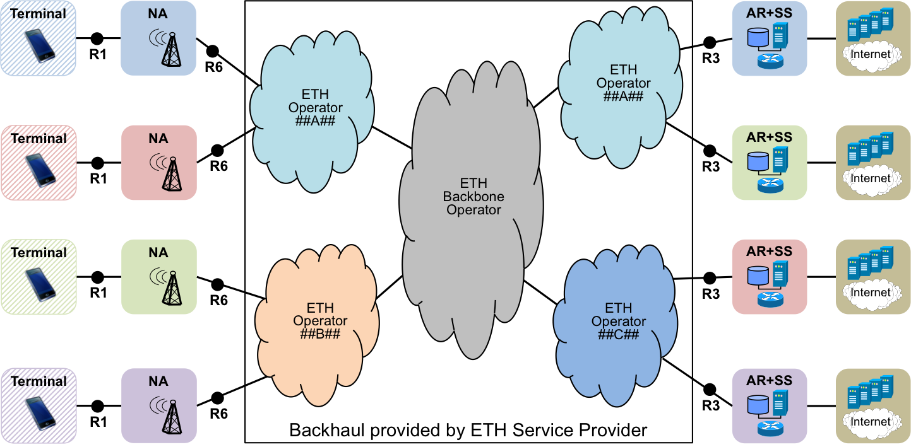
Figure 7-8: Multi-operator backhaul infrastructure
The backhaul operators provide to each of the wireless service providers dedicated Ethernet connectivity for aggregation and interconnection of their node of attachments to their access routers, respectively.
The backhaul connectivity of the Ethernet operators is statically configured according to the requirements of the individual service providers. Nevertheless service providers may provide through such infrastructure various different services to their subscribers, with the need to provide point-to-point service as well as tree-service and LAN service forwarding behavior by the same infrastructure.

Functional Requirements
Data path SHOULD be configurable as either point-to-point or multipoint-to-multipoint or rooted-multipoint (point-to-multipoint) behavior
Successful completion of data path establishment SHOULD be indicated.
Relocation of data path within the access network SHOULD be supported.
Data path SHOULD be configurable to support the transport of C-VIDs between terminal and access router
Data path SHOULD protect integrity of user payload.
Data path SHOULD support encrypted transport of user payload
Data path SHOULD allow for differentiated services based on C-VIDs and priority bits.
Data path SHOULD support wired and wireless links in the access and backhaul.

Data Path specific attributes

Node of Attachment
- R1 MAC and PHY configuration parameters
- R1 performance and QoS parameters
  - E.g. supported service classes (Throughput up/down, delay, jitter)
- R6 configuration parameters
- VLAN configuration and mapping

Backhaul
- R6 configuration parameters
- R3 configuration parameters
- Service specification
- Service mapping table

Access Router
- R3 configuration parameters
- Network Interface performance
  - E.g. supported service classes (throughput up/down, delay, jitter)

Subscription Service
- User specific service specification

Data path specific basic functions

Retrieval of session specific data path configuration values for access network
Session specific data path configuration values are usually provided by the SS as part of the authorization information, which is forwarded from the SS to the AN as part of the final message of a successful authentication procedure.

Activation of data path in the NA
The ANC generates the session specific configuration values for the data path establishment in the NA and forwards the values into the NA

Teardown of data path in the NA
The ANC sends a command to NA to teardown a particular data path and to release the used resources. It may happen either due to the termination of a session, or due to movement of the TE into the coverage area of another NA and a relocation of the connectivity to the other NA.

Activation of data path in the BH
The ANC generates the session specific configuration values for the establishment of the data path in the BH. Depending of deployment scenario and concurrent usage of the AN, a new session may not require the activation of a data path in the BH, but may leverage an existing one.

Teardown of data path in the BH
The ANC sends a command to BH to teardown a particular data path and to release the used resources. It may only happen after the teardown of the last related data path in any of the connected NAs, i.e. only when all sessions making use of the particular data path has been terminated.

AR interface establishment
When data paths are dynamically established for each of the sessions, the ANC informs the AR about the demand for a new interface and proposes its R3 related configuration parameters. The AR acknowledges the proposed parameters or provides other values when the proposed values are not feasible. ANC and AR agree on configuration parameters after one or more roundtrips, or terminate the session establishment with a failure notice.
AR may request for a particular session further configuration values from the SS.

AR interface teardown
When session specific data paths are deployed, the ANC MAY inform the AR about the termination of a data path when the last session making use of that data path has been released.

Detailed procedures
Data path procedures are taking place as part of the session establishment, as part of the session termination, or during a session when the TE changes its NA due to a handover process.
The following figure shows the occurrence of data path procedures during the life cycle of a terminal session.
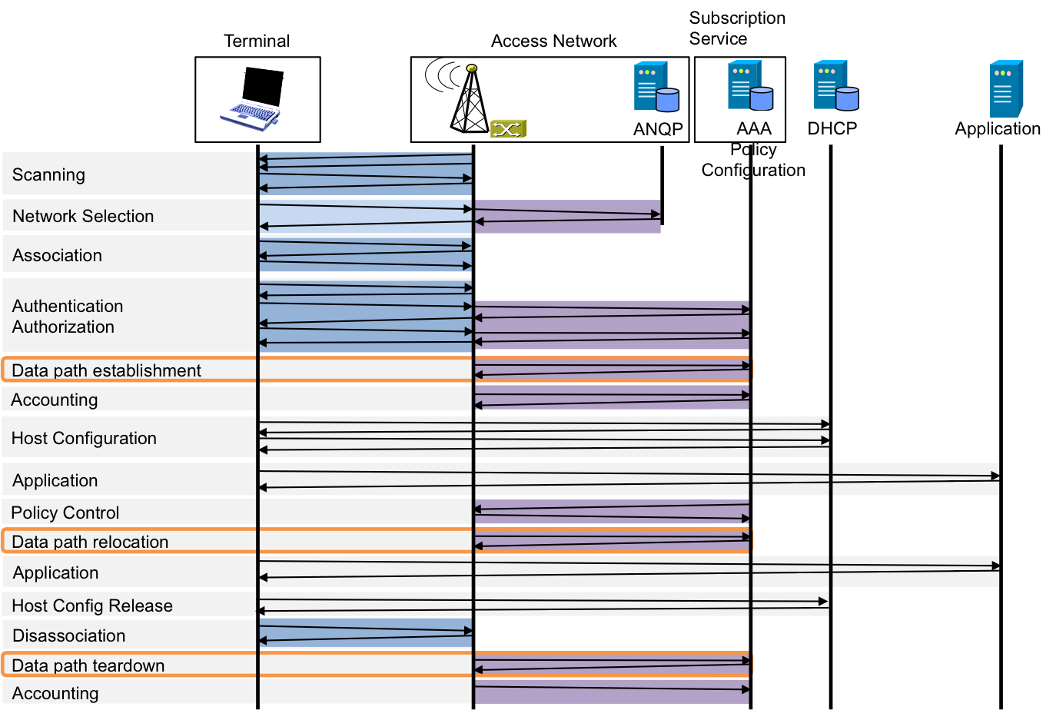
Figure 7-9: Data path actions

Data path establishment
The data path establishment occurs after the association of the terminal to the access network and after successful completion of the authentication procedure.
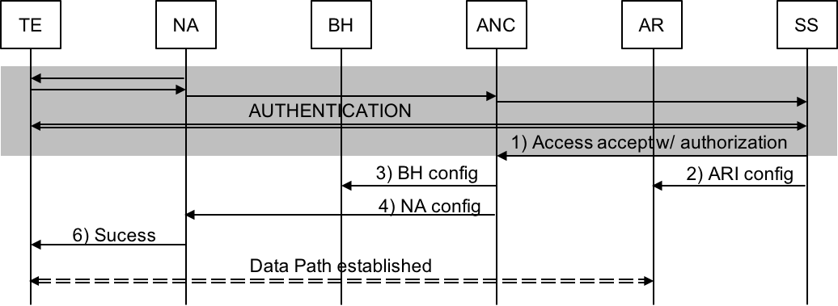
Figure 7-10: Data path establishment
- The service specific configuration details of the data path are provided by the Subscription Service through the authorization following the successful authentication.
- The SS informs the AR about the network attachment of a new subscriber and the related service parameter.
- The ANC creates the user-specific data path configuration information for the BH and delivers such configuration to the BH
- The ANC creates the user-specific data path configuration information for the NA and forwards the information to the NA
- The NA performs the configuration of the data connectivity for the new terminal.
- When the NA is ready for accepting user data, the NA sends an Authentication Success message to the TE to inform about the possibility to transfer data.
- Once the TE enabled the TEI, the data path is established and allows for forwarding user data between the terminal and the access router.

Data path relocation
Various versions exist for the relocation of the data path due to a handover from one NA to another NA.
In the case of break-before-make, the TE terminates the connectivity to its current NA, searches through Network Discovery and Selection a more appropriate NA and establishes the data path across the new NA. In this case, the data path relocation is essentially a data path teardown followed by a data path establishment.
Make-before-break describes a procedure, which allows the TE to leverage the current data path connectivity to prepare for the preparation of the handover and to immediately use the prepared data path when the association changes to the new NA. The following figure shows the make-before-break procedure.
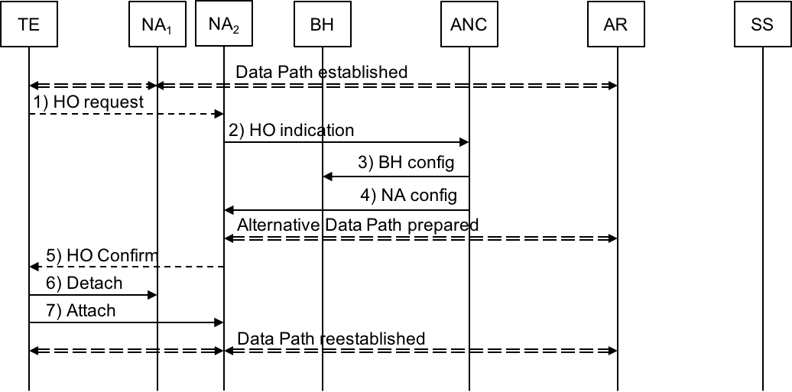
Figure 7-11: Data path relocation
- In the case of make-before-break, the TE uses the established data path to communicate with the new NA. The TE sends the indication that it would like to handover to the new NA by a HO request message over the established data path to the new NA.
- The new NA informs the ANC about the request of a TE to relocate its attachment to the new NA.
- The ANC arranges for BH connectivity for such TE to the new NA.
- The ANC sends the configuration information for the TE to the new NA. With this information, the NA can preinstall and pre-activate the data path for the TE
- Once the preparation is completed, the new NA informs the TE about the possibility to handover immediately.
- The TE informs its current NA about the end of its attachment.
- The TE informs the new NA that the attachment moved to the new NA and the data path is reestablished over the new NA.

Data path tear down
When a TE has terminated its connectivity to an access network, the access network tears down the data path and releases the allocated resources.
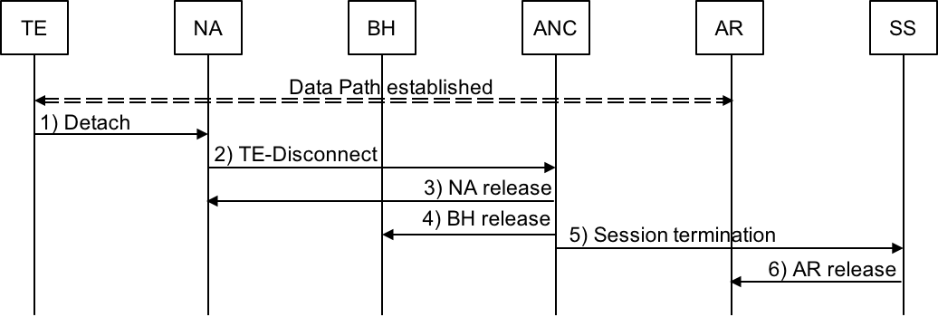
Figure 7-12: Data path tear down
- When a TE intends to terminate its service, it sends a detach message to the NA, to inform the NA about the end of the connectivity.
- The NA informs the ANC about the end of the connectivity of the TE.
- The ANC instructs the NA to remove the connectivity for the TE and to release the allocated resources.
- Once the NA has terminated the connectivity and the remaining data frames have been delivered, the ANC informs the BH about the termination of the service for the TE and requests the removal of the configuration and the release of the allocated resources.
- Thereafter the ANC indicates to the SS that the service for the TE has been terminated.
- The SS informs the AR to remove the configuration for the TE and to release the allocated resources.

Mapping to IEEE 802 Technologies

Overview

The following table provides IEEE 802 technology specific attributes for the data path configuration.
 |  | 802.3 | 802.11 | 802.16 | 802.22
R1 Config | QoS Parms
 | Forwarding
 | Filtering
 | Security
R6 Config
VLAN Config
R3 Config

IEEE 802.3 specifics

IEEE 802.11 specifics

IEEE 802.16 specifics

IEEE 802.22 specifics

However, there is one deficiency of the Ethernet-Tree behavior for establishing public access networks. IPv6 operation requires direct host-to-host connectivity for neighbor discovery messages to allow secure neighbor discovery.

