|  |  |  |  |
| --- | --- | --- | --- |
| Comment Resolution for CID #9, #11, #12  Revision of Chapter 7.1.2.7 Detailed procedures | | | |
| Date: 2016-11-09 | | | |
| **Authors:** | | | |
| Name | Affiliation | Phone | Email |
| Hao Wang | Fujitsu R&D Center | +86-10-59691000 | wangh@cn.fujitsu.com |
| Su Yi | Fujitsu R&D Center | +86-10-59691000 | yisu@cn.fujitsu.com |
| Xiaojing Fan | Fujitsu R&D Center | +86-10-59691000 | fanxiaojing@cn.fujitsu.com |
| Ryuichi Matsukura | Fujitsu/Fujitsu Laboratory | +81-44-754-2667 | r.matsukura@jp.fujitsu.com |
| **Notice:**  This document does not represent the agreed view of the OmniRAN TG It represents only the views of the participants listed in the ‘Authors:’ field above. It is offered as a basis for discussion. It is not binding on the contributor, who reserve the right to add, amend or withdraw material contained herein. | | | |
| **Copyright policy:**  The contributor is familiar with the IEEE-SA Copyright Policy <<http://standards.ieee.org/IPR/copyrightpolicy.html>>. | | | |
| **Patent policy:**  The contributor is familiar with the IEEE-SA Patent Policy and Procedures:  <[http://standards.ieee.org/guides/bylaws/sect6-7.html#6](http://standards.ieee.org/guides/bylaws/sect6-7.html)> and <[http://standards.ieee.org/guides/opman/sect6.html#6.3](http://standards.ieee.org/guides/opman/sect6.html)>. | | | |

# Abstract

This document provides the comment resolution for detail procedures of AN setup on ASA bands in Recommended Practice specification of IEEE 802.1CF D0.3.

**Comments on D0.3:**

|  |  |  |  |  |  |  |
| --- | --- | --- | --- | --- | --- | --- |
| **CID** | **Category** | **Page** | **Sub-clause** | **Line #** | **Comment** | **Proposed Change** |
| 9 | Technical | 44 | 7.1.2.7.1 | 1086 | 'SA registration request' may lead to mis-understanding for those who are familiar with 802.22-2011. - The only 'registration' process is provided between BS (NA) and CPE (TE). Quote from chapter 7.14.2.11 in 802.22-2011, 'Registration is the process by which the CPE verifies its configuration with the BS.' - It is necessary to carry out authentication between NA/ANC and CIS, but through legacy EAP protocols. Quote from chapter 10.6.3 in 802.22-2011, 'The IEEE 802.22 network shall use the same authentication protocols for device and database service authentication and for interacting with the database (i.e., EAP-TLS or EAP-TTLS, see 1679H8.4.3) as those specified for device authentication...'. | provided in a separate contribution |
| 11 | Technical | 45 | 7.1.2.7.2 | 1109 | refer to comment #4 | provided in a separate contribution |
| 12 | Technical | 46 | 7.1.2.7.3 | 1129 | The existence of the primary service can be detected by spectrum sensing in either distributed or centralized manner, therefore the AN renewal process doesn't have to be controlled by a timer. | provided in a separate contribution |

**Discussion:**

1. Regarding comment #9

The message called ‘SA registration request/response’ may lead to misunderstanding for those who is familiar with IEEE 802.22 terminology, as defined in the specification, the registration should be performed between CPE (TE) and BS (AN), and ‘by which the CPE verifies its configuration with the BS.’ Quote from 802.22-2001.

As the purpose of these SA registration messages is defined to provide mutual authentication, it may also lead to misunderstanding for those is familiar with IEEE authentication terminology.

Moreover, it doesn’t coincide with the descriptions of authentication in OmniRAN’s specification.

1. Regarding comment #9

As ‘mutual authentication is used by ANC and CIS’, quote from L1020 in D0.3, and NA is fully controlled and configured by ANC, NA may not be necessarily involved in some part of the procedure.

Moreover, if multiple NAs in operation are under control of one single ANC, it will be not necessary for each NA to be authenticated with the CIS.

1. Regarding comment #11

As defined in chapter 7.19 in 802.22-2011, the function of autonomous spectrum sensing should be performed separately by both CPE and BS. And a whole mechanism called ‘incumbent protection’ is defined in particular to detect and protect incumbent services. Therefore, channel switching is the mandatory countermeasure to avoid interference to the primary services on the shared spectrum. Only in one exceptional case that the backup channel is unavailable, the ANC should control NA to stop its service.

1. Regarding comment #12

The existence of the primary service can be detected by spectrum sensing in either distributed or centralized manner. But ANC still needs to update the location of NA to the CIS through the renewal process.

**Proposed Text Changes:**

Instruction to Editor:

Please replace the following text to the sub-section of 7.1.2.7 Detailed procedures of P802.1CF D0.3 specification.

------------- Begin Text Changes ---------------

7.1.2.7 Detailed procedures

7.1.2.7.1 AN setup

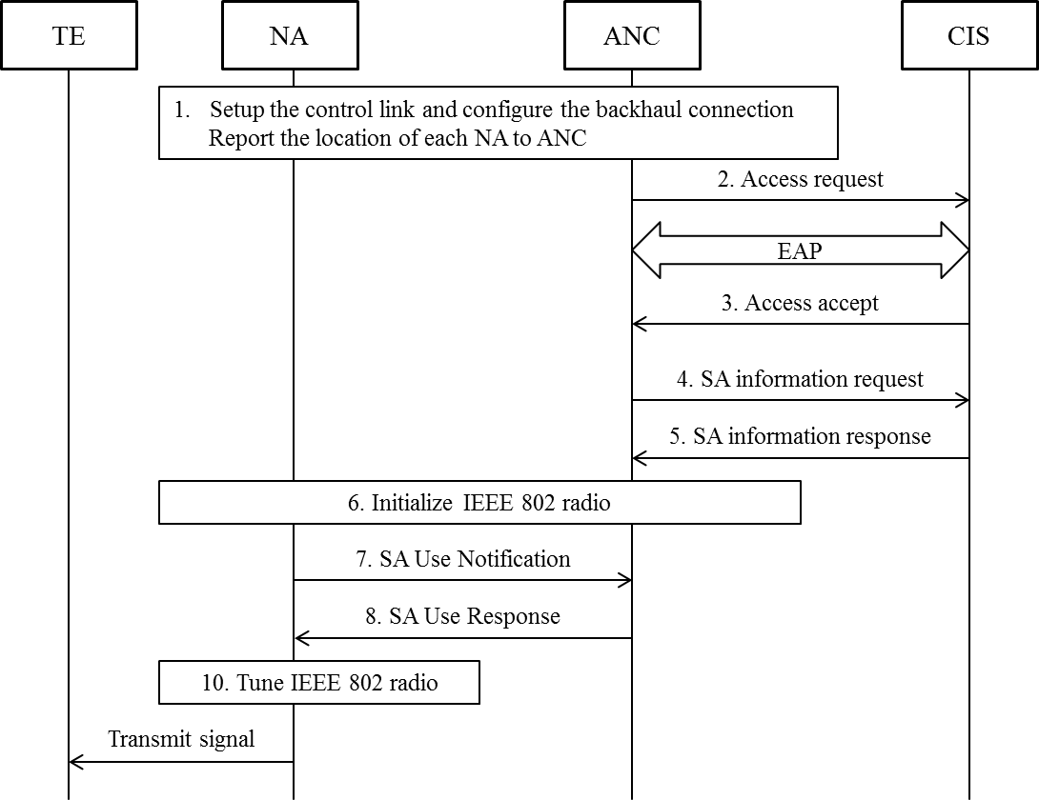

FIG 16 Detail procedure of access network setup on ASA bands

1. After boot-up, the NA should establish a secure connection to the ANC and report its geolocation based on the pre-configured information and configures the port to the BH.
2. The ANC generates an access request message on behalf of the NA containing the geolocation and other related information. The access request message is sent from the ANC over R10 to the valid CIS.

After receipt of an access request message, the CIS starts the EAP message exchange with the ANC. When the identifier of ANC is known and requested access can be granted, the CIS informs the ANC with an access accept message of the allowed access. The pairwise master key is delivered in the access accept message from the CIS to the ANC.

1. Once the authentication process succeeds, the ANC can query the CIS via sending the SA information request message that allows the ANC to request a list of available channels and maximum allowed EIRP per channel from the CIS. After receipt of an SA information request message, the CIS returns an SA information response message to the ANC providing the requested information.
2. Based on the retrieved information, NA can be initially switched on and perform a spectrum sensing procedure on the specified channels. The result of the above sensing should be provided to ANC embedded in an SA use information request message.
3. As all the information on the spectrum availability resulting from the CIS and spectrum sensing function at the NA is gathered, the ANC should determine the operation channel(s) and indicate the NA through SA use response message to commence operation on the selected channel(s).
4. NA may hand over radio configuration information used for the ASA spectrum to the TEs located in the same area in order to control the interference to the primary services.

7.1.2.7.2 Primary service protection

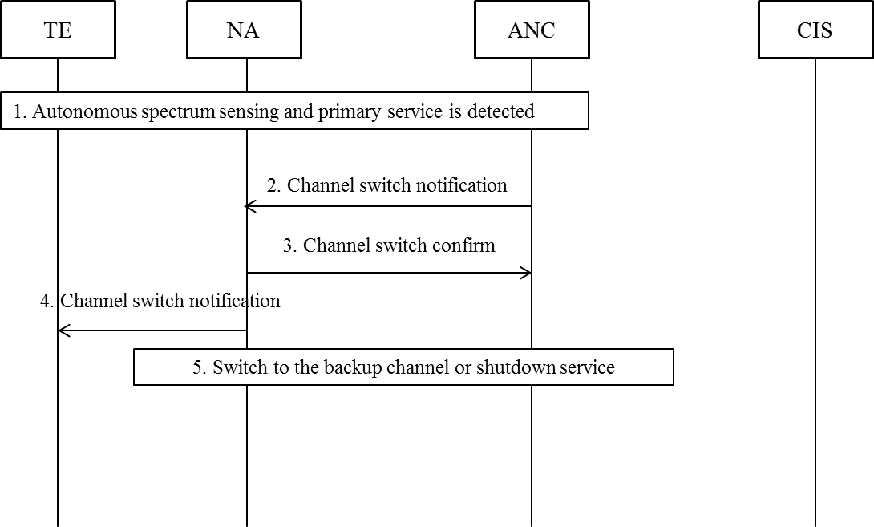

FIG 17 Detailed procedure for primary service protection in ASA bands

1. Independent procedure of spectrum sensing may be performed periodically by TE and NA as the operation of the primary service changes over time. If the activity of the primary service is detected through the distributed sensing technique by both TE and NA, the ANC should be notified immediately.
2. If the ANC concludes that the operating channel is under interference and primary service needs to be protected, a channel switch notification message will be generated and sent from the ANC to the NA.
3. In this situation, the NA should update the status of the listed backup channels and notify the ANC with a channel switch confirm message. Meanwhile, the NA will start a timer to schedule the channel switch and notifies the TE about the action with a channel switch notification message.
4. If the backup channel is available when the timer expired, the NA will continue its operation on the backup channel and re-establish communication with the TE. Otherwise, the NA should terminate its operation on current channel and the access service will be shutdown.

7.1.2.7.3 AN Renewal

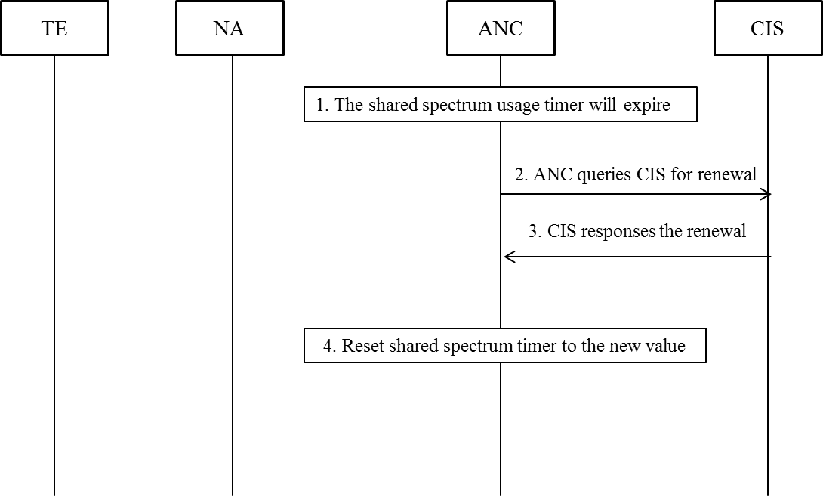

FIG 18 Detailed procedure for AN renewal in ASA bands

1. When NA is operating on the shared spectrum, its ANC needs to set up a timer to track the granted operation period.
2. When the shared spectrum usage timer expired, the ANC will query the CIS with the updated location of NA to renew the use of shared spectrum.
3. If the operating channel is available, the CIS will grant the renewal request. Otherwise, it will reject the renewal request and trigger the re-initialization of the AN.
4. When the renewal request is granted, the ANC resets the timer to the granted value and prolong the operation on current channel.

-------------- End Text Changes ----------------