Section 7 introduction
Date: 2016-09-27
Authors:
Name | Affiliation | Phone | Email
Max Riegel | Nokia Bell Labs |  | Maximilian.riegel@nokia.com
Notice:
This document does not represent the agreed view of the OmniRAN TG It represents only the views of the participants listed in the ‘Authors:’ field above. It is offered as a basis for discussion. It is not binding on the contributor, who reserve the right to add, amend or withdraw material contained herein.
Copyright policy:
The contributor is familiar with the IEEE-SA Copyright Policy <http://standards.ieee.org/IPR/copyrightpolicy.html>.
Patent policy:
The contributor is familiar with the IEEE-SA Patent Policy and Procedures:
<http://standards.ieee.org/guides/bylaws/sect6-7.html#6> and <http://standards.ieee.org/guides/opman/sect6.html#6.3>.

Abstract
This document proposes text for an introduction of Chapter 7 Functional decomposition and design.
The revision -01 provides further information regards potential access network configurations and initialization before providing user sessions.

7 Functional Decomposition and Design 3
7.1 Access network setup 4

Functional Decomposition and Design
This chapter provides detailed description of the functional behavior of IEEE 802 access network based on the network elements and overall architecture presented in chapter 6 Network Reference Model.
The functional decomposition and design details not only the individual steps for establishing, maintaining, and tearing down user sessions from scanning the environment for the best suited node of attachment to the concluding step to collect usage information about the just finished user session and send the information to the subscription service for statistics and business purposes. It also describes preparatory functions in the access network to initialize the infrastructure and to tune the radio transmitter to appropriate channels in the case of licensed shared access or licensed-exempt operation, as well as the network management functions for fault diagnostics and maintenance.
After successful completion of the network setup procedures, the
life cycle of a user session follow the sequence shown in figure 7-1:
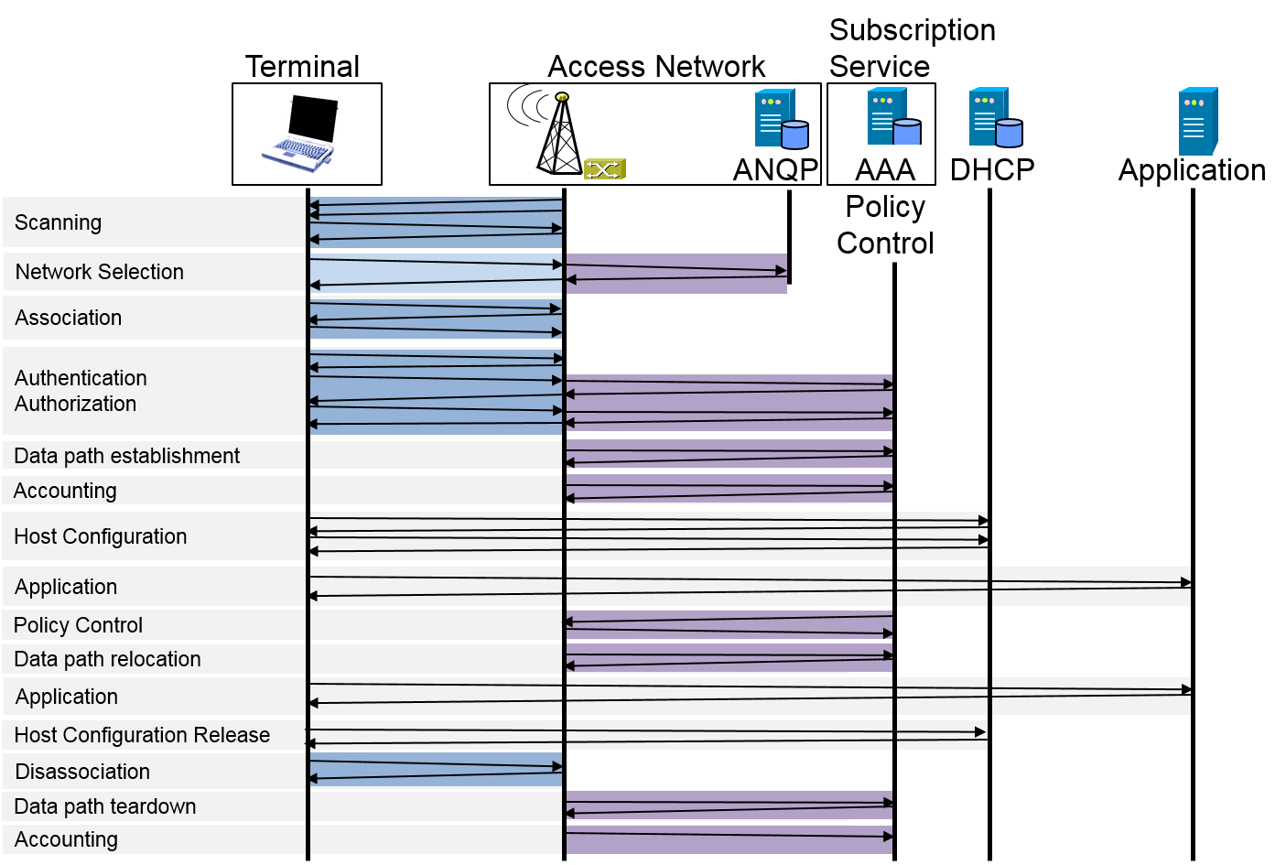
Figure 7-1: Typical sequence of functions of a user session
When access network setup is completed, a user session usually begins with the terminal scanning for appropriate access networks providing services under the subscription service, previously established between the service provider and the user. When multiple potential access networks are detected, the terminal executes a network selection procedure to decide for the most appropriate access network and node of attachment. Based on the selection decision the terminal initiates an association process to establish the physical connection and the link layer protocols to establish the possibility to exchange user data with the access network. Usually access networks as well as terminals require first to authenticate the peer of the association to establish trust, that the communication peer should receive user data. When trust has been established between terminal and access network, the network provides the communication resources in its infrastructure by establishment of the data path across the access network to the desired access router.
When the data path is established all the lower layer functions in scope of IEEE 802 are established, and communication commence with the establishment of higher layer networking functions like configuration of the IP address of the host and exchanging IP packets carrying the data of applications. In the middle of ongoing user sessions it may be required to change the QoS parameters of the connection, or to relocate the data path to another node of attachment due to movement of the terminal while maintaining the integrity of the upper layer protocols.
When either the user or the access network intends to terminate the user session, the teardown procedure is initiated by first performing the termination of the higher layer protocols and releasing the higher layer resources, e.g. IP addresses, before initiating the disassociation to tear down the link between the access network and terminal. Once connectivity to the terminal is broken, the access network will remove the data path and release the resources associated with it. When releasing the resources, the access network collects all usage information of the session and provides it to the subscription service for statistics and business purposes.
Each of the access network functions from access network setup to fault diagnostic and maintenance are explained more in detail in the following sections adopting a common structure as shown below to present the detailed functional descriptions:
- Introduction
- Roles and identifiers
- Use Cases
- Functional Requirements
- Function specific attributes
- Function specific basic functions
- Detailed procedures
- Mapping to IEEE 802 Technologies
All the sections close with references to the IEEE 802 technologies to provide pointers to the specification of the normative behavior.

Access network setup

