Text Proposal for Deployment Scenarios
Date: 2016-09-27
Authors:
Name | Affiliation | Phone | Email
Hao Wang | Fujitsu R&D Center | +86-10-59691000 | wangh@cn.fujitsu.com
Su Yi | Fujitsu R&D Center | +86-10-59691000 | yisu@cn.fujitsu.com
Xiaojing Fan | Fujitsu R&D Center | +86-10-59691000 | fanxiaojing@cn.fujitsu.com
Ryuichi Matsukura | Fujitsu/Fujitsu Laboratory | +81-44-754-2667 | r.matsukura@jp.fujitsu.com
Notice:
This document does not represent the agreed view of the OmniRAN TG It represents only the views of the participants listed in the ‘Authors:’ field above. It is offered as a basis for discussion. It is not binding on the contributor, who reserve the right to add, amend or withdraw material contained herein.
Copyright policy:
The contributor is familiar with the IEEE-SA Copyright Policy <http://standards.ieee.org/IPR/copyrightpolicy.html>.
Patent policy:
The contributor is familiar with the IEEE-SA Patent Policy and Procedures:
<http://standards.ieee.org/guides/bylaws/sect6-7.html#6> and <http://standards.ieee.org/guides/opman/sect6.html#6.3>.

Abstract
This document proposes additional text based on 802.1cf d0.2 for the deployment scenarios with focus on the home network services.

Change the title of 6.9.1 and add a new subclause title as follows:

6.9.1 Residential network (Wi-Fi router)

6.9.1.1 Wi-Fi router
In the case of a residential access network, all the entities of the NRM including terminal belong to the same operational domain. Such deployment allows for a number of simplifications, mainly in the area of network security.

Add a new subclause as follows:

6.9.1.2 Home gateway
As a result of the spread of the broadband network, it has become common to interconnect devices in the home to build a home network. A home network is made up of a mix of devices that are different in the way they are installed, maintained, and connected to the network and the level of quality they require, such as home appliances, audio-video and other consumer electronics products, set-top boxes (STBs), sensors, home gateways (HGWs), PCs, smartphones, tablets, and game consoles.
Figure 15 illustrates the functional architecture for the home network as defined in ITU-T Y.2070 and TTC TR1053. Home gateway is an always on, always connected device which acts as the central point connecting the devices on the home network to the applications on the wide area network, and monitors and provides data transport service within the home network as well as between the home network and the wide area network. Access network (AN) and terminal (TE) can be mapped to the home gateway and the end devices inside the home separately.
- For a device with wired connection, it is usually connected to the home gateway directly. In this case, home gateway acts as a whole AN.
- For a wireless device, it is connected to the home gateway though an access point. Therefore the access point is NA and the home gateway resembles the functions of backhaul plus ANC in the comprehensive NRM.
In either case the home gateway provides the control functions of ANC, such as device provision, application execution, and resource information collection.
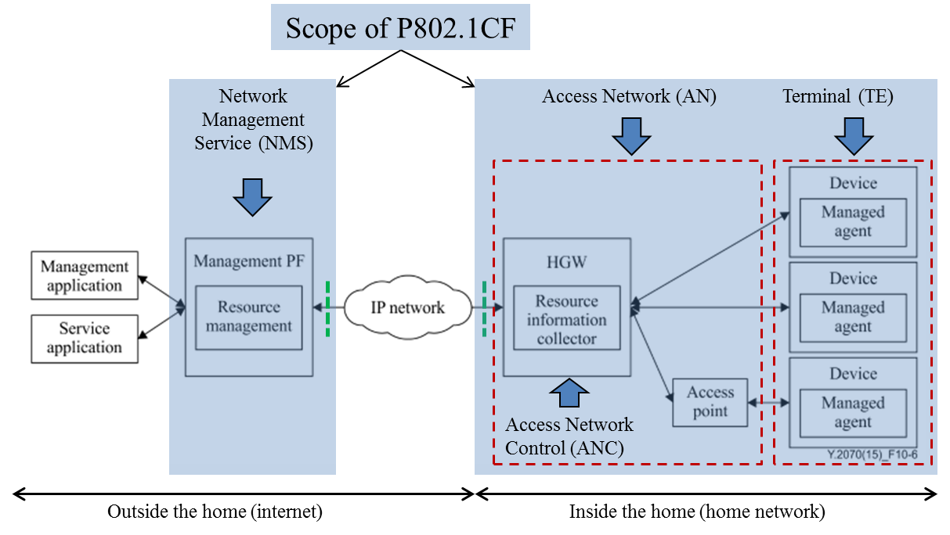
Figure 15: Functional architecture for home network
In the distributed type of architecture shown in Figure 15, the management functions are separately distributed to the home gateway inside the home and the management platform on the Internet. This architecture enables the applications to access the devices from the Internet. For example, some management applications such as energy management system monitor and control devices connected to the home network from outside the home through this architecture.
The management application is the application for use by network operators or service providers such as call centers and customer support centers. It provides a function to display the entire resource information for faults diagnosis and to set the specified properties for recovery operation from such faults. Functions in the applications which provide operations that make use of the functions of the management platform (PF) include: device management function, device operation function, fault diagnosis function and so on.
Management platform is the NMS which has common functions providing the interface and the management for the home network applications, and the device management and the resource management for the home gateway and the devices.

