|  |  |  |  |
| --- | --- | --- | --- |
| Data Path Functional Description | | | |
| Date: 2015-11-11 | | | |
| **Authors:** | | | |
| Name | Affiliation | Phone | Email |
| Max Riegel | Nokia Networks | +49 173 293 8240 | maximilian.riegel@nokia.com |
|  |  |  |  |
|  |  |  |  |
| **Notice:**  This document does not represent the agreed view of the OmniRAN TG It represents only the views of the participants listed in the ‘Authors:’ field above. It is offered as a basis for discussion. It is not binding on the contributor, who reserve the right to add, amend or withdraw material contained herein. | | | |
| **Copyright policy:**  The contributor is familiar with the IEEE-SA Copyright Policy <<http://standards.ieee.org/IPR/copyrightpolicy.html>>. | | | |
| **Patent policy:**  The contributor is familiar with the IEEE-SA Patent Policy and Procedures:  <[http://standards.ieee.org/guides/bylaws/sect6-7.html#6](http://standards.ieee.org/guides/bylaws/sect6-7.html)> and <[http://standards.ieee.org/guides/opman/sect6.html#6.3](http://standards.ieee.org/guides/opman/sect6.html)>. | | | |

# Abstract

This document proposes initial text for the data path establishment, relocation and teardown chapter within Functional Design and Decomposition.

The text proposal still requires further refinements and amendments.

7 Functional Decomposition and Design 3

7.5 Data Path Establishment, Re-location and Teardown 3

7.5.1 Introduction 3

7.5.2 Roles and identifiers 4

7.5.2.1 Terminal Interface (TEI) 5

7.5.2.2 Node of Attachment (NA) 5

7.5.2.3 Backhaul (BH) 6

7.5.2.4 Access Router Interface (ARI) 6

7.5.2.5 Subscription Service 6

7.5.2.6 Access network controller 7

7.5.3 Use Cases 7

7.5.3.1 Single, plain access network 7

7.5.3.2 Shared wireless access network 7

7.5.3.3 Multi-operator backhaul infrastructure 8

7.5.4 Functional Requirements 9

7.5.5 Data Path specific attributes 9

7.5.5.1 Node of Attachment 9

7.5.5.2 Backhaul 10

7.5.5.3 Access Router 10

7.5.5.4 Subscription Service 10

7.5.6 Data path specific basic functions 10

7.5.6.1 Data path establishment 11

7.5.6.2 Data path relocation 11

7.5.6.3 Data path tear down 11

7.5.7 Mapping to IEEE 802 Technologies 11

# Functional Decomposition and Design

## Data Path Establishment, Re-location and Teardown

### Introduction

The data path denotes the transport facility for the user payload between the terminal and the access router, or between the terminal and another terminal when direct communication between terminals on the same link is enabled.

Ethernet data frames are carried over the data path between the Link Service Access Points in the end stations of the communication. Forwarding on the data path between end stations is performed by IEEE 802.1Q bridging related to the destination MAC address and further information elements in the Ethernet frame.

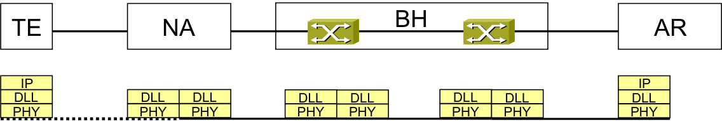

Figure ‑: Ethernet Data Path

Forwarding behavior may be restricted in both the NA as well as the BH to one of the following schemes:

* **E-Line Service** represents a point-to-point connection carrying Ethernet frames between two interfaces of the access network.

fig#-eth-line

Figure ‑: Ethernet Line Service

* **E-LAN Service** provides multipoint-to-multipoint connectivity for Ethernet frames across a number of interfaces. Any station on an E-LAN Service can communication with any other station on the same E-LAN Service.

fig#-eth-lan

Figure ‑: Ethernet LAN Service

E-LAN service is usually deployed when all connected end stations belong to the same security domain.

* **Ethernet Tree Service** distinguishes between Leaf interfaces and Root interfaces, as depicted in Figure 7‑4. Leaf interfaces are restricted in the exchange of data only with Root interface, but never directly with another Leaf interface. Root interfaces can exchange data with any Leaf interface and with any other Root interface.

fig#-eth-tree

Figure ‑: Ethernet Tree Service

* The E-Tree service could be useful for providing public broadband access or for delivering multicast services efficiently to multiple interfaces[1].

In the case of Ethernet LAN Service and Ethernet Tree Service multiple terminals may use the same data path.

The data path is either pre-established during Access network setup and/or dynamically configured when terminal connects to access network. A terminal resides on one data path during a terminal session, i.e. is associated with a single data path at session initiation, but may be assigned to different data paths for subsequent sessions.

### Roles and identifiers

The data path is established from the terminal interface over R1 to the node of attachment, continued over R6 to the backhaul and carried on over R3 to the access router interface.

The red line in the following figure of the NRM depicts the involved functional entities and the reference points representing different sections of the data path.

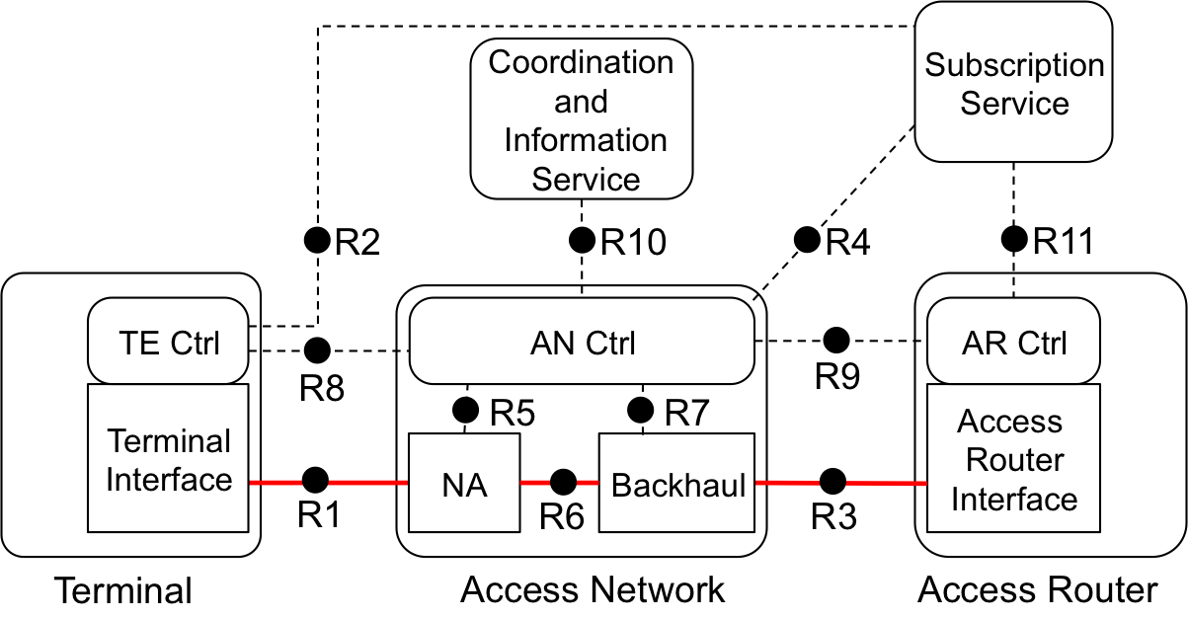

Figure ‑: Data path within the NRM

The following entities participate in the operation of the data path.

#### Terminal Interface (TEI)

The TEI is the endpoint of the data path at the terminal. It provides the capability to establish the data path connection over the R1 interface by negotiation of transmission parameters with the NA according to configuration information provided by the terminal controller.

Identifiers:

* TE-ID
  + As defined in section 6.3
* TEI-ID
  + The TEI-ID represents the port of the terminal towards the access network.

#### Node of Attachment (NA)

The NA provides the communication port at the access network, to which the terminal connects to over R1, and forwards user payload from the terminal towards the backhaul, and vice versa.

The NA has at least two ports, one directing towards the terminal, and another directing towards the backhaul, but may have multiple ports towards terminals, when the NA concurrently connects multiple terminals. Ports towards terminals may be dynamically created and released when terminals establish or release their sessions. For each of the terminal side ports, the NA negotiates with the TEI the configuration parameters of the data path connection over R1 and forwards the data path over R6 towards the BH according to configuration information received from the ANC.

Forwarding behavior of the NA may be either point-to-point towards the BH, or it may realize LAN service or tree service behavior when multiple terminals are connected to the same NA and assigned to the same data path.

The NA realizes a single interface towards the BH for a particular data path.

Identifiers:

* NA-ID
  + As defined in section 6.5
* R1-Port ID
  + Represents the port of the NA towards the TE. An R1-Port may concurrently serve multiple terminals on a single or multiple data paths.
* R6-Port ID
  + Represents the port of the NA towards the BH. An R6-Port may concurrently serve multiple data paths.

#### Backhaul (BH)

The BH provides the communication port, to which the NA connects to over R6, and forwards user payload from the NA towards the AR, and vice versa, or when direct terminal connections are enabled, towards the destination terminal, and vice versa.

The BH comprises at least two ports, one directing towards the NA, and another directing towards the ARI, but may comprise many more ports, when the AN consists of multiple NAs and eventually has interconnections with multiple ARs. The BH forwards the data path from the NA over R6 towards the AR over R3 or eventually also to other NAs, when LAN service or Tree service behavior is part of configuration information received from the ANC. Forwarding behavior of the BH may be either point-to-point between a single R6 and a single R3, or it may realize LAN service or tree service forwarding behavior when multiple NAs and/or multiple ARs are connected and assigned to the same data path.

Identifiers:

* BH-ID
  + As defined in section 6.5
* R6-Port ID
  + Represents the port of the BH towards the NA. An R6-Port may concurrently serve multiple data paths.
* R3-Port ID
  + Represents the port of the BH towards the AR. An R3-Port may concurrently serve multiple data paths.

#### Access Router Interface (ARI)

The ARI is the endpoint of the data path at the access router. It terminates the data path towards the router, which forwards user payload to communication peers not residing on the same data path based on IP addresses.

An access router may terminate multiple data paths either over a single access router interface serving multiple data paths, or over multiple access router interfaces attached to an AR instance.

Identifiers:

* Access Router Identifier (AR-ID)
  + As defined in section 6.3
* R3-PortID
  + R3-PortID represents the port of the AR towards the access network.

#### Subscription Service

The subscription service provides configuration information for the data path of a particular subscriber as part of the authorization to the access network controller and forwards related configuration information for the particular subscriber to the access router.

Identifier:

* Subscription Service Identifier (SS-ID)
  + As defined in section 6.3

#### Access network controller

The access network controller generates and distributes configuration information for the data path of a particular subscriber based on the authorization received from the Subscription Service eventually taking system configuration directives received from the Coordination and Information Service into account.

Identifiers:

* Access Network Controller Identifier (ANC-ID)
  + As defined in section 6.3

### Use Cases

#### Single, plain access network

A single, plain wireless access network consists out of several node of attachements connected to a bridge with connection to a single access router and a single subscription server.

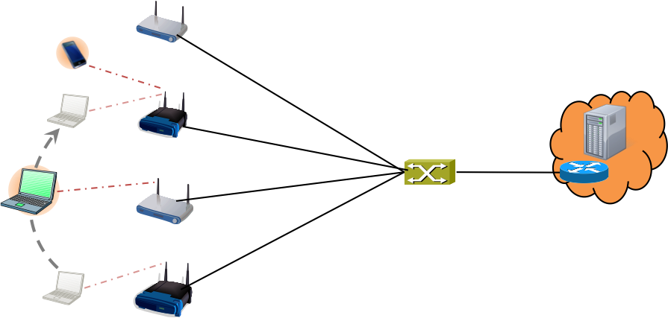

Figure ‑: Simple plain access network

LAN Service behavior is provided by the single Ethernet bridge, which connects all the node of attachments with the access router. All terminals are assigned to the common data path, which allows for direct terminal-to-terminal communication and inherently provides mobility support when the terminals move from node of attachment to node of attachment, as the terminals stay on the same access router interface, which ensures that IP addressing is maintained during movements.

#### Shared wireless access network

A shared wireless access network leverages the same access network infrastructure for multiple separate services, each with its own access router and its own subscription service. It isolates each of the connected terminals to block direct terminal-to-terminal communication and enforces that all communication passes through the access router, providing enhanced capabilities for subscriber specific services and centralized policy enforcement and accounting.

Still mobility support by the bridged infrastructure has to be supported, to enable subscribers to move around in the wireless coverage area without losing IP connectivity or session states of applications.

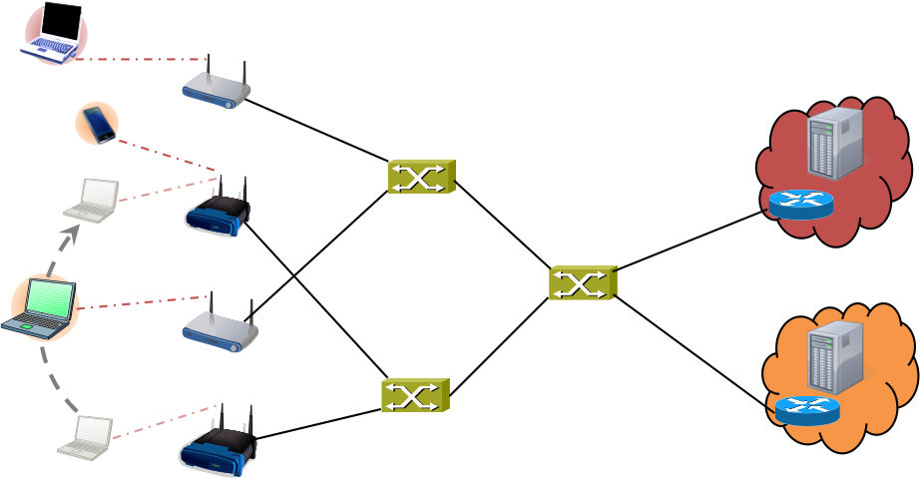

Figure ‑: Shared wireless access network

Bridges and node of attachments provide two independent access networks in a virtualized manner with the same coverage area for each of the service provider operating its own access router and subscription service. Forwarding behavior in the node of attachments and in the bridges is restricted to point-to-point behavior enforcing all user payload packets to pass through the access router.

#### Multi-operator backhaul infrastructure

The third use case shows the scenario, when a backhaul infrastructure composed by networks of multiple Ethernet operators is used by multiple service providers, each with its own access points and its own subscription service and access router.

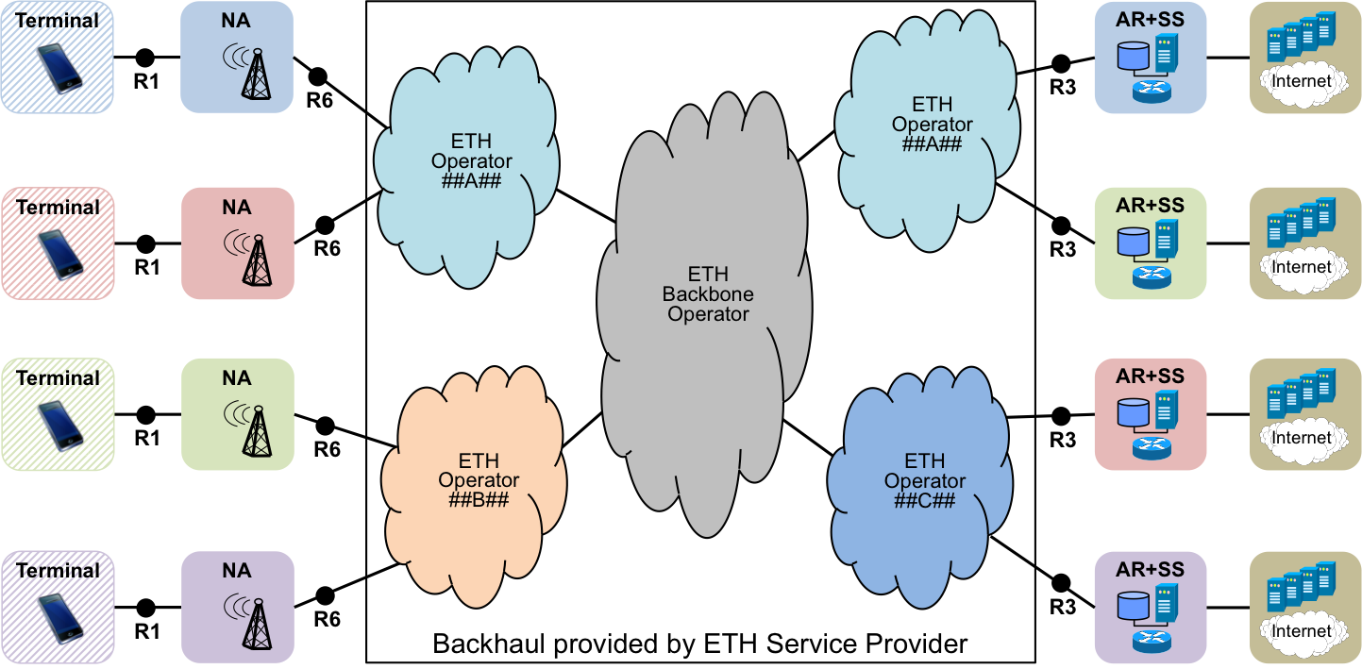

Figure ‑: Multi-operator backhaul infrastructure

The backhaul operators provide to each of the wireless service providers dedicated Ethernet connectivity for aggregation and interconnection of their node of attachments to their access routers, respectively.

The backhaul connectivity of the Ethernet operators is statically configured according to the requirements of the individual service providers. Nevertheless service providers may provide through such infrastructure various different services to their subscribers, with the need to provide point-to-point service as well as tree-service and LAN service forwarding behavior by the same infrastructure.

### Functional Requirements

* Data path SHOULD be configurable as either point-to-point or multipoint-to-multipoint or rooted-multipoint (point-to-multipoint) behavior
* Successful completion of data path establishment SHOULD be indicated.
* Relocation of data path within the access network SHOULD be supported.
* Data path should be configurable to support the transport of C-VIDs between terminal and access router
* Data path should protect integrity of user payload
* Data path should support encrypted transport of user payload
* Data path should allow for differentiated services based on C-VIDs and priority bits
* Data path should support wired and wireless links in the access and backhaul.

### Data Path specific attributes

#### Node of Attachment

* R1 MAC and PHY configuration parameters
* R1 performance and QoS parameters
  + E.g. supported service classes (Throughput up/down, delay, jitter)
* R6 configuration parameters
* VLAN configuration and mapping

#### Backhaul

* R6 configuration parameters
* R3 configuration parameters
* Service specification
* Service mapping table

#### Access Router

* R3 configuration parameters
* Network Interface performance
  + E.g. supported service classes (throughput up/down, delay, jitter)

#### Subscription Service

* User specific service specification

### Data path specific basic functions

The following figure shows the occurrence of data path specific functions during the life cycle of a terminal session.

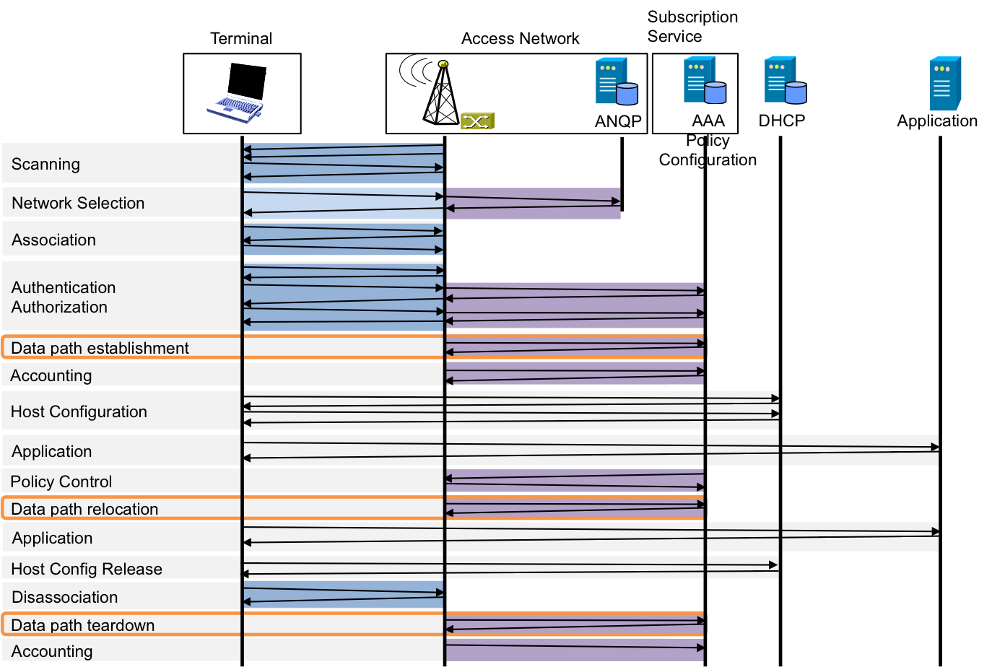

Figure ‑: Data path functions

#### Data path establishment

* Retrieve user specific configuration information from Subscription Service
* Configure terminal interface R1
* Configure forwarding and interfaces R1 and R6 in NA
* Configure link performance and interfaces R6 and R3 in Backhaul
* Initiate configuration of R3 in AR
* Signal completion of access link establishment

#### Data path relocation

* Reconfigure terminal interface R1 to new NA
* Configure forwarding and interfaces R1 and R6 in new NA
* Relocate interface R6 in Backhaul towards new NA
* Signal completion of access link relocation

#### Data path tear down

* Teardown interface in Terminal
* Teardown forwarding function and interfaces in NA
* Teardown interface in AR
* Remove resource allocations in Backhaul
* Signal completion of teardown

### Mapping to IEEE 802 Technologies

The following table provides IEEE 802 technology specific attributes for the data path configuration.

|  |  |  |  |  |  |
| --- | --- | --- | --- | --- | --- |
|  | | 802.3 | 802.11 | 802.16 | 802.22 |
| R1 Config | QoS Parms |  |  |  |  |
| Forwarding |  |  |  |  |
| Filtering |  |  |  |  |
| Security |  |  |  |  |
| R6 Config | |  |  |  |  |
| VLAN Config | |  |  |  |  |
| R3 Config | |  |  |  |  |

1. However, there is one deficiency of the E-Tree service for establishing public access networks. IPv6 operation requires direct host-to-host connectivity for neighbor discovery messages to allow secure neighbor discovery.