Minutes of September 29th IEEE 802.1 OmniRAN TG conference call
Date: September 30th, 2015
Author(s):
Name | Affiliation | Address | Phone | email
Walter Pienciak | IEEE-SA |  | +1 303 527 0934 | w.pienciak@ieee.org

Abstract
Minutes of the IEEE 802.1 OmniRAN TG conference call on September 29th, 10-11AM ET.

Tuesday, September 29th, 2015

Chair: Max Riegel
Recording secretary: Walter Pienciak

Call to order
- Meeting called to order by Max Riegel at 10:05AM ET.
- Meeting was guided by the slides uploaded and maintained during the call by the chair:
- https://mentor.ieee.org/omniran/dcn/15/omniran-15-0049-01-00TG-sept-29th-confcall-slides.pptx

Minutes
- Walter Pienciak volunteered to take notes.

Attendance
- Roll call

Name | Affiliation
Max Riegel | Nokia Networks
Walter Pienciak | IEEE SA
Juan Carlos Zuniga | Interdigital
Krishnanand Karnath | ViaVi Solutions

IEEE WG Guidelines
- The chair presented the mandatory IEEE SA guideline slides and asked for anybody willing to make an IPR announcement.
- No IPR declaration was raised.

Agenda approval
- Agenda as proposed in the chair’s meeting slides:
- Review of minutes
- https://mentor.ieee.org/omniran/dcn/15/omniran-15-0047-00-00TG-sept-2015-f2f-meeting-minutes.docx
- Reports
- Report to 802WGs and IETF/IEEE802 Coordination
- https://mentor.ieee.org/omniran/dcn/15/omniran-15-0046-00-00TG-sept-2015-status-report-to-802wgs.pptx
- November plenary OmniRAN schedules
- See next slide
- Review editor's draft of P802.1CF
- https://mentor.ieee.org/omniran/dcn/15/omniran-15-0045-01-CF00-review-comments-on-doc-0035-01.xls
- https://mentor.ieee.org/omniran/dcn/15/omniran-15-0048-00-CF00-comment-resolution-proposals-for-doc-15-0045-01.docx
- P802.1CF contributions
- Network reference model
- SDN abstraction
- Functional design and decomposition
- https://mentor.ieee.org/omniran/dcn/15/omniran-15-0042-01-CF00-an-setup-over-unlicensed-band.docx
- Component model within the scope of P802.1CF
- AOB
- Agenda approved without objections.

Review of minutes
- https://mentor.ieee.org/omniran/dcn/15/omniran-15-0047-00-00TG-sept-2015-f2f-meeting-minutes.docx
- No comments received.

Reports
- Report to 802WGs and IETF/IEEE802 Coordination
- https://mentor.ieee.org/omniran/dcn/15/omniran-15-0046-00-00TG-sept-2015-status-report-to-802wgs.pptx
- Juan Carlos mentioned that IETF/IEEE 802 coordination meeting is taking place two hours after the OmniRAN TG call
- 802.11 closing plenary concluded to continue discussions about ‘802.11 as a component’ in 802.11 ARC SC until better understanding is reached.
- November plenary OmniRAN schedules
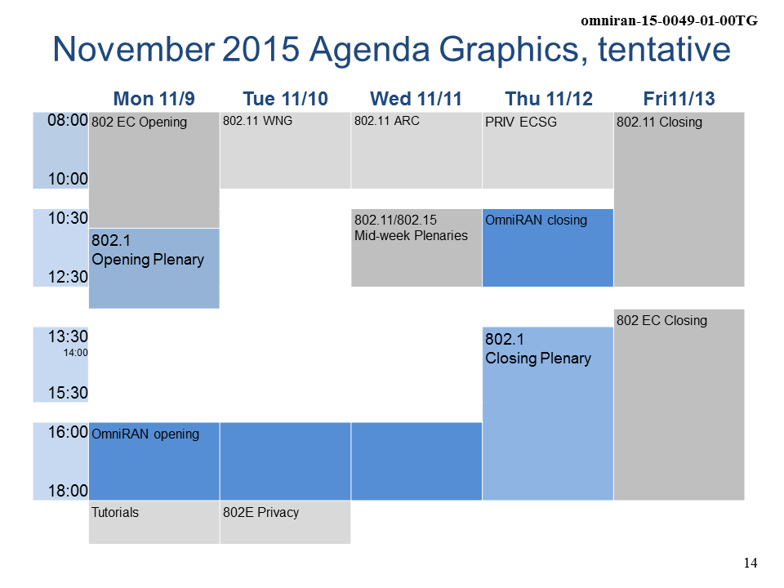
- Participants in the call were fine with the proposed schedules.
- Correction of https://mentor.ieee.org/omniran/dcn/15/omniran-15-0045-01-CF00-review-comments-on-doc-0035-01.xls on mentor
- Chair reported that previous file (.xlsx format) was replaced by a version in the legacy .xls format, as .xlsx file on mentor caused ‘corrupted file’ error message with Excel 2013.
- OmniRAN on http://sdn.ieee.org
- P802.1CF is now listed on the Standardization tab at sdn.ieee.org
- IEEE 802 fellowship program
- Juan Carlos reported that 802EC is starting a fellowship program in November

P802.1CF editor’s draft
- https://mentor.ieee.org/omniran/dcn/15/omniran-15-0035-01-CF00-cf-text-review.pdf
- Review and comments resolution
- https://mentor.ieee.org/omniran/dcn/15/omniran-15-0045-01-CF00-review-comments-on-doc-0035-01.xls
- Short review of opens out of the discussions at September F2F. Issues noted in the September F2F are addressed by contribution of Max Riegel:
- https://mentor.ieee.org/omniran/dcn/15/omniran-15-0048-00-CF00-comment-resolution-proposals-for-doc-15-0045-01.docx
- Max introduced the two proposed text amendments for the NRM section and NDS section, respectively.
- Editor to work on the references to the table for NRM section.
- Participants agreed that proposed amendment should be adopted to the draft P802.1CF text.

P802.1CF contributions

Functional decomposition and design
- Revision of text on network setup for operation in unlicensed bands
- https://mentor.ieee.org/omniran/dcn/15/omniran-15-0042-01-CF00-an-setup-over-unlicensed-band.docx
- Agreement to postpone the proposal for discussion in November meeting, as the contributor was not available for presentation and discussion.

Component model within scope of 802.1CF
- Juan Carlos reported that planned presentation of Wi-Fi as part of 5G will not happen in the October NGMN meeting
- Max asked Juan Carlos to forward links to publically available material about the upcoming 5G core network to the OmniRAN TG.
- How P802.1CF fits with the emerging ideas of the 5G core network may become a discussion topic in one of the upcoming OmniRAN meeting.

AOB
- A new revision of the draft P802.1CF text is planned for early October incorporating the material and comment resolutions discussed until the end of this conference call.
- Walter will contact chair when questions about adoption of resolved comments and proposed text are coming up.
- Proposed agenda for November F2F:
- Chair presented proposed agenda:
- Review of minutes
- Reports
- Review of 802.1CF editor’s draft
- Comment resolution
- New P802.1CF contributions
- Functional design and decomposition
- Backhaul representation
- SDN Abstraction
- Wi-Fi as component of 5G within the scope of P802.1CF
- Project planning
- Publicity activities
- Status report to IEEE 802 WGs
- AOB
- Juan Carlos proposed to amend ‘Component model…’ to ‘Wi-Fi as component of 5G within the scope of P802.1CF’ to provide more clear description of the topic.
- After adopting the proposed change no further comments were raised. OmniRAN TG will go with agenda proposal above into the Nov F2F meeting.
- No other topics brought up.

Meeting adjourned by chair at 11:05AM ET

