IEEE 802.1 OmniRAN TG
Minutes of OmniRAN TG Teleconference
June 30th, 2015
Date: 2-July-2015
Author(s):
Name | Affiliation | Address | Phone | email
Walter Pienciak | IEEE SA |  |  | w.pienciak@ieee.org

Abstract
Minutes of the IEEE 802.1 OmniRAN TG teleconference on Tuesday, June 30th, 2015.
Tuesday, June 30th, 2015

Chair: Max Riegel
Recording secretary: Walter Pienciak

Call to order
- Meeting called to order on at 10:03 AM ET.

IEEE WG Guidelines
- The chair read the IEEE guidelines and asked for declaration of Potentially Essential Patents.
  - No IPR issues were brought up

Appointment of recording secretary
- Walter Pienciak volunteered to take notes.

Roll Call

Name | Affiliation
Max Riegel | Nokia Networks
Walter Pienciak | IEEE SA
Yonggang Fang | ZTE
Marcel Kiessling | Siemens

Agenda
- Agenda proposal:
  - Agenda bashing
  - Review of minutes
    - Meeting minutes of Apr 2015 meeting
    - Meeting minutes of May 2015 F2F meeting
  - Reports
    - Report to IETF-IEEE 802 coordination
    - Schedules and plans for July Waikoloa F2F
  - Review initial editor's draft of P802.1CF
  - P802.1CF contributions
    - Network reference model
    - SDN abstraction
    - Functional design and decomposition
  - AOB

- Agenda accepted for meeting without further amendments.

Review of minutes
- Minutes of April 16th confcall
  - https://mentor.ieee.org/omniran/dcn/15/omniran-15-0027-00-00TG-april-16th-confcall-minutes.docx
  - Pending for review by participants of April 16th call.
- Minutes of Pittsburgh F2F
  - https://mentor.ieee.org/omniran/dcn/15/omniran-15-0030-00-00TG-may-2015-f2f-meeting-minutes.docx
  - Chair shortly presented minutes of Pittsburgh meeting and explained major topics and outcome of F2F meeting. Pittsburgh meeting was mainly spend as editors’ session in preparation for initial 802.1CF draft with rich communication with experienced 802.1 editors.
  - No comments brought up by participants, but chair will bring up minutes again in the Waikoloa F2F for broader review.

Reports
- Report to IETF IEEE 802 Coordination Group
  - https://mentor.ieee.org/omniran/dcn/15/omniran-15-0031-00-00TG-status-report-to-ietf-ieee-802-coordination.pptx
  - Chair shortly went over slides and explained current status of OmniRAN TG, as presented in the IETF IEEE 802 Coordination meeting.
- OmniRAN participation in July tutorial on IEEE 802.11 as a component
  - Chair reported about intentions, plans and initial draft presentation for tutorial. The contribution of OmniRAN to the tutorial will show that P802.1CF provides essential input for defining 802.11 as a network component.
- OmniRAN schedules for July F2F
  - Chair presented meeting graphics contained in the meeting slides:
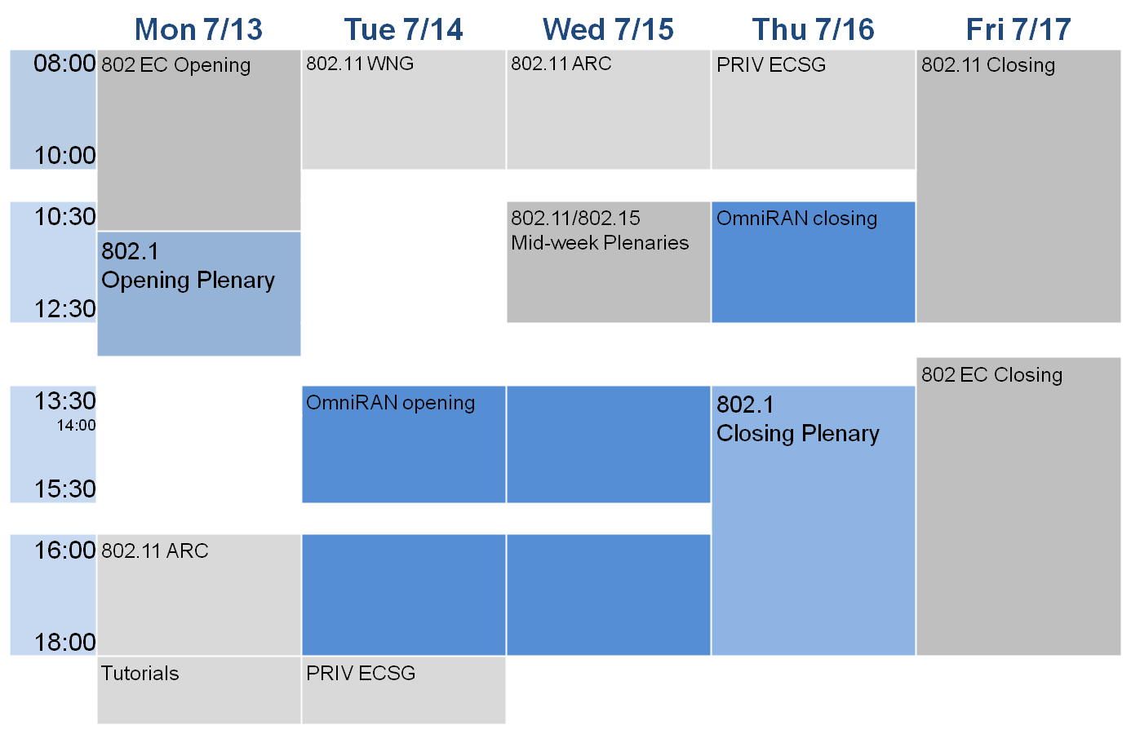
  - There will be no OmniRAN session on Monday afternoon, as meeting organizer was not able to provide a room. As OmniRAN sessions overlap with sessions of other groups attended by the contributors, chair will set up detailed schedules in the opening session taking into account availability of the contributors.

Review of initial editor’s draft of P802.1CF
  - Walter presented initial draft document, and explained how editorial work has been prioritized to date, what has been done, what is outstanding.
- Review and clean-up procedure
  - Draft not yet ready for public uploading; more content is desired, more editorial work required.
  - Chair asked participants in the call for proof-reading the draft document, listing down all the issues with the document either in email or Excel table.
  - Chair will distribute document together with Excel comment sheet per email after the conference call to the reviewers.
  - OmniRAN TG will review comments during July F2F for preparation of the initial editor’s draft for uploading to the 802.1 private file archive.

Contributions to 802.1CF
- No contributions received for the conference call.

AOB
- Waikoloa F2F in July 2015
  - Chair presented Agenda proposal for the Waikoloa F2F on July 12th - 16th
  - OmniRAN TG sessions will take place on July 14th, 15th, and 16th.
  - Agenda proposal after adding item on review of editor’s draft:
    - Review of minutes
    - Reports
    - Review of 802.1CF editor’s draft
    - P802.1CF contributions
      - Review of network reference model chapter
      - Backhaul representation
      - SDN Abstraction
      - Functional design and decomposition
    - Project planning
    - Publicity activities
    - Status report to IEEE 802 WGs
    - AOB
  - No further proposals were made on agenda.

Adjournment
- Meeting adjourned at 11:01 AM, EDT

