Revision proposal of omniran-14-0083-00-00TG
Date: 2015-03-05
Authors:
Name | Affiliation | Phone | Email
Max Riegel | Nokia Networks | +49 173 293 8240 | maximilian.riegel@nokia.com
Notice:
This document does not represent the agreed view of the OmniRAN TG It represents only the views of the participants listed in the ‘Authors:’ field above. It is offered as a basis for discussion. It is not binding on the contributor, who reserve the right to add, amend or withdraw material contained herein.
Copyright policy:
The contributor is familiar with the IEEE-SA Copyright Policy <http://standards.ieee.org/IPR/copyrightpolicy.html>.
Patent policy:
The contributor is familiar with the IEEE-SA Patent Policy and Procedures:
<http://standards.ieee.org/guides/bylaws/sect6-7.html#6> and <http://standards.ieee.org/guides/opman/sect6.html#6.3>.

Abstract
This document proposes a further revision of the text on the P802.1CF network reference model incorporating the agreed edits in omniran-15-0005-01-CF00. The revision mainly addresses the issues explained in the omniran-15-0008-02-00CF-nrm-refinements presentation.

1 P802.1CF Network Reference Model 3
1.1 Nomenclature: 3
1.2 Introduction 3
1.3 Basic Network Reference Model 4
1.3.1 Reference Points 6
1.4 Network Reference Model including Coordination and Information Service 6
1.4.1 Reference Points 7
1.5 Network Reference Model exposing Access Network details 8
1.5.1 Reference Points 8

P802.1CF Network Reference Model

Nomenclature:
AN: Access Network
ANC: Access Network Controller
BH: Backhaul

CIS: Coordination and Information Service
CN: Core Network
CNC: Core Network Controller
CNI: Core Network Interface
NA: Node of Attachment
NRM: Network Reference Model
SS: Subscription Service
TE: Terminal
TEC: Terminal Controller
TEI: Terminal Interface

Introduction
The network reference model defines a generic foundation for the description of IEEE 802 access network, which may include multiple network interfaces, multiple network access technologies, and multiple network subscriptions, aimed to unify the support of different interface technologies, enabling shared network control and use of software defined networking (SDN) principles.
It adopts the generic concepts of SDN by splitting the network model into an infrastructure layer and a control layer with well defined semantics for interfacing with higher layer management, orchestration and analytics functions. Additionally the model deploys a clear separation of functional roles in the operation of access networks to support various deployment models including leveraging wholesale network services for backhaul, network sharing and roaming.
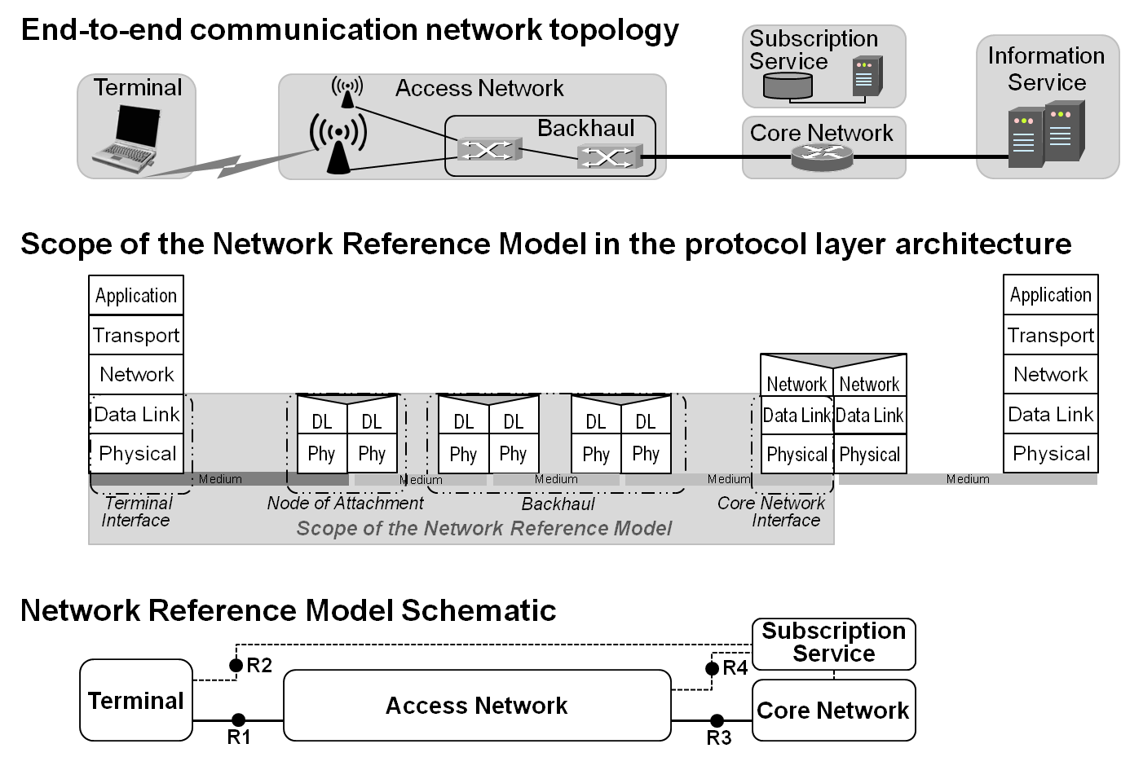
Figure 1:
Within the bigger picture of an end-to-end network model for providing access to IP services, the NRM deals in particular with the link layer communication infrastructure between the host in the terminal and the access router in the core network as depicted in figure 1.
For IEEE 802 access network the user plane traffic is forwarded according to the destination MAC address in the Ethernet frames, which represent the endpoints of the link in the access network. Avoiding a functional separation of the user plane from the transport plane, the specification provides an integrated model for backhaul connectivity combined with subscriber specific connectivity functions as facilitated by modern IEEE 802.1 bridging technologies.
At a first glance, the network model for IEEE 802 access network consists of the terminal, the access network comprising the node of attachment and the backhaul, the core network where the access router resides, and the subscription service, which provides authentication, authorization, accounting as well as policy functions for the users of the terminals. Communication interfaces between the entities are denoted by R1 for the interface between the terminal and the node of attachment, by R2 for the authentication procedures between terminal and subscription service, by R3 for the interface between access network and the core network, and by R4 for the authorization, accounting and policy functions between the access network and the subscription service.

Basic Network Reference Model

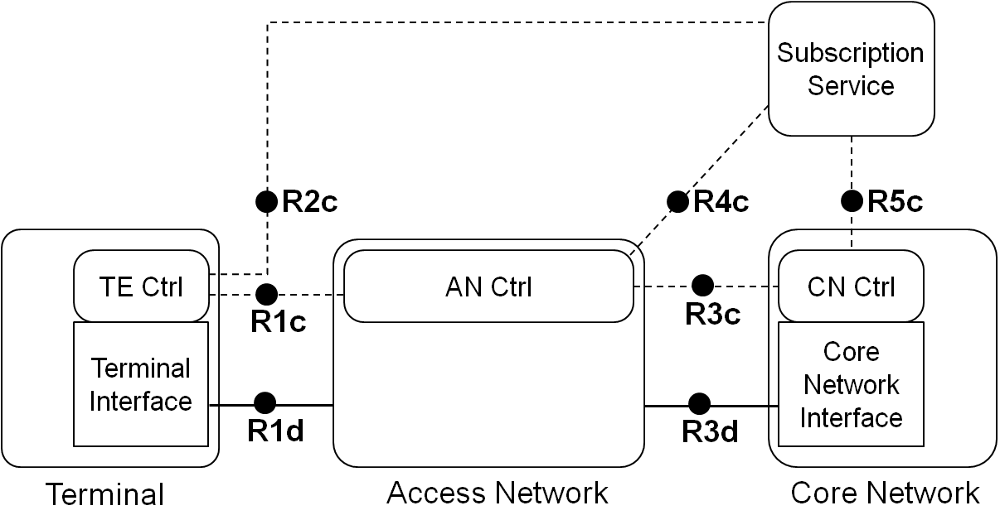
Figure 2: Basic Network Reference Model
Figure 2 presents the Basic Network Reference Model (NRM). Solid lines represent the data path, while dotted lines show the flow of control information. This NRM is the foundation of further refinements and includes the basic differentiation between services and the reference points for their communication. The Basic NRM is composed of four main elements; i) the Terminal (TE), ii) the Access Network (AN) and iii) the Core Network (CN), and iv) the Subscription Service (SS).
As depicted in Figure 1, the TE, the AN, and the CN comprise each a control entity, which is denoted Controller (Ctrl). Each of the three elements has its specific Controller.
Remark: Please note that currently no assumption on the service providers is made.

Reference Points
- R1: represents the reference point for the communication between the Terminal and the Access Network.
  - R1d represents the reference point for the PHY and MAC layer functions for the data path, as specified in numerous IEEE 802 standards, between terminal and access network.
  - R1c: represents the control interface between the AN and the TE, which terminates in Access Network Controller and the Terminal Controller, respectively. The functionalities of this reference point are related to the configuration of logical interfaces in the terminal and the control of the data flows in the terminal. In addition, the reference point may include some additional configuration parameters to influence the behavior and configuration of the terminal.

- R2c: represents a control interface between terminal and the subscription service, e.g. for authentication.
- R3: represents the reference points for the communication between the access network and the core network.
  - R3d: represents the IEEE 802 data path interface between the access network and the core network.
  - R3c: represents a control interface between the access network controller and core network controller.
- R4c: represents a control interface communicating subscription-specific information elements between the access network controller and the subscription service.
- R5c: represents a control interface communicating subscription-specific information between the subscription service and the core network controller.

Network Reference Model including Coordination and Information Service

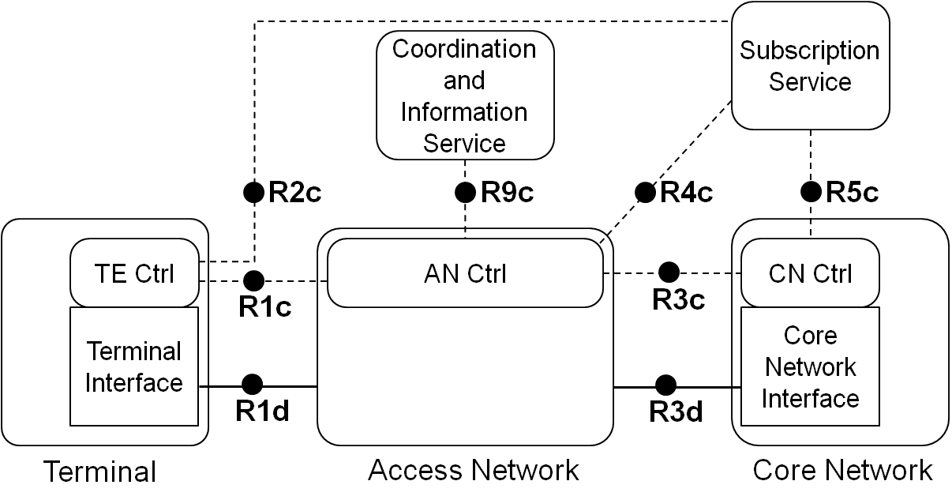
Figure 3: NRM including Coordination and Information Service
Some deployments include a Coordination and Information Service (CIS) to provide advanced services such as spectrum management, coexistence, and information services for mobility. The reference model includes the possibility of having CIS entities in the network and provides a reference point to communicate the information from these services to the AN control, and possibly TE control and CNS control entities.

Reference Points
- R9c: represents a control interface between the Access Network Controller and the CIS.

Network Reference Model exposing Access Network details
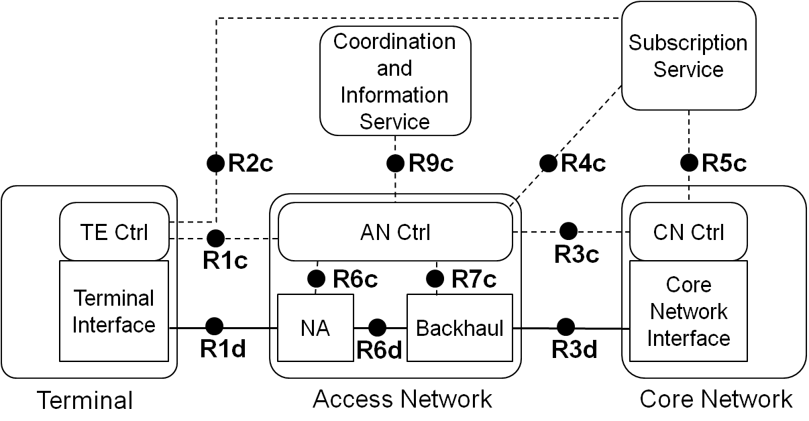
Figure 4: Network Reference Model exposing Access Network details
In Figure 4 the access network is decomposed into a Node of Attachment (NA) and the Backhaul (BH). The NA represents the entity providing the link to the terminal, the interface to the backhaul and the data forwarding function between these two. The connections between NA, backhaul and AN control are described by reference points R6d, R6c and R7c.

Reference Points
- R6: Node of Attachment Interfaces
  - R6d: User-plane interface carrying user data between the node of attachment and the backhaul.
  - R6c: Control-only interface for the configuration of the node of attachment. It includes information elements for the configuration of the R6d interface to the backhaul, the R1d interface to the access link, and the data forwarding functions of the Node of Attachment.
- R7: Backhaul Interfaces
  - R7c: This interface is used to control and configure the user plane within the backhaul. The backhaul interconnects the NAs with the CNS.

