Short introduction of OmniRAN P802.1CF
Date: 2015-03-03
Authors:
Name | Affiliation | Phone | Email
Max Riegel | Nokia Networks | +49 173 293 8240 | maximilian.riegel@nokia.com
Notice:
This document does not represent the agreed view of the OmniRAN TG It represents only the views of the participants listed in the ‘Authors:’ field above. It is offered as a basis for discussion. It is not binding on the contributor, who reserve the right to add, amend or withdraw material contained herein.
Copyright policy:
The contributor is familiar with the IEEE-SA Copyright Policy <http://standards.ieee.org/IPR/copyrightpolicy.html>.
Patent policy:
The contributor is familiar with the IEEE-SA Patent Policy and Procedures:
<http://standards.ieee.org/guides/bylaws/sect6-7.html#6> and <http://standards.ieee.org/guides/opman/sect6.html#6.3>.

Abstract
This document provides for information a short introduction into OmniRAN P802.1CF as submitted by the author to the Wireless Broadband Alliance for considerations of SDN.

IEEE 802.1 OmniRAN
The IEEE 802.1 OmniRAN TG was established and authorized in March 2014 to create a recommended practice on Network Reference Model and Functional Description of IEEE 802 Access Network. An IEEE 802 access network is characterized by a user plane forwarding Ethernet frames between the network interface in the terminal and the core network interface, where the access link is terminated by the access router.
The standardization project is denoted P802.1CF and describes the use of IEEE 802 technologies to build heterogeneous access networks, which may include multiple network interfaces, multiple network access technologies, and multiple network subscriptions, aimed to unify the support of different interface technologies, enabling shared network control and use of software defined networking (SDN) principles.
While adopting the generic concepts of SDN by splitting the network model into an infrastructure layer and a control layer with well defined semantics for interfacing with higher layer management, orchestration and analytics functions, the specification maintains a clear separation of functional roles in the operation of access networks to support various deployment models including leveraging wholesale network services for backhaul, network sharing and roaming.

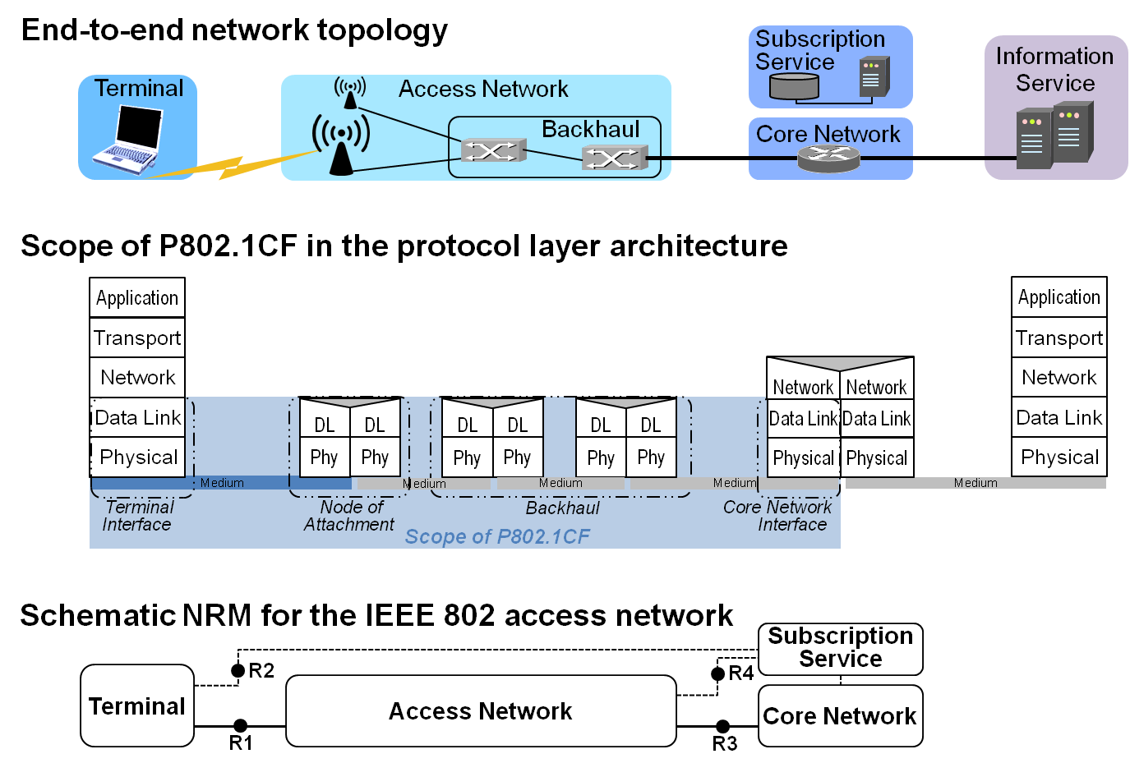
Figure 1: Scope of IEEE P802.1CF
Within the scope of the end-to-end network model for providing access to IP services, the P802.1CF deals with the communication link between the host in the terminal and the access router in the core network. User plane traffic forwarding is performed on base of MAC addresses, even when the Ethernet frames are tunneled over some other transport technologies in the backhaul. By avoiding the functional separation of the user plane and the transport plane in the access network, the specification provides a combined control model for integration of setting up backhaul connectivity together with provisioning subscriber specific user connectivity as facilitated by modern IEEE 802.1 bridging technologies. For the SDN abstraction of the backhaul an opaque service model adopting well known semantics of the Metro Ethernet Forum is applied, which inherits the full functional and operational flexibility of Carrier Ethernet.
SDN is also a leading aspect for the design of the NRM consisting of the definition of the functional entities of the IEEE 802 access network as well as of the reference points for the communication between the functional entities. At a glance, the network model for IEEE 802 access network consists of the terminal, the access network comprising the node of attachment and the backhaul, the core network where the access router resides, and the subscription service, which provides authentication, authorization, accounting as well as policy functions for the users of the terminals. Communication interfaces between the entities are denoted by R1 for the interface between the terminal and the node of attachment, by R2 for the authentication procedures between terminal and subscription service, by R3 for the interface between access network and the core network, and by R4 for the authorization, accounting and policy functions between the access network and the subscription service.
Figure 2 below presents the complete NRM, which exposes a terminal controller in the terminal and a core network controller in the core network, both interconnected with the access network controller in the access network. Moreover a further entity denoted coordination and information service is added for the management of shared network resources among multiple access networks like a spectrum database for controlling access to spectrum in the case of TV white space or licensed shared access.
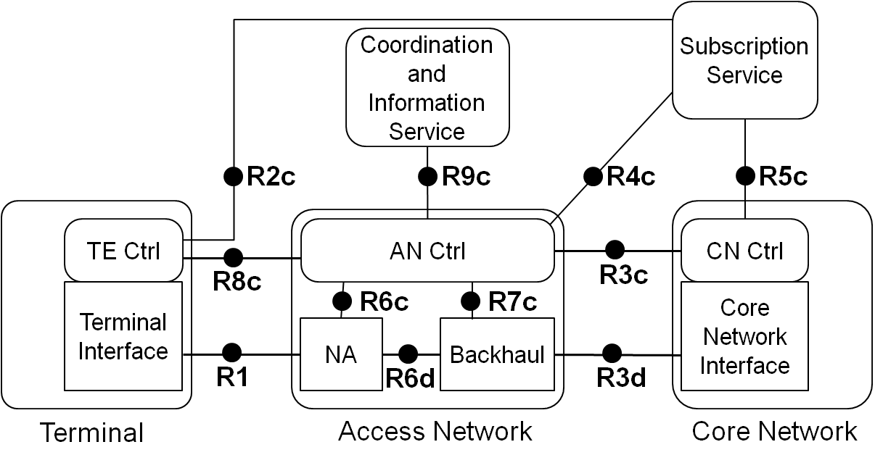
Figure 2: IEEE 802 Access Network Reference Model
Reference points in the NRM denote either datapath interfaces forwarding Ethernet frames, or control interfaces for IEEE 802 related parameters, which may be carried either within IEEE 802 protocols or within IP based protocols. In the case that IEEE 802 specific identifiers or configuration information are carried within IP protocols, the details of the IP protocols are left open to accommodate various deployments. Nevertheless the P802.1CF specification provides a comprehensive behavioral and functional description of the message exchanges between the entities of the NRM to guide implementers in the appropriate choice of the IP protocols. By focusing its scope to the architectural model and to the specification of the related IEEE 802 identifiers and attributes P802.1CF delivers an SDN enabled abstraction of IEEE 802 access network, which well fits to various protocol proposals for communication between SDN controller and infrastructure layer and enables interoperable implementations of SDN for IEEE 802 based access networks.
The radio access network (RAN) of a Carrier Wi-Fi network is well aligned to the P802.1CF model and scope as IEEE 802.11 APs are the node of attachments and the complete link between the terminal and the access router is enabled for transport of Ethernet frames. Authentication procedures as well as the interfaces into the AAA infrastructure are represented by the R2, R4 and R5 reference points, respectively. Even latest enhancements in Carrier Wi-Fi like ANQP are reflected in the functional description and in the NRM by reference point R8. However due to its focus on SDN principles and IEEE 802 technologies, P802.1CF may not provide much guidance for the virtualization of legacy Carrier Wi-Fi access infrastructures, in particular for split-MAC designs with an access controller in the datapath.
IEEE 802.1 OmniRAN TG continuously monitors the SDN related activities in other standardization organizations to keep the specifications aligned. To determine and evaluate emerging approaches in SDN the OmniRAN TG hosts at IEEE 802 plenary meetings a dedicated Wireless SDN BoF session and maintains a wiki page listing standardization efforts in other SDOs with close relation to the technologies developed by IEEE 802.
Related Links:
P802.1CF project status: http://www.ieee802.org/1/pages/802.1cf.html
OmniRAN TG status: https://mentor.ieee.org/omniran/bp/StartPage
OmniRAN SDN Wiki: https://mentor.ieee.org/omniran/bp/SDN_Wiki

