Comments on omniran-14-0083-00-00TG
Date: 2015-01-14
Authors:
Name | Affiliation | Phone | Email
Roger Marks | EthAirNet Associates | +1 802  227 2253 | roger@ethair.net
Notice:
This document does not represent the agreed view of the 802.1 OmniRAN TG. It represents only the views of the participants listed in the ‘Authors:’ field above. It is offered as a basis for discussion. It is not binding on the contributor, who reserve the right to add, amend or withdraw material contained herein.
Copyright policy:
The contributor is familiar with the IEEE-SA Copyright Policy <http://standards.ieee.org/IPR/copyrightpolicy.html>.
Patent policy:
The contributor is familiar with the IEEE-SA Patent Policy and Procedures:
<http://standards.ieee.org/guides/bylaws/sect6-7.html#6> and <http://standards.ieee.org/guides/opman/sect6.html#6.3>.

P802.1CF Network Reference Model

Nomenclature:
AN: Access Network
SS: Subscription Service
CNS: Core Network Service
CIS: Coordination and Information Service
TE: Terminal
NA: Node of Attachment

Basic Network Reference Model

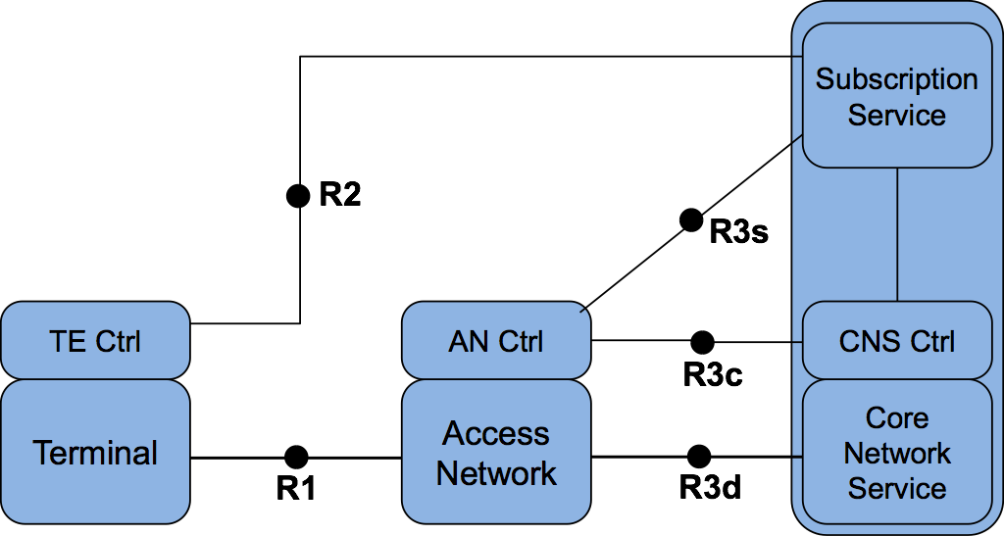
Figure 1: Basic Network Reference Model

Figure 1 presents the Basic Network Reference Model (NRM). This NRM is the basis of further models and includes the basic differentiation between services and the reference points for their communication. This NRM is composed of three main elements; i) the terminal, ii) the Access Network and iii) the Core Network, consisting of Core Network Service (CNS), CNS Control and Subscription Service. Please note that currently no assumption on the service providers is made.

In the NRM depicted in Figure 1, for each element we assume a control entity, which we will call Controller (Ctrl). Each of the elements has a specific Controller.

Reference Points

- R1: represents the PHY and MAC layer functions, as specified in numerous IEEE 802 standards, between terminal and access network.
- R2: represents a control interface between terminal and the subscription service, e.g. for authentication.
- R3: represents the reference points for the communication between the access network and the core network, up to the interface between L2 and L3 in the first L3 router.
  - R3d: represents the IEEE 802 data path interface between access network and the first hop router of the Core Network Service.
  - R3c: represents a control interface between the access network controller and core network controller.
  - R3s: represents a control interface communicating subscription-specific information elements between the access network controller and the subscription service.

Network Reference Model including Terminal Controller Reference Point
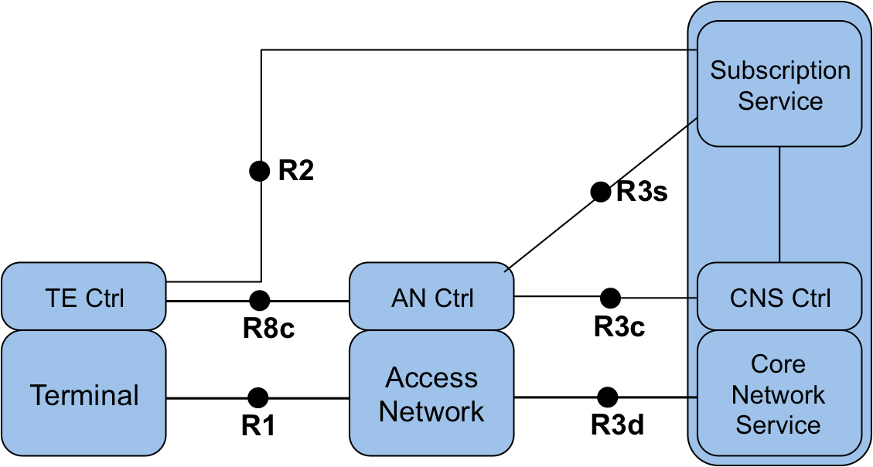
Figure 2: Network Reference Model with interface between TE Ctrl and AN Ctrl

Figure 2 depicts an evolution of the basic NRM, including a communication reference point between the terminal and the access network controller. The functionalities of this reference point are related to the configuration of logical interfaces in the terminal and the control of the data flows in the terminal. In addition, the reference point may include some additional configuration parameters to influence the behavior of the terminal.

Reference Points

- R8c: represents a control interface between the Access Network Controller and the Terminal Controller.

Network Reference Model including Coordination and Information Service

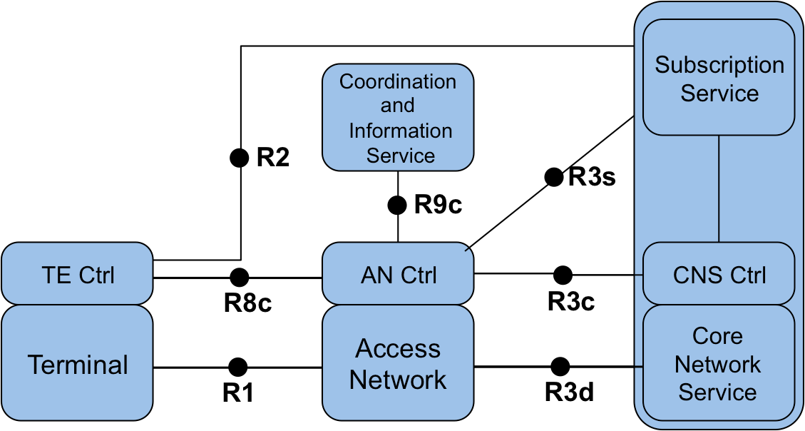
Figure 3: NRM including Coordination and Information Service

Some deployments include a Coordination and Information Service (CIS) to provide advanced services such as spectrum management, coexistence, and information services for mobility. The reference model includes the possibility of having CIS entities in the network and provides a reference point to communicate the information from these services to the AN control, and possibly TE control and CNS control entities.

Reference Points

- R9c: represents a control interface between the Access Network Controller and the CIS.

Network Reference Model exposing Access Network details
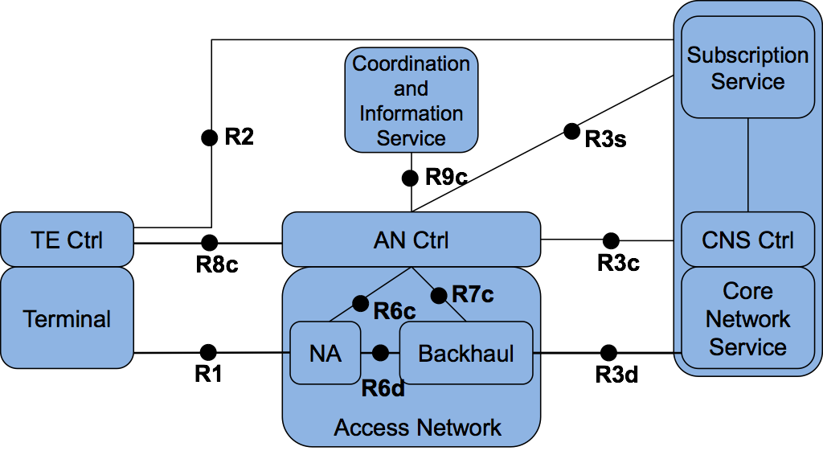
Figure 4: Network Reference Model exposing Access Network details

In Figure 4 the access network is decomposed into a Node of Attachment (NA) and the Backhaul. The NA represents the entity providing the link to the terminal, the interface to the backhaul and the data forwarding function between these two. The connections between NA, backhaul and AN control are described by reference points R6d, R6c and R7c.

Reference Points

R6: Node of Attachment Interfaces

- R6d: User-plane interface carrying user data between the node of attachment and the backhaul.
- R6c: Control-only interface for the configuration of the node of attachment. It transfers information elements for the configuration of the R6d interface to the backhaul, and the configuration of the Node of Attachment.

R7: Backhaul Interfaces

- R7c: This interface is used to control and configure the user plane within the backhaul. The backhaul interconnects the NAs with the CNS.

- R0: User Interface?

