P802.1CF Network Reference Model

**Nomenclature:**

AN: Access Network

SS: Subscription Service

CNS: Core Network Service

CIS: Coordination and Information Service

TE: Terminal

NA: Node of Attachment

## Basic Network Reference Model



Figure 1: Basic Network Reference Model

Figure 1 presents the Basic Network Reference Model (NRM). This NRM is the basis of further models and includes the basic differentiation between services and the reference points for their communication. This NRM is composed of three main elements; i) the terminal, ii) the Access Network and iii) the Core Network, consisting of Core Network Service (CNS), CNS Control and Subscription Service. The basic NRM differentiates two service types: i) Subscription service and ii) Core Network service. Please note that currently no assumption on the service providers is made.

In the NRM depicted in Figure 1, for each element we assume a control entity which we will call Controller (Ctrl). Each of the elements has a specific Controller.

### Reference Points

* **R1:** represents the PHY and MAC layer functions between terminal and access network. These are completely covered by the IEEE 802 specifications.
* **R2:** represents a control interface between terminal and the subscription service, e.g. for authentication.
* **R3:** represents the reference points for the communication between the access network and the core network, up to the interface between L2 and L3 in the first L3 router.
  + **R3d:** represents the IEEE 802 data path interface between access network and the first hop router of the Core Network Service.
  + **R3c:** represents a control interface between the access network controller and core network controller.
  + **R3s:** represents a control interface communicating subscription-specific information elements between the access network controller and the subscription service.

## Network Reference Model including Terminal Controller Reference Point

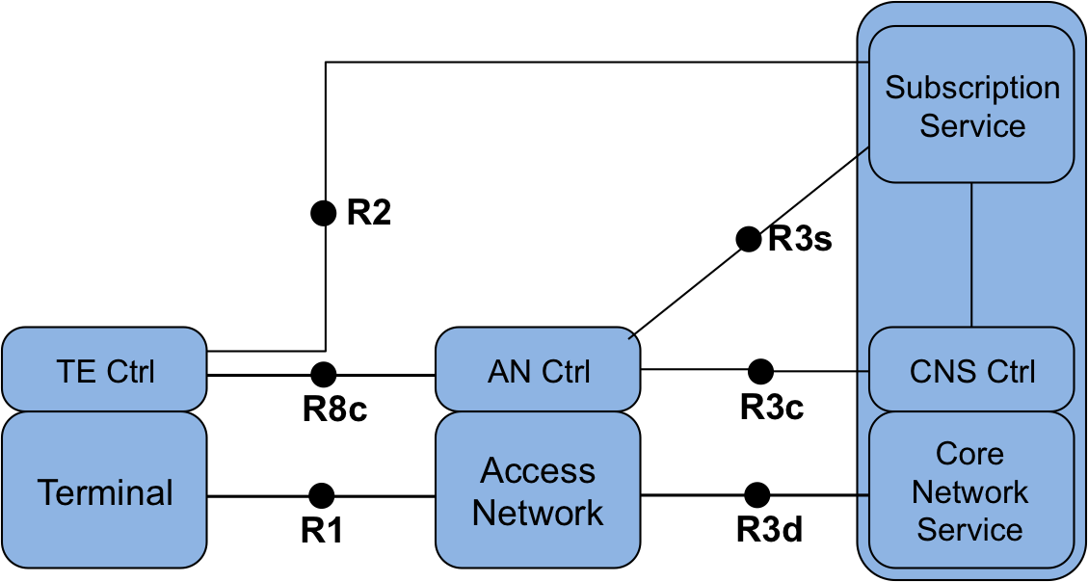

Figure 2: Network Reference Model with interface between TE Ctrl and AN Ctrl

Figure 2 depicts an evolution of the basic NRM, including a communication reference point between the terminal and the access network controller. The functionalities of this reference point are related to the configuration of logical interfaces in the terminal and the control of the data flows in the terminal. In addition, the reference point may include some additional configuration parameters to influence the behavior and configuration of the terminal.

### Reference Points

* **R8c**: represents a control interface between the Access Network Controller and the Terminal Controller.

## Network Reference Model including Coordination and Information Service

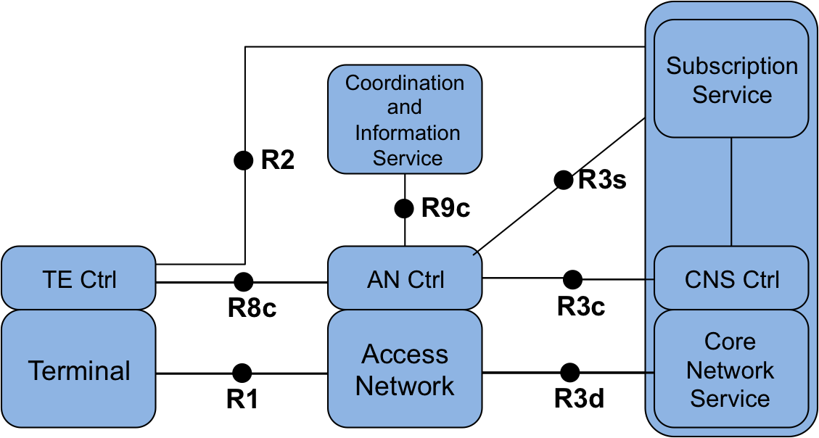

Figure 3: NRM including Coordination and Information Service

Some deployments include a Coordination and Information Service (CIS) to provide advanced services such as spectrum management, coexistence, and information services for mobility. The reference model includes the possibility of having CIS entities in the network and provides a reference point to communicate the information from these services to the AN control, and possibly TE control and CNS control entities.

### Reference Points

* **R9c**: represents a control interface between the Access Network Controller and the CIS.

## Network Reference Model exposing Access Network details



Figure 4: Network Reference Model exposing Access Network details

In Figure 4 the access network is decomposed into a Node of Attachment (NA) and the Backhaul. The NA represents the entity providing the link to the terminal, the interface to the backhaul and the data forwarding function between these two. The connections between NA, backhaul and AN control are described by reference points R6d, R6c and R7c.

### Reference Points

**R6: Node of Attachment Interfaces**

* **R6d**: User-plane interface carrying user data between the node of attachment and the backhaul.
* **R6c**: Control-only interface for the configuration of the node of attachment. It includes information elements for the configuration of the interface to the backhaul, the interface to the access link and data forwarding functions.

**R7: Backhaul Interfaces**

* **R7c: T**his interface is used to control and configure the user plane within the backhaul. The backhaul interconnects the NAs with the CNS.