|  |  |  |  |
| --- | --- | --- | --- |
| Generic IEEE 802 Network Reference Model Proposal | | | |
| Date: [2014-11-03] | | | |
| **Authors:** | | | |
| Name | Affiliation | Phone | Email |
| Antonio de la Oliva | University Carlos III of Madrid |  | [aoliva@it.uc3m.es](mailto:aoliva@it.uc3m.es) |
| Juan Carlos Zúñiga | InterDigital |  | [juancarlos.zuniga@interdigital.com](mailto:juancarlos.zuniga@interdigital.com) |
| Luis Miguel Contreras | Telefonica |  | [luismiguel.contrerasmurillo@telefonica.com](mailto:luismiguel.contrerasmurillo@telefonica.com) |
| Roger Marks | EthAirNet Associates |  | [roger@ethair.net](mailto:roger@ether.net) |
| **Notice:**  This document does not represent the agreed view of the 802.1 OmniRAN TG. It represents only the views of the participants listed in the ‘Authors:’ field above. It is offered as a basis for discussion. It is not binding on the contributor, who reserve the right to add, amend or withdraw material contained herein. | | | |
| **Copyright policy:**  The contributor is familiar with the IEEE-SA Copyright Policy <<http://standards.ieee.org/IPR/copyrightpolicy.html>>. | | | |
| **Patent policy:**  The contributor is familiar with the IEEE-SA Patent Policy and Procedures:  <[http://standards.ieee.org/guides/bylaws/sect6-7.html#6](http://standards.ieee.org/guides/bylaws/sect6-7.html)> and <[http://standards.ieee.org/guides/opman/sect6.html#6.3](http://standards.ieee.org/guides/opman/sect6.html)>. | | | |

# Abstract

This contribution addresses a generic reference model for IEEE 802 networks. It is based on the following contributions:

* “omniran-14-0051-01-CF00-omniran-network-reference-model-with-backhaul”, Roger Marks, 15 Jul 2014
* omniran-13-0018-00-ecsg, “OmniRAN Introduction to IEEE802.1”, Max Riegel, 18 Mar 2013
* omniran-14-0044-02-0000, “SDN Use Cases Summary”, Antonio de la Oliva, Juan Carlos Zuniga, Roger Marks, 17 Jul 2013
* omniran-13-0048-04-ecsg, “OmniRAN ECSG Results and Outlook”, Max Riegel, 25 Jun 2013
* omniran-13-0060-00-ecsg, “OmniRAN SDN Use Case for external communication”, Max Riegel, 7 Aug 2013
* omniran-13-0067-00-0000, “OmniRAN architecture suggestions”, Yonggang Fang, 11 Sep 2013
* omniran-14-0030-00-0000, “Backhaul in OmniRAN”, Max Riegel, 19 Mar 2014
* omniran-14-0038-00-CF00, “802.1CF R3 Considerations”, Max Riegel, 14 May 2014

Generic IEEE 802 Network Reference Model Proposal

This document considers an evolution of the NRM proposal presented in DCN-68r0, updated with the latest agreements, captured in Annex I.

**Nomenclature:**

PoA: Point of Attachment

# Network Reference Model (NRM)



Figure : Generic IEEE 802 Network Reference Model

# Reference Point Descriptions

Herein we will describe the reference points R6d, R6c and R7c, which are added on top of the basic NRM.

# R6: Point of Attachment Interfaces

### R6d: User plane PoA interface

User-plane interface carrying user data between the point of attachment and the backhaul.

### R6c: Control plane PoA interface

Control-only interface for the configuration of the point of attachment. It includes information elements for the configuration of the interface to the backhaul, the interface to the access link and data forwarding functions.

# R7: Backhaul Interfaces

### R7c: Control interface to Backhaul

This interface is used to control and configure the user plane within the backhaul. The backhaul interconnects the PoAs with the CNS.

Annex I: Agreed reference model in Athens September 2014 Meeting

In the following we provide an evolving Network Reference Model based on the discussions held in Atenas at the September 2014 interim meeting.

**Nomenclature:**

AN: Access Network

SS: Subscription Service

CNS: Core Network Service

CIS: Coordination and Information Service

TE: Terminal

## Basic Network Reference Model

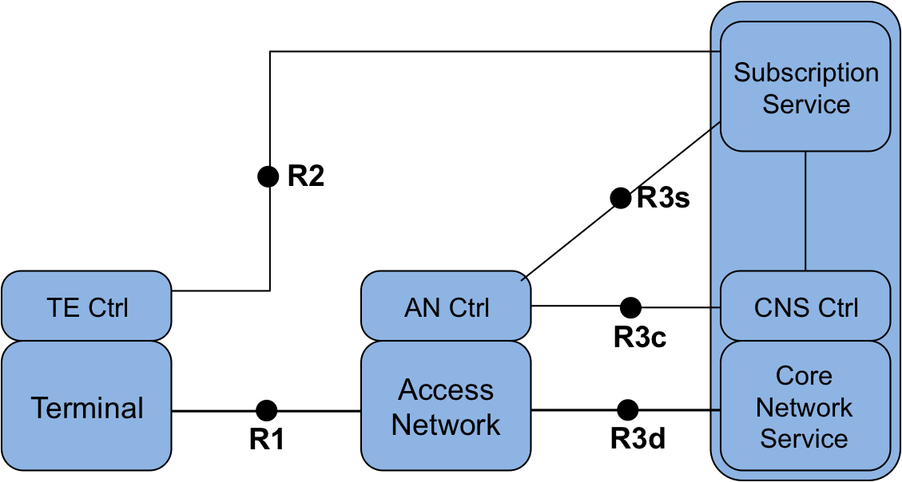

Figure : Basic Network Reference Model

Figure 2 presents the Basic Network Reference Model (NRM). This NRM is the basis of further models and includes the basic differentiation between services and the reference points for their communication. This NRM is composed of three main elements; i) the terminal, ii) the Access Network and iii) the Core Network, consisting of Core Network Service (CNS), CNS Control and Subscription Service. The basic NRM differentiates two service types: i) Subscription service and ii) Core Network service. Please note that currently no assumption on the service providers is made.

In the NRM depicted in Figure 2, for each element we assume a control entity which we will call Controller (Ctrl). Each of the elements has a specific Controller.

### Reference Points

* **R1:** represents the PHY and MAC layer functions between terminal and access network. These are completely covered by the IEEE 802 specifications.
* **R2:** represents a control interface between terminal and the subscription service, e.g. for authentication.
* **R3:** represents the reference points for the communication between the access network and the core network, up to the interface between L2 and L3 in the first L3 router.
  + **R3d:** represents the IEEE 802 data path interface between access network and the first hop router of the Core Network Service.
  + **R3c:** represents a control interface between the access network controller and core network controller.
  + **R3s:** represents a control interface communicating subscription-specific information elements between the access network controller and the subscription service.

## Network Reference Model including Terminal Controller Reference Point

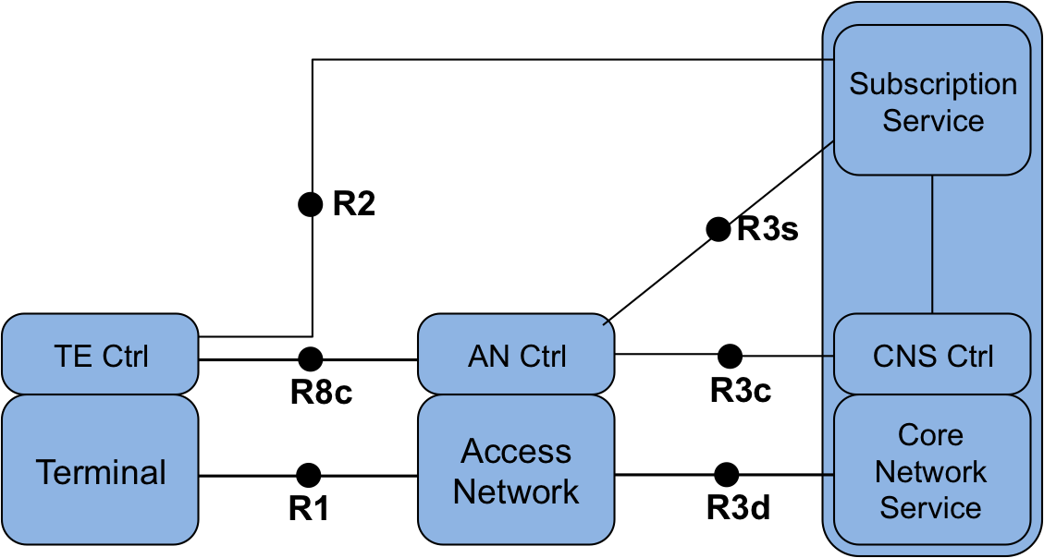

Figure 3: Network Reference Model with interface between TE Ctrl and AN Ctrl

Figure 3 depicts an evolution of the basic NRM, including a communication reference point between the terminal and the access network controller. The functionalities of this reference point are related to the configuration of logical interfaces in the terminal and the control of the data flows in the terminal. In addition, the reference point may include some additional configuration parameters to influence the behavior and configuration of the terminal.

### Reference Points

* **R8c**: represents a control interface between the Access Network Controller and the Terminal Controller.

## Network Reference Model including Coordination and Information Service

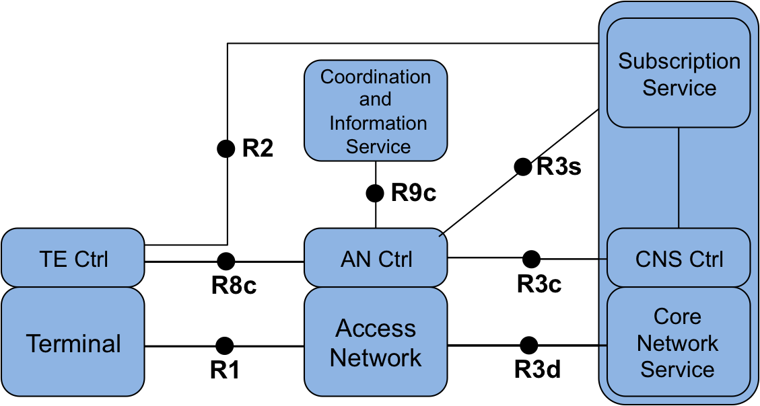

Figure : NRM including Coordination and Information Service

Some deployments include a Coordination and Information Service (CIS) to provide advanced services such as spectrum management, coexistence, and information services for mobility. The reference model includes the possibility of having CIS entities in the network and provides a reference point to communicate the information from these services to the AN control, and possibly TE control and CNS control entities.

### Reference Points

* **R9c**: represents a control interface between the Access Network Controller and the CIS.