Generic IEEE 802 Network Reference Model Proposal
Date: [2014-11-03]
Authors:
Name | Affiliation | Phone | Email
Antonio de la Oliva | University Carlos III of Madrid |  | aoliva@it.uc3m.es
Juan Carlos Zúñiga | InterDigital |  | juancarlos.zuniga@interdigital.com
Luis Miguel Contreras | Telefonica |  | luismiguel.contrerasmurillo@telefonica.com
Roger Marks | EthAirNet Associates |  | roger@ethair.net
Notice:
This document does not represent the agreed view of the 802.1 OmniRAN TG. It represents only the views of the participants listed in the ‘Authors:’ field above. It is offered as a basis for discussion. It is not binding on the contributor, who reserve the right to add, amend or withdraw material contained herein.
Copyright policy:
The contributor is familiar with the IEEE-SA Copyright Policy <http://standards.ieee.org/IPR/copyrightpolicy.html>.
Patent policy:
The contributor is familiar with the IEEE-SA Patent Policy and Procedures:
<http://standards.ieee.org/guides/bylaws/sect6-7.html#6> and <http://standards.ieee.org/guides/opman/sect6.html#6.3>.

Abstract
This contribution addresses a generic reference model for IEEE 802 networks. It is based on the following contributions:
- “omniran-14-0051-01-CF00-omniran-network-reference-model-with-backhaul”, Roger Marks, 15 Jul 2014
- omniran-13-0018-00-ecsg, “OmniRAN Introduction to IEEE802.1”, Max Riegel, 18 Mar 2013
- omniran-14-0044-02-0000, “SDN Use Cases Summary”, Antonio de la Oliva, Juan Carlos Zuniga, Roger Marks, 17 Jul 2013
- omniran-13-0048-04-ecsg, “OmniRAN ECSG Results and Outlook”, Max Riegel, 25 Jun 2013
- omniran-13-0060-00-ecsg, “OmniRAN SDN Use Case for external communication”, Max Riegel, 7 Aug 2013
- omniran-13-0067-00-0000, “OmniRAN architecture suggestions”, Yonggang Fang, 11 Sep 2013
- omniran-14-0030-00-0000, “Backhaul in OmniRAN”, Max Riegel, 19 Mar 2014
- omniran-14-0038-00-CF00, “802.1CF R3 Considerations”, Max Riegel, 14 May 2014

Generic IEEE 802 Network Reference Model Proposal
This document considers an evolution of the NRM proposal presented in DCN-68r0, updated with the latest agreements. Annex I presents text explaining the actual view of the TG on the general NRM as future reference.

OmniRAN Network Reference Model (NRM)
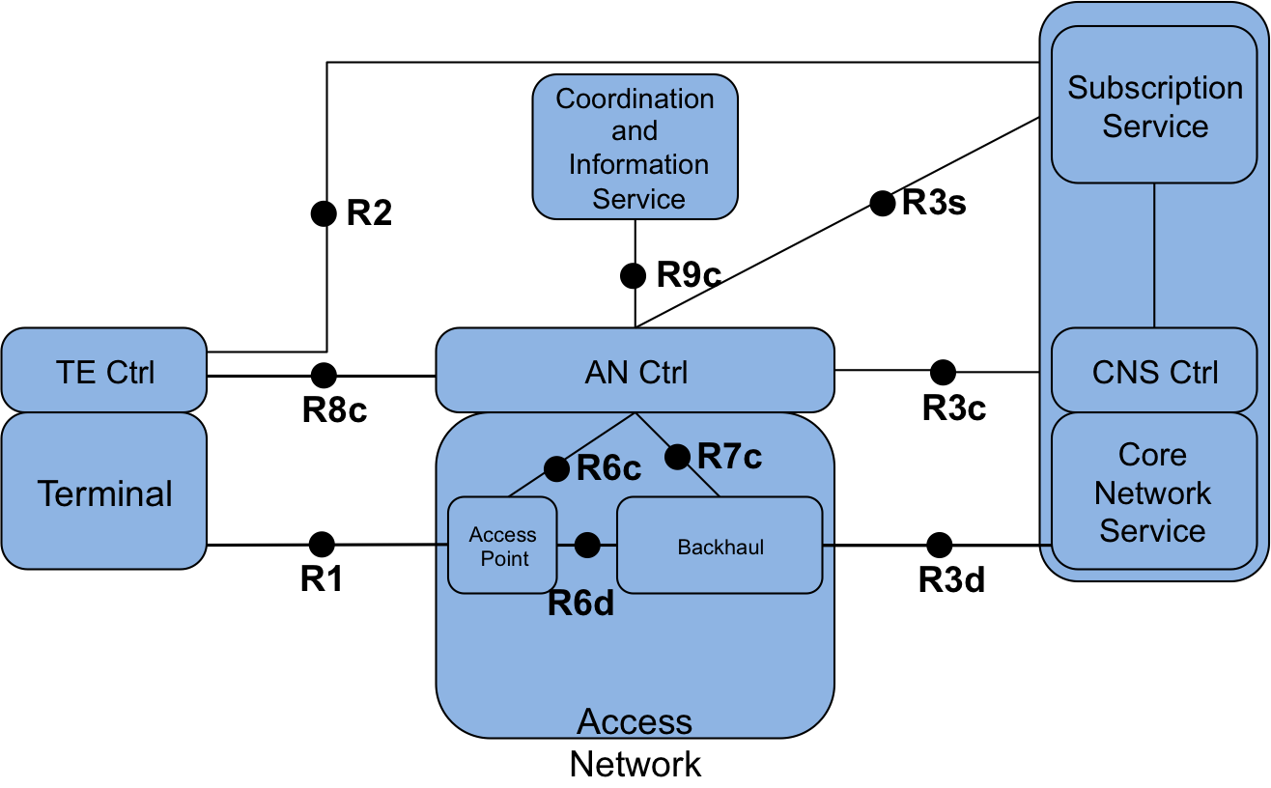
Figure 1: Generic IEEE 802 Network Reference Model

Reference Point Descriptions
Herein we will describe the Reference Points 6 and 7, which have not been previously discussed. For the

R6: Access Point Interfaces

R6d: Data-only Access Point interface
Data-plane interface carrying user data between the access point and the backhaul.

R6c: Control interface to Access Point
Control-only interface for the configuration of the access point. It includes the configuration of the access point to the backhaul, as well as to the access link.

R7: Backhaul Interfaces

R7c: Control interface to Backhaul
This interface is used to control and configure the data-path of the user flows within the backhaul. The backhaul interconnects the access points with the core.

Annex I: Agreed reference model in Athens September 2014 Meeting

Nomenclature:
AN: Access Network
SS: Subscription Service
CNS: Core Network Service
CIS: Coordination and Information Service
TE: Terminal

Core Network Reference Model

In the following we provide an evolving Network Reference Model based on the discussions held in Atenas September 2014 meeting.

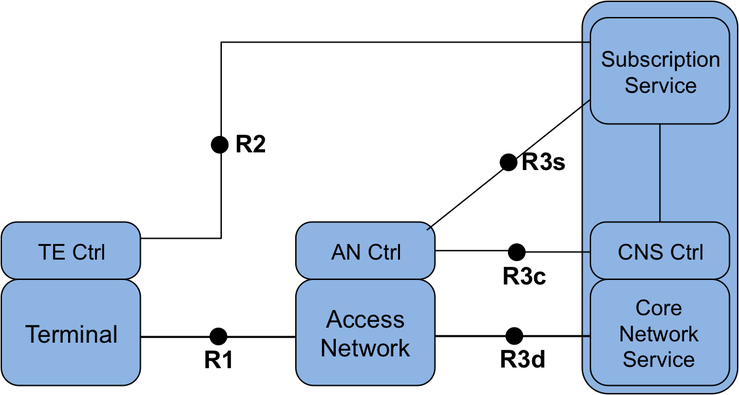
Figure 2: Core Network Reference Model

Figure 2 presents the Core Network Reference Model. This NRM is the basis of further models and includes the basic differentiation between services and the reference points for their communication. This reference model is composed of 3 main domains; i) the terminal, ii) the Access Network and iii) the Core Network. The basic NRM differentiate 3 services: i) Access Network service, ii) Subscription service and iii) Core Network service. Please note that currently no assumption on the service providers is made.

In the NRM depicted in Figure 2, for each domain we assume a control entity which we will call Controller (Ctrl). Each of the domains has a specific Controller.

Reference Points

- R1:represents the PHY and MAC layer functions between terminal and base station, which are completely covered by the IEEE 802 specifications
- R2:represents a control interface between terminal and the subscription service, e.g. for authentication
- R3: represents the reference point for the communication between the access network to the core network up to the interface between L2 and L3 in the first L3 router.
  - R3d:represents the IEEE 802 data path interface between access network and the first hop router of the Core Network Service
  - R3c: represents a control interface between the Access Network and Core Network Controllers
  - R3s:represents a control interface between the access network controller and the subscription service, this interface can be used to influence the authentication mechanisms

Network Reference Model including Terminal Controller Reference Point

The following evolution of the NRM includes the communication reference point between the terminal and the Access Network Controller. Some of the functionalities of this reference point will be related to the configuration of the logical interface in the terminal and the control of the actual path followed by data flows in the terminal. In addition, the terminal controller may include some configuration parameters so the access controller can influence the configuration of the terminal.

Reference Points

- R8c: represents a control interface between the Access Network Controller and the Terminal Controller.
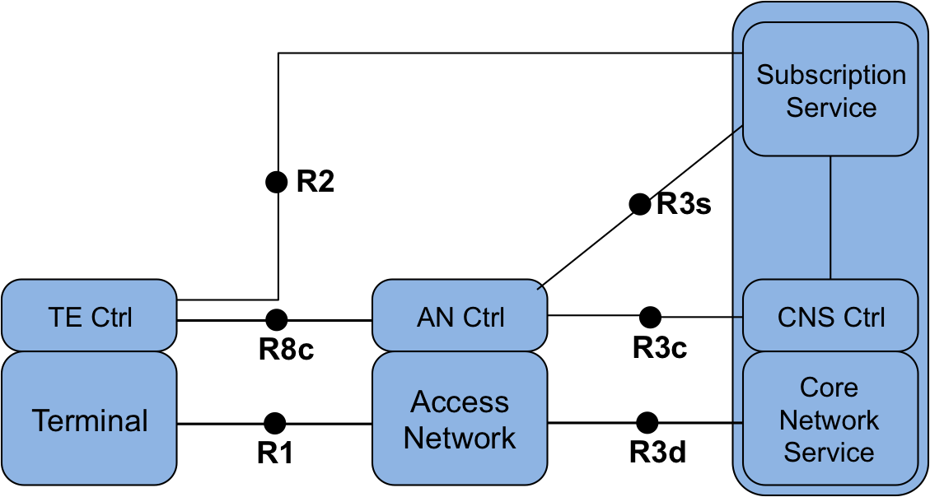
Figure 3: NRM with R8c

Network Reference Model including Coordination and Information Service

Some deployments include Coordiantion and Information Services to provide advance services such as spectrum management, coexistence, information services for mobility and so on. This reference model includes the possibility of having CIS entities in the network and provides a reference point to configure and control the information provided by these services.

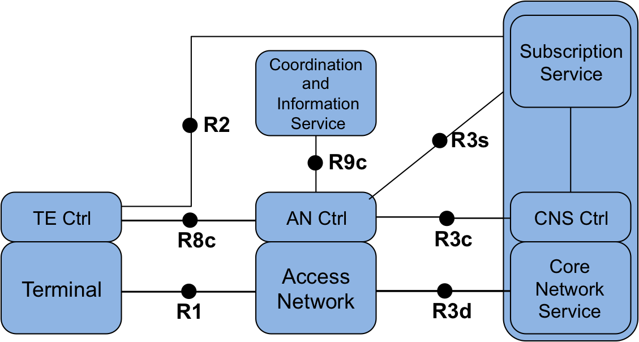
Figure 4: NRM including CIS

Reference Points

- R9c: represents a control interface between the Access Network Controller and the CIS system. It allows the configuration of the CIS and the control of the information provided by this system to the user.

