Generic IEEE 802 Network Reference Model Proposal
Date: [2014-09-17]
Authors:
Name | Affiliation | Phone | Email
Antonio de la Oliva | University Carlos III of Madrid |  | aoliva@it.uc3m.es
Juan Carlos Zúñiga | InterDigital |  | juancarlos.zuniga@interdigital.com
Luis Miguel Contreras | Telefonica |  | luismiguel.contrerasmurillo@telefonica.com
Roger Marks | EthAirNet Associates |  | roger@ethair.net
Notice:
This document does not represent the agreed view of the 802.1 OmniRAN TG. It represents only the views of the participants listed in the ‘Authors:’ field above. It is offered as a basis for discussion. It is not binding on the contributor, who reserve the right to add, amend or withdraw material contained herein.
Copyright policy:
The contributor is familiar with the IEEE-SA Copyright Policy <http://standards.ieee.org/IPR/copyrightpolicy.html>.
Patent policy:
The contributor is familiar with the IEEE-SA Patent Policy and Procedures:
<http://standards.ieee.org/guides/bylaws/sect6-7.html#6> and <http://standards.ieee.org/guides/opman/sect6.html#6.3>.

Abstract
This contribution addresses a generic reference model for IEEE 802 networks. It is based on the following contributions:
- “omniran-14-0051-01-CF00-omniran-network-reference-model-with-backhaul”, Roger Marks, 15 Jul 2014
- omniran-13-0018-00-ecsg, “OmniRAN Introduction to IEEE802.1”, Max Riegel, 18 Mar 2013
- omniran-14-0044-02-0000, “SDN Use Cases Summary”, Antonio de la Oliva, Juan Carlos Zuniga, Roger Marks, 17 Jul 2013
- omniran-13-0048-04-ecsg, “OmniRAN ECSG Results and Outlook”, Max Riegel, 25 Jun 2013
- omniran-13-0060-00-ecsg, “OmniRAN SDN Use Case for external communication”, Max Riegel, 7 Aug 2013
- omniran-13-0067-00-0000, “OmniRAN architecture suggestions”, Yonggang Fang, 11 Sep 2013
- omniran-14-0030-00-0000, “Backhaul in OmniRAN”, Max Riegel, 19 Mar 2014
- omniran-14-0038-00-CF00, “802.1CF R3 Considerations”, Max Riegel, 14 May 2014

Generic IEEE 802 Network Reference Model Proposal

OmniRAN Network Reference Model (NRM)
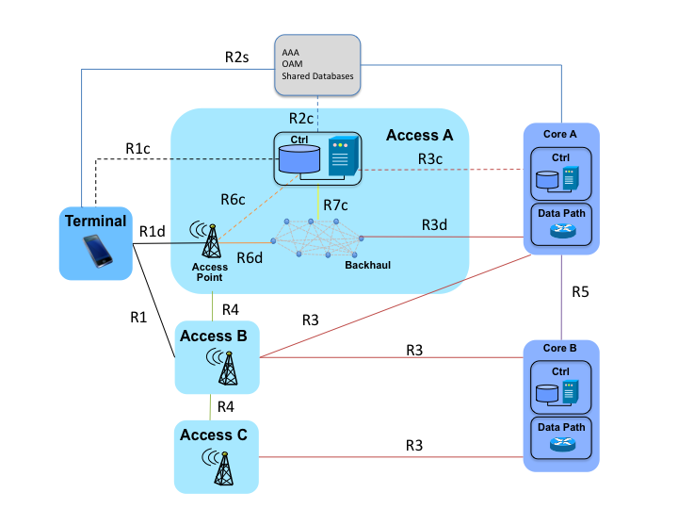
Figure 1: Generic IEEE 802 Network Reference Model

Reference Point Descriptions

R1: Access link interfaces

R1d: Data-only interface at the link between the Terminal and the Access Point.
This interface corresponds to the data path in the wireless interface between the terminal and the access point.

R1c: Control interface to the terminal.
This interface includes configuration of the terminal.

R2: User & terminal authentication, subscription & terminal management interfaces

R2s: Subscription interface to the AAA, OAM and Shared Databases
This is an interface carrying service specific frames, including session management, interface with AAA services, communication with management platform and shared databases such as IEEE 802.19 data base, IEEE 802.21 MIIS or even external databases e.g., possible interaction with ANDSF- like databases. This interface can span towards external operators, which carry their own processes such as AAA servers.

R2c: Control-interface to AAA, OAM and Shared Databases
This interface enables the path followed by R2s frames and also serves as the control interface to AAA, OAM and shared databases.

R3: User data connection, service management interfaces

R3d: Data-only Core interface
Data-plane only core interface carrying user data between the backhaul and core network.

R3c Control Core interface
Control interface between the access network controller and the core control. It is used, for example, for the orchestration of multi-tenant access networks.

R4: Inter-access network coordination and cooperation, fast inter-technology handover
Interface carrying user interconnecting different access networks.

R5: Inter-operator roaming control interfaces
Inter-operator roaming outside access network. Subscription information exchange between service operators

R6: Access Point Interfaces

R6d: Data-only Access Point interface
Data-plane interface carrying user data between the access point and the backhaul.

R6c: Control interface to Access Point
Control-only interface for the configuration of the access point. It includes the configuration of the access point to the backhaul, as well as to the access link.

R7: Backhaul Interfaces

R7c: Control interface to Backhaul
This interface is used to control and configure the data-path of the user flows within the backhaul, connecting the access point to the core.

