Proposed Text for AN setup in IEEE 802.1CF
Date: 2014-07-14
Authors:
Name | Affiliation | Phone | Email
Yonggang Fang | ZTE TX |  | yfang@ztetx.com
Bo Sun | ZTE |  | sun.bo1@zte.com.cn
Notice:
This document does not represent the agreed view of the IEEE802.1CF. It represents only the views of the participants listed in the ‘Authors:’ field above. It is offered as a basis for discussion. It is not binding on the contributor, who reserves the right to add, amend or withdraw material contained herein.
Copyright policy:
The contributor is familiar with the IEEE-SA Copyright Policy <http://standards.ieee.org/IPR/copyrightpolicy.html>.
Patent policy:
The contributor is familiar with the IEEE-SA Patent Policy and Procedures:
<http://standards.ieee.org/guides/bylaws/sect6-7.html#6> and <http://standards.ieee.org/guides/opman/sect6.html#6.3>.

Abstract
This documents proposes initial draft text for the access network setup section in Recommended Practice specification of IEEE 802.1CF. The proposal is based on IEEE P802.19.1 draft standard for TV White Space Coexistence Methods.

IEEE 802 Access Network Setup

- Introduction and Scope
- Abbreviations, Acronyms, Definitions, and Conventions
ASA: Authorized Shared Access
LSA: Licensed Shared Access.
ASA and LSA allow spectrum that has been licensed for international mobile telecommunications (IMT) to be used by more than one entity in the share matter.
SA: Shared Access
SA-DB: Shared access database
- References
- Identifiers

- Network Reference Model
  - Overview
  - Access Network Architecture
5.2.1 IEEE 802 based authorized shared access (ASA) network reference model

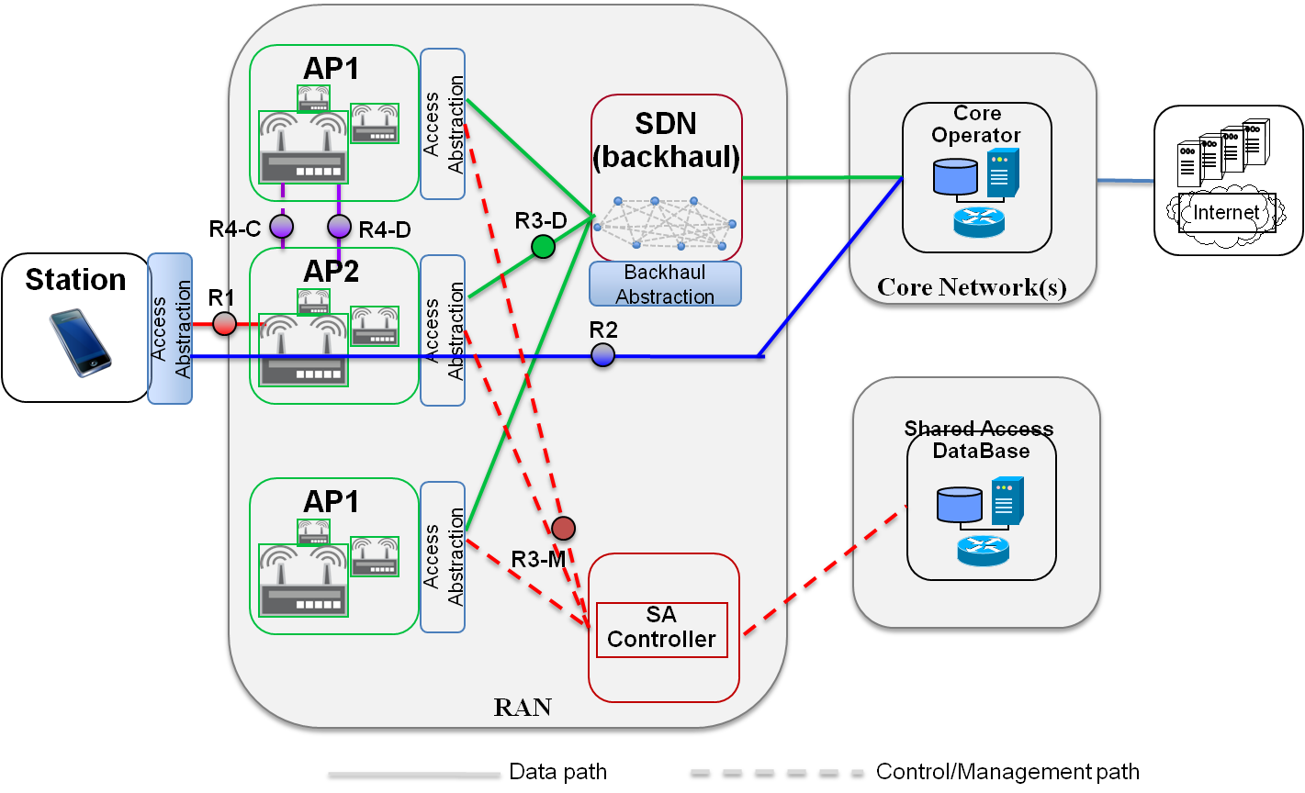
FIG 1. IEEE 802 based authorized shared access network reference model

FIG. 1 shows the logic entities and logic interfaces of network reference model for IEEE802 technology co-existence with primary services in the authorized shared spectrum such as TV White Space. Each logic entity is defined by its functional roles and interfaces with other logic entities.
IEEE 802 based network reference model for authorized shared access consists of following logic network entities:
- IEEE 802 based ASA station (ASA STA)
- IEEE 802 based Access Point (ASA AP)
- SDN based backhaul network
- Shared access controller (SA Controller)
- Shared access database (SA-DB)
- Operator’s Core network

A Reference Point is a logic interface between two logic entities which contains a set of communication protocols used for the information exchange between two logic entities. The IEEE 802 based authorized shared access network reference model contains a couple of Reference Points.
- R1 reference point: R1 is the radio access interface related to IEEE802 technologies on the authorized shared spectrum.
- R2 reference point: R2 is the interface between STA and Core network entity through the radio access connection.
- R3 reference point: R3 is the interface of AP to the Core network through backhaul network such as SDN. The R3 interface contains three planes:
- Data plan interface called R3-D which consists of a set of data transmission protocols
- Control plane interface called R3-C which is used to control the data plane’s setup, switching and teardown.
- Management plane interface called R3-M which is used to control the ASA AP operation such as setup, provisioning and teardown over the authorized shared access spectrum.
- R4 reference point: R4 is the interface between two ASA APs which is used to support communications across APs for the services such as inter-AP handover. R4 reference point contains sets of protocols for data plane (R4-D) and control plane (R4-C).

  - Network Entity Descriptions
5.3.1 ASA Station (STA)
IEEE 802 based radio access network contains one or more stations (STA), which provides radio access for the end user to access the service in Core network. An ASA STA is a logic entity of IEEE 802 based radio station operating in the authorized frequency channel(s) such as TV white space, which is shared with primary services of TV broadcast over the same authorized spectrum.

5.3.2 ASA Access Point (AP)
IEEE 802 based authorized shared access network contains one or more ASA Access Points (AP), which could be controlled by single network control entity. An ASA AP provides radio access connectivity to the IEEE 802 based ASA STAs in the authorized license frequency channel(s), which is shared with primary services over this authorized spectrum.

5.3.3 Shared Access Controller
The shared access controller (SA-Controller) is a logic entity in the IEEE 802 based authorized shared access network which is used to manage and control operation of ASA APs, such as setup, provisioning, and tear-down over the authorized spectrum shared with primary services. The SA-Controller also control the operation of ASA STAs over the authorized shared spectrum.

The shared access controller may support following but not limited to functions for co-existence with primary servers and/or other services over the authorized shared spectrum.
- Co-existence management: it is responsible for determine enabling ASA AP to co-exist with primary wireless device in the authorized shared spectrum.
- Co-existence discovery and information server is used to store the co-existence information used for determining co-existence of ASA APs operating in the authorized spectrum shared with primary wireless services.

The shared access controller can communicate with one or more IEEE 802 based ASA APs through the Reference Point. The shared access controller can also communicate with IEEE 802 based ASA APs through the interface element called Co-existence Enabler (CE) defined in IEEE 802.19.1 that represents one or more IEEE 802 based APs in the co-existence system.
A Reference Point is a logic interface between two logic entities which contains a set of communication protocols used for the information exchange between two logic entities.
The interface at a Reference Point could consist of separated planes
- Data Plane: it defines a set of protocols for functionalities implemented in two network entities regarding user data traffic encapsulation, sequencing, encryption, tunneling, forwarding amongst the Core network, ASA AN and STAs.
- Control Plane: the control plane defines a set of protocols used for implementing the control functions of service management, user traffic connection setup and termination, mobility management, accounting, etc.
- Management Plane: the management plane defines a set of protocols for implementing management functions of the network such as IEEE 802 based authorized shared access network’s authentication, authorization and provisioning.
The shared access controller uses the Management Plane of Reference Point (R3-M) to communicate with one or more IEEE 802 based ASA APs for the authentication, authorization and provisioning.

The shared access controller can communicate with one or more shared access databases (SA-DB) through the external Interface C defined in IEEE 802.19.1 which is out of scope of this document.

5.3.4 Shared Access Database (SA-DB)
The authorized shared access database (SA-DB) or authorized shared access server (SA-Server) is a logic entity in the IEEE 802 based authorized shared access network reference model to provide storage of the information used for the access services over the authorized spectrum shared with primary services. The information could include
- authorized shared frequency band and channels information
- shared access spectrum geo-location information
- allowed maximum transmit power in the authorized shared access spectrum
- primary service provider and secondary service providers and their operating status
- potential neighboring services and their interference levels
SA controller communicates with SA-DB/SA-Server through the Interface C to get the authorized shared access information and may store them in the local memory. SA controller may update the local stored information periodically to synchronize with SA-DB/SA-Server.

SA-DB/SA-Server is only required for shared access with primary services in the authorized spectrum.

- Functional Design and Decomposition
  - ASA Access Network Setup and Configuration
The ASA Access Network setup and configuration is to provide a procedure of operating APs in the authorized spectrum environment shared with primary wireless devices.

  - Operating in shared access frequency bands
In order to operate in the authorized access spectrum shared with primary services, the IEEE 802 based ASA AP is required to check the availability of shared authorized spectrum first before turning on its radio transmission. IEEE 802 based ASA AP should request and get authorization of using the authorized shared spectrum for transmitting signal over the shared medium.

FIG xx shows the procedure of IEEE 802 based access network setup.

- The IEEE 802 based ASA AP establishes a backhaul IP connection for the management plane to communicate to the SA controller. After the IP connection is established, the ASA AP and SA controller can exchange the information through the interface of backhaul.
- Once IP connection is established, the ASA AP can send a SA registration request message through the Reference Point to the SA controller to register with the SA controller for the shared access service operation over the authorized shared spectrum. The SA controller may forward this SA registration request message to the SA-Server/SA-DB for authentication and authorization.
- The SA-Server/SA-DB authenticates the ASA AP to determine operation on the shared spectrum. The SA-Server/SA-DB sends the response message to SA-Controller about the authentication and authorization result. Then the SA controller sends the SA registration response message to the ASA AP upon receiving the response message from the SA-Server/SA-DB.
- Once the registration for the shared access service succeeds, the ASA AP can send the SA information request message to SA controller to get the status of the shared spectrum usage information and status.
- The SA controller provides the shared spectrum information and occupancy status back the ASA AP.
- Based on received shared spectrum information and status, the ASA AP decides how to operate the wireless services over the shared spectrum. If ASA AP decides to operate the wireless access services over the shared spectrum, it sends the SA usage notification message to the SA-controller for updating the shared spectrum occupancy status.
- The SA-controller sends an acknowledgement message to the ASA AP after it communicates and updates the shared spectrum usage in SA-DB.
- The ASA AP can now turn on its radio transmission on the shared authorized spectrum to provide access services.

