IEEE 802ECSG
OmniRAN
Minutes of OmniRAN EC SG Teleconference
December 11th, 2013
Date: December 11th, 2013
Author(s):
Name | Affiliation | Address | Phone | email
Paul Congdon | Tallac Networks | 6528 Lonetree Blvd.  Rocklin, CA 95765 | +1 916.757.6350 | paul.congdon@tallac.com
Abstract
Minutes of the OmniRAN EC SG teleconference on December 11th, 2013.
Wednesday, December 11th, 2013

Chair: Max Riegel
Recording secretary: Paul Congdon

Call to order
- Meeting called to order on Wednesday, December 11th, 2013 by Max Riegel at 11:03AM (ET).

Secretary position
- Nobody volunteering; position remains open

Appointment of recording secretary
- Paul Congdon volunteered to take notes

Roll Call

Name | Affiliation
Max Riegel | NSN
Daniel Borges | Apple
Antonio de la Oliva | UC3M
Behcet Sarikaya | Huawei
Paul Congdon | Tallac Networks
Yonggang Fang | ZTE

Agenda
- https://mentor.ieee.org/omniran/dcn/13/omniran-13-0095-00-ecsg-dec-11th-confcall-slides.pptx
  - Approval of minutes
  - Reports
    - EC Closing Plenary in Dallas
    - Contribution to EC Workshop
    - other reports
  - Plans for January Interim and beyond
  - AOB
  - Adjourn
- Agenda approved without objections

Approval of minutes
- Minutes of the November Dallas F2F session not yet available. Approval postponed to the January F2F session.

Reports
- EC Closing Plenary in Dallas
  - https://mentor.ieee.org/omniran/dcn/13/omniran-13-0093-01-ecsg-nov-2013-ec-closing-report.pptx
  - EC approved the PAR by 10-3-1 vote
  - How to handle Charlie Perkin's late comments was discussed
  - The Recommended Practice document project will be P802.1CF
  - Study Group will continue until NesCom approves PAR and P802.1CF is established

- Contribution to EC Workshop
  - https://mentor.ieee.org/omniran/dcn/13/omniran-13-0094-00-ecsg-considerations-for-cooperation-with-802-wgs.pptx
  - The structure and proposal for method of collaboration and creation of the Recommended Practice document was shown
  - Discussion:
    - Antonio asked how SDN will fit into this work.
    - Max points out that the recommended practise has more of an impact on the control interface.
    - Paul suggests that SDN is a means to implement things (an answer to How to make this work) and we should be documenting the common framework and steps across 802 networks (an answer to What needs to be accomplished).
    - Some concern if the work doesn't provide enough of a solution or use case description it will not solve the intended problems.
    - The scope of the TG is to provide the Reference document, not specific protocols. Part of the document will document requirements and current procedures of existing 802 technologies.
    - Antonio believes that we will be providing guidelines for specific use cases,
    - Max points out that the scope is to provide the unified reference across all 802 access technologies, not necessarily particular use cases.
    - Max concludes that we need to have a follow-on discussions about the structure and content of the document we will produce.
  - Max proposes that we put together some initial text of the document to be presented to WGs in March.

- other reports
  - Max reported that he has had discussions with Serge Manning (Wireless & Mobility WG Chair in ONF). Since both groups are new, there is still some start-up coordination that is needed and follow-on discussions will occur.

Plans for January Interim and beyond
- January plans as outlined in meeting slide set were discussed. Intention is to agree to a document outline and organization of the work within IEEE 802.
- Agreed agenda proposal for Jan 2014 L.A. F2F session:
  - Approval of minutes
  - Reports
    - Summary documentation of OmniRAN technical discussion
    - Report on ONF status and activities
  - Outline of the intended specification
    - Intentions and tentative ToC
    - Technical contributions
    - Tenets of IEEE 802 Access Network
  - Organization of the work
    - Cooperation with the other IEEE 802 WGs
      - Liaisons, inbound and outbound
    - Operation within IEEE 802.1
  - Conference calls until March 2014 session
  - Liaison report to IEEE 802 WGs
  - AOB
- The details of the meeting logistics include 4 meetings proposals:
  - Tuesday AM-2, Tuesday PM-1, Wednesday PM-1, Thursday AM-2.
  - There are WG plenaries on Wednesday AM-2 that we are avoiding.
  - Schedule graphics:
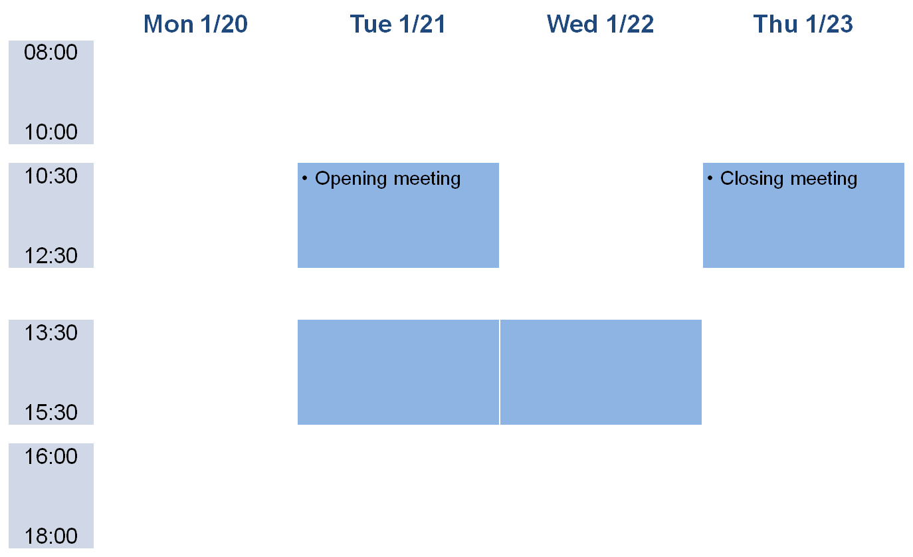

AOB
- No other issues were raised.

Adjournment
- Meeting adjourned at 12:15PM, ET

