IEEE 802 ECSG
OmniRAN
Minutes of OmniRAN EC SG F2F Session
in Nanjing, China on September 17th , 2013
Date: 17-September-2013
Author(s):
Name | Affiliation | Address | Phone | email
Stephen McCann | BlackBerry | 200 Bath Road, Slough, Berkshire, SL1 3XE, UK | +44 1753 667099 | smccann@blackberry.com
Abstract
Minutes of the OmniRAN EC SG F2F session in Nanjing, China on September 17th, 2013.
Tuesday, September 17th, 2013, 19:30 to 21:30 China Standard Time (CST)

Chair: Michael Montemurro
(EC SG chair Max Riegel participated on the telephone)
Recording secretary: Stephen McCann

- Call Meeting to Order
  - Session called to order by the host at 19:39 CST
  - The chair presented the mandatory guiding slides of IEEE SA contained in the session guiding slide set for the September F2F session:
https://mentor.ieee.org/omniran/dcn/13/omniran-13-0068-02-ecsg-september-2013-nanjing-f2f-agenda-material.pptx

- Attendance recording
Chair explained that attendance recording is done byroll call to accommodate F2F participation as well as remote participation. No IMAT registration available this time. Attendence was captured by the chair in the amended meeting slides: https://mentor.ieee.org/omniran/dcn/13/omniran-13-0068-03-ecsg-september-2013-nanjing-f2f-agenda-material.pptx).

- Secretary position
  - Chair asked for volunteers to fill open secretary position
    - No volunteers showed up. The position remains open.
  - Stephen McCann volunteered for taken minutes of the session.

- Approval of agenda
  - Chair brought up the agenda propsal created in the teleconference on June 20th and published on the OmniRAN website.
September 2013 Agenda
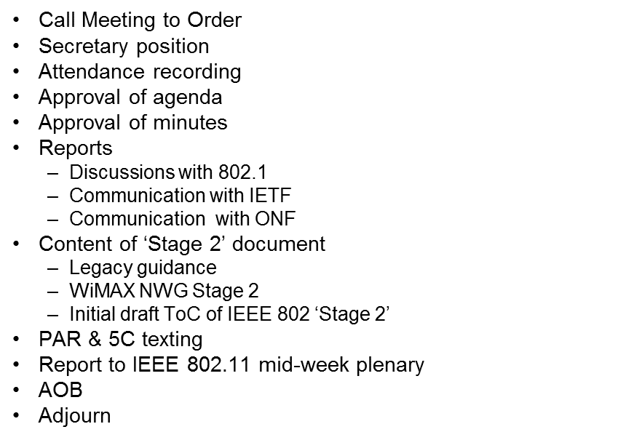
  - The chair asked for demand for additional agenda items or changes to the agenda
    - No requests were brought up
  - The chair asked for objections to acceptance of the proposed agenda
  - The agenda was approved without objections.

- Approval of minutes
  - The minutes of the last meeting in York, UK are not currently available and will be considered during the next meeting.

- Reports
  - The EC SG chair Max Riegel provided the reports remotely.
  - Outcome of closing EC meeting in Geneva
    - Max brought up slides from the closing report of the Geneva meeting to remind everyone of the current status of OmniRAN
    - https://mentor.ieee.org/omniran/dcn/13/omniran-13-0057-00-ecsg-omniran-ec-closing-report.pptx
    - Some specific areas of IEEE 802 projects were identified where standardization could occur also shown in the slides.
    - The IEEE 802.1 chair indicated that they were happy to host the OmniRAN PAR and 5C going forward, once the PAR and 5C ahave been created. The slides show a suggested OmniRAN timetable to create these required documents throughout September and October.

  - York meeting summary
    - https://mentor.ieee.org/omniran/dcn/13/omniran-13-0068-02-ecsg-september-2013-nanjing-f2f-agenda-material.pptx
    - Discussions on gap analysis regarding network detection and selection.
    - IEEE 802.1 items (slide #12)
      - The IEEE 802.11 ANQP solution would be re-worked for the wired technologies.
      - Suggested ways forward will be put into a Stage 2 document and views take to see if ANQP can be extended to fit into the IEEE 802.1X framework.
      - The solution for point-to-point links over bridged infrastructures will be likely based on IEEE 802.1AE.
      - Question (Q): On one slide, it states that OmniRAN was going to define control attributes for IEEE 802 technologies.
      - Max: These are items like master keys delivered from an authentication server to an access point. It is a piece of information defined within IEEE 802. For example it could be transported by RADIUS.
      - Q: Is this described within any of the OmniRAN documents?
      - Amswer (A): No, as it would be defined within one the IEEE 802 WG specifications. OmniRAN is only producing the framework. Network transport technologies will be defined by the IETF.
      - Q: Is there a document where this gap analysis is recorded?
      - A: There will be a document submitted to the IETF in about 2 weeks time.
      - Q: Within ONF (Open Networking Foundation), they expect to have participation by members only. Standards organisations are not usually involved.
      - A: This is probably an issue for IEEE 802.1.
  - IETF items (slide #12)
    - There is already a coordination document between IEEE 802 and the IETF (RFC 4441bis)
    - IETF related issues discovered by OmniRAN will be submitted to this effort.

- ToC of the OmniRAN Recommended Practice
  - The slides show some information on this topic (slide #13)
  - There are high similarities to the Stage 2 definition from ITU-T Q.65:
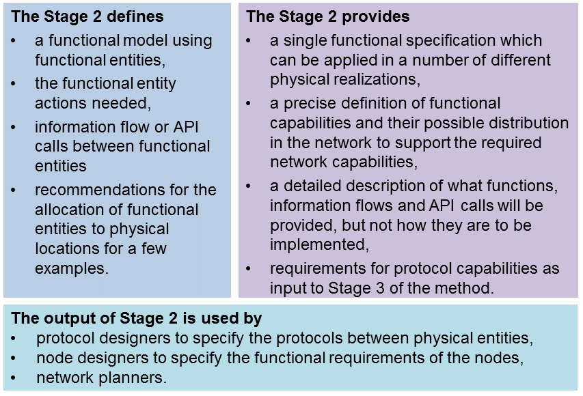

  - Regarding WiMAX (slide #13), they created a Tenets section which may be useful to consider. Tenets would be helpful as a kind of generic requirements for the Stage 2 documentation.
  - Max: These documents are providing very good examples for the ToC of an IEEE 802 Stage 2 document, which will result from the PAR and 5C. Content examples are indicated by the slides #16 and #17.
  - Q: On page #17, is this just an example of a solution, or an actual solution
  - Max: It’s just an example at this point and that is also true of slide #16.
  - Max: Within the PAR I think we need to describe what sort of documentation will be produced.
  - Comment (C): Ok, so can we put some of this material in a PAR explanation document.
  - Max: Sure, we can do this at the November meeting, as we will need to explain the PAR context. In addition, the PAR does not require a table of contents. Parts of slide #14 (shown above) may go into the PAR.
  - Q: On slide #15, it shoes Link Relocation, which is the only handover relevant item. There does not appear to be a requirement for stage 2 handover material.
  - Max: That’s because there has not been very much input material for handover provided. However, I think the scope for the 1st step must be restricted, so we can actualy finish this project in reasonable time.

- PAR and 5C (slide #18)
  - This slide shows some draft text of a PAR and 5C which was started at the York, UK meeting:
  - https://mentor.ieee.org/omniran/dcn/13/omniran-13-0070-00-0000-omniran-par-and-5c-text.docx
  - This is the first snapshot of this document.
  - Max: The PAR is currently in an MSWord document, but eventually will go into an onine form. It is easier to process in this form.
  - Section 3.1: This will be completed by the IEEE 802 Executive Committee (EC)
  - Section 5.5: Expand the last word of section 5.5 to say ‘network operators and service operators”.
  - Max: Ok, I will change that.
  - Dick: Section 5.5: I would change some of these words to state that a new access network is not being generated. The second sentence should be changed. By the way, user terminals do support multiple multiple technologies in multiple ways. Of course, this is done in a proprietary way at the moment. The statement “The project will generate a specification to design access networks able to cope with such complexity”, is therefore incorrect.
  - Max: Ok, I will change it to what you suggest in my local copy.
  - C: Perhaps we can do some word smithing offline, rather than doing it now.
  - Max: Ok, I will upload my revised version to the server at the end of this meeting. We can then continue in a future conference call.
  - Chair: By the way, we only have 13 minutes left.
  - Max: Ok, let’s just spend 3 mote minutes on this document.
  - Max: Regarding section 8.1, I have some proposed text for the next conference call. Now onto the 5C section (within the same document).

- Liaison Report to IEEE 802.11 Mid Week Plenary
  - Chair: I’ve generated some material for this meeting tomorrow. However, the slides still need to be updated
  - Max: I would remove document 54, as it does not exist anymore.
  - Chair: Ok, that’s fine.
  - Max: The plan for November should state that a PAR and 5C will be completed and presented to the EC.
  - Max: I would note that IEEE 802.1 has only offered to take OmniRAN, but has not accepted it, until they see the PAR and 5C documents.
  - Document was uploaded after incorporating proposed changes:
https://mentor.ieee.org/omniran/dcn/13/omniran-13-0069-00-ecsg-omniran-ec-sg-liaison-report-september-2013.pptx

- AOB
  - No other business was brought up.
  - Max: I would like to thank Michael for organizing and chairing this meeting this evening.
  - C: In the text proposal for 5C it says ‘all modern standards are developed using Stage 2”, but excludes any mention to the IETF. This is not true, as they do that work.
  - C: OmniRAN appears to be moving to IEEE 802.1, which is a wired group, whereas it had been initiaed by wireless experts. Therefore I have a concern that the final outcome of this project is not what was originally expected.

- Adjourn
  - The session of the OmniRAN EC SG was adjurned by the chair at 21:31 CST.

- Attendance

Name | Affiliation
Max Riegel (by phone) | NSN
Michael Montemurro | BlackBerry
Stephen McCann | BlackBerry
Mark Hamilton | Spectralink
Charlie Perkins | Futurewei
Yong Gang Fang | ZTE
Dick Roy | SRA
Hyeong Ho Lee | ETRI
Hyunho Park | ETRI

