IEEE 802 ECSG
OmniRAN
Minutes of OmniRAN EC SG F2F Session
in Geneva, Switzerland on July 15th – 19th , 2013
Date: 24-July-2013
Author(s):
Name | Affiliation | Address | Phone | email
Antonio de la Oliva | UC3M |  | +34 91 624 8803 | aoliva.it@gmail.com
Juan Carlos Zuniga | InterDigital | 1000 Sherbrooke W  10th Floor  Montreal, QC, Canada | +1 (514) 904 6300 | j.c.zuniga@ieee.org
Max Riegel | NSN | St-Martinstr 76  Munich, 81541, Germany | +49 (173) 293 8240 | maximilian.riegel@nsn.com
Abstract
Minutes of the OmniRAN EC SG F2F session in Geneva, Switzerland on July 16th-18th, 2013.
Tuesday, July 16th, 2013, 13:30 to 15:30 CET
Chair: Max Riegel
Recording secretary: Juan Carlos Zuniga, Antonio de la Oliva

- Call Meeting to Order
  - Session called to order by the chair at Tue 13:35
  - The chair presented the mandatory guiding slides of IEEE SA contained in the session guiding slide set for the Geneva F2F session:
    - https://mentor.ieee.org/omniran/dcn/13/omniran-13-0050-01-ecsg-july-2013-geneva-f2f-agenda.pptx

- Attendance recording
  - Chair explained that attendance recording is done by paper sheets with the possibility to gain reciprocal attendence credits by using registration by IMAT as well.

- Secretary position
  - Chair asked for volunteers to fill open secretary position
    - No volunteers showed up. The position remains open.
  - Juan Carlos Zuniga volunteered for taken minutes of the session.

- Approval of agenda
  - Chair brought up the agenda propsal created in the teleconference on June 20th and published on the OmniRAN website.
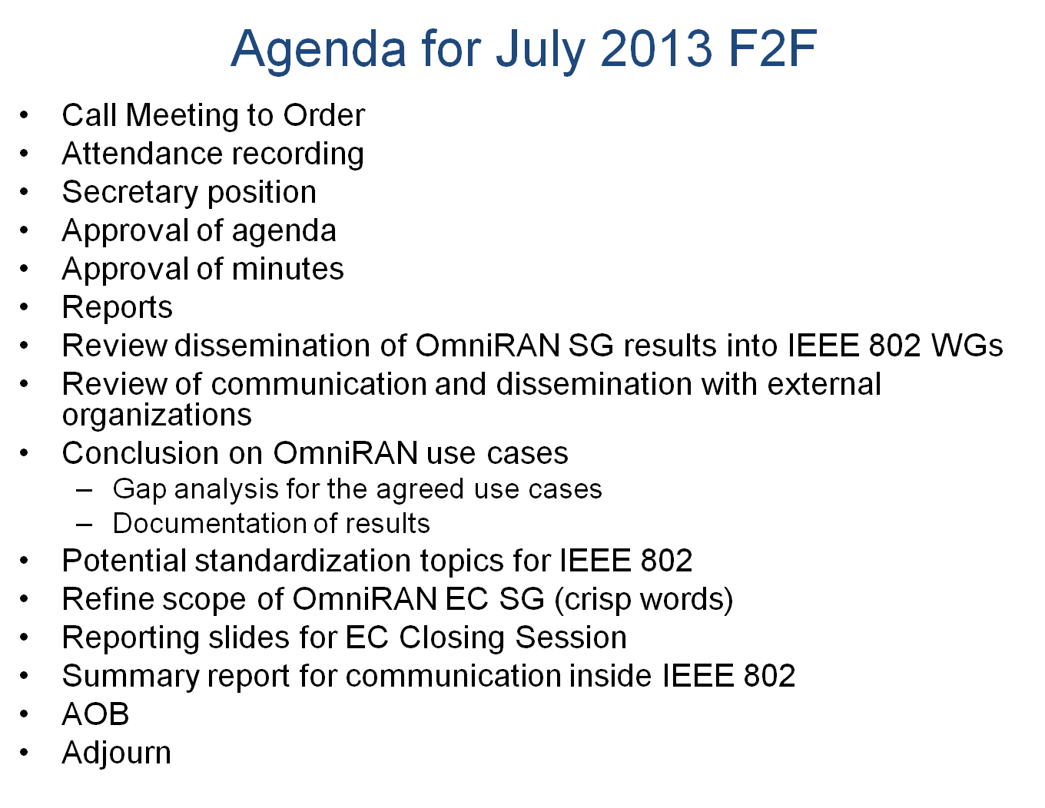
  - The chair asked for demand for additional agenda items or changes to the agenda
    - No requests were brought up
  - The chair went over the meetings of the week and pointed out that a joint meeting with 802.11ARC is planned for the first hour of the Wed AM1 meeting (in CICG room 14) and with 802.21 in the first hour of the Wed PM1 session.
  - A further joint meeting with 802.16 has been scheduled for Thursday morning and a presentation to 802.15 is tentatively scheduled for Wednesday 15:00.
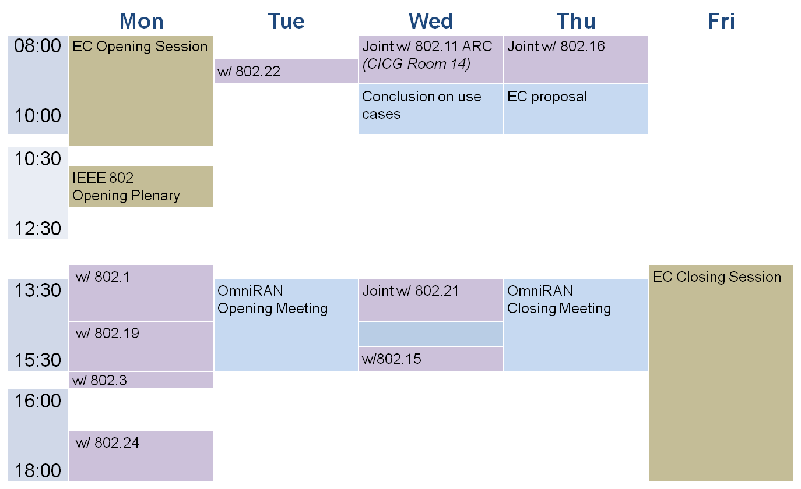
  - The chair asked for objections to acceptance of the proposed agenda
  - The agenda was approved without objections.

- Approval of minutes
  - https://mentor.ieee.org/omniran/dcn/13/omniran-13-0047-00-ecsg-meeting-minutes-for-may-2013-waikoloa-session.docx
    - The chair brought up the minutes of the Waikoloa session and asked for corrections or amendments. No request to change the minutes was raised.
    - The chair asked for objections to approve the minutes of the waikoloa session.
    - The minutes were approved without objections.
  - https://mentor.ieee.org/omniran/dcn/13/omniran-13-0049-00-ecsg-meeting-minutes-of-june-20th-conference-call.docx
    - The chair brought up the minutes of the June 20th conference call and asked for corrections or amendments. Antonio requested to correct the spelling of his affiliation. The spelling of the affiliation was corrected and the revision of the minutes was uploaded to Mentor.
    - https://mentor.ieee.org/omniran/dcn/13/omniran-13-0049-01-ecsg-meeting-minutes-of-june-20th-conference-call.docx
    - No other requests for modifications were made.
    - The chair asked for objections to approve the minutes of the June 20th conference call.
    - The minutes were approved without objections.

- Reports
  - The chair brought up the slides 11 and 12 of the session guiding slide set pointing out the objectives and the current stage of the work.
  - The chair opened the slides provided to the EC opening meeting and explained that only a verbal report was given due to shortage of time.
    - https://mentor.ieee.org/omniran/dcn/13/omniran-13-0051-01-ecsg-jul2013-ec-opening-report.pptx
- Review dissemination of OmniRAN SG results into IEEE 802 WGs
  - The chair mentioned that presentations of OmniRAN EC SG findings were presented to 802.1, 802.19, 802.22 and 802.24 based on the slides:
    - https://mentor.ieee.org/omniran/dcn/13/omniran-13-0048-03-0000-omniran-ecsg-results-and-outlook.pptx
  - The slides 14 and 15 of the session guiding slide set capture the essential outcomes of the presentations to the 802.1, 802.3, 802.19, 802.22 and 802.24
  - The study group reviewed the presentation slides to the WGs and provided comments, in particular to create more concrete statements for the directions of the EC SG going forward.
  - Due to the limited presentation time the presentation to 802.3 was done based on the following slides with the invitation to the 802.3 attendents to come to the OmniRAN EC SG meetings to get a more comprehensive insight into the findings of the EC SG
    - https://mentor.ieee.org/omniran/dcn/13/omniran-13-0052-00-ecsg-omniran-liaison-report.pptx
  - The chair recessed the session at Tue 15:30 reminding that the group meets Wed AM1 first with 802.11ARC before reconveneing OmniRAN EC SG business in CCV Room C at about 09:00.

Wednesday, July 17th, 2013, 08:00 to 10:00 CET
Chair: Max Riegel
Recording secretary: Juan Carlos Zuniga, Antonio de la Oliva

- Joint meeting with 802.11 ARC
  - In the joined meeting with 802.11ARC the following slides were presented:
  - https://mentor.ieee.org/omniran/dcn/13/omniran-13-0048-03-0000-omniran-ecsg-results-and-outlook.pptx (without slides 33-35). Also, the following slides were presented:
  - https://mentor.ieee.org/omniran/dcn/13/omniran-13-0055-00-0000-progressing-omniran.pptx
  - The second presentation raised quite some discussion, finally leading to the conclusion that 802.11 ARC would support the extension of OmniRAN EC SG for creation of a draft PAR and 5C.
  - The joint meeting was closed at 09:15 CET

  - The chair reconvenend the meeting in CCV room C at 09:25 CET and called the meeting to order.
  - The chair reminded that the joint meeting with 802.16 has been scheduled for the first hour of the Thursday AM1 session, and a presentation to 802.15 has been finally reserved for Wednesday 15:00.
  - Following the announcements the study group continued on with the agenda.

- Review of communication and dissemination with external organizations
  - No response received yet from 3GPP

- Conclusion on OmniRAN use cases
  - Gap analysis for the agreed use cases
  - Documentation of results
  - Juan Carlos Zuniga presented the revision of the slides on the SDN use case pointing to the edits, which went into the revision.
    - https://mentor.ieee.org/omniran/dcn/13/omniran-13-0044-01-0000-sdn-use-cases-summary.pptx
    - Discussion came up on some editorial details in the slides finally leading to another revision.
      - https://mentor.ieee.org/omniran/dcn/13/omniran-13-0044-02-0000-sdn-use-cases-summary.pptx
    - The group agreed on putting the slides in a new revision of the ec-results-and-outlook slides (ominran-13-0048-03).
  - The meeting was recessed by the chair at 10:05.

Wednesday, July 17th, 2013, 13:30 to 15:30 CET
Chair: Max Riegel
Recording secretary: Juan Carlos Zuniga, Antonio de la Oliva

- Joint meeting with 802.21
  - The chair called the meeting to order at Wed 13:40 explaining that the first hour of the PM1 meeting is reserved for the joint discussion with 802.21 and a presentation slot in 802.15 as reserved for 15:00 requireing the chair to recess the meeting latest 14:55.
  - The chair opened the joint meeting with 802.21.
  - The discussion with 802.21 was based and guided by the presentation
    - https://mentor.ieee.org/omniran/dcn/13/omniran-13-0048-04-0000-omniran-ecsg-results-and-outlook.pptx
  - as revised according to the discussions in the AM1 meeting.
  - Joe brought up in the discussion that the EC SG should address a full standard instead of a recommended practice to show the importance of the work.
  - There was no conclusion whether it would be more appropriate to go for full standard.

  - After closing the joint meeting at Wednesday14:55 the chair recessed the meeting to head for the assigned presentation slot in 802.15 at 15:00

Thursday, July 18th, 2013, 08:00 to 10:00 CET
Chair: Max Riegel
Recording secretary: Juan Carlos Zuniga, Antonio de la Oliva

- Joint meeting with 802.16
  - Reconvening the meeting at Thursday, 08:30 the chair called the meeting to order and opened the joint meeting together with 802.16.
  - The discussion was following the presentation of the slides
  - https://mentor.ieee.org/omniran/dcn/13/omniran-13-0048-04-0000-omniran-ecsg-results-and-outlook.pptx
  - The group discussed that there is a need for a common interface from lower layers to higher layers, and that it was good from the work in OmniRAN to highlight issues common to all 802 technologies

- Conclusion on OmniRAN use cases, cont.
  - After closing the joint meeting with 802.16 at 09:30 the chair continued with the agenda asking for the presentation of the following contribution:
    - https://mentor.ieee.org/omniran/dcn/13/omniran-13-0054-00-ecsg-omniran-architecture.pptx
  - As the submitter was not present for presentation, the chair continued with the agenda.

- Potential standardization topics for IEEE 802
  - The group addressed the wording of the plan to create a PAR and 5C for a Recommended Practice
  - The outcome of the edits were captured of the last slide of a slidedeck, which the chair prepared as input for the creation of the report to the EC closing meeting.
  - The chair recessed the meeting at 10:00.

Thursday, July 18th, 2013, 13:30 to 15:30 CET
Chair: Max Riegel
Recording secretary: Juan Carlos Zuniga, Antonio de la Oliva
  - Reconvening the meeting the chair called the meeting to order at Thursday 13:40.

- Refine scope of OmniRAN EC SG (crisp words)
- Reporting slides for EC Closing Session
  - The chair opened the discussion on the two topics by going through the presentation
  - https://mentor.ieee.org/omniran/dcn/13/omniran-13-0056-00-ecsg-omniran-ecsg-jul13-conclusions.pptx
  - By discussion and online editing a revision of the jul13-conclusion with the presentation content for the EC closing meeting was created and uploaded.
  - https://mentor.ieee.org/omniran/dcn/13/omniran-13-0056-01-ecsg-omniran-ecsg-jul13-conclusions.pptx
  - As a focused slide set without any back-up material is needed for the report a dedicated EC reporting slideset was created and uploaded.
  - https://mentor.ieee.org/omniran/dcn/13/omniran-13-0057-00-ecsg-omniran-ec-closing-report.pptx
  - A motion was brought up approving the report to the EC closing plenary together with requesting the extension of the OmniRAN EC SG was brought up.
  - The motion passed by 7 yes/0 no/o abstain

- Summary report for communication inside IEEE 802
  - Michael Montemurro presented his proposal for the summary report to working groups within IEEE 802.
  - https://mentor.ieee.org/omniran/dcn/13/omniran-13-0053-00-ecsg-omniran-ec-sg-liaison-report-july-2013.pptx
  - No proposals for corrections or amendments were raised.
  - The summary report was approved without objections.

- AOB
  - No other business was brought up.

- Adjourn
  - The session of the OmniRAN EC SG was adjurned by the chair at 15:50 CET.

