IEEE 802ECSG
OmniRAN
OmniRAN Executive Committee Study Group
Meeting Minutes for May 2013 Session
Waikoloa, HI, U.S.A.
Date: 19-May-2013
Author(s):
Name | Affiliation | Address | Phone | email
Charles E. Perkins | Futurewei | 2330 Central Expressway  Santa Clara, CA 95050, USA | +1-(408)-330-5305 | charliep@computer.org
Juan Carlos Zuniga | InterDigital | 1000 Sherbrooke W, 10th Floor  Montreal, QC, Canada | +1 (514) 904 6300 | j.c.zuniga@ieee.org
Michael Montemurro | RIM | 4701 Tahoe Blvd ,  Mississauga, ON.,Canada | +1-905-629-4746 | mmontemurro@rim.com
Max Riegel | NSN | St-Martinstr 76,  Munich, 81541, Germany | +49-173-293 8240 | maximilian.riegel@nsn.com
Abstract
Minutes for the OmniRAN ECSG session held in Waikoloa, HI, U.S.A. in May 2013.
Monday, May 13, 2013, 10:30 to 12:30

Chair: Max Riegel
Recording secretary: Charles Perkins

Call to order and agenda

- Call Meeting to Order
  - Meeting called to order on Monday, May 13th 2013 by Max Riegel at 10:30.
  - The chair then brought up the introductory slides 3-8 of the agenda slideset https://mentor.ieee.org/omniran/dcn/13/omniran-13-0030-01-ecsg-may-2013-waikoloa-agenda.pptx
  - Juan-Carlos introduced himself as vice chair
  - Charlie Perkins volunteered to take minutes, but not to be Secretary.

- Attendance recording
  - The chair advised to use the paper sheets – and in addition IMAT for reciprocal attendance credits in other WGs

- Approval of Agenda
  - The chair brought up the proposed agenda:
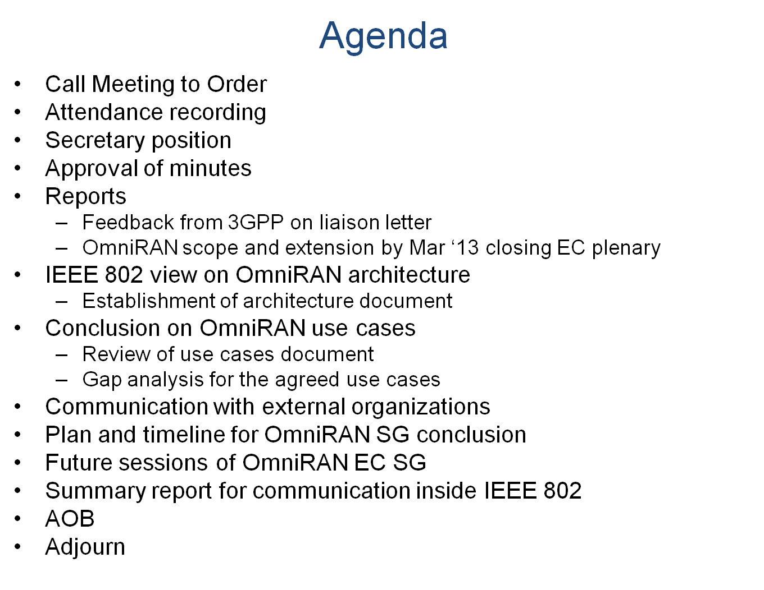
  - For the course of the week the chair proposed the assignment of agenda topics to meeting slots according to the plan provided in the agenda slideset.
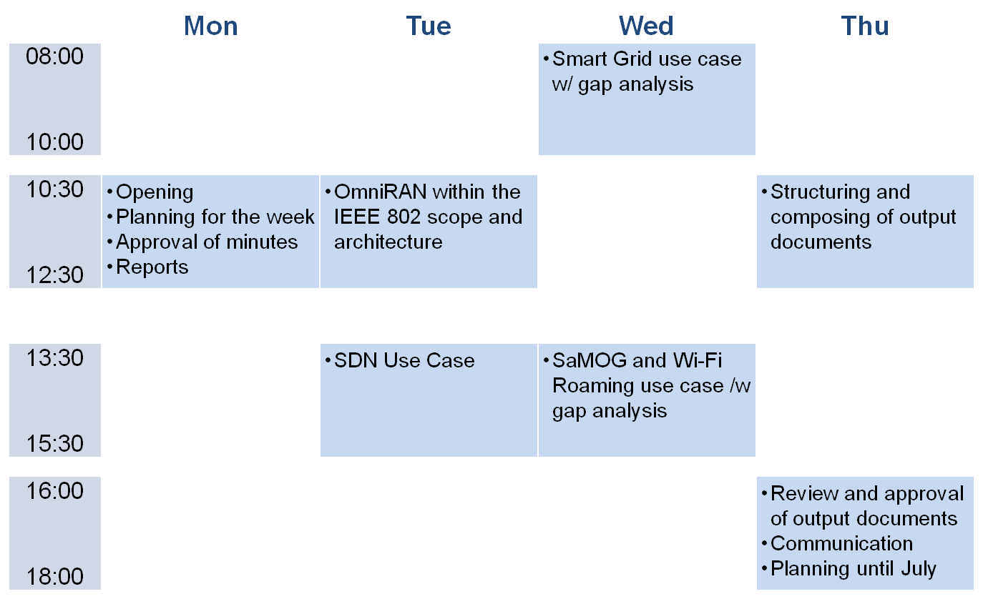

  - The agenda as well as the allocation of the agenda topics to the meeting slots were approved without objections.

- Secretary position
  - When the chair asked the participants, nobody volunteered for the position.
  - The position is kept open looking for a volunteer.

- Approval of minutes
  - March Orlando F2F session
    - https://mentor.ieee.org/omniran/dcn/13/omniran-13-0033-00-ecsg-meeting-minutes-for-march-2013-plenary-meeting.docx
    - No comments
    - Approved without objections
  - April 11th conference call
    - https://mentor.ieee.org/omniran/dcn/13/omniran-13-0035-00-ecsg-meeting-minutes-for-april-2013-teleconference.docx
    - No comments
    - Approved without objections
  - May 2nd conference call
    - https://mentor.ieee.org/omniran/dcn/13/omniran-13-0036-00-ecsg-meeting-minutes-for-may-2013-teleconference.docx
    - No comments
    - Approved without objections
  - Documentation of attendance in F2F sessions
    - While attendance in conference calls is captured in the minutes of the call, the attendence in F2F meetings will be captured in an Excel sheet on Mentor.
    - https://mentor.ieee.org/omniran/dcn/13/omniran-13-0045-00-ecsg-omniran-ecsg-f2f-attendance.pdf

- Reports
  - OmniRAN liaison letter to 3GPP SA2
    - https://mentor.ieee.org/omniran/dcn/13/omniran-13-0024-01-0000-3gpp-liaison-on-samog-interpretations.docx
    - Sent out on March 28th, 2013
    - So far no response received
  - OmniRAN extension by EC closing plenary in March ‘13
    - Chair introduced the discussion and decision in the EC closing plenary in March leading to a refined scope of the OmniRAN ECSG
    - The chair expressed that the EC decision effectively stretched out the investigation phase of OmniRAN until July ’13 without the need to step already into concrete wording for the PAR and 5C, which would have been challenging due to the limited time before submission deadline of PAR proposals to the July ’13 plenary.

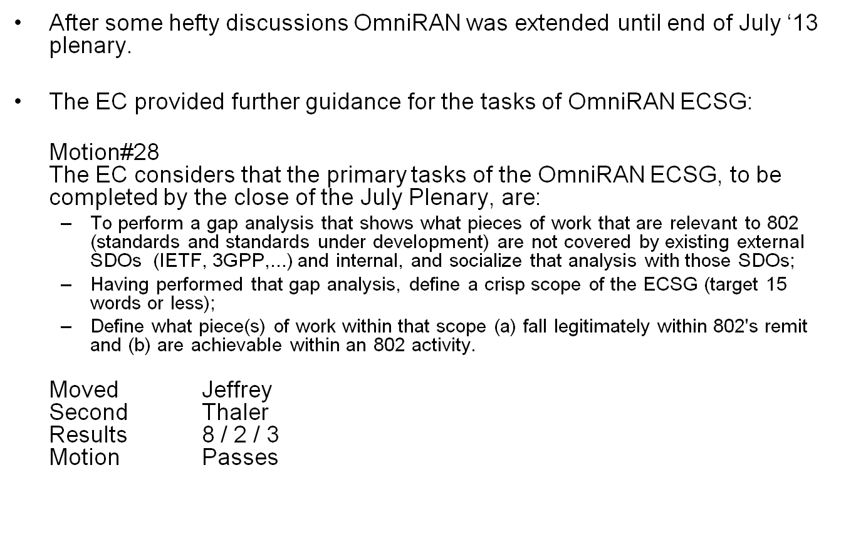
    - The changes to the project plan were presented and reviewed.
    - No objections following the guidance of the EC were brought up.

Recess
The meeting was recessed, without objection, at 12:30

Tuesday, May 14, 2013, 10:30 to 12:30

Chair: Max Riegel
Recording secretary: Juan Carlos Zuniga

Meeting called to order by Max Riegel at 10:30. The chair then reviewed the following topics from the agenda:

- IEEE 802 view on OmniRAN architecture
  - https://mentor.ieee.org/omniran/dcn/13/omniran-13-0032-03-0000-ieee-802-scope-of-omniran.pptx
    - Max presented his contribution introducing the different perspectives of access network architectures
    - A number of enhancementments were proposed during the discussion
    - In particular better differentiation between IEEE 802 scope issues and OmniRAN deliverables was wanted (e.g. definition of 802 attributes and protocols clearly belongs in the IEEE 802)
  - Establishment of architecture document
    - The proposal to establish an OmniRAN scope document based on the presentation was generally agreed
    - It was agreed that a revision of the scope document incorporating the discussed enhancements will be submitted for acceptance in closing session of OmniRAN SG.
Recess
The meeting was recessed, without objection, at 12:10

Tuesday, May 14, 2013, 13:30 to 15:30

Chair: Max Riegel
Recording secretary: Max Riegel

Meeting called to order by Max Riegel at 13:30. The chair then introduced the first topic area for the agenda item:

- Conclusion on OmniRAN use cases
  - Review of use cases document
  - Gap analysis for the agreed use cases

- SDN use case

The meeting was assigned to the presentation and discussion of the contributions on the SDN use case:

  - https://mentor.ieee.org/omniran/dcn/13/omniran-13-0029-01-0000-sdn-use-case-requirements.pptx
  - Juan Carlos presented the SDN requirements
    - Q: what do you mean w/ access abstraction
A: interface independent of particular technology
    - Q: related to OpenFlow
A: Yes, will be shown in subsequent presentation
    - Q: Are reference points compatible with established architecture
A: Yes. In this case, data paths remain, however control is centralized into one single entity
    - Q: is SDN control the centralization of all control
A: Yes, it separates all control functions from the user plane functions
    - Q: How multi-operator is handled
A: SDN controller is centralized for multi-operator (MVNO scenario); no multiple SDN controllers for each operator; Assumption that multiple operators can agree on single controller
  - Gap Analysis to existing technologies
  - https://mentor.ieee.org/omniran/dcn/13/omniran-13-0038-00-0000-sdn-use-case-gap-analysis.pptx
  - Juan Carlos presented the slides
  - The discussion brought up the following aspects:
    - Gap analysis is needed for missing functionality in any of the protocols
    - Need to have unified generic 802 logical interface to IP
    - Gap analysis also contains configuration of traffic forwarding rules over R2, which can also be done OTT, e.g. by use of ANDSF
  - Connection oriented SDN
  - https://mentor.ieee.org/omniran/dcn/13/omniran-13-0039-00-0000-connection-oriented-software-defined-networking.pdf
  - Roger presented his slides
    - model extends legacy SDN by management of the connection links between ports of switches
    - may be more related to R3 than to R1 as it aggregates links

  - Conclusion of SDN use cases discussion
    - SDN use cases got broad support for inclusion into the scope of OmniRAN
    - It was agreed that presentations are complementing each other and should be combined into one document following the agreed structure of use cases documents.
    - A combined presentation should be submitted for the closing meeting of OmniRAN SG
Recess
The meeting was recessed, without objection, at 15:30
Wednesday, May 15, 2013, 08:00 to 10:00

Chair: Max Riegel
Recording secretary: Michael Montemurro

Meeting called to order by Max Riegel at 08:10. The chair then continued the following topics from the agenda:

- Conclusion on OmniRAN use cases, cont.

- SEP2 Smart Grid use case

  - https://mentor.ieee.org/omniran/dcn/13/omniran-13-0041-00-0000-sep2-smart-grid-use-case-analysis.pptx
  - Max presented the slides
    - On slide 12 of the document, it would be good to point out explicitly what we are defining in OmniRAN with respect to this particular reference model.
    - Document omniran-13-00132-03-0000 describes the scope of OmniRAN
    - Slide 25 of the document summarizes the scope of OmniRAN
  - https://mentor.ieee.org/omniran/dcn/13/omniran-13-0037-01-0000-sep2-smart-grid-gap-analysis.docx
    - Document omniran-13-0037-01-0000-sep2-smart-grid-gap-analysis describes the OmniRAN solution requirements
    - It would be beneficial to go through each OmniRAN use case and identify the GAP’s that would be addressed by IEEE 802 groups.
    - It would be worthwhile to consolidate the solution to describe the scope more clearly.
    - The challenge is that OmniRAN has both an informative and normative solution.
  - Agreement to update the document to make a clearer description of how the Smart Grid use case maps to OmniRAN.
    - Draw a clear mapping of this use case to slide 11 and slide 25 of the OnmiRAN scope document.
    - Add a procedural view for the Smart Grid use case.
    - Revision expected for closing OmniRAN SG meeting on Thu PM2
Recess
The meeting was recessed, without objection, at 09:45

Wednesday, May 15, 2013, 13:30 to 15:30

Chair: Max Riegel
Recording secretary: Juan Carlos Zuniga

Meeting called to order by Max Riegel at 13:40. The chair then reviewed the following topics from the agenda:

- Conclusion on OmniRAN use cases, cont.

- 3GPP SaMoG use case
  - https://mentor.ieee.org/omniran/dcn/13/omniran-13-0042-00-0000-orchestration-of-son-features-for-wifi-offloading-using-network-empowerment-mechanisms.pptx
  - The slides were presented by Marc Emmelmann
    - Potential interest to merge proposal with information available by ITS
    - Marc will check possibility to refine proposal
  - https://mentor.ieee.org/omniran/dcn/13/omniran-13-0040-00-0000-3gpp-trusted-wlan-use-case-analysis.pptx
  - Max presented the slides
    - Use case focusing on already defined R11 specification, and not looking at open issues from R12
    - Agreement that OmniRAN will concentrate on the gaps identified in R11 as out of scope for 3GPP
    - Use case generally acceptable
    - Narrow focus on TS 23.402 raised some concern that it would restrict general use of the feature
      - Presenter explained that missing features would be beneficial for multiple use cases when available
  - Wi-Fi Roaming use case
  - https://mentor.ieee.org/omniran/dcn/13/omniran-13-0019-02-0000-omniran-wi-fi-hotspot-use-case.pptx
  - Max brought slides up for discussion
    - Agreement that use case does not add to OmniRAN, as currently no IEEE 802 specific attributes are used in roaming exchanges.

- Cancel Thursday morning AM2 meeting
  - As no agenda items were left before closing meeting of OmniRAN at Thursday PM2, the chair proposed to cancel the Thursday AM2 meeting to give the contributors more time to prepare their revised submissions.
  - The group agreed without objections to cancel Thur AM2 meeting and reconvene for the closing meeting on Thur PM2.

Recess
The meeting was recessed, without objection, at 15:10

Thursday, May 16 , 2013, 16:00 to 18:00

Chair: Max Riegel
Recording secretary: Juan Carlos Zuniga

Meeting called to order on by Max Riegel at 16:05. The chair then reviewed the topics from the updated agenda:

- Review and approval of revised documents
  - IEEE 802 scope and OmniRAN specification work
    - The document was considerably reworked to create a straight storyline and get the content consistent.
    - Some more hint and corrections were added during the discussion, which led to a version -05
    - The document is ready for distribution inside the IEEE 802 to address the concerns of the EC in the March ‘13 meeting.
    - A motion was brought up to accept the document as SG outcome
  - Motion:
Approve document
    - https://mentor.ieee.org/omniran/dcn/13/omniran-13-0032-05-0000-ieee-802-scope-of-omniran.pptx
as SG result for defining the scope of OmniRAN within the legitimate scope of IEEE 802 and disseminate the document within IEEE 802
    - Moved: Michael Montemurro
    - Second: Juan Carlos Zuniga
    - Vote: 8/0/1

  - SDN use case analysis
    - A completely revised version following the agreed structure was presented. Some questions were brought up for clarification of terminology, however finally the presented wording was kept because all alternative proposals were considered less clear by the group.
  - SEP2 Smart Grid use case analysis
    - The recommended enhancements of the initial discussion were presented. No further enhancements were proposed for the document.
  - Trusted WLAN access to EPC use case analysis
    - The document did not require a revision, as its content was considered complete in the initial presentation and discussion.
  - Wi-Fi Roaming use case analysis
    - The Wi-Fi roaming use case analysis is not anymore considered in scope for OmniRAN. As shown in the initial presentation, the use case does not add anything to the scope definition of OmniRAN, as all messaging and information elements are addressing topics outside the scope of IEEE 802.
  - Finally a motion was brought up to accept the SDN use case, the SEP2 Smart Grid use case and the Trusted WLAN access to EPC use case as defined by the documents above for the further work of the SG.
  - Motion:
Accept the use case examples documented in the listed documents as base for the further work of OmniRAN SG:
      - https://mentor.ieee.org/omniran/dcn/13/omniran-13-0044-00-0000-sdn-use-cases-summary.pptx
      - https://mentor.ieee.org/omniran/dcn/13/omniran-13-0040-00-0000-3gpp-trusted-wlan-use-case-analysis.pptx
      - https://mentor.ieee.org/omniran/dcn/13/omniran-13-0041-01-0000-sep2-smart-grid-use-case-analysis.pptx
    - Moved: Harry Bims
    - Second: Michael Montemurro
    - Vote: 8/0/0

- Communication with external organizations
  - It was agreed without objections that no formal liaisons will be send out to external organizations before Jul ‘13 session, as technical content has to be matured before requesting review by external organizations.

- Plan and timeline for OmniRAN SG conclusion until Jul ’13
  - 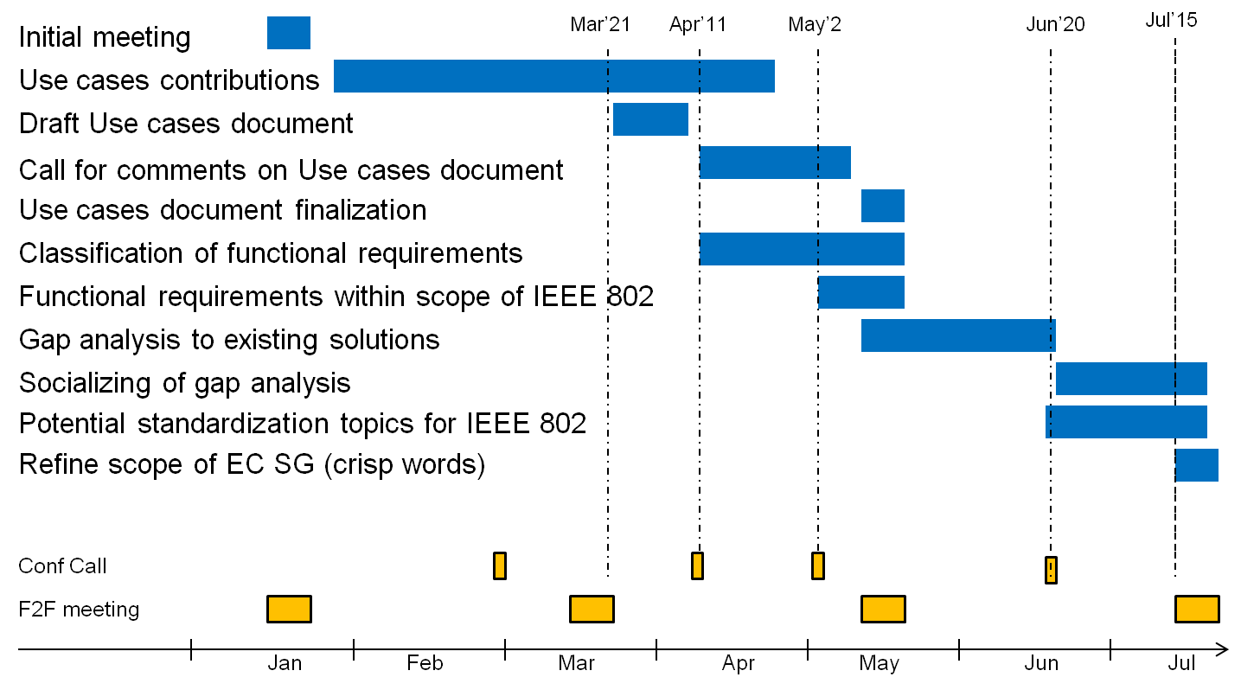
  - No modifications except providing a concrete date for the conference call were proposed to the established plan and timeline for the progress of the work in OmniRAN SG.
  - Detailed planning for the next session in July will be established in the conference call in June.
  - Conference calls of OmniRAN EC SG until Jul ’13
    - It was agreed to have a conference call on Thursday, June 20th, at 0900am ET
  - Number of slots for Jul ‘13 meeting
    - 5 meeting slots (Tue PM1; Wed AM1, PM1; Thu AM1, PM1) will be requested

- Summary report for communication inside IEEE 802
  - Michael Montemurro presented his draft summary report for IEEE 802 internal distribution.
    - Several small modifications were added.
  - https://mentor.ieee.org/omniran/dcn/13/omniran-13-0043-00-ecsg-omniran-ec-sg-liaison-report-may-2013.pptx
  - The revised and uploaded document was approved without objections.

- AOB
  - None

- Adjourn
  - The session was ajourned at 18:15

