myProject™
Volunteer User Guide

Last Updated: June 25, 2013

Table of Contents
1 Introduction 4
2 Getting Started 5
2.1 Accessing myProject™ for the First Time. 5
2.2 Accessing/Updating myProject™ Account Information 5
2.3 Accessing Messages and Notification Preference 6
2.4 The myProject™ Home Screen 8
3 Managing Activities, Roles and Affiliations 10
3.1 Join an Activity/Register as an Interested Party (Sponsor, Working Group, Project) 10
3.2 Update Affiliation Information 11
3.3 Entity Members and myProject™ 12
3.4 Enroll as DR or DRA (Entity Working Groups) 12
3.5 Manage DR and DRA (Entity Working Groups) 14
4 Manage Sponsors and Working Groups 16
4.1 Upload & Manage Sponsor or Working Group P&Ps 16
4.2 Submitting an L50S 18
4.3 Assign/Change Sponsor Officers 19
4.4 Add a Working Group 21
4.5 Assign/Change Working Group Officers 22
4.6 Accept an Assigned Role 24
4.7 Select Involvement Levels 25
4.8 Assign Involvement Level in a Working Group 27
4.9 Assign/Change Sponsor Ballot Designee and Other Project Officers 28
4.10 Send Sponsor Message 30
4.11 Send a Notification to Group 31
4.12 PAR/Standard Report 33
5 The PAR Submission and Approval Process 34
5.1 Submit a PAR for a New IEEE Standard 35
5.2 Saving, Editing, Sharing and Deleting a Draft PAR 37
5.3 Submit a PAR for a Revision, Corrigendum, or Amendment 38
5.4 Modify an Approved PAR 40
5.5 Extend an Existing PAR 42
5.6 Withdraw an Approved PAR 44
5.7 Accept or Reject a PAR 45
5.8 Commenting and voting on a PAR 46
5.9 Downloading a .zip file 49
5.10 Respond to NesCom Comments About a PAR 50
6 Sponsor Balloting 52
6.1 Submit a Draft for MEC 53
6.2 Initiate Ballot Invitation 55
6.3 Close Ballot Invitation 58
6.4 Reopen/Extend Ballot Invitation 59
6.5 Join a Sponsor Ballot (Individual Balloting) 60
6.6 Pay to Join a Single Ballot (Individual Balloting) 62
6.7 Join a Ballot (Entity Balloting) 64
6.8 Manage Ballot Representatives (Entity Balloting) 66
6.9 Remove Yourself from a Ballot 68
6.10 Change Your Voter Classification 69
6.11 Initiate Sponsor Ballot 70
6.12 Review Ballot 71
6.13 Vote and/or Comment on a Ballot 73
6.14 Edit/Delete a Comment 75
6.15 Change (Flip) a vote 77
6.16 View Ballot Summary 79
6.17 View Ballot Comments 81
6.18 Submit Rogue Comment 82
6.19 Comment Resolution 84
6.19.1 Resolution Status Definitions 84
6.19.2 Respond To Ballot Comments Individually 85
6.19.3 Download Comments Resolution File 86
6.19.4 Upload Comments Resolution File 87
6.20 Initiate Recirculation 88
6.21 Request a Ballot Reset or Termination 90
7 RevCom Submission and Review 92
7.1 Submit a Project to RevCom 93
7.2 View or Download an Agenda 95
7.3 Vote and Comment on a Submission 97
7.3.1 Import Comments 99
7.3.2 View All Comments 101
7.4 View RevCom Submission and Respond to Comments 102
7.5 View Meeting Minutes 104
8 User Roles 105
8.1 Volunteer User Roles 105
9 Glossary 107

Introduction

myProject™ is:
- A web-based tool that facilitates the IEEE standards process
- A database that holds information related to the standards process
- A tool used by IEEE members, staff, and other individuals who want to participate in the standards process

In order to use my project, you must have:
- Access to the internet
- A web browser (e.g. Internet Explorer, Firefox, etc.)
- A PDF viewer (e.g. Adobe Reader)
- A spreadsheet editor only for download/upload comment functions (e.g. Excel)
- An IEEE web account
  - IEEE Web Accounts are free and do not require IEEE membership.
  - If you do not have an IEEE web account, create one by going to: https://www.ieee.org/profile/public/createwebaccount/showRegister.html

How myProject™ is used in the standards development process:

Relevant sections of the myProject™ User Guide:
- Committee Formation – Sec 3. Managing Activities, Roles and Affiliations, Sec 4. Manage Sponsors and Working Groups
- Project Authorization – Sec 5. The PAR Submission and Approval Process
- Sponsor Balloting – Sec 6. Sponsor Balloting
- Approval – Sec 7. RevCom Submission and Review

Getting Started

Accessing myProject™ for the First Time.
Applicable Users:
- All myProject™ users

Instructions:
- Go to https://development.standards.ieee.org/my-site
- Enter your IEEE Account username/email and password and click “LOGIN”.
  - If you do not have an IEEE web account, you can create one by clicking on the “Need an IEE Account?” link.

Accessing/Updating myProject™ Account Information
When you access myProject™ for the first time, the Account page will open, requesting information. This information is used by the system to notify you of events and tasks, as well as to automatically add your information to some fields, and is maintained separately from your IEEE Web Account information. This information is required, and only asked for once. You can change this information, however, at any time by clicking on the “Account” link on the Home Screen.

Applicable Users:
- All myProject™ users

Instructions:
  - Select/enter your employer/position information (you can select your employer from the list, or type it in if it isn’t visible).
  - Enter your address information.
  - Enter your telephone numbers.
  - Enter a secondary email, if any (If provided, a copy of all messages will be sent here). Your primary email is maintained through your IEEE Web Account and can be changed by clicking the “Click to change” link.
  - Select your preferred list size from the dropdown box. This value will be used across myProject/IMAT/Mentor when showing a list.
  - Click “OK” to save your information.

Accessing Messages and Notification Preference
MyProject™ users are notified of important events through the myProject™ “Messages” section as well as through email.

Applicable Users:
- All myProject™ users

Instructions:
- From the myProject™ home screen, click “Messages”.

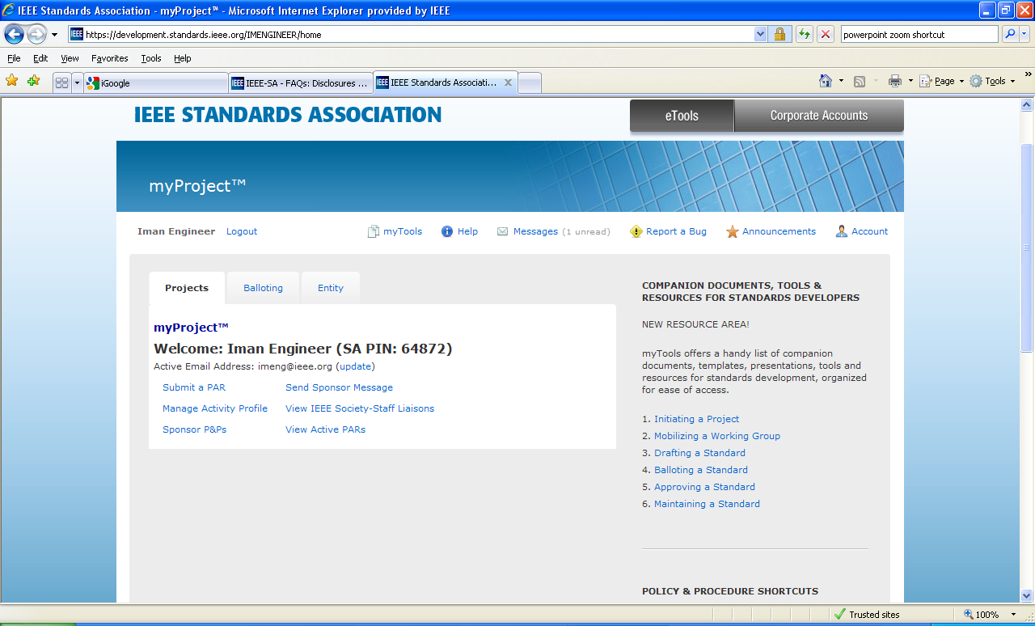

- From this screen, you will be able to see all myProject™ notifications.
- Click on the message subject text to display the message.
- Place a check in the boxes next to the message to mark messages as read or flagged, or to delete messages.
  - You can check a range of boxes at once by clicking the first box, holding the “Shift” key and clicking the last box.

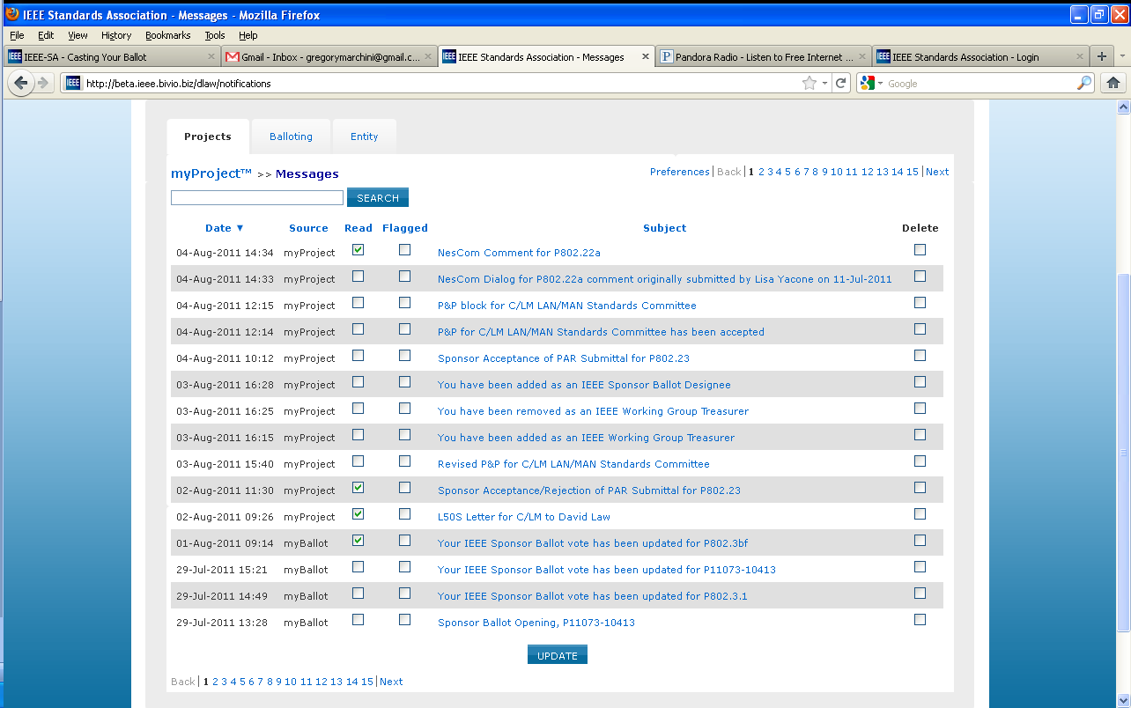

- Click “UPDATE” to apply any changes.
- To manage notification preferences, click “preferences”.

- Check the box to activate or deactivate features.

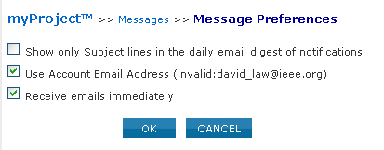

  - “Show only Subject…” when checked will only show subjects in your daily email summary, not the message text.
  - “Use Web Account Email…” when checked will send emails to your primary email address.
  - “Receive emails immediately” when checked will send notification emails as they are generated instead of a daily email digest.
- Click “OK” to save your changes.

The myProject™ Home Screen

The following features are available to all users. Additional features may be available to you based on your specific role and will appear in the lower section.

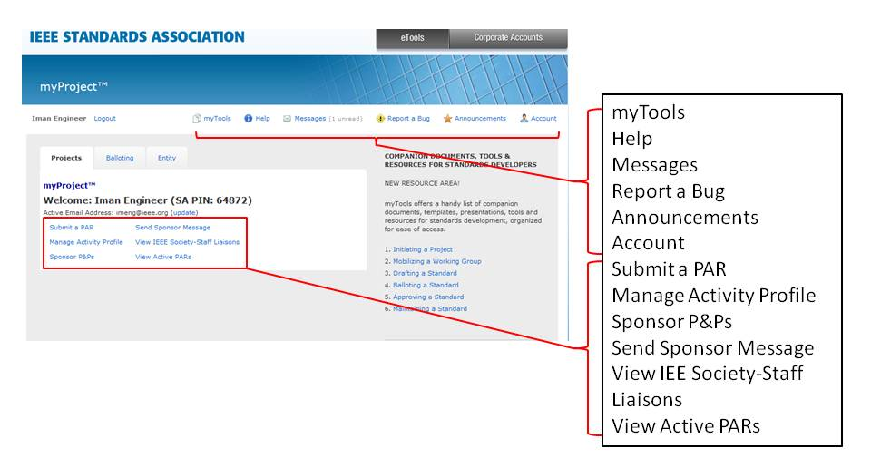
Click on “eTools” to access other tools (Mentor and IMAT)
Additional options may appear here.
Additional resources can be found here
myTools
This section will give you access to resources related to the standards process.

Help
Use this link to get the latest information and help related to the screen you are on.
Messages
This screen allows you to view all system notifications. You can also manage your email notifications here.

Report a Bug
This page lets you report a myProject™ bug to the system administrator.

Announcements
Breaking news about myProject™ may be found here.

Account
This area allows you to edit your IEE-SA contact information as well as manage your affiliations.
Submit a PAR
This is for use by any SA Member who wishes to submit a PAR (Project Authorization Request) for consideration by NesCom. This screen is used for all PAR requests and all PAR actions (modify, extend, withdraw).

Manage Activity Profile
Use this screen to join sponsor committees, working groups and projects of interest to you.
Sponsor P&Ps
This is a comprehensive list of IEEE Sponsor P&Ps (Policies and Procedures) including their acceptance status.
Send Sponsor Message
This is for committee chairs and IEEE Standards Staff use in sending an email notification to a sponsor.
View IEEE Society-Staff Liaisons
This link brings you to a list of all IEEE Society-staff liaisons.

View Active PARs
This screen provides a view and search function on all active PARs. A link to view the approved PAR is provided.

Managing Activities, Roles and Affiliations

Join an Activity/Register as an Interested Party (Sponsor, Working Group, Project)
Joining an activity allows you to receive ballot invitations and other notifications, be selected as Working Group chair or other officer and get access to the group’s Mentor area (Mentor is the IEEE-SA tool for group collaboration). Joining an activity also adds you to the roster and allows the chair to assign involvement levels. Working Group officers will also be notified when you register interest in the group. For more information on rosters, see Sec 4.8 Assign Involvement Level in a Working Group.

Applicable Users:
- All myProject™ users

Notes:
- To be appointed as an officer or other designation you must register at the appropriate level, e.g. Standards Representative – Sponsor Level, Working Group Chair – Working Group Level, Ballot Designee – Project Level
- IEEE-SA Basic Corporate membership or above is required to observe an entity project.
- Only IEEE-SA Advanced Corporate Members can contribute and hold voting privileges in entity working groups.

Instructions:
- On the myProject™ Home Screen, select “Manage Activity Profile”.
- On the “Manage Activity Profile” Page, scroll down to the Society or SCC you are interested in and expand the tree by clicking the "+" sign to view Sponsors, Working Groups, and Projects.

Sponsor
Working Group
Project
Society

- Check the box next to the activity you are interested in (Sponsor, Working Group, Project).
- Click “CONTINUE”
- Confirm your interest area and enter your affiliation information.
  - Select from the list or type in your company/organization.
- Click “CONTINUE”

Update Affiliation Information
Use this function to manage your affiliation for each project/PAR. A person could be affiliated with different entities on different PARs. See affiliation guidelines at http://standards.ieee.org/faqs/affiliation.html

Applicable Users:
- All myProject™ users

Instructions:
- On the myProject™ Home Screen click the “Account” link in the upper right.
- Click the “Affiliation Information” link.

- Update your affiliation for each project listed.
  - Select from the list or type in your company/organization.
- Click “OK”.

Entity Members and myProject™
Management of entity roles (DR/DRA & EBR/EBRA) is done by the EMR (Entity Member Representative). Other information for Entity Membership is not managed through myProject™ and is obtained from the MemberClicks database. This information includes: The name of the organization, the username of the EMR and the type of entity membership (basic or advanced).

Enroll as DR or DRA (Entity Working Groups)
Participation in Entity Working Groups is limited to IEEE-SA Entity Members. These entities are represented by a DR (Designated Representative) and DRA (Designated Representative Alternate). Any employee of the Entity Member organization may enroll as the DR or DRA if the slot has not already been filled. Only the EMR (Entity Member Representative) has the ability to replace the DR or DRA.

Applicable Users:
- Employees of Entity Member organizations

Notes:
- Users must have an IEEE-SA Entity Member organization listed as their employer in order to represent his/her company in entity projects.

Instructions:
- On the myProject™ Home Screen, click the “Entity” tab.
- Click “Entity Project Enrollment”.

- Place a check next to the projects you would like to enroll in and enter your company in the “Affiliation” box. Make sure you enter the same Entity Member organization that you have listed as your employer.

- Click “OK” to confirm enrollment in the project.
- Click “Entity Designated Representative”

- Click “enroll as designated representative” next to the project you would like to enroll as DR for. (If the DR slot has already been filled, you will be able to select “enroll as alternate representative”. If both have been filled, you will be able to select “add to representative waitlist” to add your name to a waiting list visible to the EMR.)

- Click “OK” to confirm your enrollment.
- Your name will now show up under “Designated Representative” or “Alternate Representative”.

Manage DR and DRA (Entity Working Groups)
Participation in Entity Working Groups is limited to IEEE-SA Entity Members. These entities are represented by a DR (Designated Representative) and DRA (Designated Representative Alternate). Any employee of the entity member institution may enroll as the DR or DRA if the slot has not already been filled. Only the EMR (Entity Member Representative) has the ability to replace the DR or DRA.

Applicable Users:
- EMR

Notes:
- Users must already be enrolled in the entity project to be added as DR or DRA.

Instructions:
- On the myProject™ Home Screen, click the “Entity” tab.
- Click “Manage (your company)”.

- Click “Manage WG Roles” next to the Working Group you want to manage.

- You will see individuals currently enrolled as the DR and DRA as well as a waiting list of other individuals who have expressed interested in becoming the DR/DRA.
  - To remove an individual from a DR/DRA position, delete their username from the box and click “OK”
  - To replace an individual in a DR/DRA position, replace their username with the username of the new individual and click “OK”
  - You may replace both usernames at the same time or switch the two.
  - You may assign a new DR/DRA, but it is recommended that you let the individual enroll him/herself or use a name from the waiting list to ensure they have already enrolled in the project.

Manage Sponsors and Working Groups

Upload & Manage Sponsor or Working Group P&Ps
In order to submit PARs, Sponsor Committees must have approved P&Ps (Policies and Procedures) on file. P&Ps can be submitted and status monitored through myProject™. Working Groups may be requested to submit P&Ps, although regular approval is not necessary.

Applicable Users:
- Sponsor Chair, Standard Representative, Working Group Chair/Vice-Chair/CO-Chair

Instructions:
- On the myProject™ Home Screen, select “manage committees”.
- Under the “Sponsor Committees” or “Working Group Committees” section click “Manage” under the “Actions” column.
- Select “Manage Sponsor/Working Group P&P”.

- The status of all submitted P&Ps can be seen in this screen, including submission, acceptance and expiration dates.
- Click the “Browse” button to locate the file.
  - Select the P&P file and click “OK”.
  - Click “OK” when you are prompted by “Are you sure?”

- The uploaded P&P will now be placed on the next AudCom agenda.
- If a P&P is rejected, click “view checklist” for more details.

Submitting an L50S
Sponsors are responsible for submitting an L50S form annually to report the financial activity of the committee.

Applicable Users:
- Sponsor Chair, Standard Representative, Sponsor Treasurer

Notes:
- You will receive email notification through the myProject™ messaging system that L50S forms need to be submitted.
- Actual submission of the L50S is not done within myProject™.

Instructions:
- From the myProject™ home screen, click “Messages”.
- Click on the message relating to the L50S.

- Follow the instructions and links in the message for additional information on completing the L50S and due dates.
- Complete the online form and upload your completed L50S by going to: http://grouper.ieee.org/cgi-bin/upload_l50

Assign/Change Sponsor Officers
The Sponsor chair has the ability to assign a standards representative, secretary, vice-chair(s), co-chair and treasurer.

Applicable Users:
- Sponsor Chair, Standard Representative (Only Sponsor Chair will have access to change Standard Representative)

Notes:
- The Standard Representative will have the same access in myProject™ as the sponsor chair. Other officers will not be given special access.
- The person you are about to assign this role must sign up as an interested party in the activity area first and be an IEEE and IEEE-SA member.
- For instructions on joining activities, see Sec 3.1
- The individual’s username is needed to assign them an officer position.

Instructions:
- On the myProject™ Home Screen, select “manage committees”.
- Under the “Sponsor Committees” section click “manage” under the “Actions” column.

- Click “Manage Officer Roster”

- Enter the myProject™ usernames of any individuals you would like to assign roles and click “OK”. You can also change or un-assign roles by changing or deleting the username that appears in the box.
- The next screen will confirm the changes you are making. Click “OK” to save the changes.

Add a Working Group

Applicable Users:
- Sponsor Chair, Standard Representative

Instructions:
- On the myProject™ Home Screen, select “Manage Committees”.
- Under the “Sponsor Committees” section click “manage” under the “Actions” column.

- On the next screen select “Add a Working Group”.

- Enter the working group information.
  - Name - Enter the full name of the working group. e.g. “Implementing Technology to Limit Climate Change”.
  - Short name - (This is 23 characters or less. The short name shows up in the tree and should be consistent within the sponsor and working group, e.g., CCWG (will appear as PE/ED&PG/CCWG).
  - Website – Enter the URL if the Working Group has a website (optional).
- Select “OK”

Assign/Change Working Group Officers
The Sponsor Chair and Standard Representative have the ability to assign officers for any of their Working Groups. Once a WG (Working Group) chair is assigned, he/she has the ability to manage the WG actions in myProject, including: manage committee, assign WG Officers, manage the WG Voting Member roster, initiate ballot invitations, start sponsor ballots, and more. A working group can manage more than one PAR/project. The working group chair may solicit help from the WG to manage the Sponsor ballots for the PARs. The person assigned to manage a Sponsor ballot for a specific PAR is called the Sponsor Ballot Designee. If a sponsor ballot designee is not assigned the responsibility falls on the WG chair.

Applicable Users:
- Sponsor Chair, Standard Representative, Working Group Chair/Vice-Chair/Co-Chair
- Only Sponsor Chair/Standard Representative can assign Working Group Chair

Notes:
- The person you are about to assign this role must sign up in this activity area first and be an IEEE and IEEE-SA member.
- Officers of working groups developing under the entity method must be representatives of Advanced Entity Members.
- For instructions on joining activities, see Sec 3.1
- The individual’s username is needed to assign them an officer position.

Instructions:
- On the myProject™ Home Screen, select “Manage Committees”.
- Under the “Sponsor Committees” section click “manage” under the “Actions” column.

- Click “Manage Officer Roster”

- Enter the myProject™ usernames of any individuals you would like to assign roles and click “OK”. You can also change or un-assign roles by changing or deleting the username that appears in the box.
- The next screen will confirm the changes you are making. Click “OK” to save the changes.

Accept an Assigned Role

Applicable Users:
- Working Group Chair

Notes:
- Do this to accept the role of working group chair.
- For other officer roles, individuals will just receive a notification that they have been added as an officer.
- The chair will not be able to use myProject™ until he/she accepts or declines the role.

Instructions:
- Login to myProject™
- You will be prompted with a message informing you that you have been selected to serve as (role title) along with an agreement for acceptance.
- Select “Accept” to accept the role.

Select Involvement Levels
These are the involvement levels available to Working Groups:
- Voting Member = a voting member
- Non Voting Member = a member without voting rights
- Observer = someone who attends meeting or gets notices but does not participate
- Aspirant Member, Nearly Member, Potential Member = anything the group would like them to mean
Since not all Working Groups use all of these involvement levels, groups have the ability to select the ones they would like to use in myProject™ and Mentor.

Notes:
- The “Observer” involvement level may not be removed
- The “Interested” involvement level is also not optional, as it represents a user who has not been assigned an involvement level.

Applicable Users:
- Sponsor Chair, Standard Representative, Working Group Officers

Instructions:
- On the myProject™ Home Screen, select “manage committees”.
- Under the “Working Group Committees” section click “manage” under the “Actions” column.

- Click “Involvement Levels”.

- Click the boxes to place a check next to the levels you would like to use.

- Click “OK” to save your selection.

Assign Involvement Level in a Working Group
Working Group Officers have the ability to define the involvement level of those who have enrolled in a committee using myProject™. Involvement levels are used to allow write access to the group’s Mentor area.

Applicable Users:
- Sponsor Chair, Standard Representative, Working Group Officers

Notes:
- The involvement level set for a person in myProject™ will determine the type of access that person has to the Working Group area in Mentor.
  - See Mentor documentation for more information on how involvement levels affect access. https://mentor.ieee.org/etools_documentation/dcn/11/etools_documentation-11-0017-MENT-mentor-user-guide.pdf

Instructions:
- On the myProject™ Home Screen, select “manage committees”.
  - You can also access this feature from the “Manage Committee” screen. See 4.8 Assign Involvement Level in a Working Group for more information on accessing this screen
- Under the “Working Group Committees” section click “manage” under the “Actions” column.

- Under the “Involvement Level” column, select the appropriate involvement level for each person from the drop-down box next to his/her name.

- Click “UPDATE” to apply any changes.

Assign/Change Sponsor Ballot Designee and Other Project Officers
A Working Group can manage more than one PAR/project. The Working Group Chair may solicit help from the working group to manage the Sponsor ballots for the PARs. The person assigned to manage a Sponsor ballot for a specific PAR is called the Sponsor Ballot Designee. The Working Group Chair may also assign individuals to assist with other phases of the project. If a designee is not assigned, the responsibility falls on the working group chair. Designees will be granted access in myProject™ to facilitate their specific function.

Project officers are:
Sponsor Ballot Designee/Alternate Ballot Designee – This individual may act on behalf of the Sponsor Chair and Working Group Chair to manage ballot activity for a specific project.
NesCom Designee – This individual has the ability to submit changes to existing PARs on behalf of the Working Group Chair.
RevCom Designee – This individual has the ability to submit material to RevCom on behalf of the Working Group Chair.
Coordination Designee – This individual has the ability to manage coordination (MEC, SCC14, etc.) on behalf of the Working Group Char.
Technical Editor – This individual will be granted Standards Dictionary access

Applicable Users:
- Sponsor Chair, Standard Representative, Working Group Chair/Vice-Chair/Co-Chair

Notes:
- The person you are about to assign this role must sign up in this activity area first and be an IEEE and IEEE-SA member.
- For instructions on joining activities, see Sec 3.1
- The individual’s username is needed to assign them an officer position.
- The Designees for an entity project must be representatives of Advanced Entity Members.

Instructions:
- On the myProject™ Home Screen, select “Manage Committees”.
- Under the “Projects” section click “manage” under the “Actions” column.

- Click “Manage Officer Roster”.

- Enter the myProject™ usernames of any individuals you would like to assign roles and click “OK”. You can also change or un-assign roles by changing or deleting the username that appears in the box.
- The next screen will confirm the changes you are making. Click “OK” to save the changes.

Send Sponsor Message
This feature can be used to send a message to a Sponsor Committee Chair or Working Group Chair.

Applicable Users:
- All myProject™ Users

Instructions:
- On the myProject™ Home Screen click “Send Sponsor Message”.
- Select the chair you would like to send a message to.

- Add additional email addresses in the “CC” box to send copies of the message.
- Enter a subject and message text.
- Click “Choose file” to add an attachment.
- Click “OK” to send your message.

Send a Notification to Group
MyProject™ will automatically send notifications to all users who have expressed interest in a group for specific activities, e.g. ballot invitations. “Send Notification to Group” allows officers and staff to send additional notifications to interested users.

Applicable Users:
- Sponsor Chair, Standard Representative, Working Group Officers

Notes:
- Anyone who registers as interested in the group in the “Manage Activity” area will receive messages sent to that group. Notifications are not tied to access levels or IEEE-SA membership.
- Sponsor and Working Group level interests are treated separately, therefore: Users interested at the sponsor level will not receive notifications sent to related Working Groups only. Users interested at the Working Group level will not receive notifications sent to the related sponsors only.

Instructions:
- On the myProject™ Home Screen, select “Send Notification to Group”.
- Click “SELECT RECIPIENTS” to select the groups you would like to send the notification to.

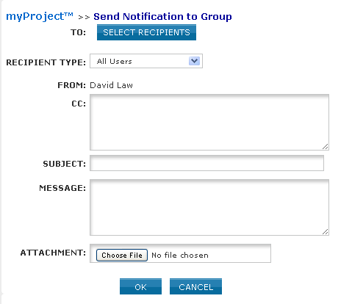

- Click the boxes to place a check next to all of the groups you would like to send the notification to and click “OK”.

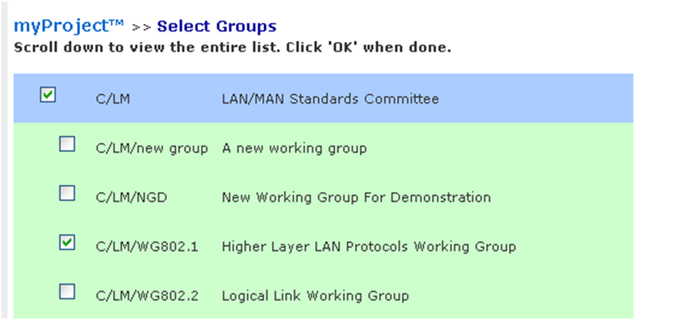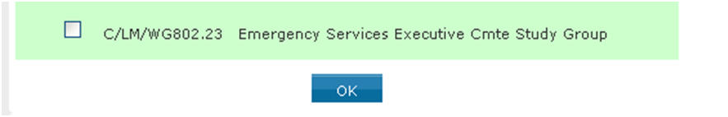

- From the “Recipient Type” box, select “All Users” to send messages to everyone who has registered interest in the group, select “Officers Only” if you would like the message only sent to officers or select “By Involvement Level to choose specific involvement levels to notify.

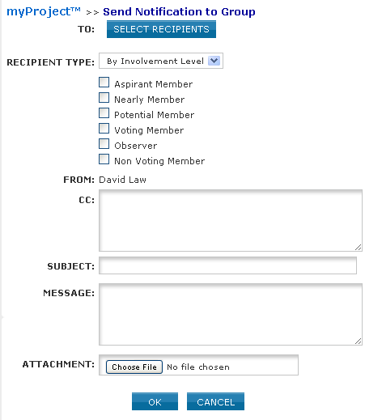

- Enter additional email addresses you would like the notification sent to in the “CC” field, separated by commas.
- Type your subject and message.
- Click “Choose file” to add an attachment.
- Click “OK” to send the notification.

PAR/Standard Report
The PAR/Standard report can be used to view important information about active and completed projects as well as approved standards. Projects may be searched, filtered by Sponsor or Working Group and downloaded in CSV format.

Applicable Users:
All myProject™ Users

Instructions:
- On the myProject™ Home Screen, select “PAR/Standard Report”.
- Select the report type from the dropdown menu.
  - Select “Active PARs” to only view active PARs
  - Select “Active, Pending and Completed PARs” to include submissions pending approval as well as completed projects in the report.
  - Select “Standards” to view all current approved standards.
- Select a Sponsor or Working Group to filter the report.
- Click “Refresh” to update the view based on your selections.

2
4
3

- Click on any of the blue column headings to sort by that field.
- Type a search term in the box and click “Refresh” to search within the currently displayed results.
- Click “Download as CSV” to download the displayed results.

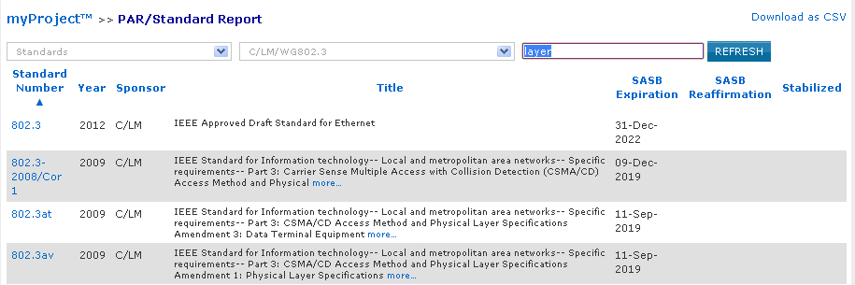
7
6
5

The PAR Submission and Approval Process
In order to start work on a new standard, a PAR (Project Authorization Request) must be submitted. Work cannot start on a standard until the PAR is reviewed by NesCom (New Standards Committee) and approved by the Standards Board.

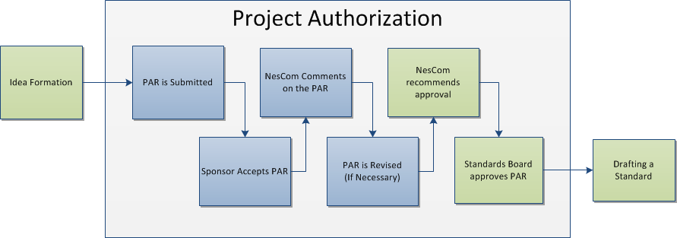

Relevant sections of the myProject™ user guide:
- PAR is Submitted - 5.1 Submit a PAR for a New IEEE Standard, 5.3 Submit a PAR for a Revision, Corrigendum, or Amendment, 5.4 Modify an Approved PAR , 5.6 Withdraw an Approved PAR
- Sponsor Accepts PAR - 5.7 Accept or Reject a PAR
- NesCom Comments on the PAR - 5.8 Commenting and voting on a PAR, 5.10 Respond to NesCom Comments About a PAR

Submit a PAR for a New IEEE Standard
This form is for submitting a PAR related to a completely new standard. The project can be worked on by an existing Working Group, or a new one can be requested. You must have approval of a sponsor committee, however, for your PAR to be considered.

Applicable Users:
- IEEE-SA Members

Notes:
- The Sponsor must have an approved P&P (policy and procedures) before it can submit a PAR. You can view approved Sponsor P&Ps at https://development.standards.ieee.org/pub/view-sponsor-pnps.
- If the Sponsor’s P&P is expired, the P&P must be reapproved before submitting a PAR. (For more information on uploading Sponsor P&Ps, see Sec 4.1 Upload & Manage Sponsor or Working Group P&Ps.)

Instructions:
- On the myProject™ Home Screen, select “Submit a PAR”.
- Select “PAR for a New Standard” under “PAR Requests” then click “NEXT”.
- Select the appropriate working group by using the “+” to expand the Society/Sponsor Committee. (This is the group that is responsible for supporting the work. By selecting the appropriate group, the Sponsor Chair and Working Group Chair are notified of the PAR submittal. The Sponsor Chair will need to accept the PAR in order for NesCom to approve it.)

  - If the PAR is for a new working group that you need to create:
    - Select “Request New Working Group” next to the appropriate sponsor/committee.
    - When Prompted, enter the full name of the working group, e.g., “Implementing Technology To Limit Climate Change” and a short name, e.g., CCWG (will appear on PAR as PE/ED&PG/CCWG), then click “NEXT”
    - Review the information displayed and click “NEXT”
    - The sponsor chair will be notified of the new group and will need to approve it and assign a working group chair
  - If the PAR is for an existing working group:
    - Find the working group in the green area and click “Select”
    - Review the information displayed then click “NEXT”
    - If the any Working Group information is incorrect or blank, contact the Sponsor Chair. This information must be corrected before submitting a PAR.

- Complete the PAR form. Instructions on filling out the form will be displayed by moving your cursor over the “i” buttons.

- When complete, click “Preview And Submit”
- Review the PAR and click “Submit to NesCom Administrator”
- The PAR will now be added to the next NesCom agenda and notifications will be sent to the Working Group Chair, Sponsor Chair, Staff Liaison, and NesCom Administrator)
    - NOTE: Once you approve and submit the information, changes may only be made through the NesCom Administrator.

Saving, Editing, Sharing and Deleting a Draft PAR
You can save a PAR at any time as a draft and return to it later, share it, or delete it.

Applicable Users:
- IEEE-SA Members

Instructions:
- Click “SAVE” on any PAR form.
- When you are ready to resume, go to the myProject™ Home page and select “Manage My PARs”
- To return to the PAR, locate the PAR in the list and click “edit”, then continue editing the PAR.

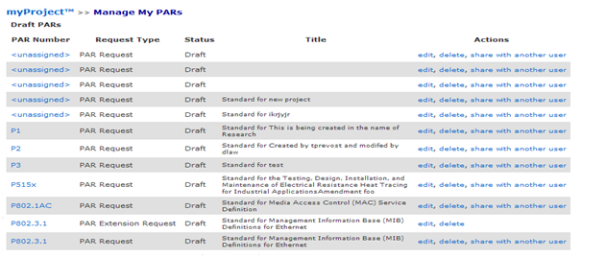

- To share the PAR with another user, click “share with another user” (This person will have the ability to view, edit, submit and delete the PAR)
- Enter the email address or username of the person with whom you would like to share the PAR and click “OK” (The email address must be associated with an IEEE Web Account)
- To permanently delete a draft PAR, click “delete”

Submit a PAR for a Revision, Corrigendum, or Amendment
These forms are similar PARs for a new standard but are for PARs to change existing IEEE standards. Revisions are documents that replace the current standard, corrigenda add technical corrections, and amendments are other additions or corrections to the standard.

Applicable Users:
- IEEE-SA Members

Instructions:
- On the myProject™ Home Screen, select “Submit a PAR”.
- Select “PAR for a Revision…”, “PAR for a Corrigendum…” or “PAR for an Amendment…” under “PAR Requests”, then click “NEXT”.
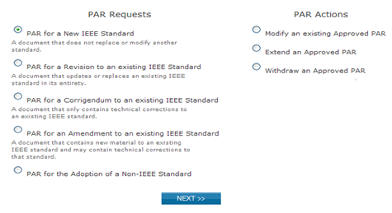

- Enter the standard number in the box and click “SEARCH”.
- Click “select” next to the standard you want to revise, amend, etc.
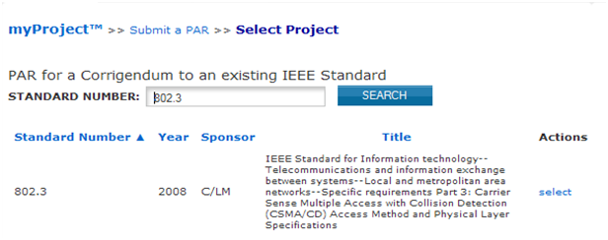

- You will be presented with a confirmation page to review the contact information.
  - If the any Working Group information is incorrect or blank, contact the Sponsor Chair. This information must be corrected before submitting a PAR.
  - If you want to assign the PAR to a different working group:
    - Click “Reassign the Working Group”.
    - Enter the information for the new working group.
    - Click “NEXT”.

- Click “NEXT”.
- Review the information displayed on the subsequent page, some fields may be pre-filled with information from the standard.
- Modify the information or fill in fields as needed. Make sure to include the reasons for the revision, amendment or corrigendum.
  - You can save your PAR at any time and return to it later. For more detailed instructions, see sec. 5.2.
- Instructions on filling out the form will be displayed by moving your cursor over the “i” buttons.

- When complete, click “Preview And Submit”
- Review the PAR and click “Submit to NesCom Administrator”
- The PAR will now be added to the next NesCom agenda and notifications will be sent to the Working Group Chair, Sponsor Chair, Staff Liaison, and NesCom Administrator)
    - NOTE: Once you approve and submit the information, changes may only be made through the NesCom Administrator.

Modify an Approved PAR
If the scope, purpose, or other elements of the draft standard change in any way, the PAR must be modified and approved.

Applicable Users:
- IEEE-SA Members

Instructions:
- On the myProject™ Home page, select “Submit a PAR”.
- Select “Modify an existing Approved PAR” and click “NEXT”.

- Enter the PAR number in the box and click “SEARCH”.
- Click “select” next to the PAR you want to modify.
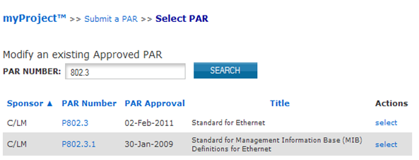

- You will be presented with a confirmation page to review the contact information.
  - If the any Working Group information is incorrect or blank, contact the Sponsor Chair. This information must be corrected before submitting a PAR.
  - If you want to assign the PAR to a different working group:
    - Click “Reassign the Working Group”.
    - Enter the information for the new working group.
    - Click “NEXT”.

- Click “NEXT”.
- Review the information displayed on the subsequent page; some fields may be pre-filled with information from the existing PAR.
- Modify the information or fill in fields as needed.
  - Be sure to list what is being modified and the reasons for the modifications.
  - You can save your PAR at any time and return to it later. For more detailed instructions, see sec. 5.2
- Instructions on filling out the form will be displayed by moving your cursor over the “i” buttons.

- When complete, click “Preview And Submit”
- Review the PAR and click “Submit to NesCom Administrator”
- The PAR will now be added to the next NesCom agenda and notifications will be sent to the Working Group Chair, Sponsor Chair, Staff Liaison, and NesCom Administrator)
NOTE: Once you approve and submit the information, changes may only be made through the NesCom Administrator.

Extend an Existing PAR
PARs are only valid for 4 years. If the working group needs more time to draft the standard, an extension must be filed and approved by NesCom before the PAR expires.

Applicable Users:
- IEEE-SA Members

Instructions:
- On the myProject™ Home page, select “Submit a PAR”.
- Select “Extend an Approved PAR” and click “NEXT”.

- Enter the PAR number in the box and click “SEARCH”.
- Click “select” next to the PAR you want to extend.

- You will be presented with a confirmation page to review the contact information.
  - If the any Working Group information is incorrect or blank, contact the Sponsor Chair. This information must be corrected before submitting a PAR.
  - If you want to assign the PAR to a different working group:
    - Click “Reassign the Working Group”.
    - Enter the information for the new working group.
    - Click “NEXT”.

- Click “NEXT”.
- Select the number of years for the extension. Review the title, scope and purpose to ensure that they match the current draft.
- Provide an explanation for the extension. (a description of what the working group has accomplished, what remains to be accomplished and the reasons why the work was unable to be completed in the allotted time frame)
- Review the rest of the information displayed on the page and modify as needed.
  - You can save your PAR at any time and return to it later. For more detailed instructions, see sec. 5.2.
- Instructions on filling out the form will be displayed by moving your cursor over the “i” buttons.

- When complete, click “Preview And Submit”
- Review the PAR and click “Submit to NesCom Administrator”
- The PAR will now be added to the next NesCom agenda and notifications will be sent to the Working Group Chair, Sponsor Chair, Staff Liaison, and NesCom Administrator)
NOTE: Once you approve and submit the information, changes may only be made through the NesCom Administrator.

Withdraw an Approved PAR
This option is used if, for any reason, the working group decides to discontinue work on a project.

Applicable Users:
- IEEE-SA Members

Instructions:
- On the myProject™ Home page, select “Submit a PAR”.
- Select “Withdraw an Approved PAR” and click “NEXT”.
- Enter the PAR number in the box and click “SEARCH”.
- Click “select” next to the PAR you want to withdraw.

- Select a reason for the withdrawal from the drop-down menu and provide a more detailed explanation of the reason for withdrawal.
- Click “OK” to submit the withdrawal request.
- The PAR withdrawal will now be added to the next NesCom agenda and notifications will be sent to the Working Group Chair, Sponsor Chair, Staff Liaison, and NesCom Administrator.

Accept or Reject a PAR
After the PAR is submitted, it will tentatively be placed on the agenda for the next NesCom meeting. The PAR must be accepted, however, by the Sponsor Chair or Standard representative before the NesCom meeting. In the case of Joint sponsorship, only the primary Sponsor must accept the PAR. The joint sponsor, however, will receive all notifications and have access to NesCom comments and related dialogue.

Applicable Users:
- Sponsor Chair, Standard Representative

Notes:
- The PAR will not be put onto the final NesCom agenda without sponsor approval. If the sponsor fails to approve the PAR, it will move to the following NesCom meeting agenda.
- If you require changes to the PAR before accepting, please contact the NesCom Administrator to make those changes. Rejecting the PAR may delay approval.

Instructions:
- On the myProject™ Home page, select “Manage My PARs”.
- Under the “Submitted PARs” section, click “accept” or “reject” next to the PAR to accept or reject that PAR.
- You can also click on the PAR number to view the PAR as well as reading and making comments by clicking on the comments number.

Commenting and voting on a PAR
Once the PAR is submitted, there will be a review period where NesCom members can make comments and vote on the PAR.

Applicable Users:
- NesCom Members

Notes:
- The NesCom Administrator must approve all comments before they are visible to the submitter.

Instructions:
- On the myProject™ Home Screen, select “NesCom Member Area”.
- Here you will see a list of past and upcoming meetings along with the meeting status and actions. To view the agenda and comment or vote on PARs, click “agenda” next to a meeting that is in individual or open review status.

- Now you will be able to view the meeting agenda. To view the PAR, click on the PAR number. To vote or add comments, click “Comments/Vote”.

- On the next screen, you will be able to cast a vote, add a new comment, or add to the dialog on an existing comment.
  - To cast a vote, simply choose your vote from the dropdown menu. Your current vote will be displayed in the box. You can change your vote by selecting a different option.

  - To add a new comment, click “Add New Comment”, select the type of comment, add your comment text, add any supporting files and click “OK”.
  - To add to an existing comment, click on the number next to that comment, add your text to the dialog and click “add to dialog”.

- From the NesCom Member area you can also access the submission summary screen by clicking on “submission summary”.

- This screen shows all of the PARs submitted for a particular meeting. From here you can access the comments/vote screen by clicking the number under “comments”, and see the detail of votes cast by clicking on your vote under “My Vote”.

- Comments can be made offline and uploaded as a CSV file.
  - Click “Download Blank Comment File” and save the file to your computer.

  - Edit the CSV file using any spreadsheet editor, making sure to maintain the format, and save it on your computer.
  - Click “Upload Comments”

  - Click “Browse…” to select the file with your comments and click “OK”.

Downloading a .zip file
NesCom members have the ability to download a .zip file containing PDF files of the meeting agenda, complete PARs, a submission summary, complete comment detail, and a blank comment upload file. These files allow NesCom members to review the PARs and record comments while offline.

Applicable Users:
- NesCom Members

Instructions:
- On the myProject™ Home Screen, select “NesCom Member Area”.
- To download a .zip file, click “download offline zip”

- Follow your web browser prompts to save the file.

Respond to NesCom Comments About a PAR
Once the PAR is submitted, there will be a review period where NesCom members can comment on the PAR. The comments will be moderated by the NesCom administrator, who is also responsible for making any changes to the PAR before the NesCom meeting.

Applicable Users:
- Par Submitter, Sponsor Chair, Standard Representative, Working Group Chair/Vice-Chair/Co-Chair, NesCom Designee

Notes:
- Failure to respond to a comment may result in deferral of the PAR to the next NesCom agenda.
- Only the NesCom administrator can make changes to the PAR at this stage. Your agreement with requested changes or submission of new wording can be included in your dialog response. If the changes are extensive, respond to the comment and email your changes to the NesCom administrator (nescom-admin@ieee.org)

Instructions:
- On the myProject™ Home page, select “Manage My PARs”.

- Locate the PAR and click the number under the Comments column.

- Locate the comment you wish to respond to and click the number under “Dialog”.

- Enter your response in the text box and click “Add to Dialog”.
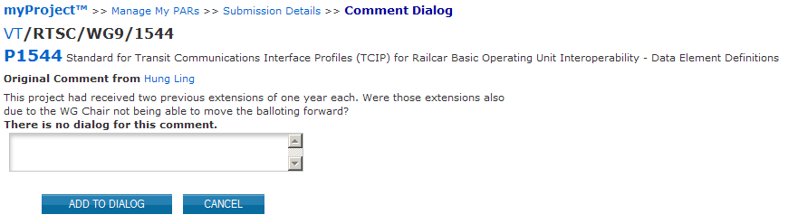

- You can use this feature to continue a dialog with NesCom members and the NesCom administrator.

Sponsor Balloting
Once a draft document is stable, it is ready for balloting. A ballot invitation must be initiated, a ballot group formed and a ballot initiated. The draft must receive a consensus approval or be recirculated until one is obtained.

Relevant Sections of the myProject™ User Guide:
- MEC – 6.1 Submit a Draft for MEC
- Ballot Invitation – 6.2 Initiate Ballot Invitation
- Ballot Group Formation – 6.5 Join a Sponsor Ballot (Individual Balloting), 6.6 Pay to Join a Single Ballot (Individual Balloting), 6.7 Join a Ballot (Entity Balloting)
- Balloting – 6.11 Initiate Sponsor Ballot, 6.12 Review Ballot
- Comment Resolution – 6.19 Comment Resolution

Submit a Draft for MEC
Mandatory Editorial Coordination (MEC) is required prior to the start of a Sponsor Ballot. MEC ensures conformance with all IEEE requirements. Review of your draft and permission letters will reduce the number of recirculations and help to avoid delays in approval or possible rejection by RevCom.

Applicable Users:
- Sponsor Chair, Standard Representative, Working Group Chair/Co-Chair/Vice-Chair, Sponsor Ballot Designee

Notes:
- The Mandatory Editorial Coordination (MEC) should be initiated by the start of the ballot invitation.
- Be sure to include all copyright permissions letters at this time.

Instructions:
- On the myProject™ Home Screen click the “Balloting” tab.

- Click “Mandatory Editorial Coordination”.

- Complete the form displayed, making sure to fill out all relevant fields. Make sure to select the correct staff liaison. Liaisons for your working group can be found here: https://development.standards.ieee.org/pub/liaisons
- Click the “Browse…” button to select your file for upload. If you are including copyright permissions letters or other additional files, you will need to create a .zip file and upload a single file.
- Click “Upload selected file now” to submit the form, upload your file and notify your Staff liaison.

Initiate Ballot Invitation
The first step in sponsor balloting is forming the ballot group. In order to form this group, a ballot invitation must be initiated. All users who have expressed interest in the project through myProject™ will be notified of the ballot group formation. During the invitation period, typically 30 days, individuals (or entity representatives) can join the balloting group, change their voter classification, or withdraw from the ballot. Working Group officers should monitor the group for balance during this period.

Applicable Users:
- Sponsor Chair, Standard Representative, Working Group Chair/Co-Chair/Vice-Chair, Sponsor Ballot Designee

Notes:
- The MEC should be initiated before the ballot invitation is sent out. For more information on submitting a draft for MEC, see Sec 6.1 Submit a Draft for MEC.
- The invitation will not open until your staff liaison reviews and sends the invitation.
- The Sponsor Chair/Standards Representative will be notified of the invitation, but are not required to mark approval.
- Sponsor balloting must begin within six months of the invitation. If sponsor balloting does not begin within six months, the ballot group must be re-formed.

Instructions:
- On the myProject™ Home Screen click the “Balloting” tab.

- Click “Initiate Invitation Request”.

- Complete the fields and click “NEXT”.
- Project: Select the project from the drop-down menu.
- Ballot Type: Select the type from the drop-down menu.
- Length of Your Invitation: Enter the length of the invitation, a minimum of 15 days is required; 30 is preferred.

- Select the groups and individuals you would like to invite to the Balloting Group.
- Click the “+” sign beside the Society and Committee (Sponsor) names to see a list of working groups under that committee
- Put a check mark next to each Committee and/or Working Group you wish to invite.
- Additional people can be invited by entering e-mail addresses in the “Additional Invitations” section.
- Click “NEXT”.

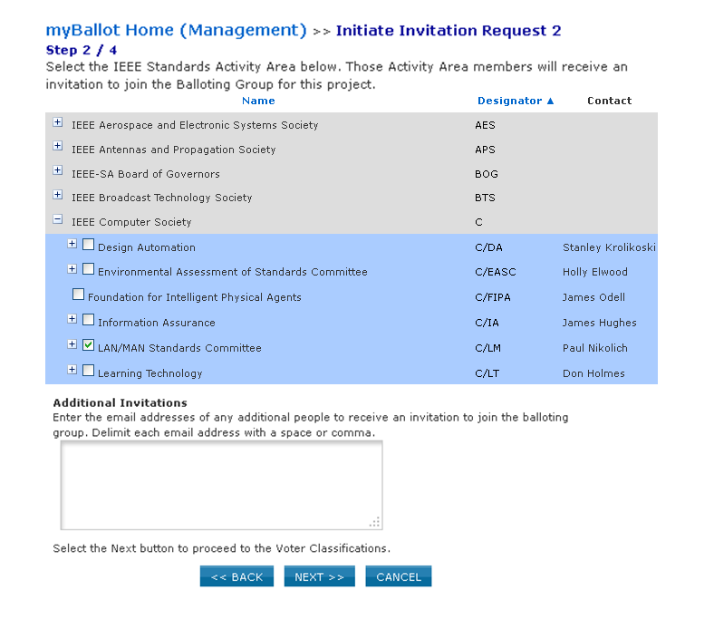
- Confirm the voter classifications for the ballot.
- Verify that at least 3 voter classifications are displayed.
- To add another voter classification, click “Add New Voter Classifications”.
- To edit a voter classification, click “edit” next to the classification
- To remove a voter classification, click “delete” next to the classification. (This is not recommended).
- Click “NEXT”.

- Verify the Invitation information.
- Review the invitation. Use the “BACK” button to make changes.
- For most ballots, do not include an attachment.
- Additional description can be added in the “Sponsor Text” area.
- Do not attach published standards or drafts, necessary documents will be made available in myProject™ once the ballot has opened.
- Click “OK” to complete the invitation process.

Close Ballot Invitation
This option is for closing a currently open ballot invitation.

Applicable Users:
- Sponsor Chair, Standard Representative, Working Group Chair/Co-Chair/Vice-Chair, Sponsor Ballot Designee

Instructions:
- On the myProject™ Home Screen click the “Balloting” tab.
- Click “View Invitation Summary”.

- Locate the project and click “close invitation” under the “Actions” column.

- Click “OK” to confirm close of the invitation. The “stage” will no display as “PreBallot”.

Reopen/Extend Ballot Invitation
This option is for extending a ballot invitation to allow potential balloters more time to join the ballot group or change their voter classification.

Applicable Users:
- Sponsor Chair, Standard Representative, Working Group Chair/Co-Chair/Vice-Chair, Sponsor Ballot Designee

Notes:
- This can only be done after the initial invitation period closes and before the ballot opens (“PreBallot” or PreBallot Review” stage).

Instructions:
- On the myProject™ Home Screen click the “Balloting” tab.
- Click “View Invitation Summary”.

- Locate the project and click “extend invitation” under the “Actions” column.

- Enter in the Invitation Close Date, then Click “OK”.

Join a Sponsor Ballot (Individual Balloting)
Applicable Users:
- All IEEE-SA Members

Notes:
- You are required to be an IEEE-SA member or pay a per-ballot fee to join an IEEE-SA ballot.
- Joining a ballot allows you to vote and submit comments when the project opens for balloting.
- Balloting group members have an obligation to respond during the balloting period; failure to return a ballot may disqualify the balloter from participation in future balloting groups.
- You can easily add or remove yourself from a balloting group, but only while the balloting group is forming. Your participation is fixed after the ballot invitation closes.

Instructions:
- On the myProject™ Home Screen click the “Balloting” tab.
- If you have sponsor authority (e.g. sponsor chair, working group chair, sponsor ballot designee), select “myBallot” Home (Voter)”.

- Select “Show/Join Open Ballot Invitations”.

- On this screen you will initially see open ballot invitations that are tied to your selection(s) under “Manage Activity Profile”. Check the box next to “Show all open ballot invitations” to see all ballot invitations you are eligible to join.

- Find the project you would like to join. Scroll to the right and click “join” under the Actions column.
- Specify your affiliation and your voter classification for this ballot.

- Click “OK” to complete joining the ballot.

Pay to Join a Single Ballot (Individual Balloting)

Applicable Users:
- All Non IEEE-SA Members.

Notes:
- You are required to be an IEEE-SA member or pay a per-ballot fee to join an IEEE-SA individual ballot group.
- Joining a ballot group allows you to vote and submit comments when the project opens for balloting.
- You can easily add or remove yourself from a balloting group, but only while the balloting group is forming. Your participation is fixed after the ballot invitation closes.
- Be sure to leave enough time to process your payment/membership before the close of the ballot invitation.
- While you do not have to be an IEEE member or IEEE Society member to join the SA, it is far more cost effective to do both:
  - IEEE-SA membership entitles you to unlimited individual balloting.
  - If you currently are or become an IEEE Member or Society Member, you can add SA membership to your IEEE Membership or Society Membership at a reduced price.
  - The most expensive option is to join a single ballot. Single ballot fees are higher than annual membership in the IEEE-SA, and entitle you to join just one ballot group and any recirculations of that ballot. To take advantage of this service which is unavailable online, complete the form at least 5 working days prior to invitation closing to allow time for processing.
  - More information on membership can be found at: http://standards.ieee.org/membership/

Instructions:
- On the myProject™ Home Screen click the “Balloting” tab.
- Select “Join Single Ballot”.

- Fill out the form to submit your information electronically or click “print & mail” to print the form and follow the instructions on the page to mail in your request.

- Click “OK” when done. The form will automatically be sent to the IEEE-SA Balloting Center, which will process your request for the per-ballot fee. During this period, you will be contacted by the IEEE-SA Balloting Center requesting your "classification category selection” for the ballot (e.g., user, producer, general interest, academic), as this must be entered into myProject by Balloting Center staff. If you have any questions or require assistance, please send an email to: sa-ballot@ieee.org

Join a Ballot (Entity Balloting)
Participation in Entity Ballots is limited to IEEE-SA Entity Members. These entities are represented by an EBR (Entity Ballot Representative) and EBRA (Entity Ballot Representative Alternate). Any employee of the Entity Member institution may enroll as the EBR or EBRA if the slot has not already been filled. Only the EMR (Entity Member Representative) has the ability to replace the EBR or EBRA.

Applicable Users:
- EBR (Entity Ballot representative) or EBRA (Entity Ballot Representative Alternate) of an IEEE-SA Entity Member.

Notes:
- Joining a ballot allows you to vote and submit comments when the project opens for balloting.
- You can easily add or remove yourself from a balloting group, but only while the balloting group is forming. Your participation is fixed after the ballot invitation closes.
- Each entity shall name one primary voting representative and, optionally, one alternate voting representative. Only a ballot from one of these representatives will be accepted. If ballots are received from other parties, they will not be counted. If ballots are received from both the primary voting representative and the alternate voting representative, only the vote from the primary voting representative will be counted.
- By joining a ballot, you will automatically be entered as the EBR if one has not already been entered. If the EBR slot is filled, you will be entered as EBRA. If both slots are filled, you will be added to a waiting list.
- Each primary and alternate voting representative can ballot for only one entity; no individual can represent the interests of more than one entity.

Instructions:
- On the myProject™ Home Screen click the “Entity” tab.
- Select “Entity Project Enrollment”.

- Check the “Join/Remove Interest Area” box to the left of the project(s) you are enrolling, select your affiliation for that project from the “Affiliation” drop-down box on right, and click “OK”.
- Your affiliation must be an entity member. Entity members have “(Entity Member)” at the end of their names in the drop-down box.
- Entities can be represented in a ballot group by a maximum of two individuals: a primary member and an alternate member. If your affiliate is already represented in the ballot group in those two roles, you will be asked if you wish to join a wait list.

- Review the next screen an click “OK”.
- From the Entity tab, select “Show/Join Open Ballot Invitations”.
- Click “Join” next to the ballot you would like to join.

Manage Ballot Representatives (Entity Balloting)
Participation in Entity Ballots is limited to IEEE-SA Entity Members. These entities are represented by an EBR (Entity Ballot Representative) and EBRA (Entity Ballot Representative Alternate). Any employee of the Entity Member institution may enroll as the EBR or EBRA if the slot has not already been filled. Only the EMR (Entity Member Representative) has the ability to replace the EBR or EBRA.

Applicable Users:
- EMR

Notes:
- Users must already be enrolled in the entity project to be added as EBR or EBRA and it is recommended that they enroll themselves as EBR and EBRA. For more information on joining an entity ballot, see Sec 6.7 Join a Ballot (Entity Balloting)

Instructions:
- On the myProject™ Home Screen, click the “Entity” tab.
- Click “Manage your company”.

- Click “manage ballot” next to the project ballot you want to manage.

- You will see the details on the open ballot, along with any votes that have been submitted on behalf of your company. To manage the ballot representatives, click “Manage Ballot Roles”.

- You will see individuals currently enrolled as the EBR and EBRA as well as a waiting list of other individuals who have expressed interested in the ballot.
  - To remove an individual from a EBR/EBRA position, delete their username from the box and click “OK”
  - To replace an individual in a EBR/EBRA position, replace their username with the username of the new individual and click “OK”
  - You may replace both usernames at the same time or switch the two.
  - You may assign a new EBR/EBRA, but it is recommended that you let the individual enroll him/herself or use a name from the waiting list to ensure they have already enrolled in the project.
  - You may also change the voter classification for your entity using this screen.

Remove Yourself from a Ballot

Applicable Users:
- IEEE-SA members currently enrolled in a ballot

Notes:
- You can easily remove yourself from a balloting group, but only while the balloting group is forming.
- Your participation is fixed after the ballot invitation closes.
- If you have paid a per-ballot fee or your membership is processing, you will not be able to remove yourself from a ballot. IEEE-SA balloting center staff must make any necessary changes. Contact balloting center at:
sa-ballot@ieee.org
- Instructions for Entity Balloting are the same, but ballots are accessed through the “Entity” tab instead of the “Balloting” tab.

Instructions:
- On the myProject™ Home Screen click the “Balloting” tab.
- If you have sponsor authority (e.g. sponsor chair, working group chair, sponsor ballot designee), select “myBallot” Home (Voter)”.
- Select “Show/Join Open Ballot Invitations”.

- On this screen you will initially see open ballot invitations that are tied to your selection(s) under “Manage Activity Profile”. Check the box next to “Show All Open Ballot Invitations” to see all ballot invitations you are eligible to join.
- Click “remove” next to the project you wish to remove yourself from.

- Click “OK” to confirm your removal.

Change Your Voter Classification

Applicable Users:
- IEEE-SA members currently enrolled in a ballot

Notes
- You may change your voter classification for any single ballot during an invitation period only.
- If you have paid a per-ballot fee or your membership is processing, you will not be able to change your voter classification. IEEE-SA staff must make any necessary changes.
- Instructions for Entity Balloting are the same, but ballots are accessed through the “Entity” tab instead of the “Balloting” tab.

Instructions:
- On the myProject™ Home Screen click the “Balloting” tab.
- If you have sponsor authority (e.g. sponsor chair, working group chair, sponsor ballot designee), select “myBallot” Home (Voter)”.
- Select “Show/Join Open Ballot Invitations”.

- On this screen you will initially see open ballot invitations that are tied to your selection(s) under “Manage Activity Profile”. Check the box next to “Show all open ballot invitations” to see all ballot invitations you are eligible to join.

- Click “update” next to the project you wish to remove yourself from.
- Select your new classification under the “Classification” column.
- Click “OK” to save your changes.

Initiate Sponsor Ballot
Once the ballot invitation is closed, and the ballot group has been balanced, it is time to prepare the final draft and initiate the ballot.

Applicable Users:
- Sponsor Chair, Standard Representative, Working Group Chair/Co-Chair/Vice-Chair, Sponsor Ballot Designee

Notes:
- Ballots cannot be opened unless all permission letters for borrowed material have been received, reviewed and approved by staff.
- The ballot will not actually open until your staff liaison approves the uploaded draft.
- A cover letter is not required.

Instructions:
- On the myProject™ Home Screen click the “Balloting” tab.
- Click “Initiate Sponsor Ballot”.

- Select your project from the PAR drop down list.
- Enter the “Ballot Open Date”.
- Enter the “Ballot Close Date” (must be a minimum of 30 days).
- Enter the “Draft #” (must match the draft number in the draft).
- Select File for Uploading: Click the Browse… to find your draft file. The file must be in PDF format.
- Review the system generated text. If you would like to add additional instruction or information, use the “Sponsor Text” Area.
- Click “Initiate Ballot”.

Review Ballot
After a sponsor ballot is initiated but before it is approved by a staff liaison, the Sponsor has the ability to edit the sponsor text portion of the ballot notification and view/replace the draft.

Applicable users:
- Sponsor Chair, Standard Representative, Working Group Chair/Co-Chair/Vice-Chair, Sponsor Ballot Designee

Notes:
- The ballot will not actually open until your staff liaison approves the uploaded draft.
- Sponsor review is not required before liaison approval of the ballot.

Instructions:
- On the myProject™ Home Screen click the “Balloting” tab.
- Click “Manage Sponsor Ballot Activity”.

- Click “Review Ballot” next to the project you want to review.

- Review the ballot notification and edit the “sponsor text” section if desired.

- Click on the draft file name to review the draft and click “replace” to replace the file.

- Click “OK” to save any changes.

Vote and/or Comment on a Ballot

Applicable users:
- myProject™ users currently enrolled in a ballot

Notes:
- Instructions for Entity Balloting are the same, but ballots are accessed through the “Entity” tab instead of the “Balloting” tab.
- You must follow some rules for uploading multiple comments, and strictly adhere to the formats presented in the "Data Field Descriptions". Failure to do so will, at best, result in difficulties with the upload and, at worse, could cause your upload to be rejected or partially uploaded.
- You must use a blank template when uploading comments. Files containing comments already uploaded will be rejected.

Instructions:
- On the myProject™ Home Screen, click the “Balloting” tab.
- If you have sponsor authority (e.g. sponsor chair, working group chair, sponsor ballot designee), select “myBallot Home (Voter)”.
- Select “Manage myBallot Activity”.

- On this screen, you will see all active ballots that you have participated in (check “include Inactive ballots” to show all ballot history). You can view the draft document by clicking on the file under the draft number.
- If the project is in the balloting stage, you will see a dropdown box under the “Vote” column. Select your vote and click “OK” so save.

- To make a comment, click the “Comments” button.
  - To submit a single comment:
- Click “Single Comment Submittal”.
- Complete the comment form, then click “OK” (be sure to be as clear as possible with your reasons for a disapprove vote).
- Complete the previous steps again to make additional comments.
  - To submit multiple comments at one time:
    - Click “Offline Comment Submittal”.
    - Select the file format you want to use and download the appropriate template.
    - Add your comments to the template and save it to your computer.
    - Go back to the Offline Comment Submittal page and enter the file location in the input box. (Click the Browse button to find the file you saved)
    - Click “OK”

  - Must be Satisfied
    - If a person has voted Approve or Abstain, he/she will not see the "Must be Satisfied" field when commenting.
    - If a user has voted “Disapprove” and has checked "Must be Satisfied" with his/her comments, but later changes his/her vote, "Must be Satisfied" will be blank.
    - If the user changes his/her vote back to Disapprove, then "Must be Satisfied" will appear again.
    - You can change the “Must Be Satisfied” field by clicking on the “Yes/No” under the “Must Be Satisfied” column. You may then check/uncheck the box and click “OK” to save.

Edit/Delete a Comment

Applicable users:
- myProject™ users currently enrolled in a ballot

Notes:
- Comments may only be edited or deleted while the ballot period is open.
- Instructions for Entity Balloting are the same, but ballots are accessed through the “Entity” tab instead of the “Balloting” tab.

Instructions:
- On the myProject™ Home Screen, click the “Balloting” tab.
- If you have sponsor authority (e.g. sponsor chair, working group chair, sponsor ballot designee), select “myBallot Home (Voter)”.
- Select “Manage myBallot Activity”.

- Click the “Comments” button next to an open ballot to bring up a list of the comments you have made.

- Click “edit” next to the comment you would like to edit/delete.

- Edit any of the comment fields and click “OK” to save or click “DELETE” to remove the comment entirely.

Change (Flip) a vote
After balloting closes, voters who have voted “Disapprove”, may “flip” their vote to either “Approve” or “Abstain” at any time before recirculation or the RevCom meeting.

Applicable users:
- myProject™ users who have voted “Disapprove” on a ballot.

Notes:
- You will receive notification of your vote change. This notification will be included with the RevCom submission.
- You may only change you vote once using this feature. You will not be able to change the vote back to “Disapprove”.
- Instructions for Entity Balloting are the same, but ballots are accessed through the “Entity” tab instead of the “Balloting” tab.

Instructions:
- On the myProject™ Home Screen, click the “Balloting” tab.
- If you have sponsor authority (e.g. sponsor chair, working group chair, sponsor ballot designee), select “myBallot Home (Voter)”.
- Select “Manage myBallot Activity”.
- Click “CHANGE VOTE” next to the vote you would like to flip. This option will only be available if you have voted “disapprove”.

- Select either “Abstain” or “Approve” from the “VOTE” menu and click “OK”.

- After confirming your change, a message will be sent to you, the Working Group Chair and Sponsor Chair notifying them of the flipped vote. A record of the vote flip will be stored and made available as part of the submission to RevCom.

  - Flipped votes will appear as the following:

View Ballot Summary

Applicable Users:
- Sponsor Chair, Standard Representative, Working Group Chair/Co-Chair/Vice-Chair, Sponsor Ballot Designee

Instructions:
- On the myProject™ Home Screen click the “Balloting” tab.
- Click “Manage Sponsor Ballot Activity”.

- You will see all currently active ballots. To view all ballots, check “Include Inactive Ballots”.
- Click on the number under the “# of Balloters” column for the ballot you would like to view a summary of.

- Click on “Initial Ballot” or the recirculation to view the results from that round of balloting.

- To download the selected results, click “Download Ballot Group CSV File” (includes entire ballot group) or “Download Ballot Voter CSV File” (includes only those who have voted).
- To search for a specific voter, you may enter their name into the box and click “SEARCH”.
- Click “Show only non-voters” to display a list of ballot group members who have not voted.

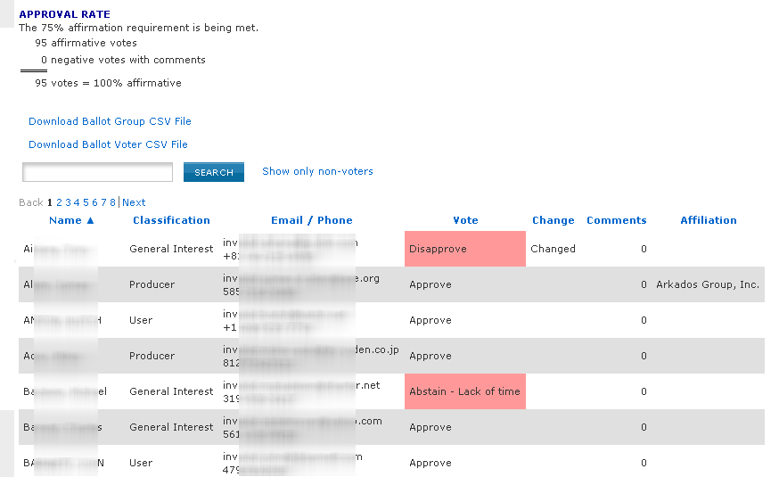

View Ballot Comments
You may view all of the comments that have been made on a ballot, along with the resolution status of each comment after the ballot has closed. During recirculation, comments from previous rounds will be visible.

Applicable Users:
- All myProject™ users who have participated in a ballot.

Instructions:
- On the myProject™ Home Screen, click the “Balloting” tab.
- If you have sponsor authority (e.g. sponsor chair, working group chair, sponsor ballot designee), select “myBallot Home (Voter)”.
- Select “Manage myBallot Activity”.
- Click the “Comment” button next to the ballot you would like to view comments from.
- To view ballot comments and responses from prior circulations of the ballot (e.g., Initial Ballot, Recirculation 1, Recirculation 2, etc.), click the corresponding link in the box at the top of the page.
- To see the detailed comment and resolution, click on the comment text.
- To only show comments that have been marked “must be satisfied”, select “show only MBS comments…” from the dropdown menu.
- To download all comments as a .csv file that you can view in a spreadsheet program, click “Download Comments”.

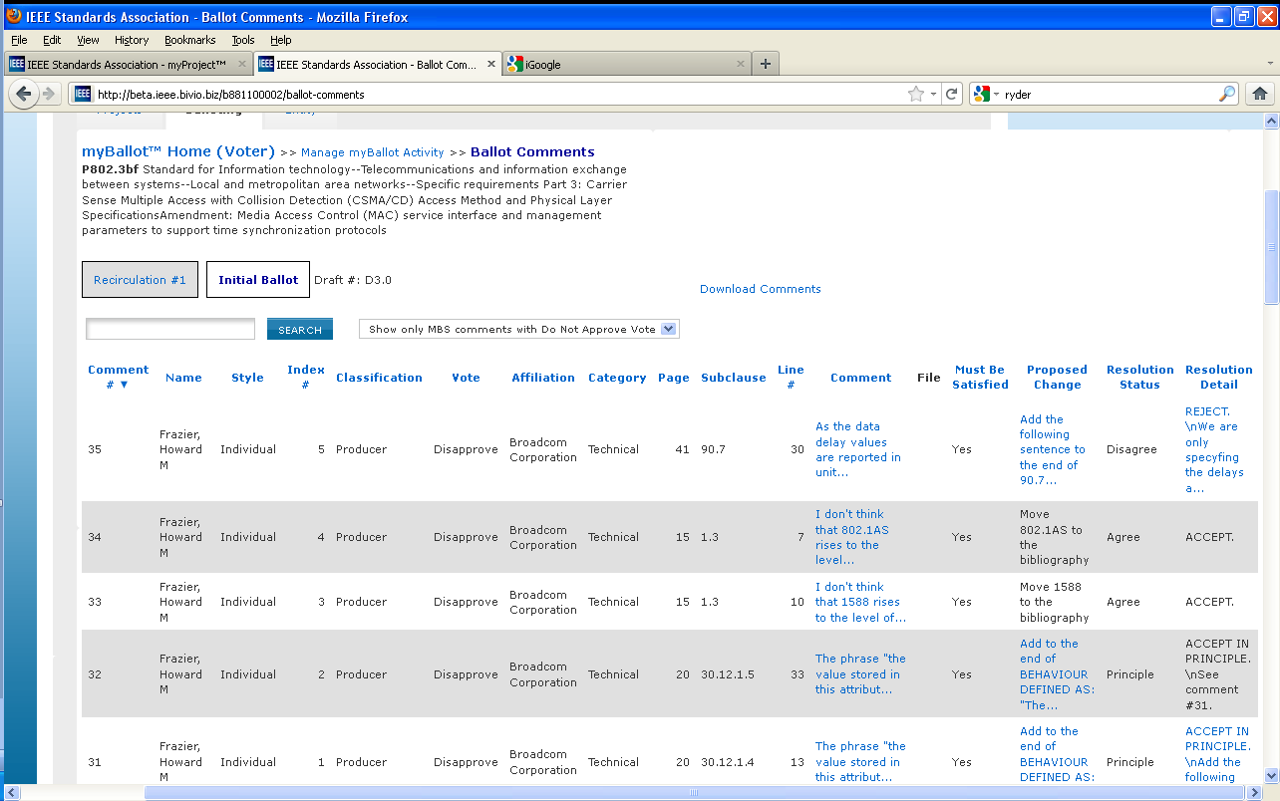
5.
6.
8.
7.

Submit Rogue Comment
This feature can be used to submit comments that have been received by the Working Group outside of the myProject™ system. These comments cannot be marked as “Must Be Satisfied”, but will become part of the record that is submitted to RevCom.

Applicable Users:
- Sponsor Chair, Standard Representative, Working Group Chair/Co-Chair/Vice-Chair, Sponsor Ballot Designee

Instructions:
- On the myProject™ Home Screen click the “Balloting” tab.
- Click “Submit Rogue Comment”.

- Select the PAR/Standard you would like to submit comments for and click “OK”.

- Fill out the form to enter a single comment.
  - You may also upload multiple comments by clicking “bulk upload rogue comments”.

  - Click “Plain Text Comments (CSV)” to download the CSV template and edit the CSV file using any spreadsheet editor and save the file to your computer.
  - Click “Browse…”, select the saved CSV file and click “OK” to upload.

- Click “OK” to submit the comment.

Comment Resolution

Resolution Status Definitions

The IEEE-SA has not defined the meaning of the Resolution Status to give a leeway to the committee. Here are some guidelines:

Accepted – The committee agrees with the comment and implements change exactly as suggested.

Revised – The ballot resolution committee accepts the suggested remedy in principle. This means that the ballot resolution committee will make a change to the draft based on a revision of the suggested remedy. The Resolution Detail field shall provide sufficient detail for ballot group members to understand the revision of the suggested remedy provided by the commenter.

Rejected – The ballot resolution committee does not accept the suggested remedy. The Resolution Detail field shall provide sufficient detail for ballot group members to understand the rationale for this rejection.

The following resolution status values are obsolete beginning 1 June 2011: For all initial and recirculation ballots in process at the time of the roll-out (1 June 2011), the "OLD" Resolution Status options will be used. For all ballots that start after the roll-out (initial and recirculation), only the "NEW" Resolution Status options will be used.

For bulk comment files, here are the find/replace operations you may need to do if you completed the field with “old” responses and need to convert to “new” responses.
(1) Highlight the Resolution Status column and perform the ‘find/replace’ procedure with the following:
(2) Replace Agree with Accepted.
(3) Replace Principle with Revised
(4) Replace Disagree, Out of Scope and Unresolvable with Rejected
*NOTE: Verify that the Resolution Details are accurate or make sense after the replacements are made. Suggest adding the text “out of scope” for “unresolvable” to the Resolution Details where applicable

Disagree/D: committee does not agree with the comment.

Out of Scope/OOS: comment may refer to something that is not available for comment at this time /comment is outside of the scope of the document or recirculation. Note: The section of the document that was not commented on the first review is recognized as approved section and the negative comment on the recirculation may not be recognized unless majority of WG/BRC (Ballot Resolution Committee) feels the need to address the comment.

Principle/P: committee agrees in theory but does not agree with the change or the other way around. In any case, a detail response needs to be made to state your action.

Unresolvable: comment cannot be resolved (may be too broad or vague) or the chair has unsuccessfully attempted to contact the commenter to resolve the issue.

Respond To Ballot Comments Individually
Applicable Users:
- Sponsor Chair, Standard Representative, Working Group Chair/Co-Chair/Vice-Chair, Sponsor Ballot Designee

Notes:
- All comments must be responded to. The response should show that the comment was seriously considered (myProject will accept a resolution status without any detail but RevCom will look for the details).

Instructions:
- On the myProject™ Home Screen click the “Balloting” tab.
- Click “Manage Sponsor Ballot Activity”.

- Find the project you want to manage and click the number under the “Comments” column to view the comments.

- Click the “edit” link under “Resolution Status” for the comment you would lke to respond to.

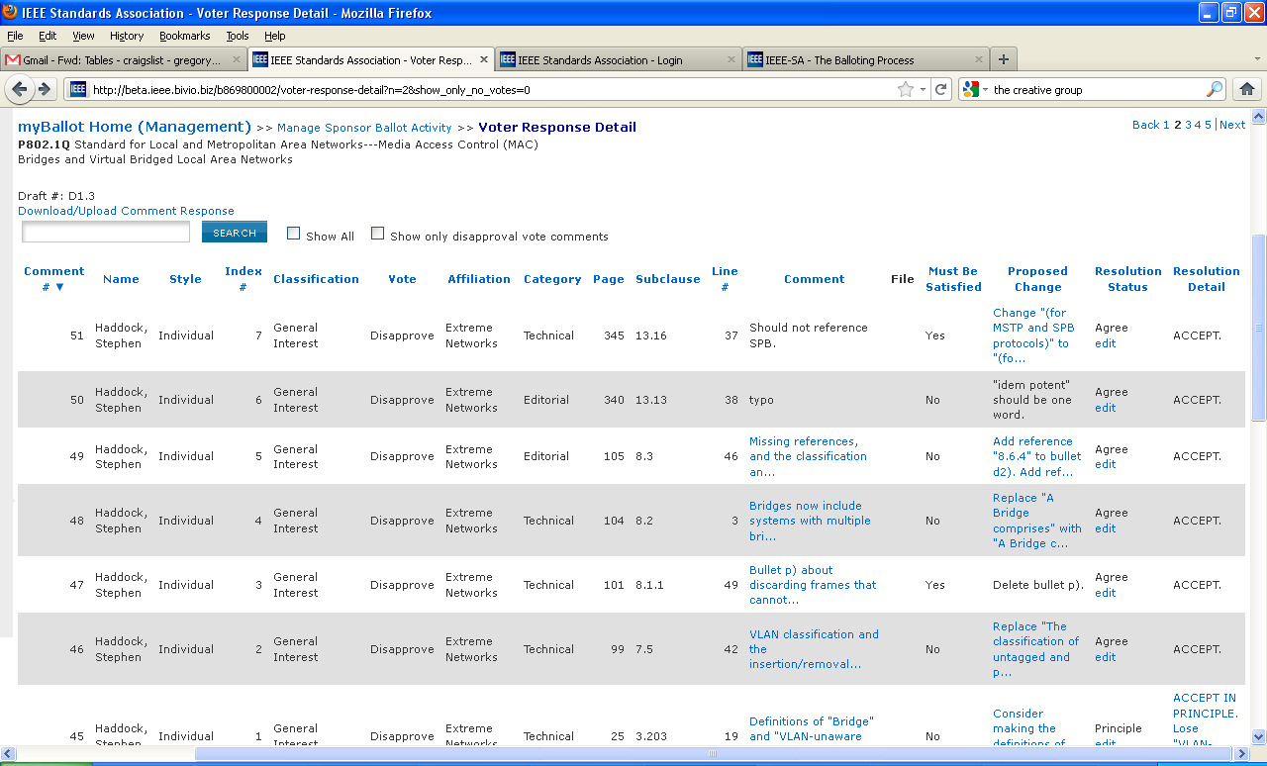

- Select the applicable resolution status from the drop-down menu and enter a description of the resolution.
- Click “OK”.
To download comments and prepare responses offline:
- Click Download/Upload Comment Response
- See Sec. 6.19.3 Step 3.

Download Comments Resolution File
This option allows officers the ability to respond to comments offline and then upload them.

Applicable Users:
- Sponsor Chair, Standard Representative, Working Group Chair/Co-Chair/Vice-Chair, Sponsor Ballot Designee

Instructions:
- On the myProject™ Home Screen click the “Balloting” tab.
- Click “Download/Upload Comment Response”.

- Select the PAR # from the drop-down box and click “OK”.
- Click “Download Comments Resolution Zip File”. This will download a .zip file containing a CSV file of the comments and any files that may be attached to the comments.

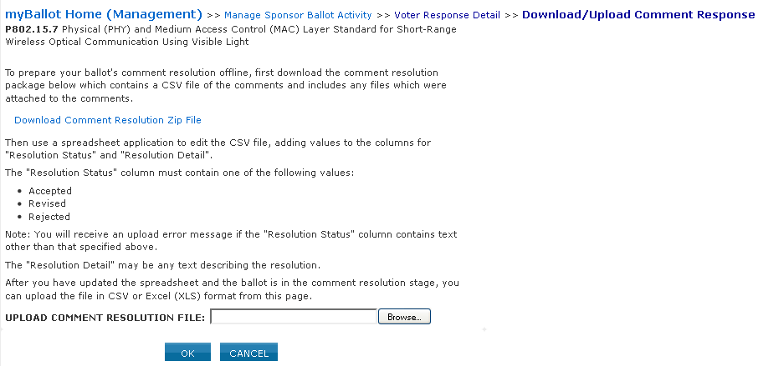

- Edit the CSV file using any spreadsheet editor and save the file in either .csv or .xls format.
  - Make sure to only use only the values listed on the download page (Accepted, Revised, Rejected) in the “Resolution Status” column.

Upload Comments Resolution File

Applicable Users:
- Sponsor Chair, Standard Representative, Working Group Chair/Co-Chair/Vice-Chair, Sponsor Ballot Designee

Notes:
- All comments must be responded to. The response should show that the comment was seriously considered.

Instructions:
- On the myProject™ Home Screen click the “Balloting” tab.
- Click “Download/Upload Comment Response”.
- Select the PAR # from the drop down-box and click “OK”.
- Click the “Browse” button to upload your edited comment resolution file.

- Click “OK”
- View the comments in myProject and make sure your comments were uploaded correctly (See Sec 6.19.2 for more detail).

Initiate Recirculation
A recirculation is needed when:
- Substantive changes were made since the last balloted draft (whether triggered by comments accompanied with YES or NO votes).
- Comments are received from IEEE-SA editors marked “must be satisfied” (MBS).
- A recirculation resulted in negative votes with new comments within the scope of the recirculation.
On a recirculation, a vote shall be based only on the changed portions of the balloted document, clauses affected by the changes, or portions of the balloted document that are the subject of the unresolved negative votes

Applicable Users:
- Sponsor Chair, Standard Representative, Working Group Chair/Co-Chair/Vice-Chair, Sponsor Ballot Designee

Notes:
- A cover letter is required.
- The recirculation must be approved by the Staff liaison.

Instructions:
- On the myProject™ Home Screen click the “Balloting” tab.
- Click “Initiate Recirculation”.

- Select the PAR from the drop-down box and click “OK”.
- Complete the fields, click “Browse…” to select files, making sure to include:
  - Cover letter stating the reason for recirculation. Click the “view a sample cover letter” link to view/download a sample cover letter that you can use as a template.
  - Draft number, if changes have been made. This number must match the draft number on the file being uploaded.
  - New draft in PDF format, if changes have been made. If a draft is not provided, the system will assume you did not make any changes to the draft since it was last balloted. If this is the case, the last balloted draft will be available to the ballot group during the recirculation ballot.
  - Additional files you wish the ballot group to review (optional). You can only upload one file; if you want to include multiple files, create a .zip file first and upload that.
  - Number of days you want the recirculation ballot to remain open (minimum 10).

- Click “CONTINUE”.
- Review the Recirculation Ballot Announcement, add any additional messages into the “Sponsor Text” box and click “CONTINUE”.
- Review the confirmation screen and make changes if needed. When you are done, click “Submit to Staff Liaison”. Your request for a recirculation ballot will now be sent to your staff liaison.

Request a Ballot Reset or Termination
Resetting a ballot will delete any votes and comments made and will return the ballot to the stage after invitation. Terminating a ballot means that the ballot group has been disbanded. A request will be sent to Balloting Center staff, who will reset or terminate the ballot.

Applicable Users:
- Sponsor Chair, Standard Representative, Working Group Chair/Co-Chair/Vice-Chair, Sponsor Ballot Designee

Notes:
- You must supply a reason for resetting/terminating the ballot.
- When reset, the ballot must be opened again and a draft uploaded but the ballot group will be maintained.
- When reset, even though the number under the column heading "Invitations Sent" will say "0" it does not mean that the ballot pool is not intact.
- A ballot may not be reset after a recirculation has begun.
- When terminated, the ballot must re-start from the invitation stage and all individuals must re-enroll in the ballot at that time.
- You may terminate a ballot at any stage in the balloting process.

Instructions:
- On the myProject™ Home Screen click the “Balloting” tab.
- Click “Manage Sponsor Ballot Activity”.

- Find the ballot you want to terminate and click “terminate ballot” or “reset ballot” next to it.

- Select a reason for termination/reset from the drop-down box.
- Enter a description of your reasons for termination/reset in the “COMMENTS” box.

- Click “OK” to submit your request.

RevCom Submission and Review
After a draft has been balloted and consensus reached, the project can be submitted for approval. The draft, along with information from the balloting process will be submitted for review by the RevCom (Review Committee). RevCom will then recommend approval of the standard to the Standards Board. Once the Standards Board approves the project, the draft becomes a standard and is ready to be prepared for publishing.

Relevant sections of the myProject™ user guide:
- Draft is Submitted - 7.1 Submit a Project to RevCom
- RevCom Reviews Submission - 7.3 Vote and Comment on a Submission
- Working Groups Provide Additional Information - 7.4 View RevCom Submission and Respond to Comments

Submit a Project to RevCom
A balloted draft may be submitted to RevCom at any time after balloting or during a recirculation. Additional information on requirements for RevCom submission can be found here: http://standards.ieee.org/about/sasb/revcom/revguide.html

Notes:
- Additional documents and/or source files may be uploaded at any time. These files will be saved even if you do not complete the submission.
- Source files include the Word or Framemaker files for the draft and all figures created outside of the Framemaker or Word document. These files are required and must be sent to editorial staff if they are not uploaded via myProject™.

Applicable Users:
- Sponsor Chair, Standard Representative, Working Group Chair/Co-Chair/Vice-Chair, RevCom Designee

Instructions:
- On the myProject™ Home Screen click “RevCom Submission”.
- Click “submit to RevCom” next to the PAR/Standard you would like to submit.

- You will be presented with a summary screen of your submission to RevCom including results of the last ballot recirculation and a list of files associated with the balloting.
- Click the file name to download any of the files.
- Additional files can be added by clicking the “Add Document” button.
  - Do not place document source files in this section
  - Click “Browse” to select a file for upload and click “OK” to return to the submission form.
  - Click the “X” to remove any uploaded files.

- Click “Manage Source Materials” to upload source materials.
  - Click “Browse” to select a file for upload.
  - Click the “X” to remove any uploaded files.

- Answer all of the questions on the page by clicking the appropriate button.
- Check the box to confirm your adherence to policies and procedures and click “OK” to complete your submission.

View or Download an Agenda
Agendas for meetings that have closed or are in “Individual Review” or “Open Review” will be visible to RevCom members.

Applicable Users:
- RevCom Members

Instructions:
- On the myProject™ Home Screen click the “RevCom Area”.
- Click “agenda” next to the meeting you would like to view.

- To access submission details and files, click “Submission Detail”.

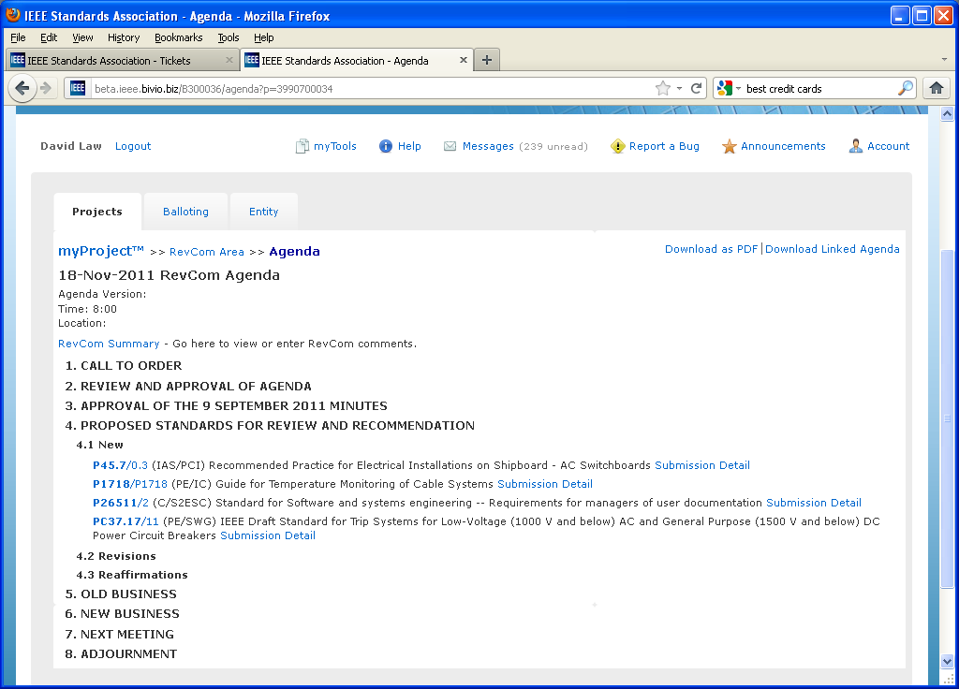

- To download the agenda along with all associated files, click “download linked agenda”.

- Enter the date and time of your last download to get updates to the linked agenda or leave the box blank to download a complete linked agenda. This should be filled in automatically if you have already downloaded an agenda.
- Click “DOWNLOAD”.

- Save the .ZIP file to your computer.
- Unzip the file to a new folder on your computer using Winzip or other utility.
- Open the “RevCom Agenda.html” file with your web browser.

- Click on any of the related files in the agenda to open them.

Vote and Comment on a Submission
RevCom members may submit comments, dialog with submitters and cast preliminary votes on submissions.

Applicable Users:
- RevCom Members

Instructions:
- On the myProject™ Home Screen click the “RevCom Area”.
- Click “submission summary” next to the meeting that is currently in a review period.

- Click “Submission Detail” to view the details of the submission.

- From this screen, you can select your vote, make a comment, or reply to an existing comment.

- To submit a vote, choose your vote from the dropdown menu. Your vote will be recorded without any additional action.

- Only initial comments will be shown at first. To show entire comment threads, click “Expand all”. Click “Collapse All” to return to the previous view.

- To add a new comment, click “Add New Comment”.

- Select whether the comment will be private (visible only to the administrator) or be recorded for the agenda, type your comment, attach any relevant files and click “OK” to save your comment. Your comments will not be made available until reviewed by the RevCom Administrator.

- Click “EDIT COMMENT” to edit your comment text and/or file after it has been submitted. This option will only be available until the administrator approves the comment.

- Click “Reply” to add to a comment thread.

Import Comments
It is also possible to record comments offline in a spreadsheet and upload them when connected to myProject™.

Applicable Users:
- RevCom Members

Instructions:
- On the myProject™ Home Screen click the “RevCom Area”.
- Click “submission summary” next to the meeting that is currently in a review period.

- Click “Import Comments”.

- Click “Download Blank Comment File” and save the file to your computer.

- Enter your comments next to the relevant PAR.
- If you would like to make more than one comment per PAR, just copy the PAR number to a new line and enter your comment.

- Save the file as a .CSV file to your computer.
- Return to the “Import Comments” page and click “Browse…”

- Locate the .CSV file and click “OK” to upload.

View All Comments
The “Complete Comment Detail” screen allows RevCom members and staff to view all comments for an agenda

Applicable Users:
- RevCom Members

Instructions:
- On the myProject™ Home Screen click the “RevCom Area”.
- Click “submission summary” next to the meeting that is currently in a review period.

- Click “View Complete Comment Detail”.

- All Comments for the meeting agenda will be displayed. Click “Download as PDF” to download.

View RevCom Submission and Respond to Comments
When a Revcom member or RevCom Administrator makes a comment on your submission, you can view the comment and add a response that will be recorded for the agenda.

Applicable Users:
- Sponsor Chair, Standard Representative, Working Group Chair/Co-Chair/Vice-Chair, RevCom Designee

Instructions:
- On the myProject™ Home Screen click the “Balloting” tab.
- Click “RevCom Submission”.
- Click “RevCom submission” next to the submission you would like to view.

- You may view all of the details from the submission form, current coordination statuses, preliminary RevCom member votes and comments.
- You may also upload additional documents and/or source files by clicking on the “Related Documents” tab.

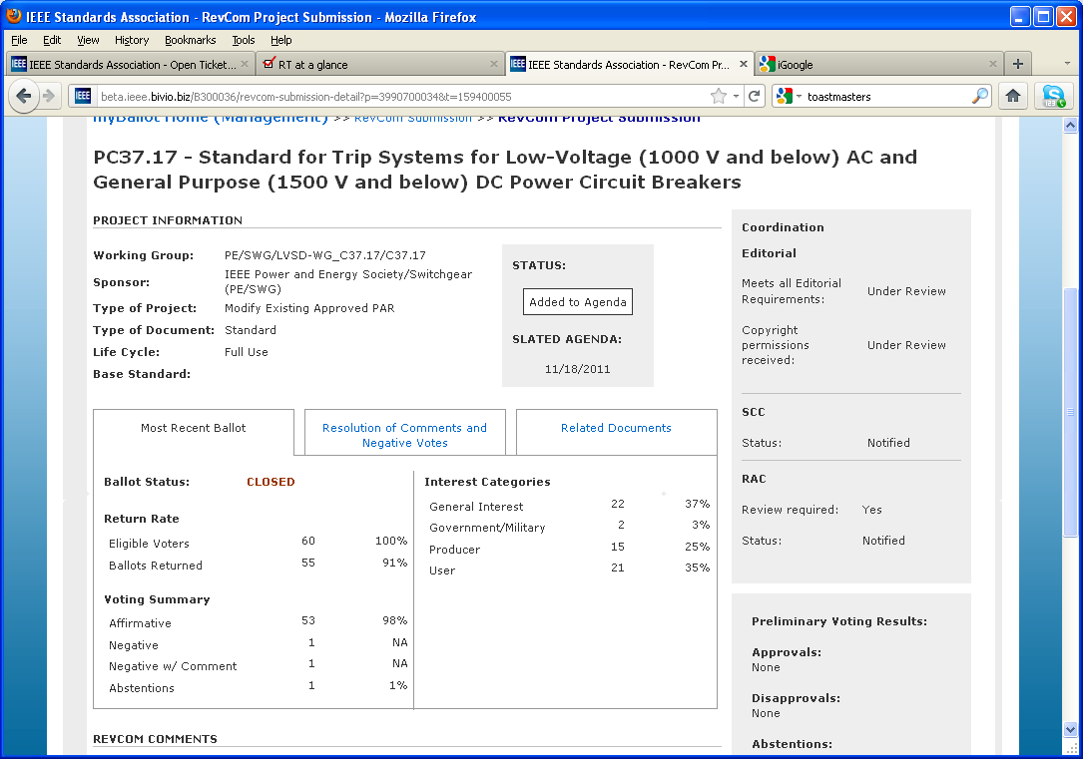

- Comments will be displayed at the bottom of the screen. Click “Expand all” to view the entire comment threads.

- Click “REPLY” to add to a comment thread.

- Add your comment and click “ADD TO DIALOG” to save your comment.

View Meeting Minutes
The meeting agenda will be transferred into the meeting minutes. Submissions along with recommendations will be placed in the minutes automatically. Minutes can also be downloaded as a PDF.

Applicable Users:
- RevCom Members

Instructions:
- On the myProject™ Home Screen click “RevCom Area”.
- Click “minutes” next to the meeting you would like to view minutes for.

- Click “Download as PDF” to generate a PDF copy of the minutes.

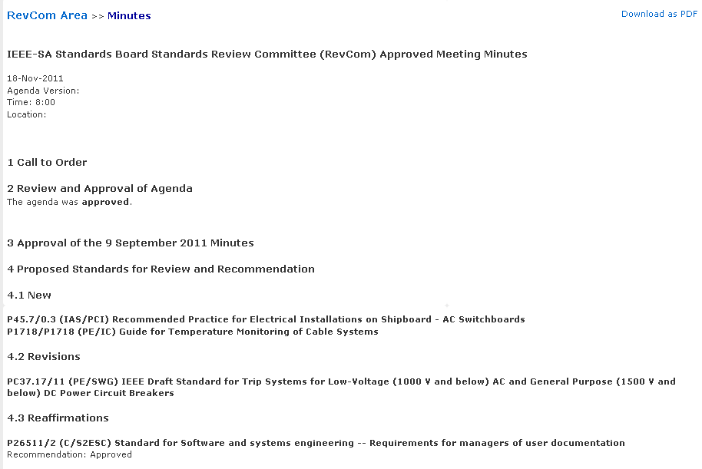

User Roles

Volunteer User Roles
General User - This is default user type if a user is not an IEEE-SA member and has not been given any additional authority. As a general user, you can:
- Register as interested in a Sponsor, Working Group or Project and be assigned an involvement level
- View Active PARs, Sponsor P&Ps and Society-Staff Liaisons
- Create a PAR (but not submit)
- Send a message to a Sponsor
- Join a single Ballot and vote/comment on that ballot (for a fee)
- View all ballot and invitation history
- Access membership information
- Send a message to the balloting center
- Enroll as DR/DRA or EBR/EBRA (if employed by an Entity Member Organization)

IEEE-SA Member – IEEE-SA Members can:
- Register as interested in a Sponsor, Working Group or Project and be assigned an involvement level
- View Active PARs, Sponsor P&Ps and Society-Staff Liaisons
- Submit a PAR
- Send a message to a sponsor
- Join a Ballot
- Vote/Comment on a ballot
- Send a message to the balloting center
- Enroll as DR/DRA or EBR/EBRA (if employed by an Entity Member Organization)

Sponsor Chair/Standard Representative – Sponsor Chairs/Standard Representatives have all abilities of IEEE-SA Members plus:
- Accept/Reject a PAR
- Manage Roster involvement for Sponsor, Working Groups and Projects
- Manage Officers for Sponsor, Working Groups and Projects (only Sponsor Chair can manage Standard Representative)
- Send notifications to a Group (Sponsor, Working Group)
- Initiate Ballot Invitation Requests
- Submit a draft for MEC
- Initiate a Sponsor Ballot
- Initiate Recirculation
- Manage Misc Coordination
- View Invitations
- Replace Drafts for Balloting
- View ballot Activity and respond to comments
- Submit Rogue Comments
- Prepare for RevCom Submission
- Send Notifications to Balloting Groups

Working Group Chair/Officer – Working Group Chairs/Officers have all abilities of IEEE-SA Members plus:
- Manage Roster involvement for Sponsor, Working Groups and Projects
- Manage Officers for Sponsor, Working Groups and Projects (Chair/Co Chair/ Vice-Chair Only)
- Send notifications to the Working Group
- Initiate Ballot Invitation Requests
- Submit a draft for MEC
- Initiate a Sponsor Ballot
- Initiate Recirculation
- Manage Misc Coordination
- View Invitations
- Replace Drafts for Balloting
- View ballot Activity and respond to comments
- Submit Rogue Comments
- Prepare for RevCom Submission
- Send Notifications to Balloting Groups

Designee – Designees (Sponsor Ballot Designee, Nescom Designee, Revcom Designee, Coordination Designee) will have all abilities of IEEE-SA Members plus access to features relevant to performing their specific function.

EMR – Entity member Representatives will have all abilities relevant to their personal roles plus:
- Manage Representatives for the Entity (DR/DRA)

DR/DRA – Designated Representatives/Alternates will have all abilities relevant to their personal roles plus:
- Participate in Entity Working Groups

EBR/EBRA – Entity Ballot Representatives/Alternates will have all abilities relevant to their personal roles plus:
- Vote/Comment on Entity Ballots

Technical Editor – This is a designation given to all Sponsor and Working Group officers as well as anyone who has been given the “Technical Editor” role at the Sponsor, Working Group or Project level. Technical editors will be given access to the Standards Dictionary.

Glossary

Activity Area | A group of people with a common technical interest such as a Working Group, Sponsor, or project, joining an Activity Area is open to the public and merely expresses interest
Affiliation | An individual or entity that has been, or will be, financially or materially supporting an individual's participation in a particular IEEE standards activity, this is not necessarily the same as an employer
AudCom | Oversees the standards development activities of Societies, their standards-developing entities, and the Standards Coordinating Committees (SCCs) of the IEEE-SA Standards Board
Ballot | See Sponsor Ballot
Ballot Group | The list of individuals or entities formally approved to cast a yes/no/abstain vote during a ballot
Committee | A generic term referring to any group of people with a leader (e.g. Working Group, Study Group, Sponsor Executive Committee, SASB standing committee, adhoc, etc.)
CSM | Client Services Manager, an IEEE-SA staff member responsible for facilitating funded projects
CSV | Comma Separated Value, a file format that can be edited by spreadsheet programs like MS Excel
DR/DRA | Designated Representative/Designated Representative Alternate, the individual responsible for representing an Entity Member organization in an entity Working Group
EBR/EBRA | Entity Ballot Representative/Entity Ballot Representative Alternate, the individual responsible for representing an Entity Member Organization by casting a vote in a specific entity ballot
EMR | Entity Member Representative, the individual responsible for managing representatives of an Entity member Organization
Entity Member | Membership in the IEEE-SA by a company or other organization, only one vote may be cast by a single entity in an entity ballot
IEEE Web account | A single web account used for all IEEE web services
IEE-SA | The IEEE Standards Association, the division of the IEEE responsible for creating and maintaining standards
Interested Party | An individual who has expressed an interest in the activities of an Activity Area, does not imply higher Involvement Levels in the area; this is a self-assigned level of involvement and cannot be removed by anyone other than the individual him/herself
Involvement Level | The classification of a user's involvement within a committee (e.g. Interested Party, Observer, Non-Voting Member, Voting Member)
MEC | Mandatory Editorial Coordination, required review by staff to verify all legal, copyright and other editorial matters related to a draft
myProject™ | A set of web-based tools that facilitate the IEEE standards process
NesCom | New Standards Committee, serves as the gatekeeper for new and revised standards, recommending the approval of new or revised standards requests to the Standards Board
NesCom Administrator | IEEE-SA staff member responsible for facilitating activities of NesCom
Officer | Any member of a committee with a special role, e.g. Chair, Designee, Secretary
PAR | Project Authorization Request, PARs are used to authorize work on a new standard or revision to an existing standard
PDF | Portable Document Format, a file format used for sharing documents
Project | Projects are initiated when a PAR is submitted, a working group can be responsible for several projects
Recirculation | An additional round of voting on a Sponsor Ballot
RevCom | Review Committee, recommends the approval of standards to the Standards Board
Rogue Comment | A comment received on a sponsor ballot from someone outside of the balloting group or outside of the ballot or recirculation period
SASB | The IEEE-SA Standards Board
Society | IEEE technical societies
Sponsor | An entity authorized by the IEEE-SA Standards Board per the IEEE-SA Standards Board Bylaws to submit a PAR or conduct a Sponsor Ballot. This includes, but is not limited to, Society Sponsors (e.g. C/LM or C/MMSC), Standards Coordinating Committees, the Corporate Advisory Group and IEEE Councils such as the Nanotechnology Council.
Sponsor Ballot | The process of conducting the formal consensus ballot (as opposed to the actual yes/no vote that is the actual vote cast by a user)
Sponsor Ballot Designee | The individual responsible for handling the Sponsor Ballot activities for a specific project. By default, the Working Group Chair assumes these responsibilities
Sponsor Chair | The chair of record for a Sponsor as defined above
Staff Liaison | A member of the IEEE-SA staff responsible for guiding Sponsors and Working Groups through the standards process
Standards Board | Oversees the process and policies that support standards development
Standards Representative | The individual responsible for handling the standards activities within a Sponsor. By default, the Sponsor Chair is the Standards Representative.
Voter | An individual authorized to cast a vote on a Sponsor Ballot
Working Group | A formally recognized organization, usually under a Sponsor, responsible for the development of one or more standards projects
Working Group Chair | The chair of record for a Working Group as defined above
ZIP | A file format used to combine multiple files into a single, smaller file for purposes of uploading and downloading

