**IEEE P802.24**

**Vertical Applications Technical Advisory Group**

|  |  |  |
| --- | --- | --- |
| Project | IEEE P802.24 Vertical Applications Technical Advisory Group | |
| Title | **IEEE 802 Networks for Alternative Fuel Vehicle (AFV) Fueling Infrastructure White Paper** | |
| Date Submitted | 2022-03-12 | |
| Source | Craig Rodine, Jin Seek Choi, Hyeong Ho Lee, Young Kyu Ko, Adedamola Adesokan, Sheryl Drake |  |
| Re: | Additional content | |
| Abstract | < to be added > | |
| Purpose | < to be added > | |
| Notice | This document has been prepared to assist the IEEE P802.24. It is offered as a basis for discussion and is not binding on the contributing individual(s) or organization(s). The material in this document is subject to change in form and content after further study. The contributor(s) reserve(s) the right to add, amend or withdraw material contained herein. | |
| Release | The contributor acknowledges and accepts that this contribution becomes the property of IEEE and may be made publicly available by P802.24. | |

# Introduction

The growing adoption of vehicles powered by electricity and hydrogen, instead of traditional fossil fuels like gasoline and diesel, creates the opportunity and need to re-consider fueling processes and infrastructure. The ‘user experience’ of fueling a traditional Internal Combustion Engine (ICE) powered vehicle is very familiar throughout the world. Everything from station locations and hours of operation, to safety precautions and ergonomics; the resources (time and money) required; how to use the dispenser; the units of measure and method of sale, including financial transaction and receipt; are well-known and effectively taken for granted by the driving public. However, many aspects of the fueling experience can and will likely be quite different for the new, non-ICE vehicles.

Throughout this report, the term Alternative Fuel Vehicle (abbreviated AFV) designates Electric Vehicles (EVs) and Hydrogen Surface Vehicles (HSVs), the two leading types of AFVs coming into use.

One significant difference is that AFV vehicles connect to their fueling infrastructure via a coupler that enables analog signaling and/or digital communication between the devices. (By way of wires in the cables used for EV charging, and an infrared link for HSV fueling.) This capability currently supports control protocols that manage the transfer of electrical energy or gaseous hydrogen; in principle, it could be used for other purposes as well.

This whitepaper presents some use cases, requirements, and integration oppor­tunities for AFV fueling that take advantage of mainstream communications capabilities and networking standards, across a range of scenarios and sites.

# Overview of AFV Fueling

This section describes common aspects and characteristics of AFV fueling processes, which may provide orientation to the AFV application domain and enhance understanding of the use cases presented in Section N.

## AFV – fuel dispenser mechanical connection

Every fueling process requires a means for fuel (liquid gas/petrol, electricity, liquid or gaseous hydrogen) to flow between the dispenser and a vehicle. It’s helpful to refer to this mechanism as a *coupler* with two mating components, an *inlet* (on the vehicle) and a *connector* or *nozzle* (on the dispenser).

The familiar “gas pump handle” used to fuel an ICE can be understood as a simple coupler, with the critical mating feature being the diameter of the nozzle spout and fuel filler neck. (This prevents a diesel fuel nozzle from being inserted into a petrol inlet.) Its control and safety features are mechanical: fuel-tank shutoff, attitude shut-off, a no-pressure-no-flow device, etc. There is no communication – not even a mechanical linkage – between fueling infrastructure and vehicle.

A gaseous hydrogen fuel coupler is similar to the ICE design but more complex, requiring a mating collar with magnet for dispenser activation and a sealing/locking feature for safety, since the gas is under pressure. The HSV specifies its fueling pressure (H35 or H70 service) via one-way infrared communication and can send an ‘emergency stop’ message if the vehicle detects an unsafe condition. (The dispenser can also detect an anomaly and shut down, but it can’t communicate this to the vehicle.)

For *conductive* charging of EVs, there are multiple standards-based couplers designed for manual, ergonomic insertion; almost all use mating pin-and-sleeve (or pin and contact-tube) electrical contacts following the practice and standards for high-voltage electrical plugs and sockets. All DC couplers support mechanical or magnetic locking to prevent arc flash on separation of connector from inlet with high voltage on the contacts. Some AC coupler designs include a locking feature, primarily for physical security (to prevent a charging cord from being stolen) not electrical safety.

There are some additional means of connecting EVs to the charging infrastructure.

For inductive (also known as ‘wireless’) charging, electrical energy is passed over an air gap between coils in the infrastructure and the vehicle. In a typical prototype implementation, the dispenser coil is embedded in the floor or in a moveable pad or platform, and the mating coil is mounted on the underside of the E as shown in Figure X1 [s1]. Mating is done by positioning the vehicle over the pad for optimal energy flow between the coils; this positioning could use automatic vehicle control (e.g. EV autonomous driving capabilities). Naturally the communications used to control inductive charging is also wireless. One system sends control signals on the energy transfer frequency (~25 kHz or 85 kHz), while one prototype used JSON messages over IEEE 802.11/Wi-Fi® for coil geometry compatibility and positioning.

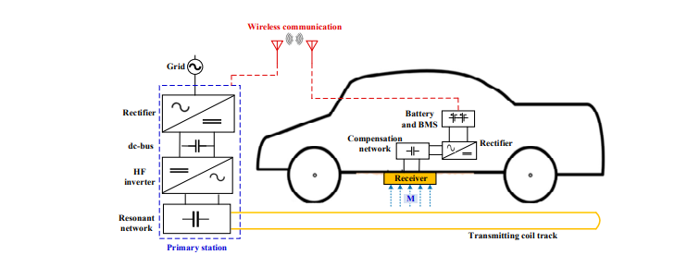

Figure X. EV Inductive Power Transfer Components

There are standards and technologies for robotic control of EV-infrastructure charging using pantograph mechanisms to connect rails or other, multi-pole contact systems to charge e.g. electrific buses as shown in Figure X2 [s2] Such a system can deliver power at high levels, up to 1 MW for 30 seconds or 400 kW for 15 minutes. As for wireless charging, the communications used to engage and disengage the pantograph, do electrical connectivity safety checks, and control the energy flow is some form of wireless, including IEEE 802.11n.

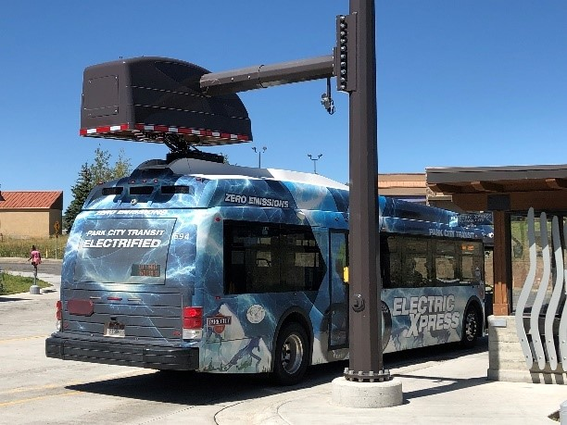

Figure X2. Pantograph charging.

## Energy Requirements and Supply

AC charging: uses ubiquitous utility service to power conversion devices (AC-DC converters) on board the EV. In North America, utility service is 117 VAC or 208-240 VAC, both single phase; these are called Level 1 (L1) and Level 2 (L2) AC charging levels, respectively. In Europe the coupler has five pins for power, enabling it to support both single-phase and three-phase AC charging; nominal service voltage is 230 VAC and most homes and commercial buildings have single-phase service.

DC charging: < explain power conversion in charging stations using 400-480 VAC three-phase service as input, to delivery up to 400 kW (800 VDC, 500 A) at the connector. Liquid cooling of cable and connector pins required above 200 kW, etc. Higher voltage and power levels are being supported in emerging standards, e.g. up to 1250 VDC AND 3000 A per CharIn per the so-called CharIn Megawatt Charging System (MCS): IEC 63379, SAE 3271>

Future: < explain that there is interest in using DC as EV charging system input. This would improve system efficiency by avoiding AC-DC conversion losses. The most likely sites for this development would be those with DC voltage sources like PV arrays, stationary fuel cells, and batter energy storage systems. In such an environment, IEEE 802 communications would offer a communications fabric for the integration, coordination, and control of energy and AFV fueling systems. >

## Fueling Session Frequency and Duration

< Describe short dwell high power, longer dwell lower power, etc. Some EV chargig equipment is lightly used, delivering one or two charging sessions per day, e.g. 3.5-11 kW AC charging in a residence or workplace. Others will be used with higher frequency, up to 24-30 sessions per day. (Strawman: one 30 minute session every 45 minutes for 18 hours, e.g. 66% duty cycle when the station is publicly accessible with six hours down time per 24-hour period). Extremes of activity would be seen in medium-and heavy-duty vehicle charging sites, with large numbers of stations/dispensers used at high duty cycles and/or energy levels. >

## Deployment geographies (environments? sites?)

< Describe the sites where AFV Fueling is taking place. Attention will be paid to physical site characteristics that matter for network design, e.g. size and span (horizontal and vertical); connectivity to power systems and power density; physical security; brownfield vs. greenfield; etc.

Examples include

* residences (single- and multi-family): one to ten(?) AC stations, power level 3-11 kW each; typical cable length 5 ± 2 m; medium physical security; mostly retrofit, some greenfield; spans would be covered by a single Wi-Fi AP.
* workplaces and other long-dwell, high-user-density sites; tens to a thousand AC stations, power level 6-22 kW each, currently almost all 6.6 kW AC; typical cable length 5 ± 1 m; more DC stations to come (same input voltage as AC but higher power level e.g. 11 kW); spans would require one to many Wi-Fi Aps; some workplace sites will resemble large public parking facilities, e.g. municipal or airport parking lots.
* publicly accessible facilities for short-dwell, high-power-delivery “fast charging”, such as urban and suburban dedicated fueling stations, parking structures, and highway rest stops;
* fleet vehicle depots, including privately owned (goods delivery, taxi pools) and publicly owned facilities (school districts, postal services, etc.)
* highway-side fueling facilities for extremely-high-power-delivery long-haul truck re-fueling (“truck stops”) >

< to be reconciled with content from the April, 2023 draft >

## EV – charging infrastructure communications

< Describe the variety of communications standards and technologies currently used in AFV fueling systems, focusing on EV charging. Include for EV charging: SWCAN, CAN, PWM, PLC, BPLC/TCP/IP; for HSV fueling: IrDA. >

< Observe here that the EV charging communications methods described are all ad-hoc ‘point’ solutions created by auto and electrical infrastructure/safety engineers without knowledge of or regard for communications/network orientation or expertise. That EV-EVSE interactions are not demanding and could remain fairly isolated, but could also be one among multiple e-mobility services that infrastructure offers to vehicles. This will set up our discussion of next-generation communications and networking requirements in Section 4. >

# AFV Fueling Use Cases

CR: Since we’ve covered the status quo in Section 2, I recommend that we present use cases for new or extended functionality that will motivate extensive use of IEEE 802 standards. So far, all contributions regarding use cases meet this criterion.

< Note: order and numbering of the Use Case sub-sections might change. >

## Public Parking with Advanced Charging Services

< Describe the use case ref. 24-22-0020-01-0000-afv-fueling-vertical-update.pptx, #5 >

An EV coule be equipped with an IEEE 802.11 Station (STA), which enables it to establish a secure wireless network connection. Upon entering the range of the parking structure's Wi-Fi network (e.g. an Access Point), the EV's onboard communication system scans, identifies and initiates a connection process with an infrastructure Access Point (AP) broadcasting it’s SSID.

The STA and AP engage in the IEEE 802.1X authentication process. This involves the EV STA acting as the Supplicant, the AP serving as the Authenticator, and a back-end Authentication Server, which is part of the Charging Station/Services Management Server (CSMS), validating the credentials. EAP (Extensible Authentication Protocol) over LAN (Local Area Network) (EAPOL) is used to transport authentication data. The EV presents its credentials in the form of a digital certificate and upon successful authentication, the network applies dynamic encryption keys, ensuring a secure IEEE 802.11i/WPA2 or WPA3 encrypted connection between the EV and the network. Simultaneously, application-level message using protocols such as ISO 15118 or JSON over HTTPS could be exchanged between the EV and the EV Charging Services Management System (CSMS) enabling the transmission of data necessary for charging services.

Following the establishment of a secure connection, the EV and EVSP would commence a negotiation process to determine the specific parameters of the charging service. This negotiation might include determining the type of charging service needed, such as conductive (plug-in) or inductive (wireless) charging, and whether the power flow will be uni-directional (only charging the EV) or bi-directional (allowing for energy sharing between the EV and the grid – Vehicle-to-Grid, V2G capabilities). Additionally, the EV could communicate its specific needs, such as the amount of energy in kilowatt-hours (kWh) or additional range (in miles or kilometers) required; the desired duration of the charging session; and the pricing terms acceptable to the driver based on dynamic pricing models or pre-negotiated rates. This information exchange is crucial for tailoring the charging service to the individual needs of the EV and its driver, and also for matching energy supply available at the site with overall EV energy demand.

The EVSP would then process this information and make the best match between the EV's request and the capabilities of the Electric Vehicle Charging Infrastructure (EVCI) available at the parking structure. This determination involves several key considerations:

* Account Verification: The EVSP checks if the driver has an existing account or subscription with the service, usually through a query to a Charging Station/Services Management Server (CSMS).
* Charging Station Availability: The EVSP assesses the availability of a charging station that can deliver the power level needed to provide the requested amount of energy or range within the desired session duration. This involves checking the current occupancy and operational status of the charging stations.
* Other Considerations: Additional factors such as compatibility with the EV's charging system, current grid conditions, and any special requirements or preferences set by the driver may also be considered.

<<TODO: Insert a network architecture diagram>> Network segmentation considerations etc

* Public Wi-Fi Network for Users
* EV Charging Infrastructure Network
* Operational and Administrative Network
* Payment Processing Network
* IoT and Surveillance Network
* Application to Hydrogen Surface Vehicle (HSV) Fueling
  + Describe current one-way IR link, need for two-way, ISO ans SAE standards WG intetest in using secure [enterprise] Wi-Fi (perhaps extending EV PKI for this case)

Advanced Use Case – Automated Valet EV Parking

Upon approaching the parking structure, the EV initiates communication using IEEE 802.11p Wireless Access in Vehicular Environments (WAVE), a standard designed for automotive communication. This facilitates direct vehicle-to-infrastructure (V2I) communication, allowing the EV to securely connect to the parking structure's communication network. Leveraging IEEE 802.1X for authentication, the EV establishes a secure communication link with the parking structure’s network, ensuring encrypted data exchange. Through this secure link, the EV communicates with the Electric Vehicle charging services platform (EVSP) to negotiate charging service parameters, like the standard EV charging scenario but with the addition of specifying the need for automated valet parking.

Once the charging service parameters are agreed upon, including type of charging, energy requirements, and session duration, the parking structure's management system activates the automated valet service for the EV. The EV could utilize standards under the IEEE P2040 family, which are related to road vehicle automation, to safely navigate within the parking structure. This involves real-time data exchange between the EV and infrastructure to guide the vehicle to the designated parking spot with the appropriate charging station. The EV's ADAS, enhanced with capabilities for autonomous navigation in confined spaces, takes control. Using a combination of onboard sensors, cameras, and V2I communication, the EV autonomously navigates to the assigned parking spot, avoiding obstacles and adhering to the parking structure's traffic flow guidelines.

Upon reaching the designated parking spot, the EV aligns itself with the charging station and depending on the charging technology (conductive or inductive), the vehicle either automatically connects to the charging station through a robotic arm mechanism (for conductive charging) or positions itself accurately over an inductive charging pad. With the physical connection established, the EV and the charging station commence the charging session based on the pre-negotiated parameters. The EVSP monitors the session, adjusting as necessary to ensure optimal charging.

Throughout the charging session, the EV maintains a conductive or wireless communication link with the EVSP, providing updates on charging progress and any adjustments required due to changes in the EV's energy needs or the parking structure's power availability. Once the charging session is complete, or if the vehicle needs to be moved (e.g., to optimize parking space usage or for load balancing on the power grid), the EV can be autonomously navigated to a different spot or made ready for the driver to take over.

## Low-power, long-dwell EV Fleet Charging

< Describe the use case ref. 24-22-0020-01-0000-afv-fueling-vertical-update.pptx, #4 >

Narrative:

- A package distribution or postal service operator is using electrified vans (E-Vans) in its fleet of delivery vehicles, requiring the installation of hundreds of medium-power (Level 2, or L2) AC charging stations in its depot.

- Since AC charging is simple (e.g. using analogue control, see Appendix 1), these stations can be inexpensive. Fleet charging sations are often residential designs enhanced to be more reliable over time, meet fleet-specific environmental or usability requirements, etc. Since first-generation products were ‘standalone’ with minimal or no integration requirements, they often have no external communications interfaces (except perhaps and RFID reader and Bluetooth capabilities for configuration).

- For a number of use cases, communications beween AC charging stations and a site-based or remote Charging Service Management System (CSMS) is required. Examples include vehicle and/or driver authentication; matching E-Van energy needs to charging station capabilities and availability; tracking and managing energy supply among charging stations; and providing firmware upgrade services to EV charging stations.

- Looking at the second example above in more detail: the main fleet use case is for overnight E-Van charging, but there might also be a need to charge vans between delivery runs. E-Van range with a full battery pack is typically 125 to 160 miles; charging requires the delivery of 68 kWh (Ford E-Transit) to 135 kWh (Rivian EDV/ECV). Depending on the initial state of charge (SoC, how much energy is in the battery when charging starts); and station power (7.6 kW to 22 kW), charging time to fully charge the E-Van battery can range between 3-18 hours. Fleets will have mix of shorter- and longer-range E-Vans; if every charging station must be able to charge any van overnight (say, between midnight and 6am) there will also be a mix of lower and high-power stations. To match stations to charging requirements, an E-Van could connect to a secure site Wi-Fi service when entering the depot and report its energy needs to the CSMS, which would make the match with an appropriate parking/charging bay. (Using the same process described in the Public Parking use case, Section 3.1, with perhaps additional service parameters exchanged in support of fleet logistics – see below.)

Authentication of the E-Van or driver could also be implemented as exchanges over the secure Wi-Fi network. When the E-Van arrives at the designated parking/charging bay, an EVSE with cable and connector (conductive charging service) might be plugged in to the EV by a robot arm that uses a camera and positioning sensors that all communicate via Wi-Fi. If the EVSE charges wirelessly, using inductive power transfer, Wi-Fi could be used to align the coil on the E-Van with the the charging station coil embedded in the floor or mounted on a pillar. In both inductive and conductive charging cases, energy transfer can be managed by Wi-Fi messages beween the EV and the charging station.

*< We need to work out network configurations: whether these Wi-Fi services are infrasrtuture/ AP-based, over an ad-hoc network, over a point-to-point link, etc. based on site and use case requirements for coverage, performance, etc. >*

## High-power Medium/Heavy-duty Vehicle Charging

< Describe the use case ref. 24-22-0016-01-0000-ev-charging-vertical-overview.pptx, #8 >

## < Additional Use Cases >

…

## Charging in Cooperative Energy and Smart Home Management

* Use Case Narrative: An EV user travels primarily between work and home, relying upon a robust charging infrastructure both at his place of business and their residence. In this case, their work location is a small to medium sized office building and their residence could be either small multi-family residence or single family dwelling. “Level 2” (L2) AC charging systems which have the capability of delivering between 3 and 20 KW of power are used for residential and small commercial sites for employee use. Traditionally, these L2 charging systems are primarily standalone and have not been highly integrated into either a cooperative or Smart Home management system, if at all.
* For small commercial building managers seeking to effectively utilize charging resources, the ability to integrate business power management with EV charging requirements is crucial to ensure the business is able to sustain both activites effectively.
* Homes or small multi-family dwellings with multiple charging stations will also benefit form an integrated approach to energy management for EV charging and power requirements (day/time utilization, etc.)
* Additional services such as charging station contention management, reservations, waitlist queuing, matching user charging requirements with limited charging resources in contrained areas such as small multi-family dwellings or small office commercial complex assist in improving charging resource allocation.

### Communications aspects of residential/small building charging

As L2 AC charging is controlled by analog circuits within the charging device and the EV, , there has been no need for communications interfaces on either to support the charging function. Nevertheless, some vendors have included wireless communications capabilities in their wallbox products to provide user access to additional services. Examples include Bluetooth™ for charging station configuration using a vendor-provided app on the user’s smartphone; and Wi-Fi® for communication between the charging station and the vendor’s cloud-based charging network (and device) management system, via the user’s home Wi-Fi AP/router. This external connectivity offers opportunities for consumers and building managers integrate secondary communications for EV charaging management such as selecting advantageous utility time-of-day pricing structures, reservation systems, charging payment processing, Vehicle to Grid energy transfer (VTG), etc.

< an example in multi-family dwellings or small commercial buildings: ‘waitlist’ queueing with notifications when charging stations become available; note: this uses NFC/M2M/cloud/app but not 802 comms, in a non-trivial way >

Such EV charging services use IEEE 802 communications (Wi-Fi) in a limited way, and depend on the device vendor (or service provider) and utility to partner on providing service offerings. Developments in Smart Home promise to expand opportunities for EV charging to participate in comprehensive, dynamic cooperative energy management.

### Smart Home platforms for Cooperative Energy Management

The term ‘Smart Home’ designates a system that coordinates and controls services in a single- or multi-family dwelling, such as HVAC, lighting, media and information, security, water, and distributed energy resources (DERs) including rooftop solar, fixed energy storage, and electric vehicle charging/discharging. The goals of such a Smart Home system are to enable constituent devices and systems to respond to user requirements and desires, while also optimizing as much as possible the use of resources, in particular electrical energy.

As home energy becomes more electrified due to environmental and regulatory policiies, there will be opportunities to balance convenience and cost considerations with energy delivery and consumption. To foster this potential, devices managed within a smart home including the EV charging infrastructure will require improved control interface visibility and communitications to various management systems. Examples of this industry focus include the Matter protocol, which has emerged as a foundation for a comprehensive Smart Home ecosystem. Part of the ISO/IEC 15067-3 set of standards, the Energy Management Action Plan (EMAP), provides a framworkfor next-generation Smart Home integration. . IEEE 2030.5, the successor of the ZigBee Alliance’s Smart Energy Profile 2.0, is a “standard for communications between the smart grid and consumers … built using Internet of Things concepts”. All of these can be deployed on IEEE 802 (Wi-Fi, Ethernet, 805.15) networks.

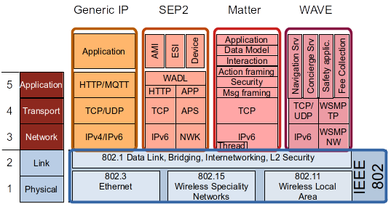

*Figure N: Examples of Smart Home platforms that can be deployed on IEEE 802 networks*

IPv4/IPv6

UDP

CoAP

EMAP

Applications

### Integrating EV charging in an EMAP network

#### Energy management for Smart home integrated with EV charging

Smart Home Management Systems can provide an approach that ttempts to coordinate and control house smart devices such as, that energy management heating, air conditioning, distributed energy resources (DERs) and EV chargingto increase energy efficiency (e.g., power balance, power-sharing, energy management, and optimizing) [6]. The smart home energy management framework, , must extend high-level communication that allow a bidirectional energy flow among energy systems including DERs and EVs [1]. In this context, control of the energy systems allows the management of energy flow generated from DERs and EVs for consumption or for storage in the collective EVs.



ISO/IEC JTC1 SC25 provides a standardized Enviornmental Management Application (EMA) that plays an important role to optimize the energy use of home appliances in smart homes by utilizing standardized two-way communication in home area networks (HAN). EMA is a self-contained autonomous software agent for energy management by allocating/scheduling limited energy resources (e.g., thermostat) within residential and small buildings [2]. An EMA can be embedded in devices such as a thermostat, a smart appliance, or other consumer products such as EV charging system and distributed energy resources (DERs) [3]. EMA allocates energy among houses efficiently in a community and among appliances within houses, and to accommodate a choice of external or local or both energy sources linked to DERs or EVs [4]. External sources can be public utilities or DERs in other homes, possibly purchased using transactive energy while local sources can include electric vehicles, renewable power generators and storage devices at the customer premises linked to its own EMA. In this system, EMA automatically react to demand-response (DR) events, while EVs are charged and discharged (i.e., V2G) in appropriate time slots by taking into account changes in energy consumption, time-of-use rate information, and users’ vehicle usage plan. For realizing different levels of coordination, EMA is useful to optimize the energy use in smart homes by using EV as an emergency backup power when power outage occurs, and also it is beneficial for peak shift by charging EV in off-peak periods and discharging it in peak periods (V2G).

*Figure N: EMAs for Cooperative Energy Management*

#### EMA Protocol (EMAP) in Smart home integrated with EV charging

For Smart homes integrated with EV charging, various standard communication protocols have been developed. For sending DR signals between grid and the home, OpenADR is often used as an application layer protocol. Within the home, Smart Energy Profile (SEP 2.0) developed by the Zigbee Alliance and the Energy Concervation and Homecare Network (ECHONET) are application communication standards and protocols for use in smart home to manage energy resources and security devices. SAE J2836/J2847/J2931 and ISO/IEC 15118 are suites of standards of two-way digital communication between EV and EV supply equipment (EVSE) for smart charging and discharging control [7]. IEEE's standard 1547 is intended to mitigate many of these DER impacts by defining how DER devices are designed and tested, and how DER will be integrated into the power system.

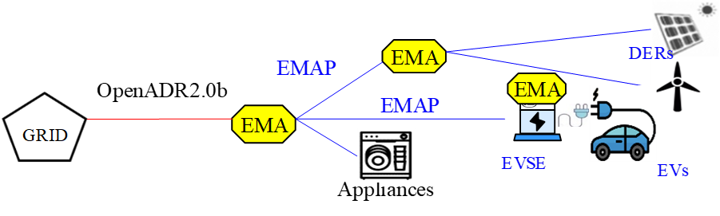

*Figure N: EMAs for Cooperative Energy Management*

EMAP specifies message formats for energy related information including DERs, pricing, and DR commands to manage customer energy resources, including load, generation, and storage in a home, building and apartment complex. The message sets support direct load control, time-of-use (TOU), critical-peak-pricing (CPP), real-time pricing (RTP), peak time rebates, various types of block rates, transactive energy, charging, discharging and a range of opt-in, opt-out and service modifications. EMAP must support bi-directional exchange of DR event between EMAs for co-operative energy management by using the opt commands in a hierarchical or point-to-point architecture.

EMAP is an IEC-ISO application layer protocol among EMAs for cooperative energy management in smart home environment [5]. EMAP specifies interacting procedures and message formats to ensure interoperability over a broad range of EMA deployments. It also specifies a communication mechanism through which application layer messages based on UML based data modeling may be passed across EMAs.

EMAP gives a set of the message interactions for performing various functions and operations. The transport mechanisms rely upon standard-based IP communications, such as Constrained Application Protocol (CoAP) and JavaScript object notation (JSON) messaging: CoAP is a specialized Internet Application Protocol for devices with limited processing capability, as defined in RFC 7252[8]. It enables EMA devices to communicate with the Internet using similar protocols. CoAP is designed for use between devices on the same constrained network (e.g., low-power wireless home networks), between devices and general nodes on the Internet, and between devices on different constrained networks both joined by an internet. JSON is a public file format as defined in RFC 7159 that uses human-readable text to transmit data objects consisting of attribute–value pairs and array data types (or any other serializable value) [9]. It is a very common data format used for asynchronous browser–server communication.



*Figure N: High-level protocol architecture of EMAP*

#### IEEE 802 Requirement for Integrating EV charging in an EMAP network

~~EMAP network might benefit from the use of IEEE 802.11/TSN technology and standards to integrate smart home, DERs and EV charging system for cooperative energy management and control.~~

* ~~Bidirectional data flow among Storages, DERs and EVs to support coordinated Energy Management and automation control (e.g., active and reactive power balance) in home microgrid.~~
* ~~Regulation of power demand for the continuous balancing of generation, load, and interchange at a very granular level.~~
* ~~Metering and sensing measurement for real-time control of power systems or microgrids~~

~~EMAP network requires evolution of IEEE 802.11/TSN for Electric Vehicle and Smart home Integration.~~

* ~~To take advantage of the charging system and allow for a scalable approach while improving reliability and resilience in smart home with renewable energy sources.~~
* ~~To take advantage of Collaboration and Coordination among smart home, DERs and EVs~~
* ~~to compute charging schedules and to implement demand response and ancillary services [Collaborative Autonomy]~~



*Figure N: High-level protocol architecture of IEEE 802 based EMAP*

#### ~~Future IEEE 802 communication design (802.11 series vs. Ethernet vs. TSN) enables near real-time communications for Integrating EV charging in an EMAP network~~

~~IEEE 802.11p technology is the popular standard for vehicular networks, offering a coverage area of up to 1km, data rates of up to 54 Mbps and latency as low as 50 ms. IEEE 1609 “Wireless Access in Vehicular Environments (WAVE)" is a higher layer standard based on the IEEE 802.11p. This includes data exchange between high-speed vehicles and between the vehicles and the roadside infrastructure, so called V2X communication, in the licensed ITS band of 5.9 GHz (5.85–5.925 GHz).~~

~~IEEE 802.11 is less expensive, supports mobility of devices, and its widespread prior adoption compared with other communication technologies is useful to equip the locations, such as parking areas, with wireless communication between EVs and CSs.~~

~~The significant advancement has been accomplished for the communication infrastructure with the special technologies that include the IEEE 1588 v2 or Precision Time Protocol (PTP) and Time-Sensitive Networking (TSN) standards to this area. These technologies are a clear evolution of the real-time control and allow synchronization levels of over few ms to be achieved.~~

~~TSN based LAN networks allow for higher levels of bandwidth utilization (75%) with lower latencies. TSNs were able to reduce this latency. With IEEE TSN’s ability to both synchronize timing for measurements as well as quickly move this data through a network, the feasibility of a large distributed state estimation system becomes more practical. It enables near real-time communications to request immediate energy consumption at the moment of generation or for use of the reserved energy to switch the energy systems from charging mode to power supply mode.~~

# Distributed Energy System support for EV Charging

Introduce and expand on the concept of ‘energy edge’ and its convergence with LAN/MAN (the Internet and content edge) and edge computing (the data/ML edge).

# Communications and Networks supporting AFV Fueling

The culmination of our whitepaper, providing details on the topics in the subsections below.

## Communications requirements

Speeds and feeds, both minimal and aspirational.

## Network architecture

Expanding on the diagrams below from 24-23-0007-00-0000-draft-afv-whitepaper.docx

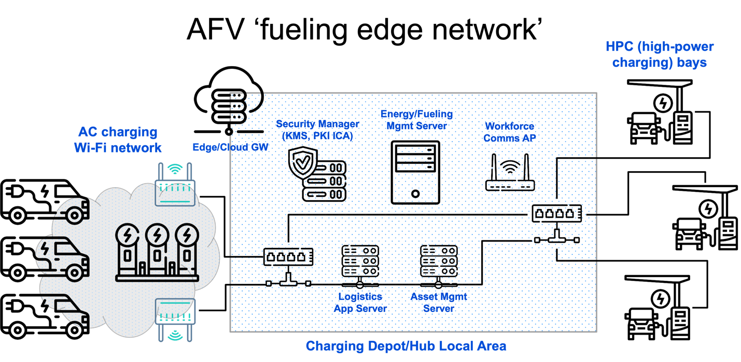

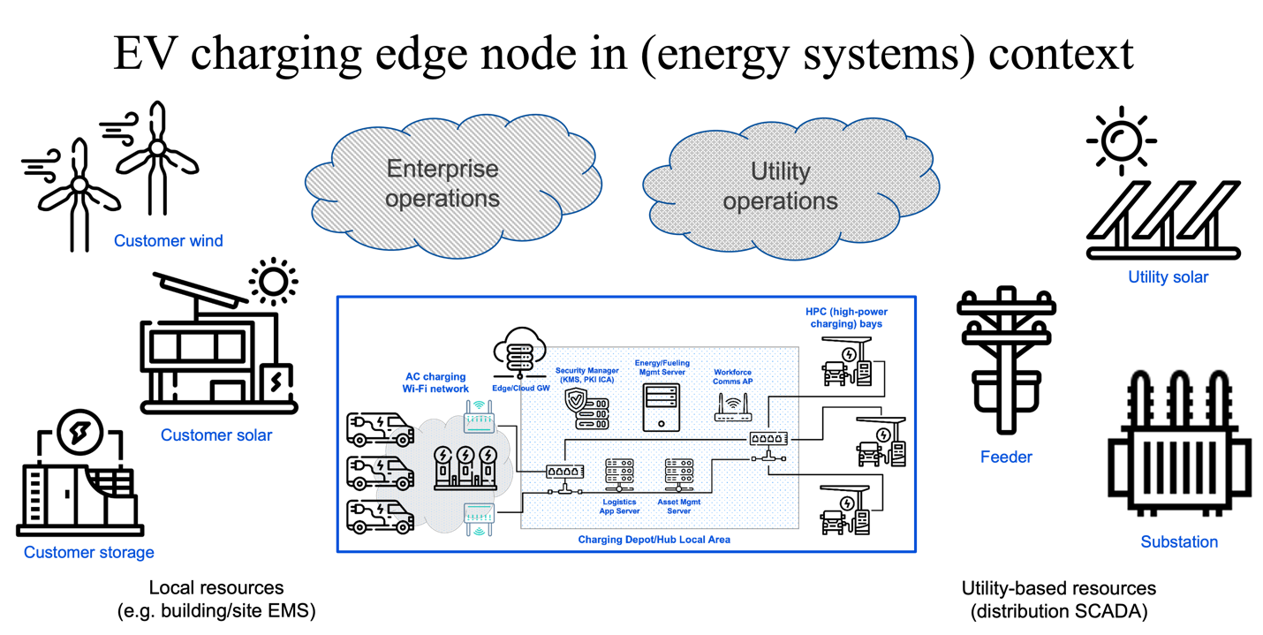

## Device and network cybersecurity and management

Survey the applicable IEEE 802 standards relevant and applicable to this concern.

# IEEE 802 Standards and Technologies supporting AFV Fueling and the Energy Edge

A survey of specific IEEE 802 Standards/Clauses and Amendments that would comprise a secure communications fabric/foundation for the ‘energy edge’.

# Conclusions and Recommendations

# References

1. J. S. Choi, "Energy management agent frameworks: Scalable, flexible, and efficient architectures for 5G vertical industries," IEEE Industrial Electronics Magazine, vol. 15, no. 1, pp. 62-73, March 2021
2. ISO/IEC 15067-3:2012, Information technology – Home Electronic System (HES) application model – Part 3: Model of a demand-response energy management system for HES
3. ISO/IEC 15067-3-3:2019, Information technology – Home Electronic System (HES) application model – Part 3-3: Model of a system of interacting energy management agents (EMAs) for demand response energy management
4. ISO/IEC 15067-30:FIDS, Information technology – Home Electronic System (HES) application model – Part 30: EMA functional requirements and interfaces
5. ISO/IEC 15067-3-31:FDIS, Information technology – Home Electronic System (HES) application model – Part 3-31: Protocol of energy management agents for demand response energy management and interactions among these agents
6. J. S. Choi, "A hierarchical distributed energy management agent framework for smart homes, grids, and cities," IEEE Communications Magazine, Vol. 57, No. 7, pp. 113-119, 2019
7. T. Shimizu, T. Ono, W. Hirohashi, K. Kumita, and Y. Hayashi, “Experimental demonstration of smart charging and vehicle-to-home technologies for plugin electric vehicles coordinated with home energy management systems for automated demand response,” SAE International Journal of Passenger Cars-Electronic and Electrical Systems, vol. 9, no. 2016-01-0160, pp. 286–293, 2016.
8. IETF RFC 7252, The Constrained Application Protocol (CoAP), edited by Z. Shelby et al., June 2014, available at: <https://tools.ietf.org/rfc/rfc7252.txt> [viewed 2023-05-31]
9. IETF RFC 7159, The JavaScript Object Notation (JSON) Data Interchange Format, edited by T. Bray, March 2014, available at: https://tools.ietf.org/rfc/rfc7159.txt [viewed 2023-05-31]

A. A. S. Mohamed, A. A. Shaier, H. Metwally, and S. I. Selem, “An Overview of Dynamic Inductive Charging for Electric Vehicles,” *Energies*, vol. 15, no. 15, p. 5613, Aug. 2022, doi: https://doi.org/10.3390/en15155613.

**Appendix 1: Electrical Characteristics of Residential and Small Building Charging**

Appendix 2: Smart Home Overview

In order to meet these goals, the devices and systems in a home need to have some degree or information processing and communication capability. Modern media devices, which are highly configurable and connected, provide a good example of how any subsystem within the home can be automated and integrated with others. For example, meshed Wi-Fi nodes – originally meant primarily to provide consumer devices with wireless access to the Internet –now incorporate microphones and speakers, allowing for natural-language interaction from almost anywhere in the home; can retrieve or relay data such as music playlists or television viewing preferences and activate services accordingly; and can report the status or change the settings of environmental controllers such as thermostats, skylights, and window shades. One can imagine such nodes soon incorporating sensors to gauge environmental factors (e.g. air quality, human/pet motion/activity, light or noise levels) as well.

**Appendix 3: DER Overview**

DER energy sources (such as solar energy and wind energy) have become important alternative sources of energy in the smart home. EVs are also becoming popular, because of their fuel efficiency and economic benefit, as compared to the conventional fuel-based vehicles. Energy management is an early target for similar verticals such as healthcare, agriculture, manufacturing, automotive, public transportation, utilities and energy, environmental, smart cities, and more. In energy vertical, it is crucial to find solutions to manage the peak demand while supporting substation automation of renewable energy systems such as DERs and EVs.

Appendix 4: Smart Energy Environmental Management Systems

EMAs enable the allocation of energy among appliances and switching energy sources from grid to local generation or storage according to consumer preferences [1]. EMAs also enable automated demand-response (DR) services in a house, a residential community or a building consisting of multiple apartments for coordinating and allocating energy consumption and generation among multiple EMAs in different locations [6]. DR programs are being offered to residential consumers for energy conservation and for energy management to align demand for power with available supplies for appliance usage and budget constraints. The co-ordination among EMAs offers improved energy management and overall efficiency according to customer preferences.

Typical smart energy services can include integrated energy management for efficient energy usage. The coordinative energy management is a combination of DR services and distributed energy sharing and trading within the community, energy information sharing among multiple energy systems for more efficient energy usage, etc. These cooperative energy services offer benefits in electrical energy management in a house, a residential community or a building consisting of multiple apartments by energy sharing and trading among EMAs, EVs, DERs and home appliances [6].

Appendix 5: Additional Use Cases:

An example of a service delivered to the charging device via Wi-Fi and the vendor’s cloud, is to allow the user to select their electricity pricing rate program from a list provided by the utility or utilities serving their location. Some utilities offer discounted rates for overnight consumption, encouraging EV charging at lower cost when electricity is not in high demand. If the user enrolls in such a program and selects that rate, their wallbox might be configured to block charging, or post a warning, if the EV is plugged in when rates are higher (e.g., during daytime). Given the rate program, the wallbox could calculate and display the cost of charging the EV. (Only after energy has been delivered, unless the EV’s battery capacity was set on the station and the EV sent its state of charge before charging, which is not currently possible using SAE and IEC L2 AC charging protocols).

A similar service that could be provided to EV drivers via the vendor cloud and Wi-Fi include charging power level regulation and/or incentive based on energy pricing or utility capacity constraints. Thus, an attempt to charge an SUV or pick-up truck with a 120 kWh battery pack at 14.4 kW (60 A) during hours of peak energy demand might result in the charging station being limited to delivering only 7.2 kW (30 A) and perhaps incentives – a price discount or confirmed reservation – to charge at a nearby public fast charging station that gets its energy from solar panels and energy storage, rather than the grid.