IEEE P802.24
Vertical Applications Technical Advisory Group

Project | IEEE P802.24 Vertical Applications Technical Advisory Group
Title | Internet of Things White Paper
Date Submitted | 2022-06-30
Source | Alan Berkema  HP Inc. | Mobile: +  E-mail: alan-c.berkema@hp.inc
Re: | N/A
Abstract | This contribution provides a first version of the Internet of Things White Paper. It will be updated (along with this Abstract) as the content materializes and is included.
Purpose | First Draft to begin discussion the IoT White Paper
Notice | This document has been prepared to assist the IEEE P802.24. It is offered as a basis for discussion and is not binding on the contributing individual(s) or organization(s). The material in this document is subject to change in form and content after further study. The contributor(s) reserve(s) the right to add, amend or withdraw material contained herein.
Release | The contributor acknowledges and accepts that this contribution becomes the property of IEEE and may be made publicly available by P802.24.

Background and Introduction
This white paper is to consider the applications related to the Internet of Things

References
[1] Gartner Gartner Glossary: Internet Of Things (IoT)
[2] ITU Internet of Things Global Standards Initiative
[3] Techopedia What Does Internet of Things (IoT) Mean?
[4] IBM What is the Internet of Things (IoT)?
[5] ISO/IEC 20924:2021 Information technology — Internet of Things (IoT) — Vocabulary
[6] IEEE 2413-2019 IEEE Draft Standard for an Architectural Framework for the Internet of Things (IoT)
[7] SAS Internet of Things (IoT) What it is and why it matters

What is the Internet of Things?
This paper begins with several definitions of the Internet of Things
- The network of physical objects that contain embedded technology to communicate and sense or interact with their internal states or the external environment. [1] Gartner.
- A global infrastructure for the information society, enabling advanced services by interconnecting (physical and virtual) things based on existing and evolving interoperable information and communication technologies. [2] ITU
- The Internet of Things (IoT) is a computing concept that describes the idea of everyday physical objects being connected to the internet and being able to identify themselves to other devices and send and receive data. [3] Techopedia
- The Internet of Things is the concept of connecting any device (so long as it has an on/off switch) to the Internet and to other connected devices. The IoT is a giant network of connected things and people – all of which collect and share data about the way they are used and about the environment around them. [4] IBM.

These definitions from the Industry provide an introduction to considering the Internet of Things to begin the investigation.
The International Standards Organization and the International Electrotechnical Commission [5] ISO/IEC also provide definitions of an “IoT Device”, the Internet of Things and many other components which contribute to the Internet of Things. The definition of an “IoT Device” emphasizes the idea that new IoT Devices are Sensors and/or Actuators.
The IEEE also provides definitions in their Draft Standard for an Architectural Framework of the Internet of things [6] IEEE Std 2413-2019.
“It is important to understand what the Internet of Things is and what the difference is between the IoT environment and an IoT system. A simple definition of an Internet of Things system is “a system of entities (including cyber-physical devices, information resources, and people) that exchange information and interact with the physical world by sensing, processing information, and actuating.”
The set of IoT components available to be composed into IoT systems, the networks connecting the components, and any associated services that provide the mechanisms for discovery, composition, and orchestration can be called an IoT environment.
Core to the idea of IoT is this interaction with physical entities. An entity of interest is a physical entity that is of interest to a human or organization for the completion of a goal. A physical entity is a discrete, identifiable part of the physical environment. Physical entities can be any physical object: humans; animals; cars; store or logistics-chain items; mechanical devices; computing devices; etc.”
The comprehensive descriptions above include the major components when contemplating the concepts comprised in the Internet of Things. Many of the definitions above mention common elements such as data sharing over a communication path. Most are very inclusive of a broad range of “things” including people and hardware. Some emphasize Sensors and Actuators.

IoT Things – Sensors and Actuators
Many common definitions of the Internet of Things are based on the concept that IoT things are primarily new devices based on Sensors and Actuators. Sensors and Actuators are an important device class for the IoT. To aid in the understanding of Sensors and Actuators, common definitions for these devices are provide below.
A sensor is a device that responds to any change in physical phenomena or environmental variables like heat, pressure, humidity, movement etc. and turns that into to a more usable form.
Sensors contain a transducer, a device that converts energy from one form to another
An actuator is a device that is responsible for moving or controlling a mechanism or system. It is operated by a source of energy, which can be mechanical force, electrical current, hydraulic fluid pressure, or pneumatic pressure, and converts that energy into motion.
A great example of a Senor/Actuator device is a fire sprinkler, these have been around for over a hundred years. The Sensor detects excess heat and the Actuator turns on the water to the sprinkler. A useful IoT device, however, modern systems take this closer to the value of the Internet of Things by including additional data. The system monitors the health of the Sensors and Actuators and the water delivery system to determine if it is in good working order and to communicate alerts if the system needs maintenance.

Smart Home
A major class of IoT devices live in the Smart Home and are gaining adoption and popularity.
Smart devices are interesting, however, it is debatable whether these individual devices create an Internet of Things?
Today, in many cases, each Smart Device includes its own App and performs a limited Smart function.
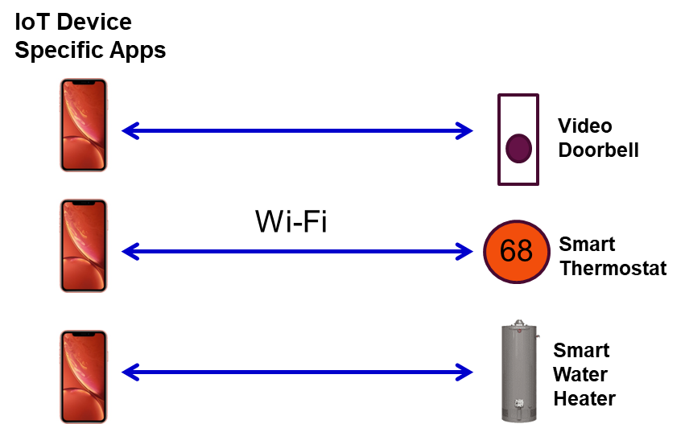

When the Smart Home devices communicate with each other and work together, the system begins to approach a greater Internet of Things concept. In the example below the Smart Home can implement a system that attempts to coordinate and control when the house needs services such as heating, air conditioning and hot water to increase efficiency. The IoT App could know when the home is vacant and deploy an “Away” mode to reduce energy consumption. Further, it could contribute to the “Smart City’ concept by reducing energy usage during peak hours.
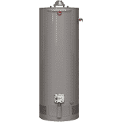
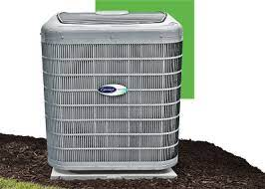
IoT App Controls a system of devices
Wi-Fi
Local Power Company
Lower power consumption
during energy peak hours
Smart Devices talk to each other
68

Vertical Applications
While the Smart Home is an early target including any other verticals are also making progress such as healthcare, agriculture, manufacturing, automotive, public transportation, utilities and energy, environmental, smart cities, and others.
Special cases for automotive IoT – use of Single Pair Ethernet. <Chris D to insert section here>

It is about the Data
Things are important, it’s in the name. The ultimate value of all of the things could be the data that these things collect and communicate.

Information
Data
Knowledge
Wisdom
Intelligence
& Analytics
People make better Decisions
With an abundance of data, intelligence and analytics can be applied to that data to create superior information which contributes to knowledge and greater wisdom. This will allow people and information systems to make better decisions.

In Closing
This paper will conclude with another definition that wraps of the concept of the Internet of things.
The Internet of Things (IoT) refers to a vast number of “things” that are connected to the internet so they can share data with other things – IoT applications, connected devices, industrial machines and more. Internet-connected devices use built-in sensors to collect data and, in some cases, act on it. IoT connected devices and machines can improve how we work and live. Real-world Internet of Things examples range from a smart home that automatically adjusts heating and lighting to a smart factory that monitors industrial machines to look for problems, then automatically adjusts to avoid failures. [7] SAS.
So it should not be about the definition of IoT devices.
The IoT includes ALL devices, examples included below:
New IoT things (sensors and actuators) such as
  - Video doorbells
  - Smart thermostats
  - IP Security cameras
  - Health & Activity trackers
  - Lighting & Electrical
  - Blinds & Shades
  - Smart Speakers
  - Irrigation
  - Fire Sprinklers
  - Motion detectors
  - Plumbing Leak Detectors
  - Etc.
But traditional computing devices play a role and should not be excluded
  - PCs
  - Mobile Phones
  - Smart TVs
  - Game consoles
  - Printers
  - Etc.
Certainly not a complete list, although it attempts to make the point that all addressable connected things can provide data that contributes to the IoT ecosystem.
So maybe “what is a thing” should not be the focus?
If a
Device is connected
Able to communicate
Provides data and/or a useful function
Able to be configured, monitored and provide status
Then
It may be considered part of the IoT ecosystem

