**IEEE 802.24**

**Vertical Applications TAG**

|  |  |  |
| --- | --- | --- |
| Project | IEEE 802.24 Vertical Applications Technical Advisory Group | |
| Title | Internet of Things (IoT) – Overview White Paper Draft | |
| Date Submitted | 2019-11-14 | |
| Source | 802.24 | Ludwig Winkel, Self |
| Re: | White Paper Development | |
| Abstract | IoT in respect of IEEE 802 | |
| Purpose | IoT overview and find gaps that falls in the scope of IEEE 802 | |
| Notice | This document has been prepared to assist the IEEE P802.24. It is offered as a basis for discussion and is not binding on the contributing individual(s) or organization(s). The material in this document is subject to change in form and content after further study. The contributor(s) reserve(s) the right to add, amend or withdraw material contained herein. | |
| Release | The contributor acknowledges and accepts that this contribution becomes the property of IEEE and may be made publicly available by P802.24. | |

Introduction

The Internet of Thing (IoT) is already reality. Even if the needed architectural framework is not yet defined, the market adopted IoT in his fundamental idea: bringing together the historical separated verticals so that the compatibility level between the things historically independently developed are in the future of a higher compatibility level and with that usable in more application domains.

The sweeping convergence of technologies, markets, applications, and the Internet through the *IEEE Future Directions Internet of Things (IoT)* Initiative is the driving force.

# Scope

This white paper provides overview of Internet of Thinks (IoT) activities that are ongoing and potential missing activities that are in scope of IEEE 802.

# Normative References

NA

# Definitions, acronyms

## Definitions

## Acronyms

# Overview of standardization groups for IoT

## Landscape of standardization groups for IoT

Subclause 4.1 briefly introduces main IoT initiatives of Standards Development Organizations (SDO) and Consortia or Alliances that have a worldwide visibility and applicability. Figure 1 shows the initiatives ordered as follows.

* The SDOs can be split in international standards bodies recognized by the world trade organization or by the SDOs with a general agreement to be recognized as an international standards body.
* An alternate method using open source to attract an approach is providing open source as the result of the harmonization process.
* Some SDOs and Consortia or Alliances explicitly say that they are doing promotion for IoT and coordinating standardization efforts without writing a standard.
* As IoT should cover cross domains, also new activities in some application domains are important as they could be participating in the IoT initiative with a limited scope, but under the umbrella of IoT.

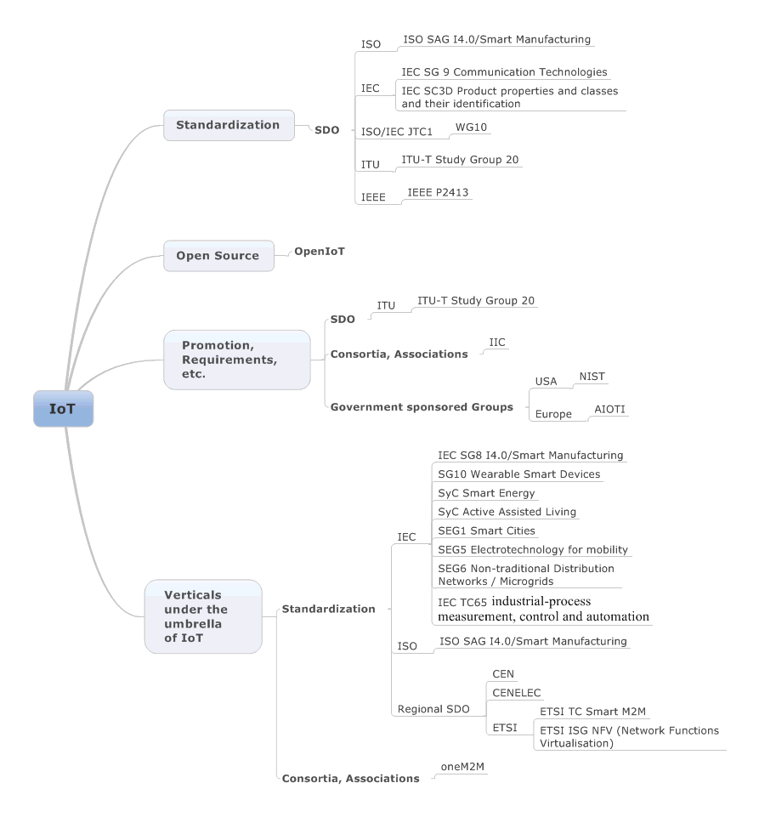

Figure 1 – IoT landscape

## Description of the initiatives

### Standardization

#### ISO

##### ISO SAG I4.0/Smart Manufacturing

ISO SAG I4.0/Smart Manufacturing finalized their report by fall 2016 and the ISO TMB supported most of the recommendations.

The most important result is to create a coordination committee (CC) under the ISO TMB with the charter to coordinate the efforts of Smart Manufacturing within ISO and other SDO and consortia dealing with Smart Manufacturing and IoT.

##### ISO coordination committee Smart Manufcaturing (CC SM)

This is the follow-up to the ISO SAG I4.0/Smart Manufacturing with the charter of the ISO TMB to coordinate the work about Smart Manufacturing in ISO and the other SDOs. The kick-off meeting was in the 1st week of August 2017 in Montreal, Canada. IEC SEG 7 was invited to participate.

#### IEC

##### IEC SG 8 Smart Manufacturing (SM)

##### IEC SG 9 Communication Technologies

IEC SG 9 Communication Technologies finalized their report to the IEC SMB.

They extended the term IOT to IoE:

“*The* ***Internet of Things (IoT)*** *and the even more expansive* ***Internet of Everything (IoE)*** *are concepts now in sharp focus for the technology industry as well as for standards development organizations. These are not fully new paradigms but rather steady evolutions from earlier (and somewhat more limited) concepts such as Wireless Sensor Networking (WSN), Machine to Machine (M2M) and Cyber Physical Systems (CPS).*

*Two major extensions have made Internet connectivity progress to IoT and IoE:*

*- The evolution from fixed locations to mobile users (connectivity anywhere, anytime).*

*- The enlargement from people and computers only to the whole physical world through a myriad of sensors, devices and equipment.*”

And they identified:

“*In a functional and organization structure for communication and related applications, two common disciplines often emerge – Information Technology (IT) and Operational Technology (OT). IT/OT Convergence has been identified as an important trend. This trend has both cultural and technical implications to explore. This clause* (Editor Note: 2.2 in the SG9 report) *will describe IT and OT in more detail, and then define the impact of the convergence trend on communication technologies and standards.*”

IEC SG9 recommends the following to the IEC SMB with relevance to IEEE 802:

“*SG 9 identified networking and application level interoperability as well as communication security and privacy as two critical topics and enablers for making the IoT a reality.*

* *Engage with JTC1/SC 41 (IoT and related technologies) to assess the applicability of the IoT Reference Architecture and contribute to the new work item on Interoperability.*
* *Engage with JTC 1/SC 27 (IT security techniques) and ACSEC to discuss and evaluate the following requirements:*

*o Communication security and privacy …*

*➢ Identify all IEC domains where time sensitive information is exchanged between devices and/or applications. Applicability of TSN in their standards should be assessed (e.g. TC 9, TC 57, TC 65, TC 100).*

*➢ Identify committees and produce practical guidelines for the adoption of Deterministic Networking standards.*

*➢ Consider endorsing existing Deterministic Networking technologies developed by other organizations and recommend standards based on them. Consider establishing liaisons with these organizations.*

*➢ Identify all IEC domains where LP-WAN technologies are either already considered or could fit existing requirements.*

*➢ Develop technical guidelines, technical reports, white papers, webinars or any other training material to raise awareness among the concerned committees.*

*➢ Consider establishing liaisons with external organizations working on standardizing LP-WAN technologies.*

➢ Investigate relevant approaches to implementing prioritized use of non-licensed exempt frequency spectrum. In particular:

o Specify parameters that characterize the medium utilization of wireless applications.

o Specify parameters that can be used to adapt the medium utilization of wireless communication applications.

o Specify generic services for gathering information about medium utilization.

o Specify generic services for controlling medium utilization.

o Enhance the coexistence model of IEC 62675-2 to support the development of algorithms for automated coexistence management.

➢ Facilitate information exchange between TC 65/WG 17 and relevant IEC committees and external SDOs.

The IEC SG9 considered the following emerging communication technologies:

* Deterministic Networking
* Low Power Wide Area Networking (LP-WAN) and Evolution of RF Technologies
* 5G
* Trends in Cybersecurity for IoT
* Transition to IPv6
* Time Synchronization
* Data Centre Evolution
* Automated Spectrum Management
* Flexible Ethernet
* IP Radio
* Learning Machines and Analytics
* Smart Collaboration

and the following new architectures for communication networks:

* Software Defined Networking (SDN)
* Network Function Virtualization (NFV)
* Autonomic Networking
* Fog Computing and Distributed Intelligence
* Information Centric Networking (ICN).

##### IEC SEG8 Communication Technologies

This is the follow-up to the IEC SG9. The scope is drafted to read:

1. Develop and execute a process for including communication system aspects (such as interfaces, data models and behaviours) into existing and new IEC deliverables.
2. Monitor new or emerging communication technologies and architectures that are specified or standardized outside the IEC (e.g. 5G, Low Power Wide Area Networking, Deterministic Networking, Edge Computing/Intelligence, Management & Orchestration, and others).
3. Monitor new market trends (e.g. IT/OT convergence) and analyse new business and development models (e.g. Open Source, DevOps) related to communication technologies and assess their impact on IEC activities.
4. Take into account additional essential aspects of communication technologies such as security, reliability, safety, privacy, energy efficiency, and others.
5. Evaluate the impact of these technologies, architectures and trends on current and foreseen IEC work, in particular on systems related activities, and engage with the concerned IEC committees by raising awareness and making technical recommendations.
6. Identify key standardization stakeholders external to the IEC and define appropriate engagement models, where required, to ensure IEC requirements are being addressed.
7. Be the IEC focal point for spectrum management related issues and coordinate with ITU-R and regional spectrum policy organizations.
8. Evaluate gaps in standardization of communication technologies based on requirements provided by selected IEC use cases, and take appropriate actions within the IEC or through collaboration with external bodies.
9. Review the current status of relevant TC/SC work in the IEC to identify any duplication of work or potential inconsistencies.
10. Define a structure for the coordination of cross TC/SC work in the IEC and with external bodies, where required.
11. Recommend to the SMB the appropriate long term structure to sustain the effective adoption and/or standardization of communication technologies across the IEC.

SEG 9 finalized their work mid of 2019 and send out the final report to IEC SMB recommending to establish a System Committee on Communication Technologies. This will be established early 2020.

##### IEC SC3D Product properties and classes and their identification

The result of joint conversations with ISO TMB and eClass resulted in a statement of both that they would like to cooperate with IEC SC3D. That means that the existing property definitions in ISO will be forwarded to IEC SC3D to be filled in the common data dictionary (CDD) and the eClass definitions of properties will be able to be converted to CDD and vice versa.

#### ISO/IEC JTC1

##### WG10

The description in the draft document is somewhat restrictive since it only focuses on the sensing and communication parts of the IoT. To make the IoT really valuable to product manufacturers and eventually end users, some kind of information processing needs to be associated to the IoT. ISO/IEC JTC 1 captured this requirement in the following definition2:

*“An infrastructure of interconnected objects, people, systems and information resources together with intelligent services to allow them to process information of the physical and the virtual world and react.”*

ISO/IEC CD 30141 was circulated from the ISO/IEC JTC1/WG10 committee by September 2016 for getting comments from the national committees. The content is missing some fundamentals in this early draft:

* The architecture viewpoints in 30141 are clearly biased toward a ‘telecom/Google’ business model and suffer thus from a deployment/implementation bias/lock-in. This runs contrary to the deployment/implementation openness needed for Siemens applications.
* Lifecycle perspective does not permeate 30141. Many system facets such as security, safety, availability, etc. must be addressed throughout the system lifecycle. Otherwise, assurance of these facets becomes difficult if not even elusive.
* Assurance methods and mechanisms, e.g. quality of service, not addressed in 30141 reference model nor reference architecture. Assurance is paramount for system aspects such as conformance and productivity.

##### ISO/IEC JTC 1 SC41

The WG10 was disbanded and a new Subcommittee was established to deal with IoT.

#### ITU

##### ITU-T Study Group 20

#### IEEE

#### IEEE P2413

Published early 2019 the IEEE 2413:

‘*This standard defines an architectural framework for the Internet of Things (IoT), including descriptions of various IoT domains, definitions of IoT domain abstractions, and identification of commonalities between different IoT domains.*

*The architectural framework for IoT provides a reference model that defines relationships among various IoT verticals (e.g., transportation, healthcare, etc.) and common architecture elements. It also provides a blueprint for data abstraction, and the quality “quadruple” trust, security, privacy, and safety." Furthermore, this standard provides a reference architecture that builds upon the reference model. The reference architecture covers the definition of basic architectural building blocks and their ability to be integrated into multi-tiered systems. The reference architecture also addresses how to document and, if strived for, mitigate architecture divergence. This standard leverages existing applicable standards and identifies planned or ongoing projects with a similar or overlapping scope.*’

The approach to provide a reference model and a reference architecture was abandoned by IEEE P2413 in 2015-11 in order to better align IEEE P2413 with the architecture framework model provided in ISO/IEC/IEEE 42010:2011. Instead of a reference model and architecture, IEEE P2413 will provide architecture viewpoints and guidance of how to derive architecture views from theses viewpoints.

The purpose of IEEE P2413 is:

*‘The Internet of Things (IoT) is predicted to become one of the most significant drivers of growth in various technology markets. Most current standardization activities are confined to very specific verticals and represent islands of disjointed and often redundant development. The architectural framework defined in this standard will promote cross-domain interaction, aid system interoperability and functional compatibility, and further fuel the growth of the IoT market. The adoption of a unified approach to the development of IoT systems will reduce industry fragmentation and create a critical mass of multi-stakeholder activities around the world.’*

### Open Source

#### OpenIoT

### Promotion, Requirements, etc.

#### SDO

##### ITU

###### ITU-T Study Group 20

### Consortia, Associations

#### IIC

### Government sponsored Groups

#### USA

##### NIST

#### Europe

##### AIOTI

### Verticals under the umbrella of IoT

#### Standardization

##### IEC

###### IEC SG8 I4.0/Smart Manufacturing

The IEC SG8 was dealing with recommendations concerning Indurty4.0/Smart Manufacturing to the IEC SMB and finalized their work early 2016. Most of the recommendations were accepted by the IEC SMB. The committee was transformed to the IEC SEG7 Smart Manufacturing.

###### IEC SEG 7, Smart Manufacturing (SM)

Successor of IEC SG8. They finalized their report 2018 to establish a System Committee for SM.

###### System Committee for SM

They started their work 2018.

###### SG10 Wearable Smart Devices

###### SyC Smart Energy

###### SyC Active Assisted Living

###### SEG1 Smart Cities

###### SEG5 Electrotechnology for mobility

###### SEG6 Non-traditional Distribution Networks / Microgrids

###### IEC TC65 industrial-process measurement, control and automation

##### ISO

###### ISO SAG I4.0/Smart Manufacturing

##### Regional SDO

###### CEN

###### CENELEC

###### ETSI

ETSI TC Smart M2M

ETSI ISG NFV (Network Functions Virtualisation)

#### Consortia, Associations

##### oneM2M

## Liaison

### IEEE P2413

Established Liaison to

* IEEE 802.24
* IEC SG8
* IIC

### IEEE 802.24

Established Liaison to

* IEEE 802.24

### IEC SG8

Established Liaison to

* IEEE 802.24
* ISO SAG I4.0/Smart Manufacturing
* ISO/IEC JTC1/WG10

# Activities in IEEE 802 related to IoT

## Overview of IEEE 802 topics

As a general statement, most networking technologies have potential use somewhere in the Internet of Things including all those developed in IEEE 802.

Beyond that, 802 has (and continues) to work on several projects seeking to address specific IoT problems/needs in an optimal way.

While IoT is most strongly associated with wireless communications, wired is also an essential component.

The following text highlights a few of both in IEEE 802.

The whole of any networking solution can't work without a core infrastructure any more than leaves can work without the branches and trunk of the tree under them.

Wired (i.e. copper and fiber) infrastructure, be it twig or trunk is an essential element of IoT as a system. IEEE 802.3 is dedicated to providing that core infrastructure.

IEEE 802.1 is working on a local addressing project (IEEE 802c) to deal with scaling towards much larger numbers of ports to handle the expected large numbers of things.

IEEE 802.1 is also working on Privacy issues (802E)-- specifically looking at Privacy concerns applicable to Internet protocols and IoT, and will be providing suggestions on how IEEE 802 can help address them.

The IEEE 802E work is also relevant to projects like IEEE 802c (local address usage) and to new groups that are starting to take privacy recommendations into account for defining requirements of new wireless technologies for IoT.

IEEE 802.3 is working on single pair systems to provide lower cost wired connections for IoT especially for things on vehicle platforms.

From a legacy perspective, IEEE 802.3 has defined Power over Ethernet (PoE) and Power over Data Links (PoDL, pronounced "poodle") for single pair, both of which are useful for powering things in a wired IoT The IEEE P802.3bt DTE Power via MDI over 4-Pair will provide at least 49 Watts. For example, LED lighting can get both power and control over the Ethernet.

Additionally, IEEE 802.3 provides the backbone infrastructure for the Internet including IoT the (ever improving) wired connections for end stations the main method to avoid the security and spectrum utilization issues of wireless IoT connections.

IEEE 802.11ah is intended specifically to address IoT “sensor” like devices. Areas of optimization include:

* Operating in the 900 MHz frequency band, it achieves longer range,  but provides relatively low data rates suitable for IoT
* Achieving enhanced power-savings based on better coordination between AP and sensor device.
* Efficiently supporting short data exchanges since data exchanges in an IoT network are typically short.
* Operating efficiently when there is a large imbalance between AP and non-AP device transmit power and receive sensitivity.

Additionally there is a “Long-range, Low-power” initiative in IEEE 802.11 (currently in its very early days):

* Will look to extend the range and reduce power consumption, both of which are important for IoT devices.
* It is too early to know what technical approaches will be used, but it is likely to be an optional feature added to 802.11ax, which will be the next “must have” release (i.e. after IEEE 802.11ac).
* Will likely build on the OFDMA features of IEEE 802.11ax to provide long range and low power using narrow channels and other PHY techniques.

IEEE 802.15.4 was developed specifically for IoT. It provides:

* a very low energy per payload bit ratio (i.e. very battery or harvested energy friendly);
* data rates appropriate for IoT rather than streaming HD video;
* very low cost to implement as a consequence;
* support for easy mesh networking;
* support for location based services;
* widely adopted by multiple IoT centric Industry Groups such as Thread, Wi-SUN, and ZigBee.

IEEEE 802.15.7 is a standard for Optical Wireless Communications. It provides a simple secure non RF method for Things to communicate, particularly mobile devices.

IEEE 802.15.10 Layer 2 Routing. It provides an integrated layer 2 method to mesh network in IEEE 802.15.4, essential for large scale self-organizing IoT networks.

Plus many more targeted IoT optimization projects.

IEEE 802.16 is crafting a proposal to apply the 4G WirelessMAN-OFDMA standard to narrowband applications relevant to smart grid and other utility IoT applications.

IEEE 802 and IETF are collaborating on Internet Privacy. With new technologies showing up (e.g. IoT, wearables, etc.), users will become more prone to privacy attacks. Privacy concerns are therefore more and more relevant when defining new technologies and regulations to protect users of these new technologies. Goal of this collaboration is to make the Internet more secure and protect users against criminal, commercial or national entities performing illegal or privacy-unfriendly practices.

This is just the tip of the iceberg in a large body of IoT applicable networking work ongoing in IEEE 802.

Bottom line: In addition to what it has already done and continues to do, IEEE 802 is highly responsive to the market and will efficiently produce high quality technical specs in response to IoT market drivers.

## Time Sensitive networks (TSN)

See separate white paper TSN (TSN Utility Applications White Paper; IEEE P802. 24-17-0006-04-sgtg).

IEC SC65C/MT9.PT61784-6 started to draft a profile for TSN suitable for industrial automation applications. This is now a jpoint project with IEEE and is called: IEC/IEEE 60802.

## Single Twisted Pair 1000 m reach, 10Mbit/s

This effort in IEEE 802.3 is also usable for IoT devices to link those together and to higher layer control, visualization, analyze, management systems. The amendment IEEE 802.3cg is now finalized.

# Gaps, proposed new work

# Compatibility levels

The wide range of application domains in which IoT systems are deployed and the increasing number of IoT developers and equipment manufacturers requires a higher level of compatibility as before in a smaller ecosystem.

If combining IoT systems from different manufacturers/domains into larger systems up to a "systems of systems", then it is needed to define the compatibility levels. The related context and semantic requirements are described in IEC 61804-2 and also in a subset in IEEE 2413.

There are certain levels of compatibility when devices have to cooperate together. Especially when the IoT devices have to be applicable in different application domains, so that no implicit specified context and sematic can be assumed. The levels are dependent on well-defined communication and application features, see Figure 1.



1. — Levels of device compatibility

NOTE—This figure and the used terms are copied from IEC 61804-2. The same figure and terms are also used in IEC/TR 62390.

Interoperability requires Semantic and context knowledge. Interoperability with this requirement is the basis requirement for IoT devices. In some application domains like process automation it is even required to provide interchangeable devices from different vendors. The interchangeable devices do not need any parameterization before an interchangeable device replaces another device. The parameters of the replaced device can be used for the interchangeable device without an alteration. This is not required for IoT devices. This feature is a domain specific feature.

Context and Semantic

One of the impediments to a development of interoperable IoT systems is the lack of a common language and understanding of IoT. It is desired that this document will foster both. Standard organization are a "common-denominator" addressee for such an approach.

Context and semantic of things becomes the most crucial issue to use IoT devices in different application domains. In the worldwide IoT a real thing shall be uniquely identified. The characterization of things shall follow the Property Principle (PP) which postulates that each thing shall have

* an unique standardized identifier (ID);
* a semantically standardized name;
* a standardized data format with a description of the context and semantic for its value.

NOTE—A lot of International Standards (or drafts) of IEC, ISO and IEEE invented by Industrial Automation domain may be the basis for the future IoT devices. The context and sematic description for industrial automation devices is specified in IEC 62769.