**IEEE 802.24**

**Vertical Applications TAG**

|  |  |  |
| --- | --- | --- |
| Project | IEEE 802.24 Vertical Applications Technical Advisory Group | |
| Title | Smart Grid Task Group – Sub 1 GHz White Paper Draft | |
| Date Submitted | May 18, 2016 | |
| Source | 802.24 | (list contributing authors here) |
| Re: | White Paper Development | |
| Abstract | Sub 1 GHz White Paper | |
| Purpose | Sub 1 GHz White Paper | |
| Notice | This document has been prepared to assist the IEEE P802.24. It is offered as a basis for discussion and is not binding on the contributing individual(s) or organization(s). The material in this document is subject to change in form and content after further study. The contributor(s) reserve(s) the right to add, amend or withdraw material contained herein. | |
| Release | The contributor acknowledges and accepts that this contribution becomes the property of IEEE and may be made publicly available by P802.24. | |

**Why Sub 1 GHz is of interest for Smart Grid?**

In many of the deployment environments and scenarios for smart grid devices, the frequencies below 1 GHz provide superior propagation characteristics Compared to higher frequencies. For example, using simple modulation, signals at 900MHz will tend to penetrate foliage (trees, shrubs, other plants) more readily compared with 2.4GHz, which is attenuated more by the water contained in plants and animals. Propagation through some building materials too may be improved at lower frequencies. The effective antenna aperture will be improved at lower frequencies at well (to a point). Bands in the 400 to 900 MHz frequency range provide good tradeoffs.

In most regions of the world, there are license exempt frequency allocations between 800 MHz and 1 GHz, and in many regions allocations in the 400 to 500 MHz frequency ranges as well. IEEE 802 standards include operating modes to address these sometimes limited allocations effectively, with simple and low cost implementations.

* + Include some example of range calculations comparing 915 MHz to 2.4 GHz.

ISM bands have many incumbents and existing users in the bands. The nature of these users depends on the regulatory domain. In North America, the 915 MHz band is less congested than the 2.4 GHz band, but it is still used by multiple services and devices. One notable user is the Progeny location service which operates in the 915 MHz ISM band under a license, and thus can transmit with much higher power levels.

In the TV White Space spectrum, the incumbents are TV broadcasters. TVWS operation is only permitted in areas and on channels that are unused. The status of unused is based on conservative rules intended to eliminate any possibility of interference with broadcasters. In many large metropolitan areas, there are no available channels. In rural areas there are many. After the FCC auctions much of the 600 MHz band, there will be even less availability of TV White Space channels.

**Standards for regional sub-GHz channel plans**

The figure below summarizes 802 wireless standards with channel plans specifying operation below 1 GHz.



**802.15.4g (SUN)**

IEEE 802.15.4g is a PHY amendment, published April 2012, built on the success of the 802.15.4 standard for application to Smart Utility Networks in the field, neighborhood and home area networking. IEEE 802.15.4g provides 3 additional PHY layer definitions, supporting data rates from 2.4 kbps to 800 kbps. This amendment complements the short-range PHYs of IEEE 802.15.4-2011 with the capability to support large, geographically diverse networks with minimal infrastructure, with a large number of participating devices.

The amendment includes three different PHY options:

* FSK PHY based on legacy AMI systems (part of which used by Wi-SUN)
* Extension of the legacy 802.15.4 DSSS PHY
* OFDM PHY for higher data rates (50 to 800 kbps)

The adoption of IEEE 802.15.4g together with some of MAC enhancements in IEEE 802.15.4e has been widespread in SUN and IoT applications. Conforming 802.15.4g based implementations are available from a large number of vendors, and has proven to be an effective basis for constructing large scale outdoor wireless mesh networks. The proven technology standard enables interoperable products and addresses global market and has been adopted in many regions and markets.

The standard defines operation in license exempt and licensed bands in US/Canada/EU/Japan/China/AU and other regions. Each PHY define multiple data rates to provide adaptability to the deployment environment.

**802.11ah (S1G)**

IEEE 802.11ah is a MAC/PHY amendment of the 802.11 standard for potential applications such as Internet of everything (IoT), Smart Grid, Healthcare, Smart Appliances, Wearable consumer electronics.

This amendment defines an Orthogonal Frequency Division Multiplexing (OFDM) Physical layer (PHY) operating in the license-exempt bands below 1 GHz, e.g., 868-868.6 MHz (Europe), 950 MHz -958 MHz (Japan), 314-316 MHz, 430-434 MHz, 470-510 MHz, and 779-787 MHz (China), 917 - 923.5 MHz (Korea) and 902-928 MHz (USA), and enhancements to the IEEE 802.11 Medium Access Control (MAC) to support extended range (up to 1 km), higher power efficiency, large number of devices.

The data rates defined in this amendment optimize the rate vs range performance of the specific channelization in a given band. (see the below figure)

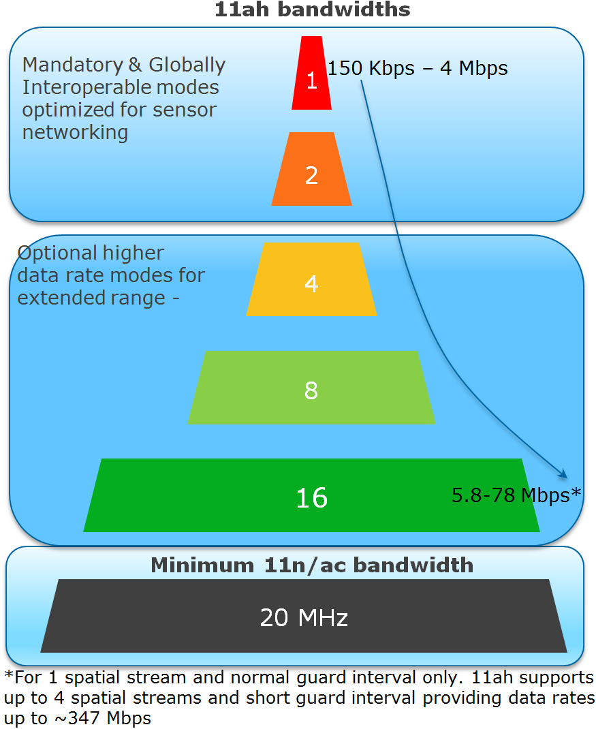

PHY features of IEEE 802.11ah are summarized as the following:   
- OFDM (FFT size 32 and 64)  
- New reliable MCS working with larger delay spread and Doppler for outdoor  
- Diverse data rates:150Kbps-347Mbps  
- Range >1 km

MAC features of IEEE 802.11ah are summarized as the following:   
- Scalability up to 8191 devices per AP (Hierarchical TIM structure)  
- Efficient frames and transmissions (Short frame format, Short control/mgmt. frames)  
- Reducing power consumption (Non-TIM operation, Target Wake Time mechanism)   
- Relay Operation

Since having started a standardization activity from November 2010, currently IEEE 802.11ah amendment is in a phase of sponsor ballot. The expected publication date of IEEE 802.11ah amendment is July 2016.

**Standards for TV White Space**

Although TVWS standards have been available for several years, there has not been widespread commercialization and deployment. This may be partially due to the uncertainty around the outcome auctioning of 600 MHz spectrum by the FCC. The reduction of available channels will significantly curtail availably of vacant TV channels in metropolitan areas. Another aspect is the lack of maturity of database services that these IEEE 802 TVWS standards depend on for operation.

**802.15.4m (TVWS)**

802.15.4m amendment specifies a physical layer definitions and MAC layer extensions for 802.15.4 enabling operation according to TV white space regulatory requirements in various regulatory domains. The standard enables operation in the VHF/UHF TV broadcast bands between 54 MHz and 862 MHz, supporting typical data rates in the 40 kbits per second to 2000 kbits per second range, to realize optimal and power efficient device command and control applications.

The alternate PHYs support principally outdoor, low-data-rate, wireless, TV white space (TVWS) network applications. The TVWS PHYs are as follows:

* Frequency Shift Keying (TVWS-FSK) PHY
* Orthogonal Frequency Division Multiplexing (TVWS-OFDM) PHY
* Narrow Band Orthogonal Frequency Division Multiplexing (TVWS-NB-OFDM) PHY

802.15.4m TVWS devices are expected to operate indoors and outdoors at frequencies from 54 to 862 MHz. Frequency availability varies by location and time. Frequency management is done using centralized coordination databases. Regulatory authorities have established operating and access rules in North America, EU, UK, parts or Asia and other regions.

The frequency band and transmit power limits available in TVWS operation typically allow radio range up to several kilometers. 802.15.4m leverages features of 802.15.4, such as narrow band channelization, inherently low duty cycles, and favorable coexistence characteristics enable scalability to large network topologies. For example in some regions the TVWS channel allocation is made in 6 to 8 MHz per TVWS channels, which using 802.15.4m narrow band PHYs allows for many PHY channels to be used in a single TVWS channel which enables support for high device density. The 802.15.4 MAC security features may be used to meet the confidentiality requirements imposed in some regulatory domains for exchange of channel availability information.

802.15.4m PHYs provide features to improve link reliably such as forward error correction, multiple modulation and coding schemes as well as existing features of the standard such as 32-bit frame check sequence, and acknowledged frame exchange with automatic retransmission.

**802.11af (TVHT)**

With the global transition to Digital TV (DTV), sub-Gigahertz RF spectrum is becoming available, much of it for unlicensed, license exempt and/or lightly licensed use. 802.11af made the necessary MAC and PHY changes to enable 802.11 products to take advantage of this additional spectrum. In the US, this represents a reconsideration of FCC regulations - the November 2008 FCC Part 15 Subpart H Television Band Devices rules; Ofcom (UK) is in the process of making this Digital Dividend band available, and the EU has conducted a consultation on the TV band. Other regulatory domains are expected to follow. The project will adapt to changes in the regulations, as they progress. It is in the best interest of users and the industry to strive for a level of coexistence between wireless systems in the TVWS bands. IEEE 802.11af provides mechanisms for coexistence with other systems. One approach is a common coexistence mechanism (IEEE 802.19.1) that may be used by other TVWS systems; other approaches are also possible.

**802.22**

The IEEE 802.22 (Wi-FAR™) Standard on Cognitive Radio based Wireless Regional Area Networks (WRAN) takes advantage of the favorable transmission characteristics of the VHF and UHF TV bands to provide broadband wireless access over a large area with a range of 10 - 30 km from the transmitter. Hence each IEEE 802.22 Base Station can potentially provide a typical coverage over 300 sq km and in some cases, up to 900 sq. km.

IEEE 802.22-based wireless regional area networks take advantage of the favorable propagation characteristics in the VHF and low UHF TV bands, to provide broadband wireless access under both line-of-sight (LoS) and non-line-of-sight (NLoS) conditions. This occurs while operating on a strict non-interference basis in “TV white space” (TVWS)—spectrum that is assigned to, but unused by, incumbent licensed services. As a result, some industry trade associations, such as the WhiteSpace Alliance, have started referring to IEEE 802.22 standard as “Wi-FAR™.” Each IEEE 802.22 network proposes to deliver up to 22 Mbps per 6 MHz channel and 28 Mbps per 8 MHz Channel. This technology is especially useful for serving rural areas, and developing countries where most vacant TV channels can be found.

Use cases for IEEE 802.22-based devices include broadband access over large distances and NLoS conditions, broadband Internet access for remote and rural areas, Internet of Things (IoT) applications, cellular offload, monitoring of the rain forests, long-range backhaul, smart grid, critical infrastructure monitoring, defense, homeland security, healthcare, small office/home office (SoHo) and campus-wide broadband wireless access. The IEEE 802.22 Wireless Regional Area Networks Working Group is a winner of the IEEE Standards Association (IEEE-SA) Emerging Technology Award.

IEEE 802.22 incorporates advanced cognitive radio capabilities including dynamic spectrum access, incumbent database access, accurate geolocation techniques, spectrum sensing, regulatory domain dependent policies, spectrum etiquette, and coexistence for optimal use of the available spectrum. In addition, IEEE 802.22 systems have been incorporated with enhanced security features for both, traditional and cognitive functions.

IEEE 802.22b is an amendment to IEEE 802.22™-2011. IEEE 802.22b-2015 is designed to double the throughput of devices based on the original IEEE 802.22 standard. The new amendment is intended also to serve more users per base station and enable relay capability for machine-to-machine (M2M) and Internet of Things (IoT) use cases.

**802.19.1**

Project P802.19.1 to develop a standard for “TV White Space Coexistence Methods” was initiated in December 2009 and published in June 2014. The standard provides coexistence solutions for different cognitive radio systems operating in TVWS frequency bands. It specifies radio technology independent methods for coexistence among dissimilar or independently operated TV band networks. The IEEE 802.19.1 is designed to perform three key tasks required to solve coexistence problems between different TVWS radio networks:

• Discovery of WS radio systems that need to coexist with each other.

• Changing operating parameters of these WS radio systems to improve their performance.

• Providing a unified interface between different types of WS radio systems and a coexistence system.

As stated, the first task of a coexistence system is to discover WS radio systems that need to coexist with each other. To solve the first task, a logical entity called a Coexistence Discovery and Information Server (CDIS) is defined. Its key function is to support discovery of the neighbor WS radio systems. Two WS radio systems are neighbors if they are likely to cause one-way or mutual harmful interference to one another if they operate on the same frequency channel.

The second task of a coexistence system is to continuously update operating parameters of WS radio systems in a way that improves their performance. The IEEE standard 802.19.1 provides two coexistence services to solve this task, namely, information service and management service.

Within the information service, the coexistence system provides neighbor discovery information to a WS radio system, and the WS radio system autonomously updates its operating parameters. Within the management service, the coexistence system manages the operating parameters of a WS radio system. To provide the management service, a logical entity called a coexistence manager (CM) is defined.

Once a coexistence system is deployed and in operation, it is intended to serve various types of white space radio systems. Correspondingly, there is a need to have a unified interface between different types of WS radio systems and a coexistence system. This task is solved by defining a logical entity called a coexistence enabler (CE). A CE provides a unified interface between a WS radio system and the IEEE 802.19.1 coexistence system. The interface between a CE and a WS radio system is outside of the scope of the IEEE 802.19.1 standard. In fact, the service access point is defined in an abstract manner in the standard, while exact implementation is left up to manufacturers. Such an approach is very beneficial, because it does not require any changes in already published and future standards in order to use coexistence services provided by the IEEE 802.19.1 coexistence system. A CE will serve as a translator of WS radio system specific messages to be exchanged between a CE and a CM.

**Application-domain standards that build on IEEE 802 standards**

The scope of IEEE 802 standards is limited to Layers 1 and 2 (MAC and PHY). In the application domain, additional standardization of higher layer functionality is often required to ensure interoperability. This can be accomplished by application-focused communication profiles.

Industry Alliances build upon IEEE 802 standards and integrate multiple standards at multiple layers.

One example is the Wi-SUN Alliance. The Wi-SUN FAN specification builds upon IEEE 802.15.4g, 802.15.4e, 802.15.4m, 802.1X, 802.15.9, security mechanisms from 802.11, and ANSI 4957. The specification also includes higher layer standards from IETF, defining operation up to the transport layer.

**Applications**

Smart grid applications can be divided into several broad categories related to the topologies and performance characteristics of both the individual devices and networks used to connect devices.

Field and neighborhood area networks endpoints may include applications such as:

* Electric meters
* Water and gas meters
* Distribution automation (grid control)
* Distributed energy resources
* Street lights, environmental sensors and other “smart city” devices
* Plug-in vehicle charging

Many of endpoints in the modern grid and/or smart city application share similar requirements from the network, such as moderate data rates, high device densities, very low energy consumption, and limited spectrum resources. 802 standards address well this type of device. For example, 80.15.4 includes PHY definitions and MAC features to specifically address these needs by offering low data rates with narrow bandwidth channelization, high spectral and special reuse factors, ability to support very low power operation and protocol options that enable adaptation to range/density trade-offs and varying environmental conditions. The standard includes means to use nearly every conceivable type of spectrum allocation available around the world, with options to fit what regulations allow. In these types of applications, the low data rate requirements complement the limited amount of spectrum at sub-1GHz frequencies, and the application of narrow band modulations in 802.15.4 optimizes use of the spectrum. Another common trait of many of these applications is low duty cycle for network access: communication is required infrequently. In some of these applications, energy available to run the device is limited. For example a water meter or environmental sensor may be battery operated, with the need for the primary battery to last years. Features in the standard are optimized for such low duty cycle, “sleepy node” situations, enabling use of the communications link to be matched to the performance need (infrequent) saving energy by turning the radio off the rest of the time.

Other applications in the modern grid and/or smart city network have different trade-offs between energy, data rate, and spectrum utilization. 802 standards exist to address higher data rate applications such as network gateways, traffic aggregation points, data concentration (collectors) and inter-network routers. Where spectrum allocations allow the bandwidth for high data rates, standards such as 802.11, 802.16 and 802.22 provide spectral efficiency optimized for high data throughput appropriate for these kinds of applications.

**Summary of characteristics and key comparisons**

The SGIP PAP 2 committee developed a comprehensive matrix[1] that highlights key features and characteristics of wireless standards used for Smart Grid applications. A subset of that matrix including the sub-1 GHz standards is presented below.



Figure Excerpt from SGIP PAP 2 Wireless Characteristics Matrix for standards operating in sub-1 GHz spectrum

Notes:

802.11ah uses a wider bandwidth and can provide a higher data rate

802.11ah is not generally deployed as a mesh, it is more suitable for star networks (although it does implement a multi-hop relay function for range extension)

802.15.4g and 802.15.4m are typically combined with a meshing standard (at layer 2 or layer 3) to provide coverage over a broader area

802.22 is also a star-topology.

**Techniques for wide-area coverage**

Due to the RF power limitations in ISM bands, ensuring adequate range and coverage is a technical challenge. Different techniques are used to extend range in different standards, based on receiving and forwarding packets to other devices within range so they will eventually reach their final destination.

IEEE 802.15.4 – based standards are typically used with a meshing layer:

* Layer 3 mesh (RPL or similar)
* Layer 2 mesh (802.15.10)

IEEE 802.11ah provides relay operation with an unlimited number of hops.

**Mesh vs. Repeater**

Mesh network topologies are used to extend the range of the network further than the range of the radios. With a simple star topology, it may be difficult or impossible to reach all endpoints.

Adding a repeater can solve this in some situations. A repeater typically provides a static route: it can connect act as a relay between one or more end points and the network coordinator, but does not provide dynamic routing. This is typically a simple “1 hop” relay between static points.

A mesh network topology will support dynamic route determination, as well as redundant routing paths. Combined these enable dynamic routing that is “self healing” in the event that a given path (radio link) is disrupted and/or a routing node in the network fails. The mesh more easily adapts to the environment and can be simpler to deploy, as the mesh protocol typically includes automatic route determination and adaptation.

A star with relay topology is simpler, and where flexibility and dynamic characteristics of the mesh are less important, may require fewer devise over all to support a given geographic area, especially where the area is large and devise are sparsely deployed. In contrast, the mesh may provide more cost efficient in high density deployments where environmental conditions are changing and/or network configuration changes frequently.

See also <https://mentor.ieee.org/802.24/dcn/13/24-13-0028-00-0000-draft-release-2-of-nistir-7761-2013-07-12-sgip-pap02wg-00009-pap2-v2.doc>

**Global regulatory environment**

FCC, CEPT, ARIB, CENELEC, ETSI, OFCOM

Areas that adopt other domain’s rules

(Map of world with regulatory agencies highlighted)

Need to show regulatory bodies, spectrum availability, and channel access mechanism

References to defining documents for further information

Coexistence in global bands

Other technologies that standards will need to coexist with

* LORA
* SigFox
* WeightLess
* Progeny (?)

Conclusions

Unlicensed spectrum is valuable and beneficial for Smart Grid applications, due to the scarcity and cost of licensed spectrum in comparable frequency ranges. The Sub-1 GHz spectrum offers superior propagation and penetration properties when compared to higher frequency ISM bands. TV White Space spectrum can provide additional options for operation in rural areas with sufficient availability of unused TV channels. The Sub-1GHz standards implement coexistence mechanisms that make it possible to operate effectively in this shared spectrum.

1. http://collaborate.nist.gov/twiki-sggrid/pub/SmartGrid/PAP02Wireless/Consolidated_Wireless_Characteristics_Matrix2_09-03-13.xlsx