**IEEE 802.24**

**Vertical Applications TAG**

|  |  |  |
| --- | --- | --- |
| Project | IEEE 802.24 Vertical Applications Technical Advisory Group | |
| Title | Smart Grid Task Group – Sub 1 GHz White Paper Draft | |
| Date Submitted | 15 September 2015 | |
| Source | 802.24 | (list contributing authors here) |
| Re: | White Paper Development | |
| Abstract | Sub 1 GHz White Paper | |
| Purpose | Sub 1 GHz White Paper | |
| Notice | This document has been prepared to assist the IEEE P802.24. It is offered as a basis for discussion and is not binding on the contributing individual(s) or organization(s). The material in this document is subject to change in form and content after further study. The contributor(s) reserve(s) the right to add, amend or withdraw material contained herein. | |
| Release | The contributor acknowledges and accepts that this contribution becomes the property of IEEE and may be made publicly available by P802.24. | |

Introduction: (criteria for inclusion, and evaluation)

What is the real range of interest? Generally 400 MHz to 1 GHz

But TV allocations go as low as 54 MHz, so theoretically TVWS standards can operate that low also

Why Sub 1 GHz is of interest for Smart Grid?

* Primarily superior propagation – compared to higher frequencies
  + Include some example of range calculations comparing 915 MHz to 2.4 GHz.
* Effective propagation in real-world environments – building and foliage penetration
  + - Availability of unlicensed bands
    - Low cost implementation

Existing incumbents and uses in the bands.

Depends on regulatory domain. In North America, the 915 MHz band is less congested than the 2.4 GHz band, but it is still used by multiple services and devices.

In the TV White Space spectrum, the number of available channels is limited. In many large metropolitan areas, there are no available channels. In rural areas there are many. After the FCC auctions the 600 MHz band in 2016, there will be even less availability of TV White Space channels.

Standards for regional sub-GHz channel plans

802.15.4g (SUN)

IEEE 802.15.4g is a PHY amendment, published April 2012, built on the success of the 802.15.4 standard for application to Smart Utility Networks in the field, neighborhood and home area networking. IEEE 802.15.4g provides 3 additional PHY layer definitions, supporting data rates from 2.4 kbps to 800 kbps. This amendment complements the short-range PHYs of IEEE 802.15.4-2011 with the capability to support large, geographically diverse networks with minimal infrastructure, with a large number of participating devices.

The amendment includes three different PHY options:

* FSK PHY based on legacy AMI systems (part of which used by Wi-SUN)
* Extension of the legacy 802.15.4 DSSS PHY
* OFDM PHY for higher data rates (50 to 800 kbps)

The adoption of IEEE 802.15.4g together with some of MAC enhancements in IEEE 802.15.4e has been widespread in SUN and IoT applications. Conforming 802.15.4g based implementations are available from a large number of vendors, and has proven to be an effective basis for constructing large scale outdoor wireless mesh networks. The proven technology standard enables interoperable products and addresses global market and has been adopted in many regions and markets.

The standard defines operation in license exempt and licensed bands in US/Canada/EU/Japan/China/AU and other regions. Each PHY define multiple data rates to provide adaptability to the deployment environment.

802.11ah (S1G)

IEEE 802.11ah is a MAC/PHY amendment of the 802.11 standard for potential applications such as Internet of everything (IoT), Smart Grid, Healthcare, Smart Appliances, Wearable consumer electronics.

This amendment defines an Orthogonal Frequency Division Multiplexing (OFDM) Physical layer (PHY) operating in the license-exempt bands below 1 GHz, e.g., 868-868.6 MHz (Europe), 950 MHz -958 MHz (Japan), 314-316 MHz, 430-434 MHz, 470-510 MHz, and 779-787 MHz (China), 917 - 923.5 MHz (Korea) and 902-928 MHz (USA), and enhancements to the IEEE 802.11 Medium Access Control (MAC) to support extended range (up to 1 km), higher power efficiency, large number of devices.

The data rates defined in this amendment optimize the rate vs range performance of the specific channelization in a given band. (see the below figure)

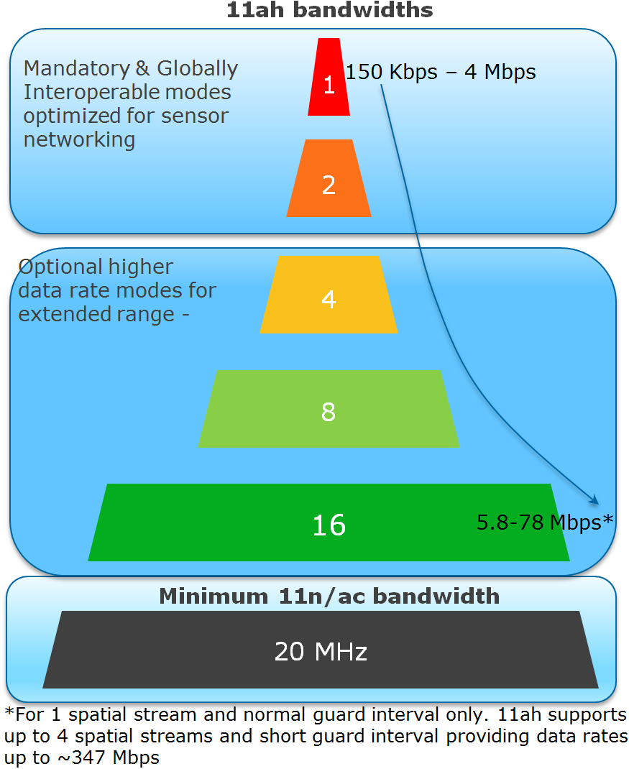

PHY features of IEEE 802.11ah are summarized as the following:   
- OFDM (FFT size 32 and 64)  
- New reliable MCS working with larger delay spread and Doppler for outdoor  
- Diverse data rates:150Kbps-347Mbps  
- Range >1 km

MAC features of IEEE 802.11ah are summarized as the following:   
- Scalability up to 8191 devices per AP (Hierarchical TIM structure)  
- Efficient frames and transmissions (Short frame format, Short control/mgmt. frames)  
- Reducing power consumption (Non-TIM operation, Target Wake Time mechanism)   
- Relay Operation

Since having started a standardization activity from November 2010, currently IEEE 802.11ah amendment is in a phase of sponsor ballot. An expected publication date of IEEE 802.11ah amendment is July 2016. Standards for TV White Space

802.15.4m (TVWS)

802.15.4m amendment specifies a physical layer definitions and MAC layer extensions for 802.15.4 enabling operation according to TV white space regulatory requirements in various regulatory domains. The standard enables operation in the VHF/UHF TV broadcast bands between 54 MHz and 862 MHz, supporting typical data rates in the 40 kbits per second to 2000 kbits per second range, to realize optimal and power efficient device command and control applications.

The alternate PHYs support principally outdoor, low-data-rate, wireless, TV white space (TVWS) network applications. The TVWS PHYs are as follows:

— Frequency Shift Keying (TVWS-FSK) PHY

— Orthogonal Frequency Division Multiplexing (TVWS-OFDM) PHY

— Narrow Band Orthogonal Frequency Division Multiplexing (TVWS-NB-OFDM) PHY

802.15.4m TVWS devices are expected to operate indoors and outdoors at frequencies from 54 to 862 MHz. Frequency availability varies by location and time. Frequency management is done using centralized coordination databases. Regulatory authorities have established operating and access rules in North America, EU, UK, parts or Asia and other regions.

The frequency band and transmit power limits available in TVWS operation typically allow radio range up to several kilometers. 802.15.4m leverages features of 802.15.4, such as narrow band channelization, inherently low duty cycles, and favorable coexistence characteristics enable scalability to large network topologies. For example in some regions the TVWS channel allocation is made in 6 to 8 MHz per TVWS channels, which using 802.15.4m narrow band PHYs allows for many PHY channels to be used in a single TVWS channel which enables support for high device density. The 802.15.4 MAC security features may be used to meet the confidentiality requirements imposed in some regulatory domains for exchange of channel availability information.

802.15.4m PHYs provide features to improve link reliably such as forward error correction, multiple modulation and coding schemes as well as existing features of the standard such as 32-bit frame check sequence, and acknowledged frame exchange with automatic retransmission.

802.11af (TVHT)

802.22

802.19.1

Application-domain standards that build on IEEE 802 standards

The scope of IEEE 802 standards is limited to Layers 1 and 2 (MAC and PHY). In the application domain, additional standardization of higher layer functionality is often required to ensure interoperability. This can be accomplished by application-focused communication profiles.

Industry Alliances build upon IEEE 802 standards and integrate multiple standards at multiple layers.

One example is the Wi-SUN Alliance. The Wi-SUN FAN specification builds upon IEEE 802.15.4g, 802.15.4e, 802.15.4m, 802.1X, 802.15.9, security mechanisms from 802.11, and ANSI 4957. The specification also includes higher layer standards from IETF, defining operation up to the transport layer.

Applications

List of applications (Elec, Gas, Water meters, DA (PV/DER), street lights, “smart cities”, heat use sensors, DR, EV Charging)

Application for backhaul from (GW/Concentrator/Router/Collector)

Duty Cycle Requirements, Power Limitations, and their impact on usable applications

Specific limitations of applications to portions of bands.

Summary of characteristics and key comparisons

PAP 2 table for facts about the standards



Figure Excerpt from SGIP PAP 2 Wireless Characteristics Matrix for standards operating in sub-1 GHz spectrum

*{Need a table showing standards on one axis, and supported frequencies on the other axis}*

Explanation and Interpretations of the data

Key differences between the standards

802.11ah uses a wider bandwidth and can provide a higher data rate

(Insert specifics of BW and data rates in a chart)

802.11ah is not generally deployed as a mesh, it is more suitable for star networks (although it does implement a one-hop repeater function for range extension)

802.15.4g and 802.15.4m are typically combined with a meshing standard (at layer 2 or layer 3) to provide coverage over an broader area

802.22 is also a star-topology.

Explanations of coexistence between similar standards in each group

Applicability of 802.19.1 TVWS coexistence standard

Global regulatory environment

FCC, CEPT, ARIB, CENELEC, ETSI, OFCOM

Areas that adopt other domain’s rules

(Map of world with regulatory agencies highlighted)

Need to show regulatory bodies, spectrum availability, and channel access mechanism

References to defining documents for further information

Coexistence in global bands

Other technologies that standards will need to coexist with

* LORA
* SigFox
* WeightLess
* Progeny (?)

Conclusions

Unlicensed spectrum is valuable and beneficial for Smart Grid applications, due to the scarcity and cost of licensed spectrum in comparable frequency ranges

The Sub-1GHz standards implement coexistence mechanisms that make it possible to operate effectively in this shared spectrum.