IEEE 802 Standards for Smart Grid
IEEE P802.24
Smart Grid
Technical Advisory Group
Trademarks and Disclaimers
IEEE believes the information in this publication is accurate as of its publication date; such information is subject to change without notice. IEEE is not responsible for any inadvertent errors.

The Institute of Electrical and Electronics Engineers, Inc.
3 Park Avenue, New York, NY 10016-5997, USA

Copyright © 2014 by The Institute of Electrical and Electronics Engineers, Inc.
All rights reserved. Published Month 20xx. Printed in the United States of America.

IEEE is a registered trademark in the U. S. Patent & Trademark Office, owned by The Institute of Electrical and Electronics Engineers, Incorporated.

PDF: ISBN 978-0-7381-xxxx-x STDVxxxxx
Print: ISBN 978-0-7381-xxxx-x STDPDVxxxxx

IEEE prohibits discrimination, harassment, and bullying. For more information, visit http://www.ieee.org/web/aboutus/whatis/policies/p9-26.html.

No part of this publication may be reproduced in any form, in an electronic retrieval system, or otherwise, without the prior written permission of the publisher.

To order IEEE Press Publications, call 1-800-678-IEEE.
Find IEEE standards and standards-related product listings at: http://standards.ieee.org

Notice and Disclaimer of Liability
Concerning the Use of IEEE-SA Documents
This IEEE Standards Association (“IEEE-SA”) publication (“Work”) is not a consensus standard document. Specifically, this document is NOT AN IEEE STANDARD. Information contained in this Work has been created by, or obtained from, sources believed to be reliable, and reviewed by members of the IEEE P802.24 Smart Grid Technical Advisory Group that produced this Work. IEEE and the IEEE P802.24 Smart Grid Technical Advisory Group members expressly disclaim all warranties (express, implied, and statutory) related to this Work, including, but not limited to, the warranties of: merchantability; fitness for a particular purpose; non-infringement; quality, accuracy, effectiveness, currency, or completeness of the Work or content within the Work. In addition, IEEE and the IEEE P802.24 Smart Grid Technical Advisory Group members disclaim any and all conditions relating to: results; and workmanlike effort. This IEEE P802.24 Smart Grid Technical Advisory Group document is supplied “AS IS” and “WITH ALL FAULTS.”

Although the IEEE P802.24 Smart Grid Technical Advisory Group members who have created this Work believe that the information and guidance given in this Work serve as an enhancement to users, all persons must rely upon their own skill and judgment when making use of it. IN NO EVENT SHALL IEEE OR IEEE P802.24 SMART GRID TECHNICAL ADVISORY GROUP MEMBERS BE LIABLE FOR ANY ERRORS OR OMISSIONS OR DIRECT, INDIRECT, INCIDENTAL, SPECIAL, EXEMPLARY, OR CONSEQUENTIAL DAMAGES (INCLUDING, BUT NOT LIMITED TO: PROCUREMENT OF SUBSTITUTE GOODS OR SERVICES; LOSS OF USE, DATA, OR PROFITS; OR BUSINESS INTERRUPTION) HOWEVER CAUSED AND ON ANY THEORY OF LIABILITY, WHETHER IN CONTRACT, STRICT LIABILITY, OR TORT (INCLUDING NEGLIGENCE OR OTHERWISE) ARISING IN ANY WAY OUT OF THE USE OF THIS WORK, EVEN IF ADVISED OF THE POSSIBILITY OF SUCH DAMAGE AND REGARDLESS OF WHETHER SUCH DAMAGE WAS FORESEEABLE.

Further, information contained in this Work may be protected by intellectual property rights held by third parties or organizations, and the use of this information may require the user to negotiate with any such rights holders in order to legally acquire the rights to do so. IEEE and the IEEE P802.24 Smart Grid Technical Advisory Group members make no assurances that the use of the material contained in this work is free from patent infringement. Essential Patent Claims may exist for which no assurances have been made to the IEEE, whether by participants in this IEEE P802.24 Smart Grid Technical Advisory Group activity or entities outside the activity. The IEEE is not responsible for identifying essential patent claims for which a license may be required, for conducting inquiries into the legal validity or scope of patents claims, or determining whether any licensing terms or conditions, if any, or any licensing agreements are reasonable or non-discriminatory. Users are expressly advised that determination of the validity of any patent rights, and the risk of infringement of such rights, is entirely their own responsibility. No commitment to grant licenses under patent rights on a reasonable or non-discriminatory basis has been sought or received from any rights holder. The policies and procedures under which this document was created can be viewed at http://standards.ieee.org/about/sasb/iccom/.

This Work is published with the understanding that IEEE and the IEEE P802.24 Smart Grid Technical Advisory Group members are supplying information through this Work, not attempting to render engineering or other professional services. If such services are required, the assistance of an appropriate professional should be sought. IEEE is not responsible for the statements and opinions advanced in this Work.

Contents

INTRODUCTION 1

History and values of IEEE 802 1

Characteristics of IEEE 802 networks that support Smart Grid applications 2

APPLICATIONS FOR SMART GRID 3

AMI 3

DA 3

Application requirements for network communications 3

Security 3

Non-mains powered operations (for some devices) 4

Coverage requirements 4

Advantages of IEEE 802 networks 4

CONCLUSIONS 5

REFERENCES 6

IEEE 802 Standards for Smart Grid

Introduction

History and values of IEEE 802
IEEE 802® is the leading standards development organization for networking. IEEE 802 is actively developing standards for both wired and wireless networks.
Smart Grid is defined as an evolution of the energy supply and consumption infrastructure that will enable providers and consumers with unprecedented levels of reliability and control while reducing the adverse environmental impact of energy generation and consumption. One of the key aspects of the Smart Grid is the underlying communication between the various network elements.
The first IEEE 802 network standard, IEEE Std 802.3™ (Ethernet), was approved more than 30 years ago. The first IEEE 802 wireless standard, IEEE Std 802.11™, was approved in 1997, and has evolved through five generations of increasing performance. IEEE Std 802.15™ and IEEE Std 802.16™ were both initiated in 1999 and have achieved substantial success as well. Other groups in IEEE 802 that are relevant to Smart Grid applications are as follows:
- IEEE Std 802.1™ for bridging, time-sensitive networks, and security
- IEEE Std 802.21™ for media independent handover
- IEEE Std 802.22™ for wireless regional area networks (WRAN) in the TV white space (TVWS) bands
IEEE 802 has endorsed the OpenStand principles (see http://open-stand.org/), which include cooperation, adherence to principles, collective empowerment, availability, and voluntary adoption. These principles are part of the process IEEE 802 uses to create high-quality, widely-adopted standards.
Many utility applications are examples of the broader application area of Machine-to-machine (M2M) technology, which enables devices to communicate with each other. There are three general layers in M2M, as shown in Figure 1.
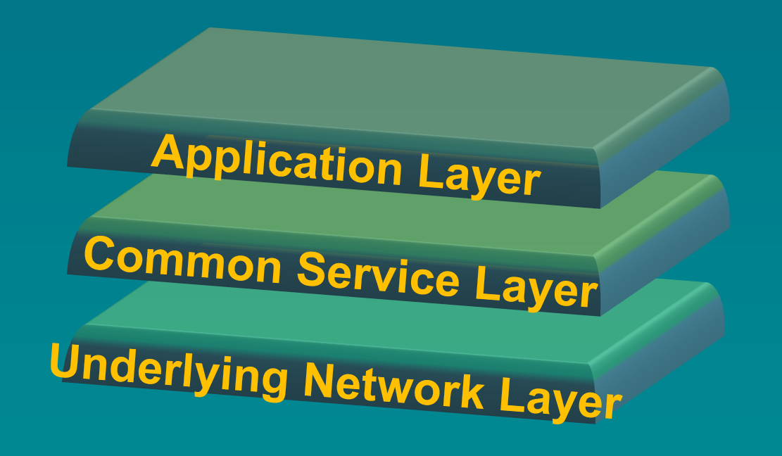

Figure 1: Layering of M2M technology

The application layer, which is the highest layer, provides the relevant application data. Organizations such as the Smart Grid Interoperability Panel (SGIP) and Continua (eHealth) are involved in the definition of this layer.
A middle layer called the common service layer enables the exchange of information between the application layer and the access independent underlying network or transport layer. Organizations such as oneM2M are leading the effort to standardize this layer.
Below the common service layer is the underlying network layer. IEEE 802 standards provide underlying networks with enhanced coverage and accessibility, quality of service, security (such as authentication and encryption), and reliability (high availability of network infrastructure). IEEE 802 standards can also provide additional capabilities for an ad-hoc self-organizing network, such as low cost, low power, low duty cycle, and low data rate.
Some IEEE 802 networking technologies offer the ability to bound communication latency of a link. IEEE 802 technologies that are not based on multi-hop networks will generally offer better ability to bound communication latency.
A list of Smart Grid standards that focus on PHY and MAC layer have been documented and approved by IEEE 802 [1].

Characteristics of IEEE 802 networks that support Smart Grid applications
IEEE 802 networking technologies bring the following advantages to Smart Grid communications:
- Enterprise grade security compatibility
- Huge ecosystem (billions of products, hundreds of manufacturers)
- Long-term (20 year), battery-powered operation
- Continued operation during line fault events when using wireless media
- Wide choice of products across the spectrum of power versus performance
- Ability to be implemented in resource-constrained devices
- Ongoing development of standards to address changing environment and technology
- Wireless standards that operate in a licensed and license-exempt spectrum
- Offers a rich set of data rate/range/latency tradeoffs
- Common upper layer interface to seamlessly integrate into existing IT systems
Operation in license-exempt spectrum offers an alternative for the lack of licensed spectrum for utilities. TV White Space (TVWS) is an example of a cognitive radio technology that represents a new model for spectrum sharing between licensed and license exempt services..
Multi-hop mesh networks, such as those defined in some IEEE 802 standards, are widely used in the utility network. There are a number of characteristics that make the mesh topology favorable in some deployment situations.
Mesh topology extends the range of the network well beyond the range of a single radio link. Multi-hop delivery can assist in reaching endpoints in poor RF environments, as adjacent neighbors will forward messages to the hard-to-reach node. This in turn allows greater network range with low power radios that can operate in license-exempt frequency bands.
In dense deployment scenarios, mesh topology can allow reducing the transmit power and/or increasing the symbol rate. These measures can reduce interface from and with other nodes by reducing the interference footprint. An inherent tradeoff in multi-hop network topologies is that forwarding will, in some cases, increase latency. In interference limited environments, use of mesh topology can improve delivery reliability, which will reduce retransmission delays. Similarly the resistance to interference improves delivery reliability, which can improve the effective throughput as well, as retransmission caused by collisions increase the spectrum bandwidth required to deliver the message.
In a wireless system, rate (throughput) and range are inversely related if all other factors are equal. A lower rate can operate over a longer range. In multi-hop (relay or mesh networks), there is also an inverse relationship between latency and range. If range is extended by forwarding packets through a mesh or multi-hop network, the latency increases proportionally to the number of hops. This topic is presented in greater depth in NISTIR 7761 V2 (2013), Section 6.1 [2].

Applications for Smart Grid
The electric power system is logically separated by three main domains; these domains include Generation, Transmission, and Distribution. Among the categories of Smart Grid applications are Advanced Metering Infrastructure (AMI) and Distribution Automation (DA).

AMI
AMI improves utility metering by providing two-way communication, which enables the following features: Utility service outage and restoration management, meter reading, demand response, load management, remote service disconnection/re-connection, and service pricing capabilities (including Real Time Pricing, Time of Use pricing, and Critical Peak pricing). For more information, refer to NISTIR 7761 V2 (2013) [2].

Figure 2: High level example of an AMI system

DA
DA extends intelligent control to the distribution system that includes the following capabilities: Voltage Optimization, Load Reduction/Optimization, system fault detection and remediation, and SCADA. For more information, refer to NISTIR 7761 V2 (2013) [2].

Application requirements for network communications

Security
The security of power grid communications is vital from a national security point of view. Security protocols and encryption need to be certified by international bodies. Security protocols need to be interoperable, widely deployed, and have years of testing and deployment in the field.
IEEE 802.1X link layer security is based on FIPS approved technologies and defines the encapsulation of Extensible Authentication Protocol (EAP) over an IEEE 802 network. In addition to providing port-based authentication to a server, the 802.1X protocol provides a secure mechanism for transferring keys used for link-layer encryption. IEEE 802 link layer security has been widely deployed in enterprise environments where security of corporate data is of utmost importance.
The emerging IEEE 802.21d will provide additional security mechanisms for group management and key distribution for multicast communication.
These protocols have been vetted by a large number of security professionals.

Non-mains powered operations (for some devices)
There are many Smart Grid applications that require non-mains powered operation, for example, certain types of sensors may not have access to the mains power in a cost effective manner or need to operate during power outages.
Many IEEE 802 standards have been developed with energy constrained devices in mind. This focus enables the implementation of networked devices that operate for years from small capacity primary cell batteries. Some IEEE 802 standards have been developed with the goal to work from energy harvesting as well.

Coverage requirements
In general, Smart Grid systems need to provide network services throughout the utility’s service area. To do this, Smart Grid systems need to support a hierarchy of networks that have different link distance requirements. In addition, the network needs to be robust enough to allow end point devices to reach the gateways. There are a variety of IEEE 802 standards for the networks that implement these requirements.
To achieve the required coverage, IEEE 802 standards provide a variety of solutions
- Multi-hop, non-deterministic networks (e.g., wireless mesh networks and bridged wired networks).
- Star networks with a base station and relatively long distance wireless links
- A variety of physical layers with different data rates (e.g., modulation, coding, etc.)
- Fiber links when right of way is available
While 80% of the people lie within 20% of the service territory, AMI networks need to service 100% of the meters. Multi-hop networks can be used for hard to reach meters to get 100% coverage.
For resource constrained devices, multi-hop networks provide connectivity with low power usage. In some cases, constraints on the allowed transmit power levels for wireless networks restrict the practical link distance, which multi-hop networks are applicable. Multi-hop networks, both wired and wireless, also allow resiliency during the failure of nodes in the system.
Communications over fiber or wireless gives resilience to induced voltage differences when operating in proximity to high voltages.
For connectivity within a single facility, e.g., intra-substation networking and the head end, IEEE 802.3 (Ethernet) provides a cost-effective solution.

Advantages of IEEE 802 networks
Utilities expect that the current deployment of Smart Grid networks will have a minimum lifetime of ten (10) to twenty (20) years. In general, IEEE 802 standards support backward-compatibility, as continuous improvements are adopted. This framework assists in preventing the need for "fork-lift upgrades" in the field. IEEE 802 has more than forty years of history in creating successful, backward-compatible standards.

Network and devices upgrades are achieved via incremental implementations that support multiple generations of IEEE 802 standards in the same network. In addition, the process in IEEE 802 includes the evaluation of coexistence with existing networking technologies to ensure good performance.

Conclusions

The IEEE 802 standards family provides a foundation of connectivity that higher layer protocols can build upon to form a flexible, interoperable ecosystem serving a variety of applications.
The IEEE 802 family is well established in many utility communications applications. IEEE Std. 802.3 (Ethernet) finds broad application in enterprise LANs and intra-substation networks. IEEE Std. 802.16 (WiMAX) is deployed for utility field area networks. IEEE Std. 802.15.4 (ZigBee) and IEEE Std. 802.11 (Wi-Fi) are widely used for Home Area Networks and other customer premises networks for energy management, load control, and automation.
The variety of IEEE 802 standards addresses the different requirements for different tiers of an integrated utility network (performance, range, latency, etc.) The unified architecture enables integration across the network. The architecture and design principles of IEEE 802 have been extended into other standards that have utility application, such as the IEEE1901 PLC standards, enabling broader integration.
IEEE 802 standards are backward compatible between generations, and evolve to address new requirements, while protecting investments and allowing incremental upgrades.
In summary, IEEE 802 standards provide a platform to support the communication requirements of diverse applications across the range of utility operations, and other devices in support of the SmartGrid, eHealth industry, intelligent transportation systems, smart city applications, and general Internet of Things (IoT).

Citations
- “IEEE 802 recommendations on IEEE 802 related Smart Grid standards”, https://mentor.ieee.org/802.24/dcn/12/24-12-0033-04-0000-package-of-802-smart-grid-standards.docx
- NISTRIR 7761 V2, Guidelines for Accessing Wireless Standards for Smart Grid Applications.

