IEEE 802.24
Smart Grid TAG
Project | IEEE 802.24 Smart Grid TAG
Title | IEEE 802 Standards Use in Smart Grid
Date Submitted | [15 September, 2013]
Source | [Clint Powell]  [PWC, LLC] | Voice: [480-586-8457]  Fax: [ ]  E-mail: [cpowell@ieee.org]
Re: | []
Abstract | [Diagram for inclusion in whitepaper]
Purpose | []
Notice | This document has been prepared to assist the IEEE 802. It is offered as a basis for discussion and is not binding on the contributing individual(s) or organization(s). The material in this document is subject to change in form and content after further study. The contributor(s) reserve(s) the right to add, amend or withdraw material contained herein.
Release | The contributor acknowledges and accepts that this contribution becomes the property of IEEE and may be made publicly available by IEEE 802.24.

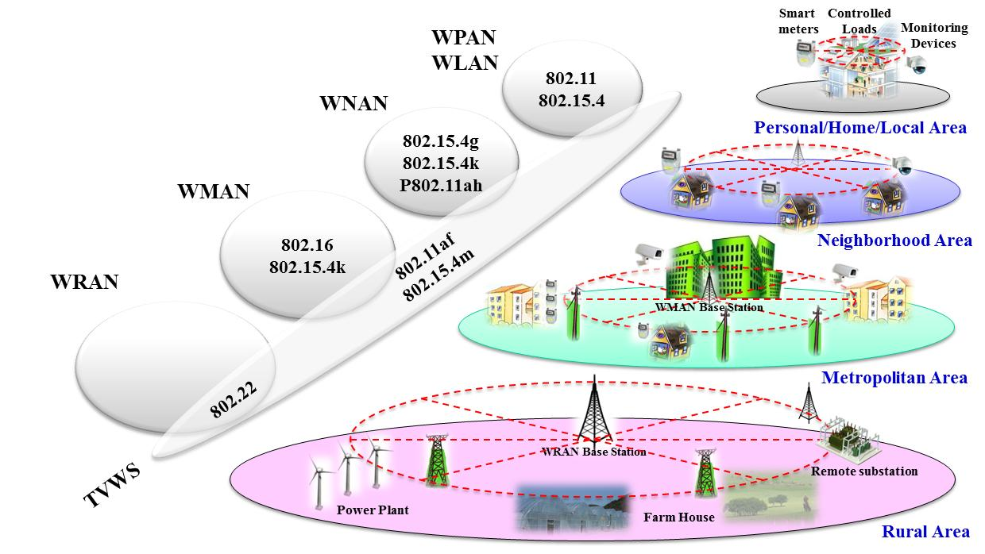

- IEEE 802 Standards Use in Smart Grid

