# 6 Practical Considerations in the Deployment of Wireless Networks for SG Applications

Section 4 provided a detailed description of the various attributes and performance parameters that would be important in making an assessment of how different wireless access technologies would apply in a Smart Grid communications network. Section 4 also provides a link to the Wireless Functionality and Technology Matrix which provides a summary of performance details for several wireless access technologies as submitted by Standards Development Organizations.

In Section 5, a number of propagation and path loss models were presented along with various graphs, tables, and other models and relevant information that would be applicable to a land-based wireless technology deployment. A special effort was made in this section to take into account the specific deployment requirements and trade-offs that are applicable to Smart Grid applications as opposed to traditional cellular networks.

The goal for this section is to build on what was presented in Sections 4 and 5 and take into account some of the varied challenges and trade-offs that will likely be encountered in a typical Smart Grid communications network deployment. In section 6.5, an Excel-based tool is introduced. This tool is intended to provide a means for quantitatively assessing alternative terrestrial-based wireless solutions in deployment regions with varied demographic and propagation characteristics based on average Smart Grid network uplink and downlink payload requirements.

Specifically, this section is structured as follows:

* Section 6.1: Coverage, Capacity, Latency Tradeoffs
* Section 6.2: Advanced Antenna Systems and Spectrum Considerations
* Section 6.3: Multi-Link/Multi-Hop/Mesh Topologies
* Section 6.4: Addressing the Challenges with Multi-Tenant High Rise Buildings
* Section 6.5:Smart Grid Deployment Modeling Framework and Tool
* Section 6.6: Interoperating and Interworking with Other Wireless Technologies
* Section 6.7: Assessment of Modeling Tool Results
* Section 6.8: Cross-Wireless Technology Considerations

## 6.1 Coverage, Capacity, Latency Tradeoffs

This section discusses key performance factors that are common to any smart grid wireless communication network deployment and how these factors relate to the demographics and characteristics of the area being considered for deployment. From an operational perspective key performance parameters are propagation range, UL and DL channel capacity, and latency. In section 5 we discussed and provided generally accepted path loss models for indoor and outdoor land-based wireless networks. Additionally we described how link budgets can be derived and how range and channel capacity can be determined. In this section we bring in the other key deployment variable; demographics.

In a wireless network we can generally describe deployments as ***Range-Limited*** or ***Capacity-Limited***. Range-limited scenarios cover the case where each base station is deployed in a manner that fully utilizes its range capability determined solely by the applicable link budget and the path loss characteristics of the area being covered without regard to data capacity requirements. Capacity-limited describes scenarios for which data traffic requirements are high and base stations or access points have to be spaced closer together to limit the number of actors per base station so as not to exceed the base station capacity capability.

***Latency*** is another key SG performance requirement and depending on; channel goodput, average message size and rate, and number of actors, could result in a deployment that is limited in its ability to meet latency requirements in accordance with the model that was described in section 5.2.7. In addition to the channel access delay predicted by the model, it may, in some cases, be necessary to account for node processing delays. These would account for encryption/de-encryption, error detection and correction, etc. Generally these are small enough to be neglected but may come into play with large latency-critical payloads. The remaining contributor to delay is propagation (over-the-air) delay, 3.33 μs per km. This can safely be ignored for terrestrial wireless networks but can be a factor with satellite links.

**6.1.1 Demographic Breakdown**

From a demographics perspective it is informative to group deployment regions into the five categories described in the following table which includes area breakdowns based on US census data[1].

| **Demographic Region** | **Housing Unit Density  (HU/sq-mi)** | **% of US Population** | **% of US Land Area** | **Typical Characteristics** |
| --- | --- | --- | --- | --- |
| Dense Urban | ≥ 4,000  (≥1545 HU/km2) | 11.0 | 0.05 | Large number of high rise multi-tenant buildings large number of businesses |
| Urban | 1,000 to 3,999 | 34.7 | 0.6 | Densely packed 4-6 storey buildings, residential and industrial |
| Suburban | 100 to 999 | 30.7 | 3.2 | Mix of 1 and 2-family homes, low rise apartment buildings, shopping centers, more trees, parks, etc. |
| Rural | 10 to 99 | 17.0 | 22.7 | Larger parcels, low rise buildings, more trees and terrain obstacles |
| Low Density Rural | < 10  (<4 HU/km2) | 4.2 | 72.3 | More extreme terrain characteristics, HU densities vary from clusters to individual HU miles apart |

In addition to the typical area characteristics included in the table there are some additional generalizations that can be made related to population and HU densities that relate directly to terrestrial wireless SG network deployments.

In deployment regions with very high population densities one can expect:

* Limited spectrum options: Spectrum congestion will always be limited factor in areas with high population density. These are prime markets for other wireless operators and if any excess network capacity does exist it will, very likely, be quickly consumed to keep up with the growing demand. That said, any spectrum that is available for Smart Grid networks may be in limited amounts and may not always be in a favorable frequency band for best range and coverage. This may require the use of smaller channel BWs, subsequently leading to lower channel capacity.
* Higher interference: With higher traffic densities and smaller cell sizes the potential for interference will be higher in these regions. This will be especially true in the unlicensed bands but can also play a role in licensed bands unless generous guard-bands are used. Limited spectrum dictates more aggressive frequency reuse giving rise to greater sector to sector and cell to cell interference. The need for greater margins to account for interference will lower the link budget.
* Most deployments will be capacity-limited or limited in the number of actors per channel to meet latency requirements: Limited spectrum and high HU densities will lead to deployments that will have to be sized to meet capacity and latency requirements for most SG network segments.

In contrast, for areas with very low population densities it is reasonable to expect:

* Spectrum availability: Spectrum is more likely to be available. Existing license holders in some cases will be willing to lease portions of underutilized blocks of spectrum. Sharing the Public Safety bands with local municipalities is a realistic expectation and the use of license-exempt spectrum can be considered without the concern for large amounts of interference.
* Most deployments will be range-limited: With the ability to deploy a wireless network with a reasonable channel BW, deployments in rural areas will most always be limited by the range capability. The exception would be in the unlicensed bands where regulators impose EIRP restrictions.

It is informative to delve deeper into the two extreme demographic categories, Dense Urban and Low Density Rural, to gain a better understanding of the challenges associated with each with respect to a SG wireless network.

### 6.1.2 Dense Urban Regions

In addition to the high density of meters and other utilities infrastructure that must be connected in a Dense Urban area wireless network, the deployment must also deal with significant propagation challenges. With the prevalence of underground utilities in metropolitan areas, meter banks will often be located in grade-level weatherized enclosures or below ground level in the basements of high-rise multi-tenant buildings. In either case the penetration losses will be significant. Additionally, as was discussed in Section 5, all of the relevant path loss models predict a higher path loss for urban deployments as compared to average suburban and rural areas due to building blockage. The range capability is further impacted when base station antennas are located below the rooftops of the surrounding buildings. This is clearly illustrated in the following figure, where range projections are shown for an AMI network under the following conditions:

* Outdoor pole-mounted DAP (Base Station) with an antenna height of 10 meters
* Basement located or cabinet-enclosed meter banks (denoted as ID Basement)
* Above ground located meter banks in indoor locations (denoted as ID Other}

The range projections are based on the ITU-R M.2135-1 Urban Micro-cell path loss model described in Section 5.2.1.2. This model is considered valid for the 2000 MHz to 6000 MHz frequency range. The dotted lines extending the data to 700 MHz are simply estimated projections for illustrative purposes.

The third plot in figure 37 is based on the ITU-R M.2135-1 Large City Urban path loss model and assumes:

* An outdoor roof-mounted base station (30 meter height)
* Terminals consisting of outdoor pole-mounted DAPs (10 meter height)

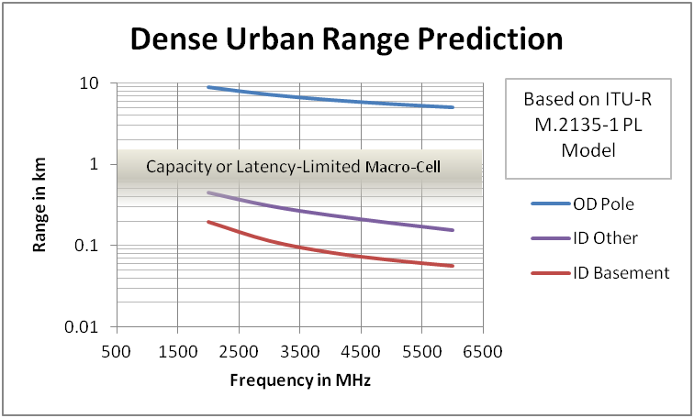What can be surmised by this is that for AMI deployments in Dense Urban and probably many Urban area deployments, the deployment will very often be range-limited and not capacity-limited since the coverage area will be severely limited by the high penetration loss to reach installed meter banks and the higher urban area path loss with DAPs mounted below adjacent roof-tops. With the small coverage area the number of meters per DAP will generally be well within the capacity capability of the base station. At 3500 MHz, based on 4000 HU/sq-mi, the traffic load for each sector would be about 300 smart meters per channel. It is important to mention that mounting the DAPSs above the prevailing roof height in a dense urban area would not yield a significant benefit. Since the DAP antennas, with a fan-shaped beam, would be pointed downward to reach the grade or below grade located meters, the effective area coverage would not be increased enough to offset the added complexity and cost of acquiring roof-rights.

**Figure 37: Dense Urban Range Projections**

The above analysis suggests a layered architecture for dense urban areas as shown in figure 38. The Pico-cells and Micro-cells represent DAPs with a nominal antenna height of 10 meters. The Pico-cells access basement-located and vault-enclosed smart meters while the Micro-cells have access to smart meters in more favorable locations from a path loss perspective and, with lower penetration loss, cover a wider area. The Macro-cell provides an aggregation node for the DAPs and may also pick up additional smart meters within its wider coverage area. The Macro-cell would have to handle the combined data traffic and in most cases will be capacity-limited.

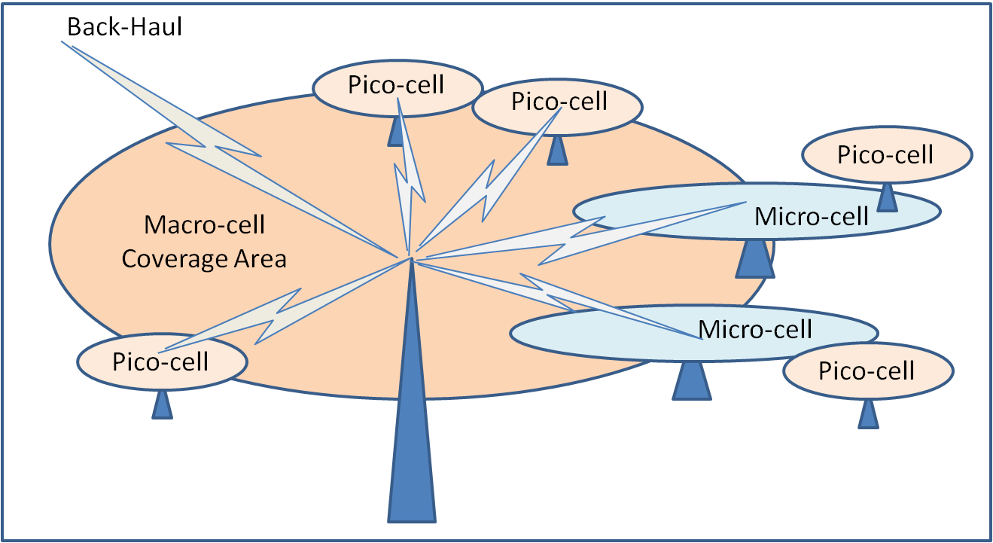**Figure 38: “Layered” Architecture for Dense Urban**

#### 6.1.2.1 Dense Urban Latency Considerations

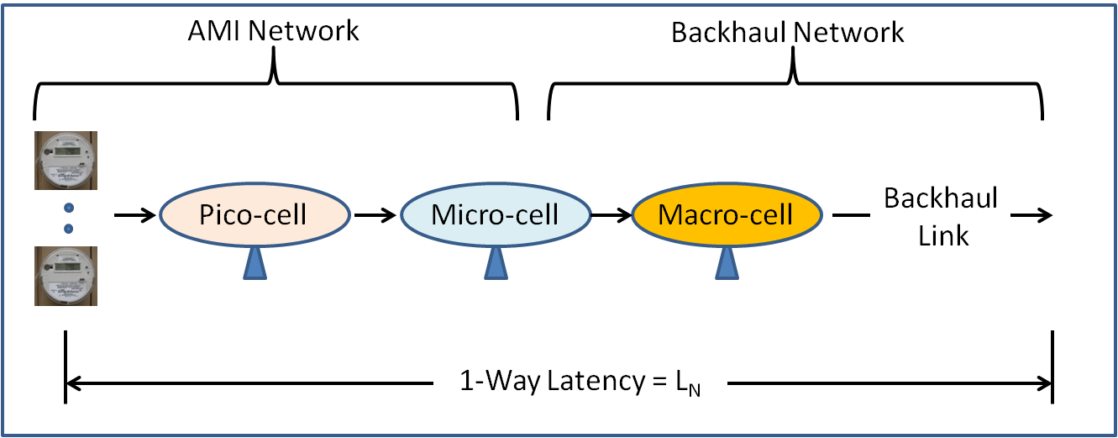As mentioned earlier, a model for assessing the network’s ability to meet latency requirements was described in Section 5.2.7. The model applies to a single link with a known average channel goodput. The same model can be used for a layered network architecture provided the latency allocated for the network is properly apportioned to the link being analyzed. For an end-to-end latency requirement of LN and the data path illustrated in figure 39, each link must be designed to meet a latency of LN/4. The probability (or confidence) factor must also be apportioned between the multiple links. For an end-to-end requirement of 99% and 4 links, each link would be required to meet a 0.994 = .9975 (99.75%) per link.

**Figure 39: Latency with Layered Architecture**

The AMI network will have a greater number of actors with small data packets. The DAP backhaul network, on the other hand, will be supporting fewer actors but data payloads will be larger. Even with the same channel BW, the average channel goodput will typically be higher for the macro-cell since it will be in, in most cases, capacity-limited or limited in its ability to meet latency requirements.

#### 6.1.2.2 Relating Channel Capacity and Latency

In the design of any communications network the decision that must always be addressed is whether to design to meet ***average*** or ***peak busy-hour*** demand. Sizing the network for average demand reduces network cost but means that reduced performance will have to be tolerated during periods of peak demand. For a telephony network it generally translates to a higher probability of a ‘busy signal’, for a Smart Grid network it may result in higher average latency. Designing the network to meet peak demand increases network cost and may result in a network that has excess capacity for a large percentage of time. For a Smart Grid network ‘highload’, driven by large payload firmware upgrades and other special events, can be orders of magnitude greater than ‘baseload’.

Even though the pico-cell deployment in the AMI network will, in most cases, be range-limited due to the high penetration losses, ‘highload’ traffic conditions, especially in dense urban areas, may approach the channel capacity limit.

Since the AMI network is likely to be operating with limited spectrum and link latency requirements may be quite stringent due to the multiple links or hops in the end-to-end communications path it is important to understand the relationship between the channel data capacity and the link latency. As was described in Section 5.2.7, the latency prediction is based on the channel goodput (CGP), the average packet size (PAVG), and the message (or packet) rate RMSG.

If, as an example, we assume a CGP of 1.0 Mbps and a peak data rate per actor or end-point of 100 bps (approximately 12 Bytes/sec), the channel capacity at peak load would be 10,000 actors per channel. The actor message rate, RMSG, under these conditions is 0.05/second or 180/Hr.

Figure 40 shows the probability of meeting a particular link latency requirement as a function of the actor load on the channel. With 8500 actors (85% of the channel actor capacity) there is a 99.5% probability that a packet will meet a 0.5 second latency requirement or, alternatively, less than 0.5% of the packets will exceed a latency of 0.5 seconds. This value is about 10% at 92.5% of the channel capacity and grows to over 30% when the channel is loaded to more than 97.5% of capacity. If the channel were operating at full capacity the latency would be about 20 seconds

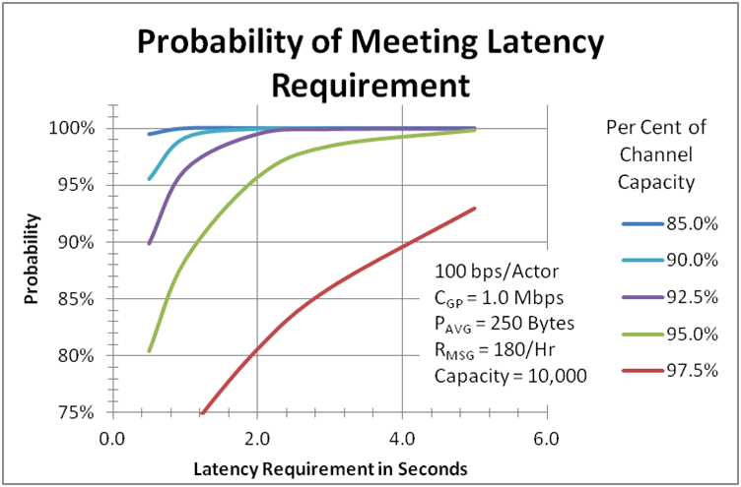**Figure 40: Probability of Meeting Latency Requirement**

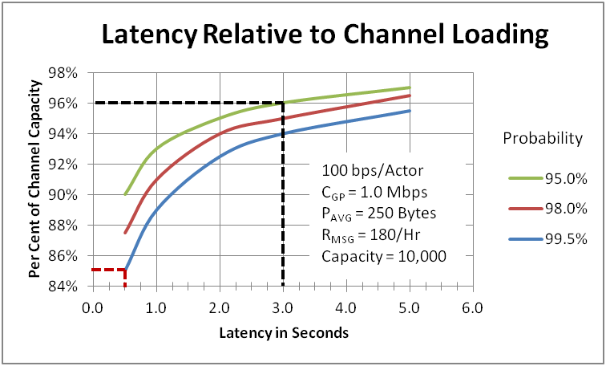Another way to present this data is shown in Figure 41, where the channel load as a percentage of channel capacity is plotted versus the latency prediction for different probabilities. This representation may prove more useful as a network design or planning tool when one is faced with the decision of dimensioning the network capacity to meet ‘baseload’, ‘average load’, or ‘highload’ requirements.

**Figure 41: Latency Relative to Channel Loading**

For this particular example, if one wanted to maintain a latency of 0.5 seconds with a probability of 99.5% during periods of ‘highload’, it would be necessary to design for a channel capacity 15% higher. If, on the other hand, a latency of 3 seconds with a probability of 95% could be tolerated during peak loads, one could operate up to 96% of the channel capacity.

Figure 41 is applicable for this particular example and would have to be re-plotted for different parameter assumptions. Generally a reduced packet size would support higher channel loading for a given latency. Although a smaller packet size increases the message rate (RMSG), the probability that a packet falls within the specified latency window increases. Bear in mind that smaller packet sizes will also increase the channel OH so one can also expect a slight reduction in channel goodput.

This analysis does not take into account any of the QoS features that are supported by most wireless technologies. The analysis assumes all packets are treated with equal priority. With QoS support it would be possible to assign higher priorities to packets that are more latency-sensitive while relegating latency-tolerant packets to a ‘Best-Effort’ status. From the standpoint of evaluating the channel’s ability to meet latency requirements, with QoS, the ‘Best Effort’ packets would be ignored.

### 6.1.3 Low Density Rural

The opposite extreme to Dense Urban is the area designated as Low Density Rural. According to the United States census data over 4 % of the US population lives in over 70 % of US land area. With housing unit densities less than 10 per sq-mi (< 4 HU/km), deployments in these regions will always be range-limited with any reasonable amount of spectrum. The key challenge for a terrestrial wireless network deployment is to optimize the coverage so as to reach all housing units and enterprise units that are connected to the electrical grid. Special attention has to be paid to:

* **Terrain characteristics** that can vary from flat wide-open spaces to rugged mountainous terrain with high tree density.
* **Long distance back-hauls** that may require daisy-chained point-to-point (PtP) links or a satellite link for connectivity to the command center.

Path loss models for foliage and path obstacles were presented in section 5 and a modified version of the Erceg-SUI path loss model was shown to be an effective path loss predictor for various terrain categories in rural and suburban areas over the full 700 MHz to 6000 MHz frequency range. A description of the three terrain categories are repeated here for convenience:

* **Terrain Type A:**  Hilly with moderate to heavy tree density
* **Terrain Type B:** Hilly with light tree density or Flat with moderate to heavy tree density
* **Terrain Type C:** Flat with light tree density

Although not all terrain types that are likely to be encountered throughout North America can be fit into one of the above types, it is believed that these three terrain types can be used to describe a large majority of Low Density Rural deployment scenarios. For extreme terrain conditions other approaches, as noted in section 5.2.1.3.11, may have to be employed to provide a more accurate estimate.

Figure 42 provides the coverage area projections for the three terrain types for an AMI network for the 700 MHz to 6000 MHz frequency range. The link budget of 143 dB[2] in the UL direction is the limiting factor for the range determination due to the lower EIRP and antenna gain for the wireless enabled smart meter. The DAP antenna height is assumed to be 20 meters with a gain of 15 dBi. This height should not be unreasonable in rural areas where existing transmission towers would be logical candidates for base station locations.

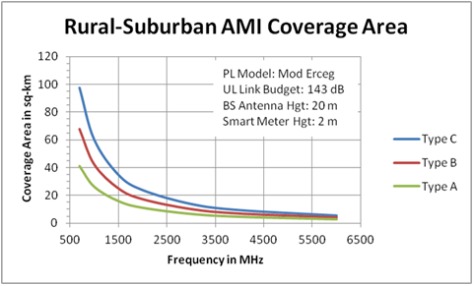**Figure 42: AMI Coverage Area Projections**

In figure 43 the sensitivity of the coverage area is plotted for different antenna heights for those locations where a 20 meter height is impractical. The chart also shows the benefit of higher heights for situations where suitable structures or standalone towers are available. This data is plotted for a frequency of 2000 MHz but the results are not significantly different at either 700 MHz or 6000 MHz. With its large impact on coverage area, base station antenna height will play an especially big role in determining equipment requirements for SG networks in low density rural areas.

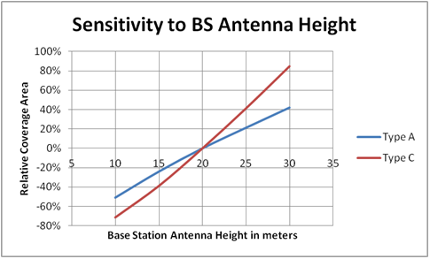**Figure 43: Sensitivity to Base Station Antenna Height**

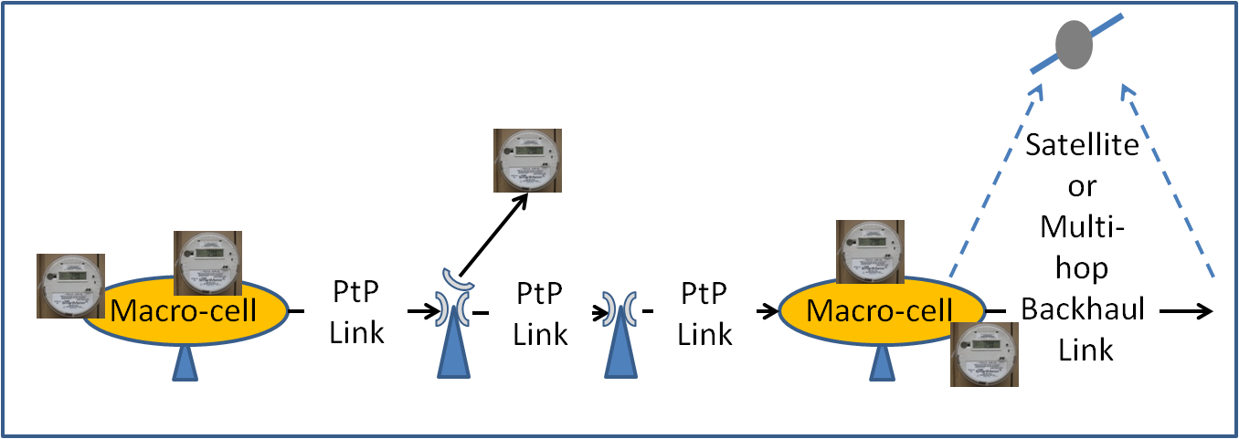The second key challenge in low density rural areas is the backhaul connection which may require multiple PtP links for a land-based solution or the possible use of a satellite link or some combination of the two. A typical Low Density Rural or Rural wireless network architecture may resemble what is shown in figure 44.

**Figure 44: Typical Network Architecture for Low Density Rural**

#### 6.1.3.1 Low Density Rural Latency Considerations

As shown in figure 44 the end-to-end data path will very often encompass multiple links or hops, each with very different characteristics. As was the case with dense urban, the network latency budget should be properly apportioned to each individual link before applying the latency model described in section 5.2.7. If a satellite link is employed, the propagation (over-the-air) delay should also be considered. When end-to-end latency gets to be the limiting performance factor, fewer terrestrial long links will be preferable to a higher number of short links for reducing latency. This replaces node processing delay with propagation delay. Longer links of course, will generally require increased antenna heights and higher EIRPs.

### 6.1.4 Summary

Urban area path loss and high penetration losses will significantly limit the range and coverage for a wireless AMI network. In most cases these deployments will be range-limited pico and microcells. With roof-mounted base station antennas to provide a backhaul connection for the DAPs, the coverage potential will be much greater but capacity requirements to handle the aggregated traffic will ultimately determine the coverage not the range.

Low density rural area deployments will be primarily range-limited. The use of the lower frequency bands and deploying base station heights of 20 meters or more will greatly reduce equipment requirements. A combination of PtP links and satellite links may prove to be the best choice to fulfill backhaul requirements in remote areas but with an increasing number of links, latency could become a limiting factor.

The various trade-offs and considerations for deployments in Dense Urban and Low Density Rural areas should provide some insights into the factors that must be considered in the other three demographic regions described earlier; Urban, Suburban, and Rural. Urban areas would still have the building clutter to deal with but, with lower average building heights, slightly better propagation characteristics. Deployments however, will still tend to be capacity-limited.

Residential suburban and rural areas will not generally be able to accommodate the higher base station antenna heights due to visual impact and the limited height of utility poles that would often be the preferred choice for base station locations. Depending on channel BW limitations imposed by limited spectrum availability and HU density, suburban areas may be either range-limited or capacity-limited.

## 6.2 Advanced Antenna Systems and Spectrum Considerations

Advanced antenna systems have become commonplace in today’s wireless networks, even indoor WiFi Access Points (APs) are often equipped with multiple antennas. These advanced antenna systems can be grouped into two generic categories designated as Multiple Input Multiple Output (MIMO) and Beamforming (aka Phased Arrays). Each of these generic categories has different attributes that translate to improved range and coverage, improved channel capacity, higher availability, or a combination of the three.

### 6.2.1 Multiple Input Multiple Output (MIMO) Antennas

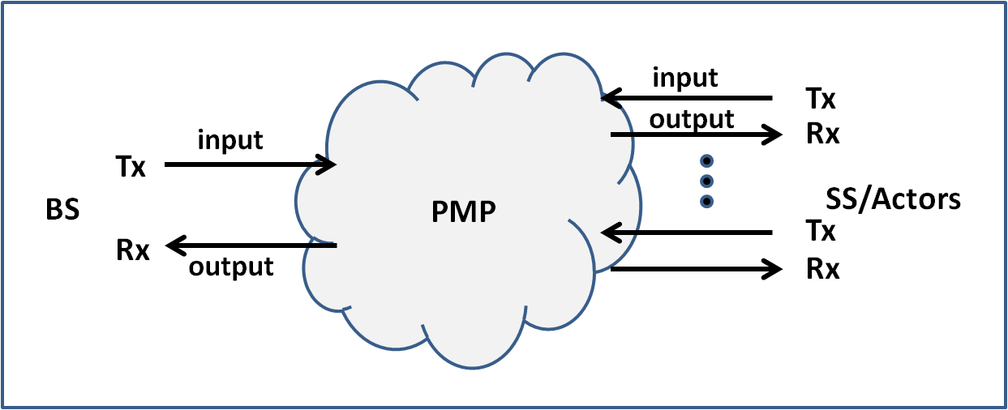MIMO systems are described as illustrated in Figure 45, where transmit antennas are designated as inputs to the over-the-air channel and receive antennas are receptors of multiple input paths. A base station equipped with “NT” transmit (Tx) antennas and “NR” receive (Rx) antennas would therefore be described as having a (NT x NR) MIMO antenna configuration. A configuration with 1 Tx antenna and 2 Rx antennas would be designated as having a (1x2) SIMO (Single Input Multiple Output) antenna configuration.

**Figure 45: Antenna Nomenclature**

To take maximum advantage of the performance attributes that MIMO antenna systems can support it is necessary to minimize correlation between antennas. This can be accomplished through spatial separation, typically 3 to 5 wavelengths or more. With only two antennas, cross polarization can be used.

With multiple Tx antennas, MIMO systems can generally operate in one of two transmit modes and in most cases can auto-adapt to the mode most applicable to existing channel conditions at any given time. These transmit modes are called:

* Transmit Diversity
* Spatial Multiplexing

***Transmit diversity*** describes a scenario whereby the same data stream is transmitted over each of the transmit antennas. This provides multiple independent transmit paths thus increasing the probability of a satisfactory reception at a distant terminal. This feature translates to an increase in system gain resulting in either an increase in range or an increase in availability. Assuming there is no correlation between antennas, a system with 2 Tx antennas will result in a 3 dB system gain increase and a 4 Tx antenna system will result in a 6 dB increase.

With ***spatial multiplexing*** each Tx antenna transmits a different data stream to effectively increase the channel capacity. This can provide up to a 2x increase with two Tx antennas and up to a 4x increase with four Tx antennas.

As a practical matter the performance gains for Transmit Diversity or Spatial Multiplexing will be somewhat less than theoretically predicted due to variations in multipath, antenna patterns, and mounting limitations.

Multiple Rx antennas in MIMO systems generally support:

* Receive Diversity with or without Maximal Ratio Combining (MRC)
* Multi-User MIMO (MU-MIMO)

***Receive Diversity*** enhances link reliability by providing multiple independent receive paths. In its simplest implementation the receiver simply selects the highest signal level from one of the multiple antennas. Since a deep fade is unlikely to occur simultaneously on each path the probability of receiving a signal above the threshold level is increased. With Maximal Ratio Combining (MRC) the received signals are combined to provide a received signal level higher than any of the antennas receive individually.

***Multi-User MIMO (MU-MIMO)*** is a technique typically employed on the receive side at the base station. With multiple Rx antennas, this approach combines transmissions from multiple terminals to increase the base station UL channel throughput.

### 6.2.2 Beamforming

Beamforming is another advanced multiple antenna option that is available with many terrestrial-based wireless systems. This approach requires each base station antenna in the array to be spaced one-half wavelength apart. With proper phasing and amplitude control the resulting antenna pattern is formed into a narrow beam that can be steered to direct the beam to different areas within a sector coverage area as illustrated in Figure 46. The beamwidth is indirectly proportional to the number of antennas in the array. Typically 4 to 8 antennas are used to achieve the desired beamwidth. The resulting increase in antenna gain increases the link budget in both the DL and UL directions and significantly reduces the potential for interference in UL.

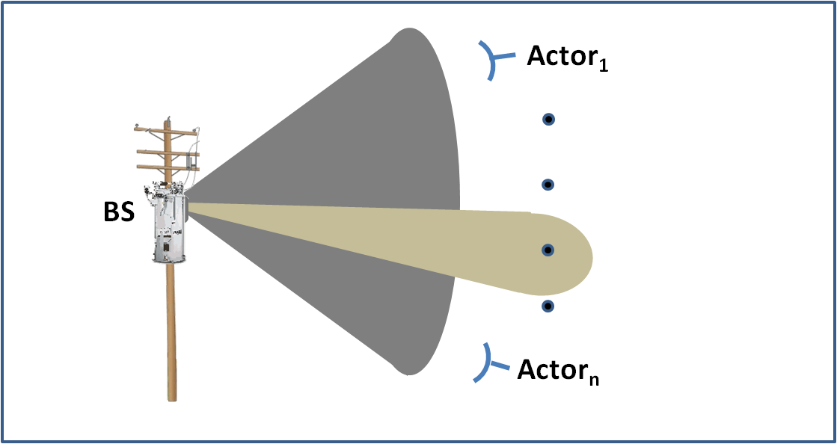**Figure 46: Beamforming**

Since all of the terminals must maintain a connection with the base station at all times, the range is determined by the control channels which are generally linked in a sector-wide “broadcast” mode. The added link budget in a beamform system therefore, does not translate to a significant increase in range or coverage but does enable a higher throughput and higher link availability.

### 6.2.3 Practical Considerations and Spectrum Trade-offs

Advanced antenna systems can definitely provide significant performance advantages for terrestrially-based wireless access systems however one must also consider the deployment implications, especially in the lower frequency bands. The impact on spectrum choices with respect to multiple antenna systems was briefly mentioned in section 5.2.2.2.2.

As described above, antenna spacing is an important consideration for these systems to be effective. This can be especially challenging for higher order MIMO systems in the lower frequency bands. The following figure shows the spacing for a (4x4) MIMO array assuming, for illustrative purposes, an antenna to antenna spacing of three wavelengths. Note that this is a minimum requirement which will result in reduced performance due to the potential for antenna to antenna correlation as compared to a spacing of five or more wavelengths.

Only taking into account the antenna spacing, at frequencies below 1000 MHz the size of a (4x4) MIMO array will exceed 4 meters with a 3-wavelength antenna separation.

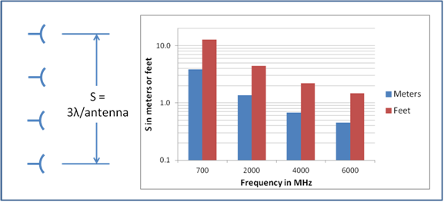

**Figure 47: (4x4) MIMO Array with 3 Wavelength Spacing**

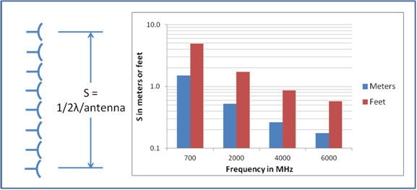The dimensional requirements for beamforming arrays are somewhat better since the antennas are spaced at one-half wavelength apart rather than several wavelengths. Nevertheless, since beamforming arrays generally require more elements to be effective the arrays still get quite large in the lower frequency bands as shown in Figure 48 for an 8-element beamforming array.

**Figure 48: An 8-Element Beamforming Array**

In addition to antenna spacing the relative size of the antenna itself must also be considered. The gain of an antenna can be expressed as:

Antenna Gain in dBi = 10 Log10 (4πηA/λ2),

Where A = the size of the antenna aperture, η = the area efficiency (generally a value between 30 % and 50 % depending on the antenna type design), and λ = wavelength.

As the equation indicates the antenna gain varies inversely as the square of the wavelength thus providing a significant variation in gain for a fixed antenna aperture over the frequency range 700 MHz to 6000 MHz.

Base station antennas for wide area networks are typically designed to provide a fan-shaped pattern with a gain in the order of 12 dBi to 16 dBi. Figure 49 shows the gain for a base station antenna with an aperture to height ratio of 10 to 1 and an aperture height of 0.67 m. This provides a gain of about 15 dBi at 3000 MHz assuming an aperture efficiency of 50%.

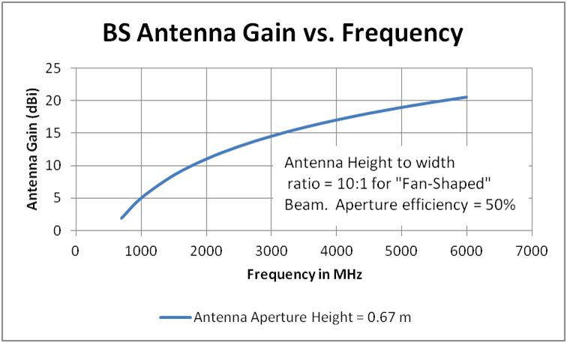

**Figure 49: Antenna Gain Variation with Frequency**

In the following figure the antenna aperture height required to maintain a 15 dBi gain over the 700 MHz to 6000 MHz is plotted. This, of course, is a simplistic analysis since it does not consider alternative antenna designs that can potentially improve the aperture efficiency in the lower bands. Although the curves in these two figures may present a more pessimistic prediction for the lower frequency bands the general trend is the same; antennas in the lower bands will be larger and have lower gain.

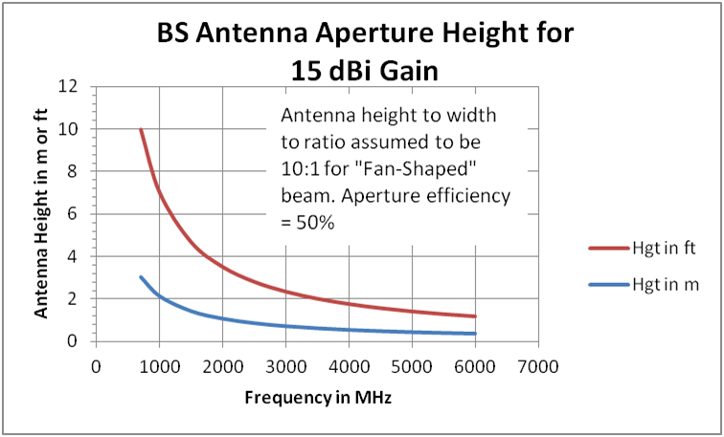**Figure 50: Estimated Aperture Height for 15 dBi BS Sector Antenna**

When deploying MIMO or Beamforming arrays, taking into account the required antenna spacing and antenna size, one must carefully consider the following factors:

* Visual impact
* Space requirements on existing utility infrastructure (utility poles, transmission towers, etc)
* Structural requirements for wind-loading forces

As described above the challenges with respect to these deployment factors are greater in the lower frequency bands. Since some of the commercially available advanced antenna systems may prove impractical in the lower frequency bands due to the antenna and array size, the path loss advantage is mitigated somewhat. Analysis will indicate that there is still a significant coverage advantage in the lower frequency bands, but the point to be made is that the projected path loss difference should not be the sole criteria for selecting these bands.

## 6.3 Multi-Link/Multi-Hop/Mesh Topologies

Several networking topologies were briefly discussed in Section 4.2.2.4. This section will provide additional discussion of some of these topologies and specifically, those more commonly used in the Neighborhood Area Networks (NAN). One definition of a NAN is a common network infrastructure that links multiple intelligent devices in a relatively small or neighborhood sized geographic area. This section will provide a general overview of the NAN and several important considerations for its use in a Smart Grid environment.

Figure 2 of Section 3 (repeated on the following page) describes the Smart Grid Conceptual Reference Diagram illustrating the multiple Domains and the network infrastructures interconnecting those domains. Shown are two holistic NAN infrastructures; one identified as a



Field Area Network (FAN), and the other identified as an AMI Network. Although the FAN and AMI could be the same network they are each shown as composite but separate networks in this diagram in order to show their relationship and support for two of the Smart Grid Reference Domains. More specifically, the FAN is depicted as supporting and serving the Distribution Domain, and the AMI Network supporting and servicing the Customer Domain. While this depiction is appropriate for the conceptual or high level Domain view of the SG, it is somewhat misleading from the physical network implementation perspective. In actual practice both the FAN and the AMI Networks can and usually are composed of multiple smaller geographically based networks or NANs, each with one or more Data Aggregation Points (DAPs) as will be described in greater detail below. Also depicted in Figure 2 of Section 3, the communication network endpoints for the AMI Network NANs include the 2-Way AMI Meters and ESI – Utility. The endpoints for the FAN and NANs include distribution feeder devices and may also include a FAN Gateway linking with a Substation Network. While the conceptual reference diagram illustrates the ‘Domain’ view of the SG Systems, it should be noted that both the Distribution Domain and Customer Domain will have significant geographic overlap, and thus the network infrastructures serving them likewise will have significant geographic overlap. This overlap leads to the potential for integrating the FAN and AMI Network NANs in these common geographic areas into a common network infrastructure. Thus in these areas, a single composite NAN may be implemented to provide connectivity for the endpoints from both the AMI Network (i.e. the AMI meters) and FAN endpoint devices (i.e. field Distribution Automation devices). Throughout the rest of this section the distinction of the Domains served will be considered only insomuch as the endpoint devices for the Domains will bring different use cases and thereby bring different network requirements. However, the primary focus of this section will be on the underlying NAN infrastructure and considerations for supporting the uses cases for the various end devices it serves. The subsections below will cover the components of the NAN in greater detail but a common network element of the NAN is the Data Aggregation Point (DAP), as mentioned above. While the different AMI and NAN vendors typically identify the DAP using their own specific product names, the primary purpose of the DAP is to serve as a gateway from the NAN to other networks to ultimately link back to one or more common application system and services. In some cases more sophisticated NANs allow more than one DAP for an individual NAN that may allow segregation of traffic types and may allow linking with different upstream application systems. Other commonalities and distinctions will be discussed further in the following subsections considering the technology and topology of the NAN.

Furthermore, for the current Smart Grid implementations the dominate use of the NAN is for AMI. In these implementations the NAN provides connectivity between AMI meters and a DAP, with the DAP having a backhaul path via a WAN to the host AMI System or AMI Head-End. For these dedicated AMI system there are specific requirements for information flow between the back-office metering systems, through the NAN, and to the individual AMI meters. For these AMI systems, there is no need for the meters to share their metering information amongst themselves, but only to share this information with the AMI Head-End and the centralized metering system. Therefore meter to meter (i.e. peer-to-peer) information sharing in the NAN is not required. However, in a Multi-Hop AMI NAN the meter communication modules may be called on to relay messages between the DAP and other meters too far removed from the DAP to directly link with it and they may also exchange network housekeeping messages between the communication modules of neighboring AMI meters. As these AMI NAN networks are expanded to include DA devices there may be additional requirements for the NAN to support direct peer-to-peer information exchanges between these DA devices leading to additional requirement for the NAN to support these peer-to-peer routes along with effectively managing message priorities. Both the current and potential future requirements of the NAN should be fully considered when choosing a technology and topology for NAN connectivity.

### 6.3.1 Network Topology Revisited

In order to better identify the common NAN infrastructure a brief digression further into network topology is in order. Multiple terms are often used in conjunction with the NAN; Point to Multipoint (PMP), Multi-Link, Multi-Hop, and Mesh. However, these terms may be misleading and it can be said may inaccurately describe the commonly deployed NAN topologies.

The term Multi-Link network can be defined as interconnecting multiple discrete networks, such as linking a HAN with a NAN, then to a WAN. The obvious reason for interconnecting these networks is to allow data exchanges between the devices connected to these discrete networks. That is, a Multi-Link network path can be established through the linked HAN, NAN, and WAN Multi-Linked networks.

The term Multi-Hop network can be defined as group of interconnected nodes in a common network infrastructure where links to traverse this network can be established by using node-to-node or hop-to-hop links, thus the term Multi-Hop.

The term Mesh is used to describe a family of interconnected nodes in a common network infrastructure. There are several forms of mesh topologies which are well documented in multiple books and other technical papers on network systems. However, briefly here, the term full mesh is commonly used to describe a mesh where each node is directly connected to each other node, which can lead to an inordinately large number of links in large networks but also provides the largest number of direct communication paths. With a larger set of links, a full mesh has more choices to dynamically adapt to faults or traffic loads in any given communication link. A partial mesh is a subset of a full mesh where not all nodes are directly linked to all other nodes, and traversing the network may involve relaying or routing through multiple nodes or in essence forming a Multi-Hop link.

The goal of a classical mesh network is to provide connectivity from any node to any other node. However, in an AMI NAN, the application level or “use case” data is usually limited to exchanges between the DAP and the AMI meter. Stated another way, within the AMI NAN the community of interest is between the DAP and the individual AMI meters with one being considered the source and the other being considered the destination or sync of the data. Thus for an AMI NAN, the goal is to provide links from a DAP to the AMI meters. A potential exception to this DAP to end device community of interest within a NAN may be if DA devices are linked via the NAN and the DA applications or use cases require some peer-to-peer data exchanges between the DA devices. Node-to-node data exchanges for AMI NANs are otherwise generally limited to network housekeeping messages where the AMI meter communication modules share information amongst themselves on link and network status and best routes. However, it should be obvious in Multi-hop AMI NANs the meter communication modules will often be used as relay points to relay messages between the DAP and other AMI meters further downstream.

As indicated in Section 4.2.2.4 the nodes in a Multi-Hop NAN are typically intelligent devices (endpoints), that have the ability to discover (multi-hop) forwarding paths in the network and make their own forwarding decisions based on various pre-configured constraints and requirements. Using this dynamic routing capability, the endpoints first determine which neighbor nodes are within radio range, assess potential links with these neighbors and dynamically choose the best or most appropriate path as their primary route through the NAN to an DAP. Depending on the routing algorithms implemented in the endpoint nodes, this best route determination may be based on RF signal strength, ability to exchange messages with neighbor nodes with minimal errors, using neighbors that provide the minimum number of hops back to an DAP, the geographic coordinates of the nodes, or a combination of the these. The subject of routing and route determination algorithms for wireless Multi-Hop networks has been the subject of study for many years and multiple books and other publications are available on this subject. Suffice it say here the meter nodes will use their programmed algorithms to select what they have determined as the best route back to a DAP at that particular point in time. It has been noted that some of the dynamic self configuration algorithms implemented in currently deployed NAN networks may occasionally lead to unstable or otherwise infeasible routes and may need some external oversight to force a usable route or the additional of other NAN network devices to establish useful routes.

In addition to selecting a primary path and route to a DAP, an AMI meter node will typically also preselect other (second best) routes to be used should its primary route become degraded or unavailable. Normally all AMI meter traffic to and from a DAP will use only their currently established primary path. The secondary path would be used if and when it is promoted to be the primary path because the previous primary path had degraded or become unserviceable.

An interesting side note is that while the NAN AMI meter nodes have the ability to link with any of their neighboring nodes (within RF range) and potentially route through them, in practice as the routes are established between the DAP and the AMI meters, the routes usually form a “tree” network structure. For an AMI NAN this is a consequence of the need and requirement that the AMI meters exchange information only with their selected DAP, using the Multi-Hop links through other AMI meter nodes merely as relay or routing points. In this tree structure the primary branches or links extend from the DAP to a first layer of nodes and from this first layer of nodes additional branches or link extend to secondary nodes, and so on until all nodes have established a path between themselves and the DAP. The distribution of the number of hops from the end nodes to the DAP is then a general index of how effective the NAN may be in providing connectivity to the devices in that NAN. The nodes further removed from the DAP having a greater number of hops to traverse will also have greater latency and are generally more susceptible to having their path to the DAP interrupted as propagation conditions in the NAN may change.



Figure 51: Full Mesh, Partial Mesh, and Tree Topologies

Finally, while the AMI NAN is often described as an AMI Mesh, in reality most AMI NANs used to establish connectivity between the DAP and the AMI meters are using Multi-Hop links simply to relay messages between the DAP and the meter. Thus the routed links in an AMI NAN usually form into a tree network structure and using the term mesh to describe this network, while not totally inaccurate, is generally misleading regarding the data carrying network structure established in the NAN. It is worth mentioning for an AMI NAN that even though the nodes attempt to establish the best path back to a DAP, and thereby form a tree structure, often the NAN nodes will also preselect other (or second best) neighboring nodes to link with should its link with the currently selected next hop node in the route to the DAP become unavailable. An important consideration for a Multi-Hop NAN is its ability to dynamically adapt to communication link faults by utilizing alternative branches from the Multi-Hop link possibilities.

### 6.3.2 The Neighborhood Area Network (NAN) in a Larger Context

Another concept is the use of the term AMI Network or mesh to describe a single monolithic network spanning large geographic areas. However, an individual NAN infrastructure will consist of at least one DAP and a number of endpoint nodes or meters linked to it, and potentially other relaying/routing devices to extend the reach of the NAN or to provide additional reliability. Thus the term AMI Network while generally used to connote a single monolithic network is in reality an aggregation of multiple individual NANs, each consisting of a DAP and the end nodes connected to and through it. These multiple individual NANs collectively provide coverage and connectivity to the end nodes in larger geographic area. However, this is not to say the individual NANs operate totally autonomously and independent of each other. As several DAPs are deployed in a geographic area, the AMI meters in this area will use dynamic routing to establish the best route to a DAP, which in some cases may not be the geographically closest DAP. In reviewing the links established in working AMI NAN networks, it is often observed there are significant areas where individual meters in common geographical areas establish links to different DAPs. One of the obvious advantages to this is the potential redundancy offered in areas with multiple DAPs. If one DAP fails, or the backhaul link serving it fails, the meters normally served by that failed DAP can and will dynamically reroute to link with other meters connected to other working DAPs. An example of this is shown in Figure 52a.



Figure 52a: Node Reroute Example – Failed DAP

In addition to rerouting to bypass a failed DAP the individual nodes have the ability to dynamically reroute within the NAN should the path currently chosen as their primary route to the DAP become unavailable or unreliable. In this case, the node will typically try to route through its preselected second best route, or if that also fails, the node will continue to evaluate neighbor links to find the best route back to an DAP. An example of this is shown in Figure 52b.



Figure 52b: Node Reroute Example – Failed Node

Similarly if an intra-NAN link fails, the nodes that were supported through that failed link will reroute to establish a new path to a DAP. An example of this is shown in Figure 52c. However, in this example note the new route chosen is to a different DAP only because that new route may have been determined as the ”best” route to a DAP during the route recovery process.



**Figure 52c: Node Reroute Example – After Failed Link**

### 6.3.3 Other Neighbor Area Network (NAN) Topologies

While the focus of this section is on the AMI Multi-Hop network topologies it is of value to mention other alternatives commonly used to provide connectivity between AMI meters and the AMI host or AMI Head-End system.

One example is the use of commercial or private cellular-like networks to establish point-to-multipoint links from a master radio site or base station to the endpoint devices. While the commercial cellular networks are designed and deployed primarily to support mobile devices moving from cell to cell, they can and do also serve fixed devices like the AMI meters. In these systems, each base station typically serves smaller geographic areas but are generally deployed in order to provide overlapping coverage serving larger geographic areas. Utilizing commercial cellular services for linking with AMI meters may be appropriate in areas where implementing private or purpose built wireless network are not feasible or are not cost-effective. These are described in some detail in other sections.

Other AMI systems may use purpose built point-to-multipoint wireless networks designed specifically to support fixed locations. As such they can be implemented without the additional complication of tracking and handing off mobile devices as they move from cell to cell. These are generally tower-based systems and are typically designed to provide connectivity extending multiple miles to remote AMI meters. A single master radio or base station therefore, may be able to provide coverage over a large geographic area.

In both point-to-multipoint networks described above, the master radio or base station would then be linked through an appropriate backhaul network to a centralized AMI system or host.

Point-to-multipont networks may be implemented to cover different geographic areas ranging from Pico-cells covering tens to hundreds of feet across to Mega-cells covering areas hundreds of miles across. Pico-cells might be appropriate in small geographic areas like meter closets in multiple dwelling units, whereas satellite-based Mega-cells might be appropriate for linking multiple remote meters spread over large geographic areas covering thousands of square miles. Use of these technologies should be considered when the use of other primary technologies may not provide effective coverage for all meters in a service territory. These examples are illustrated Figure 53.

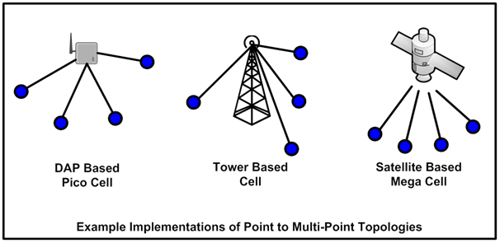

**Figure 53: Point-to-Multipoint Implementations**

### 6.3.4 NAN Network Components

This section identifies some of the network elements commonly used in implementing NAN systems. One of the original purposes of the NAN was to provide network connectivity from a centralized metering system to remote AMI meters, thus the original name AMI NAN. Using the network connections, the centralized metering system was able to retrieve energy usage and other information from the AMI meters and to send configuration and other command and control functions to them.

Typical AMI NAN implementations also included a centralized AMI Head-End management system linked to the NAN through a backhaul network to provide network management and control of the NAN elements themselves. This AMI Head-End system is depicted in network diagram Figure 2 of Section 3.

As for the NAN nodes themselves, to some extent the type and function of these nodes are dependent on the technology and topology used to implement the NAN. However, there are some elemental components commonly used in these nodes. For wireless NANs, one of the elemental components of a node is a NAN radio. The NAN radio is typically modularized and will consist of a RF transmitter and receiver, antenna, and the control electronics which allow the radio (and thus the node) to actively participate in the NAN. NAN radios are mated with end devices, for example, AMI meters, DA devices, etc., typically in a composite package provided by the OEM or end device manufacturer. For AMI meters, this package is almost always in the meter housing itself or “under cover”. In any case, the NAN radio provides a data interface used to interconnect with the meter or other end device. Other NAN radios may be implemented as standalone repeaters, relays, or routers used to strengthen and/or extend the reach of the NAN. Also common to wireless NAN systems are the DAPs. The DAP serves as the centralized connection point for its supported NAN nodes and thus will include one or more NAN radios to link with these nodes. The DAP will also contain a backhaul network interface and necessary controlling electronics to allow it to be linked with the NAN Head-End through a backhaul network.

Depending on the vendor and NAN networking technology used, the NAN radio module may also be capable of supporting additional data processing functions as may be required to properly interface with its connected end device. This data processing capability may be necessary to aggregate end device data for more efficient network transmission thought the NAN or to accommodate specific application level or native protocols utilized by that end device.

### 6.3.5 Characteristics Multi-Hop Networks

In evaluating the use of Multi-Hop NAN networks the following are some of the major elements and characteristics to be considered.

Note: Many of the following characteristics apply to MESH and point-to-multipoint.

Note: Reconsider the use of “NAN”

* Intended use of the Network – AMI only, DA, HAN Interconnectivity, Direct Load Control, or a combination of these. The applications and use cases, both current and those projected for the future should be considered carefully when establishing NAN requirements and evaluating NAN capabilities.
* Size of the Network – Consideration must be given to the number of devices, their function, their location, their density, and the variability of their density.
* Geographic location and RF morphology – The terrain and other RF environmental factors that could impact the reach and reliability for each geographic area should be considered.
* Bandwidth Requirements – Consideration for deterministic and non-deterministic traffic, average and bursty traffic patterns, and the relationship of the traffic patterns with latency requirements.
* Node Throughput – Consideration for the processing power and packet throughput capacity of the NAN device nodes, repeater nodes, and the DAPs
* Mesh Multi-Hop Latency– Each application and use case may bring additional latency requirements. In a Multi-Hop NAN, latency can be significantly impacted by several factors including the node-to-node effective data throughput rate (which is in turn related to RF bandwidth, RF modulation efficiency, and error rates) and the internal processing delay introduced by intermediate nodes in relaying data packets. Consideration should be given to the distribution of the number of intervening nodes or hops that may exist between the DAP and nodes in that NAN. The cumulative or combined latency of multiple hops encountered in reaching end nodes further removed from the DAP may be significant.
* Incremental expansion of the mesh topology – Both in number of devices and functionality without risk to the existing topology.
* Resiliency and Redundancy – Requirements for recovery of failed network elements along with the techniques employed to provide redundancy.
* Security – Security requirements for joining the network, preventing unauthorized attachment or connections, and permitting data exchanges between authorized nodes
* Backhaul requirements and availability – The requirements of the backhaul links from the NAN DAPs to the centralized systems, and the availability of these backhaul links. Of particular importance here is the additional latency or any capacity constraints that may be introduced by the Backhaul component of the network.
* Deployment Considerations – How capable or flexible does the Network need to be to adjust to the deployment planning, processes, and physical environments.
* Incremental Cost to Achieve 100% Coverage – Typical applications require 100% coverage; different topologies have different incremental cost to go from a nominal coverage to 100% coverage. Scalability – number of nodes per cluster.

### 6.3.6 Additional Technical Characteristics of the NAN

Several vendors offer NAN systems designed to support AMI and other SG data requirements. While most of these employ the use of Mesh or Multi-Hop networks as described in this section, they can vary significantly with respect to their implementation.

Several technical issues to consider when selecting a technology, topology, and vendor include the following:

* Spectrum Used – Many commercial AMI NAN systems use the 900 MHz (902-928 MHz) Industrial Scientific and Medical (ISM) band. Others use the 2.4 GHz ISM bands. These bands are unlicensed, and with some technical restrictions on their use, they are shared by multiple users. Other systems use private licensed frequencies, thus minimizing potential interference with shared users. Still others may use the registered but non- exclusive 3.65 GHz band. Regardless of the spectrum used, the capabilities and limitations inherent with this spectrum should be considered in choosing a NAN technology and topology. A number of other sections provide much more information on the capabilities and restrictions of the spectrum choice.
* Route Forming and Maintenance – As a NAN, that is a DAP and associated end devices, forms a PtP, PMP, mesh, or Multi-Hop network, a set of data paths or routes will be established from the end devices to the DAP. These routes will form as a result of the dynamic self-routing ability inherent in the nodes of the NAN. As indicated in Section 4.2.2.4 the nodes in a Multi-Hop NAN are typically intelligent devices that have the ability to discover (multi-hop) forwarding paths in the network and make their own forwarding decisions based on various pre-configured constraints and requirements.

Consideration should be given to the length of time it takes to initially form and stabilize the routes, how often and under what conditions automatic route maintenance (i.e. the process of analyzing network performance data and automatically performing node-to-node incremental network tuning) is performed, as well as routing recovery time for internal NAN node failures.

Another important consideration is the ability of the NAN nodes to route to an alternate DAP should a node’s primary DAP fail. Yet another important consideration is the ability of a NAN to recover after a significant widespread power outage. The ability of the nodes to hold their current configuration and routes in non-volatile memory would offer a significant advantage for quickly restoring operation after power is restored, although some network “churn” may be expected as the nodes are repowered and begin to return to normal operation.

.

Related to these automatic routine process is the possibility that due to the long lasting loss of end device nodes or any long lasting changes in the RF environment in an area may necessitate a manual redesign process including the relocation or addition of the DAPs, repeaters, relays, or routers

* NAN Throughput – Its capability to support the volume and latency requirements for data exchanges from the DAP to the end nodes. This is, in turn, related to multiple technical aspects and operational processes used by the DAP and other NAN nodes. The DAP must support the interconnection with the WAN network, the links with its internal NAN nodes, and process and relay all data to and from all of the DAP’s attached NAN nodes. The internal NAN nodes must relay data for its supported downstream nodes and also process all data exchanges between itself and the DAP. Considerations should be given to the following technical aspects:
  + The processing power of the DAP
  + Number of discrete radios in an DAP
  + Processing power of the internal NAN nodes
  + The bandwidth of the NAN radio links
  + The RF modulation scheme used
  + The point-to-point latency
  + Data fidelity checks and recovery processes used in the NAN

Equally important to these technical aspects is the degree to which the NAN technology is conforming or adhering to the Standards being fostered and promulgated by the SGIP in the Catalog of Standards (CoS). For greater detail of the technical aspects, multiple books and technical papers have been written on these subjects. Suffice it to say here these are important items to be fully considered in selecting a NAN infrastructure.

### 6.3.7 Further Considerations for NAN Design and Routing

This sub-section addresses some of the complications that would be encountered in designing Multi-Hop NANs.

As indicated in this section, a Multi-Hop NAN generally will be self-forming by the nodes themselves using dynamic routing algorithms. To use standard RF modeling techniques to predict the optimal routes that would be formed in a NAN and then predict the operation characteristics of the combined links and routes for each NAN node would be a formidable task. Consider that the number of nodes or AMI meters in a NAN and linked through a single DAP may be in the order of thousands, and as a result, there may tens of thousands of candidate RF links that would need be modeled and evaluated to determine an optimal connectivity path or route from each internal NAN node to the DAP. Further complicating this exercise would be the recognition that a NAN will be in a dynamic RF environment. Considering that nodes are subject to being added or removed, obstructions such as vehicles changing locations, changing weather conditions, vegetation changes throughout the year, etc. the NAN will always be in some state of flux as it dynamically adapts to the changing environment. To model this environment would be an extremely difficult task when using discrete RF modeling techniques as may be used in modeling point-to-multipoint network links as described in Section 5. Considering the sheer number of point-to-point links possible in a Multi-Hop NAN network consisting of thousands of relatively closely located end nodes make this an almost impossible task. In summary, each individual link has associated with it a specific probability, at any given time, a satisfactory connection will be achieved; that is to say having a received signal above threshold, it is a daunting task to come up with an easy-to-use mathematical model to analyze and accurately predict the routing within a NAN.

Even with the difficulties identified above, most vendors supplying AMI meters and/or the Multi-Hop networks to support them have typically developed a set of internal tools and capabilities to assist them in developing effective and efficient Multi-Hop NANs. Given the number and location of the AMI meters or other end points to be covered, they use these internal tools along with knowledge of the terrain, clutter, and other characteristics for a particular geographic area, combined with “rules-of-thumb” they have developed while implementing previous NAN systems to produce the infrastructure designs. Using techniques and process they have found to be successful allows them to predict with some degree of accuracy the number and placement of the DAPs and RF repeaters or relays or routers required to effectively service the specified number and location of the AMI meters or other end nodes. It is worth noting these vendors may also have internal simulation tools to validate their designs prior to implementation. However, it would be prudent and indeed necessary to validate expected performance of the NAN after implementation in the field and to augment or adjust infrastructure if necessary to achieve required performance.

Finally, there are evolving commercially available RF software modeling tools specifically designed for designing and analyzing Multi-Hop NANs. These tools use the proposed number and location of the AMI meters or end point devices to be included in the NAN, along with some NAN design constraints (for example the maximum number of hops allowed from an end node to the DAP) to develop an infrastructure designs. These tools take into account the combined RF coverage that would be provided by the proposed infrastructure devices (DAPs, relays, repeaters, and routers) along with the additional RF coverage that will be provided by the end nodes themselves to propose an infrastructure design which would include the predicted routes the AMI meters or other end nodes will form when linking back to the DAP. These tools allow a designer to specify design constrains like load and maximum hop counts allowed within the NAN. However, the routes formed within a NAN when deployed in the field will likely not exactly match the predicted configuration for the same reasons mentioned above relating to the dynamics of the RF environment in a given area. Nevertheless, the proposed infrastructure design should enable the formation of a Multi-Hop NAN suitable for providing effective and reliable connections of the NAN end nodes with the DAP. As one might expect, these tools are extremely process intensive and may require multiprocessor computing power to develop designs within a reasonable amount of time for large numbers of end devices covering large geographic areas. An example of a several relatively small NAN designs and their predicted links or routes is shown in the following figure.

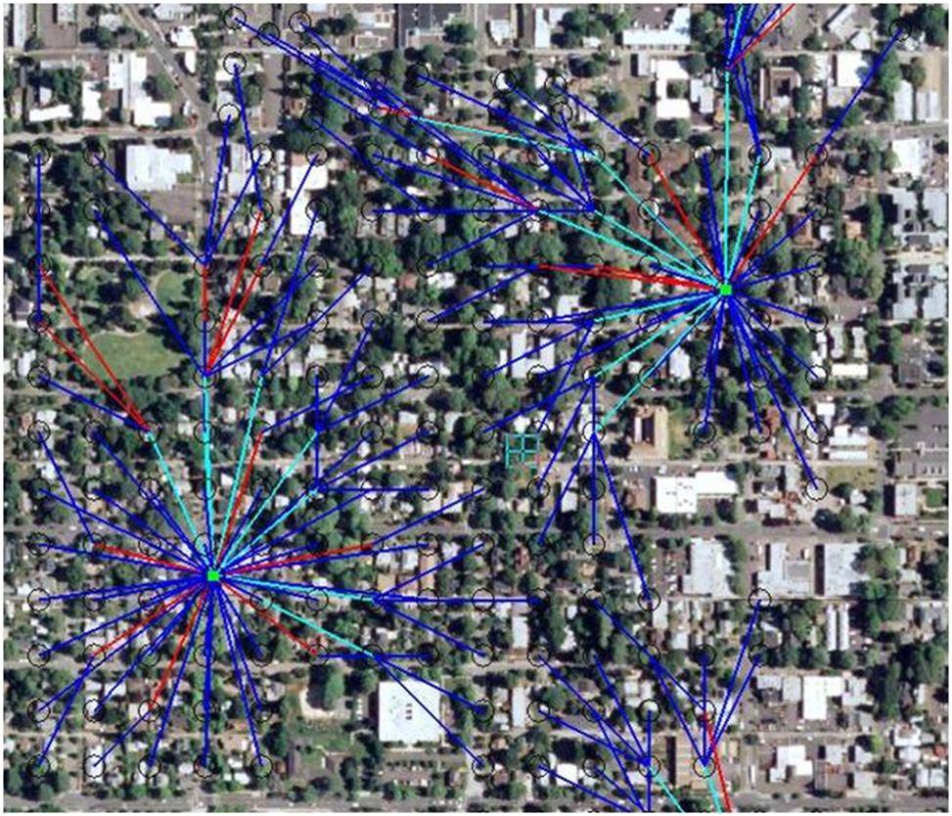**Figure 54: Example of NAN Design from Software Design Tool**

**6.3.8 Smart Grid Neighborhood Area vs. Wide Area Networks**

The preceding sections have provided considerable detail concerning Multi-Hop networks with a specific focus on the smart grid NAN networks utilized to provide connectivity to multiple end points such as meters and/or DA devices. However, the Multi-Hop topology may be utilized in other Smart Grid network systems as well. More specifically Wide Area Networks (WANs) may be implemented utilizing PMP, Mesh, or Multi-Hop techniques and topology. This section briefly considers these WAN implementations in the context of the Smart Grid network. In general a NAN PMP, Multi-Hop, or mesh network may have a number of similarities with a WAN. However, due to differences in the intended uses, specific use cases, capacity, and reliability requirements for which these networks are designed to support, will often lead to significant differences in implementation technology and operational characteristics. A brief comparison of some general requirements and operational characteristics will help illustrate these differences.

| **Requirement/Characteristic** | **NAN** | **WAN** |
| --- | --- | --- |
| Geographic coverage | Neighborhood area size – ranging from several hundred square yards to a small number of square miles or square km | Larger geographic areas – ranging from multiples of square miles up to hundreds of square miles or square km – or even larger. |
| Technology used | Usually a single technology – usually wireless with a common physical interface. | Can be made up of multiple technologies (wireless and wire-line/fiber optics) with bridging devices or routers used to connect disparate technologies. |
| Node-to-Node physical spans or links | Usually established and changed dynamically as needed by the nodes | Usually established statically and may or may not be dynamically changed by the nodes |
| Ability to route data through the network | Dynamic routes can be established by the connected nodes through the dynamic links and can automatically update as needed by network topology changes. | Dynamic routes can be established by the connected nodes through the static links and can automatically update as the state of the nodes or static links change. |
| Number of connected nodes | Ranging from tens to multiple thousands of nodes per individual NAN | Typically ranging 10 to 100 nodes – except for very large WANs (i.e. the Internet). |
| Capacity per node to node link | Ranging from tens of Kbps to several hundred Kbps (ref. IEEE 802.15.4g) | Typically several Mbps to several Gbps |
| Node-to-Node distance | Typically several hundred feet to several thousand yards or meters | Typically multiple miles to hundreds of miles or km. |
| Example networks | AMI NAN encompassing 10 to 20 city blocks in an urban or dense urban environment | A composite network spanning a city, county, or state – or even a global network. |

Another significant difference in the NAN and WAN may be in the source and ownership of the equipment used to implement the network. A WAN may be provided by a network service provider as a virtual private network and will appear to the user or customer as a cloud that provides connectivity between nodes as required and as negotiated in the service contract with the network service provider. In that case the topology and technology of the physical network is less important than the service level agreement contracted by the customer. Alternatively a user may elect to construct and build a private network infrastructure. The user may plan and develop the network by using internal network design talent or relying on a service provider or other contract services to design and implement the network. In this case the user is free and indeed obligated to specify the topology and technology utilized to implement the network. For a private WAN the owner can specify and design a PMP or Multi-Hop network or other topology to best suit their requirements and budgetary and operational constraints.

Just like for a NAN, for a WAN Multi-Hop or mesh network, considerations and evaluation must be given to the intended use and operational characteristics of the WAN before committing to a specific topology and technology. This is particularly true for a private WAN where the cost to implement the WAN may be substantial and mistakes in choosing the proper technology and topology caused by not properly evaluating the current and potential future requirements can lead to an untenable situation that can result in costly redesign and rework.

In contrast, for a SG NAN, the network infrastructure and the end nodes (i.e. meters) are commonly owned by the utility. A notable exception to this is if the utility subscribes to a service provider to provide discrete links or lines of service to each end node. However, in this case it is not a question of the use of a Multi-Hop, or even if it is a NAN or a WAN but instead the significant element of concern to the utility is the service level agreement contracted with the service provider.

In most cases the utility contracts with a NAN system vendor to develop and provide a customer owned network consisting of the necessary NAN infrastructure and head end services to provide connectivity to meters and other end devices required by that utility.

Another distinction between a WAN and a NAN is that a NAN almost by definition is much smaller and less costly on an individual NAN instantiation basis. Mistakes in evaluating the capacity requirements for a particular isolated NAN can usually be corrected with minimal cost by adding another Access Pont or forcing traffic through an alternate takeout point. However, all the caveats mentioned earlier should be carefully considered when specifying the operational characteristics of the NAN system to serve an enterprise. It must be remembered that the enterprise NAN system will be composed of multiple individual NANs to provide the required enterprise coverage. Mistakes at the system or enterprise level can also be very costly to remedy or correct.

Although this section describes NANs and WANs as separate entities, in practice a WAN may be used to provide connectivity for SG end devices if this connection mechanism is more effective than implementing a NAN to provide this connectivity. The intent of this section is to acknowledge that there are a number of similarities in Multi-Hop NANs and Multi-Hop WANs, but there are also a number of differences in the purposes of these networks and the operational characteristics of each.

This concludes a brief coverage of the WAN Multi-Hop network. This description is not intended to be a comprehensive treatise on all aspects of network theory, design, or operations. It is merely to acknowledge that there are multiple network types and classifications and the choice of technology, topology, and whether to build or buy services is going to be highly dependent on the utility and their business and regulatory environment, requirements, and obligations.

Finally, and again, this section is not intended to be definitive guide for a utility in selecting their SG network technology or topology. Further information is available in other sections in this document and information in much greater depth can be obtained from a number of books and technical papers devoted to the theory of network design.

## 6.4 Addressing the Challenges with Multi-Tenant High Rise Buildings

A major challenge faced by utilities in Dense Urban and Urban centers is establishing a reliable communications link between the Smart Meter and the HAN in high-rise, multi-tenant buildings. With the utilities infrastructure generally underground, meter banks are often located at ground level in weatherized enclosures or below ground in basement locations. To consider an all-indoor wireless solution for this application, one must take into account the excess path loss caused by successive floor penetrations.

A number of indoor path loss models were described in section 5.2.1.2. Two of the models, ITU-R M.1225 and WINNER II, include a parameter for predicting floor-to-floor penetration losses. Although the two models diverge considerably with an increased number of floor penetrations, both predict a higher penetration loss for the first floor with a diminishing loss per floor for successive floors. For three floor penetrations the ITU model predicts 25 dB excess path loss at 1900 MHz and the WINNER II model predicts 44 dB. Another field study cited in Section 5.2.1.2 predicts about 35 dB for three floor penetrations, which coincidentally, is close to the average loss predicted by the two path loss models.

Whichever model is used to project floor-to-floor penetration loss, it is clear that propagation paths that go beyond 4 or 5 levels will create a major deployment challenge for an **all-indoor wireless meter to HAN connection**. In addition to the high total path loss, EIRP limitations to comply with human safety exposure limits further reduces the range potential for an indoor wireless link. One potential deployment solution is to position relays every 2 to 4 floors. This approach might be suitable for buildings under 9 or 10 stories but probably not cost-effective for taller buildings.

### 6.4.1 An Alternative Wireless Approach

An alternative deployment approach for a wireless solution that can be considered for this scenario is one in which a basement-located DAP communicates with an outdoor pole-mounted[3] base station acting as a relay to connect to apartment HANs on higher floors as illustrated in figure 55. In addition to reducing the total penetration loss compared to the all-indoor wireless solution, this approach can take advantage of higher gain antennas and higher EIRPs on the outdoor pole-mounted base station labeled as “Relay Node” in the figure.

The RelayNode serves multiple functions. It provides a PtP link to the basement-located DAP, a PMP link to the HANs in the multi-tenant building, and a backhaul link to a Macro-Cell in the NAN or WAN.

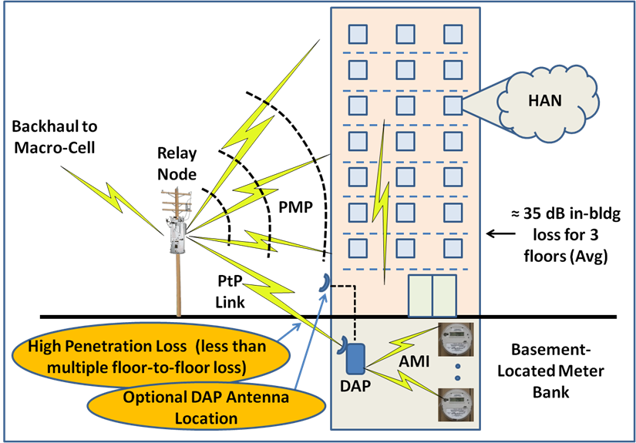

**Figure 55: Approach for basement to HAN connections in multi-story buildings**

To better understand the attributes for this approach, it is informative to look at the characteristics of each communications link individually.

**Basement-located AMI Network:** This is a totally indoor PMP link probably comprising a single sector in a license-exempt band to aggregate the data traffic to and from the smart meters. The meters are typically tightly clustered and the distances to the DAP will relatively short. The DAP can be strategically positioned for the most optimal favorable propagation path to the outdoor pole-mounted Relay Node. Where very high penetrations losses are anticipated one can consider running a line to an outdoor mounted antenna. The cable losses will be far less than the basement to outdoor penetration loss thus greatly increasing the link margin.

**DAP to/from Relay Node:** Both the DAP and the Relay Node would employ a high gain, narrow beamwidth antenna to provide a PtP connection between the two sites. Although the DAP EIRP, depending on how and where it is mounted, may still be limited for compliance to human safety exposure limits, the narrow beamwidth will help mitigate the potential for interference in a license-exempt band. Even with dedicated spectrum, the narrow beamwidth will help protect against interference from a similar deployment in the adjacent building or the next block. With careful antenna positioning and alignment at each end of the link and the relatively short path length, the 20 dB to 30 dB penetration loss will be easily accommodated. With the lower EIRP at the DAP the link budget in the UL will be the dominant determinant for the link budget and link availability.

**Relay Node to/from HAN:** At the Relay Nodethis would be a single sector PMP link in an unlicensed band consistent with the operating frequency of the HANs. Rather than being optimized for surface area coverage, the PMP antenna would be positioned to have wide elevation angle and relatively narrow azimuth consistent with the building height to width ratio. The link budget would have to take into account at least one external wall and in some cases multiple internal walls to access individual HANS. The relatively shallow angle of incidence for the upper floors in a very high building will result in a higher penetration loss than that encountered with the lower floors. As in the last case, the link budget in the UL will be the major determinant for the link performance due to the lower EIRP and lower antenna gain for the HAN.

**Relay Node Backhaul to/from Macro-Cell:** The backhaul connection for the Relay Node would employ a high gain fixed antenna that is aligned to optimize the link between it and the Macro-Cell base station which would typically be mounted on one of the adjacent building roof-tops for maximum coverage. The Macro-Cell BS would employ a typical PMP sector antenna to provide a backhaul for several Relay Nodes or other Pico-Cells (DAPS) within its coverage area. Since the Relay Node would be mounted on a pole about 8 to 10 meters above ground, accessible only by trained personnel, it would be able to operate at a higher EIRP. The narrow antenna beamwidth would also help to mitigate the potential for interference to the relay node. For this link the DL and UL link budgets would be quite comparable due to the higher antenna gain at the relay node.

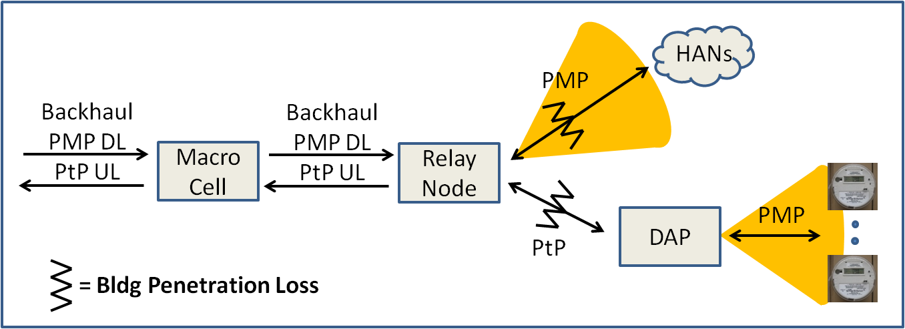A schematic view of this proposed solution is shown in figure 56. As was stated in previous sections, when considering end-to-end payload latency requirements it is necessary to apportion the latency requirement on a per-link basis.

**Figure 56: Schematic view of the network architecture**

### 6.4.2 Conclusion

Implementation of the alternative to an all-indoor wireless solution described above depends on having access to a conveniently located structure for mounting the “Relay Node” equipment and associated antennas. The location must provide a good propagation path to the antenna for the basement-located DAP as well as to the HANs on the highest floors. In some situations it may pay to take advantage of the roof-mounted Macro-Cell base station site. This site may have a better propagation path to HANs on the highest floors of the building while the Relay Node can be used for connectivity to the lower floors in the building.

## 6.5 Smart Grid Deployment Modeling Framework and Tool

The modeling framework discussed in section 5.2 was extended both on the input parameters and the outputs of a wireless model. This section describes this extended framework and a wireless modeling tool that has been developed to exercise the framework to provide more information to help assess wireless standards, representative technologies, and spectrum band usage specific to terrestrial wireless Smart Grid networks.

*A link to modeling tool to be provided here*

The Model Area Wireless Assessment Modeling Tool (see Figure 57), is structured to provide an estimate for the number of base stations[4] required to provide ubiquitous coverage and the required base station-to-base station spacing to meet data throughput, payload latency, and reliability requirements called for by the demographics for the specific geographical area under consideration.



**Figure 57: Smart Grid Model Area Wireless Assessment Modeling Tool**

The smart grid requirements section of the tool accommodates several approaches for adaptation of SG requirements data for input into the SG Wireless Modeling Engine. Normally the utility or other organization wanting to use this tool, would base the inputs on their specific SG Deployment area specifics. The tool framework also allows use of data proxies in the absence of specific SG Deployment details. The details of preparation and use of proxied input data as based on the SG Network TF’s Requirements data is described in section 6.5.1.

The wireless section of the tool utilizes five large scale terrestrial path loss models, the latency model, and other relationships developed and discussed in section 5 for outdoor-located base stations. Whereas the modeling tool assumes outdoor-located base stations, terminal or end-point locations can be specified as being indoors or outdoors. Recognizing the fact that no mathematical model is an ideal choice for all deployment scenarios, the modeling tool makes use of the five terrestrial models where appropriate. That said, depending on the range of requirement parameters that are inputted to the model, there will be cases for which multiple solutions result. It is left to the user to decide which is most appropriate for the specific case being analyzed considering the terrain characteristics and demographics for the region being analyzed.

### 6.5.1 Modeling tool input parameters

As shown in figure 57, required inputs to the modeling tool fall into three categories:

* **Deployment Area Demographic Requirements:** This information would generally originate from the Utility specific to the SG Deployment area of interest. Alternatively readily available census data combined with local utility information can be used as a reasonable proxy. End-point actors quantities (or densities), combined with substation and feeder circuit information can be converted into a data density requirement over the specific geographical area under consideration. The model supports inputs in sq-miles, consistent with US census data information, or sq-km for those preferring the metric system. Another input in this category is the terrain and area characteristics
* **Smart Grid Deployment Requirements:** These inputs are specific to the Smart Grid use cases, payloads, and actors per specific deployment profiles being studied. These inputs also includes the payload volumetric (architectural non-functional) requirements. The OpenSG SG Network Task Force System Requirements Specification [[5] ] describes a method for adapting the SG Network TF Requirements Table data for input into the SG Wireless Modeling Tool. The SG Framework & Wireless Modeling Tool spreadsheet includes a tab that contains these same detailed method steps. The following provides an overview of the steps.

**Adaptation of SG Network TF’s Requirements Table Data for Use in Network Modeling Tools**

**General Steps - Regardless of study analysis intent**:

* + 1. Select the Study/Analysis Deployment Profile (including endpoints, Use Cases, payload requirement sets
    2. Identify which Requirements (Table or Database) payload requirement sets (parent rows and selected comm-paths) are in play based on selections and restrictions from step 1 above.
       1. Flag the Deployment Profile parent rows
       2. Flag the Deployment Profile' child (or parents with no children) rows
       3. Optionally, Identify the child's parent Rqmt Ref (used for back reference and audit purposes)
       4. Extract the Deployment Profile Requirements to a Separate Workspace
    3. Select one value for the documented non-functional metrics where ranges or unspecified parms (variables) are identified in the Requirements tab, specific to your business requirements. Optionally, modify the other fixed/specified metrics to your business requirements.
       1. How Often
       2. Business App Payload Latency
       3. App Payload Size
       4. Daily Clock Period Factor for Specific Hour
    4. Scale the non-functional app payload metrics in the Requirements tab specific to the study/analysis deployment characteristics. These step is where optionally, the type and quantities of the actors can use the census and model-area parameters and relationships between some of the deployment characteristics can be used as proxies for the specific utility deployment study/analysis area actor quantities.
       1. Multiple actor payloads multiplier for shared child row data flows /interfaces
       2. How Often Actor Quantity conditional/qualified & root actor names
       3. Summarized Table of Actor Quantities
       4. Payload Frequency metric per unit of time per How Often conditional/qualified Actor
       5. Conditional/Qualified Actor Quantities

**Additional Steps for:**

General Telecomm Traffic modeling

* + 1. Specify which application payload data flow and/or interfaces are to be studied/analyzed.
    2. Specify the wireless “Uplink” and “Downlink” designation for the requirement rows.
    3. Specify the use case payloads requirement as being Baseload or Highload traffic and Specify the associated Payload Frequency:
       1. tag the requirements as "baseload" and/or "highload"
       2. specify those qualified actor where their quantities vary from “baseload” to “highload”
       3. create “baseload” and “highload” Payload Frequency Metric calculations for each payload as appropriate
    4. Specify the Application Payload and Application Packet Size and Latency values:
       1. Specify a variable for telecomm application packet size e.g. the payload portion of a transmitted packet that also includes protocol overheads
       2. Calculate the “number of packets” to accommodate the application payload
       3. Adjust the payload latency metric to account for the adjustment made in step 6 for wireless technologies that require the use of a DAP or “basestation” for endpoint to endpoint communication versus peer-to-peer
       4. Calculate the packet latency for each requirement row

SGIP PAP02 Wireless Modeling

* + 1. Seed the DAP quantities and refresh after initial model runs.
    2. Specifying the calculations – Part 1 of the Non-functional application payload requirement metrics. Note: these are the raw calculations by each requirement row that are then further process in step 11 to create the inputs into the SGIP PAP02 Wireless Modeling Tool. For the various combinations of “uplink”/”downlink” and “baseload”/”highload” calculate the following:
       1. Payload and packet rates (qty/sec)
       2. MBps / sq-mile
       3. Payload and packet size
       4. Payload and Packet Latency
    3. Specifying the calculations – Part 2 of the Non-functional application payload requirement metrics and consolidating for input into the wireless model. The SGIP PAP02 Wireless Modeling Tool inputs from the SG Network Task Force Requirements are categorized as follows for each modeling area density category e.g. high density urban, urban, suburban, rural, low density rural:

• RF Propagation Path Loss - Calculating the number of DAPs required to provide coverage for the data volume across the geographic area that contain the endpoints:

* MBps per sq-mile [(baseload or highload) & (uplink or downlink) traffic]
* study/analysis area (sq-miles)
* number of endpoints in the study/analysis area

• Payload Latency Rqmts - Calculating the number of endpoints that a DAP can support at a specific probability of satisfying the latency requirements [(baseload or highload) & (uplink or downlink) traffic]:

* Message Rate #/s (Rmsg)
* Avg time between Message sec (Tmsg = 1/Rmsg)
* Avg app packet (without overheads) size bytes (Pavg)
* Single Network Link Latency sec (L) from [avg or manual input or minimum] app packet latency
* Probability that msg event falls within latency window (Pmsg = L/Tmsg) from [avg or manual input or minimum] app packet latency"
* **Wireless Technology Parameters:** Required information about the specific wireless technology under consideration will not only be technology-specific but in most cases will also be vendor-specific. System gain information for both UL and DL transmission is essential for estimating range and coverage. Channel bandwidth, modulation and coding schemes, and channel overhead factors are required to provide an estimate for the average channel or sector and base station goodput and net spectral efficiency. If the overhead factors available do not account for all higher level protocols, headers, encryption, etc, there is provision for the user to add to the OH to take these factors into account. In assessing different technologies in different frequency bands (and possibly different countries) local regulatory rules must also be considered. These rules will generally place limitations on antenna gain and EIRP, two parameters essential for calculating the system gain and may also impose restrictions on occupied spectrum or allowable channel BW.

### 6.5.2 Modeling tool outputs

The modeling tool provides an estimate for the base station-to-base station spacing necessary to meet the data density and latency requirements while achieving ubiquitous coverage over the specified geographic area. Insome cases, based on frequency, antenna heights, and region type, there may be more than one applicable path loss model thus resulting in two or more output results that may or may not be similar. When results differ, it is left to the user, based on more specific knowledge of the terrain characteristics, to decide on which result to use. Alternatively, one could simply rely on the more conservative result, which for planning purposes may be quite adequate.

The following figure illustrates how the output information would apply to a specific area that is being studied. Since the base station requirements are rounded up to the next highest whole number, the combined base station coverage will meet or exceed the area coverage requirements. The tool also takes into account the fact that end-points at the cell-edge in a multi-cellular deployment will generally have connectivity access to more than one base station as shown in the figure. This reduces the fade margin requirement thus enhancing the link budget and the effective range.

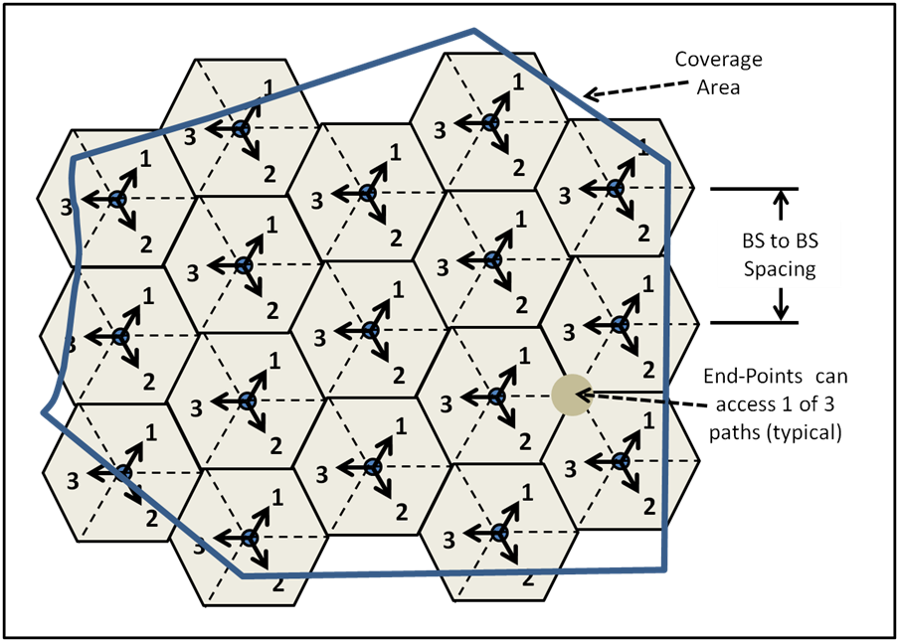

**Figure 58: Modeling engine assumes a uniform BS-to-BS spacing**

### 6.5.3 Limitations of the modeling tool

The modeling tool has been developed specifically to facilitate terrestrially-based wireless network planning with outdoor-installed base stations and terminals located indoors or outdoors. As currently configured the tool is not intended to address indoor Home Area Networks (HANs). Although a similar approach can be used for HANs, additional study would be required to arrive at better mathematically-based path loss models for wall and floor penetrations, covering the frequency range of interest for residential and enterprise environments. The current tool is also not intended for analyzing satellite networks, as these would require a different set of path loss models.

To estimate propagation path loss, the modeling tool is based on large-scale mathematical models each derived from field measurements in selected environments as described in Section 5. These models are convenient and easy to apply but have limitations as there is no practical way to develop a mathematical model that would cover all possible deployment scenarios over the unlimited range of terrain characteristics and building densities that are likely to be encountered over a large geographical area.

The latency model is based on queuing theory and assumes the average packet time for the end-points of interest is less than the required latency. This is a reasonable assumption for most Smart Grid network segments with channel data throughputs that are likely to be encountered with any of the wireless technologies being considered. An error message will indicate when the desired latency requirement cannot be met and there is provision in those cases to select a different latency so as to determine the latency that can be met. The modeling tool also assumes all packets have equal priority. QoS, which provides a means for prioritizing latency-critical packets, is not taken into account. Therefore, in assessing the modeling results with respect to latency for a specific wireless technology, it is important to also consider the QoS that is supported by the technology of interest.

The modeling tool assumes uniform distribution of terminals (actors) over the area of interest for estimating average channel data density and average channel throughput. This may be a reasonable assumption in many suburban and most urban and dense urban areas where base station coverage areas are relatively small and households are close to being distributed uniformly over the coverage area of interest. It may not be an accurate assumption however, in rural areas where clusters of closely spaced housing units can be separated by several miles or kilometers from other clusters with scattered individual housing units in between thus resulting in a very non-uniform distribution of terminal locations as illustrated in figure 59.

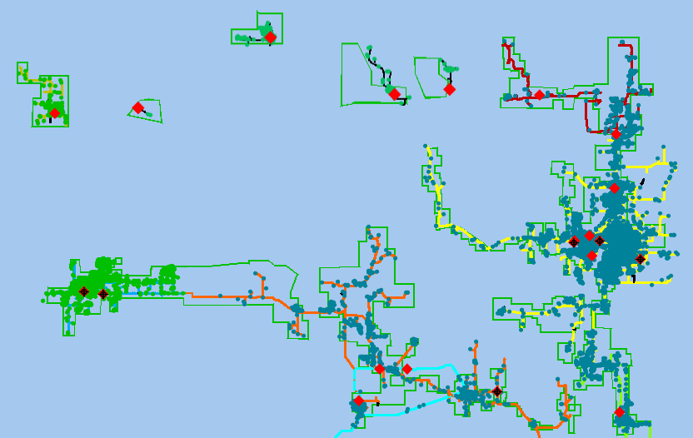

**Figure 59: Typical rural area demographics**

Typically in this type of environment, base stations would be deployed close to or within areas where housing or endpoint clusters are concentrated, or where placement is needed to satisfy the application latency requirements. For this deployment scenario, channel or base station capacity will be under-estimated rather than over-estimated since a higher percentage of terminals will be closer to the base station than what would be predicted assuming a uniform distribution of housing units. It can also be argued that, for most land-based wireless technologies under consideration, the most important metric for rural area deployments will be range capability whereas average channel capacity will only be of secondary interest. Where average channel and base station throughput will play a larger role is in the more heavily populated urban and dense urban areas. In these high density environments, it is quite reasonable, for planning purposes, to assume utility customers are uniformly distributed over the area of interest.

The Smart Grid Deployment Modeling Tool can be an effective tool for comparing the relative performance of different terrestrial wireless technologies and to provide initial estimates of network base station requirements to meet coverage, data density, and latency requirements in a wide range of deployment venues. Since the tool does have limitations, it is strongly recommended, before actual deployments are undertaken that the results be supplemented with more detailed network planning and, in some cases, on-site field testing or RF surveying. This is especially important for extreme terrain characteristics and unique deployment situations as might be encountered with below grade, indoor, or vault-located smart meters in an AMI network.

## 6.6 Interoperating and Interworking with Other Wireless Technologies

Section 5 and most of what has been presented in section 6 so far has been focused on terrestrial-based wireless technologies in the 700 MHz to 6000 MHz frequency range. Although these technologies, which are all cellular-like, can and will play a significant role in any of the demographic areas of interest for Smart Grid networks, it must be recognized that they may not provide an optimum solution for all possible scenarios that are likely to be encountered. In this section we discuss some of the other technologies that are included in the ‘Wireless Characteristics Matrix’ discussed in Section 4 and, additionally where these different technologies should be considered for application in the Smart Grid communication network.

## 6.6.1 Satellite Communication Networks

Satellite communications is another wireless solution that can play a vital role in a Smart Grid network. It was already pointed out in section 6.1 how a satellite link could be used to provide or augment a backhaul connection in a rural Smart Grid network. In other rural or low density rural regions with extreme terrain characteristics, a satellite solution may prove to be the only cost-effective approach to reach all of the desired utility end-points. The intent of this sub-section is to provide additional insights as to the attributes and trade-offs for satellite-based networks.

### 6.6.1 Attributes for satellite communication networks

Satellite communications technologies have features which can be used for many of the use cases identified for the Smart Grid. For example, satellite services are available throughout North America and cover 100% of the conterminous United States. This means that the same user terminal can work anywhere in any rural or urban location.

Furthermore, since satellite communications is independent of any local infrastructure it is ideal for emergency response and restoration, as well as for a redundant path to support highly reliable communications.

Satellite communications systems all operate in licensed-band spectrum. Mobile Satellite Services (MSS) spectrum is available in L-band and S-band and includes both Geostationary Earth Orbit constellations as well as Low Earth Orbit constellations. Fixed Satellite Services (FSS) spectrum includes C-Band, Ku-Band, and Ka-Band. Fixed satellites are generally in the Geostationary Earth Orbit. FSS is becoming a misnomer as portable, transportable and fully mobile terminals are routinely supported.

The one way path delay between a user terminal and a geostationary Earth orbit satellite is between 117 ms and 135 ms. The round trip latency due to propagation between a remote terminal and a gateway hub station is between 468 ms and 540 ms. In addition to propagation there are processing and queuing delays which are dependent on the specific implementation. This delay is acceptable for most Smart Grid applications. While some latency is tolerable, certain events have to be logged with an accurate time stamp. The mobile satellite technologies are completely integrated with the GPS system for routine functions like spot beam selection and paging area location and many terminals are required to have GPS receivers. The fixed satellite technologies are not required to have a GPS receiver but are routinely integrated with GPS depending on the application. Therefore, accurate GPS time is available for time stamp.

The ubiquitous nature of satellite communications means that repair crews can use satellite terminals or handsets anywhere in the United States where such crews may be dispatched in the event of emergencies. Mobile terminals in both MSS and FSS bands can be used at speeds up to 1,200 km/hour with Doppler compensation but are more routinely used below 100 mph (160 km/hr).

In order to close the link and provide adequate margin, MSS satellites all deploy on the order of hundreds of spot beams throughout their coverage areas. Not only do spot beams provide improved satellite EIRP and G/T but also increased capacity with frequency reuse. New fixed satellites feature similar numbers of spot beams.

Several MSS terminal types are small handheld devices similar to a cell phone having low antenna directivity. These are ideal for emergency crew dispatch. Both data and voice are supported, though the available bandwidths are commensurate with the antenna gain performance and terminal type.

Satellite communications typically rely on line of sight propagation. Fading from foliage and imperfect terminal orientation is tolerated in low directivity handheld terminals used in MSS. Some MSS terminals have several dB of directivity and operate best when oriented properly and may really be considered transportable. These terminals can support up to 590 kbps of data in the forward direction or downlink direction from satellite to terminal and 186 kbps in the return or uplink direction from the terminal to the satellite. These data rates exceed the required rates.

Many MSS networks employ the 3GPP Iu-interface between the radio access stratum and the core network non-access stratum. The physical and media access control layers are optimized for the satellite radio propagation characteristics but the higher layers are integrated. MSS terminals can be dual-mode satellite/terrestrial and have a single shared protocol stack above the radio resource control layer so that mobility management and session management are the same for both modes. Core networks can also be fully integrated sharing the same 3GPP Serving GPRS Support Node (SGSN).

FSS terminals use highly directive offset parabolic dish antennas, between 0.5 and 1 meter in diameter. But they support data rates up to 440 Mbps in the forward link and 16 Mbps in the return link. These terminals are intended for fixed transportable and mobile applications.

**6.6.2 SG Solutions in the 450 – 470 MHz IG Band**

Relevant regulatory information for the IG Band (Industrial/Business Band) can be found at [[6]] Note that the 450-470 MHz band is a sub-band of the entire IG Band which, in addition, includes several other blocks of spectrum between 150 MHz and 512 MHz.

**Frequency Usage and Capabilities**: This band is one of the oldest bands for industrial group use. It requires FCC licensing and usually requires a Frequency Coordinator[7] when obtaining licenses in this band. When licensed, operators in this band are, in effect, operating a private network and generally have protection against interference and less restrictive operating conditions compared to operating in any of the unlicensed ISM bands. Compared to higher frequencies, this band is notable for its longer communication range, typically 5 to 7 km with an outside end-point antenna at a 1.5 meter elevation, level ground, and a transmit power of 2 Watts[8] (33 dbm) (ref. 90.238e). There is also lower penetration loss for end-points in buildings or other highly obstructed areas. For in-building communications, lower transmit powers can be used. Transmitters generally use some form of Frequency Shift Keying (FSK) transmission and AM and FM usage is permitted. The channel bandwidth as of 1 Jan 2013 in this band is now all narrowband (+/- 12.5 kHz) around channel center frequency. Licenses are typically good for a 32 km radius from the base station although with appropriate licensing it is possible to string additional licenses on the same channel to daisy chain the use of the channel over greater areas. Due to the popularity of this band, spectrum availability in large metropolitan areas such as New York, NY may be limited. SIMPLEX or half Duplex communication is the usual method of radio to radio communication although limited paired channels are available for Full Duplex operations. This means that small short messages (less than a Twitter message) are the preferred messaging strategy in this band. These frequencies are particularly useful both in NAN and WAN designs. To prevent congestion in a given area of dense coverage such as a urban environment reduced transmitting power to limit range and using frequency diversity to prevent saturation and message collision issues are common design elements of these NAN’s and WAN’s. This band is particularly suited to longer distance and sparse transceiver network trees. So it would be an ideal candidate for rural and suburban applications. Commercial and Industrial (C&I) and irrigation type monitoring and control applications where there may be increased distances between complexes or fields are also good candidates for this frequency band.

There are approximately 2,180 individual channels in this part of the IG Band available for licensing. While these channels are generally available nationwide, it is unlikely that any given licensee would have universal nationwide access to any given channel in this band. This means Smart Grid applications must be able to handle multiple channels in their data backhaul designs when using this frequency band.

**Implementation using this Band:** The Okumura-Hata Model can be used to evaluate coverage potential in this band (see section 5.2.1.3.1). This model generally assumes that roof top antennas are being used so this model should be used as a maximum or ideal usage model. For rural areas the ITU-R M2135-1 path loss model is also valid in the 450 MHz band. This model also requires BS antennas higher than neighboring roof-tops but has entries for actual building heights and road-widths (see section 5.2.1.3.4). Use inside of buildings even with the greater penetration capability of this frequency band will limit a given transmitter’s effective range. This band is very useful in retrieving meter items such as pulse counts (odometers) data and is used in Real Time Demand Response and time of use applications where the age of the data is a critical component for implementing reductions or increases in energy or water usage in response to outside triggers or predetermined usage or pricing points. Usually a Smart Grid application will use a partial mesh network with a tree and multiple data acquisition points design. Repeaters can be used in difficult communication areas to assure that messages are delivered in a timely manner to the base station or data acquisition point (DAP). Because of the risk of having messages continually passed back and forth between mesh elements in a message hopping technique, most systems have a limit to the number of hops a message can make before it is discarded. This limitation will define the maximum depth of a given tree. So as not to lose data most endpoints will have a data-logger or equivalent device from which to independently recover missing data points when the RF and network conditions permit retransmission of the missing data.

As important as the transmitting power is to these solutions, the receiver sensitivity is also an important factor when selecting a transceiver as the increased distances capable in this band are maximized with a high receiver sensitivity. Current models typically will detect signal strengths as low as -123 dbm to -118 dbm or lower depending on the RF Baud rate.

Antenna tuning, placement and gain is also a key factor in the success of communications networks in this band. Ref(90.261(c). Typically the “mobile” units (or end-points) will use omnidirectional antennas. Base Stations (DAPs) depending on terrain may use beam antennas in their solutions, but the transmission signal range must remain within the licensed area so as to minimize interference issues and conform to FCC requirements. Maximum antenna heights are also a part of the FCC license. (Typically 12.2 m above the structure to which it is mounted)

**IG Band summary:** Wireless solutions for Smart Grid in the 450 to 470 MHz IG Band offer the potential for increased range and coverage and reduced penetration loss for indoor located end-points. Additionally, since it is licensed spectrum there is protection against inter-operator interference throughout the geographical area covered by the license and less restrictive operating rules as compared to wireless solutions in the unlicensed ISM bands.

When considering solutions in the IG band however, one must also take into account the trade-offs imposed by the FCC-mandated channel BW limitations. As stated above, high density regions with high data density requirements will require a pico or micro-cellular deployment topology to compensate for the limited channel capacity and in the lower density demographic regions cell-edge data rate performance requirements will play a big role and may very likely mitigate much of the range benefit. Nevertheless, with careful RF planning and frequency reuse, it is in rural and low density rural regions where the IG Band is likely to have the greatest benefit in the Smart Grid network.

## 6.7 Assessment of Modeling Tool Results

Ihis section is under construction in a separate document.

## 6.8 Cross Wireless Technology Considerations

In considering a Smart Grid network, it should be recognized that the network quite likely will not be a single homogeneous network, but will in fact likely be a network consisting of multiple disparate sub-networks interconnected to form an overall Smart Grid network system. These sub-networks could include both non shared private networks and shared commercial networks. Technologies will likely include both wire line and wireless networks. In addition they could utilize both standards based and proprietary network technologies and protocols. However, regardless of the number and type of sub-networks used to implement the enterprise Smart Grid network system, it is critical that proper attention and consideration be given to the operational and load characteristics of each of the sub-networks individually and collectively to ensure that the composite Smart Grid network system will satisfy the overall Smart Grid Systems requirements.

While the overall Smart Grid System requirements will likely vary from one implementation to the next, they will, in general, include elements of and be driven by the following:

* Business Goals & Requirements
* Regulatory Requirements
* Security Requirements
* System Functionality
* System and Operational Characteristics
  + Coverage
  + Capacity and Latency
  + Responsiveness
  + Availability and Reliability
  + Resiliency to failure modes and Redundancy to overcome failed network links
  + Flexibility to accommodate system growth, changing requirements, and changes in technology

The following characteristics should be carefully considered and can be used as a guide in formulating the requirements for the overall SG network system and each of the constituent sub-networks. In addition and very importantly, a Smart Grid network system should be implemented to support the current requirements and yet be flexible enough to gracefully grow and evolve to accommodate expected future requirements and technology enhancements.

Important Network Characteristics

* Intended use of the Network – What is the intended use of the network system? It is important to understand the intended and potential future use of the network, which could be exclusively for AMI, or for DA, or for HAN Interconnectivity, or for Direct Load Control, or for a combination of these. Often an enterprise may focus narrowly on a particular application without fully considering future applications that may also be able to leverage and effectively utilize the proposed network infrastructure. The applications and use cases, both current and those projected for the future should be considered carefully when establishing requirements for the SG Network and in evaluating the network capabilities in this overall context. Even after fully considering potential future applications, it is very possible that some SG sub-networks may be implemented to serve specific use cases where other sub-networks may serve other use cases (for example, a sub-network specifically implemented for DA and a separate sub-network implemented specifically for direct load control). However, it is also likely that all sub-networks will interconnect with other shared network facilities and a common backbone network infrastructure linking them to one or more centralized service facilities. Thus while each sub-network should be evaluated for its intended specific use, the common and shared network infrastructure should be evaluated for its intended composite use.
* Size of the Network – Consideration must be given to the number of end points, their function, their location, their density, and the variability of their density. This is particularly important for a NAN network directly linking with the end points. The density of the end points in a geographic area or region along with their expected traffic load characteristics will directly drive the requirements for the capacity and latency of the network in that area.
* Network Capacity Requirements – Consideration for the expected traffic load, both deterministic and non-deterministic traffic, average and bursty traffic patterns, and the relationship of the combined traffic patterns with the use case latency requirements are all critical elements when considering capacity. Often, while it may not be known a-priori what the ultimate traffic capacity requirements will be, especially with periodic bursty payloads, it is critical that proper analysis and planning of capacity requirements are conducted for all network segments and facilities. Insufficient planning can result in overbuilding the network, resulting in higher costs for no appreciable gain, or under building the network, potentially less costly but negatively impacting responsiveness.
* Latency Requirements – Each application and use case will have different latency requirements. End-to-end latency can be significantly impacted by several factors including node-to-node effective data goodput (which in turn is related to: the application design; security risk mitigation techniques employed; the bandwidth capacity between the nodes; error rates; protocol efficiency; and network load) as well as the internal processing delays and queues introduced by intermediate nodes in the data path. Careful consideration must be given to the latency characteristics of any and all network segments utilized to establish the path between the source and sync nodes for all applicable use cases. The cumulative or combined latency of multiple network segments encountered in linking source and sync nodes can be significant. Equally important is consideration for any potential concurrent execution of multiple use cases as may occur in the SG system, and the impact this would have on any potential network congestion points. Network congestion at critical points that may occur as a result of concurrent use case execution may in turn introduce unexpected but significant additional latency that could negatively impact latency sensitive applications and use cases.
* Router and Node Throughput – In addition to the throughput of the individual network links, consideration must be given to the processing power, packet throughput capacity, and internal latency of the routers, relays, or repeaters and other transient network nodes used to implement connectivity between the various network segments.
* Spectrum and Bandwidth Requirements – For private wireless network components, consideration should be given for spectrum availability and the bandwidth that may be needed to satisfy the transport capacity requirements.
* Geographic location and RF morphology – The terrain and other RF environmental and existing RF interference factors will significantly impact the coverage, capacity, and reliability of any wireless network. These characteristics should be fully considered in any areas intended to be served by wireless technologies. The ‘Framework-Modeling Tool’ described in Section 6.5 and used in Section 6.7 to assess various terrestrial wireless technologies provides a means to gain initial insights in this regard.
* Availability and Reliability – Adequate link margins for wireless networks should be part of the planning process to ensure satisfactory link connectivity under highly variable propagation conditions.
* Resiliency and Redundancy – Requirements for network resiliency, or the ability of the network to tolerate failures and the requirements for network redundancy to route around failures should be fully considered to insure the Availability and Reliability requirements are met.
* Flexibility for Growth and other Changes – The ability to accommodate growth and changes in the number of applications, the number and type of end points, and any likely or potential changes in functionality of those end points are key considerations when selecting a network system and in selecting the technology and topology of the sub-networks.
* Security – Security requirements are particularly important for a SG system and the networks supporting them. Important and significant elements of network security include requirements for:
  + Policies and procedures for nodes and devices joining the network
  + Protecting confidentiality of the data on the network
  + Safeguards to prevent modification or destruction of the information and data being transmitted over the network
  + Preventing unauthorized attachment or connections to the network
  + Authorizing and permitting data exchanges only between nodes authorized to do so

Failure to recognize and properly plan for adequate network security could be very costly both in potential fines for regulatory violations and in the cost of any retrofits as may be required by governmental mandates. Additionally, corrupted or lost data payloads can lead to costly service disruptions, organizational disruptions, billing errors, etc.

* Ease of Deployment – How capable or flexible does the network have to be to adapt to changes in the deployment planning, processes, and physical environments.
* Ease of Monitoring and Managing the Network – The ability to provide comprehensive monitoring and management of the individual sub-networks as well as the overall SG network system is a critical element for the ongoing effective operation of a SG system.

The above list provides some of the key characteristics that must be carefully considered when establishing the requirements for the SG network system. Particular care must be taken when considering sub-networks (like the SG NAN systems that directly connects to the SG end points), both for their intended initial use and for any expected expansion beyond their initial use cases which may include both new use cases and additional numbers of end point devices. Proper network planning prior to deployment can lead to a more efficient SG network and mitigate the need for significant and costly network re-engineering in the future.

1. The data for area breakdowns are from the US 2010 Census data which is based on square miles
2. Assumes 14 dB fade and interference margin and outdoor-located smart meters with 0 dBi antenna gain
3. Pole is used generically to indicate any suitable existing mounting location, such as a street light, traffic light structure, or the side of a building across the street.
4. The term Base Station as used in the context of the modeling tool, describes an aggregation point for a point-to-multipoint topology. Other terminology may be encountered with different land-based wireless technologies to describe similar functionality e.g.: Central Station, Access Point, Cell-Site, and specifically for SG Network Requirements: for AMI networks, Data Aggregation Point (DAP); for Field Area Networks, FAN Gateway.
5. Reference pending
6. Code of Federal Regulations (CFR) 47 CFR vol 5 CH 1 part C (10–1–12 Edition) **PART 90—PRIVATE LAND MOBILE RADIO SERVICES** § 90.35 (b,c ) , 90.261(b)
7. Frequency Coordinators are FCC certified private organizations that recommend specific channel frequencies most appropriate for the applicant.
8. Human safety exposure limits are not applicable at these lower frequencies.