DCN 22-19-002-00-0003
LB4-Section 4 Revised Structure

- System Architecture
This section describes the entities and interactions of the SCOS software architecture.
  - System Entities and Services
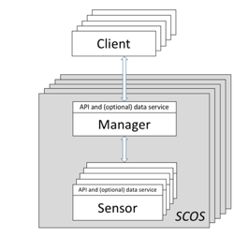
Figure 1: Simplified Block Diagram

Figure 1: Simplified Block Diagram illustrates a simplified block diagram of the SCOS architecture. The SCOS system architecture is based on the separation of function between command & control systems and sensing data distribution systems.
The two SCOS entities are Sensor Manager (SM) and Sensing Device (SD), which together make up the SCOS Platform:
Sensor Manager: The Sensor Manager allows user clients (whether individuals or other systems) to interact with the SCOS Platform. It exposes the capabilities of the SCOS platform to users, and manages and mediates tasks requests by users to the sensing devices. Once sensing tasks are performed and the respective Sensing Devices transmits the data back to the SM, the SM then manages distribution of that data according to its policies to one or more end points. The Sensing Manager entity is exposed to the SCOS Client via the SCOS Control Service via a directly coupled interface, or via an API.
Sensing Device: SDs gather, condition and sample the radio frequency environment, taking the processed samples, and package them within a compute platform into a standardized format along with relevant metadata. This is transmitted to the Sensing Manager for final transmission to the appropriate end point for consumption by the SCOS Client.
The conceptual model behind this standard is that Sensing Device can be treated as a “block box” where its capabilities and sensing tasks are defined and communicated without regard for underlying hardware or implementation specifics, and the Sensor Manager coordinates resources and tasks on its associated SDs.
- Inputs into black box: the Sensor Manager credentials and identity of the SCOS Client requesting the scan, the measurement parameters, which algorithm is to be used, the destination for the scan data
- Outputs from the black box: the identity of the Sensing Manager and SCOS Client requesting the scan, the requested scan parameters and the algorithm model used, any relevant scan system metadata and the scan results.
  - Roles
A SCOS system offers access for the following roles:
- Client or SCOS Client: The individual or system that can request data and/or a sensor action to be scheduled.
- Sensor Operator: The individual with design and administrative control of the sensor technology. The Sensor Owner is responsible for registering a sensor with SCOS.
- SCOS Operator: The individual or organization that deploys and manages the SCOS network of sensors and has approving authority for all SCOS configurations and operations. The SCOS Operator approves all Data Client and Sensor Operator accounts and sensor actions, and has administrative and physical control over the SCOS System.
The general use case is as follows:
- SCOS Operator establishes an Authority to Operate (ATO) on the SM server application according to a Service Level Agreement (SLA) that specifies system confidentiality, integrity, and availability requirements. The SCOS system offers a sensor and task control service which can be either directly controlled via a Web console or via an API, with permissions set according to a specified role. Interfaces to the SCOS Control Service must meet appropriate information technology security requirements defined in Annex C.8 Security Requirements
- Sensor Operator establishes sensing devices with well-documented sensor technology with a list of possible actions available via the Control Service on the SD. Sensor APIs must meet data transfer and network security requirements defined in Annex C.9 Transport Mechanism Requirements.
- SCOS/Sensor Operator installs a network of sensors and registers each sensor with the SM server application. During registration, the SM acquires an inventory of sensor capabilities (i.e. possible actions) and maintains a list of available SCOS actions for that sensor network. SM also maintains a list of scheduled actions and their status being performed by the sensor network.
- SCOS Client registers with the SCOS System and queries available sensing capabilities. The Client can request information on sensed data and/or scheduled sensing actions. If approved by SCOS Operator through policy enforcement, it can request sensing tasks to be performed, and data acquisitions are made available to the Client at the Data Consumer endpoint.
  - Interactions
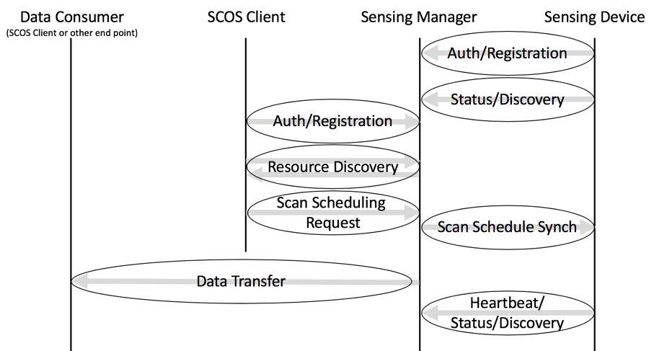
Figure 2: Simplified Interactions Model
A SCOS System is composed of one or more Sensor Devices and a Sensor Manager. The SCOS System provides sensing as a service to a SCOS Client, and transfers the data to an endpoint nominated by the SCOS Client.
- The Sensor Manager (SM) has two functional areas: Control and Data Distribution. The Control Service enables the Clients of SCOS system to authenticate, do resource discovery and to make requests for sensing tasks. The SCOS Data Distribution Service collects and transmits the sensing data to the Data Consumer endpoint which enables the SCOS Clients to consume the requested data.
- A SCOS Client connects to the SM using a published address of the SM and authenticates itself with it. Upon successful authentication, the SCOS Client performs a query on the SCOS System using the resource discovery mechanism. A SCOS Client can then request sensing tasks to be performed by the SCOS System. A SCOS Client may request the status of the requested sensing task.
- A Sensing Device connects to the Sensor Manager of the SCOS System. The Sensing Device and Sensing Manager perform mutual authentication. Upon successful authentication, the SM performs capability discovery on the SD. The SM schedules sensing tasks on the SDs. The SM maintains periodic heartbeat with the SDs to maintain resource inventory and task status.
- The SDs connect with the SM Data Distribution Service, and pushes the sensing data to the SM.
- The Data Distribution Service distributes sensor data to the SCOS Client’s nominated Data Consumer endpoint or endpoints.

  - Hardware System Requirements
The two key entities in this standard are the Sensing Manager (SM) and one or more Sensing Devices (SD), which make up the SCOS System. The interfaces between these entities are summaries in Figure 3.

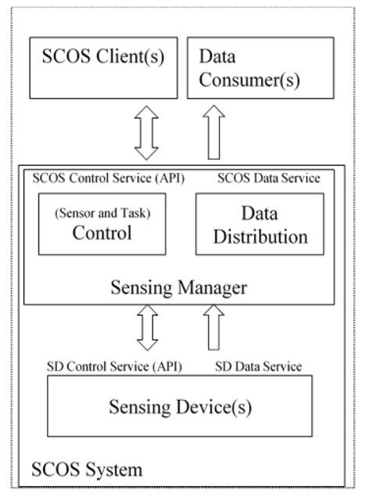
Figure 3: System Entities and Interfaces
The SM and SD entities interact via two key types of services: Control Services, and Data Distribution Services:
Control Services: Device authentication/association, sensing task management and sensing device control form the SCOS Control Service. It involves the transfer and processing of sensing task requests from the SCOS Clients to the Sensor Manager, and scheduling the sensing tasks to Sensing Devices. In this standards document, the SCOS Control Service is defined normatively only around sensing and association of the system entities. Control Service activities for system configuration, management and monitoring tasks are described in informative annexes, and considered out of scope of the normative standard as they are implementation dependent.
Data Distribution Services: This functional area involves collecting sensor data generated and locally processed by the Sensing Device, packaging of this data with related metadata and finally distributing it to the SCOS Clients for consumption at the Data Consumer endpoint(s). Data Distribution is done via any suitable transport mechanism, and is defined in terms of functional requirements in this standard as the technical method is implementation specific.
    - Sensing Device Hardware Requirements
One or more Sensing Devices must be deployed in the field to sense the radio spectrum environment. These devices consist of sensor capabilities, and a controller system that can perform platform functions (system authentication, discovery, data packaging and transmission, etc) along with signal detection and classification functions.
A simplified hardware block diagram of a general SD model is depicted in Figure 4. SD hardware designs are not required to have each component shown in the block diagram. Metadata that describe each component (e.g., presence, model, operational parameters), however, are required in response to queries for sensor capabilities and to accompany data acquisitions.

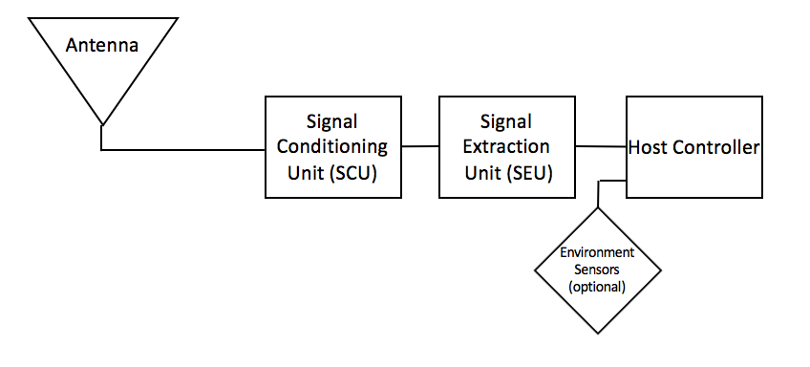
Figure 4: SD Simplified Hardware Model Block Diagram

- Functional element 1 – Antenna: An antenna converts environmental electromagnetic fields into a voltage. An RF cable connects the antenna with the next hardware component.
- Functional element 2 – Signal Conditioning Unit (SCU): An RF front end that could provide (among other things) preselection filtering, improved sensitivity via low noise amplification, and a calibration signal source. An RF cable connects the SCU with the next hardware component.
- Functional element 3 – Signal Extraction Unit (SEU): Analog Digital Converter (ADC), spectrum analyzer, Software Defined Radio (SDR), or other sampling device that also typically provides down-conversion and signal processing. A typical output of the SEU is a discrete baseband representation of the acquired signal.
- Functional element 4 – Host Controller: Provides control signals and messages to SCU and DEU. Raw data can be processed, e.g., to calculate calibrated absolute power at a reference point in the sensor RF path. Data acquisitions are packaged with metadata from sensor configuration onboard instruments, e.g., GPS. Furthermore the Host Controller receives configure and control metadata and sends necessary command and control signals to Functional Element 2 (Conditioning Unit), Functional Element 3 (Extraction Unit) and Functional Element 1 (Antenna), if the Antenna is a reconfigurable unit. It receives data from the Sensor/SDR, and polls any environment sensor input devices for necessary metadata items, such as GPS location. Interaction of the various elements is described in Figure 5.
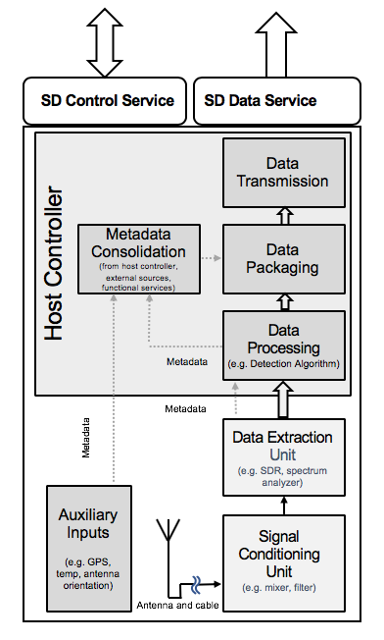
Figure 5: SD Functional Elements
This block diagram can be split into the hardware layer and the software processes that run alongside. These hardware blocks and software services generate metadata that is associated with each item.
    - Sensor Manager Hardware Requirements
There are no normative hardware requirements for the Sensing Manager, as it is a software system running in a suitable compute environment. Choice of technology is implementation specific.

