IEEE P802.22 Wireless RANs
2018 March Plenary IEEE 802.22 Working Group Minutes
Date: 2018-03-08
Author(s):
Name | Company | Address | Phone | email
Apurva Mody | BAE Systems | Merrimack, NH, USA | 404-819-0314 / 603-809-0459 | apurva.mody@baesystesms.com; apurva.mody@WhiteSapceAlliance.org
Oliver Holland | King’ s College, London |  |  | oliver.holland@kcl.ac.uk

IEEE 802.22 Wireless Regional Area Networks
Notice: This document has been prepared to assist IEEE 802.22. It is offered as a basis for discussion and is not binding on the contributing individual(s) or organization(s). The material in this document is subject to change in form and content after further study. The contributor(s) reserve(s) the right to add, amend or withdraw material contained herein.

Release: The contributor grants a free, irrevocable license to the IEEE to incorporate material contained in this contribution, and any modifications thereof, in the creation of an IEEE Standards publication; to copyright in the IEEE’s name any IEEE Standards publication even though it may include portions of this contribution; and at the IEEE’s sole discretion to permit others to reproduce in whole or in part the resulting IEEE Standards publication. The contributor also acknowledges and accepts that this contribution may be made public by IEEE 802.22.

Patent Policy and Procedures: The contributor is familiar with the IEEE 802 Patent Policy and Procedures
<http://standards.ieee.org/guides/bylaws/sb-bylaws.pdf>, including the statement "IEEE standards may include the known use of patent(s), including patent applications, provided the IEEE receives assurance from the patent holder or applicant with respect to patents essential for compliance with both mandatory and optional portions of the standard." Early disclosure to the Working Group of patent information that might be relevant to the standard is essential to reduce the possibility for delays in the development process and increase the likelihood that the draft publication will be approved for publication. Please notify the Chair Apurva N. Mody <apurva.mody@ieee.org> as early as possible, in written or electronic form, if patented technology (or technology under patent application) might be incorporated into a draft standard being developed within the IEEE 802.22 Working Group. If you have questions, contact the IEEE Patent Committee Administrator at <patcom@ieee.org>.
Abstract
This document contains the minutes of the IEEE 802.22 Working Group 2018 November Plenary Meeting held in Chicago from March 4th to 9th 2018.

March 2018 Plenary Meeting Minutes
MINUTES

5th March Monday PM1 (WG Opening Plenary)
The WG chairman, Dr Mody, called the meeting to order at 1:30 PM local time. There were 6 participants (4 are voting members) in the room at the opening of the session.

WG announced that the meeting was in quorum since it was announced more than 45 days in advance.

1.1 Approval of Agenda
The WG chair, Dr. Mody, explained agenda for the plenary session in March.
Motion - Approval of Agenda
Move to Approve the Agenda as shown in Document 22-18-0011 Rev2
https://mentor.ieee.org/802.22/dcn/18/22-18-0011-02-0000-802-22-march-plenary-agenda.xls
Move: Jerry Kalke
Second: Oliver Holland
For: 3
Against: 0
Abstain: 2
Motion Passes. Agenda is approved

1.2 Approval of the minutes of the last session
The minutes of the 802.22 March 2017 WG Plenary Meeting can be found at:
https://mentor.ieee.org/802.22/dcn/17/22-17-0088-00-0000-802-22-november-plenary-meeting-minutes.docx

Motion- Approval of Minutes
Move to approve the 802.22 WG November 2017 Plenary meeting minutes held in Orlando as shown in Document 22-17-0088 Rev0
https://mentor.ieee.org/802.22/dcn/17/22-17-0088-00-0000-802-22-november-plenary-meeting-minutes.docx
Move: Jerry Kalke
Second: Oliver Holland
For: 3
Against: 0
Abstain: 2
Motion Passes. Minutes are approved

2. Administrative Issues

The WG Chair, Dr. Mody, reviewed the usual administrative slides on Patent Policy, Letter of Assurance, Anti-trust statement, IEEE code of ethics, etc.
The WG Chair, Dr. Mody, reminded everyone that the attendance recording is being done electronically as usual.

The Chair of the Working Group asked if anyone was aware of any patents that were infringing on the 802.22 Standards. There were none.
Other Working Group Motions
The chair informed the Working Group that he appoints Bradley Eales, NTIA to be an 802.22 Working Group Member.
Motion- Appoint New Members to the 802.22 WG
Motion to appoint Bradley Eales, NTIA to be an 802.22 Working Group Voting Member?
Move: Jerry Kalke
Second: Gianfranco Miele
Any objection to the Chair appointing Bradley Eales, NTIA to be an 802.22 Working Group Voting
No objections were heard,
Motion Passes.

5th March, Monday PM2 – 802.22.3 Spectrum Characterization and Occupancy Sensing
The Task Group carried out 802.22.3 Draft 3.0 Working Group Letter Ballot comment review.

6th March Tuesday AM1 - Spectrum Characterization and Occupancy Sensing
The Task Group carried out 802.22.3 Draft 3.0 Working Group Letter Ballot comment review.
NTIA provided a walkthrough of their Open Source SCOS Solution.

6th November Tuesday AM2 - Spectrum Characterization and Occupancy Sensing
The Task Group carried out 802.22.3 Draft 3.0 Working Group Letter Ballot comment review.

6th March Tuesday PM1 – TV WhiteSpace Tutorial
The IEEE 802.22 WG led the TV WhiteSpace Tutorial which was well appreciated by the IEEE 802 Fellows.

6th March Tuesday PM2 – Spectrum Characterization and Occupancy Sensing
The Task Group carried out 802.22.3 Draft 3.0 Working Group Letter Ballot comment review.

7th March Wednesday AM1 – 802.22 Revision
Reviewed the contribution on TV WhiteSpace regulations.

7th March Wednesday AM2 – Spectrum Characterization and Occupancy Sensing
The Task Group carried out 802.22.3 Draft 3.0 Working Group Letter Ballot comment review.

7th March Wednesday PM1 – 802.22 Mid-week Plenary – 802.22.3 PAR Response
Working Group Elections
The IEEE 802 Working Group Policy and Procedures Elections for the IEEE 802 Working Group need to be held during the March Plenary of the even numbered years.
The Chair requested Jerry Kalke to conduct the 802.22 WG Elections.
So far, two candidates have come forward for the position of Chair and Vice Chair of 802.22 – Dr. Apurva N. Mody, BAE Systems and Dr. Oliver Holland, King’ s College London.
The call period for candidates for these position is now officially closed.
Motion- Election of 802.22 Working Group Officers
Move to elect Apurva N. Mody to be the Chair of the 802.22 WG.
Move: Jerry Kalke
Second: Oliver Holland
Any discussion on the motion?
For: 5
Against: 0
Abstain: 0
Motion Passes – 5/0/0

Motion- Election of 802.22 Working Group Officers
Move to elect Oliver Holland to be the Vice Chair of the 802.22 WG.
Move: Jerry Kalke
Second: Mike Cotton
Any discussion on the motion?
For: 5
Against: 0
Abstain: 0
Motion Passes – 5/0/0

Motion to Confirm the Officers
Working Group confirms the following slate of candidates for the 802.22 Working Group Officer position with acclamation.
IEEE 802.22 Working Group Chair: Apurva N. Mody
IEEE 802.22 Working Group Vice Chair – Oliver Holland

Move: Jerry Kalke
Second: Mike Cotton
For: 5
Against: 0
Abstain: 1
Motion Passes
Motion – 802.22.3 PAR Comment Resolutions
Move that the 802.22 WG approves the comment resolutions to the 802.22.3 PAR and CSD as shown in Document: https://mentor.ieee.org/802.22/dcn/18/22-18-0016-00-0003-802-22-3-par-modification-comment-responses.pptx

Move: Jerry Kalke
Second: Oliver Holland
For: 5
Against: 0:
Abstain: 1
Motion Passes

Motion – 802.22.3 PAR Changes
Move that the 802.22 WG approves 802.22.3 PAR and CSD Documents as shown in:
https://mentor.ieee.org/802.22/dcn/18/22-18-0005-01-0003-802-22-3-par-modification.docx
https://mentor.ieee.org/802.22/dcn/14/22-14-0061-08-0003-802-22-spectrum-characterization-and-occupancy-sensing-csd.docx

Move: Gianfranco Miele
Second: Mike Cotton
For: 5
Against: 0:
Abstain: 1
Motion Passes

7th March Wednesday PM2 – 802.22 Revision
The working group discussed the modification of the 802.22 Standard to provide lower latency.

8th March Thursday AM1 – Spectrum Characterization and Occupancy Sensing
The Task Group carried out 802.22.3 Draft 3.0 Working Group Letter Ballot comment review.

8th March Thursday AM2 – IEEE 802.22 Working Group Closing Plenary
At the start of the Plenary Meeting there were 6 Voting Members in the Room.
Motion- Approval to Schedule Teleconference Meetings
Move to authorize the 802.22 WG chair to schedule teleconference meetings as he sees fit to conduct the business of 802.22 WG from now until November 2018 plenary meeting.
Move: Mike Cotton
Second: Jerry Kalke
For: 5
Against: 0
Abstain: 1
Motion Passes.

Motion- Empower the 802.22 WG Chair to Schedule Face to Face Meetings when Necessary
Move to empower the 802.22 WG chair to schedule the Interim Meetings when necessary as long as 45 day notice is provided.
Description: The 802.22 WG is likely to meet only during Plenary Meetings. But more interim meetings may be necessary
Move: Bradley Eales
Second: Oliver Holland
For: 5
Against: 0
Abstain: 1
Motion Passes.

Chair asked the 802.22 WG Members to report any intellectual property. There were no IP reported.
None of the members stood up to report any IP related to any of the 802.22 Standards.
Chicago Location Survey
2/10. Hotel is fine but not close to Chicago. Did not like the idea of going to Chicago in winter.
Food was average. Breakfast – they were out of stuff.

Motion– Motion to adjourn

Move to adjourn.

Move: Oliver Holland
Second: Jerry Kalke

Any discussions, Any objections.
Motion Passes.

The group was adjourned at 11:50 am local time on Thursday 9th March 2018.

802.22 Attendance List
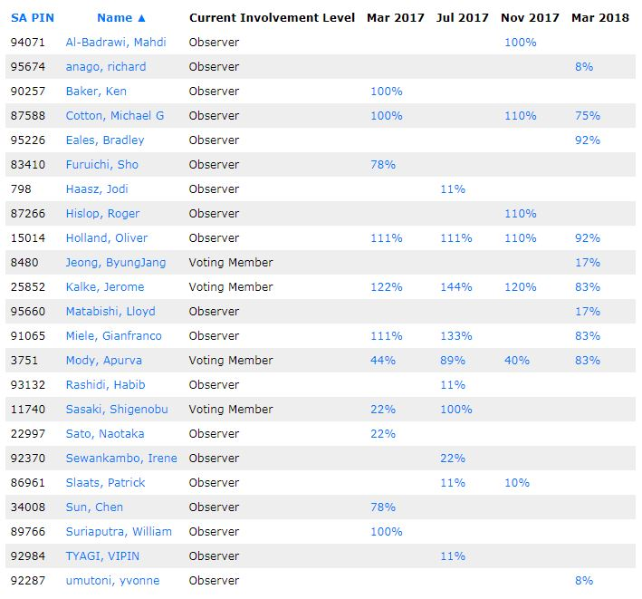

ANNEX
Working Group Contributions can be found at https://mentor.ieee.org/802.22/documents

