P802.22™/D2
Draft Standard for Information Technology – Telecommunications and information exchange between systems
Wireless Regional Area Networks (WRAN)—Specific requirements
Part 22.3: Spectrum Characterization and Occupancy Sensing
Sponsor

LAN/MAN Standards Committee
of the
IEEE Computer Society

Approved <Date Approved>

IEEE-SA Standards Board

Copyright © 2014 by The Institute of Electrical and Electronics Engineers, Inc.
Three Park Avenue
New York, New York 10016-5997, USA
All rights reserved.
This document is an unapproved draft of a proposed IEEE Standard. As such, this document is subject to change. USE AT YOUR OWN RISK! IEEE copyright statements SHALL NOT BE REMOVED from draft or approved IEEE standards, or modified in any way. Because this is an unapproved draft, this document must not be utilized for any conformance/compliance purposes. Permission is hereby granted for officers from each IEEE Standards Working Group or Committee to reproduce the draft document developed by that Working Group for purposes of international standardization consideration. IEEE Standards Department must be informed of the submission for consideration prior to any reproduction for international standardization consideration (stds.ipr@ieee.org). Prior to adoption of this document, in whole or in part, by another standards development organization, permission must first be obtained from the IEEE Standards Department (stds.ipr@ieee.org). When requesting permission, IEEE Standards Department will require a copy of the standard development organization's document highlighting the use of IEEE content. Other entities seeking permission to reproduce this document, in whole or in part, must also obtain permission from the IEEE Standards Department.
IEEE Standards Department
445 Hoes Lane
Piscataway, NJ 08854, USA

Abstract: This standard specifies the architecture, abstraction layers, interfaces and metadata requirements for Spectrum Characterization and Occupancy Sensing (SCOS) system, and defines performance parameters, units and measures. This SCOS system comprises one or more semi-autonomous Spectrum Sensing Devices which scan electromagnetic spectrum, digitize it and perform processing, transmitting the resultant data with appropriate metadata to a central storage and processing system, according to rules, policies or instructions imposed on the Spectrum Sensing Devices by a management system.

Keywords: radio spectrum sensing, spectrum monitoring, signal characterization, cognitive radio, IEEE 802.22.3, WRAN standards

•
Important Notices and Disclaimers Concerning IEEE Standards Documents
IEEE documents are made available for use subject to important notices and legal disclaimers. These notices and disclaimers, or a reference to this page, appear in all standards and may be found under the heading “Important Notices and Disclaimers Concerning IEEE Standards Documents.” They can also be obtained on request from IEEE or viewed at http://standards.ieee.org/IPR/disclaimers.html.
Notice and Disclaimer of Liability Concerning the Use of IEEE Standards Documents
IEEE Standards documents (standards, recommended practices, and guides), both full-use and trial-use, are developed within IEEE Societies and the Standards Coordinating Committees of the IEEE Standards Association (“IEEE-SA”) Standards Board. IEEE (“the Institute”) develops its standards through a consensus development process, approved by the American National Standards Institute (“ANSI”), which brings together volunteers representing varied viewpoints and interests to achieve the final product. IEEE Standards are documents developed through scientific, academic, and industry-based technical working groups. Volunteers in IEEE working groups are not necessarily members of the Institute and participate without compensation from IEEE. While IEEE administers the process and establishes rules to promote fairness in the consensus development process, IEEE does not independently evaluate, test, or verify the accuracy of any of the information or the soundness of any judgments contained in its standards.
IEEE Standards do not guarantee or ensure safety, security, health, or environmental protection, or ensure against interference with or from other devices or networks. Implementers and users of IEEE Standards documents are responsible for determining and complying with all appropriate safety, security, environmental, health, and interference protection practices and all applicable laws and regulations.
IEEE does not warrant or represent the accuracy or content of the material contained in its standards, and expressly disclaims all warranties (express, implied and statutory) not included in this or any other document relating to the standard, including, but not limited to, the warranties of: merchantability; fitness for a particular purpose; non-infringement; and quality, accuracy, effectiveness, currency, or completeness of material. In addition, IEEE disclaims any and all conditions relating to: results; and workmanlike effort. IEEE standards documents are supplied “AS IS” and “WITH ALL FAULTS.”
Use of an IEEE standard is wholly voluntary. The existence of an IEEE standard does not imply that there are no other ways to produce, test, measure, purchase, market, or provide other goods and services related to the scope of the IEEE standard. Furthermore, the viewpoint expressed at the time a standard is approved and issued is subject to change brought about through developments in the state of the art and comments received from users of the standard.
In publishing and making its standards available, IEEE is not suggesting or rendering professional or other services for, or on behalf of, any person or entity nor is IEEE undertaking to perform any duty owed by any other person or entity to another. Any person utilizing any IEEE Standards document, should rely upon his or her own independent judgment in the exercise of reasonable care in any given circumstances or, as appropriate, seek the advice of a competent professional in determining the appropriateness of a given IEEE standard.
IN NO EVENT SHALL IEEE BE LIABLE FOR ANY DIRECT, INDIRECT, INCIDENTAL, SPECIAL, EXEMPLARY, OR CONSEQUENTIAL DAMAGES (INCLUDING, BUT NOT LIMITED TO: PROCUREMENT OF SUBSTITUTE GOODS OR SERVICES; LOSS OF USE, DATA, OR PROFITS; OR BUSINESS INTERRUPTION) HOWEVER CAUSED AND ON ANY THEORY OF LIABILITY, WHETHER IN CONTRACT, STRICT LIABILITY, OR TORT (INCLUDING NEGLIGENCE OR OTHERWISE) ARISING IN ANY WAY OUT OF THE PUBLICATION, USE OF, OR RELIANCE UPON ANY STANDARD, EVEN IF ADVISED OF THE POSSIBILITY OF SUCH DAMAGE AND REGARDLESS OF WHETHER SUCH DAMAGE WAS FORESEEABLE.
Translations
The IEEE consensus development process involves the review of documents in English only. In the event that an IEEE standard is translated, only the English version published by IEEE should be considered the approved IEEE standard.
Official statements
A statement, written or oral, that is not processed in accordance with the IEEE-SA Standards Board Operations Manual shall not be considered or inferred to be the official position of IEEE or any of its committees and shall not be considered to be, or be relied upon as, a formal position of IEEE. At lectures, symposia, seminars, or educational courses, an individual presenting information on IEEE standards shall make it clear that his or her views should be considered the personal views of that individual rather than the formal position of IEEE.
Comments on standards
Comments for revision of IEEE Standards documents are welcome from any interested party, regardless of membership affiliation with IEEE. However, IEEE does not provide consulting information or advice pertaining to IEEE Standards documents. Suggestions for changes in documents should be in the form of a proposed change of text, together with appropriate supporting comments. Since IEEE standards represent a consensus of concerned interests, it is important that any responses to comments and questions also receive the concurrence of a balance of interests. For this reason, IEEE and the members of its societies and Standards Coordinating Committees are not able to provide an instant response to comments or questions except in those cases where the matter has previously been addressed. For the same reason, IEEE does not respond to interpretation requests. Any person who would like to participate in revisions to an IEEE standard is welcome to join the relevant IEEE working group.
Comments on standards should be submitted to the following address:
Secretary, IEEE-SA Standards Board
445 Hoes Lane
Piscataway, NJ 08854 USA
Laws and regulations
Users of IEEE Standards documents should consult all applicable laws and regulations. Compliance with the provisions of any IEEE Standards document does not imply compliance to any applicable regulatory requirements. Implementers of the standard are responsible for observing or referring to the applicable regulatory requirements. IEEE does not, by the publication of its standards, intend to urge action that is not in compliance with applicable laws, and these documents may not be construed as doing so.
Copyrights
IEEE draft and approved standards are copyrighted by IEEE under U.S. and international copyright laws. They are made available by IEEE and are adopted for a wide variety of both public and private uses. These include both use, by reference, in laws and regulations, and use in private self-regulation, standardization, and the promotion of engineering practices and methods. By making these documents available for use and adoption by public authorities and private users, IEEE does not waive any rights in copyright to the documents.

Photocopies
Subject to payment of the appropriate fee, IEEE will grant users a limited, non-exclusive license to photocopy portions of any individual standard for company or organizational internal use or individual, non-commercial use only. To arrange for payment of licensing fees, please contact Copyright Clearance Center, Customer Service, 222 Rosewood Drive, Danvers, MA 01923 USA; +1 978 750 8400. Permission to photocopy portions of any individual standard for educational classroom use can also be obtained through the Copyright Clearance Center.
Updating of IEEE Standards documents
Users of IEEE Standards documents should be aware that these documents may be superseded at any time by the issuance of new editions or may be amended from time to time through the issuance of amendments, corrigenda, or errata. An official IEEE document at any point in time consists of the current edition of the document together with any amendments, corrigenda, or errata then in effect.
Every IEEE standard is subjected to review at least every ten years. When a document is more than ten years old and has not undergone a revision process, it is reasonable to conclude that its contents, although still of some value, do not wholly reflect the present state of the art. Users are cautioned to check to determine that they have the latest edition of any IEEE standard.
In order to determine whether a given document is the current edition and whether it has been amended through the issuance of amendments, corrigenda, or errata, visit the IEEE Xplore at http://ieeexplore.ieee.org/ or contact IEEE at the address listed previously. For more information about the IEEE-SA or IEEE’s standards development process, visit the IEEE-SA Website at http://standards.ieee.org.
Errata
Errata, if any, for all IEEE standards can be accessed on the IEEE-SA Website at the following URL: http://standards.ieee.org/findstds/errata/index.html. Users are encouraged to check this URL for errata periodically.
Patents
Attention is called to the possibility that implementation of this standard may require use of subject matter covered by patent rights. By publication of this standard, no position is taken by the IEEE with respect to the existence or validity of any patent rights in connection therewith. If a patent holder or patent applicant has filed a statement of assurance via an Accepted Letter of Assurance, then the statement is listed on the IEEE-SA Website at http://standards.ieee.org/about/sasb/patcom/patents.html. Letters of Assurance may indicate whether the Submitter is willing or unwilling to grant licenses under patent rights without compensation or under reasonable rates, with reasonable terms and conditions that are demonstrably free of any unfair discrimination to applicants desiring to obtain such licenses.
Essential Patent Claims may exist for which a Letter of Assurance has not been received. The IEEE is not responsible for identifying Essential Patent Claims for which a license may be required, for conducting inquiries into the legal validity or scope of Patents Claims, or determining whether any licensing terms or conditions provided in connection with submission of a Letter of Assurance, if any, or in any licensing agreements are reasonable or non-discriminatory. Users of this standard are expressly advised that determination of the validity of any patent rights, and the risk of infringement of such rights, is entirely their own responsibility. Further information may be obtained from the IEEE Standards Association.

Participants
At the time this draft was completed, the 802.2 Working Group
had the following membership:
Roger Hislop, Chair
Oliver Holland, Vice Chair

Nilesh Khambekar, editor
Mike Cotton
Ken Baker
Gianfraco Miele
Gianni Cerro
Jerry Kalke
Apurva Mody
Participant8
Participant9

The following members of the 802.22.3 TG balloting committee voted on this 802.22.3 Standard. Balloters may have voted for approval, disapproval, or abstention.
[To be supplied by IEEE]

Balloter1
Balloter2
Balloter3
Balloter4
Balloter5
Balloter6
Balloter7
Balloter8
Balloter9

When the IEEE-SA Standards Board approved this 802.22.3 standard on <Date Approved>, it had the following membership:
[To be supplied by IEEE]

<Name>, Chair
<Name>, Vice Chair
<Name>, Past Chair
Konstantinos Karachalios, Secretary

SBMember1
SBMember2
SBMember3
SBMember4
SBMember5
SBMember6
SBMember7
SBMember8
SBMember9

*Member Emeritus

Introduction
This introduction is not part of P802.22/D1, Draft 1 for Part22.3: Spectrum Characterization and Occupancy Sensing.
<Select this text and type or paste introduction text>
Contents

Table of Contents
1. Overview 13
Scope 13
Purpose 14
Application 14
2. Normative references 14
3. Definitions 15
4. System Architecture 15
4.1 System Block Diagram 15
4.2 SCOS System Architecture Layering 16
4.3 SCOS System user roles 16
4.4 SCOS Platform System entities 17
4.4.1 System Entity: Sensing Manager 18
4.4.2 System Entity: Sensing Device 21
5. Interfaces, Messaging and Primitives 26
5.1 SCOS Interfaces 27
5.1.1 SCOS communication interfaces 27
5.1.2 Data Client to TM Interface 28
5.1.3 TM to SD Interface 29
5.2 Sensing Manager Tasking Function 29
5.2.2 Data Manager 30
5.2.3 Data Client 32
5.2.4 Data Consumer 32
5.2.5 Data Manager to Data Consumer Interface 33
5.3 SCOS Messaging 33
5.3.1 Message Encoding 34
5.3.2 Message Transport protocols 35
5.3.3 Response Codes 35
5.4 Primitives 35
5.4.1 SD<>TM Messages 36
5.4.2 DCli<>TM Messages 40
5.4.3 SD<>DM Messages 46
5.4.4 DCon<>DM Messages 49
5.4.5 TM<>DM Messages 55
6. System Administration and Security 59
6.1 Administration 59
6.1.1 SD Administration 60
6.1.2 Sensing Task Administration 61
6.1.3 SCOS Platform Behavior Specification 62
6.2 Security Systems 62
6.2.1 Scope 62
6.2.2 Authentication, Confidentiality, and Integrity 62
6.2.3 Authorization 63
Annex A Informative: Reference Applications 64
A.1 White Space device radio operation 64
A.2 National spectrum regulation 64
A.3 Research programs 65
A.4 Law enforcement and public order 65
A.5 Network Operator Applications 65
Annex B Informative: Metadata Specification 66
B.1 Metadata categorization 66
B.1.1 System Metadata 66
B.1.2 Current Status Metadata 66
B.1.3 Sensing related Metadata 67
B.2 Data Types 67
B.2.1 Simple data type 67
B.2.2 Complex data types 68
B.3 Description of metadata 68
B.3.1 Antenna 69
B.3.2 Current Azimuth Beam Direction 71
B.3.3 Current Elevation Beam Direction 71
B.3.4 RF Front-End Metadata 71
B.3.5 Calibration Metadata 72
B.3.6 A.3.6 SDR Metadata 73
B.3.7 Host Metadata 73
B.3.8 Environmental Metadata 74
B.3.9 Reference Geolocation 74
B.3.10 Frequency 74
B.3.11 Sample rate 75
B.3.12 Bandwidth 75
B.3.13 Timestamp 75
B.3.14 Scanned Time 75
B.3.15 Data Typology 76
B.3.16 Sensing Technique 76
B.3.17 Priority 76
B.3.18 Timing 77
B.3.19 Compression 77
B.3.20 Format 77
B.3.21 Sensing device name 77
B.3.22 SCOS operator 77
B.3.23 SD Mode 78
B.3.24 Type of the sensing device 78
B.3.25 Sensing Device ID 78
B.3.26 SD certificate file 78
B.3.27 SD Task Control metadata 79
B.3.28 SCOS Association Metadata 79
Annex C Normative Functional Requirements 80
C.1 Data Quality and Definition 80
C.2 Regulatory requirements 80
C.3 Policy Management and Enforcement Requirements 80
C.4 Sensor Location-Fixing Requirements 80
C.5 Service Level Agreement Requirements 81
C.6 Certification Requirements 81
C.7 Technical Requirements 81
C.7.1 Device classes and complexity 81
C.7.2 Number of devices 81
C.7.3 Real-time applications 82
C.7.4 Channelization 82
C.8 Security Requirements 82
C.8.1 Intra-device Layer Security (physical interfaces) 82
C.8.2 Inter-Layer Security 83
C.8.3 Security of sensed data 83
C.8.4 Security of analyzed or characterized spectrum data 83
C.9 Transport Mechanism Requirements 83
Annex D SCOS Operational Modes 84
Annex E SCOS Topology Examples 88
E.1 Non 802.22.3 compliant SDs and SCOS Cascading 88
Annex F System Policy Model 90
F.1 SCOS Policy 90
F.1.1 The SCOS policy schema: 90
F.1.2 Policy Evaluation 94
F.1.3 SCOS Policy Examples 95
Annex G Informative: Latency Requirements for Scans 98
Annex H Informative: Regulatory Technical requirements 99
Annex I Device and System Security Recommendations 100
Annex J Radio performance requirements 101
J.1 Sensitivity and Noise 101
Annex K (informative) Sensing 102
Annex L References 103
Annex M (informative) Bibliography 104

Draft Standard for Information Technology – Telecommunications and information exchange between systems
Wireless Regional Area Networks (WRAN)—Specific requirements
Part 22.3: Spectrum Characterization and Occupancy Sensing

- Overview

Scope
The scope of this document is to define a standard for Spectrum Characterization and Occupancy Sensing (SCOS). It establishes a high-level architecture, defines functional entities and their interfaces, specifies command & control messages and the parameters they would pass, and defines metadata describing the nature and configuration of the sensing system and the data it gathers. It also describes operating characteristics and behaviours of the components of the SCOS system, with reference implementations for common use cases. Further, it defines measurement parameters in such a way that they are of an equivalency with other related standards so that data gathered by an 802.22.3 compliant system can be consistently and meaningfully interpreted by users.
The intent of this standard is to allow interoperability between different 802.22.3 SCOS systems, or to allow elements of an 802.22.3-compliant SCOS system that are operated by different system owners to be interconnected. It would also allow proprietary and other sensing systems to be interconnected with the 802.22.3 system through proxy mechanisms.
The focus of this standard is on management and control of a sensor network, the ability for a variety of users to interrogate system capabilities and task scanning functions, the definition of a simple reference implementation for the sensing devices, and for the sensing data to be transmitted to an end-point.
The SCOS architecture is intended to provide incentive for the evolution and implementation of the following three areas of specialization: sensor technology, data acquisition/distribution, and data science.

Purpose
The purpose of the Spectrum Characterization and Occupancy Sensing (SCOS) system is to characterize and assess the occupancy of spectrum resource towards supporting its more efficient and effective use. The intent of the SCOS is to create a high-level architecture to support different spectrum sensing technologies and deployments, to enable specialization and provide profit-incentive, to promote broad adoption of sensing technologies and subsequent economies of scale, and to ultimately achieve broader availability and usage of sensing information from different sources. This will enable clients to acquire and use spectrum sensing information from a multiplicity of predefined independent systems to serve their goals.

Application
Various national regulators and government authorities are developing regulatory and policy frameworks to allow cooperative spectrum sharing approaches in order to optimize spectrum utilization. There is emphasis on greater spectrum efficiencies, spectrum sharing and spectrum utilization, which requires not only database-driven configuration of the radios, but systems that can provide spectrum occupancy at a particular location and at a particular time.
The Spectrum Characterization and Occupancy Sensing (SCOS) System has many applications which include, but are not limited to:
- Policy and Planning
- Management and Engineering
- Automated Enforcement where systems can Detect (RF incursion), Locate (source), Classify (by type and severity), Resolve/Remediate
- Research and Technology Development

- Normative references
The following referenced documents are indispensable for the application of this document (i.e., they must be understood and used, so each referenced document is cited in text and its relationship to this document is explained). For dated references, only the edition cited applies. For undated references, the latest edition of the referenced document (including any amendments or corrigenda) applies.
[TO BE COMPLETED AS NECESSARY]
[1] RFC-3339, "Date and Time on the Internet: Timestamps", Klyne, Newman, July 2002.

- Definitions
For the purposes of this document, the following terms and definitions apply. The IEEE Standards Dictionary Online should be consulted for terms not defined in this clause.
SC SCOS Client
DC Data Consumer
DDS Data Distribution Service
SCS Sensing Control Service
RF Radio Frequency
SCOS Spectrum Characterization and Occupancy Sensing
SM Sensing Manager
SD Sensing Device
TM Task Manager

- System Architecture
  - System Block Diagram
Figure 1 illustrates a block diagram of the SCOS architecture. The SCOS system architecture is based on the separation of function between control and data planes. The two SCOS entities are Sensing Manager (SM) and Sensing Device (SD). A SCOS Client (SC) requests sensing data using the SCOS Control Service on the SM. The SM communicates with the SD though its Control Service to initiate spectrum sensing tasks. Data generated is made available by the SD to the SM for distribution to the Data Consumer (DC).

SCOS Control Service (API) SCOS Data Service

SD Control Service (API) SD Data Service

SCOS System
Sensing Manager
SCOS Client(s)
(Sensor and Task) Control
Sensing Device(s)
Data Consumer(s)
Data
Distribution
Figure 1: SCOS high level system block diagram.

  - SCOS System Architecture Layering
SCOS Control Plane: Sensing task management and sensor control instructions forms the SCOS control plane. It involves the transfer and processing of sensing task requests from the SCOS clients and scheduling the sensing tasks to sensors. The SCOS control plane is exclusively defined around sensing tasks – system configuration, management and monitoring tasks are described in informative annexes (Annex XXXxx), and considered out of scope as they are implementation dependent.
SCOS Data Plane: This functional area involves collecting sensor data by the Sensing Device, local processing of sensor data at the Sensing Device, packaging this data and finally distributing it to the SCOS clients.
A SCOS system provides services for requesting sensing data, referred to as SCOS Data Request API, and consuming sensing data, referred to as SCOS Data Consumption API. (<< this needs updating)

  - SCOS System user roles
A SCOS system offers access for the following roles:
- Data Client: The individual or system that can request data and/or a sensor action to be scheduled.
- Sensor Owner: The individual with design and administrative control of the sensor technology. The Sensor Owner is responsible for registering a sensor with SCOS.
- SCOS Owner: The individual or organization that deploys and manages the SCOS network of sensors and has approving authority for all SCOS configurations and operations. The SCOS Owner approves all Data Client and Sensor Owner accounts and sensor actions.
- SCOS Administrator: The individual or organization with administrative and physical control over the SCOS System.
The general use case is as follows:
- SCOS Owner establishes an Authority To Operate (ATO) on the SM server application according to well-defined Service Level Agreement (SLA) that specifies system confidentiality, integrity, and availability requirements. The SCOS system offers a sensor and task control service which can be either directly controlled via a Web console or via an APIs with permissions according to specified role. Interfaces to the SCOS Control Service must meet appropriate Information Technology (IT) security requirements defined in Annex C.8 Security Requirements
- Sensor Owner establishes well-documented sensor technology with a list of possible actions available via the RESTful Sensor Control and Data Service. Sensor APIs must meet data transfer and network security requirements defined in Annex C.9 Transport Mechanism Requirements.
- SCOS/Sensor Owner installs network of sensors (sensorNet) and registers each sensor with the SM server application. During registration, the SM acquires sensor capabilities (i.e. possible actions) and maintains a list of available SCOS sensorNet actions.
- SCOS Owner schedules a default set of sensorNet actions that produces data acquisitions, which are moved to SM. SM retains for a relatively short period, e.g., 1 day, 1 week, 1 month, according to SCOS Owner business model. This data is available to Data Consumers, per SCOS Owner approval. SM maintains a list of scheduled sensorNet actions.
- SCOS Client registers with SCOS and inquiries about available data and capabilities. SCOS Client can request data and/or scheduled sensorNet actions. If approved by SCOS Owner, data acquisitions are made available to SCOS Client and sensorNet actions are scheduled. SCOS Client can acquire data via SCOS Data Service.

  - SCOS Platform System entities
The two key entities in this standard are the Sensing Manager (SM) and one or more Sensing Device (SD), which make up the SCOS Platform.
Sensing Manager: The Sensing Manager allows user clients (whether individuals or other systems) to interact with the SCOS Platform. It exposes the capabilities of the SCOS platform to users, and manages and mediates tasks requests by users to the sensing devices. Once sensing tasks are performed and the respective Sensing devices transmits the data back to the SM, the SM then manages distribution of that data according to its policies to one or more Data Consumer end points.
Sensing Device: The Sensing Device is exposed to the Sensing Manager via the SD Control Service, implemented as an API, which allows control and tasking messages to be exchanged. The SD transfers sensing data out to the Sensing Manager via a message transport mechanism through the SD Data Service.

    - System Entity: Sensing Manager
This entity is comprised of two functional entities, the Sensor and Task Control entity (control plane) and the Data Distribution Entity (data plane), which may be hosted within the same compute environment, or virtualized and hosted in separate environments. The Control entity is exposed to the SCOS Client via the SCOS Control Service via a directly coupled interface, or via an API. The Data Distribution Entity transfers data to the Data Consumer through the SCOS Data Service, implemented as a data transfer mechanism.

      - Sensing Manager: Control System Requirements
- SM Control service: This would be a set of standardized functions that can be controlled, accessed via a hard-wired Web service, or through an API. The mechanism for control is out of scope of the standard – however, the functions and the primitives used to interact with them are defined.
- User authentication and user profile management: this would be provided by a function that allows for permissions to be assigned to users defined by their Role to access Control and Administrative functions.
- Attached Sensor management: The SM shall provide for sensor authentication, management of the inventory of capabilities of each associated SD, management of the state of each associated SD, storage on the SM of a copy of the scheduled tasks of each associated SD (i.e. table of tasks that each SD has accepted), storage on the SM of the schedule of tasks that have been requested of associated SDs (i.e. that the SCOS Clients have requested but that SDs have not yet necessarily accepted)
- SD Control: the service that manages instructions from the SM to SDs, including the transfer of scheduling requests and acceptance status by the SD.
- Business logic: intelligence to apply polices and execute workflows

      - Sensing Manager: Control System Functional Requirements
The Sensing Manager’s Control System shall operate database services for:
- Sensor Devices: store data as to each associated SD’s state, authentication data, capabilities, and the state and nature of scheduled tasks that have been accepted by SDs)
- SCOS Resources: store data describing aggregated capabilities across all associated SDs, and the state and nature of scheduled tasks that have been requested of SDs
- SCOS Users: a data store of user credentials, user role, SCOS role profiles and the relevant CRUD permissions

The Sensing Manager’s Control System shall provide data interfaces for:
- User Management: Allows users to log in, create/change users (by Role)
- Capabilities Query: Allow SD capabilities to be queried and exposed to SCOS Clients (by Role)
- State Query: Expose sensor state for display by Client systems
- Task Query: Allow SD current schedules to be exposed (by Role and user)
- Task Management: Allow entry of tasks into request schedule (by Role and user)
- Data Transfer: Transfer sensor data for consumption by Data Consumers (by policy)

        - Sensing Manager Control Function: Task Management
The SM is primarily responsible for sensing task management. Sensing task management involves:
- Scheduling of Scan based on the requests from the Data Clients
- Enforcing policy to meet the regulatory and administrative requirements
- Communication with SDs, DCs, and DM
  - Data Request Interface with Data Clients
  - Sensing Interface with SDs
  - Sensing Coordination with DM

SCOS platform provides sensing as a service. The Sensing Manager facilitates making sensing requests in terms of frequency, start time, end time, scan duration, repetition. SCOS data request API provides the ability to specify additional sensing options.
A SCOS Client may indicate whether the desired scan slots are “Exact Time” slots or “Nearest Time” slots. The scheduler on the TM uses this indication to try meet the SCOS Client request and confirms whether scan service request is accepted or refused.
Figure 2 shows a simplified model for Sensing Manager Control.
● Sensor Management: TM maintains the information from sensors obtained during SD association message exchange. The sensor information is identified in Annex B. This information is used by the TM during task scheduling for determining which set of sensors could be used for performing the scan.
● Sensing Task Management: Task management function maintains information about to-be-scheduled, scheduled, and on-going tasks. The information about to-be-scheduled tasks is used in task scheduling, the information about scheduled tasks is synchronized with the SDs. The information about the ongoing tasks is used in task query/coordination/notification with SCOS Client, and SDs.
● Policy Enforcement: A key part of SCOS administration is enforcing policies for spectrum sensing. The TM ensures that the SCOS Client issuing a scan request is authorized to perform the requested scan, the scanning parameters comply with the regulatory policy for the location, frequency, time, and resolution
● Task scheduling: Task scheduling involves enforcing policy for the requested scan, identifying a set of eligible and available sensors using the sensor information, associating chosen sensors to the task, assigning scanTaskID to the task, updating the task status in the task information.
● Sensing coordination: The TM needs to coordinate the status of tasks with DM for example, TM assigns a DM for each of the scheduledTasks. The scanTaskID assigned by the TM is used by SDs when SDs provide sensing data to the DM.
● SCOS Data Request API: The TM communicates with the TAs using the Data Request API, provides response to the methods under the Data Request APIs, provides notification to the TAs upon task completion or error events.
● SCOS Sensing API: The TM communicates with SDs using the Sensing API, receives the sensor capabilities, and provides a spectrum scan schedule to the sensors along with necessary information for sending sensing data to the DM.
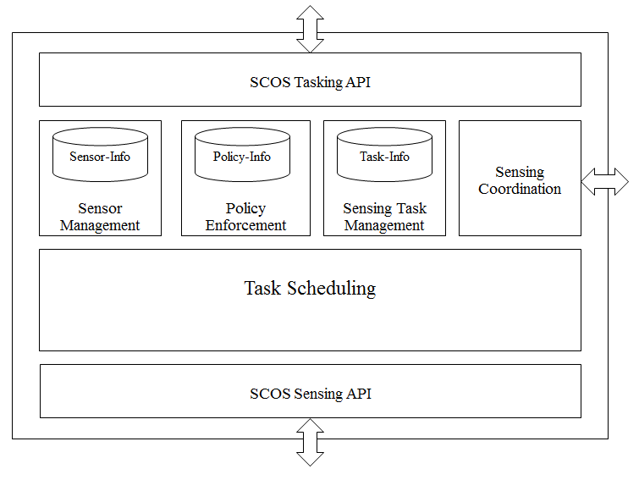
Figure 2: Task Management Control Functional Block Diagram

      - Sensing Manager: Data Distribution Service Functional Requirement
- SCOS Data Distribution Service: manages the transfer of sensor data northbound to the eventual Data Consumer(s).
- SD Data Distribution Service listener: receives northbound data transfers coming from each associated SD’s Data Distribution Service into the SM.

Figure 3 shows a simplified model for SM Data Distribution Service.
- Sensing data management: DM maintains data for the on-going tasks. The data received from the SDs needs to be stored internally for distribution to DCs. The DM may also need to have the capability to hold data for certain privileged tasks for a short duration identified by policy for the sensing data.
- Sensing data distribution: DM interprets the information associated with each scan request passed through with the scan data regarding SCOS Clients and their associated scanning tasks. Sensing data distribution involves providing necessary reliability depending on the chosen transport.
- Policy enforcement: A key part of SCOS administration is enforcing policies on the sensing data. The Data Distribution Service ensures that the Data Consumers issuing a subscription request for the sensing data are authorized to receive the data.
- Data validation and consolidation: The Data Distribution Service validates the data received from the SDs against the specified details from the task such as location, frequency, time, and measured data format. It consolidates data based on scanning task requirements.
- Sensing coordination: The DM needs to coordinate the status of tasks with TM for example, the expected sensing data from specific SDs for specific sensing tasks; also, availability of DM resources for future scanning tasks which could be used TM in choosing the DM.
- SCOS Sensing Data Collection API: The DM communicates with the SDs using the Data Collection API. It receives data for specific sensing tasks from specified SDs as coordinated with the TM.
- SCOS Sensing Data Distribution API: The Data Distribution Service communicates with Data Consumers, implements the data transport mechanism for distributing the sensing data to the authorized Data Consumers.

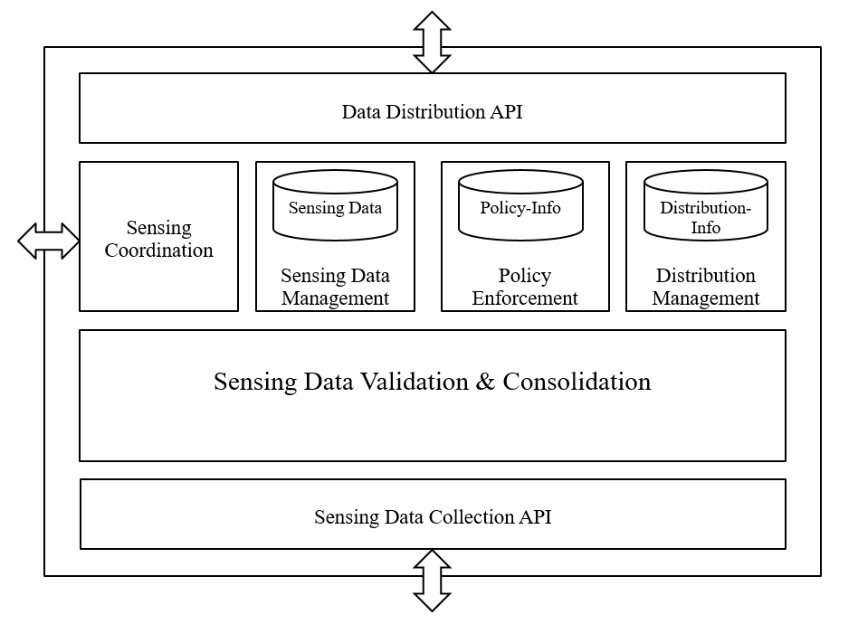
Figure 3: Data Distribution Service Functional Block Diagram

    - System Entity: Sensing Device

SDs gather, condition and sample the radio frequency environment, taking the processed samples, and package them within a compute platform into a standardised format along with relevant metadata. This is transmitted them to the Sensing Manager for final transmission to the appropriate Data Consumer.
Sensing Devices are stateless and offer an API (SD Control Service) to allow SCOS Clients, via the Sensing Manager, to schedule actions.
The SD can operate either as a slave device to the Sensing Manager, i.e. it performs scans on instruction, or it can operate semi-autonomously, i.e. it manages a schedule of scans that it periodically synchronizes with the Task Manager.
To allow the SD to be given an instruction to perform sensing activity, it is able to initiate an association with the Task Manager and perform the required authentication and authorization functions.

      - Sensing Device System Requirements
- SD Control Service: A stateless API (e.g. REST) that allows the SM to query the SD, and give it tasks to schedule.
- Capabilities Discovery: The SD shall have a system to itemise and expose its capabilities to the SM
- Sensing Task Scheduler: The SD shall have an onboard task scheduling capability to receive and make decisions about tasks, and communicate if the tasks are accepted/rejected, and locally store this schedule.
- Sensing Task Execution: the SD shall have a capability to execute defined sensing tasks itemised in the scheduler, and be able to communicate the status of these tasks back to the SM.
- Data Packager: The SD shall have a capability to package sensed data with relevant metadata into a format suitable for transmission.
- Data Transfer: The SD shall have a capability to transfer the data packages to the SM Data Distribution Service
- SD Activation Service: the SD shall have the capability to advertise itself to an SM to allow association with it, including secure authentication with the SM.

      - Sensing Device Functional Requirements

        - Sensing Device Hardware Model
A simplified hardware block diagram of a general SD model is depicted in Figure 4: SD Simplified Hardware Model Block Diagram. SD hardware designs are not required to have each component shown in the block diagram. Metadata that describe each component (e.g., presence, model, operational parameters), however, are required in response to queries for sensor capabilities and to accompany data acquisitions.
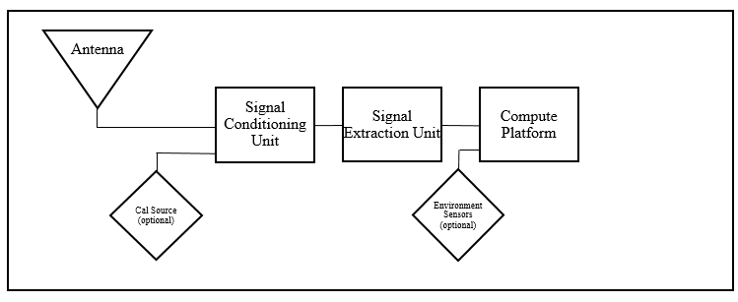
Figure 4: SD Simplified Hardware Model Block Diagram

● Functional element 1 – Antenna: An antenna converts environmental electromagnetic fields into a voltage. An RF cable connects the antenna with the next hardware component.
● Functional element 2 – Signal Conditioning Unit (SCU): An RF front end that could provide (among other things) preselection filtering, improved sensitivity via low noise amplification, and a calibration signal source. An RF cable connects the SCU with the next hardware component.
● Functional element 3 – Signal Extraction Unit (SEU): Analog Digital Converter (ADC), spectrum analyzer, Software Defined Radio (SDR), or other sampling device that also typically provides down-conversion and signal processing. A typical output of the SEU is a discrete baseband representation of the acquired signal.
● Functional element 4 – Compute Platform: that provides
o The Host Controller provides control signals and messages to SCU and DEU. Raw data can be processed, e.g., to calculate calibrated absolute power at a reference point in the sensor RF path. Data acquisitions are packaged with metadata from sensor configuration onboard instruments, e.g., GPS. Furthermore the Compute Platform receives configure and control metadata and sends necessary command and control signals to Functional Element 2 (Conditioning Unit), Functional Element 3 (Extraction Unit) and Functional Element 1 (Antenna), if the Antenna is a reconfigurable unit. It receives data from the Sensor/SDR, and polls any environment sensor input devices for necessary metadata items, such as GPS location. Interaction of the various elements is described in Figure 5: SD Functional Elements.

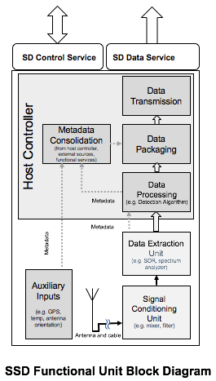
Figure 5: SD Functional Elements

This block diagram can be split into the hardware layer and the software processes that run alongside. These hardware blocks or software services generate metadata that is associated with each item.

        - SD Calibration Model
SD calibration can be done in the lab at build/commissioning time, and stored as a calibration file on the SD. Further, an SD with a self-calibration capability can be instructed through an administrative interface (not Data Client request) to perform a calibration using a local calibration source.
Where required by operating requirements or local regulations, SD shall be calibrated at build/commissioning time and periodically recalibrated as determined by those requirements (it is recommended that this is not more than 24 months). The calibration should be performed in an accredited calibration lab - if . The results of the calibration are stored as a calibration file on the SD. Further, an SD with a self-calibration capability shall be instructed to perform a calibration using a local calibration source through an administrative interface (not through a Data Client request).

        - SD Algorithm Model
The algorithm model is described in terms of
● inputs into black box: the identity of the USER and TM requesting the scan, the measurement parameters, which algorithm is to be used; and
● outputs from the black box: the identity of the USER and TM requesting the scan, the requested scan parameters, the identification of the algorithm model, and the processed results.
The following table enumerates the parameter definition object for the Algorithm Model.
Table 1 SD Algorithm Model Description
Parameter | R/O/C | Description
NAME: AlgorithmSet  DATA TYPE: Array of String | Required | Names of algorithms supported by the SD.  The maximum length of the ID string is 64 octets.

The following algorithms can be specified. At least once algorithm model needs to be supported by SD. Support for GenericEnergyDetection is normative. The standard allows development of advanced algorithms, which shall be identified in the table.
Table 2 SD Detection Algorithm Options
Scan Algorithm | Description
GenericEnergyDetection | Normative.
CyclicFeatureDetection | Optional
CustomScanAlgorithm | Optional

It is the responsibility of the SCOS Administrator to publish algorithm definitions externally. The implementation does not need to be publicly accessible. Where these algorithms are non-proprietary, the metadata should include explicit links to repositories providing algorithm details, sample code and definition, on open access sites such as GitHub.
Annex B defines how control plane and data plane information specification. In Annex B, different categories of metadata are identified and described.
        - SD Proxy
An SD Proxy interfaces with SCOS on the behalf of proprietary SD. SD proxy interaction to SCOS is identical to that of the SD except that while registering it registers with SDType as SDProxy. Following diagram illustrates the SD-Proxy’s functional architecture.

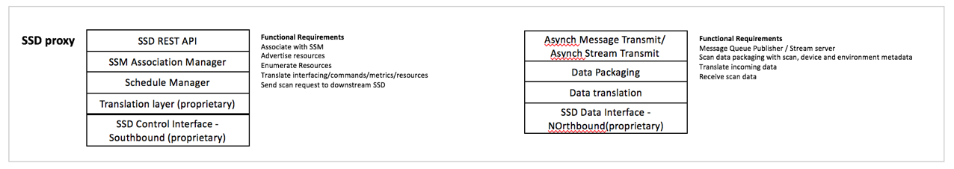
Figure 8: SD Proxy Functional Block Diagram
        - TM Proxy

The TM Proxy enables cascading of the SCOS system. There are two options for cascading
- TM Proxy acts as Proxy for all the underlying SDs and registers them with the SCOS system. Thus, all interactions with the actual underlying SDs are mediated by the TM-Proxy.
- TM-Proxy uses TM-TM interface and the two TMs interoperate with each other. This mode is planned to be introduced in the later version of the standard.

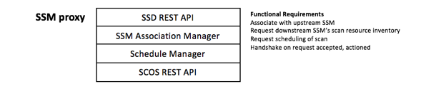
Figure 9 TM Proxy Functional Block Diagram

- Interfaces, Messaging and Primitives
The SCOS Systems shall support interfaces and messaging for the following core functional areas:

- SD Activation
- SD Capabilities Query
- SD Scheduling
- SD Control

Figure 10: Simplified Interactions Model illustrates a simplified SCOS interactions model. Here, we re-iterate a few architectural details.
- A SCOS platform is composed of sensors and a sensor manager. SCOS system provides sensing as a service.
- The SCOS system control plane is responsible for sensing task management. It enables the clients to SCOS platform to make requests for sensing data. The SCOS system data plane collects the sensing data and enables the SCOS platform clients to consume the requested data. In this regard, the Sensing Manager has two functional areas: Sensing & Task Control and Data Distribution. The SCOS control plane counterpart of a SCOS platform client making a request for sensing data is Data Client. The SCOS data plane counterpart of a SCOS platform client consuming the sensing data is Data Consumer.
- A SCOS Client connects to Sensing Manager using well-known address of the Sensing Manager and authenticates itself with the Sensing Manager. Upon successful authentication, the SCOS Client performs query on SCOS platform using Resource Discovery mechanism. A SCOS Client can the request sensing data from the SCOS platform. Sensing Mamager provides notification of the completed sensing tasks to the SCOS Client. A SCOS Client may request status on the requested sensing data.
- An SD may actively connect to the sensor manager on the SCOS platform or may passively wait to be contacted by a sensor manager. The SD and Sensing Manager perform mutual authentication. Upon successful authentication, the Sensing Manager performs capability discovery on the SD. The Sensing Manager schedules sensing tasks on the SDs. The Sensing Manager maintains periodic heartbeat with the SDs.
- The SDs connect with the Sensing Manager Data Distribution Servicethat handles the SCOS data plane functions. After successful mutual authentication, SD pushes the sensing data to the Sensing Manager.
- The Data Consumers connect with the DM in order to consume the sensing data associated with the sensing request from its counterpart SCOS Client. Data Consumer authenticates itself with the Sensing Manager Data Distribution Service. Upon successful authentication, the Data Consumer can receive the sensing data published by theSensing Manager.

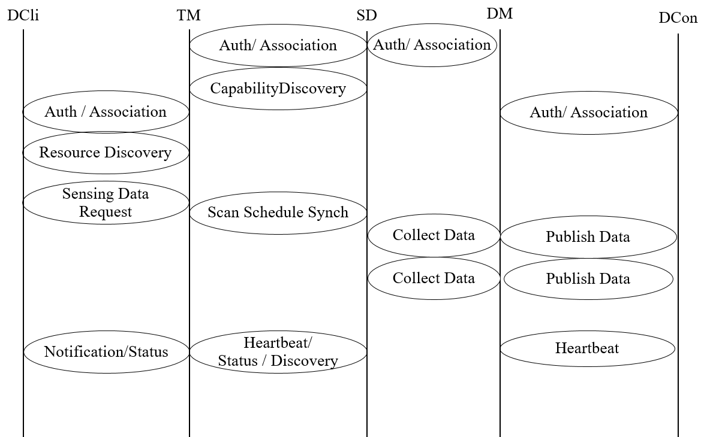
Figure 10: Simplified Interactions Model

  - SCOS Interfaces

    - SCOS communication interfaces

The following are the key SCOS communication interfaces.
- DCli and TM Interface
  - The interface between DCli and TM is asynchronous.
  - The interactions on this interface are specified in the SCOS Data Request API.
- TM and SD Interface
  - The interface between TM and SD is required to be synchronous.
  - The interactions on this interface are specified in the SCOS Sensing API.
- SD and DM Interface
  - The interface between SD and DM is asynchronous.
  - The interactions on this interface are specified in the SCOS Data Collection API.
- DM and DCon Interface
  - The interface between SD and DM is required to be asynchronous.
  - The interactions on this interface are specified in the SCOS Data Consumer API.

    - Data Client to TM Interface

      - Authentication and Registration

These procedures define the association and authentication process for an TM and Data Client entity to connect and communicate. They include facilities to prevent spoofing based on shared key exchange. Once an TM is authenticated and registered to a Data Client, the Data Client can then discover the capabilities of the TM and its associated SD’s. The Data Client may then define and make sensing requests to the TM, which include a designation of the Data Consumer(s) to which the data is to be sent. The TM will notify the Data Client when measurements are successfully completed (or not) and available at the Data Consumer.
      - Resource Discovery

Resource Discovery is the process of informing the Data Client of what capabilities that the TM has with regard to what types of measurements, what bands can be measured and associated measurement parameters that can be specified and controlled and over what locations.
This takes the form of a resource/capability message object and the current scan schedule per SD.
      - Scan Request

The Scan Request message from the Data Client to the TM includes the parameters of the desired spectrum measurement to be made and any associated processing to be performed by either the SD or the TM. This scan request is wrapped in a scheduling task description, defining the time the scan is to be made, the repetition rate (if applicable), the locations, etc. When the scan parameters in their scheduling wrapper are received by the TM it will be validated as possible to be executed (i.e. the resources requested meet the SSMs schedule of resources available), and either acknowledged as being queue, or a refusal is returned to the Data Client. If a scan schedule is updated for a particular SD, it is then replicated down to that SD.

    - TM to SD Interface

      - Authentication and Registration

These procedures define the association and authentication process for an SD and TM entity to connect and communicate. They include facilities to prevent spoofing based on shared key exchange. Once an SD is authenticated and registered to a TM, the TM can then discover the capabilities of the SD. An TM will have associated with it at least one SD. The TM may then assign sensing requests to the appropriate set of SDs in order to fulfil the sensing request of the Data Client.
      - Status and Discovery

The Status and Discovery process serves two functions. The first is to inform the TM of what capabilities that the SD has with regard to what types of measurements, what bands can be measured and associated measurement facilities (such calibration, antenna control, mobility, storage, processing) that can be specified and controlled and over what locations. The SD will transmit a package describing its capabilities and available resources at time of authentication/discovery, and if there is any change in its configuration. The second function is to maintain association with the TM. It will transmit a heartbeat periodically to indicate it is still associated with the TM. If it is to disconnect, it will transmit a disassociation message (e.g. if it is rebooting or about to go into an offline mode).
      - Scan Request

The Scan Request message originating from the TM is sent to the appropriate SDs for execution as a scan schedule. It includes the parameters of the desired spectrum measurement to be made based on knowledge of the SD’s capabilities. This request will include the time to make the measurement, the repetition rate (if applicable), the locations, etc. and the format of the measured data. In the case of a single, once-off scan, the schedule will indicate no repetition.
Message Parameters are captured in Table 3.

  - Sensing Manager Tasking Function

The following table enumerates the parameter definition object for scanTask.
Table 3 Sensing Scan Task Object Definition
Parameter | R/O/C | Description
NAME: TaskID  DATA TYPE: String | Required | Unique ID for the Spectrum Scan.  The maximum length of the ID string is 64 octets.
NAME: TaskDuration  DATA TYPE: number | Required | Duration of scan in milliseconds.
NAME: TaskStartTime  DATA TYPE: Time | Required | The start time for the task.
NAME: TaskRepeatInterval  DATA TYPE: Number | Optional | The interval in seconds after which the task needs to be repeated.
NAME: TaskRepeatCount  DATA TYPE: Number | Optional | The number of times the task needs to be repeated.  The maximum length of the ID string is 64 octets.
NAME: TaskEndTime  DATA TYPE: Time | Conditional | The end time for the task. If repeatInterval and repeatCount are specified, TaskEndTime is not required.
NAME: TaskAttributes  DATA TYPE: Integer | Optional | Currently following task attributes can be specified.  0 = Exact time.  1 = Nearest time.
NAME: TaskOptions  DATA TYPE: Integer | Optional | Custom options.

      - SCOS Association Metadata

The following table enumerates sensing manager parameters toward associating with SCOS.
Table 4 TM Parameter Object Definition
Parameter | R/O/C | Description
NAME: TMID  DATA TYPE: String | Required | Unique ID for the Task Manager.  The maximum length of the ID string is 64 octets.
NAME: TMSID  DATA TYPE: String | Required | Unique ID for the SMS.  The maximum length of the ID string is 64 octets.
NAME: SCOSOperator  DATA TYPE: String | Required | The registered name of the SCOS operator.  The maximum length of the ID string is 64 octets.
NAME: TMURL  DATA TYPE: String | Required | The URL for reaching to the TM.  The maximum length of the ID string is 256 octets.
NAME: TMCertFile  DATA TYPE: String | Required | The path of the TM certificate file.  The maximum length of the ID string is 256 octets.
NAME: TMKeyFile  DATA TYPE: String | Required | The name of the TM certificate file.  The maximum length of the ID string is 256 octets.
NAME: TMCAFile  DATA TYPE: String | Required | The name of the trusted certificate authority.  The maximum length of the ID string is 256 octets.

    - Data Manager
The DM is primarily responsible for sensing data management. The standard identifies following key functionalities within the DM entity
- Collecting spectrum scan data from SDs
- Distributing sensing data to the DCons
- Policy enforcement to meet the regulatory and administrative requirements.
- Communication with SDs, DCs, and TM
  - Data collection interface with SDs
  - Data distribution to the SDs
  - Sensing task coordination with the TM
      - Sensing Data Management
The SDs send spectrum measurements as requested by the scheduled scan. B.3.27.2 describes the sensing data. The sensing data is identified by ScanTaskId, SDID, and timestamp. The SD also provides envInfo which includes environmental data including location, humidity, and temperature. The DM validates the received data, consolidates the data with other received data for the scanning task, stores it internally for further distribution to DCs, and provides acknowledgement to the receives sensing data to the SDs.
Table 5 Scan Measurement Data Object Definition
Parameter | R/O/C | Description
NAME: dataFormat DATA TYPE: Integer | Required | The format of the output data as specified in B.3.27.2.
NAME: sizeData  DATA TYPE: Integer | Required | The number of measurements.
NAME: measData  DATA TYPE: Array of Complex | Required | The complex measurement values. The size of the array is defined by sizeData.

      - DM Metadata
The following table enumerates the parameter definition object for Data Manager.
Table 6 Data Manager Parameter Definition Object
Parameter | R/O/C | Description
NAME: DMID  DATA TYPE: String | Required | Unique ID for the Data Manager.  The maximum length of the ID string is 64 octets.
NAME: SMSID  DATA TYPE: String | Required | Unique ID for the SMS.  The maximum length of the ID string is 64 octets.
NAME: SCOSOperator  DATA TYPE: String | Required | The registered name of the SCOS operator.  The maximum length of the ID string is 64 octets.
NAME: DMURL  DATA TYPE: String | Required | The URL for reaching to the TM.  The maximum length of the ID string is 256 octets.
NAME: DMCertFile  DATA TYPE: String | Required | The path of the TM certificate file.  The maximum length of the ID string is 256 octets.
NAME: DMKeyFile  DATA TYPE: String | Required | The name of the TM certificate file.  The maximum length of the ID string is 256 octets.
NAME: DMCAFile  DATA TYPE: String | Required | The name of the trusted certificate authority.  The maximum length of the ID string is 256 octets.

    - Data Client
The standard provides SCOS Data Request API to the Data Clients for performing spectrum scans. Using the API:
- DClis are associated with the TM of the SCOS platform
- DClis perform resource discovery
- DClis request spectrum scans at the desired time, frequency, and locations
- DClis specify the Data consumers that are authorized to receive the sensing data for the scans.
- DClis optionally perform query about the sensing tasks.

Data Clients communicate the information provided by the TM to the SCOS platform user. Data Clients may implement certain logic/policy to automate the spectrum sensing process.
      - Data Client Metadata
The following table enumerates the parameter definition object for Data Client.
Table 7 Data Client Parameter Definition Object
Parameter | R/O/C | Description
NAME: DCliName DATA TYPE: string | Required | The name of the DCli registered with the SCOS operator.  The maximum length is 64 octets.
NAME: DCliID  DATA TYPE: String | Required | Unique ID for the DCli.  The maximum length of the ID string is 64 octets.
NAME: SCOSOperator DATA TYPE: string | Required | The name of the SCOS operator.  The maximum length is 64 octets.
NAME: DCliCertFile  DATA TYPE: String | Required | The path of the DCli certificate file.  The maximum length of the ID string is 256 octets.
NAME: DCliKeyFile  DATA TYPE: String | Required | The name of the DCli certificate file.  The maximum length of the ID string is 256 octets.
NAME: DCliCAFile  DATA TYPE: String | Required | The name of the trusted certificate authority.  The maximum length of the ID string is 256 octets.

    - Data Consumer
The standard provides SCOS Data Distribution API to the DCons for requesting the spectrum sensing data. Using the API,
- DCons are associated with the DM of the SCOS platform
- DCons request sensing data for specific sensing tasks
- DCons receive the data streamed or forwarded by the DM

The DCons would typically ingest and store the received data as defined the SCOS user specific logic/policy.
      - DCon Metadata
The following table enumerates the parameter definition object for a data consumer.
Table 8 Data Consumer Parameter Definition Object
Parameter | R/O/C | Description
NAME: DConName DATA TYPE: string | Required | The name of the DCon registered with the SCOS operator.  The maximum length is 64 octets.
NAME: DConID  DATA TYPE: String | Required | Unique ID for the DCon.  The maximum length of the ID string is 64 octets.
NAME: SCOSOperator DATA TYPE: string | Required | The name of the SCOS operator.  The maximum length is 64 octets.
NAME: DConCertFile  DATA TYPE: String | Required | The path of the DCon certificate file.  The maximum length of the ID string is 256 octets.
NAME: DConKeyFile  DATA TYPE: String | Required | The name of the DCon certificate file.  The maximum length of the ID string is 256 octets.
NAME: DConCAFile  DATA TYPE: String | Required | The name of the trusted certificate authority.  The maximum length of the ID string is 256 octets.

    - Data Manager to Data Consumer Interface

      - Authentication and Registration
These procedures define the association and authentication process for a Data Consumer and DM entity to connect and communicate. They include facilities to prevent spoofing based on shared key exchange. Once a Data Consumer is authenticated and registered with a DM, the DM is then authorized to cause data to be delivered to the Data Consumer based on the privileges of the Data Consumer and the DM. The Data Consumers can be grouped into Data Consumer Groups, where a transmission of data from the DM is delivered to multiple Data Consumers.
      - Data Manager
These procedures define and enable the storage of data from the DM to the Data Consumer. The successful reception of this data initiates a notification of the initiating Data Client that requested that data.
  - SCOS Messaging
The communication between each of the entities defined above can be grouped and defined within the Interface Categories shown in Figure 11: SCOS Message Sequence.
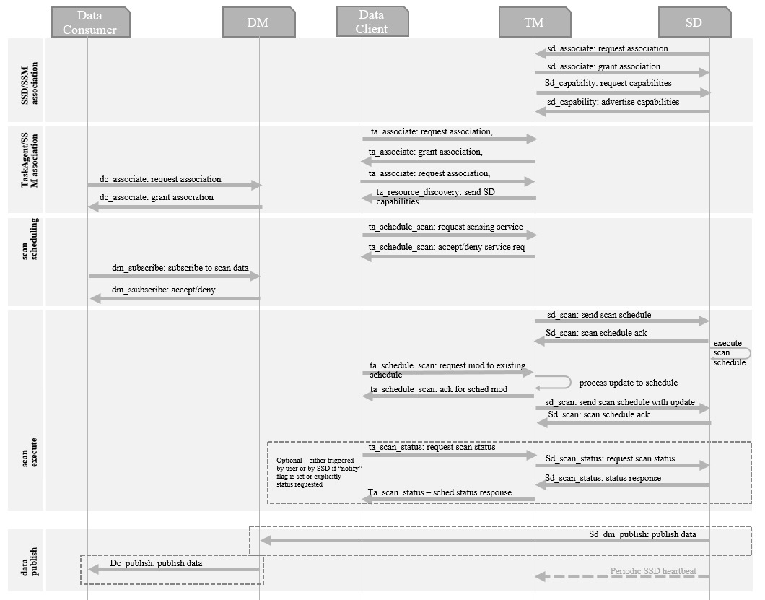
Figure 11: SCOS Message Sequence

    - Message Encoding
SCOS messages are encoded in JavaScript Object Notation (JSON). JSON is a language-independent data-interchange format that is easy for humans to read and write. There are code and functions readily available in C, C++, C#, Java, JavaScript, MATLAB, Perl, and Python for parsing and generating JSON. It is a lightweight alternative to XML, commonly used to transmit data between server and browser application.
The first five fields are the same for all messages; they are:
1. Ver = Schema/data transfer version with the major.minor.revision syntax (string)
2. Type = Type of JSON message (string) {“Sys”, ”Loc”, or “Data”}
3. SensorID = Unique identifier of sensor (string of URL unreserved characters)
4. SensorKey = Authentication key given out by MSOD (integer)
5. t = Time [seconds since Jan 1, 1970 UTC] (long integer)

Each message begins with a header comprised of attribute-value pairs in ASCII characters.
If an attribute is not relevant to the sensor implementation, then the value is set to NaN or "NaN".
The following are specific formatting rules to be followed:
- All timestamps, i.e., t (defined above)and t1 (to be defined in Data message description) will be reported as seconds since 1/1/1970 midnight UTC in the UTC time zone.
- String values must only contain URL unreserved characters (i.e., uppercase and lowercase letters, decimal digits, hyphen, period, underscore, and tilde), and
- Field names cannot start with an underscore because that convention is reserved for internal implementation-specific uses.

    - Message Transport protocols
The SCOS standard is transport-agnostic. The standard defines requirements for the transport protocol. The implementers may choose appropriate transport protocol that meets these requirements and suits to the use-case.
    - Response Codes
0: success
100 – 199: error events related to the entity association and disassociation
200 – 299: error events related to the entity configuration and policy enforcement
300 – 399: error events related to the scanning procedures
400 – 499: error events related to the data dissemination procedures
500 – 599: error events related to the heartbeat procedure and SCOS entity/platform health
600 – 699: error events related to the SCOS infrastructure administrative procedures.

  - Primitives
Each message (in general) will begin with a header as shown in the following table.
Table 9 SCOS Messager Header Definition
Parameter | R/O/C | Description
NAME: version  DATA TYPE: String | Required | IEEE 802.22.3 SCOS protocol version.  The maximum length is 64 octets.
NAME: scosmode  DATA TYPE: Integer | Required | The mode for SCOS system.
NAME: scosmethod DATA TYPE: String | Required | The SCOS method in the context of the communication. The scaos methods are listed in the message descriptions.  The maximum length is 64 octets.
NAME: msgtype DATA TYPE: Integer | Required | The valid message types are request and response. (1=Request, 2=Response 3= Notification 4=AdminCmd 5=AdminCmdResponse)
NAME: timestamp  DATA TYPE: Time | Required | Timestamp associated with the communication..

The following are specific formatting rules to be followed to avoid problems when messages are ingested into MSOD: (1) All timestamps, i.e., t (defined above)and t1 (to be defined in Data message description) will be reported as seconds since 1/1/1970 midnight UTC in the UTC time zone. (2) String values must only contain URL unreserved characters (i.e., uppercase and lowercase letters, decimal digits, hyphen, period, underscore, and tilde), and (3) Field names cannot start with an underscore because that convention is reserved for MSOD internal use.
The data fields in the JSON message descriptions below are required fields. If an attribute is not relevant to the sensor implementation, then the value is set to NaN or "NaN".

    - SD<>TM Messages
Table 10 enumerate the messages exchanged between an SD and the TM.
Table 10 SCOS Messages between SD and TM
scos_method_name | JSON Array Name of Request Message | JSON Array Name of Response Message
“sd_associate” | sdAssociateRequest | sdAssociateResponse
“sd_capability” | sdCapabilityRequest | sdCapabilityResponse
“sd_scan” | sdScanRequest | sdScanResponse
“sd_heartbeat” | sdHeartbeatRequest | sdHeartbeatResponse
“sd_disassociate” | sdDisassociateRequest | sdDisassociateResponse

      - SD-TM Association Message Exchange
Table 11 describes the sdAssociateRequest JSON object.
Table 11 SD Association Request Object Definition
Parameter | R/O/C | Description
NAME: SDName DATA TYPE: string | Required | The name of the sensing device registered with SCOS operator.  The maximum length is 64 octets.
NAME: SCOSOperator DATA TYPE: string | Required | The name of the SCOS operator.  The maximum length is 64 octets.
NAME: SDMode DATA TYPE: Integer | Required | The mode in which sensing device operates. (1=online, 2=offline)
NAME: SDType DATA TYPE: Integer | Required | The type of the sensing device. (1=SDFull, 2=SDProxy)
NAME: SDID DATA TYPE: string | Conditional | The unique ID assigned to the sensing device. If ID is not pre-assigned, this is left empty. The maximum length is 64 octets.
NAME: SDCertFile  DATA TYPE: String | Conditional | The path of the SD certificate file.  The maximum length of the ID string is 256 octets.
NAME: SDKeyFile  DATA TYPE: String | Conditional | The name of the SD certificate file.  The maximum length of the ID string is 256 octets.
NAME: SDCAFile  DATA TYPE: String | Conditional | The name of the trusted certificate authority.  The maximum length of the ID string is 256 octets.

Table 12 describes the sdAssociateResponse JSON object.
Table 12 SD Associate Response Object Definition
Parameter | R/O/C | Description
NAME: SDName DATA TYPE: string | Required | The name of the sensing device registered with SCOS operator.  The maximum length is 64 octets.
NAME: response DATA TYPE: string | Required | The response code for association.
NAME: SDID DATA TYPE: string | Required | The unique ID assigned to the sensing device. The maximum length is 64 octets.
NAME: heartbeatInterval DATA TYPE: Integer | Required | Heartbeat interval in seconds.

      - SD-TM Capability Information Exchange
Table 13 describes the sdCapabilityRequest JSON object sent by the TM to SD.

Table 13 SD Capability Request Object Definition
Parameter | R/O/C | Description
NAME: SDID DATA TYPE: string | Required | The unique ID assigned to the sensing device. The maximum length is 64 octets.
NAME: sendBaseCapability DATA TYPE: boolean | Conditional | True or False. If false, base capability information is not required.
NAME: freqIntervals DATA TYPE: Array of freqInterval | Conditional | Array of freqInterval objects. Each freqInterval object denotes a frequency range as defined in Table 14.
NAME: timeIntervals DATA TYPE: Array of timeRange | Conditional | Array of timeInterval objects. Each timeInterval object denotes a time range as defined in Table 15
NAME: scanPeriodicity DATA TYPE: Integer | Conditional | Supported scanPeriodicity interval. The periodicity interval is expressed in number of seconds.

Table 14 describes the freqInterval JSON object sent by the TM to SD.

Table 14 SCOS Frequency Interval Object Definition
Parameter | R/O/C | Description
NAME: lowFreq DATA TYPE: Integer | Required | The low frequency of a frequency interval.
NAME: highFreq  DATA TYPE: Integer | Required | The high frequency of a frequency interval.

Table 15 describes the timeInterval JSON object sent by the TM to SD.

Table 15 SCOS Time Interval Definition Object
Parameter | R/O/C | Description
NAME: startTime DATA TYPE: Time | Required | The start of a time interval.
NAME: endTime  DATA TYPE: Time | Required | The end of a time interval.

Table 16 SCOS Time Datatype Definition Object
Parameter | R/O/C | Description
NAME: time  DATA TYPE: String | Required | UTC time expressed in the format YYYY-MM-DDThh:mm:ssZ as defined by [1]

Table 17 describes the sdCapabilityResponse JSON object sent by the SD to TM.
Table 17 SD Capability Response Object Defiintion
Parameter | R/O/C | Description
NAME: SDID  DATA TYPE: string | Required | The name of the SD registered with SCOS operator.  The maximum length is 64 octets.
NAME: SDCapabilityInfo DATA TYPE: sdCapabilityInfo | Conditional | Object describing SD capability (class B SD metadata) as described in Annex B.
NAME: freqIntervals DATA TYPE: Array of freqInterval | Conditional | Array of freqInterval objects. Each freqInterval object denotes a frequency range as defined in Table 14.
NAME: timeIntervals DATA TYPE: Array of timeRange | Conditional | Array of timeInterval objects. Each timeInterval object denotes a time range as defined in Table 15
NAME: scanPeriodicity DATA TYPE: Integer | Conditional | Supported scanPeriodicity interval. The periodicity interval is expressed in number of seconds.

      - SD-TM Scan Message Exchange
Table 18 describes the sdScanRequest JSON object from TM to SD.
Table 18 SD Scan Request Message Object
Parameter | R/O/C | Description
NAME: SDID DATA TYPE: string | Required | The unique ID assigned to the sensing device. The maximum length is 64 octets.
NAME: TaskID  DATA TYPE: String | Required | Unique ID for the Spectrum Scan.  The maximum length of the ID string is 64 octets.
NAME: freqIntervals DATA TYPE: Array of freqInterval | Conditional | Array of freqInterval objects. Each freqInterval object denotes a frequency range as defined in Table 14.
NAME: scanResolution DATA TYPE: Integer | Conditional | The suggested frequency resolution for the scan.
NAME: TaskDuration  DATA TYPE: number | Required | Duration of scan in milliseconds.
NAME: TaskStartTime  DATA TYPE: Time | Required | The start time for the task.
NAME: TaskRepeatInterval  DATA TYPE: Number | Optional | The interval in seconds after which the task needs to be repeated.
NAME: TaskRepeatCount  DATA TYPE: Number | Optional | The number of times the task needs to be repeated.
NAME: TaskEndTime  DATA TYPE: Time | Optional | The end time for the task.

Table 19 describes the sdScanResponse JSON object from SD to TM.
Table 19 SD Scan Response Message Object
Parameter | R/O/C | Description
NAME: SDID DATA TYPE: string | Required | The unique ID assigned to the sensing device. The maximum length is 64 octets.
NAME: TaskID  DATA TYPE: String | Required | Unique ID for the Spectrum Scan.  The maximum length of the ID string is 64 octets.
NAME: scanStatus DATA TYPE: Array of Integer | Required | Array provides scan output status code for each of the freqIntervals. The status code is one of the response codes from Table. The freqIntervals should match with the freqIntervals from the request message.
NAME: timestamp DATA TYPE: Time | Required | Timestamp with the associated scanning output.
NAME: scanData  DATA TYPE: Array of scanData objects | Required | Array of scanData objects. Each object represents SD measurements for the freqInterval. The scanData is defined in B.3.27.2
NAME: envInfo DATA TYPE: environMetadata | Required | The environmental data including location, temperature, and humidity as described in B.3.8

Table 20 describes the scanData JSON object sent by the TM to SD.

Table 20 SD Scan Data Message Definition Object
Parameter | R/O/C | Description
NAME: dataFormat DATA TYPE: Integer | Required | The format of the output data as specified in B.3.27.2.
NAME: sizeData  DATA TYPE: Integer | Required | The number of measurements.
NAME: measData  DATA TYPE: Array of Complex | Required | The complex measurement values. The size of the array is defined by sizeData.

      - SD-TM Heartbeat Message Exchange
Table 21 describes the sdHeartbeatRequest JSON object from TM to SD.
Table 21 SD Heartbeat Request Message Object
Parameter | R/O/C | Description
NAME: SDID DATA TYPE: string | Required | The unique ID assigned to the sensing device. The maximum length is 64 octets.
NAME: calibrate DATA TYPE: boolean | Conditional | If true, SD is required to perform calibration.
NAME: calibrateTime DATA TYPE: Time | Conditional | If calibrate true, calibrateTime denotes the time for performing calibration.

Table 22 describes the sdHeartbeatResponse JSON object from SD to TM.
Table 22 SD Heartbeat Response Message Object
Parameter | R/O/C | Description
NAME: SDID DATA TYPE: string | Required | The unique ID assigned to the sensing device. The maximum length is 64 octets.
NAME: calibrateStatus DATA TYPE: Integer | Conditional | The status code for the scheduled calibration.
NAME: envInfo DATA TYPE: envMetadata | Required | The type of DCli.  The maximum length is 64 octets.
NAME: healthInfo DATA TYPE: healthMetadata | Required | The SD health metadata as described in B.3.8.

Table 23describes the healthMetadata JSON object sent by the SD to TM.

Table 23 SD Health Meatadata Object Definition
Parameter | R/O/C | Description
NAME: batteryLevel DATA TYPE: Integer | Required | The battery level in percentage rounded to closest integer.

      - SD-TM Disassociation Message Exchange
Table 24describes the sdDisassociateRequest JSON object from SD to TM.
Table 24 SD Disassociate Request Object
Parameter | R/O/C | Description
NAME: SDID  DATA TYPE: string | Required | The ID assigned to SD by the SCOS operator.  The maximum length is 64 octets.
NAME: SDName DATA TYPE: string | Required | The name of the sensing device registered with SCOS operator.  The maximum length is 64 octets.
NAME: SCOSOperator DATA TYPE: string | Required | The name of the SCOS operator.  The maximum length is 64 octets.

Table 25 describes the sdDisassociateResponse JSON object from TM to SD.
Table 25 SD Disassociate Response Object
Parameter | R/O/C | Description
NAME: SDName  DATA TYPE: string | Required | The name of the SD registered with SCOS operator.  The maximum length is 64 octets.
NAME: SCOSOperator DATA TYPE: string | Required | The name of the SCOS operator.  The maximum length is 64 octets.
NAME: status  DATA TYPE: string | Required | The response code for dissociation request.
NAME: oldSDID  DATA TYPE: string | Required | The SD ID that has been dissociated  The maximum length is 64 octets.

    - DCli<>TM Messages
Following table describes the SCOS Data Request API methods
Table 26 Messages Exchanged Between DCli and TM
scos_method_name | JSON Array Name of Request Message | JSON Array Name of Response Message
“ta_associate” | taAssociateRequest | taAssociateResponse
“ta_resource_discovery” | taResourceDiscoveryRequest | taResourceDiscoveryResponse
“ta_schedule_scan” | taScheduleScanRequest | taScheduleScanResponse
“ta_scan_status” | taScanStatusRequest | taScanStatusResponse
“ta_scan_notify” | taScanNotification | taScanNotificationResponse
“ta_dissociate” | taDissociateRequest | taDissociateResponse

      - DCli-TM Association Message Exchange
Table 27 describes the taAssociateRequest JSON object from DCli to TM.
Table 27 DCli Associate Request Message
Parameter | R/O/C | Description
NAME: DCliName  DATA TYPE: string | Required | The name of the Data Client registered with SCOS operator.  The maximum length is 64 octets.
NAME: SCOSOperator DATA TYPE: string | Required | The name of the SCOS operator.  The maximum length is 64 octets.
NAME: SMName  DATA TYPE: string | Required | The name of the sensing manager to associate with.  The maximum length is 64 octets.
NAME: DCliType DATA TYPE: string | Required | The type of DCli. Valid values include {“DCliTypeA”, “DCliTypeB”, “DCliTypeC”}
NAME: DCliID DATA TYPE: string | Optional | The unique ID assigned to the Data Client. The maximum length is 64 octets.
NAME: DCliCertFile  DATA TYPE: String | Optional | The path of the DCli certificate file.  The maximum length of the ID string is 256 octets.
NAME: DCliKeyFile  DATA TYPE: String | Optional | The name of the DCli certificate file.  The maximum length of the ID string is 256 octets.
NAME: DCliCAFile  DATA TYPE: String | Optional | The name of the trusted certificate authority.  The maximum length of the ID string is 256 octets.
NAME: admPreferences  DATA TYPE: AdmPreferences | Optional | A DCli can optionally specify certain preferences related to how scanning task administration is performed.

Table 28 describes the AdmPreferences object

Table 28 DCli Administrative Preferences
Parameter | R/O/C | Description
NAME: useNewTaskforRestart  DATA TYPE: boolean | Optional | DCli chooses to have new TaskID for a restarted task. In the case of restarting a sensing task, TM provides old TaskID as well in order to associate the two. More details in the Section 7 administration.
NAME: useNewTaskforMigration  DATA TYPE: boolean | Optional | DCli chooses to have new TaskID for a sensing task with change in SD resource. In the case of migrating a sensing task, TM provides old TaskID as well in order to associate the two. More details in the Section 7 administration.

Table 29 describes the taAssociateResponse JSON object from TM to DCli
Table 29 DCli Associate Response Object
Parameter | R/O/C | Description
NAME: DCliName  DATA TYPE: string | Required | The name of the Data Client registered with SCOS operator.  The maximum length is 64 octets.
NAME: SMName  DATA TYPE: string | Required | The name of the sensing manager to associate the DCli with.  The maximum length is 64 octets.
NAME: SCOSOperator DATA TYPE: string | Required | The name of the SCOS operator.  The maximum length is 64 octets.
NAME: status  DATA TYPE: string | Required | The response code for the DCli association request.  The maximum length is 64 octets.
NAME: DCliID DATA TYPE: string | Required | The unique ID assigned to the Data Client. The maximum length is 64 octets.
NAME: SMID DADCli TYPE: string | Required | The unique ID of the sensing manager. The maximum length is 64 octets.

      - DCli-TM Resource Discovery Message Exchange
Table 30 describes the DCliResourceDiscoveryRequest JSON object from DCli to TM.
Table 30 DCli Resource Discovery Request
Parameter | R/O/C | Description
NAME: DCliID  DATA TYPE: string | Required | The name of the Data Client registered with SCOS operator.  The maximum length is 64 octets.
NAME: perSDInfoRequest  DATA TYPE: Boolean | Required | If True, per SD resource/capability information is requested.
NAME: freqIntervals DATA TYPE: Array of freqInterval | Optional | Array of freqInterval objects. Each freqInterval object denotes a frequency range as defined in Table 14.
NAME: scanDataFormat DATA TYPE: Array of timeInterval | Optional | The format of the scan data as described in B.3.27.2.  The maximum length is 64 octets.
NAME: scanResolution DATA TYPE: Integer | Optional | The minimum desired scan resolution.
NAME: locations  DATA TYPE: Array of Location objects | Optional | Array of Location objects for the specified scan frequencies. Each Location object denotes desired coordinates as defined in B.3.9.
NAME: locationAccuracy  DATA TYPE: Integer | Optional | Desired accuracy for location in terms of maximum distance in meters from the specified coordinate.

Table 31 describes the location for the DCliResourceDiscoveryResponse JSON object from TM to DCli.
Table 31 DCli Resource Discovery Location Descriptor Object
Parameter | R/O/C | Description
NAME: Latitude  DATA TYPE: string | Required | Latitude is expressed in format DD°MM’SS’’ N/S  The maximum length is 64 octets.
NAME: Longitude DATA TYPE: string | Required | Longitude is expressed in format DD°MM’SS’’ W/E  The maximum length is 64 octets.

Table 32 describes the DCliResourceDiscoveryResponse JSON object from TM to DCli.
Table 32 DCli Resource Discovery Response Object
Parameter | R/O/C | Description
NAME: SMID DATA TYPE: string | Required | The unique ID of the sensing manager. The maximum length is 64 octets.
NAME: DCliID  DATA TYPE: string | Required | The name of the Data Client registered with SCOS operator.  The maximum length is 64 octets.
NAME: sdResourceInfo  DATA TYPE: Array of sdCapabilityInfo objects | Conditional | If perSDInfoRequest is true in the request, array of sdCapabilityInfo (Annex B) objects is included.
NAME: statusFreqIntervals DATA TYPE: Array of Integer | Conditional | Status codes for each of the freqIntervals from the request message that meet the scanDataformat and scanResolution.
NAME: AccuracyLocation  DATA TYPE: Array of Integer | Conditional | Accuracy for each of the Locations from the request message in terms of distance (measured in meter).

      - DCli-TM Scan Request Message Exchange
Table 33 describes the DCliScheduleScanRequest JSON object from DCli to TM.
Table 33 DCli Schedule Scan Request Request Message
Parameter | R/O/C | Description
NAME: DCliID  DATA TYPE: string | Required | The name of the Data Client registered with SCOS operator.  The maximum length is 64 octets.
NAME: freqIntervals DATA TYPE: Array of freqInterval | Required | Array of freqInterval objects. Each freqInterval object denotes a frequency range as defined in Table 14.
NAME: scanDataFormat DATA TYPE: Array of timeInterval | Required | The format of the scan data as described in B.3.27.2.  The maximum length is 64 octets.
NAME: scanResolution DATA TYPE: Integer | Required | The minimum desired scan resolution.
NAME: locations  DATA TYPE: Array of Location objects | Required | Array of Location objects. Each Location object denotes desired coordinates as defined in B.3.9.
NAME: locationAccuracy  DATA TYPE: Integer | Required | Desired accuracy for location in terms of maximum distance in meters from the specified coordinate.

Table 34 describes the DCliScheduleScanResponse JSON object from TM to DCli
Table 34 DCli Schedule Scan Response Object
Parameter | R/O/C | Description
NAME: SMID DATA TYPE: string | Required | The unique ID of the sensing manager. The maximum length is 64 octets.
NAME: DCliID  DATA TYPE: string | Required | The name of the Data Client registered with SCOS operator.  The maximum length is 64 octets.
NAME: DCliScanID  DATA TYPE: string | Required | The unique ID assigned for the scan scheduled for the DCli.  The maximum length is 64 octets.
NAME: status  DATA TYPE: Array of Integer | Required | Status codes for each of the scan frequency ranges that support desired scan parameters and the desired locationAccuracy.

      - DCli-TM Scan Status Inquiry Message Exchange
Table 35 describes the sdScanStatusRequest JSON object from DCli to TM.
Table 35 DCli Scan Status Request Message
Parameter | R/O/C | Description
NAME: DCliID  DATA TYPE: string | Required | The name of the Data Client registered with SCOS operator.  The maximum length is 64 octets.
NAME: SMID DATA TYPE: string | Required | The unique ID of the sensing manager. The maximum length is 64 octets.
NAME: DCliScanID  DATA TYPE: string | Required | The unique ID assigned for the scan scheduled for the DCli.  The maximum length is 64 octets.

Table 36 describes the sdScanStatusResponse JSON object from TM to DCli
Table 36 DCli Scan Status Response Message
Parameter | R/O/C | Description
NAME: DCliID  DATA TYPE: string | Required | The name of the Data Client registered with SCOS operator.  The maximum length is 64 octets.
NAME: SMID DATA TYPE: string | Required | The unique ID of the sensing manager. The maximum length is 64 octets.
NAME: DCliScanID  DATA TYPE: string | Required | The unique ID assigned for the scan scheduled for the DCli.  The maximum length is 64 octets.
NAME: status  DATA TYPE: Array of Integer | Required | Status codes for each of the scan frequency ranges that support desired scan parameters and the desired locationAccuracy.

      - DCli-TM Scan Notification Message Exchange
Upon completion of the scan or upon error event, TM notifies the DCli of the status for the scan.
Table 37 describes the sdScanNotifyRequest JSON object from DCli to TM.
Table 37 SD Scan Notification Message
Parameter | R/O/C | Description
NAME: DCliID  DATA TYPE: string | Required | The name of the Data Client registered with SCOS operator.  The maximum length is 64 octets.
NAME: SMID DATA TYPE: string | Required | The unique ID of the sensing manager. The maximum length is 64 octets.
NAME: DCliScanID  DATA TYPE: string | Required | The unique ID assigned for the scan scheduled for the DCli.  The maximum length is 64 octets.
NAME: status  DADCli TYPE: Array of Integer | Required | Status codes for each of the scan frequency ranges that support desired scan parameters and the desired locationAccuracy.

      - DCli-TM Dissociation Message Exchange
Table 38 describes the DCliDissociateRequest JSON object from DCli to TM.
Table 38 DCli Dissociation Request Message
Parameter | R/O/C | Description
NAME: DCliID  DATA TYPE: string | Required | The ID assigned to DCli by the SCOS operator.  The maximum length is 64 octets.
NAME: DCliName DATA TYPE: string | Required | The name of the DCli registered with SCOS operator.  The maximum length is 64 octets.
NAME: SCOSOperator DATA TYPE: string | Required | The name of the SCOS operator.  The maximum length is 64 octets.

Table 39 describes the sdDissociateResponse JSON object from TM to DCli
Table 39 DCli Dissociation Response Message
Parameter | R/O/C | Description
NAME: DCliName  DATA TYPE: string | Required | The name of the Data Client registered with SCOS operator.  The maximum length is 64 octets.
NAME: SCOSOperator DATA TYPE: string | Required | The name of the SCOS operator.  The maximum length is 64 octets.
NAME: status  DATA TYPE: string | Required | The response code for dissociation request.
NAME: oldDCliID  DATA TYPE: string | Required | The DCli ID that has been dissociated  The maximum length is 64 octets.

    - SD<>DM Messages
Table 40 denotes the messages exchanged between SD and DM.
Table 40 Messages Exchanged Between SD and DM
scos_method_name | JSON Array Name of Request Message | JSON Array Name of Response Message
“sd_dm_associate” | sdAssociateRequest | sdAssociateResponse
“sd_dm_publish” | sdPublishRequest | sdPublishResponse
“sd_dm_heartbeat” | sdHeartbeatRequest | sdHeartbeatResponse
“sd_dm_disassociate” | sdDisassociateRequest | sdDisassociateResponse

      - SD-DM Association Message Exchange
Table 41 describes the sdAssociateRequest JSON object from SD to DM.
Table 41 SD Associate Request Message
Parameter | R/O/C | Description
NAME: SDName DATA TYPE: string | Required | The name of the sensing device registered with SCOS operator.  The maximum length is 64 octets.
NAME: response DATA TYPE: string | Required | The response code for association.
NAME: SDID DATA TYPE: string | Required | The unique ID assigned to the sensing device. The maximum length is 64 octets.
NAME: heartbeatInterval DATA TYPE: Integer | Required | Heartbeat interval in seconds.

      - SD-DM Publish Message
Table 42 describes the sdPublishRequest JSON object from SD to DM.

Table 42 SD Publish Sensing Data Message
Parameter | R/O/C | Description
NAME: SDID DATA TYPE: string | Required | The unique ID assigned to the sensing device. The maximum length is 64 octets.
NAME: TaskID  DATA TYPE: String | Required | Unique ID for the Spectrum Scan.  The maximum length of the ID string is 64 octets.
NAME: scanStatus DATA TYPE: Array of Integer | Required | Array provides scan output status code for each of the freqIntervals. The status code is one of the response codes from Table. The freqIntervals should match with the freqIntervals from the request message.
NAME: timestamp DATA TYPE: Time | Required | Timestamp with the associated scanning output.
NAME: scanData  DATA TYPE: Array of scanData objects | Required | Array of scanData objects. Each object represents SD measurements for the freqInterval. The scanData is defined in B.3.27.2
NAME: envInfo DATA TYPE: environMetadata | Required | The environmental data including location, temperature, and humidity as described in B.3.8

Table 43 describes the scanData JSON objects from SD to DM.
Table 43 SD ScanData Object Definition
Parameter | R/O/C | Description
NAME: dataFormat DATA TYPE: Integer | Required | The format of the output data as specified in B.3.27.2.
NAME: sizeData  DATA TYPE: Integer | Required | The number of measurements.
NAME: measData  DATA TYPE: Array of Complex | Required | The complex measurement values. The size of the array is defined by sizeData.

Table 44 describes the sdPublishResponse JSON object from SD to DM.
Table 44 SD Publish Sensing Data Response Object
Parameter | R/O/C | Description
NAME: SDID DATA TYPE: string | Required | The unique ID assigned to the sensing device. The maximum length is 64 octets.
NAME: TaskID  DATA TYPE: String | Required | Unique ID for the Spectrum Scan.  The maximum length of the ID string is 64 octets.
NAME: status DATA TYPE: Array of Integer | Required | Each entry shows status for the publish request of the scanning data for each of the freqIntervals.
NAME: timestamp DATA TYPE: Time | Required | Timestamp for the associated scanning data that DM is acknowledging.

      - SD-DM Heartbeat Message
Table 45Table 45 describes the heartbeat message exchanged between SD and DM
Table 45 SD Heartbeat Request Message With DM
Parameter | R/O/C | Description
NAME: SDID DATA TYPE: string | Required | The unique ID assigned to the sensing device. The maximum length is 64 octets.
NAME: Cmd  DATA TYPE: Time | Optional | If nonzero, SD is given a command. Currently, two command codes are defined. If cmd is 1, DM is asking SD to list all topics for which the SD is publishing. If cmd is 2, DM is asking to stop publishing for a topic or all topics as suggested by next object in the message.
NAME: topic  DATA TYPE: string | Conditional | If cmd is 2, this field denotes the topic for which DM is asking SD to stop publishing. If no topic is specified, DM is asking to stop publishing for all the topics.

Table 46 denotes the topic details exchanged in the heartbeat response message from SD and DM.
Table 46 Topic Details Exchange in Heartbeat Message
Parameter | R/O/C | Description
NAME: SDID DATA TYPE: string | Required | The unique ID assigned to the sensing device. The maximum length is 64 octets.
NAME: activeTopics DATA TYPE: Array of string | Required | Each entry in the list describes an active topic. The maximum length is 64 octets.

      - SD-DM Dissociation Message Exchange
Table 48 describes the sdDissociateRequest JSON object from SD to DM.

Table 47 SD Dissociate Request Message
Parameter | R/O/C | Description
NAME: SDID  DATA TYPE: string | Required | The ID assigned to SD by the SCOS operator.  The maximum length is 64 octets.
NAME: SDName DATA TYPE: string | Required | The name of the sensing device registered with SCOS operator.  The maximum length is 64 octets.
NAME: SCOSOperator DATA TYPE: string | Required | The name of the SCOS operator.  The maximum length is 64 octets.

Table 48 describes the sdDisassociateResponse JSON object from DM to SD.
Table 48 SD Dissociate Response Object
Parameter | R/O/C | Description
NAME: SDName  DATA TYPE: string | Required | The name of the SD registered with SCOS operator.  The maximum length is 64 octets.
NAME: SCOSOperator DATA TYPE: string | Required | The name of the SCOS operator.  The maximum length is 64 octets.
NAME: status  DATA TYPE: string | Required | The response code for dissociation request.
NAME: oldSDID  DATA TYPE: string | Required | The SD ID that has been dissociated  The maximum length is 64 octets.

    - DCon<>DM Messages
Following Table 49 enumerates the messages exchanged between DM and DCon.
Table 49Messages Exchanged Between DCon and DM
scos_method_name | JSON Array Name of Request Message | JSON Array Name of Response Message
“dc_associate” | dcAssociateRequest | dcAssociateResponse
“dc_subscribe” | dcSubscribeRequest | dcSubscribeResponse
“dc_topicdata” | dcTopicData | dcTopicDataResponse
“dc_unsubscribe” | dcUnSubscribeRequest | dcUnSubscribeResponse
“dc_heartbeat” | dcHeartbeatRequest | dcHeartbeatResponse
“dc_disassociate” | dcDisassociateRequest | dcDisassociateResponse

      - DCon-DM Association Message Exchange
Table 50 describes the dcAssociateRequest JSON object from DC to DM.
Table 50 DCon Associate Request Message
Parameter | R/O/C | Description
NAME: DCName  DATA TYPE: string | Required | The name of the data-consumer registered with SCOS operator.  The maximum length is 64 octets.
NAME: SCOSOperator  DATA TYPE: string | Required | The name of the SCOS operator.  The maximum length is 64 octets.
NAME: DMName  DATA TYPE: string | Required | The name of the data manager to associate with.  The maximum length is 64 octets.
NAME: DCID  DATA TYPE: string | Optional | The unique ID assigned to the data-client. The maximum length is 64 octets.
NAME: DCCertFile  DATA TYPE: String | Optional | The path of the DCli certificate file.  The maximum length of the ID string is 256 octets.
NAME: DCKeyFile  DATA TYPE: String | Optional | The name of the DC certificate file.  The maximum length of the ID string is 256 octets.
NAME: DCCAFile  DATA TYPE: String | Optional | The name of the trusted certificate authority.  The maximum length of the ID string is 256 octets.

Table 51 describes the dcAssociateResponse JSON object from DM to DCon
Table 51 DCon Associate Response Message
Parameter | R/O/C | Description
NAME: DCName  DATA TYPE: string | Required | The name of the DCli registered with SCOS operator.  The maximum length is 64 octets.
NAME: DMName  DATA TYPE: string | Required | The name of the data manager to associate the DC with.  The maximum length is 64 octets.
NAME: SCOSOperator  DATA TYPE: string | Required | The name of the SCOS operator.  The maximum length is 64 octets.
NAME: status  DATA TYPE: string | Required | The response code for the DCli association request. The maximum length is 64 octets.
NAME: DCID  DATA TYPE: string | Required | The unique ID assigned to the Data Client. The maximum length is 64 octets.
NAME: DMID  DATA TYPE: string | Required | The unique ID of the data manager. The maximum length is 64 octets.

      - DCon-DM Subscribe Message Exchange
Table 52 describes the dcSubscribeRequest JSON object from DC to DM.
Table 52 DCon Subscribe Request Message
Parameter | R/O/C | Description
NAME: DCID  DATA TYPE: string | Required | The unique ID assigned to the DCon. The maximum length is 64 octets.
NAME: TopicID  DATA TYPE: String | Required | Unique TopicID for the spectrum sensing data to associate the DC with.  The maximum length of the ID string is 128 octets.
NAME: TAID  DATA TYPE: String | Required | ID of Data Client associated with the scan.  The maximum length of the ID string is 64 octets.

Table 53 describes the dcSubscribeResponse JSON object from DM to DC.
Table 53 DCon Subscribe Response Message
Parameter | R/O/C | Description
NAME: DCID  DATA TYPE: string | Required | The unique ID assigned to the DCon. The maximum length is 64 octets.
NAME: TopicID  DATA TYPE: String | Required | Unique TopicID for the spectrum sensing data to associate the DC with.  The maximum length of the ID string is 128 octets.
NAME: status  DATA TYPE: Integer | Required | Response code to subscribe request.

      - DCon-DM TopicData Message Exchange
Table 54 describes the dcTopicData JSON object from DM to DM.
Table 54 DCon Topic Data Message
Parameter | R/O/C | Description
NAME: DCID  DATA TYPE: String | Required | The unique ID assigned to the DCon. The maximum length is 64 octets.
NAME: TaskID  DATA TYPE: String | Required | Unique ID for the Spectrum Scan.  The maximum length of the ID string is 64 octets.
NAME: scanStatus  DATA TYPE: Array of Integer | Required | Array provides scan output status code for each of the freqIntervals. The status code is one of the response codes from Table. The freqIntervals should match with the freqIntervals from the request message.
NAME: timestamp DATA TYPE: Time | Required | Timestamp with the associated scanning output.
NAME: scanData  DATA TYPE: Array of scanData objects | Required | Array of scanData objects. Each object represents SD measurements for the freqInterval. The scanData is defined in B.3.27.2
NAME: envInfo  DATA TYPE: environMetadata | Required | The environmental data including location, temperature, and humidity as described in B.3.8

Table 55 describes the scanData JSON object from DM to DCon.

Table 55 DM Published Data Object Definition
Parameter | R/O/C | Description
NAME: dataFormat  DATA TYPE: Integer | Required | The format of the output data as specified in B.3.27.2.
NAME: sizeData  DATA TYPE: Integer | Required | The number of measurements.
NAME: measData  DATA TYPE: Array of Complex | Required | The complex measurement values. The size of the array is defined by sizeData.

Table 56 describes the dcTopicDataResponse JSON object from DCon to DM.
Table 56 Topic Data Acknowledgement Message from DCon
Parameter | R/O/C | Description
NAME: DCID  DATA TYPE: string | Required | The unique ID assigned to the Data Consumer.  The maximum length is 64 octets.
NAME: TopicID  DATA TYPE: String | Required | Unique ID for the Topic.  The maximum length of the ID string is 128 octets.
NAME: status  DATA TYPE: Array of Integer | Required | Each entry shows status for the TopicData request of the scanning data for each of the freqIntervals.
NAME: timestamp DATA TYPE: Time | Required | Timestamp for the associated scanning data that DC is acknowledging.

      - DC-DM Unsubscribe Message Exchange
Table 57 describes the dcUnSubscribeRequest JSON object from DC to DM.
Table 57 DCon Unsubscribe Request Message
Parameter | R/O/C | Description
NAME: DCID  DATA TYPE: string | Required | The unique ID assigned to the sensing device. The maximum length is 64 octets.
NAME: TopicID  DATA TYPE: String | Required | Unique TopicID for the spectrum sensing data the DC wants to unsubscribe.  The maximum length of the ID string is 128 octets.
NAME: TAID  DATA TYPE: String | Required | ID of Data Client associated with the scan.  The maximum length of the ID string is 64 octets.

Table 58 describes the dcUnSubscribeResponse JSON object from DM to DC.
Table 58 Dcon Unsubscribe Response Message
Parameter | R/O/C | Description
NAME: DCID  DATA TYPE: string | Required | The unique ID assigned to the sensing device. The maximum length is 64 octets.
NAME: TopicID  DATA TYPE: String | Required | Unique TopicID for the spectrum sensing data the DC wants to unsubscribe.  The maximum length of the ID string is 128 octets.
NAME: status  DATA TYPE: Integer | Required | Response code to unsubscribe request.

      - DC-DM Heartbeat Message
Table 59describes the dcHeartbeatRequest JSON object from DM to DC.

Table 59 DCon Heartbeat Request Message
Parameter | R/O/C | Description
NAME: DCID  DATA TYPE: string | Required | The unique ID assigned to the sensing device. The maximum length is 64 octets.
NAME: Info  DATA TYPE: Integer | Optional | If DM intends to notify DC certain information related to specific topic or DM/connectivity specific health information.  Information codes:  0-15: DM/connectivity specific information  >15: Topic specific information
NAME: topic  DATA TYPE: string | Conditional | If information code > 15, this field denotes the topic for which DM is providing additional information.

Table 60 describes the dcHeartbeatResponse JSON object from DC to DM.
Table 60 DCon Heartbeat Response Message
Parameter | R/O/C | Description
NAME: DCID DATA TYPE: string | Required | The unique ID assigned to the data-client. The maximum length is 64 octets.
NAME: topicsNeedAttention DATA TYPE: Array of string | Optional | Each entry in the list describes an active topic that needs attention.  The maximum length of each topic entry is 128 octets.

      - DC-DM Dissociation Message Exchange
Table 61 describes the dcDissociateRequest JSON object from DC to DM.
Table 61 DCon Dissociation Request Message
Parameter | R/O/C | Description
NAME: DCID  DATA TYPE: string | Required | The ID assigned to DC by the SCOS operator.  The maximum length is 64 octets.
NAME: DCName  DATA TYPE: string | Required | The name of the DC registered with SCOS operator.  The maximum length is 64 octets.
NAME: SCOSOperator  DATA TYPE: string | Required | The name of the SCOS operator.  The maximum length is 64 octets.

Table 62 describes the dcDissociateResponse JSON object from DM to DC
Table 62 DCon Dissociation Response Message
Parameter | R/O/C | Description
NAME: TAName  DATA TYPE: string | Required | The name of the DC registered with SCOS operator.  The maximum length is 64 octets.
NAME: SCOSOperator DATA TYPE: string | Required | The name of the SCOS operator.  The maximum length is 64 octets.
NAME: status  DATA TYPE: string | Required | The response code for dissociation request.
NAME: oldDCID  DATA TYPE: string | Required | The DC ID that has been dissociated  The maximum length is 64 octets.

    - TM<>DM Messages
The SCOS control plane is managed by the TM and the data plane is managed by DM. The DM and TM communicate in order to synchronize the control plane and data plane. Table 63 describes the messages exchanged between the TM and the DM.
Table 63 Messages Exchanged Between TM and DM
scos_method_name | JSON Array Name of Request Message | JSON Array Name of Response Message
“sm_dm_associate” | smAssociateRequest | smAssociateResponse
“sm_task_coordinate” | smTaskCoordinationRequest | smTaskCoordinationResponse
“sm_task_moderation” | smTaskModerationRequest | smTaskModerationResponse
“sm_dm_heartbeat” | smHeartbeatRequest | smHeartbeatResponse
“sm_dm_disssociate” | smDisassociateRequest | smDisassociateResponse

      - TM-DM Association Message Exchange
Table 64 describes the smAssociateRequest JSON object from DC to DM.
Table 64 DM Association Request Message
Parameter | R/O/C | Description
NAME: SMName  DATA TYPE: string | Required | The name of the sensing manager registered with SCOS operator.  The maximum length is 64 octets.
NAME: SCOSOperator  DATA TYPE: string | Required | The name of the SCOS operator.  The maximum length is 64 octets.
NAME: DMName  DATA TYPE: string | Required | The name of the data manager to associate with.  The maximum length is 64 octets.
NAME: SMID  DATA TYPE: string | Optional | The unique ID assigned to the sensing manager.  The maximum length is 64 octets.
NAME: SMCertFile  DATA TYPE: String | Optional | The path of the TM certificate file.  The maximum length of the ID string is 256 octets.
NAME: SMKeyFile  DATA TYPE: String | Optional | The name of the TM certificate file.  The maximum length of the ID string is 256 octets.
NAME: SMCAFile  DATA TYPE: String | Optional | The name of the trusted certificate authority.  The maximum length of the ID string is 256 octets.

Table 65 describes the smAssociateResponse JSON object from TM to DM
Table 65 DM Associate Response Message
Parameter | R/O/C | Description
NAME: SDName  DATA TYPE: string | Required | The name of the sensing manager registered with SCOS operator.  The maximum length is 64 octets.
NAME: DMName  DATA TYPE: string | Required | The name of the data manager to associate the SD with.  The maximum length is 64 octets.
NAME: SCOSOperator DATA TYPE: string | Required | The name of the SCOS operator.  The maximum length is 64 octets.
NAME: status  DATA TYPE: string | Required | The response code for the TM-DM association request.  The maximum length is 64 octets.
NAME: DMID DATA TYPE: string | Required | The unique ID of the data manager. The maximum length is 64 octets.
NAME: SMID DATA TYPE: string | Required | The unique ID of the sensing manager. The maximum length is 64 octets.

      - TM-DM Sensing Task Coordination Message Exchange
Table 66 describes the dmTaskCoordinationRequest JSON object from TM to DM.
Table 66 DM Task Coordination Request Message
Parameter | R/O/C | Description
NAME: SMID DATA TYPE: string | Required | The unique ID of the sensing manager. The maximum length is 64 octets.
NAME: TaskID  DATA TYPE: String | Required | Unique TaskID for the spectrum sensing data to associate the DM with.  The maximum length of the ID string is 128 octets.
NAME: DMID DATA TYPE: String | Required | ID of data manager associated with the scan.  The maximum length of the ID string is 64 octets.

Table 67 describes the dmTaskCoordinationResponse JSON object from DM to TM.
Table 67 DM Task Coordination Response Message
Parameter | R/O/C | Description
NAME: DMID DATA TYPE: string | Required | The unique ID assigned of the DM handling the sensing data distribution for the sensing task. The maximum length is 64 octets.
NAME: TaskID  DATA TYPE: String | Required | Unique TaskID for the spectrum sensing task.  The maximum length of the ID string is 128 octets.
NAME: status DATA TYPE: Integer | Required | Response code to subscribe request.

      - TM-DM TopicData Message Exchange
Table 68 describes the dmTaskModeration JSON object from DM to TM.
Table 68 DM Task Moderation Message
Parameter | R/O/C | Description
NAME: SMID  DATA TYPE: string | Required | The unique ID of the sensing manager. The maximum length is 64 octets.
NAME: DMID  DATA TYPE: String | Required | ID of data manager associated with the scan.  The maximum length of the ID string is 64 octets.
NAME: TaskID  DATA TYPE: String | Required | Unique TaskID for the spectrum sensing data to associate the DM with.  The maximum length of the ID string is 128 octets.
NAME: ModCmd DATA TYPE: Integer | Required | Sensing task moderation command code. Following are the defined command codes.  0: Invalid cmd  1: Data validation errors  2: Data rate mismatch  3: Switch the sensing task to another DM  4-31: reserved commands  >31: custom command codes

Table 69 describes the dmTaskModerationResponse JSON object from TM to DM.
Table 69 DM Task Moderation Response Message
Parameter | R/O/C | Description
NAME: DMID DATA TYPE: string | Required | The unique ID assigned of the DM handling the sensing data distribution for the sensing task. The maximum length is 64 octets.
NAME: TaskID  DATA TYPE: String | Required | Unique TaskID for the spectrum sensing task.  The maximum length of the ID string is 128 octets.
NAME: status DATA TYPE: Integer | Required | Response code for the task moderation request.

      - TM-DM Heartbeat message
Table 70 describes the dmHeartbeatRequest JSON object from DM to TM.
Table 70 DM Heartbeat Response Message
Parameter | R/O/C | Description
NAME: SMID  DATA TYPE: string | Required | The unique ID of the sensing manager. The maximum length is 64 octets.
NAME: DMID  DATA TYPE: string | Required | The unique ID of the data manager. The maximum length is 64 octets.
NAME: Info  DATA TYPE: Integer | Optional | If DM intends to notify DC certain information related to specific topic or TM/connectivity specific health information.  Information codes:  0-15: TM/connectivity specific information  >15: Topic specific information
NAME: topic  DATA TYPE: string | Conditional | If information code > 15, this field denotes the topic for which TM is providing additional information.

Table 71 describes the dmHeartbeatResponse JSON object from TM to DM.
Table 71 DM - TM Heartbeat Exchange
Parameter | R/O/C | Description
NAME: DMID  DATA TYPE: string | Required | The unique ID assigned to the data-client. The maximum length is 64 octets.
NAME: topicsNeedAttention DATA TYPE: Array of string | Optional | Each entry in the list describes an active topic that needs attention.  The maximum length of each topic entry is 128 octets.

      - TM-DM Dissociation Message Exchange
Table 72 describes the dmDissociateRequest JSON object from DC to DM.
Table 72 DM Dissociate Request Message
Parameter | R/O/C | Description
NAME: SMID  DATA TYPE: string | Required | The ID of the sensing manager.  The maximum length is 64 octets.
NAME: SMName  DATA TYPE: string | Required | The name of the sensing manager.  The maximum length is 64 octets.
NAME: DMID  DATA TYPE: string | Required | The ID of the data manager.  The maximum length is 64 octets.
NAME: DMName  DATA TYPE: string | Required | The name of the data manager.  The maximum length is 64 octets.
NAME: SCOSOperator DATA TYPE: string | Required | The name of the SCOS operator.  The maximum length is 64 octets.

Table 73 describes the dmDissociateResponse JSON object from DM to DC
Table 73 DM Dissociate Response Message
Parameter | R/O/C | Description
NAME: SMName  DATA TYPE: string | Required | The name of the DC registered with SCOS operator.  The maximum length is 64 octets.
NAME: DMName  DATA TYPE: string | Required | The name of the data manager.  The maximum length is 64 octets.
NAME: SCOSOperator DATA TYPE: string | Required | The name of the SCOS operator.  The maximum length is 64 octets.
NAME: status  DATA TYPE: string | Required | The response code for dissociation request.

- System Administration and Security
  - Administration
Administrative functions on the SDs and SSMs are largely assumed to be implementer-specific, and out of scope for the standard, but recommendations are included in the informative annex.
This interface shall have a secure mechanism to administer the system, allowing:
- performing of SD calibrations
- updating firmware of SDs
- changing configuration of SD, and making associated changes to the SD configuration file
- triggering SD reboots and other SD hardware maintenance functions.

Additionally, administrator shall have a mechanism allowing
- pause or delete particular scanning task and corresponding message-queue/topic.
- flush a message-queue and restart task with the existing/new taskID
- dissociate a DCli and all scheduled/ongoing tasks from the DCli
- dissociate a SD
- migrate all sensing schedules for an SD to other SD(s).

The administration interface must be a secure interface with key exchange, and these keys must not be the same as keys used for Data Client<>TM<>SD authentication.
The standard suggests using special administration mode (AdminCmd and AdminCmdResponse) in the message header. There may be multiple response messages for a single command indicating the execution status of the command such as scheduled, in-progress, and done. Following table identifies administration commands for various interfaces.

    - SD Administration
Table 74 provides Summary of the TM-SD Interface.
Table 74 TM -SD Administrative Interface Summary
Administration Command | SD Action | Administration Response | Details
NAME: admCalibrate  DATA TYPE: String | SD performs CALif no time specified else schedules CAL. | NAME: admCalibrateStatus  DATA TYPE: String | The time may be optionally specified with this command. The status from the SD could be SD_CAL_IN_PROGRESS, SD_CAL_SCHEDULED, SD_CAL_DONE, or SD_CAL_ERR
NAME: admFwUpdate  DATA TYPE: String | SD updates firmware | NAME: admFwUpdateStatus  DATA TYPE: String | The TM provides the firmware path, name, and update time. The SD status could be SD_FW_UPDATE_SCHEDULED, SD_FW_UPDATE_IN_PROGRESS, SD_FW_UPDATE_DONE, or SD_FW_UPDATE_ERR
NAME: admConfig  DATA TYPE: String | SD applies suggested configuration | NAME: admConfigStatus  DATA TYPE: String | The TM provides the config path, filename, and update time. The SD status could be SD_CONF_UPDATE_SCHEDULED, SD_CONF_UPDATE_IN_PROGRESS, SD_CONF_UPDATE_DONE, or SD_CONF_UPDATE_ERR
NAME: admPowerCycle  DATA TYPE: String | SD performs power cycle | NAME: admPowerCycleStatus  DATA TYPE: String | The TM optionally provides time. The SD status could be SD_POWER_CYCLE_SCHEDULED, SD_POWER_CYCLE_DONE, or SD_POWER_CYCLE_ERR

In addition to these commands, it is possible to define custom commands for administration. The standard may include more common use-cases in its next revision.

    - Sensing Task Administration
      - Pause/Resume a sensing task
It may be essential to pause a sensing task due to administrative or technical issue. In this case, a message-exchange is initiated from the TM to notify corresponding DCli and SDs. TM coordinates this action with DM and a message exchange is initiated from DM to DCs. The SCOS administrator may need to resume the sensing task after the issue is resolved.
      - Restart a sensing task
It may be essential to restart a sensing task due to administrative or technical issue. Here, in certain use-cases, TAs may prefer that a scanTaskID generated. TAs may communicate this preference during association (useNewTaskforRestart). If DCli prefers a new task ID, old task ID is also communicated for associating the two scanning tasks.
A message-exchange is initiated from the TM to notify corresponding DCli and SDs. TM coordinates this action with DM and a message exchange is initiated from DM to DCs.
      - Migrate all the sensing tasks associated with an SD
It may be essential to migrate all sensing tasks to other SCOS resources (due to technical or security issue) . TM may assign a new task ID depending on TAs preferences.
A message-exchange is initiated from the TM to notify corresponding DCli and SDs. TM coordinates this action with DM and a message exchange is initiated from DM to DCs.
      - Delete a sensing task
It may be essential to delete a sensing task (due to technical, resource, or security issue).
A message-exchange is initiated from the TM to notify corresponding DCli and SDs. TM coordinates this action with DM and a message exchange is initiated from DM to DCs.
      - Delete all sensing tasks from a DCli
It may be essential to delete a sensing task (due to technical, resource, or security issue) .
A message-exchange is initiated from the TM to notify corresponding DCli and SDs. TM coordinates this action with DM and a message exchange is initiated from DM to DCs.
    - SCOS Platform Behavior Specification
In addition to explicit administration, SCOS operator could define behavior of SCOS platform using policy construct. Following are a few examples of specifying SCOS platform behavior
- Allowed data distribution modes - streaming and/or store-forward
- Protocol choice for each of the interfaces - An SCOS operator may prefer MQTT for DM-DC interface and another operator may choose RESTful HTTP interface.
- Security mode for each of the interfaces - An SCOS operator may choose to enforce secure transport for all the interfaces (SD-DM, SD-TM, DM-TM, DCli-TM, and DM-DC)
  - Security Systems
    - Scope
The SCOS standard includes security measures toward the maintaining the integrity and confidentiality of the sensing tasks and sensing data. Also, SCOS standard includes measures for ensuring authenticity of the messages. The standard makes provision for the security features and these are highly recommended however, it is upto the SCOS administrator to enforce the security mechanisms on most interfaces.For TM-DM interface, the SCOS platform must include security mechanisms for maintaining the integrity and confidentiality of the sensing tasks and sensing data.
Another part of platform security is authorization. Administrators need to ensure that only authorized users can issue sensing tasks, only authorized users have access to the sensing data published by the platform, and only authorized users can issue certain privileged scans. The standard in the current draft provides an approach to implementing administrative policies. Currently, in this version of the standard, The approach is not a mandatory approach and SCOS administrators may choose to implement policy using an alternate approach.
      - Out of scope
Following security aspects are out of scope of the standard
- Physical security of the infrastructure (SDs, TM, DM)
- Availability of the sensing data - The sensing tasks would typically generate enormous amount of sensing data and the SCOS standard does not require the SCOS platform implementation to make sensing data available past it has been received by the data consumers. If data consumers happen to lose the data, sensing needs to be performed again.
- Redundancy model for TM and DM - TM and DM are key entities and administrators may include a redundancy model for TM and DM to improve SCOS platform availability. The redundancy model is out of scope of the standard,
    - Authentication, Confidentiality, and Integrity
The standard requires implementing following procedure on TM-DM interface. On the remaining interfaces, it is highly recommended.
- TLS mutual authentication shall be performed per [n.1]
- EnityA (For example,DCli) communicates with EntityB (For example, TM). TLS-v1.2 as specified in [n.3] shall be used to perform authentication. Previous versions of TLS (e.g., TLS-v1.1 per RFC-4346, TLS-v1.0 per RFC-2246 or SSL-v3.0) shall not be used.
- During the TLS exchange, mutual authentication shall be performed. The EntityA (For example, DCli) initiating the TLS connection shall authenticate the EntityB (For example, TM), and the EntityB (For example, TM) shall authenticate the EntityA (For example, DCli).
- During the TLS message exchange, the EntityA (For example, DCli) shall authenticate EntityB (For example, TM) according to the procedures defined in [n.4]. Server certificate validation shall be performed according to the procedures in [n.5].
- A EntityA (For example, DCli) which is unable to successfully authenticate an EntityB (For example, TM) shall abort the TLS connection establishment procedure. It is implementation specific when the EntityA (For example, DCli) should re-attempt the TLS connection establishment procedure.
- During the TLS message exchange, the EntityA (For example, DCli) provides its client certificate to the EntityB (For example, TM). The EntityB (For example, TM) shall perform client certificate validation according to the procedures in [n.5]. The EntityB (For example, TM) which is unable to successfully authenticate a EntityA (For example, DCli) shall abort the TLS connection establishment procedure.

    - Authorization
The standard suggests implementing authorization using policy construct for SCOS control plane and data plane.

      - Control Plane Authorization
Control plane authorization is implemented at the TM. It includes the
- ability to enforce a regulatory policy to determine if the location, time, frequency specified in the requested scan are compliant with regulations
- ability to check if the user is authorized to issue the requested sensing task
- ability to define priority for all scans from a specific user
- ability to define priority for a certain set of SD resources

      - Data Plane Authorization
Data plane authorization is implemented at the DM. It includes the
- ability to check if the data consumer is authorized to subscribe to the requested sensing data.
- rules for how data is distributed for various data consumers. Only privileged data consumers may be able to request store and forward interface.
- ability to define max storage space in case of store and forward mode

The SCOS security mechanisms and certain administration mechanisms (as described in Section 7.1.3) are implemented using a policy file which is securely installed by the SCOS operator.

Informative: Reference Applications

White Space device radio operation
Either the network operator or device operator using spectrum sensing to identify primary or other secondary users of particular channels. Spectrum sensing would either built into the radio devices or in standalone sensing units.
The standard allows a “CR Mode” of operation that would make it suitable for use in radio systems to complement Geolocation Databases (such as a WSDB).

National spectrum regulation
National radio regulators would use a system comprising spectrum sensing devices to feed into a national spectrum utilization database for assignment management and planning purposes, and generating historical records for compliance monitoring and enforcement.
Devices deployed in various scenarios:
- Fixed devices at key locations and high sites
- Mobile devices on vehicles that travel widely and can create a sample set of spectrum utilization through snapshots at time or location intervals
- Devices either at fixed locations or periodically moved to create location-based spectrum utilization datasets
- Nationally deployed in a swarm of a given device density to create real-time national spectrum utilization maps and for validation of Spectrum Geolocation databases.
When spectrum monitoring is used for automated spectrum usage enforcement, data from a spectrum monitoring system has a critical role in the six basic steps for spectrum enforcement:
1. detecting,
2. identifying and classifying,
3. locating,
4. reporting,
5. mitigating,
6. remediating interference.
It is important to note that each of these six steps may, in general, require a different data type to be collected and stored; ranging from amplitude only information to raw IQ samples. It is possible for the sensing network to process spectrum data at the edge and only report the result of the processing, where conceivably a sensor or set of sensors can identify and locate an emitter without sending the raw spectrum measurements.
For example, the sensing network might report and store only the location information along with the signal classification information. This standard has been made flexible enough to define and enable both the collection of the various data types, along with associated meta-data, as well as the reporting and collection of the results of data analysis performed at the edge.
Spectrum management systems work to accomplish agency missions in geographic area(s) with limited and often shrinking frequency assignments. Monitoring can support spectrum managers in being more efficient by providing real-time and historical information about the RF environment on-base and at-boundary. Further, monitoring information can be used to mitigate and protect government wireless assets from intentional and unintentional interference.

Research programs
Scientists using sensitive radio frequency systems (e.g. radio-telescopes) struggle with RF interference. SCOS devices can let them identify RFI and the location of their sources.

Law enforcement and public order
Law enforcement and other authorities are increasingly dealing with problems stemming from radio-controlled or radio-connected systems.
Illegal drone use: These include people flying radio-controlled unmanned aerial vehicles (drones) in prohibited places. SCOS systems can be used to detect characteristic transmissions of drone operation in areas such as in the airfield flight traffic area.
Detecting jamming devices: A problem area for security staff and law enforcement is the use of radio jammers to interfere with remote control devices like vehicle keyless entry systems or radio links for alarm systems. SCOS devices can be used to identify and locate jamming systems.
Detecting unauthorized mobile phone use: Controlled and high security areas such as prisons will frequently prohibit the use of cellular phones in certain areas, but may not jam operating frequencies because of other regulations. Identifying and locating transmissions allows direct action to be taken on equipment users.

Network Operator Applications
Radio planning for fixed radio deployment.
Spectrum forensics for identifying sources of interference.

Informative: Metadata Specification
This appendix presents the structure of metadata used in the information message exchanged between Sensor Manager (TM) and Sensing Device (SD). First, metadata classification is described in B.1. . Sub-clause B.2 elaborates on data types and structures required in formally describing metadata. Sub-clause B.3 then formally describes these parameters exchanged based on the data type descriptions given by B.2.

Metadata categorization
This sub-clause addresses the main categories of metadata included in the messages exchanged between SD and TM. They are categorized into three main classes having different purposes: Class A (System Metadata), Class B (Sensor settings) and Class C (Sensing related metadata).
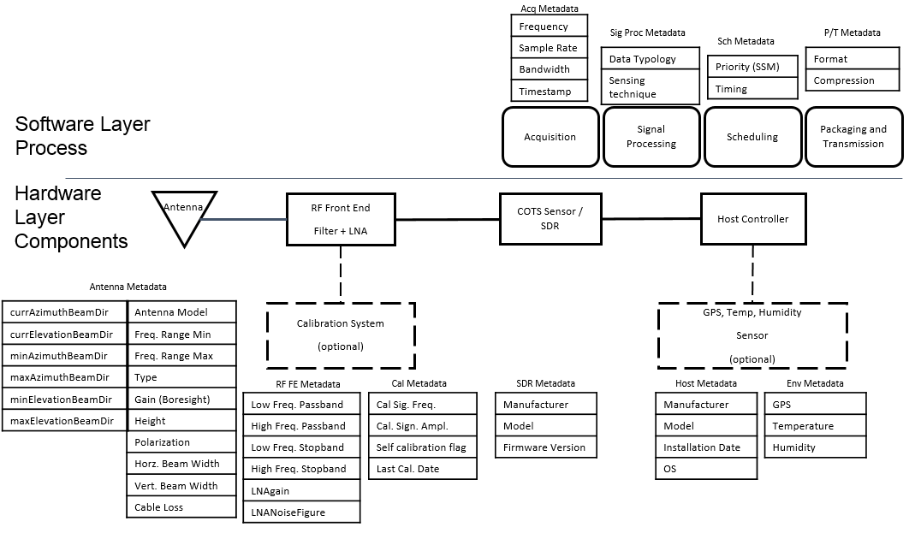
Figure 12 SD model - Hardware layer components and Software layer processes with relevant metadata

System Metadata
Class A (System Metadata) includes all factory information related pieces of data and remain constant for the entire lifespan of the component (SD). Taking into account the metadata reported in figure A1, Antenna Metadata, RF Front-End Metadata, Calibration Metadata, SDR Metadata, Host Metadata are included in this category.
Class A metadata is not subjected to any change since it is offered as a response to a specific query in SD association process.

Current Status Metadata
Class B (Current Status Metadata) includes data describing the actual configuration of the device, in terms of hardware (positioning, antenna configuration, etc.) and software (frequency settings, sampling rate, sensing algorithm, etc.).
Class B metadata is provided to TM, after a specific user request, and can be subjected to modification and special settings by the Tasking Agent.

Sensing related Metadata
Class C (Sensing related metadata), specifying parameters strictly related to performed sensing action (scanned time, timestamp, atmosphere conditions, etc.);
Class C metadata is not subjected to any change since it is offered as a response to a specific query in a Sensing request.

Data Types
This sub-clause defines the primitive data types, simple data types, and derived data types used in the definition of metadata defined in B.3. The physical units used in this definition are based on the International System of Units (SI) and are summarized in Table 1.

Table B1: Units used in the description of Metadata
Unit | Unit symbol | Value | Note
second | s |  | SI unit
Hertz | Hz | 1 Hz = 1/s | SI derived unit
meter | m |  | SI unit
Watt | W | kg•m2/s3 | SI derived unit
Power ratio | dB | [dB]=10•log10(P1[W]/P2[W]) | dimensionless
Power ratio respect to 1 mW | dBm | [dBm]=10•log10(P1[W]/1 mW) | dimensionless
radian | rad | 1 rad = 180/π | SI derived unit, dimensionless
degree of arc | ° | 1° = π/180 rad | dimensionless
Power ratio respect to isotropic antenna | dBi | [dBi]=10•log10(P1[W]/Pisotropic[W]) | dimensionless
Kelvin | K |  | SI unit

Simple data type
In this sub-clause are summarized the simple data type considered in this document.

Boolean
A primitive logical data type having one of two values of “true” (1, nonzero) or “false” (0, zero).

Integer
A primitive integral data type representing natural numbers and their negatives. Note that common binary representations limit the number range due to machine word length restrictions. In this standard, the integer length is defined as 32-bit value.

Unsigned integer
A primitive data type representing non-negative integers.

Float
A primitive data type storing real numbers, usually as floating-point numbers. Floating-point number representations as defined in IEEE Std 754TM-2008 can be taken as an example.

Array
A simple data type storing a collection of data values of a specified type.

String
A simple data type storing a sequence of bytes or characters. A string is a special use of a one-dimensional array.

Complex data types
This sub-clause summarizes complex data types such as structured types or types that rely on specific interpretation or restriction of the underlying simple type.

Enumeration
An enumeration is a listing of elements mapped to an index set consisting of natural numbers. That is, each element of the set is unambiguously represented by an ordinal value.

Cluster
A complex data type that aggregates a fixed set of labelled elements, possibly of different simple types, into a single element.

Fixed-point
Fixed-point numbers are rational numbers with a fixed length mantissa and a fixed exponent. In contrast to a floating-point representation, using a fixed length but variable exponent, the value range is limited by the mantissa length, but the resolution is constant over the value range. They can be realized by using an integer value in conjunction with an implicit multiplier.

Unsigned fixed-point
Unsigned fixed-point numbers are non-negative fixed-point numbers.

Description of metadata
Metadata descriptions are given in a tabular form throughout A.3.1 through A.3.21. They consist of the metadata name and ID, a short textual description, and a type and size specification, if needed.
⎯ Metadata name and ID
Metadata name provides a unique identification of the parameter in human readable form, whereas the numerical ID is given to unambiguously identify the metadata in the process of information exchange between SCOS entities.
⎯ Metadata type and size
Metadata types are of one of the types defined by A.2. Some parameters may be further restricted in their value range or magnitude. The size field of the parameter description is supplementary information that is either a fixed value, determined by the number of elements contained, or variable if at least one of the elements contained is optional, or is of variable size itself. To avoid implementation dependent specifications for metadata, size is always given in terms of the underlying type.
For metadata based on array types, the size is given as the number of elements stored in the array or as “variable” if the size of the array is unspecified. Note that variable size arrays demand for an implicit array length value in information exchange.
For cluster types, the aggregated size depends on the implementation of the elements enclosed and thus is omitted in the parameter description. The implementation then will decide on the binary representation, encoding, and size in terms of bits or bytes and any tag or length values needed.
Table 2 provides a summary of metadata and categorizes them into each of the three classes introduced in .1.
Table B2: Summary of metadata

ID | Metadata name | Sub-clause | Class A | Class B | Class C
001 | Antenna | B.3.1 | X
002 | Curr.Azi.Beam.Dir. | B.3.2 |  | X
003 | Curr.Elev.Beam.Dir. | B.3.3 |  | X
004 | Front-End | B.3.4 | X
005 | Cal | B.3.5 | X
006 | SDR | B.3.6 | X
007 | Host | B.3.7 | X
008 | Env | B.3. |  |  | X
009 | RGeolocation | B.3.9 |  |  | X
010 | Frequency | B.3.10 |  | X
011 | Sampl.Rate | B.3.11 |  | X
012 | Bandwidth | B.3.12 |  | X
013 | Timestamp | B.3.13 |  |  | X
014 | Scan.Time | B.3.14 |  |  | X
015 | Data.Typology | B.3.15 |  |  | X
016 | Sens.Algorithm | B.3.16 |  | X
017 | Priority | B.3.17 |  | X
018 | Timing | B.3.18 |  | X
019 | Compression | B.3.19 |  |  | X
020 | Format | B.3.20 |  |  | X
021 | SDName | B.3.21 | X
022 | SCOSOperator | B.3.22
023 | SDMode | B.3.23 |  | X
024 | SDType | B.3.24 | X
025 | SDID | B.3.25 | X
026 | SDCert | B.3.26 | X

Antenna
The Antenna metadata indicates specifications of the antenna as given by the manufacturer. The definition of each parameters and the related unit of measurements are described in table B.3.

Metadata name: | Antenna | Meas. Unit: | -------- | Data type: | Cluster
ID: | 001 | Size: | Variable
Desc.: | List of the Antenna specifications according to manufacturer specifications.
.0 | Antenna.Model | Data type: | String
.1 | Antenna.Freq.min | Data type: | Unsigned fixed-point
.2 | Antenna.Freq.max | Data type: | Unsigned fixed-point
.3 | Antenna.Type | Data type: | String
.4 | Antenna.Gain | Data type: | Float
.5 | Antenna.Polarization | Data type: | Enumeration
.6 | Antenna.Height | Data type: | Float
.7 | Antenna.Horz.Beam.Width | Data type: | Fixed-point
.8 | Antenna.Vert.Beam.Width | Data type: | Fixed-point
.9 | Antenna.Min.Azi.Beam.Dir. | Data type: | Unsigned fixed-point
.10 | Antenna.Max.Azi.Beam.Dir. | Data type: | Unsigned fixed-point
.11 | Antenna.Min.Elev.Beam.Dir. | Data type: | Fixed-point
.12 | Antenna.Max.Elev.Beam.Dir. | Data type: | Fixed-point
.13 | Antenna.Cable.Loss | Data type: | Float
.14 | Reserved (for future use)

Table B3: Antenna metadata parameters description
Name | Content |  |  |  | Meas. Unit:
Antenna.Model | It contains a string with the model of the installed antenna |  |  |  | -----
Antenna.Freq.min | Min input frequency value |  |  |  | Hz
Antenna.Freq.max | Max input frequency value |  |  |  | Hz
Antenna.Type | Antenna type |  |  |  | -----
Antenna.Gain | Antenna gain |  |  |  | dBi
Antenna.Polarization | Antenna polarization |  |  |  | -----
 | Enumerator  Enumerator  Enumerator  Enumerator  Enumerator | “VL”  “HL”  “LHC”  “RHC”  “Slant” | Value:  Value:  Value:  Value:  Value: | 0  1  2  3  4
Antenna.Height | Antenna height |  |  |  | m
Antenna.Horz.Beam.Width | Horizontal 3-dB beamwidth |  |  |  | ° (degree)
Antenna.Vert.Beam.Width | Vertical 3-dB beamwidth |  |  |  | ° (degree)
Antenna.Min.Azi.Beam.Dir. | minimum direction of main beam in azimuthal plane expressed in degrees from N |  |  |  | ° (degree)
Antenna.Max.Azi.Beam.Dir. | maximum direction of main beam in azimuthal plane expressed in degrees from N |  |  |  | ° (degree)
Antenna.Min.Elev.Beam.Dir. | minimum direction of main beam in elevation plane expressed in degrees from horizontal plane |  |  |  | ° (degree)
Antenna.Max.Elev.Beam.Dir. | maximum direction of main beam in elevation plane expressed in degrees from horizontal plane |  |  |  | ° (degree)
Antenna.Cable.Loss | Attenuation introduced by the cable that connects the antenna with the RF front-end |  |  |  | dB

Current Azimuth Beam Direction
Current Azimuth Beam Direction indicates the current direction of the antenna main beam in azimuthal plane. It is expressed in degrees from N and it is included in a range that has Antenna.Min.Azi.Beam.Dir. as lower boundary and Antenna.
Metadata name: | Curr.Azi.Beam.Dir | Meas. Unit: | ° (degree) | Data type: | Unsigned fixed-point
ID: | 002 | Size: | 1
Desc.: | It indicates the current direction of the antenna main beam in azimuthal plane.
 | Range (min/resolution/max) |  | Antenna.Min.Azi.Beam.Dir. | 1° | Antenna.Max.Azi.Beam.Dir.

Current Elevation Beam Direction
Current elevation Beam Direction indicates the current direction of the antenna main beam in elevation plane. It is expressed in degrees from horizontal plane and it is included in a range that has Antenna.Min.Elev.Beam.Dir. as lower boundary and Antenna.Max.Elev.Beam.Dir. as upper boundary.
Metadata name: | Curr.Azi.Beam.Dir | Meas. Unit: | ° (degree) | Data type: | Fixed-point
ID: | 003 | Size: | 1
Desc.: | It indicates the current direction of the antenna main beam in elevation plane.
 | Range (min/resolution/max) |  | Antenna.Min.Elev.Beam.Dir. | 1° | Antenna.Max.Elev.Beam.Dir.

RF Front-End Metadata
The RF Front-End metadata indicates specifications of the RF front-end as given by the manufacturer. The definition of each parameters and the related unit of measurements are reported in table A4.
Metadata name: | Front-End | Meas. Unit: | -------- | Data type: | Cluster
ID: | 004 | Size: | Variable
Desc.: | List of the RF Front-End specifications according to manufacturer specifications.
.0 | Front-End.Low.Freq.Passband |  | Data type: |  |  | Unsigned fixed-point
.1 | Front-End.High.Freq.Passband |  | Data type: |  |  | Unsigned fixed-point
.2 | Front-End.Low.Freq.Stopband |  | Data type: |  |  | Unsigned fixed-point
.3 | Front-End.High.Freq.Stopband |  | Data type: |  |  | Unsigned fixed-point
.4 | Front-End.LNA-Gain |  | Data type: |  |  | Float
.5 | Front-End.LNA-NF |  | Data type: |  |  | Float
.6 | Reserved (for future use)

Table B4: Front-End metadata parameters description
Name | Content | Meas. Unit:
Front-End.Low.Freq.Passband | Low passband frequency evaluated at -1 dB | Hz
Front-End.High.Freq.Passband | High passband frequency evaluated at -1 dB | Hz
Front-End.Low.Freq.Stopband | Low stopband frequency evaluated at -60 dB | Hz
Front-End.High.Freq.Stopband | High stopband frequency evaluated at -60 dB | Hz
Front-End.LNA-Gain | Low Noise Amplifier Gain | dB
Front-End.LNA-NF | Noise Figure of Low Noise Amplifier | dB

Calibration Metadata
Calibration metadata contains information about last calibration date of SD and, if it is able to execute self-calibration procedure, it also contains information about the reference signal generator built in. The definition of each parameters and the related unit of measurements are reported in table A5.
Metadata name: | Cal | Meas. Unit: | -------- | Data type: | Cluster
ID: | 005 | Size: | Variable
Desc.: | List of calibration parameters according to manufacturer specifications.
.0 | Cal.Last.Cal.Date |  | Data type: |  |  | Unsigned integer
.1 | Cal.Self.Cal.Flag |  | Data type: |  |  | Boolean
.2 | Cal.Sig.Freq |  | Data type: |  |  | Unsigned fixed-point
.3 | Cal.Sig.Ampl |  | Data type: |  |  | Float
.4 | Reserved (for future use)

Table B5: Calibration metadata parameters description
Name | Content | Meas. Unit:
Cal.Last.Cal.Date | The time stamp of the last calibration. It is denoted as a basic reference time value. Seconds since midnight (UTC) of January 1, 1970 absolute time. | s
Cal.Self.Cal.Flag | This is set to “1” if the sensor performs a periodical self-calibration procedure. Otherwise it is set to “0” if the self-calibration is performed after a user request. | -----
Cal.Sig.Freq | Frequency of the internal calibration source. If the SD is not equipped with an internal calibration source this parameter is set to the default value 0. | Hz
Cal.Sig.Ampl | Amplitude of the internal calibration source. If the SD is not equipped with an internal calibration source this parameter is set to the default value 0. | dB

A.3.6 SDR Metadata
SDR metadata contains information about SD computing hardware specifications as given by the manufacturer. The definition of each parameters and the related unit of measurements are reported in table A6.

Metadata name: | SDR | Meas. Unit: | -------- | Data type: | Cluster
ID: | 006 | Size: | Variable
Desc.: | List of SDR parameters according to manufacturer specifications.
.0 | SDR.Manufacturer |  | Data type: |  |  | String
.1 | SDR.Model |  | Data type: |  |  | String
.2 | SDR.Firmware |  | Data type: |  |  | String
.3 | Reserved (for future use)

Table B6: SDR metadata parameters description
Name | Content | Meas. Unit:
SDR.Manufacturer | SD manufacturer | -----
SDR.Model | SD model | -----
SDR.Firmware | Current firmware version | -----

Host Metadata
Host metadata contains information about the host controller of the SD. The host controller can be included in SD hardware or cab an external device that control and drives the sensor. The definition of each parameters and the related unit of measurements are reported in table A7.
Metadata name: | Host | Meas. Unit: | -------- | Data type: | Cluster
ID: | 007 | Size: | Variable
Desc.: | List of Host parameters according to manufacturer specifications and installation.
.0 | Host.Manufacturer |  | Data type: |  |  | String
.1 | Host.Model |  | Data type: |  |  | String
.2 | Host.OS |  | Data type: |  |  | String
.3 | Host.Inst.Date |  | Data type: |  |  | Unsigned integer
.4 | Reserved (for future use)

Table B7: Host metadata parameters description
Name | Content | Meas. Unit:
Host.Manufacturer | Manufacturer of the host | -----
Host.Model | Model of the host | -----
Host.OS | Operating system installed on the host | -----
Host.Inst.Date | The date when SD has been installed. It is denoted as a basic reference time value. Seconds since midnight (UTC) of January 1, 1970 absolute time. | s

Environmental Metadata
Environmental metadata reports information about the environmental conditions experienced during the measurement process. The definition of each parameters and the related unit of measurements are reported in table A8.
Metadata name: | Env | Meas. Unit: | -------- | Data type: | Cluster
ID: | 008 | Size: | Variable
Desc.: | List of Environment parameters.
.0 | Env.Temperature |  | Data type: |  |  | Float
.1 | Env.Humidity |  | Data type: |  |  | Float
.2 | Reserved (for future use)

Table B8: Environmental metadata parameters description
Name | Content | Meas. Unit:
Env.Temperature | Environmental temperature | K
Env.Humidity | Environmental humidity | g/m³

Reference Geolocation
This metadata indicates an absolute position of SD. This position is denoted considering the WGS 84 reference coordinate system or its successors (see Office of Geomatics, at www.earth-info.nga.mil). The definition of each parameters and the related unit of measurements are reported in table B8.
Metadata name: | RGeolocation | Meas. Unit: | -------- | Data type: | Cluster
ID: | 009 | Size: | 3
Desc.: | Basic reference geolocation parameter indicating the absolute geolocation of a SD based on the WGS 84 reference coordinate system or its successors.
.0 | RGeolocation.Elev |  | Data type: |  |  | Integer
.1 | RGeolocation.Lat |  | Data type: |  |  | Fixed-point
.2 | RGeolocation.Long |  | Data type: |  |  | Fixed-point

Table A9: Reference geolocation metadata parameters description
Name | Content | Meas. Unit:
RGeolocation.Elev | Elevation is the altitude with respect to sea level. | m
RGeolocation.Lat | Latitude | ° (degree)
RGeolocation.Long | Longitude | ° (degree)

Frequency
Frequency denotes the center frequency of the channel where the SD is currently tuned. This parameter is given in Hz. It is realized as an unsigned fixed-point value assuming a resolution of 1 Hz and a maximum range of 0 to 2³²–1 Hz (i.e., the equivalent of a 32-bit mantissa)
Metadata name: | Frequency | Meas. Unit: | Hz | Data type: | Unsigned fixed-point
ID: | 010 | Size: | 1
Desc.: | It denotes the center frequency of the channel where the SD is currently tuned.
 | Range (min/resolution/max) |  | 0 Hz | 1 Hz | (2³²–1) Hz

Sample rate
It is the current sampling rate adopted during the signal acquisition process. This parameter is given in Hz. It is realized as an unsigned fixed-point value assuming a resolution of 1 Hz and a maximum range of 0 to 2³²–1 Hz (i.e., the equivalent of a 32-bit mantissa).
Metadata name: | Samp.Rate | Meas. Unit: | Hz | Data type: | Unsigned fixed-point
ID: | 011 | Size: | 1
Desc.: | It denotes the current sampling rate adopted during the signal acquisition process.
 | Range (min/resolution/max) |  | 0 Hz | 1 Hz | (2³²–1) Hz

Bandwidth
Bandwidth denotes the width of the channel where the SD is currently tuned. This parameter is given in Hz. It is realized as an unsigned fixed-point value assuming a resolution of 1 Hz and a maximum range of 0 to 2³²–1 Hz (i.e., the equivalent of a 32-bit mantissa).

Metadata name: | Samp.Rate | Meas. Unit: | Hz | Data type: | Unsigned fixed-point
ID: | 011 | Size: | 1
Desc.: | It denotes the current sampling rate adopted during the signal acquisition process.
 | Range (min/resolution/max) |  | 0 Hz | 1 Hz | (2³²–1) Hz

Timestamp
Timestamp denotes the time instant in which the SD has completed the acquisition.
Metadata name: | Timestamp | Meas. Unit: | s, μs | Data type: | Cluster
ID: | 013 | Size: | 2
Desc.: | It is the time instant in which the SD has completed the acquisition. It is denoted as a basic reference time value. Seconds since midnight (UTC) of January 1, 1970.
.0 | Timestamp.s |  | Data type: |  |  | Unsigned integer
.1 | Timestamp.us |  | Data type: |  |  | Unsigned integer

Scanned Time
This metadata denotes the amount of time that the SD has employed to perform the sensing operation in a channel or set of channels.
Metadata name: | Scan.Time | Meas. Unit: | ms | Data type: | Unsigned fixed-point
ID: | 014 | Size: | 1
Desc.: | It denotes the amount of time that the SD has employed to perform the sensing operation in a channel or set of channels.
 | Range (min/resolution/max) |  | 0 ms | 1 ms | (2³²–1) ms

Data Typology
This metadata denotes the description of the received data domain.
Metadata name: | Data.Typology | Meas. Unit: | -------- | Data type: | Enumeration
ID: | 015 | Size: | 1
Desc.: | Unique identification of the possible data typology of the received data.
Enumerator | I/Q.Time |  | Value: |  |  | 0
Enumerator | FFT |  | Value: |  |  | 1
Enumerator | PSD |  | Value: |  |  | 2
Enumerator | I/Q.Freq |  | Value: |  |  | 3
Enumerator | Time.sample |  | Value: |  |  | 4
Enumerator | Occupied |  | Value: |  |  | 5
Note: FFT stands for Fast Fourier Transform and PSD stands for Power Spectral Density. I/Q.Time and I/Q.Freq denote the I/Q sample in time domain and the spectrum of the I/Q component, respectively. Time.sample is the acquired signal and occupied is used if the output is Boolean variable (the SD has scanned only one channel) or an array of Boolean variables (the SD has scanned more than one channel). “1” means that the scanned channel is occupied “0” otherwise.

Sensing Technique
It denotes the sensing technique currently adopted by the SD.
Metadata name: | Sens.Algorithm | Meas. Unit: | -------- | Data type: | Enumeration
ID: | 016 | Size: | 1
Desc.: | Unique identification of the sensing technique currently adopted by the SD.
Enumerator | Cyclostationarity |  | Value: |  |  | 0
Enumerator | Energy.detection |  | Value: |  |  | 1
Enumerator | Custom |  | Value: |  |  | 2

Priority
Priority denotes the scheduling scheme used for incoming request.
Metadata name: | Priority | Meas. Unit: | -------- | Data type: | Enumeration
ID: | 017 | Size: | 1
Desc.: | Unique identification of the priority criterium currently employed by the SD.
Enumerator | FCFS |  | Value: |  |  | 0
Enumerator | RR |  | Value: |  |  | 1
Enumerator | Custom |  | Value: |  |  | 2
Note: FCFS stands for First Come First Served and RR stands for Round Robin.

Timing
Timing metadata denotes how the SD currently manages the sensing request that it receives.
Metadata name: | Timing | Meas. Unit: | -------- | Data type: | Enumeration
ID: | 018 | Size: | 1
Desc.: | Unique identification of the timing criterium currently employed by the SD.
Enumerator | On.Demand |  | Value: |  |  | 0
Enumerator | Timed.with.periodicity |  | Value: |  |  | 1

Compression
Compression metadata denotes the compression algorithm used in order to reduce the amount of data to transmit.
Metadata name: | Compression | Meas. Unit: | -------- | Data type: | Enumeration
ID: | 019 | Size: | 1
Desc.: | Unique identification of the compression algorithm used by the SD in order to reduce the amount of data to transmit.
Enumerator | LZ |  | Value: |  |  | 0
Enumerator | DEFLATE |  | Value: |  |  | 1
Note: LZ is the Lempel-Ziv compression method.

Format
Format metadata denotes data transmission format used for data transmission by the SD.
Metadata name: | Format | Meas. Unit: | -------- | Data type: | Enumeration
ID: | 020 | Size: | 1
Desc.: | Unique identification of the data transmission format used for data transmission by the SD.
Enumerator | Little.Endian |  | Value: |  |  | 0
Enumerator | Big.Endian |  | Value: |  |  | 1

Sensing device name
This metadata denotes the name of the sensing device registered with SCOS operator.
Metadata name: | SDName | Meas. Unit: | ----- | Data type: | String
ID: | 021 | Size: | 1
Desc.: | It denotes the name of the sensing device registered with SCOS operator.

SCOS operator
It denotes the name of the SCOS operator.
Metadata name: | SCOSOperator | Meas. Unit: | ----- | Data type: | String
ID: | 022 | Size: | 1
Desc.: | It denotes the name of the SCOS operator.

SD Mode
This metadata indicates the mode in which the SD is currently operating.
Metadata name: | SDMode | Meas. Unit: | -------- | Data type: | Enumeration
ID: | 023 | Size: | 1
Desc.: | Unique identification of the mode in which the SD is currently operating.
Enumerator | Mode 0 (reserved) |  | Value: |  |  | 0
Enumerator | Tasking Mode |  | Value: |  |  | 1
Enumerator | Heartbeat Mode |  | Value: |  |  | 2
Enumerator | Offline Mode |  | Value: |  |  | 3
Enumerator | Reporting Mode |  | Value: |  |  | 4

Type of the sensing device
This metadata indicates the type of SD.
Metadata name: | SDType | Meas. Unit: | -------- | Data type: | Enumeration
ID: | 024 | Size: | 1
Desc.: | Unique identification of the SD type.
Enumerator | SD.Full |  | Value: |  |  | 0
Enumerator | SD.Proxy |  | Value: |  |  | 1

Sensing Device ID
This metadata indicates the unique ID associated to the SD.
Metadata name: | SDID | Meas. Unit: | -------- | Data type: | Unsigned integer
ID: | 025 | Size: | 1
Desc.: | The unique ID assigned to the sensing device.

SD certificate file
This metadata gives information about certificate file of the considered SD.
Metadata name: | SDCert | Meas. Unit: | ----- | Data type: | Cluster
ID: | 026 | Size: | 3
Desc.: | It gives information about certificate file of the considered SD.
.0 | SDCert.Path |  | Data type: |  |  | String
.1 | SDCert.Name |  | Data type: |  |  | String
.2 | SDCert.Cert.Auth |  | Data type: |  |  | String

SD Task Control metadata

Scheduler Specification
Algorithm | Value | Notes
Unspecified | 0
Host Controller | 1
Embedded Job Controller | 2
Multilevel | 3

SD Output Specification
Algorithm | Value | Notes
Unspecified | 0 | Invalid
Time domain IQ | 1 | Default
Freq. domain IQ | 2
Time domain Amp, Phase | 3
Freq. domain Amp, Phase | 4

SCOS Association Metadata
Following table enumerates sensing device metadata for associating with SCOS.
Parameter | R/O/C | Description
NAME: SDName DATATYPE: string | Required | The name of the sensing device registered with SCOS operator.  The maximum length is 64 octets.
NAME: SCOSOperator DATA TYPE: string | Required | The name of the SCOS operator.  The maximum length is 64 octets.
NAME: SDMode DATA TYPE: Integer | Required | The mode in which sensing device operates. (1=online, 2=offline)
NAME: SDType DATA TYPE: Integer | Required | The type of the sensing device. (1=SDFull, 2=SDProxy)
NAME: SDID DATA TYPE: string | Required | The unique ID assigned to the sensing device. The maximum length is 64 octets.
NAME: SDCertFile  DATA TYPE: String | Required | The path of the SD certificate file.  The maximum length of the ID string is 256 octets.
NAME: SDKeyFile  DATA TYPE: String | Required | The name of the SD certificate file.  The maximum length of the ID string is 256 octets.
NAME: SDCAFile  DATA TYPE: String | Required | The name of the trusted certificate authority.  The maximum length of the ID string is 256 octets.

Normative Functional Requirements

Data Quality and Definition
Data acquired must be accompanied by adequate metadata information to allow for duplication of the measurement or assessment of data quality by a subject matter expert. Hardware specification and measurement parameters are to be included in the messaging metadata requirements. Information less amenable to metadata capture should be made available via appropriate and accessible documentation, e.g., algorithm described via written article with source code in Github repository.

Regulatory requirements
This standard should provide mechanisms to meet the regulatory requirements of national operators that have defined parameters or requirements for spectrum sensing in various applications. These regulatory requirements would take two forms: the first is technical requirements for sensitivity, resolution, etc. The second is limitations on how and where sensing might be done where there are sensitivities around privacy, military use and other national policies and regulations.

Policy Management and Enforcement Requirements
To allow for granularity in what the SCOS systems can do, but also ensure spectrum occupancy or utilization data is not exposed in contravention of national policy or regulation, it is proposed that the TM would be able to apply policies to allow or disallow certain functionality in the SDs, or disallow transmission of the data to third party systems.
These policies would be determined by the TM operator in accordance with their requirements and that of local authorities (e.g. a national regulator or network operator), and cascaded down to any connected SDs. These policies would allow sensing only according to allowed metrics (e.g. no hi-resolution raw scans in military radar bands), and limit sensing data transmission to certain classes of third party systems.

Sensor Location-Fixing Requirements
The SCOS device can convey the location of the sensors to the aggregation entity such as the TM. The instruction to use available location capabilities on the SD (e.g. GPS location) will be part of the scan schedule instruction from the Data Client requiring the scan. This feature allows the TM or the aggregation entity to localize the proximity of the signal source location allowing more efficient spectrum management. This location fixing capability will be implemented by the system operator to be in accordance with local regulatory requirements.
Location can be fixed in four ways:
- At scan-time from lat/long co-ordinates from internal GPS, GLONASS or similar system
- Configured at startup-time from lat/long co-ordinates from internal GPS, GLONASS or similar system
- Configured on SD by authorised/certified installer at commissioning time with accurate lat/long coordinates
- Configured on SD by authorised/certified installer at commissioning time with street address/location
The type of location fix is specified in device metadata

Service Level Agreement Requirements
To be completed (contributions needed).

Certification Requirements
To be completed (contributions needed).

Technical Requirements

Device classes and complexity
The following sensing device categories may be considered:
- Energy Efficient Sensing Devices: This standard should provide mechanisms of energy efficient operations, eg. solar powered or battery operated spectrum sensors for monitoring applications.
- Small form factor devices: Devices that can fit the spectrum sensing function within a small form factor (e. g. a USB dongle, cell phone etc.)
- Advanced Spectrum Sensing Devices: Advanced Spectrum Sensing Devices with capable Radio Frequency Front Ends (RFFE) and dedicated resources for spectrum sensing may be considered.
- Non-dedicated Devices with Sensing Capability: A number of consumer and professional radio devices contain radio receivers that can be used as sensing devices, including mobile phone handsets, Wi-Fi access points (from 802.11ac) and Dynamic Spectrum Access radio systems (including 802.22).

Number of devices
This standard shall support at least one Spectrum Sensing Device to cover a location or area, communicating with a back-end Spectrum Sensing Management System (TM), but will extend to describing an architecture and interfaces for multiple SDs potentially communicating with multiple TM instances.

Real-time applications
The sensing devices will be performing spectrum sensing functions according to its scheduler (which is managed by its TM), which can be updated in near-real time (dependent on speed of communication between Data Client, TM and SD), or perform scans at scheduled intervals based on pre-configured schedules. However, the spectrum sensing reporting of data is out on a Best Effort basis, since the SCOS System uses the chosen available transport mechanism (e. g. 802.11, 802.22, Ethernet, Cable, Cellular etc.).
The SCOS system will benefit if sensing reports from various sensors are provided on a reasonable time-scales (e. g. minutes) so that the information is not stale. However, this is not a mandatory requirement. Also, the messaging format may be defined such that it does not produce excessive overhead penalty on the transport layer being used.
It is envisioned that real-time streaming will be provided for in future drafts of 802.22.3.

Channelization
This standard may specify a Spectrum Manager entity that can command various sensors to go and sense in certain bands, or it may even specify the spectrum sensors to ignore certain bands from sensing, and impose channelization maps for sensors to meet local regulations or technical requirements.
Specific channelization maps may be provided in future drafts of 802.22.3.

Security Requirements
The standard mandates secure authentication and authorisation between Data Client and TM, SD and TM, TM and Data Manager, and Data Manager and DC. Traffic between these components must also be encrypted. The specific security technology to be used is not mandated in this standard, but recommended best practices are described in Annex B. Note that the security model does not extend past transmission to the DC. Responsibility for securing the spectrum data at destination remains the responsibility of the operator of that store.
The technology model is designed to ensure that data derived from SCOS devices and TM are not used as an attack vector against White Space Databases, regulator spectrum management databases, etc. It is also designed to ensure that only authorised Data Clients can make use of the SCOS resources, and that they are correctly identified to enable correct application of the relevant system policies.

In each case, the security model must address:
(1) Data categorization (i.e. sensitivity/confidentiality of scan data)
(2) Access control - authorization and authentication (of each element when interacting with another)
(3) Logging and auditing (of instructions, tasks, access control)
(4) Data encryption (within devices and in transmission)
(5) System and information integrity (validation of device configuration, storage system)

(NOTE: Section to be developed further. Contribution needed)

Intra-device Layer Security (physical interfaces)
This standard defines security mechanisms to ensure integrity of sensing chain from antenna to DC.

- Antenna to amplifier/filters: physical security of device in terms of cable/connectors (tampering such as substituting antenna, physical such as connector corrosion)
- Amplifier to SDR: cable connectors or PCB connections
- SDR to processing unit: cable connectors or PCB connections
- Enclosure for active elements: Protection against moisture, dust ingress. Screening against RFI from external sources. Screening to protect antenna elements against RFI from active elements.

(NOTE: Section to be developed further. Contribution needed)

Inter-Layer Security

Network Layer
Since this standard uses any available transport mechanism for data transmission, it will not recommend its own security mechanisms, but will use the existing security mechanisms of the transport mechanism being used (e.g. network 802.11 using Transport Layer Security,

Application Layer
Data transmissions should be secured on the application layer using mechanisms to guarantee the integrity and confidentiality of sensing and control data transmissions. This standard does not specify the technology used, but recommended implementation practices are noted in Annex B: Device and System Security Recommendations.

Security of sensed data
This Standard shall not support mechanisms that expose data of radio system users that are modulated onto signals that are examined by the 802.22.3 SCOS System. For example, any kind of demodulation of the signals that may interfere with the privacy of the radio system users shall not be not be supported. However, the SCOS system shall support sophisticated spectrum sensing methods such as cyclostationary processing that can detect signals and characterize their modulation type.

Security of analyzed or characterized spectrum data
This Standard shall support security mechanisms to ensure that spectrum characterization data is transmitted to the destination DC in a secure way. This Standard shall not specify the security mechanisms used to protect this data once received by the DC – this is implementation and system user specific.

Transport Mechanism Requirements

SCOS Operational Modes
To allow great system flexibility with ability to meet multiple unknown use cases, but also allow a simplified task-specific operational use, two Operational Models are proposed:
Mode 1 (Tasking Mode):
This is a full-featured mode suitable for a wide variety of applications, where the TM acts as a management device to allow multiple different users (DCli’s) to do chosen scan activities on a single or distributed set of SDs. This mode incorporates the full set of functions of the standard.
Mode 2 (Heartbeat Mode):
This mode is suitable for cognitive radio implementations, where a sensing device is used in a semi-fixed configuration, reporting channel occupancy to the radio management system over heartbeat messages for low overhead, with some capability to perform specific scans as a task when instructed by a DCli through the TM to let a radio supervisor system request a detailed custom scan.
Mode 2 is a subset of Mode 1, using the same interfaces, primitives and protocols, but typically operating in a fixed configuration for most of the time.
Mode 3 (Offline Mode):
Offline mode would be used where the Sensing Device(s) are operating without constant connection to the SM or other control systems. This mode would enable Sensing Devices to be given a task schedule when they associate with the SM, and then be able to operate offline from the SCOS management systems for long periods of time, storing data locally on the SD itself, and synchronizing data and tasks later when re-associated to management systems.
Mode 3 uses all of the command and control methods available in other modes, but where there is modification made to timeouts or other operational parameters in the control systems.
Mode 4 (Reporting Mode):
Mode 4 is a “passive listening” mode that is light (control plane supports authentication and “start/stop” and “user/destination” messages; or ultralight mode which only supports data plane transport.
This mode is intended for systems that have sensing capability, and can transmit sensing data back to the Data Manager according to a fixed configuration, and where a sensing task is established by the owner/operator of the sensing device either manually or a simple control mechanism.
This mode would be suited to network operator radio equipment that has sensing capability, but is not part of a SCOS network as proposed in this standard. The data provided by devices in this mode would be used as data gathering units by network operators and national regulators, provided through transmission of a regular set of scans in the bands that equipment is designed to provide transceiver services in. Examples could be 3GPP-compliant mobile base stations, or Wi-Fi equipment with sensing (e.g. 802.11ac).

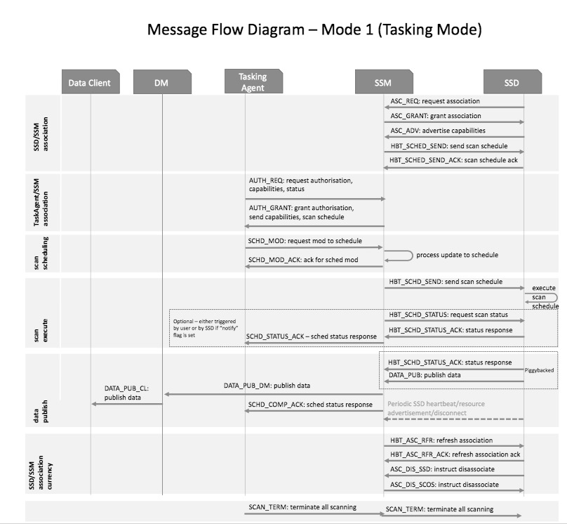

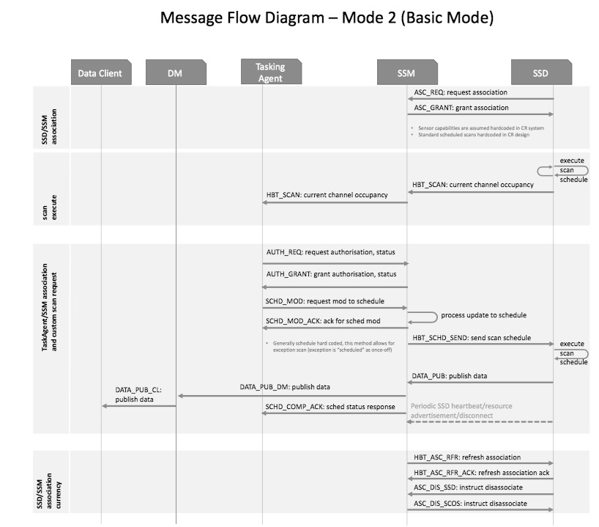

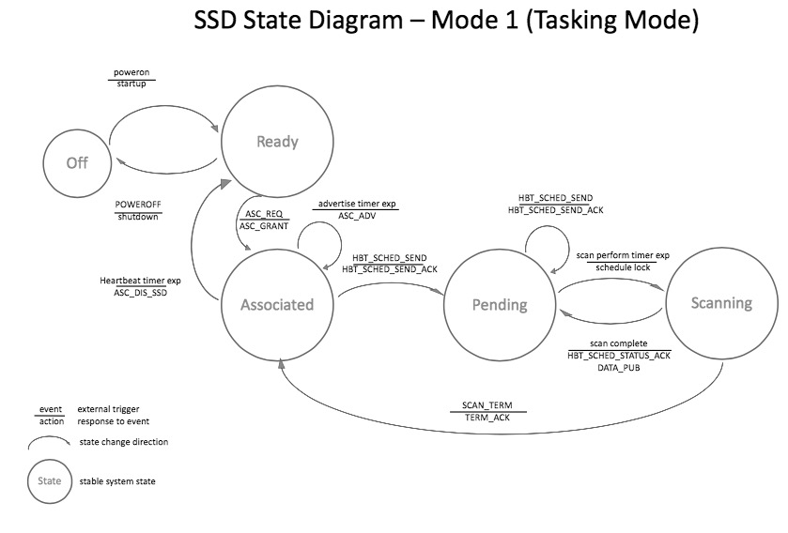

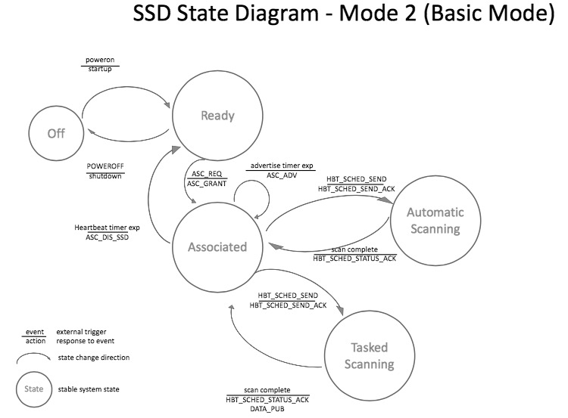

SCOS Topology Examples
An SCOS system consists of a single TM, a single DM which communicate over any standard network transport with one or more SDs, DClis, and DCs.
Figure 13: SCOS System Topologyillustrates the above described SCOS system topology.
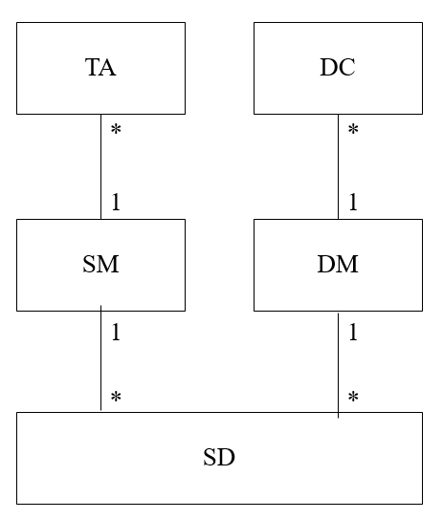
Figure 13: SCOS System Topology

Non 802.22.3 compliant SDs and SCOS Cascading
The 802.22.3 SCOS standard makes provision for proxying, that allows a non 802.22.3 compliant SD to associate with and be controlled by an TM, as well cascading of systems, where one 802.22.3 compliant TM to be associated with, and delegate tasks to, another 802.22.3 SCOS system.
SD Proxy facilitates an TM communicate with proprietary sensing hardware, acting as a software translation mechanism that translates between SCOS messages.
TM Proxy enables cascading of SCOS systems where an TM can communicate with other SMs as if they were associated SDs.
Figure 14 illustrates the extensions with an instance of system topology.
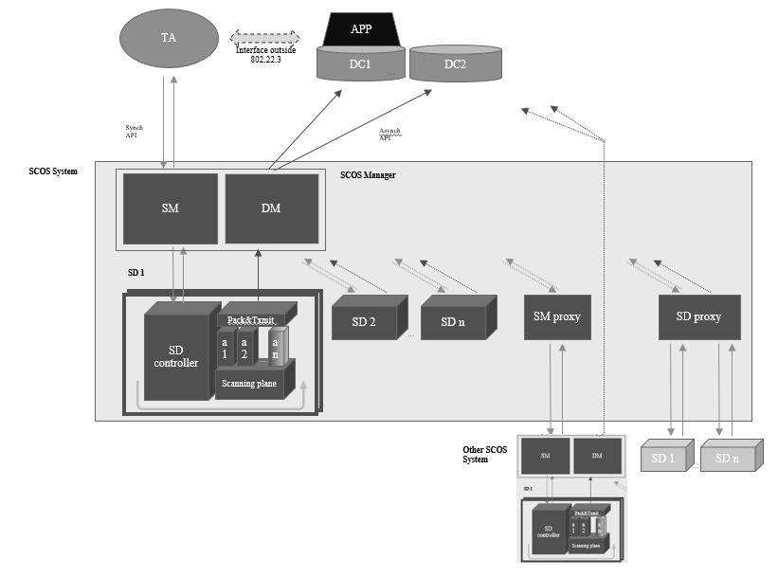
Figure 14: An SCOS System Instance with Extensions

System Policy Model

SCOS Policy
A policy layer in the TM at the northbound and southbound API will ensure that the TM is operated within requirements of a local authority (national regulator, law enforcement, military, etc).
The policy on the southbound interface will determine, based on the USER type, (e.g. how a central authority can define what kinds of sensing can be done in what bands, what data governance rules there are, etc
-- resource allocation – what kinds of users are authorized to request resources from the sensor network and in which priority (i.e. if a sensing network is resource constrained, who gets first dibs on the sensors)
Policy on the northbound interface (TM>DBstore) will have rules for how sensing data may be distibuted, and data storage policies. This would include which scan data takes priority if local storage in the store & forward buffer is running out due to a failed transmission link, and how long certain USER data is allowed to be stored in the local store & forward buffer.
Based on SCOS platform architecture, the SCOS policy is categorized based into following categories:
- Spectrum Task Manager (TM) Policy
- Spectrum Sensing Device (SD) Policy
- Sensing Data Manager (DM) Policy
- SCOS Platform Administration (SPA) Policy
- SCOS Platform User (SPU) Policy

The SCOS policy is expressed using JSON. Following subsection provides details about the schema of SCOS policy.

The SCOS policy schema:
Each SCOS policy is associated with a policy-name, policy-namespace, policy-category, policy-scope, optional policy-description, and one or more statement(s).
Following figure shows the structure of a SCOS policy.

SCOS Policy

Top-level attributes
Statement
Statement
Statement

StatementId
Policy-Action
Actor
Resource
SCOS-Task
Condition-Block
Figure 15 High-level structure of the SCOS Policy

Example:
{
# "Version": "2017-02-15",
"Policy": {
"namespace": "OperatorFoo",
"name": "Calibration-access-control",
"description": "This policy added by FooAdmin On this date."
"Policy-type": "SPA-Policy",
"Policy-Action": "permit",
"Resource": "Foo:Sensors::*"
"SCOS-Task": "Calibration-operation"
"Scope": "Sensor-management:"
"Condition": {
"equals" : {
"Actor" : "FooAdminRole"
}
}
}

The default namespace is global. Specific-Namespaces could be used to restrict the application of policy within a certain context. Namespaces avoids name collisions and enables to identify actors or resources uniquely (when the names have been reused across namespaces).

SCOS Policy Statement
Each statement specifies certain action. Different categories of SCOS-Policies are associated with different actions.
A statement may also have optional attributes that identify the context of applying the policy. These attributes allow specifying a fine-grained policy. Example context-attributes are Actor, Resource, SCOS-Task, time, frequency, and location.
A statement has an optional condition-block. The action is performed only when the condition(s) are matched.

Data Client
A Data Client is an entity that wishes to use the SCOS platform. A Taskin Agent could be specified in terms of role, user, or a user-group.

User
An user is an individual Data Client with specified name and access-credentials.

User-group
A user-group is a logical collection of users. A user-group is specified with name and access-credentials.

Role
A role is specified with a name. The role could be associated with specific SCOS services/functionality. A role could also be associated with privilege of various users of SCOS platform.
An user (or a user-group) is associated a role.

Resource
SD and Sensing data are two prime resources within SCOS platform.

Resource-group
Multiple SDs could be grouped together to jointly specify policies for using the SDs. SDs could possibly be grouped based on various attributes such as location, SD-hardware-type, SD-software-type.

Namespace
Actors or resources are associated with a namespace. This avoids name collisions and enables to identify actors or resources uniquely (when the names have been reused across namespaces).

SCOS-Task
An SCOS-task represents a specific sensing-task within SCOS platform issued by a particular Actor on particular resources. Additionally, a policy may specify pre-defined SCOS operations in the SCOS-Task. These predefined SCOS-Tasks include: Scanning, Calibration, Storage, and Transmission.

Task-group
Multiple tasks could be grouped together for convenience in specifying policies. For example, various tasks that can be performed towards sensor-management for a particular SD operator could be grouped together and referred to in the SCOS policy. Similarly, sensing data management related tasks could be grouped together for precisely and conveniently specifying sensing-data-management related policies.

Conditions
A condition is specified with a triplet of field(key), conditional-operator, and value. Condition is optional within a statement.
A condition evaluates whether a field meets certain criteria. Following table identifies various conditional operators.

Conditional-operator Name | Syntax
equals | "equals" : "<value>"
Like | "like" : "<value>"
Contains | "contains" : "<value>"
In | "in" : [ "<value1>","<value2>" ]
Exists | "exists" : "<bool>"
LessThan | "lessthan" : "<value>"
GreaterThan | "greaterthan" : "<value>"
LessThanEquals | "lessthanequals" : "<value>"
GreaterThanEquals | "greaterthanequals" : "<value>"

Logical Operators
Logical operators enable to manipulate or combine multiple conditions. Following table specifies the logical operators.

Logical operator | Syntax
Not | “not”: {<condition>}
AllOf | "allOf" : [ {<condition>},{<condition>}]
AnyOf | "anyOf" : [ {<condition>},{<condition>}]

Aliases
Aliases add convenience. Using aliases, multiple users can be combined together or multiple resources can be combined together to be referred in the SCOS policy . Furthermore, multiple tasks can be combined using task-groups.
Furthermore, locations could be specified using aliases to capture latitude, longitude, and altitude. A group of frequencies could also be combined using aliases. A group of time-slots also could be combined using aliases.

TM Policy Schema
Each TM policy has following required fields: PolicyName, PolicyScope, PolicyType, and PolicyAction.
Optional fields include: Policy-Description, condition-block, Actor, Resource, and SCOS-Task.
With Policy-Action ‘set’, TM attribute and value(s) could be specified.

SD Policy Schema
Each SD policy has following required fields: PolicyName, PolicyScope, PolicyType, PolicyAction, and Resource.
Optional fields include: Policy-Description, condition-block, Actor and SCOS-Task.
Policy-Actions: Set, Permit, Deny, Calibrate, Scan,
With Policy-Action ‘set’, SD attribute and value(s) could be specified.

DM Policy Schema
Each DM policy has following required fields: PolicyName, PolicyScope, PolicyType, and PolicyAction, and SCOS-Task.
Optional fields include: Policy-Description, condition-block, Actor and Resource.
Policy-Actions: Set, Permit, Deny, Transmit-Sensing-Data, Store-Sensing-data, Discard-Sensing-data
With Policy-Action ‘set’, DM attribute and value(s) could be specified.

SPU Policy Schema
Each SPU policy has following required fields: PolicyName, PolicyScope, PolicyType, PolicyAction, and Actor.
Optional fields include: Policy-Description, condition-block, SCOS-Task, and Resource.
Policy-Actions: Set, Permit, Deny
With Policy-Action ‘set’, SPU attribute and value(s) could be specified.

SPA Policy Schema
Each SPA policy has following required fields: PolicyName, PolicyScope, PolicyType, and PolicyAction.
Optional fields include: Policy-Description, condition-block, SCOS-Task, Actor, and Resource.
Policy-Actions: Set, Permit, Deny,
With Policy-Action ‘set’, SPA attribute and value(s) could be specified.

Policy Specification

In the first version of this standard that the TM and DM store a policy file which is installed manually by the SCOS operator (through mechanism such as SSH and update pull, or remote SCP).

Policy Evaluation
Whenever an SCOS API needs to be executed, TM needs to confirm if the action is permitted by evaluating related policies.

There exist three scopes for SCOS policies: Sensing management scope, Sensing-data management scope, and Sensor-management scope. Depending on the API, policies in the appropriate scope are looked up.
The second step is ensure that the actor is authorized to perform tasks on the resource. A specific accept policy or default-accept policy should be match for the user, user-group, or role.
The final step is ensure if the resource permits the intended task. A specific accept policy or default-accept policy should be match for the resource, or resource-group.

SCOS Policy Examples

SD Policy
Set sensitivity to -114 dBm task frequency UHFBand
PolicyID: <generated>
PolicyName: SCOSMinSensitivityRule
Policy-Category: SD-Policy
PolicyDescription: It applies to all SDs within the SCOS operational region.
Policy-Action: Set
Sensitivity: Value
Frequency: value

Discuss: Should frequency be within the context-block or condition-block?

TM Policy
Set scheduling minimum slot duration
PolicyID: <generated>
PolicyName: SSMMinSensingSlotDuration
Policy-Category: TM-Policy
PolicyDescription: It specifies the minimum slot duration for sensing task. The value is in seconds.
Policy-Action: Set
Min-sensing-slot-duration: Value (seconds)

Note: Fine-grained policy could be specified for a particular resource (SDs) or sensing-tasks.

Set sensing behavior for prioritized scan
PolicyID: <generated>
PolicyName: TM-Prioritized-Scan-Behavior
Policy-Category: TM-Policy
PolicyDescription: It specifies whether existing scan should be suspended if a prioritized scan-request is received.
Policy-Action: Set
Prioritized-scan-enabled: true
Condition-block: if wait-time greaterthan value (in seconds)
Note: Condition-block is optional. Condition-block can be used to specify a condition when existing scans can be suspended.

DM Policy
Set max-data-storage-duration at DM
PolicyID: <generated>
PolicyName: SDMMaxStorageConfig
Policy-Category: DM-Policy
PolicyDescription: It specifies how long DM can hold the sensing data.
Policy-Action: Set
Max-data-storage-duration: Value (seconds)

Note: Optionally specify task or SDs or SDS. The value is in seconds.

Discard sensing-data for <scan-task-L-band-User-Jim> if sensing-data is unqualified.
PolicyID: <generated>
PolicyName: User-Jim-L-Band-Discard-Data-Policy
PolicyDescription: If sensing data does not meet the criteria specified in the sensing task, discard the data.
Policy-Category: DM-Policy
Policy-Action: discard-data
SCOS-Task: scan-task-L-band-User-Jim
Condition-block: sensing-data-quality is ‘unqualified’.

Note: The condition-block identifies when the operation is performed. Here, sensing-data has attribute sensing-data-quality. The condition is satisfied when the attribute’s value is unqualified. The sensing-task is identified pre-defined using name-alias. Optionally, the policy could be made more specific for certain time, and location attributes.

SPA Policy

Enable TM-Proxy device usage in SCOS system.
PolicyID: <generated>
PolicyName: Enable-SD-Proxy-Config
Policy-Category: SPA-Policy
PolicyDescription: Enable TM-Proxy devices in the SCOS platform.
Policy-Action: Set
TM-Proxy-Enabled: Boolean-Value

Note: Optionally, the policy could be made more specific for certain frequency, time, and location attributes.

SPU Policy

Deny scan operation for User-Foo in the military bands
PolicyID: <generated>
PolicyName: MilitaryBandScanRestrictionPolicy
Policy-Category: SPU-Policy
PolicyDescription: Deny certain users/roles/groups to scan in certain bands.
SCOS-Task: scan
Actor: User-Foo
Policy-Action: Deny
frequency: X-band

Note: The actors could be specified with user/role/user-group. The frequency bands could be pre-defined using name-aliases. Optionally, the policy could be made more specific for certain time, and location attributes.

SDS Policy
Send sensing-data for <scan-task-L-band-User-Jim> to data-store <FooStore3>
PolicyID: <generated>
PolicyName: User-Jim-L-Band-DataStorePolicy
Policy-Category: SDS-Policy
PolicyDescription: Configure data store for a scan request.
Policy-Action: Transmit-sensing-data
SCOS-Task: scan-task-L-band-User-Jim
Resource: FooStore3

Note: The data-store is specified with resource on which operation is done. The sensing-task is identified pre-defined using name-alias. Optionally, the policy could be made more specific for certain time, and location attributes.

Informative: Latency Requirements for Scans
The latency requirement for performing a sensing task and transmitting metadata from SD to DM is a critical metric for certain use cases.
The maximum allowed latency depends on signal type and frequencies that need to be scanned, and are determined by the application. As such, a number of reference applications are given, with recommended latencies. In each case, to meet the specified latency, the SCOS system design and particular implementation would need to be capable.
Maximum Latency would be the sum of:
- Task Request Latency: Time from scan request to scan start
- Scan Time Latency: Time from scan start to scan complete
- Spectrum Characterisation Latency: Time from scan complete to algorithmic processing
- Sensing Data Delivery Latency: Time from processing to delivery to Data Consumer

Reference Application | Band Swept | Maximum Latency
TVWS Base Station Device | 460-760MHz
CBRS Base Station Device | 3.5GHz-3.8GHz
TVWS CPE Device | 460-760MHz
CBRS CPE Device | 3.5GHz-3.8GHz
Etc | 460-760MHz

Informative: Regulatory Technical requirements
Various countries will have differing requirements here, but a few countries already have definitions in place that should be observed. For example, in the FCC rules for the VHF/UHF TV bands, the FCC requires a spectrum sensing detection accuracy as specified by the Table 1: FCC Sensing sensitivity requirements.

Table 1: FCC Sensing sensitivity requirements
Regulatory domain | Type of signal | Sensing detection threshold  (in dBm) | Data fusion rule for distributed sensingª | Monitoring requirements
USA | ATSC | –114  (averaged over 6 MHz) | “OR” rule | Detection threshold referenced to an omni-directional receive antenna with a gain of 0 dBi
USA | NTSC | –114  (averaged over 100 kHz) | “OR” rule | Detection threshold referenced to an omni-directional receive antenna with a gain of 0 dBi
USA | Wireless microphone | –107  (averaged over 200 kHz) | “OR” rule | Detection threshold referenced to an omni-directional receive antenna with a gain of 0 dBi
ªThe value “1” indicates detection.

Other requirements for the 2.7 GHz to 3.7 GHz band shall be defined based on the evolving regulations. For example, the spectrum sensing devices in the 2.7 GHz to 3.7 GHz can sense for Radar Signals and provide that information to the Spectrum Access System (SAS) that is being defined in these bands.

Device and System Security Recommendations
* Remote access to SD hardware through remote secure shell (SSH) and similar technologies must not use the same keys as TM/SD interface keys

* Devices’ physical characteristics must be evaluated and enumerated at build validation and testing, with hardware and configuration parameters written to file /DEVICEHARDWAREPARAMETERS.CONFIGFILE (placeholder) and stored in non-writable file

* Any changes to hardware configuration (e.g. change of antenna) must be recorded in DEVICEHARDWARECONFIGCHANGES.LOGILE and changes made to relevant parameters in D..H...P...CONFIGFILE, either through manual editing of config file or through a secure remote update mechanism (e.g. scripted SCP file revision).

Radio performance requirements

Sensitivity and Noise

(informative)
Sensing
This annex contains descriptions of a number of sensing techniques. A sensing technique is an implementation of the spectrum sensing function.

References

(informative)
Bibliography
Bibliographical references are resources that provide additional or helpful material but do not need to be understood or used to implement this standard. Reference to these resources is made for informational use only.

The Institute of Electrical and Electronics Engineers, Inc. 3 Park Avenue, New York, NY 10016-5997, USA Copyright © 2017 by The Institute of Electrical and Electronics Engineers, Inc. All rights reserved. Published <Date Published>. Printed in the United States of America. IEEE is a registered trademark in the U.S. Patent & Trademark Office, owned by The Institute of Electrical and Electronics Engineers, Incorporated. PDF: ISBN 978-0-XXXX-XXXX-X STDXXXXX Print: ISBN 978-0-XXXX-XXXX-X STDPDXXXXX IEEE prohibits discrimination, harassment, and bullying. For more information, visit http://www.ieee.org/web/aboutus/whatis/policies/p9-26.html. No part of this publication may be reproduced in any form, in an electronic retrieval system or otherwise, without the prior written permission of the publisher.
IEEE Standards Dictionary Online is available at: http://dictionary.ieee.org

