Comments and Suggested Revisions
Towards the System Entities
of the 802.22.3 Standard Draft v1.0

Nilesh Khambekar, SpectrumFi, Inc.

Comment
Acronyms need to be updated as per latest discussions in the WG meetings.

  - Suggested Revision

System Entities
The SCOS system architecture is defined based on the SCOS control plane and SCOS data plane. The part of SCOS client associated with the SCOS control plane is referred to as Data Client and the part associated with the SCOS data plane is referred to as Data Consumer. Data Client requests sensing data using SCOS Data Request API and Data Consumer consumes sensing data using SCOS Data Consumption API.
Sensor manager (SM) is split into Task manager (TM) and Data Manager (DM). Task manager represents the SCOS control plane functionality while Data manager is responsible for SCOS data plane functionality. Figure 2: SCOS Entity Diagram illustrates the SCOS architecture entities and API defined between the entities.
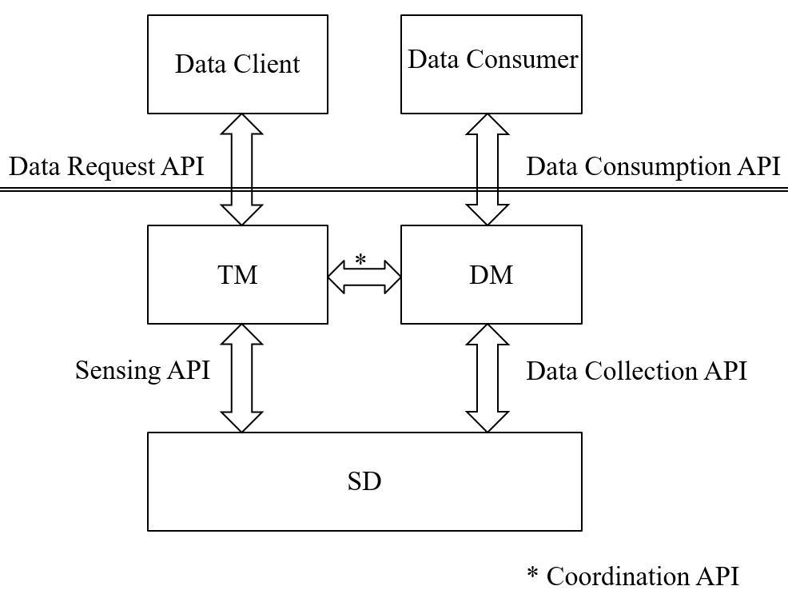
Figure 2: SCOS Entity Diagram

The TM handles sensing tasks from one or more Data Clients (DCli). The DM publishes sensing data to one or more Data Consumers (DCon). Thus, the topology mapping for sensing tasks is hence N:1:N for DCli:TM:SD. Similarly, the topology mapping for sensing data publishing is N:1:N for SD:DM:DCon.
The SCOS Platform provides a SCOS Request API to the Data Clients to initiate spectrum sensing tasks. The sensing tasks are scheduled by the SCOS platform on the sensing devices. The sensing devices send the sensing data to the SCOS platform. The SCOS platform publishes the sensing data to the Data Consumers using SCOS Data Distribution API.
The SCOS Platform provides Sensing API and Data Collection API to the Sensing devices for the purpose of associating sensor devices with the platform, performing sensing operations, and collecting the sensing data.
The SCOS control plane communication is synchronous; the data-plane communication is asynchronous.
It should be noted that within the SCOS system, the SDs shall not communicate with each other, or directly with the external roles using the SCOS system (DClis or DCons).
    - Entity Functions
Data Client is the entity that initiates a spectrum monitoring request to one or more Spectrum Task Managers (TM). Data Clients can be human or machine, and have various levels of privileges regarding what spectrum information collection can be initiated. Data Clients would determine where sensing data is to be transmitted, and authorization to access that data would rest with the owner of that data storage entity. and what spectrum information can be accessed from a Data Consumer.
A Data Client (user of the SCOS system) and TM (Task Manager) communicate by REST API to ask for available resources, and request a scan.
Data Consumer is a data store for storing spectrum information collected from the sensing network. There can be multiple DCs that sensing data is transmitted to by the Data Manager, and these can be, but not necessarily, associated with a specific Data Client.
The Data Manager transmits data to the DC via a Message Queue, and the Data Client interacts with the DC using their chosen mechanisms (out of scope of this standard)
Spectrum Task Manager (TM or Task Manager) manages a collection of Spectrum Sensing Devices (SD). Requests for spectrum measurements from Data Clients are inserted into a scan schedule on the TM for all its attached SDs, as far as possible under a set of slot availability rules. This schedule is synched to the appropriate SDs associated with the TM. Data from the SDs are collected at the Data Manager for transmission to one or more DCs for long term storage and processing.
The TM is associated with SDs (Sensing Devices) through a synchronous interface, where the TM enumerates and holds a list of available resources for each SD.
The TM stores and manages a schedule of scans against the sensing resources, and synchronizes this schedule with all SDs both on a change being made and periodically to ensure correct state.
Data Manager receives transmissions of packaged scan data from SDs, and retransmits it to one or more destinations, as defined by the policies associated with each Data Client (the source of scan requests)
The “Data Manager” applies any policies and then handles the Store & Forward to one or more DCs using a Message Queue or Streaming Mechanism
Task Manager and Data Manager together form the SCOS Manager, and each can be on the same platform or separate platforms.
Spectrum Sensing Device (SD) is the sensing hardware that collects the spectrum data requested by the TM on behalf of each Data Client. The SDs may exist with various levels of sophistication. The less sophisticated might be capable of measuring only one band, at only one resolution with little on-board processing. Other sensors may incorporate sophisticated antenna techniques, multiple bands, calibration processes, on-board data processing and/or storage and/or be capable of mobile operation.
An SD performs the scans in the schedule, and transmits the data and associated metadata through an asynchronous interface (message queue, or real-time stream) to a “Data Manager” that performs system data validation (i.e. that a transmission is received completely, partial scans are consolidated, etc).
SD Proxy enables an TM talk to any other proprietary sensing hardware, acting as a software translation mechanism that translates between commands/metrics/etc. It would need to be custom written for the particular device it talks to.
SM Proxy facilitates an SM talk to SM of another SCOS platform, with the downstream SM appearing as if it were an SD with a set of resources it provides. This downstream SCOS system would need to be 802.22.3 compliant.
The flow of instructions and data is described in Figure 3: SCOS Functional Block Diagram.
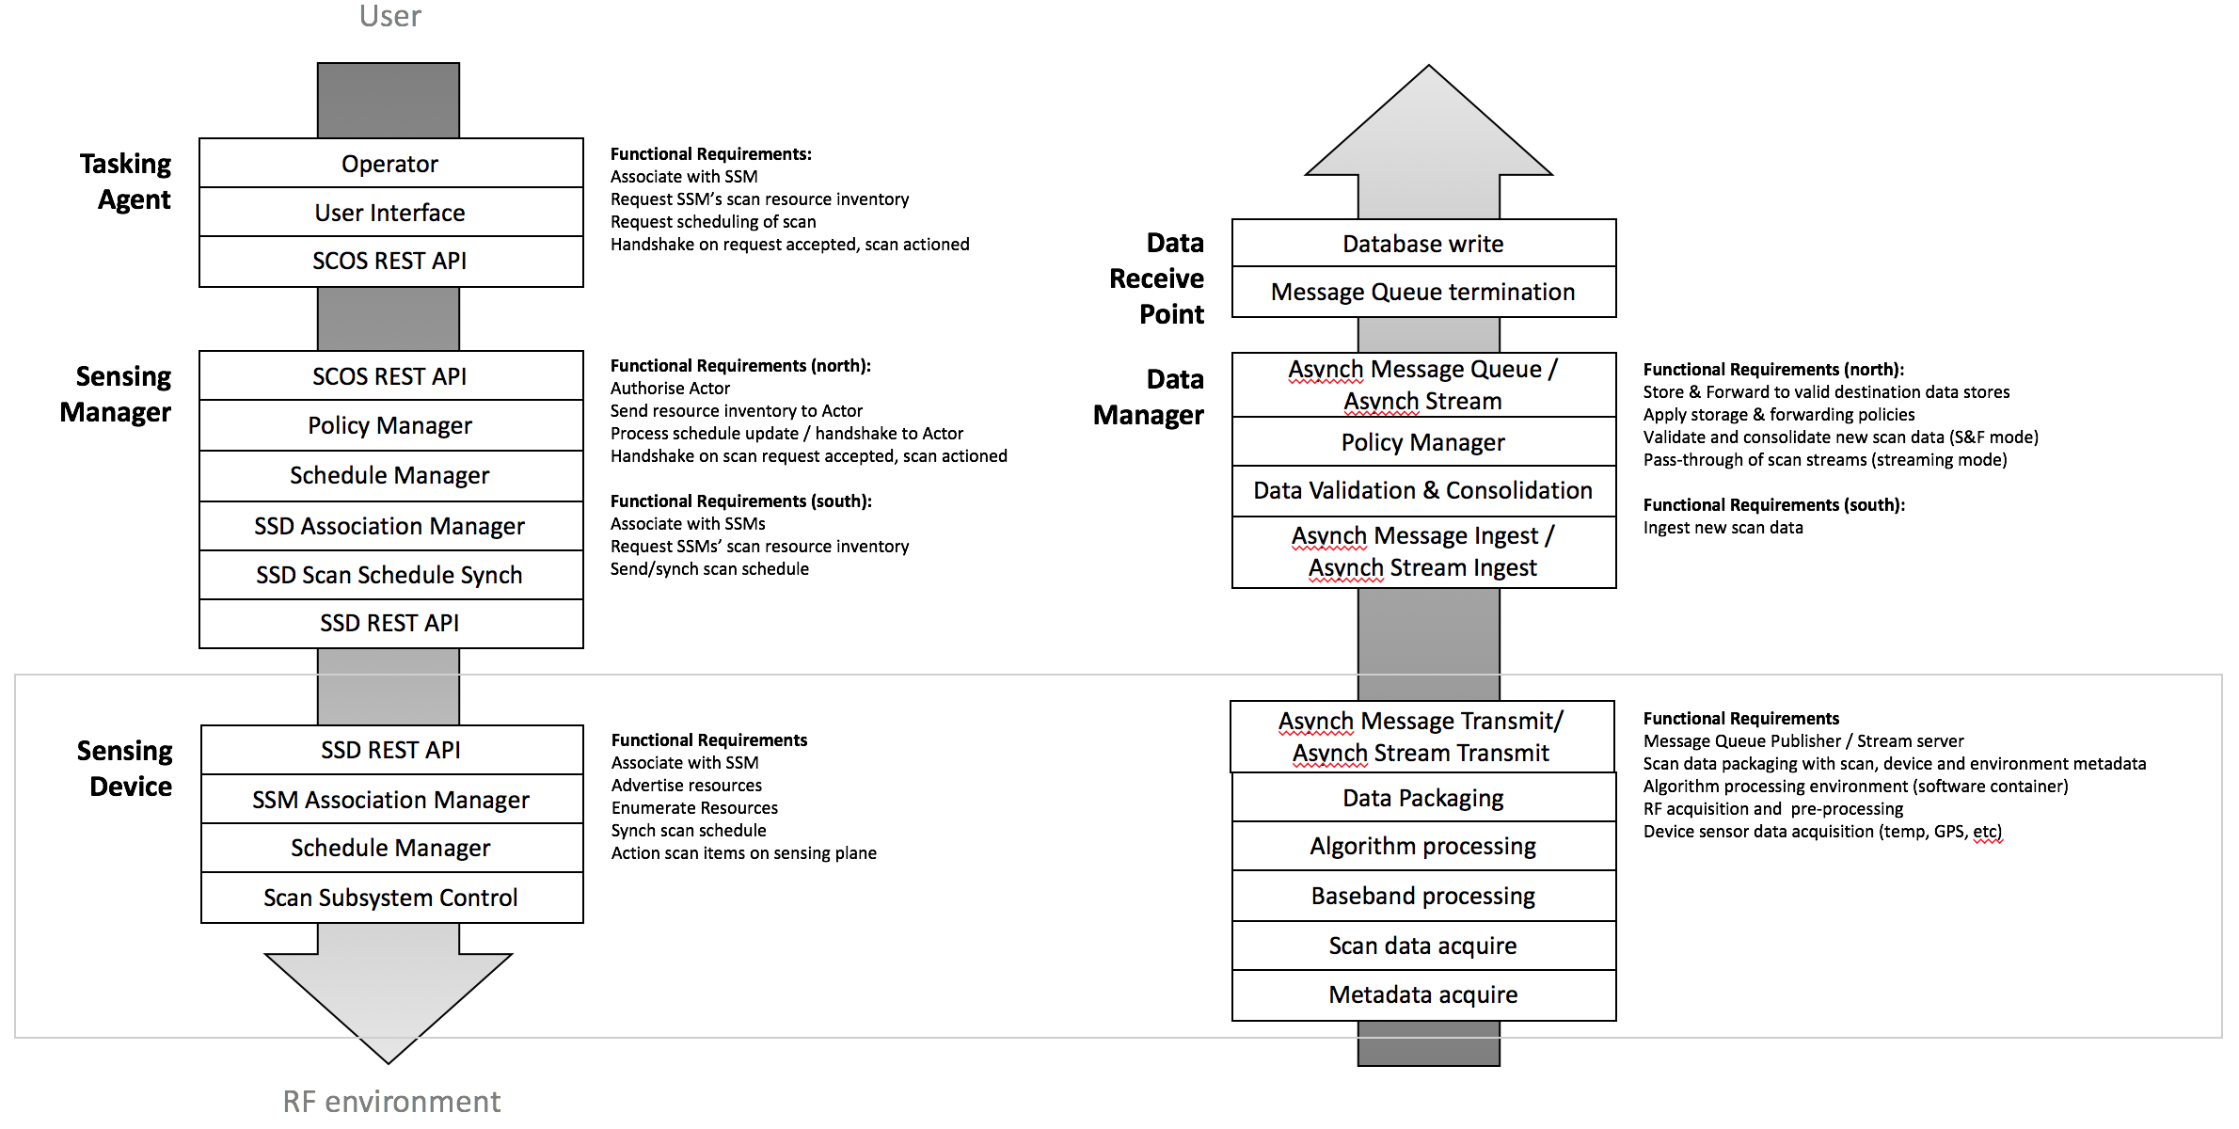
Figure 3: SCOS Functional Block Diagram

