IEEE Standard for Information Technology—
Telecommunications and information exchange between systems
Wireless Regional Area Networks (WRAN)—
Specific requirements
Part 22.3: Spectrum Characterization and Occupancy Sensing

Sponsor
LAN/MAN Standards Committee
of the
IEEE Computer Society
Approved Date XX
IEEE-SA Standards Board

Abstract: This standard specifies the architecture, abstraction layers, interfaces and metadata requirements for Spectrum Characterization and Occupancy Sensing (SCOS) system, a defines performance parameters, units and measures. This SCOS system comprises one or more semi-autonomous Spectrum Sensing Devices which scan electromagnetic spectrum, digitize it and perform processing, transmitting the resultant data with appropriate metadata to a central storage and processing system, according to rules, policies or instructions imposed on the Spectrum Sensing Devices by a management system.
Keywords: radio spectrum sensing, spectrum monitoring, signal characterization, cognitive radio, IEEE 802.22.3, WRAN standards

•
IEEE Standards documents are developed within the IEEE Societies and the Standards Coordinating Committees of the IEEE Standards Association (IEEE-SA) Standards Board. The IEEE develops its standards through a consensus development process, approved by the American National Standards Institute, which brings together volunteers representing varied viewpoints and interests to achieve the final product. Volunteers are not necessarily members of the Institute and serve without compensation. While the IEEE administers the process and establishes rules to promote fairness in the consensus development process, the IEEE does not independently evaluate, test, or verify the accuracy of any of the information or the soundness of any judgments contained in its standards.

Use of an IEEE Standard is wholly voluntary. The IEEE disclaims liability for any personal injury, property or other damage, of any nature whatsoever, whether special, indirect, consequential, or compensatory, directly or indirectly resulting from the publication, use of, or reliance upon this, or any other IEEE Standard document.
The IEEE does not warrant or represent the accuracy or content of the material contained herein, and expressly disclaims any express or implied warranty, including any implied warranty of merchantability or fitness for a specific purpose, or that the use of the material contained herein is free from patent infringement. IEEE Standards documents are supplied “AS IS.”

The existence of an IEEE Standard does not imply that there are no other ways to produce, test, measure, purchase, market, or provide other goods and services related to the scope of the IEEE Standard. Furthermore, the viewpoint expressed at the time a standard is approved and issued is subject to change brought about through developments in the state of the art and comments received from users of the standard. Every IEEE Standard is subjected to review at least every five years for revision or reaffirmation, or every ten years for stabilization. When a document is more than five years old and has not been reaffirmed, or more than ten years old and has not been stabilized, it is reasonable to conclude that its contents, although still of some value, do not wholly reflect the present state of the art. Users are cautioned to check to determine that they have the latest edition of any IEEE Standard.

In publishing and making this document available, the IEEE is not suggesting or rendering professional or other services for, or on behalf of, any person or entity. Nor is the IEEE undertaking to perform any duty owed by any other person or entity to another. Any person utilizing this, and any other IEEE Standards document, should rely upon his or her independent judgment in the exercise of reasonable care in any given circumstances or, as appropriate, seek the advice of a competent professional in determining the appropriateness of a given IEEE standard.

Interpretations: Occasionally questions may arise regarding the meaning of portions of standards as they relate to specific applications. When the need for interpretations is brought to the attention of IEEE, the Institute will initiate action to prepare appropriate responses. Since IEEE Standards represent a consensus of concerned interests, it is important to ensure that any interpretation has also received the concurrence of a balance of interests. For this reason, IEEE and the members of its societies and Standards Coordinating Committees are not able to provide an instant response to interpretation requests except in those cases where the matter has previously received formal consideration. A statement, written or oral, that is not processed in accordance with the IEEE-SA Standards Board Operations Manual shall not be considered the official position of IEEE or any of its committees and shall not be considered to be, nor be relied upon as, a formal interpretation of the IEEE. At lectures, symposia, seminars, or educational courses, an individual presenting information on IEEE standards shall make it clear that his or her views should be considered the personal views of that individual rather than the formal position, explanation, or interpretation of the IEEE.

Comments for revision of IEEE Standards are welcome from any interested party, regardless of membership affiliation with IEEE. Suggestions for changes in documents should be in the form of a proposed change of text, together with appropriate supporting comments. Recommendations to change the status of a stabilized standard should include a rationale as to why a revision or withdrawal is required. Comments and recommendations on standards, and requests for interpretations should be addressed to:
Secretary, IEEE-SA Standards Board
445 Hoes Lane
Piscataway, NJ 08854
USA
Authorization to photocopy portions of any individual standard for internal or personal use is granted by The Institute of Electrical and Electronics Engineers, Inc., provided that the appropriate fee is paid to Copyright Clearance Center. To arrange for payment of licensing fee, please contact Copyright Clearance Center, Customer Service, 222 Rosewood Drive, Danvers, MA 01923 USA; +1 978 750 8400. Permission to photocopy portions of any individual standard for educational classroom use can also be obtained through the Copyright Clearance Center.

Introduction
This standard specifies the functional elements, system architecture, abstraction layers, interfaces and metadata requirements for Spectrum Characterization and Occupancy Sensing (SCOS) system, with some limited definition of performance parameters, units and measures. It is intended to incorporate elements of existing standards and technology components to make it fast to implement using “off the shelf” hardware and software modules. The standard is intended to be flexible to make it forward-compatible as both radio sensing hardware and software technology develops, with an emphasis on using shared, virtualized, Internet-connected computing resources. The reference architecture describes one or more semi-autonomous Spectrum Sensing Devices which scan electromagnetic spectrum, digitize it and perform some level of processing, transmitting the resultant data with appropriate metadata to a Spectrum Sensing Management System. This command and control system manages scan requests from users, manages and advertises to users the scanning resources available to it from its connected Sensing Devices, and packages and forwards scan data to specified destinations according to rules, policies or instructions imposed by operator of the SCOS system.
Notice to users
Laws and regulations
Users of these documents should consult all applicable laws and regulations. Compliance with the provisions of this standard does not imply compliance to any applicable regulatory requirements. Implementers of the standard are responsible for observing or referring to the applicable regulatory requirements. IEEE does not, by the publication of its standards, intend to urge action that is not in compliance with applicable laws, and these documents may not be construed as doing so.
Copyrights
This document is copyrighted by the IEEE. It is made available for a wide variety of both public and private uses. These include both use, by reference, in laws and regulations, and use in private self-regulation, standardization, and the promotion of engineering practices and methods. By making this document available for use and adoption by public authorities and private users, the IEEE does not waive any rights in copyright to this document.
Updating of IEEE documents
Users of IEEE standards should be aware that these documents may be superseded at any time by the issuance of new editions or may be amended from time to time through the issuance of amendments, corrigenda, or errata. An official IEEE document at any point in time consists of the current edition of the document together with any amendments, corrigenda, or errata then in effect. In order to determine whether a given document is the current edition and whether it has been amended through the issuance of amendments, corrigenda, or errata, visit the IEEE Standards Association web site at http://ieeexplore.ieee.org/xpl/standards.jsp, or contact the IEEE at the address listed previously.

For more information about the IEEE Standards Association or the IEEE standards development process, visit the IEEE-SA web site at http://standards.ieee.org.
Errata
Errata, if any, for this and all other standards can be accessed at the following URL:
http://standards.ieee.org/reading/ieee/updates/errata/index.html. Users are encouraged to check this URL for errata periodically.

Interpretations
Current interpretations can be accessed at the following URL: http://standards.ieee.org/reading/ieee/interp/
index.html.
Patents
Attention is called to the possibility that implementation of this standard may require use of subject matter covered by patent rights. By publication of this standard, no position is taken with respect to the existence or validity of any patent rights in connection therewith. A patent holder or patent applicant has filed a statement of assurance that it will grant licenses under these rights without compensation or under reasonable rates, with reasonable terms and conditions that are demonstrably free of any unfair discrimination to applicants desiring to obtain such licenses. Other Essential Patent Claims may exist for which a statement of assurance has not been received. The IEEE is not responsible for identifying Essential Patent Claims for which a license may be required, for conducting inquiries into the legal validity or scope of Patents Claims, or determining whether any licensing terms or conditions provided in connection with submission of a Letter of Assurance, if any, or in any licensing agreements are reasonable or non-discriminatory. Users of this standard are expressly advised that determination of the validity of any patent rights, and the risk of infringement of such rights, is entirely their own responsibility. Further information may be obtained from the IEEE Standards Association.
Participants
At the time this standard was submitted to the IEEE-SA for approval, the following voting members had participated in the IEEE P802.22.3 Task Group:

TBC

Major contributions to this standard were made by the following individuals:

TBC

The following members of the balloting committee voted on this TBC. Balloters may have voted for approval, disapproval, or abstention.

When the IEEE-SA Standards Board approved this on TBC, it had the following membership:

Richard H. Hulett, Chair
John Kulick, Vice Chair
Robert M. Grow, Past Chair
Judith Gorman, Secretary

*Member Emeritus

Also included are the following nonvoting IEEE-SA Standards Board liaisons:

Satish Aggarwal, NRC Representative
Richard DeBlasio, DOE Representative
Michael Janezic, NIST Representative

Patricia Gerdon
IEEE Standards Program Manager, Document Development

Catherine Berger
IEEE Standards Project Editor

Contents
1. Overview 11
1.1 Scope 11
1.2 Purpose 11
1.3 Application 12
2. Normative References 12
3. Abbreviations and acronyms 12
4. Operational Modes 13
5. System Definition 13
5.1 System Roles 13
5.2 System Architecture 13
5.3 System Workflow 16
5.4 System Entity Models 17
6. Interfaces, Messaging and Primitives 21
6.1 SCOS Interfaces 22
6.2 SCOS Messaging 23
6.3 Primitives 26
7. Procedures 28
7.1 TA Association 28
7.2 SD Association 28
7.3 SD Discovery 28
7.4 Spectrum Scan 28
7.5 DC Discovery 28
7.6 Spectrum Data Collection 28
7.7 SCOS Message exchanges 28
8. System Administration and Security 32
8.1 Administration 32
8.2 Security Systems 33
9. Temporarily Moved Text 33
10. Removed Text 33
10.1 Data Ownership 33
10.2 Tasking Agent to Data Client Interface 34
Annex A Informative: Reference Applications 35
A.1 White Space device radio operation 35
A.2 National spectrum regulation 35
A.3 Research programmes 35
A.4 Law enforcement and public order 36
A.5 Network Operator Applications 36
Annex B Normative Functional Requirements 37
B.1 Tasking Agent Requirement 37
B.2 Data Quality and Definition 37
B.3 Regulatory requirements 37
B.4 Policy Management and Enforcement Requirements 37
B.5 Sensor Location-Fixing Requirements 38
B.6 Service Level Agreement Requirements 38
B.7 Certification Requirements 38
B.8 Technical Requirements 38
B.9 Security Requirements 39
Annex C Normative - SCOS Metadata Specification 41
C.1 SD metadata specification 41
10.3 System Units and Parameters (NOTE THESE NEED UNITS, SYNC W TABLES) 46
10.4 Metadata Formats 48
Annex D System Policy Model 50
D.1 SCOS Policy 50
Annex E Informative: Latency Requirements for Scans 57
Annex F Informative: Regulatory Technical requirements 58
Annex G Device and System Security Recommendations 59
Annex H Implementation Guidelines/Notes 60
H.1 Management Reference Architecture 60
Annex I (normative) IEEE 802.22 regulatory domains and regulatory classes requirements 65
I.1 Regulatory domains, regulatory classes, and professional installation 65
I.2 Radio performance requirements 66
Annex J (informative) Sensing 67
J.1 References 67
Annex K (informative) Bibliography 68

IEEE Standard for Information Technology—
Telecommunications and information exchange between systems
Wireless Regional Area Networks (WRAN)—
Specific requirements
Part 22.3: Standard for Spectrum Characterization and Occupancy Sensing
IMPORTANT NOTICE: This standard is not intended to ensure safety, security, health, or environmental protection. Implementers of the standard are responsible for determining appropriate safety, security, environmental, and health practices or regulatory requirements.

This IEEE document is made available for use subject to important notices and legal disclaimers.
These notices and disclaimers appear in all publications containing this document and may
be found under the heading “Important Notice” or “Important Notices and Disclaimers
Concerning IEEE Documents.” They can also be obtained on request from IEEE or viewed at http://standards.ieee.org/IPR/disclaimers.html.

- Section 5: System Definition

  - System Roles
The following roles have been identified based on operational requirements for the SCOS system.

Sensor Owner: The individual or organisation that deploys and has administrative and physical control over the sensing devices (SD). SDs are typically physical devices.

Sensing Data Administrator: The individual or organisation that deploys and has administrative and physical control over the Data Clients consisting of data stores or other consumers of spectrum sensing data delivered by the SCOS system.

SCOS Administrator: The individual or organisation that deploys and has administrative and physical control over the SCOS System, consisting of the Sensing Management System and Sensing Data Manager.

Tasking Agent: The individual or system that authenticates with the SCOS system and causes a scan activity to be scheduled.
  - System Architecture
The SCOS system architecture is based on the design objective of abstracting the layers between the platform users, sensing task management, sensing data management and sensor device management in order to facilitate a flexible implementation where different areas by be implemented or operated by different organizations, but still allow inter-operation.

The SCOS system is composed of five key entities:
- Sending Devices (SDs) that perform the sensing function.
- Sensing Manager (SM) that schedules spectrum scan.
- Data Manager (DM) that manages the sensing data from the sensing devices.
- Tasking Agents (TAs) that are interested in spectrum monitoring and issue spectrum sensing tasks to the SCOS platform
- Data Client (DC) that receive the sensing data published by the SCOS platform

Figure 1 shows the five key entities within the SCOS system.

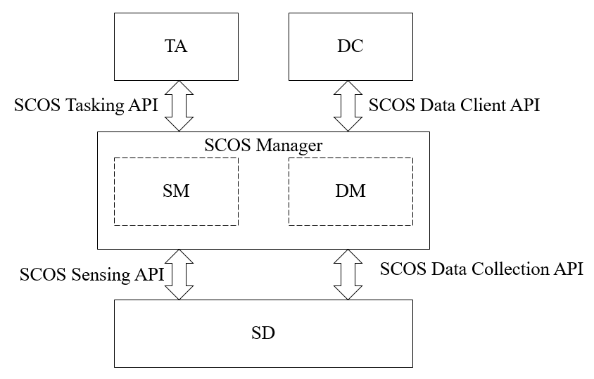

Figure 1: SCOS System Block Diagram.

SCOS Manager is an aggregate entity composed of Sensing Manager and Data Manager. SCOS platform manages sensing tasks, sensing devices, and sensing data.

The SCOS Manager provides Tasking API to the Tasking Agents to initiate spectrum sensing tasks. The sensing tasks are scheduled by the SCOS platform on the sensing devices. The sensing devices send the sensing data to the SCOS platform. The SCOS platform publishes the sensing data to the Data Clients using SCOS Data Client API.

The SCOS Manager provides Sensing API and Data Collection API to the Sensing devices for the purpose of associating sensor devices with the platform, performing sensing operations, and collecting the sensing data.

Within the SCOS system, the SDs shall not communicate with each other, or directly with the user of the SCOS system (Tasking Agent).

    - Topology
The SCOS system consists of a single SM and a single DM, which communicate over any standard network transport with one or more SDs.

The SM handles sensing tasks from one or more TAs. The DM publishes sensing data to one or more DCs.

Thus, the topology mapping for sensing tasks is hence N:1:N for TA:SM:SD. Similarly, the topology mapping for sensing data publishing is N:1:N for SD:DM:DC.

Figure 2 illustrates the SCOS system topology.
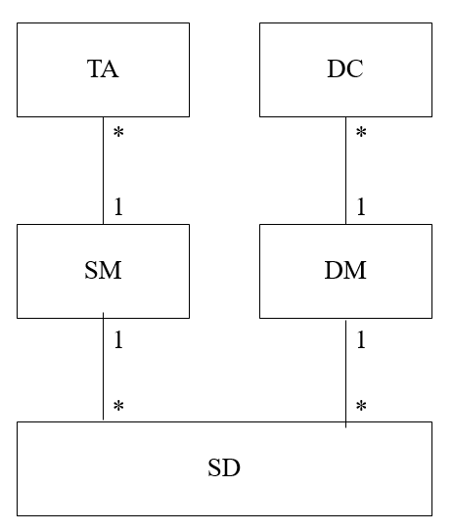
Figure 2: SCOS System Topology

      - Non 802.22.3 compliant SDs and SCOS Cascading
802.22.3 standard makes provision for proxying, that allows a non 802.22.3 compliant SD to associate with and be controlled by an SM, as well cascading of systems, where one 802.22.3 compliant SM to be associated with, and delegate tasks to, another 802.22.3 SCOS system.

SD Proxy facilitates an SM communicate with proprietary sensing hardware, acting as a software translation mechanism that translates between SCOS messages.

SM Proxy enables cascading of SCOS systems where an SM can communicate with other SMs as if they were associated SDs.
Figure 3 illustrates the extensions with an instance of system topology.
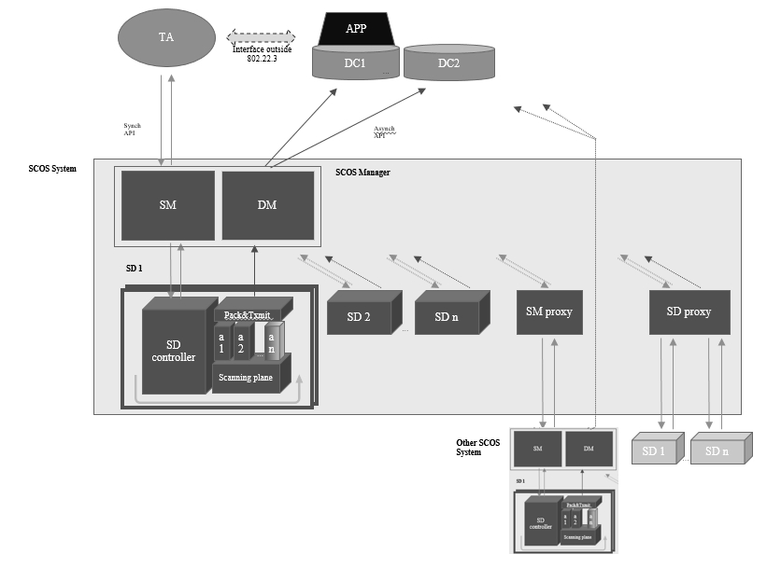
Figure 3. An SCOS System Instance with Extensions

    - Entity Functions
- Tasking Agent is the entity that initiates a spectrum monitoring request to one or more Spectrum Sensing Managers (SM). Tasking Agents can be human or machine, and have various levels of privileges regarding what spectrum information collection can be initiated. Tasking Agents would determine where sensing data is to be transmitted, and authorization to access that data would rest with the owner of that data storage entity. and what spectrum information can be accessed from a Data Client.
  - An Tasking Agent (user of the SCOS system) and SM (Sensing Manager) communicate by REST API to ask for available resources, and request a scan.
- Data Client is a data store for storing spectrum information collected from the sensing network. There can be multiple DCs that sensing data is transmitted to by the Data Manager, and these can be, but not necessarily, associated with a specific Tasking Agent.
  - The Data Manager transmits data to the DC via a Message Queue, and the Tasking Agent interacts with the DC using their chosen mechanisms (out of scope of this standard)
- Spectrum Sensing Manager (SM or Sensing Manager) manages a collection of Spectrum Sensing Devices (SD). Requests for spectrum measurements from Tasking Agents are inserted into a scan schedule on the SM for all its attached SDs, as far as possible under a set of slot availability rules. This schedule is synched to the appropriate SDs associated with the SM. Data from the SDs are collected at the Data Manager for transmission to one or more DCs for long term storage and processing.
  - The SM is associated with SDs (Sensing Devices) through a synchronous interface, where the SM enumerates and holds a list of available resources for each SD.
  - The SM stores and manages a schedule of scans against the sensing resources, and synchronizes this schedule with all SDs both on a change being made and periodically to ensure correct state.
- Data Manager receives transmissions of packaged scan data from SDs, and retransmits it to one or more destinations, as defined by the policies associated with each Tasking Agent (the source of scan requests)
  - The “Data Manager” applies any policies and then handles the Store & Forward to one or more DCs using a Message Queue or Streaming Mechanism
- The Sensing Manager and Data Manager together form the SCOS Manager, and each can be on the same platform or separate platforms.
- The Spectrum Sensing Device is the sensing hardware that collects the spectrum data requested by the SM on behalf of each Tasking Agent. The SDs may exist with various levels of sophistication. The less sophisticated might be capable of measuring only one band, at only one resolution with little on-board processing. Other sensors may incorporate sophisticated antenna techniques, multiple bands, calibration processes, on-board data processing and/or storage and/or be capable of mobile operation.
  - An SD performs the scans in the schedule, and transmits the data and associated metadata through an asynchronous interface (message queue, or real time stream) to a “Data Manager” that performs system data validation (i.e. that a transmission is received completely, partial scans are consolidated, etc).
- SM Proxy facilitates an SM talk to another, with the downstream SM appearing as if it were an SD with a set of resources it provides. This downstream SCOS system would need to be 802.22.3 compliant.
- SD Proxy enables an SM talk to any other proprietary sensing hardware, acting as a software translation mechanism that translates between commands/metrics/etc. It would need to be custom written for the particular device it talks to.

The flow of instructions and data is described in Figure 4: SCOS Functional Block Diagram.

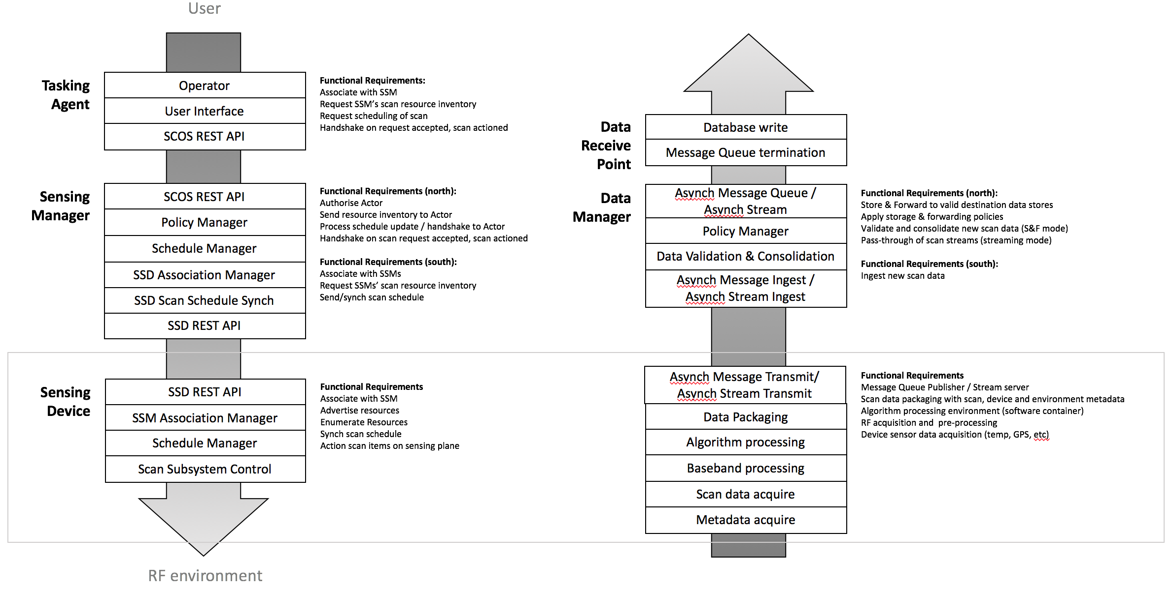
Figure 4: SCOS Functional Block Diagram

  - System Workflow

The Tasking agents interact with Sensing Manager through the 802.22.3 defined Tasking API. The tasking API facilitates querying the available sensing resources and schedule sensing tasks as permitted by resource availability, authorisation level and system policies.

The sensing devices are associated with the SCOS system using the SCOS sensing API. The SM maintains an inventory of the sensing resources along with the SD capabilities and parameters described according to this 802.22.3 standard.

Following is the typical workflow within the SCOS system.

- The Tasking Agent submits a scanning task into a schedule managed by the SM using the SCOS Tasking API defined in this 802.22.3 standard
- The SM maintains the schedule of tasks and synchronises this schedule of tasks to the SD using the SCOS sensing API defined in this 802.22.3 standard
- Within the SD, radio energy shall be collected by an antenna and transferred through an interconnect to a signal conditioner. Conditioned signal will be then transferred to a signal processing system to produce a baseband signal that can be quantised and passed in digital form to be analysed through whichever sensing technique is offered by the SD
- The data from this analysis, and the associated metadata that includes the sensing technique and environment, hardware, software and configuration parameters as defined in this standard, can be temporarily stored on the local device before it shall be transmission to an end point.
- SD transmits the sensing data to the Data Manager using the SCOS Data Collection API.
- The DM establishes the end point of data package transmissions according to the Tasking Agent’s nominated DCs, and in accordance with the policies defined in the SMS. DM publishes the data to the DCs.
- Finally, SMS reports the success or otherwise for the sensing task back to the original Tasking Agent.

  - System Entity Models

    - Tasking Agent
Tasking Agents are human or machine entities that can query SCOS resources and request scans to be performed.

There are at least three main classes of consumers of spectrum data:

Type A Agent: are specifically looking for current sensing information, and request specific scans to obtain specific data (e.g. law enforcement).

Type B Agent: have a requirement to keep spectrum information up to date (e.g. spectrum occupancy database operators), and will need to request periodic scans to achieve this.

Type C Agent: those that want to read spectrum information from a DC that is already populated with their required data. These users are not contemplated in this standard.

In general, it should be assumed that a Type A Tasking Agent would have higher priority in terms of scan resources, as governed by a Policy expanded on below.

Parameter | R/O/C | Description
NAME: TA Name DATA TYPE: string | Required | The name of the tasking agent registered with SCOS operator.  The maximum length is 64 octets.
NAME: SCOS Administrator DATA TYPE: string | Required | The name of the SCOS operator.  The maximum length is 64 octets.
NAME: TA type DATA TYPE: string | Required | The type of TA.  The maximum length is 64 octets.
NAME: TA ID DATA TYPE: string | Required | The unique ID assigned to the tasking agent. The maximum length is 64 octets.

    - Spectrum Sensing Device (SD)
SDs convert radiative electromagnetic energy into a voltage, which is then sampled. The samples can then be processed in various ways to provide information on the immediate RF environment, e.g., amplitude statistics versus frequency, amplitude and phase versus time at a given frequency, occupancy statistics, angle of arrival.
      - Hardware Model
A simplified hardware block diagram of a general SD model is depicted in 5. SD hardware designs are not required to have each component shown in the block diagram. Specifics for each component (e.g., presence, model, operational parameters), however, is required metadata when SD capabilities are queried by the SM. This SD definition metadata is also accompanied with the output data messages.

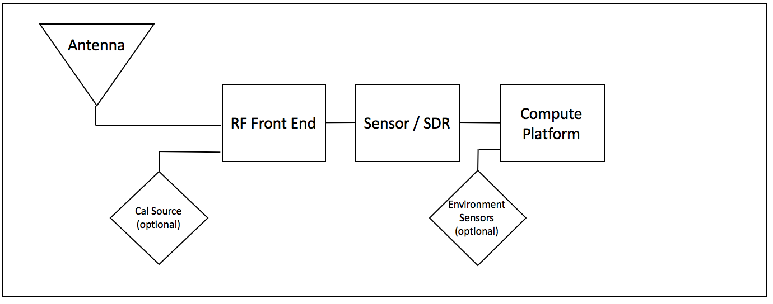
Figure 5: SD Simplified Hardware Model Block Diagram

The SD is composed of the following functional elements, as follows:
- Functional element 1 – Antenna: An antenna used to collect RF energy. This is fed to functional element 2 over a hardware interface (interconnect cable)
- Functional element 2 – Signal Conditioning Unit: An RF front end unit consisting of (all or some of) an RF switch (optional, with the ability to accept an optional calibration signal), filter, Low Noise Amplifier, mixer. This sends the conditioned signal to functional element 3 over an analogue hardware interface (interconnect cable/track).
- Functional element 3 – Signal Extraction Unit: Analogue Digital Converter, spectrum analyser or Software Defined Radio to act as a baseband processor, performing a demodulation of the conditioned signal and acquires the baseband signal. This sends a digitised signal over a digital interface (interconnect)
- Functional element 4 – Compute Platform: that provides
  - A signal processing function with a signal detection and/or classification algorithm. It sends detection/classification data to metadata consolidation and packaging function over a software interface.
  - A metadata consolidation and data packaging function that combines sensing data with environmental inputs (where implemented), hardware, operating and system-configured metadata. It sends data packages to the transmission system over a software interface.
  - A transmission unit that transmits scan data to the destination system over a best-effort IP connection.

The Compute Platform sends necessary command and control signals to Functional element 2 (Conditioning Unit) and Functional element 3 (Extraction Unit). It receives data from the Sensor/SDR, and polls any environment sensor input devices for necessary metadata items, such as GPS location. Interaction of the various elements is described in Figure 6: SD Functional Elements.

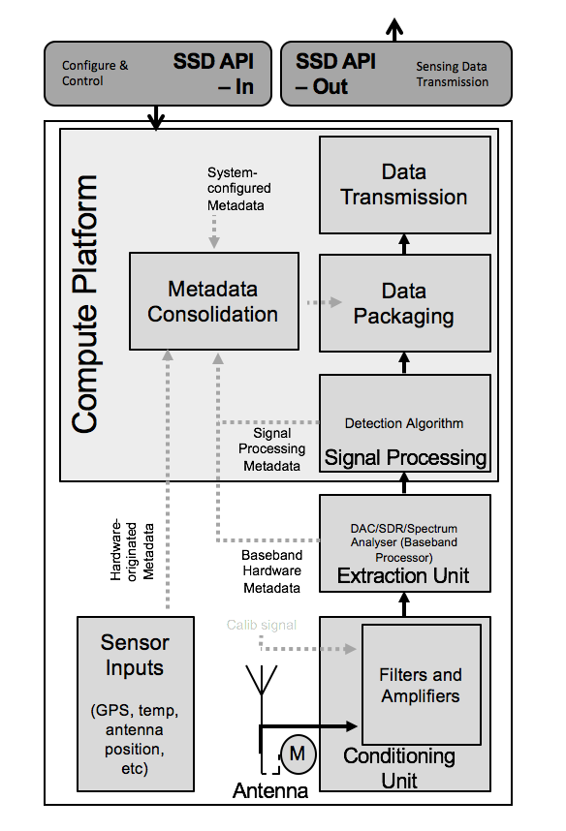
Figure 6: SD Functional Elements

This block diagram can be split into the hardware layer and the software processes that run alongside. These hardware blocks or software services generate metadata that is associated with each item.

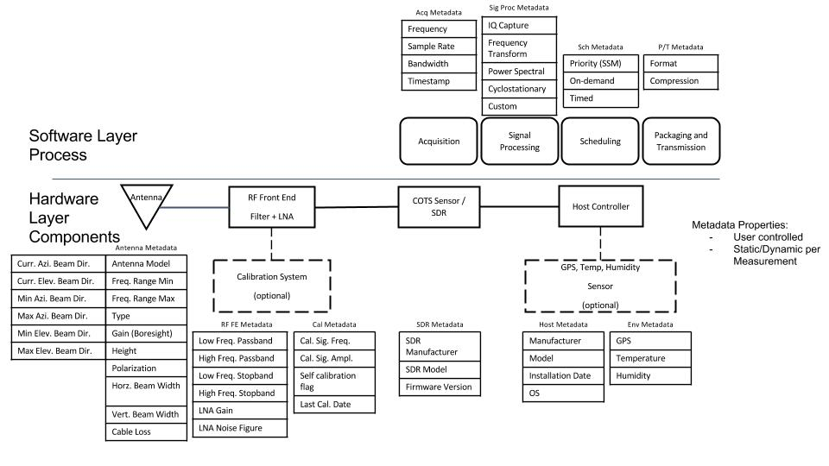
Figure 5: SD model - Hardware layer components and Software layer processes with relevant metadata

Following table enumerates the parameter definition object for Functional element 1.

Parameter | R/O/C | Description
NAME: AziBeamDir DATA TYPE: number | Required | Current boresight direction of the horizontal plane of the antenna in degrees with respect to true north. The value of this parameter is an integer with a value between 0 and 359 inclusive. A value of 0 degrees means true north; a value of 90 degrees means east.
NAME: ElevationBeamDir DATA TYPE: number | Required | The current angle between the horizontal plane and the line of sight, measured in the vertical plane.
NAME: MinAziBeamDir DATA TYPE: number | Required | The minimum azimuth beam direction.
NAME: MaxAziBeamDir DATA TYPE: number | Required | The maximum azimuth beam direction.
NAME: MinEleBeamDir DATA TYPE: number | Required | The minimum elevation beam direction.
NAME: MaxEleBeamDir DATA TYPE: number | Required | The maximum elevation beam direction.
NAME: Antenna model DATA TYPE: string | Required | The antenna model (#What are the options?).  The maximum length is 64 octets.
NAME: Antenna type DATA TYPE: string | Required | The antenna type (#What are the options?).  The maximum length is 64 octets.
NAME: FreqRangeMin DATA TYPE: number | Required | The lowest frequency
NAME: FreqRangeMax DATA TYPE: number | Required | The highest frequency.
NAME: Gain DATA TYPE: number | Required | The boresight gain.
NAME: Height DATA TYPE: number | Required | The height in meters.
NAME: Polarization DATA TYPE: number | Required | The polarization in degrees.
NAME: HorzBeamWidth DATA TYPE: number | Required | The horizontal beamwidth in degrees.
NAME: VertBeamWidth DATA TYPE: number | Required | The vertical beamwidth in degrees.
NAME: CableLoss DATA TYPE: number | Required | The cable loss in dB.

Following table enumerates the parameter definition object for Functional element 2.

Parameter | R/O/C | Description
NAME: AziBeamDir DATA TYPE: number | Required | Current boresight direction of the horizontal plane of the antenna in degrees with respect to true north. The value of this parameter is an integer with a value between 0 and 359 inclusive. A value of 0 degrees means true north; a value of 90 degrees means east.

Following table enumerates the parameter definition object for Functional element 3.

Parameter | R/O/C | Description
NAME: AziBeamDir DATA TYPE: number | Required | Current boresight direction of the horizontal plane of the antenna in degrees with respect to true north. The value of this parameter is an integer with a value between 0 and 359 inclusive. A value of 0 degrees means true north; a value of 90 degrees means east.

Following table enumerates the parameter definition object for Functional element 4.

Parameter | R/O/C | Description
NAME: AziBeamDir DATA TYPE: number | Required | Current boresight direction of the horizontal plane of the antenna in degrees with respect to true north. The value of this parameter is an integer with a value between 0 and 359 inclusive. A value of 0 degrees means true north; a value of 90 degrees means east.

Following table enumerates the parameter definition object for Functional element 5.

Parameter | R/O/C | Description
NAME: AziBeamDir DATA TYPE: number | Required | Current boresight direction of the horizontal plane of the antenna in degrees with respect to true north. The value of this parameter is an integer with a value between 0 and 359 inclusive. A value of 0 degrees means true north; a value of 90 degrees means east.

      - SD Calibration Model
A calibration can be done in the lab at build/commissioning time, and stored as a calibration file on the SD. Further, an SD with a self-calibration capability can be instructed through an administrative interface (not Tasking Agent request) to perform a calibration using a local calibration source.

Following table enumerates the parameter definition object for SD Calibration Model.

Parameter | R/O/C | Description
NAME: AziBeamDir DATA TYPE: number | Required | Current boresight direction of the horizontal plane of the antenna in degrees with respect to true north. The value of this parameter is an integer with a value between 0 and 359 inclusive. A value of 0 degrees means true north; a value of 90 degrees means east.

      - SD Algorithm Model
The algorithm model is described in terms of
- inputs into black box: the identity of the USER and SM requesting the scan, the measurement parameters, which algorithm is to be used; and
- outputs from the black box: the identity of the USER and SM requesting the scan, the requested scan parameters, the identification of the algorithm model, and the processed results.

Following table enumerates the parameter definition object for algorithmModel.

Parameter | R/O/C | Description
NAME: AlgorithmSet  DATA TYPE: Array of String | Required | Names of algorithms supported by the SD.  The maximum length of the ID string is 64 octets.

Following algorithms can be specified. At least once algorithm model needs to be supported by SD. Support for GenericEnergyDetection is normative.
Scan Algorithm | Description
GenericEnerrgyDetection | Normative.
CyclicFeatureDetection
CustomScanAlgorithm

The standard would allow development of advanced algorithms. For example, direction finding.

It is the responsibility of the SM operatorSCOS Administrator to publish algorithm definitions externally. The implementation does not need to be publicly accessible.

[#Message]
Parameter | R/O/C | Description
NAME: TA ID  DATA TYPE: String | Required | The TA ID.  The maximum length of the ID string is 64 octets.
NAME: SM ID  DATA TYPE: String | Required | The SM ID.  The maximum length of the ID string is 64 octets.
NAME: SDScanParam  DATA TYPE: Object of type SDScanParam | Required | The scan parameters object.
NAME: Algorithm  DATA TYPE: String | Required | The SM ID.  The maximum length of the ID string is 64 octets.

    - Spectrum Sensing Manager (SM)
Following table enumerates sensing manager parameters.

Parameter | R/O/C | Description
NAME: SMID  DATA TYPE: String | Required | Unique ID for the Sensing Manager.  The maximum length of the ID string is 64 octets.
NAME: SMSID  DATA TYPE: String | Required | Unique ID for the SMS.  The maximum length of the ID string is 64 octets.
NAME: SCOS Operator  DATA TYPE: String | Required | The registered name of the SCOS operator.  The maximum length of the ID string is 64 octets.

      - SM Association
SMs receive and manage association and disassociation requests from SDs. The details of the association and disassociation message objects are covered in Procedures Section, subsection 7.2.1

      - SM Task Scheduling
Scheduling is defined in terms of scan intervals that take up slots in a calendar schedule. These slots will include slots for long scans; and slots for very short scans to ensure fair allocation of scan resources.

Scheduling requests from a USER will be defined in terms of duration, time, repetition, etc, as well as a flag to indicate whether the desired scan slots are “Exact Time” slots or “Nearest Time” slots. The scheduler on the SM will use this to try meet the USER request (and either confirm the scan schedule is accepted or refused).

Following table enumerates the parameter definition object for scanTask.

Parameter | R/O/C | Description
NAME: TaskID  DATA TYPE: String | Required | Unique ID for the Spectrum Scan.  The maximum length of the ID string is 64 octets.
NAME: TaskDuration  DATA TYPE: number | Required | Duration of scan in milliseconds.
NAME: TaskStartTime  DATA TYPE: Time | Required | The start time for the task.
NAME: TaskRepeatInterval  DATA TYPE: Number | Optional | The interval in seconds after which the task needs to be repeated.
NAME: TaskRepeatCount  DATA TYPE: Number | Optional | The number of times the task needs to be repeated.  The maximum length of the ID string is 64 octets.
NAME: TaskEndTime  DATA TYPE: Time | Optional | The end time for the task.

    - Data Manager
The following table enumerates the parameter definition object for DataManager.

Parameter | R/O/C | Description
NAME: DMID  DATA TYPE: String | Required | Unique ID for the Data Manager.  The maximum length of the ID string is 64 octets.
NAME: SMSID  DATA TYPE: String | Required | Unique ID for the SMS.  The maximum length of the ID string is 64 octets.
NAME: SCOS Operator  DATA TYPE: String | Required | The registered name of the SCOS operator.  The maximum length of the ID string is 64 octets.

    - SD Proxy
[#AddDesc]

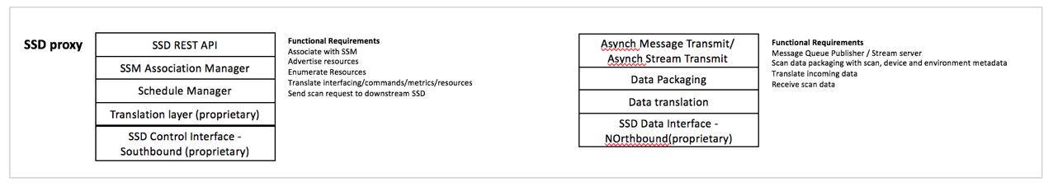
Figure 6: SD Proxy
The following table specifies the parameter definition object for SDProxy.

Parameter | R/O/C | Description
NAME: SDID  DATA TYPE: String | Required | Unique ID for the SD.  The maximum length of the ID string is 64 octets.
NAME: SMSID  DATA TYPE: String | Required | Unique ID of the SMS to which SD is associated.  The maximum length of the ID string is 64 octets.
NAME: SCOS Operator  DATA TYPE: String | Required | The registered name of the SCOS operator.  The maximum length of the ID string is 64 octets.

    - SM Proxy
[#AddDesc]

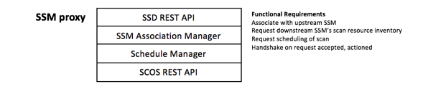
Figure 7: SM Proxy

The following table specifies the parameter definition object for SMProxy.

Parameter | R/O/C | Description
NAME: SMID  DATA TYPE: String | Required | Unique ID for the SM.  The maximum length of the ID string is 64 octets.
NAME: SMSID  DATA TYPE: String | Required | Unique ID of the SMS to which SD is associated.  The maximum length of the ID string is 64 octets.
NAME: SCOS Operator  DATA TYPE: String | Required | The registered name of the SCOS operator.  The maximum length of the ID string is 64 octets.

The Institute of Electrical and Electronics Engineers, Inc. 3 Park Avenue, New York, NY 10016-5997, USA Copyright © 2011 by the Institute of Electrical and Electronics Engineers, Inc. All rights reserved. Published 1 July 2011. Printed in the United States of America. IEEE and 802 are registered trademarks in the U.S. Patent & Trademark Office, owned by the Institute of Electrical and Electronics Engineers, Incorporated. PDF: ISBN 978-0-7381-6723-7 STD97146 Print: ISBN 978-0-7381-6724-4 STDPD97146 IEEE prohibits discrimination, harassment and bullying. For more information, visit http://www.ieee.org/web/aboutus/whatis/policies/p9-26.html. No part of this publication may be reproduced in any form, in an electronic retrieval system or otherwise, without the prior written permission of the publisher.

